Anesthetic effect of dexmedetomidine-ketamine-midazolam combination administered intramuscularly to zoo-housed naked mole-rats (heterocephalus glaber). Journal of Zoo and Wildlife Medicine 51.1 (2020): 59-66. Huckins, Gail L., Eshar, David, Shrader, Trent, and Beaufrère, Hugues. -Review by LEM

Abstract: In this study, adult intact male and female (n = 10) naked mole-rats (Heterocephalus glaber) were anesthetized using a combination of dexmedetomidine (0.06 mg/kg intramuscularly [IM]), ketamine (20 mg/kg IM), and midazolam (1.0 mg/kg IM). Atipamezole (1.0 mg/kg IM) and flumazenil (0.1 mg/kg IM) were administered 40 min after induction. Induction and recovery times were monitored and recorded. Vital parameters, including heart rate, respiratory rate, and SpO2, and reflexes were monitored every 5 min during the anesthetic period. Anesthetic induction was smooth and rapid. All monitored reflexes were lost within a median time of 60 sec (interquartile range, 15 sec). Heart rate and respiratory rate were significantly decreased from baseline, whereas there was no difference in SpO2 over the anesthetic period. The mean time to recovery was 15 ± 7 min (mean ± SD). One animal was found dead 40 min after apparent recovery, which is suspected to be an anesthetic-related death. Based on these findings, dexmedetomidine-ketamine-midazolam anesthesia is an effective anesthetic protocol in naked mole rats that provides a consistent anesthetic plane but should be used with caution in animals with underlying conditions.

Taxonomy: Order: Rodentia, Family: Bathyergidae, Genus/Species: Heterocephalus glaber

Background:
- Subterranean rodents native to sub-Saharan Africa
- Unique physiologic adaptations to combat hypoxic and hypercapnic burrow environment
  - Low basal metabolic rate, high Hct, high Hgb with increased O2 affinity
  - Thus → anesthetic doses should not be extrapolated from other mammals/rodents
- Due to temperament chemical immobilization often necessary for exam/diagnostics

Methods: evaluation of dex-ket-midaz (DKM) IM anesthetic protocol in naked mole-rats; n=10 adults

Key Points:
- Induction was smooth and rapid (60 seconds)
- All reflexes were lost within 1 minute (median)
- HR and RR were significantly decreased from baseline
  - Two animals developed transient apnea
  - Sex did have effect on RR: males had lower RR than females over time
- SpO2 was stable throughout
  - Sex did have effect on SpO2: lower in males than females
- Mean recovery time was 15 +- 7 minutes
  - Three animal required second flumazenil reversal
- 1/10 animals died 40 minutes post-recovery and WAS suspected to be anesthetic related
  - No other adverse effects
- No issues with reintroduction to colony after this protocol
- KEY: DKM is effective in naked mole rats for providing consistent anesthetic plane for ~40 min
  - Should be used with caution due to one animal dying during recovery

Anesthetic effects of alfaxalone-ketamine-midazolam and alfaxalone-ketamine-dexmedetomidine administered intramuscularly in black-tailed prairie dogs (Cynomys ludovicianus). American Journal of Veterinary Research 83.9 (2022). Kara Hiebert, David Eshar, Jasmine Sarvi, Hugues Beaufrère. - review by LEM

Abstract:
​​OBJECTIVE: To evaluate and compare the anesthetic effects of alfaxalone-ketamine-midazolam (AKM) and alfaxalone-ketaminedexmedetomidine (AKD) in black-tailed prairie dogs (Cynomys ludovicianus).
ANIMALS: 9 male black-tailed prairie dogs.
PROCEDURES: Prairie dogs were anesthetized with AKM (6 mg/kg alfaxalone, 30 mg/kg ketamine, and 1.5 mg/kg midazolam) and AKD (6 mg/kg alfaxalone, 30 mg/kg ketamine, and 0.15 mg/kg dexmedetomidine) in a prospective, complete cross-over study. Atipamezole (1.5 mg/kg) after AKD or flumazenil (0.1mg/kg) after AKM was administered 45 minutes after induction of anesthesia. Onset of general anesthesia, physiologic parameters, depth of anesthesia, and time to recovery after reversal administration were evaluated for each treatment.
RESULTS: Both AKM and AKD produced a deep plane of anesthesia in black-tailed prairie dogs that varied in duration. The median induction times for AKM and AKD were 82 and 60 seconds, respectively. The median recovery times for AKM and AKD were 27 and 21 minutes, respectively. There were no significant differences between protocols for induction (P = .37) and recovery (P = .51) times. All measured reflexes were absent in all animals at 5 minutes postinduction, with hindlimb reflexes returning prior to forelimb reflexes. Heart rate was lower but respiratory rate was higher in the AKD treatment. Body temperature decreased significantly for both protocols (P < .001) and was significantly lower with AKM than AKD (P < .001).
CLINICAL RELEVANCE: Both AKM and AKD produced a deep plane of anesthesia in black-tailed prairie dogs. For both protocols, heat support and oxygen support are indicated.

Taxonomy: Order: Rodentia, Family: Sciuridae, Genus: Cynomys

Background:
- Black-tailed prairie dogs = fractious nature = makes for difficult restraint, usually need chemical
- Problems with chamber induction (compared to IV): risk of waste gas exposure to people, greater odds ratio of anesthetic death in sick dogs/cats, greater cardiopulmonary depression
- Previous protocols in p. dogs have had mortality (3% with xyl-kt) or unreliable plane (DKM)
- Alfaxolone: neuroactive steroid - produces non reversible, nonanalgesic anesthesia and muscle relaxation through interaction with GABA receptors in CNS
  - Combo with alpha-2 agonist can provide consistent deep plane in other rodent species
- Ketamine: dissociative, centrally acting NMDA receptor antagonist

Methods: evaluated 2 IM anesthetic protocols (benzo vs. alpha-2); n=9; crossover w/ 16d washout
- AKM (alfaxalone-ketamine-midazolam) vs. AKD (alfaxalone-ketamine-dexmedetomidine)

Key Points:
- No significant differences between induction time and recovery time between protocols
- Smooth and fast induction; all animals lost measured reflexes within 5 minutes post induction
- AKM animals maintained longer surgical plane postinduction
  - AKD 20 minutes (indicated for brief procedures only), AKM 45 minutes
- HR lower with AKD (not surprising with dex), over time with AKD, and by weight of animal
- RR decreased over time with AKM (remained stable with AKD), and with heavier weight
  - No RR for either protocol were ever lower than normal physiologic values (40-60brpm)
- SPO2 not different between protocols, but did decrease with heavier weight
- Body temp decreased over time with both protocols; not affected by weight
- Half of all animals (some from each group) required a second flumazenil injection
  - Still shorter recoveries than previously described protocols in p. dogs
- HL withdrawal return before FL withdrawal
- Generally different dose of alfax (6 mg/kg) used in this study compared to other species
  - Rats, mice, guinea pigs (20-80 mg/kg); naked mole rats (2 mg/kg)
KEY: AKM and AKD both resulted in deep plane of anesthesia suitable for brief exam/clinical procedures, that varied in duration and had no mortality

JAVMA 2022 260(S2):S95-S100
Retrospective analysis of risk factors, clinical features, and prognostic indicators for urolithiasis in guinea pigs: 158 cases (2009-2019)
Edell AS, Vella DG, Sheen JC, Carotenuto SE, McKee T, Bergman PJ

ABSTRACT:
Objective: To investigate risk factors, clinical features, and prognostic indicators in guinea pigs with urolithiasis.
Animals: 158 guinea pigs with urolithiasis.
Procedures: Medical records of an exotics animal specialty service were searched, identifying guinea pigs with urolithiasis. Signalment, clinical data, and outcomes were recorded. Variables of interest were analyzed for statistical associations with outcome.
Results: Overall, 54.4% (86/158) of animals survived to discharge. Median survival time was 177 days. Females (53.2%; 84/158) were more common than males (46.8%; 74/158). Males were presented younger (mean age, 3.64 years) than females (4.41 years). In 81 of 154 (52.5%) cases, animals were presented with primary urinary concerns, while 73 (47.5%) presented for nonurinary primary concerns. Females more commonly presented with distal urinary tract urolithiasis (63/84; 75%) but fared better overall with a longer median survival time (1,149 days) than males (59 days). Surgical intervention was not a risk factor for nonsurvival; however, increased age (> 4.1 years), male sex, anorexia, weight loss, and lower rectal temperature (< 37.2 °C) on presentation were associated with nonsurvival. Reoccurrence was noted in 13.9% (22/158) of cases, at an average of 284 days.
Clinical relevance: Urolithiasis should always be considered a differential diagnosis for any unwell guinea pig. In particular, distal urinary tract urolithiasis should be considered in females. A poorer prognosis was associated with older, male guinea pigs, and those displaying anorexia, weight loss, and hypothermia. The need for surgical intervention should not confer a poorer outcome. Further studies are needed to determine specific risk factors and identify possible preventative measures.

Background
- Guinea pig urolithiasis primarily calcium carbonate, but calcium oxalate also identified
- Historically thought female > 2.5yo predisposed, but now believed both sex equally affected
- Easily diagnosed on radiographs b/c uroliths usually radiopaque
- Clinical signs:
  - Lower urinary tract: stranguria, hematuria, dysuria, pain-related vocalizations
  - Upper urinary tract: loss of body condition, reduced appetite, reduced activity
- Body temp and survival
  - Guinea pigs: each 0.55 C decrease in rectal temp from 37.9 C increased odds of death 1.6x
  - Rabbits: each 1 C less than 38 C doubled odds of death
Key Points
- Almost half (47.5%) of guinea pigs with uroliths presented for non-urinary signs
- Uroliths diagnosed on radiographs (91%) or by palpation
  - Majority found in urethra or bladder, although 10% in multiple locations
    - Males had ureteroliths, cystoliths; females had urethroliths, cystoliths
  - Stone analysis (n = 2): calcium carbonate
  - Urine culture (n = 21): majority no growth
    - Isolated Corynebacterium, Streptococcus, Pasteurella, and Staphylococcus
- Approximately half (54%) survived to discharge
  - MST 6 months, 14% had recurrence on average 9 months later
- Risk factors: females slightly overrepresented (53% vs 46%) & older at presentation (4.4 vs 3.6 yo)

- Lower survival in older patients and lower temp at presentation (≤ 37.9 °C)
- Shorter survival in males and individuals with anorexia and weight loss on presentation
- No association found between urolithiasis and:
  - Diet (most fed appropriately)
  - Having a water bowl or bottle or both
- No difference in survival found if:
  - Stones in multiple locations
  - Concurrent UTI
  - Surgical or medical treatment pursued

TLDR: Consider urolithiasis in any Guinea pig with urinary or non-urinary signs. Anorexia, weight loss, hypothermia, older age, and male are negative prognostic indicators

JAVMA 2022 260(9):1024-1030
Comparison of subcutaneous sedation with alfaxalone or alfaxalone-midazolam in pet guinea pigs (Cavia porcellus) of three different age groups
Álvarez ER, Solé LV, de Carellán Mateo AG

ABSTRACT:
Objective: To compare the cardiorespiratory effects, quality and duration of sedation of 2 subcutaneous sedation protocols for noninvasive procedures in guinea pigs (GPs).
Animals: 24 pet GPs (15 females, 9 males) of 3 different age groups: infant (n = 8), juvenile (8), and adult (8).
Procedures: The study design was a randomized, crossover, blinded, clinical trial with a washout period of at least 7 days between protocols. Guinea pigs were sedated SC with alfaxalone (5 mg/kg; group A) or alfaxalone (5 mg/kg) and midazolam (0.5 mg/kg; group A + M) to facilitate blood sampling, radiography, or abdominal ultrasonography. Vital parameters, hemoglobin saturation (SpO2), and sedation scores were recorded every 5 minutes.
Results: Mean heart rate was lower in group A than group A + M (P = 0.001), and respiratory rate was significantly (P = 0.001) decreased relative to baseline during sedation in both groups. The SpO2 remained above 95% in both sedation groups. Rectal temperature was significantly (P = 0.001) lower during recovery versus baseline. Onset of sedation was shorter and the duration longer in group A + M than in group A. The duration and depth of the sedation was different between age groups (P = 0.001), being longer and deeper in adults. Bruxism, hectic movements, twitching, and some degree of hyperreactivity were observed during 41 of the 48 sedations.
Clinical relevance: Subcutaneous administration of alfaxalone provided reliable sedation for nonpainful procedures in GPs. When combined with midazolam, alfaxalone provided longer and deeper sedation that was more significant in adults than in younger patients.

Background:
- Alfaxalone = neuroactive steroid acts on gamma aminobutyric acid A receptor
- In rodents IM injections can lead to self-mutilation, tissue reaction, myositis, and necrosis
  - Often related to pH, excipients, and volume used
  - Alfaxalone pH approximates physiological pH (6.5) and has no excipient
    - Suitable for IM or SC injection
  - SC route was selected in our study because it is simple, safe, and less painful
- Perianesthetic mortality risk in Guinea pigs = 3.80%
  - Highest reported mortality rate among small mammals
Key Points:
- HR lower with alfaxalone vs. alfaxalone + midazolam
  - Initial tachycardia seen with alfaxalone (addition of midazolam diminished tachycardia)
- RR lower in both groups vs. pre-sedation, though SpO2 > 95%
- Hypothermia seen in ~1/4 of individuals -> recommend 1+ active rewarming methods
  - Minor reactions: bruxism, hectic movements, twitching, and hyperreactivity to auditory stimulus observed in majority of animals with no difference between groups
  - No change in food intake or post-anesthetic fecal output
- Shorter onset, longer duration, and higher total sedation score w/ alfaxalone + midazolam
  - Sedation persisted longer in adults than in juveniles/infants
  - Only mild sedation achieved in infants

TLDR: Alfaxalone & alfaxalone + midazolam SC provided reliable, good quality sedation for non-invasive procedures and diagnostics with minimal side effects. Sedation more pronounced as age increased and alfaxalone + midazolam produced deeper and longer sedation in all ages.

Removal Of Pseudo-Odontomas Via Lateral Maxillotomy In Three Richardson's Ground Squirrels (Urocitellus richardsonii)
Takami Y, Une Y
JZWM 2022 53(3):600-604

Pseudo-odontoma can occur in some species with elodont teeth. Pseudo-odontomas affecting maxillary dentition may result in obstruction of the nasal cavities and lead to dyspnea. Effective treatments for the disease in Richardson's ground squirrels (Urocitellus richardsonii) have not yet been established. Three Richardson's ground squirrels exhibiting dyspnea and with maxillary pseudo-odontomas, based on diagnostic imaging, were surgically treated. The animals were placed under general anesthesia, and following excision of skin and subcutaneous tissue at the midpoint of the line connecting the medial canthus and ipsilateral nasal opening, maxillotomy of the incisive bone was performed. The reserve crown of the maxillary incisor tooth was exposed via the maxillotomy site and was sectioned into labial and palatal fragments, and the diseased tooth was completely extracted. In all three cases, dyspnea improved immediately after surgery. In one case, no recurrence was observed 600 d following surgery. These results suggest that the procedure used provides a practical approach for treating maxillary pseudo-odontomas in Richardson's ground squirrels.

Key Points:
- Species w/ elodont dentition (rodents) may develop:
  - Pseudo-odontomas = a dysplastic disease of the apex w/ idiopathic etiology
    - Causes upper respiratory obstruction/dyspnea in affected animals
  - Elodontomas = a hamartoma or benign neoplasm
- CT is particularly useful for evaluating pseudo-odontomas and surgical planning
- Treatment for pseudo-odontomas: surgical removal vs. palliative (create alternate airway)
  - Surgical removal previously reported in prairie dogs and guinea pigs
  - Present case series used a lateral approach similar to prairie dogs
- No overgrowth of opposing mandibular incisor after maxillary incisor extraction
- Intermittent sneezing post-op, but no reoccurrence up to 600 days after surgery
  - Prairie dogs with bilateral pseudo-odontomas more likely to have post-op complication
Conclusions: Recommend CT & surgery for maxillary pseudo-odontomas in Richardson's ground squirrels
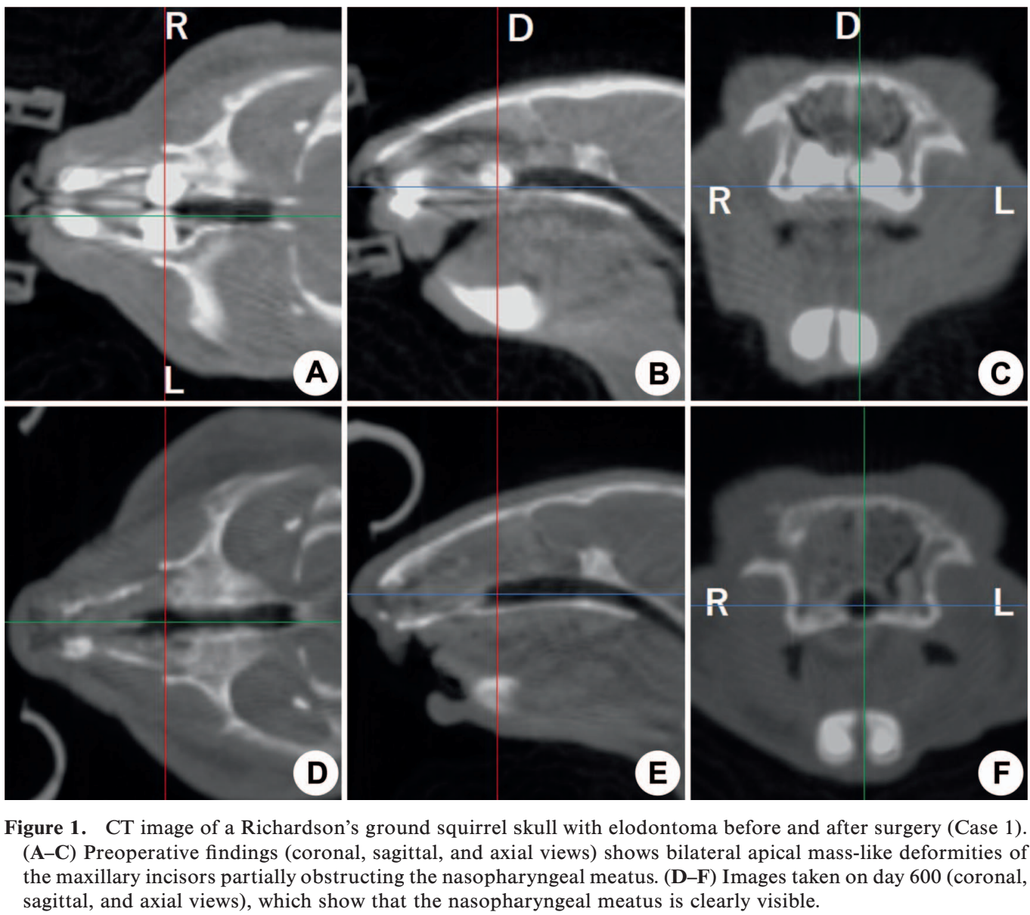
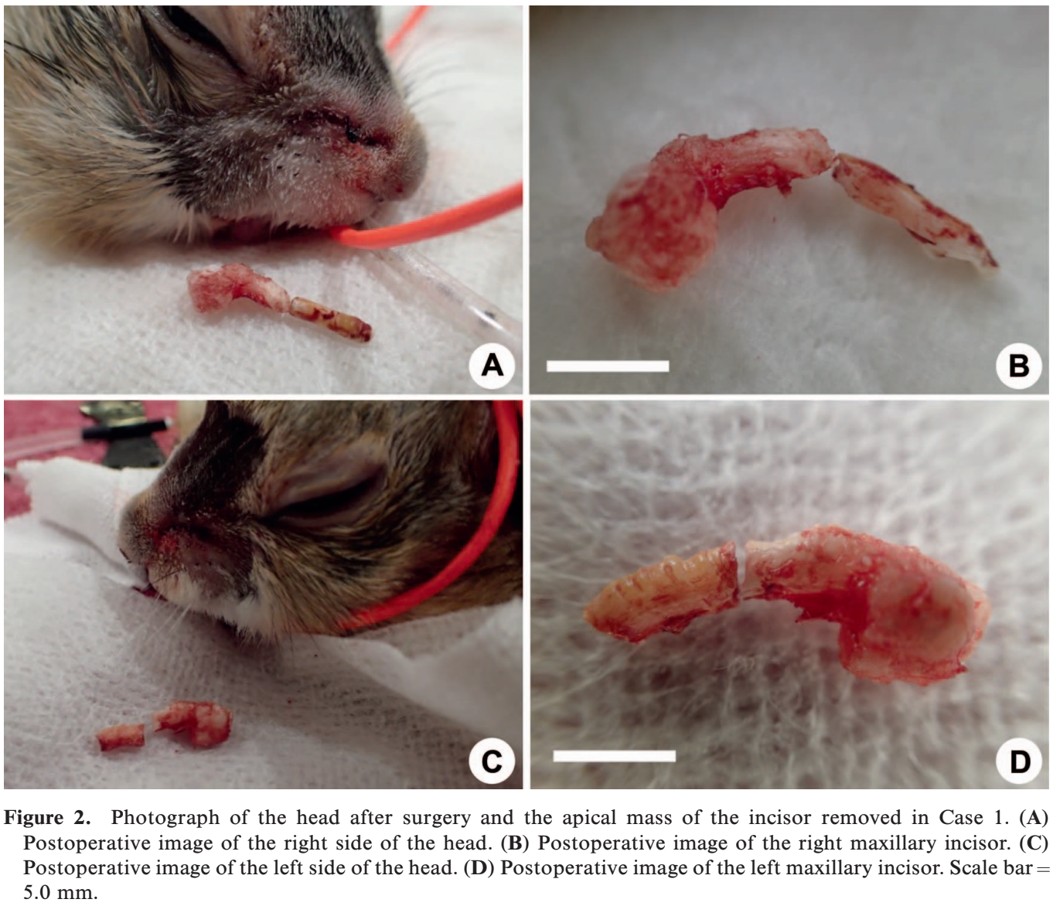

FIELD ANESTHESIA OF FREE-RANGING NUTRIAS (MYOCASTOR COYPUS) FOR SURGICAL REPRODUCTION CONTROL
Degerfeld V, Mauthe M, Serpieri M, Banchi P, Quaranta G.
Journal of Wildlife Diseases, 2021;57(3):495–502

The nutria (Myocastor coypus), a rodent native to South America, has been introduced and has established feral populations at numerous locations in North America, Europe, and Asia. As such, the nutria is subject to research and management programs, including investigation of surgical fertility control techniques. We evaluated the efficacy of a mixture of ketamine and medetomidine, with additional use of isoflurane and reversal with atipamezole, to provide safe, reliable anesthesia for surgical procedures under field conditions. We anesthetized 40 free-ranging nutrias between December 2018 and March 2019, in Turin, Italy, to perform surgical reproduction control techniques. We administered a ketamine and medetomidine mixture (6 mg/kg and 140 mcg/kg, respectively) after trapping the animals and weighing them in the cage traps. After induction, we reweighed the rodents and performed a brief clinical examination. The times of loss of palpebral and pedal reflexes were noted. After induction of anesthesia, heart rate, respiratory rate, and percentage of oxygen saturation were monitored and recorded. Isoflurane was delivered through a face mask to 27 nutrias (70%) to maintain an adequate depth of anesthesia. Upon completion of surgery and other procedures, atipamezole was administered to the animals at doses 2.5 higher than those of medetomidine (actual dose: 366 +/- 31 mcg/kg). Induction times were short (3 +/- 2 min), with the animals completely immobilized. The heart rate and respiratory rate both decreased. After administration of atipamezole, recoveries were smooth and complete. There were two deaths after higher doses of atipamezole and longer surgeries. Carprofen (4 mg/kg) was administered subcutaneously for its analgesic effects. The animals were released at the end of all the procedures. Overall, the medetomidine and ketamine mixture, with supplemental isoflurane in most instances, provided a reliable anesthesia in free-ranging nutrias, adequate for performing surgical procedures under field conditions.

Key Points:
- Short induction times similar to previously reported
- HR and RR significantly decreased 10-20 minutes after induction
  - Nutria HR decreases strongly, and in few seconds, down to 15–20 beats/min, with concomitant peripheral vasoconstriction, when submerged in water (i.e., dive reflex)
- 70% needed isoflurane 2-2.5% for maintenance during surgery
  - No significant difference in time to recovery vs animals that did not receive isoflurane
- First 6 reversed with atipamezole 5x medetomidine dose IM - two died
  - Remaining 34 dosed 2.5x medetomidine with rapid and complete recovery
  - Rare adverse effects of atipamezole: hypotension and tachycardia
- Some had iatrogenic pneumoperitoneum and required IPPV through facemask (obligate nasal breathers), did not require intubation
Conclusions:
- Ketamine/medetomidine +/- supplemental isoflurane provided reliable anesthesia of nutrias for both traditional and minimally invasive surgical procedures under field conditions
- Atipamezole provided a quick and complete recovery, allowing the animals to be released same day but two deaths occurred at routine atipamezole dose of 5x medetomidine.

Ambros, Barbara, Heather K. Knych, and Miranda J. Sadar. "Pharmacokinetics of hydromorphone hydrochloride after intravenous and intramuscular administration in guinea pigs (Cavia porcellus)." American journal of veterinary research 81.4 (2020): 361-366.
Abstract:
OBJECTIVE To determine the pharmacokinetics of hydromorphone hydrochloride after IV and IM administration in guinea pigs (Cavia porcellus).
ANIMALS 8 healthy adult guinea pigs (4 sexually intact females and 4 sexually intact males).
PROCEDURES In a crossover study, hydromorphone (0.3 mg/kg) was administered once IM (epaxial musculature) or IV (cephalic catheter) to each guinea pig at a 1-week interval (2 treatments/guinea pig). Blood samples were collected before and at predetermined intervals after drug administration via a vascular access port. Plasma hydromorphone concentrations were determined by liquid chromatography–tandem mass spectrometry. Noncompartmental analysis of data was used to calculate pharmacokinetic parameters.
RESULTS Mean ± SD clearance and volume of distribution for hydromorphone administered IV were 52.8 ± 13.5 mL/min/kg and 2.39 ± 0.479 L/kg, respectively. Mean residence time determined for the IV and IM administration routes was 0.77 ± 0.14 hours and 0.99 ± 0.34 hours, respectively. The maximum observed plasma concentration following IM administration of hydromorphone was 171.9 ± 29.4 ng/mL. No sedative effects were observed after drug administration by either route.
CONCLUSIONS AND CLINICAL RELEVANCE Pharmacokinetic data indicated that hydromorphone at a dose of 0.3 mg/kg may be administered IV every 2 to 3 hours or IM every 4 to 5 hours to maintain a target plasma concentration between 2 and 4 ng/mL in guinea pigs. Hydromorphone had high bioavailability after IM administration. Further research is necessary to evaluate the effects of other doses and administration routes and the analgesic effects of hydromorphone in guinea pigs.

Intro
- Hydromorphone is a semisynthetic full µ-opioid
- Objective was to investigate the PK of a single dose of hydromorphone, IV and IM
- Methods: 0.3 mg/kg to 8 animal IM and IV in crossover design

Results/Discussion
- No adverse effects
- IV: mean hydromorphone concentration < 2 ng/mL (suspected therapeutic) at 4 hours
- IM: mean hydromorphone concentration < 2 ng/mL at 6 hours.
- All animals had a sedation score of 0 at all timepoints after hydromorphone administration.
- No determination of pharmacodynamics.

Take Home: Pharmacokinetic data indicated that hydromorphone at a dose of 0.3 mg/kg may be administered IV every 2 to 3 hours or IM every 4 to 5 hours to maintain a target plasma concentration between 2 and 4 ng/mL in guinea pigs. No adverse effects or sedation at 0.3 mg/kg

Related article:
PHARMACOKINETICS OF BUPRENORPHINE AFTER INTRAVENOUS AND ORAL TRANSMUCOSAL ADMINISTRATION IN GUINEA PIGS (CAVIA PORCELLUS)
Sadar MJ, Knych HK, Drazenovich TL, Paul-Murphy JR.
American Journal of Veterinary Research. 2018 Mar;79(3):260-6.

- Mild to moderate transient sedation for 2 hours.
- Low bioavailability for transmucosal (rapid swallowing?), but both achieved serum concentrations above the target ‘therapeutic’ concentration

McCready, Julianne E., et al. "Effect of pneumoperitoneum on gastrointestinal motility, pain behaviors, and stress biomarkers in guinea pigs (Cavia porcellus)." American Journal of Veterinary Research 83.8 (2022).

OBJECTIVE To compare stress markers, gastrointestinal motility, and behavioral indicators of pain between guinea pigs undergoing pneumoperitoneum with carbon dioxide (CO2) and control guinea pigs. ANIMALS Fourteen 4- to 5-month-old intact female Hartley guinea pigs. PROCEDURES Guinea pigs were randomized to receive insufflation or serve as controls (anesthesia and abdominal catheter placement without insufflation), with 7 animals/group. Insufflated animals underwent 6 mm Hg of CO2 pneumoperitoneum for 30 minutes. Afterward, results for vital signs, blood glucose, fecal cortisol, appetite, fecal output, and behaviors (via video recording) were compared between the 2 groups. RESULTS There was no difference between groups and over time for body temperature, heart rate, fecal output in grams, pellets consumed, blood glucose, and fecal cortisol. Guinea pigs that underwent insufflation had significantly more fecal pellets at 36 hours after the procedure. Several behaviors were expressed similarly between groups and over time, such as body turns, incomplete movement, rearing, lying down, drinking, and hiding. Coprophagy occurred less often in the insufflated versus noninsufflated group at 12 h postprocedure but was similar between groups at other time points. At 60 hours after the procedure, insufflated animals spent less time squinting compared to noninsufflated animals. Other behaviors were differentially expressed over time but not between treatments. CLINICAL RELEVANCE Overall, there were no major differences in appetite, stress markers, and behaviors between insufflated and control guinea pigs. CO2 insufflation did not appear to cause undue pain or stress in guinea pigs and may be a reasonable technique to use during laparoscopy.

Intro
- Purpose: compare stress markers (blood glucose and fecal cortisol), markers of gastrointestinal motility (appetite and fecal production), and behavioral indicators of pain between guinea pigs undergoing abdominal insufflation with CO2 and guinea pigs undergoing abdominal catheter placement without insufflation (control).
M&M
- Anesthetized, insufflated for 30 mins or abdominal catheterization with no insufflation
- Measured markers listed above and compared between groups
Results
- All animals lost weight, only one returned to presurgical weight by day 7 post op
- There was no difference between groups and over time for rectal temperature, HR, fecal output in grams, food pellets consumed, blood glucose, and fecal cortisol
- Guinea pigs that underwent CO2 insufflation had significantly higher fecal output in fecal pellet numbers at 36 hours post op than control guinea pigs
- There were less coprophagy behaviors in the insufflated group than in the noninsufflated groups at 12 h post op, but no difference at other time points
- At 60 hours after the procedure, insufflated animals spent less time squinting compared to noninsufflated animals but not at other time points
- All guinea pigs survived anesthesia, the procedures, and the postoperative monitoring period.
- Several of guinea pigs (6 of 7 in insufflation group, 3 of 7 in control group) developed pigmenturia, which grossly appeared consistent with hematuria rather than porphyrinuria, after the procedure.
  - All treated with marbo due to hx of corynebacteirium renale cystitis outbreaks in g pigs from the same source
Takeaway: Insufflation of CO2 at 6 mm Hg for 30 minutes in guinea pigs is not associated with significant increases in observable pain or stress or decreases in gastrointestinal motility compared to control.

MORBIDITY AND MORTALITY IN ONTARIO RODENTS AND LAGOMORPHS: A 30-YEAR RETROSPECTIVE REVIEW
Shannon K. French,1,2,4 David L. Pearl,3 Brian Stevens,2 Andrew S. Peregrine,1 and Claire M. Jardine1,2

ABSTRACT: Passive surveillance is an important component of wildlife health surveillance that allows for the identification of emerging pathogens as well as population-level threats. We investigated the most common causes of morbidity and mortality in rodents and lagomorphs submitted to the Canadian Wildlife Health Cooperative (CWHC) in Ontario and the Ontario Veterinary College (OVC) over a 30- yr period. A total of 836 cases representing 13 species of rodents and three species of lagomorph were submitted to the CWHC and the OVC wildlife pathology service. Infectious or inflammatory diagnoses were most common in our data set, followed by trauma and unknown diagnoses. The most frequently identified primary diagnosis was encephalitis with histological lesions consistent with neural larva migrans including the presence of inflammation and malacia of brain tissue and, in some cases, characteristic nematode larvae. Other infectious diagnoses were squirrel fibroma virus and Toxoplasma gondii infections. Knowledge of common pathogens observed in various species of rodents and lagomorphs can aid in triage and treatment decisions at veterinary clinics and wildlife rehabilitation centers, and guide sample collection and test requisition at post-mortem examination.

- 30 year of post-mortem surveillance data to identify causes of morbidity and mortality in rodents and lagomorphs in Ontario
- Cases- pulled necropsy reports and any ancillary testing (authors were interested in neural larval migrans NLM)
- 836 animals over 29 years; most common species was EGS, eastern cottontails, and groundhogs
- Males were more common to females, and small body size was uncommon
- Most frequent primary diagnosis was “Infectious and Inflammatory conditions”
  - Followed by “Trauma”
- Most identified lesions were parasitic in nature
  - Followed by bacterial lesions
- Encephalitis was the most common infectious diagnosis
  - In 90% of encephalitis cases lesions were consistent with NLM
- Pasteurella multocida was primary seen in eastern cottontails (however, this was most likely because one facility had an event that could have inflated the perceived importance)
- With squirrel fibroma virus and toxo primarily seen in eastern gray squirrels
- NLM are typically associated with Baylisascaris procyonis or other Baylisascaris spp.
- IDed 3 species that NLM is not previously reported: northern flying squirrel, southern flying squirrel and snowshoe hare
- NML is most frequently reported in groundhogs
- Males were more affected than females
- Most animals came from two areas: Greater Toronto Area and Guelph: this means unrepresented areas the causes may be different than reported in this study
- Most animals were submitted from wildlife rehabilitation centers= which data showed that a diagnosis of infection in origin was more likely if submitted by wildlife center
- Public health concerns/Zoonotic potentials found in this survey:
  - Tularemia in beavers
  - Tyzzer’s disease in muskrats
  - Toxoplasmosis and WNV in eastern gray squirrels

PROGNOSTIC INDICATORS FOR SURVIVAL OF ORPHANED EASTERN GRAY SQUIRRELS (SCIURUS CAROLINENSIS)
Ivana H. Levy, BS, Krista A. Keller, DVM, Dipl ACZM, Matthew C. Allender, DVM, MS, PhD, Dipl ACZM, Sarah Reich, DVM, and Julia Whittington, DVM
Abstract: The eastern grey squirrel (EGS), Sciurus carolinensis, is a tree squirrel native to the eastern United States. This species commonly presents to wildlife medical clinics for a variety of human-related injuries including confrontations with road traffic and pet predation. The purpose of this study was to assess initial examination findings as prognostic indicators for survival in EGS. The medical record database of the University of Illinois Wildlife Medical Clinic was searched from January 2012 through December 2018 for records of EGS weighing ,300 g. The squirrels were identified as survivors (individuals surviving, released, or transferred to a rehabilitator within 72 hr of intake) or nonsurvivors (individuals euthanized or dying within 72 hr of intake after receiving medical care). Presenting weight, health status, method of feeding, and singleton versus group presentation were categorically recorded for each case. The data were modeled using a series of candidate logistic regression models fitted using the generalized linear model. An information theoretical approach determined the best fit model. A total of 955 EGS were included in this study. Factors that predicted a nonsurvivor status included EGSs that presented with any health system abnormality (odds ratio [OR], 4.81; 95% confidence interval [CI], 3.34–6.72), EGSs that presented between December and May (OR, 1.60; 95% CI, 1.12–2.27) rather than between June and November, and individuals with neurologic signs (OR, 2.61; 95% CI, 1.51–4.51) compared with EGSs without neurologic signs. Despite not being included in the final model, the presence of respiratory signs (OR, 3.43; 95% CI, 2.41–4.89) and diarrhea (OR, 4.01; 95% CI, 1.59–10.09) were significantly associated with a higher likelihood of nonsurvival status. Wildlife medical clinics and rehabilitation centers may use this information by initiating more aggressive therapies or instituting distinct euthanasia protocols for EGS that present with body system abnormalities, particularly neurologic clinical signs, and those that present in the winter months

- Total of 955 individual orphaned juvenile EGS were included
- Most common neuro sign= head tilt or negative proprioception/nociception
- Most common resp sign= dried blood or bloody discharge from nares
- Most common integumentary sign= soft tissue excoriations (lacerations/lesions/abrasions)
- Month, overall health status and presence of neurologic signs were top ranked models
- Squirrels with some abnormality on PE compared to those healthy were 5x more likely to be nonsurvivors
- December to May presented EGS were slightly more likely to be nonsurvivors compared to June-November
- Neurologic signs exhibited more than 2.5x higher odds of nonsurvival status
- ECG’s with respiratory signs were more likely to be a nonsurvivor compared to those without respiratory signs
- Diarrhea (like respiratory was not included in the final model) but showed a higher odd of nonsurvivor status
Key Point: EGS presenting with an abnormal overall health status, neurologic signs, or in the between the months of December and May are high risk populations for increased mortality (**this study did not divide EGS’s into trauma categories whether there were trauma signs absent or present**)-- these populations should be treated more intensely or more stringent euthanasia protocols.

