Testudine Intranuclear Coccidiosis (TINC)
Authors: Wellehan, James F. X., Jacobson, Elliott, Stilwell, Justin, Gibbons, Paul M., Garner, Michael M., et al.

- Causative agent of TINC and where it came from
  - Eukaryote: phylum Apicomplexa, subclass Coccidia then suspected family Eimeriidae
  - Apicoplast- good drug target
  - Leopard tortoises- definitive host species
  - Suspect African origin-> but only seen in captive tortoises
- Species affected? More susceptible? Carriers?
  - Variety of turtle and tortoise species: radiated tortoises, sulawesi tortoises, leopard tortoises, bowsprit tortoises, flat tailed tortoises, spider tortoises, russian tortoises, greek tortoises, red footed tortoises, Indian star tortoises, African spuured, Hermann’s, yellow footed, Galapagose tortoises– members of the Africa/Madagascar seem higher at risk
  - Radiated tortoises= overrepresented
  - Signs- asymptomatic to severe disease and death
  - The more adaptable a species is to captive conditions, the more resistant it is to disease caused by the organism
    - Improving husbandry reduces disease, qPCR carriers that do do not exhibit clinical signs are common- qPCR positive
  - Leopard and Greek tortoises inoculated = death or euthanasia
  - Hermann’s, Russian, Sulcata= just shedded oocytes
- Typical clinical signs?
  - Peracute and nonspecific: literally any clinical sign from oral plaques to death
  - Dz is chronic- never actually clear
  - Tissue necrosis and inflammation usually seen
  - Be suspicious if multiple deaths in a collection or extremely emaciated weak tortoises (can resemble mycoplasmosis with nasal discharge)
- Typical clinical path findings?
  - Intranuclear coccidia seen in cytological preparations
  - Inflammation is predominately lymphoplasmacytic (fewer granulocytes and macrophages)
- Typical gross and histo findings?
  - Many tissues can be affected- parasite burdens and tissue damage are especially severe in pancreas and kidney
  - Infected cells rupture and released merozoites that spread hematogenously-> lymphocytic inflammatory response in affected tissues (heart, brain or spleen)
  - Most severe damage in pancreas
  - H&E eosinophilic intranuclear protozoan-like organisms were seen within renal epithelial cells, hepatocytes, and pancreatic acinar cells and intestinal epithelial cells
  - Intranuclear
- Diagnostics tests
  - Organism within exfoliated epithelial and extracellularly in nasal secretions
  - Acid fast staining in smear preps (swabs of mucous membranes)
  - Best test: probe-hybridization quantitative PCR assay (UF offers)- tissues, feces, or blood (CCC swab in live animals)
  - Not all clades of tortoises can be checked for this parasite via feces (Stigmychelys/Astrochelys/Pyxis clade can)
    - BUT false negative fecals are common
- Drugs?
  - Ponazuril (different doses in different tortoises)
    - Green turtles 100 mg/kg once weekly unknown duration
    - 100 mg/kg PO q48h x 90 days and qPCR repeated every 90 days until 3 consecutive negative samples obtained
  - Either tube feed or top dress (if caught early)
- Cleared of TINC?
  - qPCR copy counts
    - Tortoises with >10,000 will need minimum 3-6 months treatment
  - 100 mg/kg Ponazuril PO q48h; retest 90 days if negative continue to treat until three negative qPCR results at 60 day intervals
  - Suspicion that encysted bradyzoites do not respond to drugs and therefore turtles are probably never cleared
  - Have been “cleared” cases that recrudesce months later
- Spread of disease?
  - Direct life cycle
  - Suspect fecal-oral route of transmission, but nasal-nasal or nasal-oral cannot be ruled out
  - Unknown vertical transmission
- Cleaning a contaminated environment?
  - GUESS= remove soil, prolonged high temperature burn because refractory to most disinfectants
  - Washing tortoises (the feces off), appropriate PPE between patients
  - Tried Rescue, guess ammonia, methyl bromide, and carbon disulphide; hydrogen peroxide
  - Paralleled to crypto-> contact time 13 minutes with 6% hydrogen peroxide
  - Invertebrate transmitters??
- Control in a large group?
  - Separate tortoises and isolate from other tortoises
  - Positive animals should be kept separated from others for rest of life and treated; if not then euthanasia + histo/necropsy should be pursued
  - Animals exposed but never test positive should be hel separately and tested monthly for at least a year
- Research?
  - Culture system with susceptibility testing
  - Host species susceptibility and oocytes shedding of different hosts
    - Natural host
  - Impact of co-infections, seasons, and other cofactors
  - Sequence the genome
  - Best dosage and frequency of ponazuril
  - Safest and most effective disinfectant
    - How long persists in soil
  - Disease surveillance of wild populations

Prevalence of Intraerythrocytic Parasites in Macrochelys temminckii, Emydoidea blandingii, Terrapene carolina, and Terrapene ornata
Raquel Doke1 Kara Hiebert1, Melanie Repella1, Megan Stuart1 , Lauren Mumm1, John Winter1, Laura Adamovicz1, Gary Glowacki2, Ethan Kessler3, Matthew C. Allender1,3,4

Abstract: Few studies have characterized the prevalence of intraerythrocytic parasites in free-ranging chelonian populations or their occurrence across habitats. It is hypothesized that chelonians in different habitats have different exposures to vectors and thus differences in hemoparasite presence. This study explored the prevalence and intensity of intraerythrocytic parasites by examining blood smears from four species of Illinois turtles: wild Blanding’s turtle (Emydoidea blandingii), eastern box turtle (Terrapene carolina carolina), ornate box turtle (Terrapene ornata ornata), and prerelease head-started alligator snapping turtle (Macrochelys temminckii). Intraerythrocytic parasites were identified in all examined species except for the alligator snapping turtle. For all age classes, Blanding’s turtles had both the highest prevalence of hemoparasites and the highest intensity of infection of all sampled species, whereas adult Blanding’s turtles had a significantly higher prevalence than juveniles (P , 0.05). Because this is the first study of hemoparasites in Illinois chelonians, further research is needed to identify the specific species of intraerythrocytic parasite, the potential vectors, and the effect that these hemoparasites have on the health of chelonians.

- Snakes= Hepatozoon organisms are the most common blood parasite
- Hemoparasites were detected in all species EXCEPT alligator snapping turtles
- Blanding’s turtles had the highest prevalence of hemoparsites compared to all other species
  - Intensity was also higher
- Adult blanding's turtles had significantly higher prevalence than juveniles
- Semi aquatic chelonian species had the highest prevalence and intensity of infection compared with terrestrial species
- NOTE: alligator snapping turtles sampled were juveniles BEFORE release into the wild
- Hemoparasite appeared similar to Haemogregarina spp.
- Common vectors: leeches (aquatic and semi aquatic turtles), fly larvae, and ticks
- Higher prevalence of blanding's turtles in IBSP than SBCP (different locations)
- Relationship between intraerythrocytic parasite infection, habitat, and population health is still poorly understood
  - Incorporate hemoparasite screening into turtle population monitoring
  - 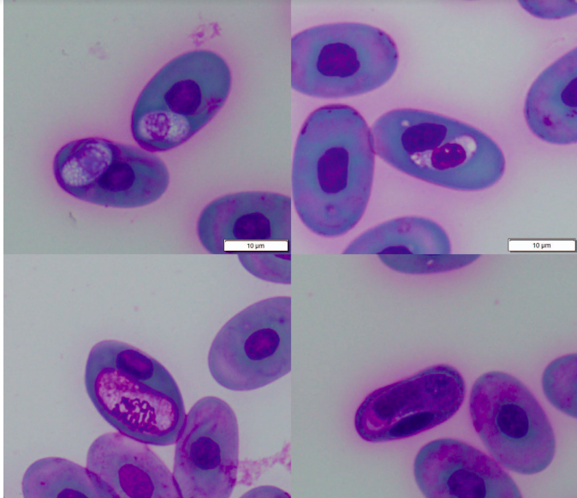

McFarland, Alexander, et al. "A retrospective analysis of amoebiasis in reptiles in a zoological institution." Journal of Zoo and Wildlife Medicine 52.1 (2021): 232-240.

Abstract: Amoebiasis is a significant protozoal disease of reptiles causing nonspecific clinical signs including diarrhea, anorexia, and lethargy. It frequently results in acute death. Investigation of the pathophysiology of amoebiasis in reptiles has been hampered by the inability to accurately identify amoeba to the species level using conventional techniques. This study reviewed reptile medical records from the Wildlife Conservation Society's archives from 1998 to 2017. Amoebae were identified histologically in 54 cases in 31 different species. Of these, amoebiasis was the cause of death in 32 (18 chelonians, 7 lizards, and 7 snakes), a significant co-morbidity in 14 (six chelonians, two lizards, and six snakes), and seen incidentally in eight cases (one chelonian, six lizards, and one snake). Relocation from one enclosure to another was also evaluated and 65% of cases had been moved within 180 days of death (median 46 days). Frozen tissue samples from 19 of these cases were tested via an Entamoeba (genus-specific) polymerase chain reaction (PCR) assay. PCR products were sequenced and Entamoeba species were identified. Six individuals were positive for Entamoeba invadens (three chelonians, two snakes, one lizard), two for Entamoeba ranarum (both snakes), and one for Entamoeba terrapinae (chelonian); the other 10 cases were negative via PCR. Entamoeba ranarum has typically been considered a disease of amphibians with only one report of disease in a snake. Entamoeba terrapinae has only been reported without associated disease in chelonians. These results suggest that amoebiasis is a complicated and nuanced disease of reptiles, and warrants additional study.

Background:
- Entamoeba invadens = parasite of reptiles/amphibians
  - Historically chelonians/croc typically asymptomatic, carnivorous lizards and snakes non-specific clinical signs with death
  - Theory herbivore gut provides more protective mechanism for disease development due to consistency; E. invadens consume gam(-) bacteria and glucose
- Diagnostics - no commercial lab test available for detection, PCR is developed, microscopy is most common method but lacks specificity
  - Histopath: trophozoites in tissue to assess for invasive behavior with PAS stain
- Methods: retrospective of amoebiasis in reptiles from WCS medical records from over 20 years
- Goals: characterize amoebiasis host and parasite relationships in a zoo collection

Key Points:
- Amoebae identified histologically in 54 cases in 31 different reptile species
  - COD (32) > with comorbidity (14) > incidental (8)
  - Majority 58% carnivores > 36% omnivores >6% herbivores
- Clinical amoebiasis most commonly reported in chelonians
  - Primarily affected liver and intestines (colon > SI)
  - Found in both liver and intestines in 65% of cases
- Incidental entamoeba infection most commonly reported in lizards
  - ONLY found in intestinal lumen; not found in liver or other organs
- Comorbidities: IBD, sepsis secondary to ulcerative enteritis, lymphosarcoma, pneumonia, bacterial hepatitis, generalized endoparasitism
- Clinical signs if noted: lethargy, anorexia, weight loss, cloacal prolapse
  - No clinical signs in 52% of cases
- PCR ID (n=19) on cases with banked tissue with histo entamoeba: 9 positive, 10 negative
  - Entamoeba invadens > Entamoeba ranarum > Entamoeba terrapinae
  - Terrapinae usually described as commensal in chelonians not reported to cause disease
  - Ranarum historically known as amphibian disease with only one report in snake
Haetrakul, Thanida, et al. "Severe, Fatal Spirorchiidiasis in Confiscated, Smuggled Black Pond Turtles (Geoclemys hamiltonii) in Thailand, a Case Report and Review of the Literature." Journal of Herpetological Medicine and Surgery 30.3 (2020): 118-122.

Abstract: In 2013, hundreds of South Asian turtles and tortoises were confiscated from an animal smuggler in the Suvarnabhumi Airport. Many of the seized animals were suspected to have died due to the stress of the smuggling operation, which was compounded by concurrent diseases; the vast majority of necropsied animals had significant endoparasitism. Two black pond turtles (Geoclemys hamiltonii) were found to be severely affected by systemic vascular spirorchiidiasis, causing significant granulomatous disease in the lungs, kidneys, mesentery, intestines, and liver, and in one of the two animals, within the heart. This is the first report of spirorchiidiasis in black pond turtles.

Background:
- Spirorchiids = blood flukes (trematode); common postmortem finding in freshwater in marine chelonians
  - Typical lesions in heart and large arteries

Key Points:
- Spirorchiidiasis is a potential pathogen in pond turtles that can cause disseminated systemic granulomatous disease
- First spirorchiid infection in black pond turtles, and of spirorchiidiasis originating from South Asia

Figure 1: Figure 2:
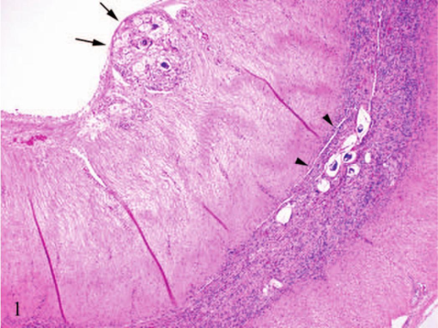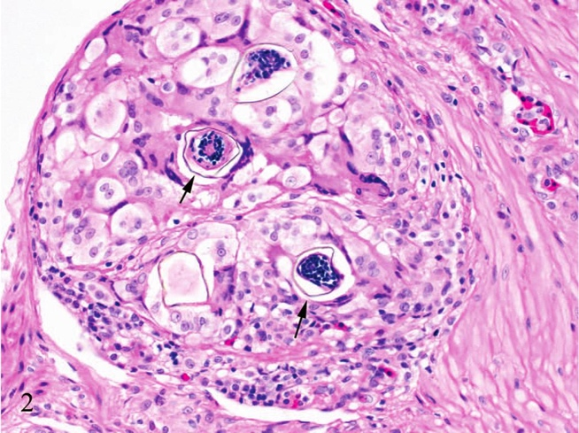
Figure 1. Gastrointestinal tract. Multifocally expanding the submucosa and the muscularis are either granulomas border trematode ova (arrows) or free ova surrounded by abundant inflammation (arrowheads). H&E 100×

Figure 2: Gastrointestinal tract. Focally and extensively elevating the mucosa is a large granuloma containing trematode ova (arrows), which consist of a 2–3 µm thick, yellow–brown, refractile shell with occasional lateral spines, and a central wide, irregular eosinophilic miracidium with numerous basophilic nuclei. H&E. 400×

Johnston, Andrea N., et al. "Choleoeimeria pogonae Alters the Bile Acid Composition of the Central Bearded Dragon (Pogona vitticeps)." Journal of Herpetological Medicine and Surgery 31.2 (2021): 99-100.

Abstract: The coccidian parasite Choleoeimeria pogonae infests the biliary ducts and gallbladder of the central bearded dragon (Pogona vitticeps). Endogenous C. pogonae development occurs in the epithelium of the gallbladder and bile ducts, leading to significant tissue injury. To determine whether bile composition in the gallbladder was disrupted by the parasite, bile samples were collected from one normal and one C. pogonae–infected central bearded dragon. Bile acid species were identified and quantified with liquid chromatography and mass spectroscopy. Tauroallochoic acid was the predominant bile acid (82.2%) in the normal bearded dragon, whereas the deconjugated allocholic acid was the predominant bile acid (40.1%) in the bearded dragon with C. pogonae. Taurine conjugation inhibits calcium precipitation in bile and bile acid–mediated ductal epithelial cytotoxicity. The shift in bile acid content identified in the C. pogonae infected bearded dragon may contribute to cholelithiasis and mucosal damage.

Key points
- Choleoeimeia pogonae infests biliary duct and gall bladder
  - Leads to chronic inflammation, cell infiltrate, hypertrophy of biliary epithelium, and cystic duct obstruction due to cholelithiasis, mucus plugging or occlusion by oocysts.
- Collected bile from gall bladder in an affected bearded and a normal bearded on necropsy.
- Normal bearded
  - Majority of bile acids were taurine conjugated = tauro
- Affected bearded
  - Deconjugtated allocholic acid
- Bile acids are deconjugated in distal small intestine by gut bacteria by enzymes known bile salt hydrolases. Once cleaved taurine may be metabolized to ammonia, carbon dioxide and sulgate. Bile acids are absorbed in ileum portal liver. Conjugated in hepatocytes andcholangiocytes
- Conjugation of BA increases solubility, prevents calcium precipitation and enhances emulsification of dietary lipids
- Suspicion that deconjugation with taurine may contribute to cholelithiasis and mucosal damage

James MacHale, Jack Stanley, and Joanna Hedley. "Successful Treatment of Anchor Worm (Lernaea cyprinacea) Using Lufenuron in the Mexican Axolotl (Ambystoma mexicanum)." Journal of Herpetological Medicine and Surgery 31.2 (2021): 107-110.

A 3-yr-old, female, captive Mexican axolotl (Ambystoma mexicanum) presented with a significant Lernaea infestation. The animal had a history of poor husbandry prior to being rescued by the current owner. The axolotl was anesthetized using a buffered 0.15% tricaine methanesulfonate (MS-222) immersion bath and then moved to a buffered 0.1% MS-222 bath for maintenance. The adult anchor worms were removed manually under anesthesia. Following recovery, the axolotl enclosure was treated with 0.1 mg/L lufenuron, which was added to the water once a week for five treatments. Six months following treatment there has been no recurrence of the Lernaea infestation. This is the first documentation of successful treatment of Lernaea in the Mexican axolotl using lufenuron.

Intro
- Anchor worms (Lernaea cyprinacea) are parasitic copepod crustaceans that predominantly affect fish kept in freshwater environments
- Following mating, the adult female burrows into the flesh of the host, with site specificity for the gills, head, and fins
- Chronic infestations can result in poor growth and secondary infxns, can lead to death
- Because of the parasite’s low host specificity, anchor worm has been reported to affect numerous amphibian species. Treatment guidelines in amphibians remain anecdotal
- This report describes the clinical findings, treatment method, and follow-up of successful treatment for anchor worm using lufenuron on a Mexican axolotl
Case report
- n=1 case report
- 3 yo F axolotl presented for numerous anchor worms seen on gills and skin (>20 worms)
- Anesthesia with MS222, removed anchor worms manually with mosquito forceps
- Followed up with immersion treatment of lufenuron once a week for 5 weeks
- 6 months later no return of anchor worms
- Take home: This case describes a safe and effective protocol for treatment of Lernaea infestation in the Mexican axolotl using manual removal under anesthesia and in-water treatment with lufenuron.

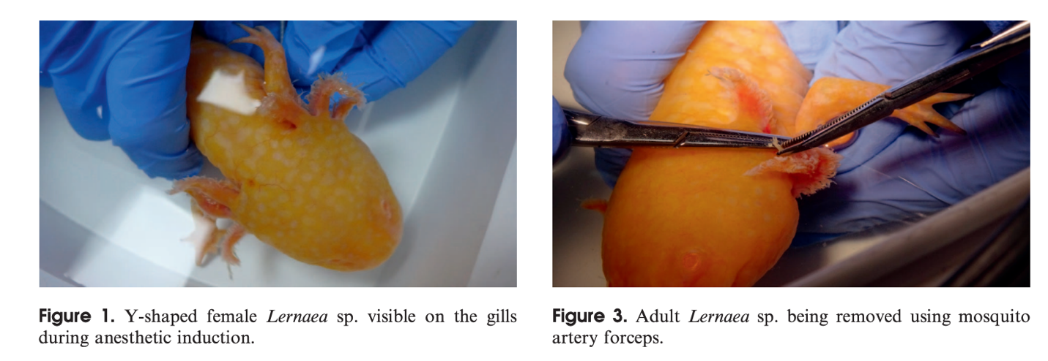

JHMS 2022;32(4):291-5
Evaluation of the Drug Combination Nitazoxanide, Azithromycin, and Rifabutin as a Treatment for Cryptosporidium serpentis Infection in Eastern Indigo Snakes (Drymarchon couperi)
Bogan Jr JE, Hoffman M, Mitchell MA et al.

ABSTRACT: Cryptosporidium serpentis is a common parasitic disease in captive snakes that is associated with substantial morbidity and mortality. To minimize the impact of this parasite, it is important to identify effective treatment methods. The purpose of this study was to evaluate a new drug regimen for treating C. serpentis in eastern indigo snakes (Drymarchon couperi). Twenty-four eastern indigo snakes naturally infected with C. serpentis were randomly divided into two groups. The first group received 20 mg/kg nitazoxanide, 10 mg/kg azithromycin, and 5 mg/kg rifabutin twice weekly in a food item for 6 wk, whereas the second group received no treatment in the food items. Cloacal swabs were collected every 2 months for 6 months to measure C. serpentis shedding by probe hybridization quantitative polymerase chain reaction (qPCR). The eastern indigo snakes that were qPCR negative after 6 months were immunosuppressed with a single dose of 4 mg/kg dexamethasone sodium phosphate SC. These eastern indigo snakes were then screened by qPCR for an additional 6 months as described previously. Eastern indigo snakes that were qPCR negative after 1 yr of serial sampling were re-evaluated for C. serpentis via gastric biopsy for histological and qPCR analyses. Only 2 (16.7%; 95% confidence interval [CI]: 0.1–37.8) of 12 eastern indigo snakes from each group were qPCR negative before immunosuppression. The eastern indigo snakes in the treatment group did have a decrease in the amount of C. serpentis DNA shedding after treatment (P = 0.025), whereas the control eastern indigo snakes did not (P = 0.232). Only 1 (8.3%; 95% CI: 0.1–23.9) of 12 eastern indigo snakes in each group was negative 6 months after immunosuppression. These findings suggest that 20 mg/kg nitazoxanide, 10 mg/kg azithromycin, and 5 mg/kg rifabutin twice weekly for 6 wk in a food item is ineffective in eliminating C. serpentis in naturally infected eastern indigo snakes.

Background:
- Eastern indigo snake (Drymarchon couperi) = threatened colubrid, native to southeast US
  - Ophiophagous -> predisposed to Cryptosporidium serpentis
- Many antiprotozoal drugs have been ineffective in treating cryptosporidiosis in mammals
  - Paromomycin (an aminoglycoside) has been used with mixed results in reptiles
  - Previously shown to be ineffective in eastern indigo snakes
- Nitazoxanide + azithromycin + rifabutin (NAR) has not been evaluated in reptiles
  - MOA of nitazoxanide us unknown
    - Better efficacy for mammalian cryptosporidiosis, longer posttreatment effect
  - Success rate may be improved azithromycin and rifabutin or rifaximine are added
Key Points:
- Nitazoxanide (+/- AR) may decrease the detectability of C. serpentis DNA
  - May also be dose dependent
- When diagnosing C. serpentis with a minimally invasive screening procedure (e.g., stomach swab), it is important to confirm the diagnosis with gastric biopsies
  - Biopsied tissues should be evaluated with histologic and molecular diagnostic methods
- NAR administered twice weekly for 6 weeks no more effective than no treatment

Related Articles: None on the current ACZM reading list

JHMS 2021 1;31(4):307-14
Evaluation of paromomycin treatment for Cryptosporidium serpentis infection in eastern indigo snakes (Drymarchon couperi)
Bogan JE, Hoffman M, Dickerson F, et al.

ABSTRACT: Thirty-four eastern indigo snakes (Drymarchon couperi) naturally infected with Cryptosporidium serpentis were randomly divided into two groups. The first group received 360 mg/kg paromomycin twice weekly in a food item for 6 wk, and the second group received the food item with no treatment. Cloacal swabs were collected every 2 months for 6 months to measure C. serpentis shedding by probe hybridization quantitative polymerase chain reaction testing (qPCR). Snakes that were qPCR negative after 6 months were immunosuppressed with a single dose of 4 mg/kg dexamethasone sodium-phosphate SC. These snakes were then screened by qPCR for an additional 6 months as described above. Snakes that were qPCR negative after 1 yr of serial sampling were then re-evaluated for C. serpentis via gastric biopsy for histological and qPCR analyses. The paromomycin-treated group were significantly (P = 0.008) more likely to test qPCR negative (8/17; 47%, 95% confidence interval [CI]: 23.2–70.7) than the control snakes (1/17; 5.8%, 95% CI: 0.01–16.9) prior to immunosuppression. However, there was no significant difference (P = 0.5) in C. serpentis status following immunosuppression, as only 2/17 (11.7%, 95% CI: 0.01–26.9) paromomycin-treated snakes were qPCR negative 6 months after immunosuppression compared to 1/17 (5.8%, 95% CI: 95% CI: 0.01–16.9) control snakes. These findings suggest that 360 mg/kg paromomycin twice weekly for 6 wk in a food item is ineffective in eliminating C. serpentis in naturally infected D. couperi.

Bacgkround:
- Eastern indigo snake (Drymarchon couperi) = threatened colubrid, native to southeast US
  - Ophiophagous -> predisposed to Cryptosporidium serpentis
- Cryptosporidium forms two clades:
  - 1) Gastric tropism
  - 2) Intestinal tropism (although respiratory or renal system also found)
  - Tissue tropism fidelity is stronger than fidelity to host species
- Transmission = fecal-oral; shedding of oocysts is intermittent
- Clinical signs: regurgitation, vomiting, weight loss, midbody swelling due to gastric hypertrophy
  - Clinical course is protracted and often fatal
- Antemortem samples: feces, regurgitated food, cloacal swab/lavage, gastric swab/lavage/biopsy
  - One study found endoscopic gastric bx 3 days post-prandial had highest sensitivity
  - PCR is considered the most sensitive screening method
    - PCR-positive samples can be sequenced to differentiate from ingested prey
    - IHC, acid fast, IFA, or ELISA also available
- Paromomycin = aminoglycoside used for Cryptosporidium therapy in reptiles with mixed results
Key Points:
- Paromomycin-treated group more likely to test PCR-negative prior to immunosuppression
  - No significant difference in C. serpentis status following immunosuppression
  - While paromomycin may decrease shedding, it may not eliminate infection
- Three snakes testing qPCR negative on gastric biopsy at the end of the study also had normal gastric mucosal architecture on histologic examination with no intralesional cryptosporidia

TLDR: Paromomycin can significantly reduce likelihood of positive test result but leads to chronic low-grade infection that cannot be detected on cloacal PCR
Related Articles:
- Bogan JE. 2019b. Gastric cryptosporidiosis in snakes, a review. J Herpetol Med Surg, 29(3–4):71–86
- Bogan JE. 2019a. An alternative technique for gastric sampling in snakes. J Herpetol Med Surg, 29(1–2):13–16

