Outcomes of Birds of Prey with Surgical or Traumatic Wing Amputation: A Retrospective Study from 1995 to 2017
Jessica Aymen, DMV, DVSc, IPSAV (Zoological Medicine), Guy Fitzgerald, DMV, MSc, Ste ́phane Lair, DMV, DES, DVSc, Dipl ACZM, Claire Vergneau-Grosset,

Abstract: Surgical amputation of a limb is often required to treat raptor orthopedic injuries at
rehabilitation centers. In some cases, amputation is an alternative to euthanasia if the bird’s
welfare is deemed appropriate under human care. The outcome for raptors maintained in a captive setting following wing amputation is poorly documented. A retrospective study was conducted in a Canadian raptor rehabilitation facility to assess the outcomes and complications observed in captive and free-living raptors with partial or complete, surgical or traumatic amputations of the wing. Data from raptors admitted to the rehabilitation center from 1995 to 2017 were reviewed. Overall, 32 records were included in this retrospective study from 11 species of raptors with surgical or traumatic wing amputations. Survival times of the 23 birds with an amputated wing (median: 1070 days, range: 68 days to 13 years and 1 month) were significantly (P 1⁄4 .02) longer than the survival times of the 404 non-amputated birds (median: 696 days, range 37 days to 27 years and 3 months). Complications occurred in 13 of 30 birds (43%) during the recovery period, with 9 of 30 (30%) birds developing life-threatening complications. Maladaptation to captivity was the leading cause of euthanasia during this period. After placement in captivity, 3/23 (13%) birds developed complications related to the amputation site. Based on this study, we conclude that some birds can tolerate partial or complete wing amputation, but the decision to place a bird in a captive setting should encompass the bird’s ability to cope with human interaction and the availability of an adapted and safe enclosure for the animal.

- Traumatic injuries are a very common cause of morbidity or death in free-living raptors; in some cases trauma is the leading cause of death
- Unmanageable orthopedic conditions involving raptor wings: severe osteoarthritis, neurologic pain, chronic radial nerve paralysis, fracture malunion or nonunion
- Amputation of foot or leg is PROHIBITED as is amputation of a wing proximal to the elbow
- Objective: describe survival times, outcomes, and complications encountered by birds of prey having undergone surgical or traumatic wing amputation; with an additional objective of comparing the survival times of captive amputated birds of prey and other captive birds maintained in the same environment
- Total 8195 raptors presented from 1995-2017; 32 with traumatic or surgical wing amputations (12 males, 15 females, 5 unknown sex)
  - 21 birds underwent surgical wing amputation
  - 7 birds treated for incomplete traumatic amputation of 1 or both wings
  - 2 birds presented with frostbite leading to partial bilateral wing amputation
- Complications occurred in 43% of the birds
  - 30% developing life threatening complications
- 23 birds maintained under human care with an amputated wing were compared with survival times of the 404 non amputated birds
- Survival time of the amputated birds was significantly longer than the survival times of the non amputated birds
- Major complications that led to euthanasia were two birds that had antebrachium amputations that were traumatized after surgery
- Once birds were placed in educational facilities the complication rate associated with the wing amputation dropped by 30%

Key Points:
- Identified longer survival times for amputated birds compared with non amputated birds under human care in the same captive conditions
- Chronic trauma to the amputation site was a complication encountered at a low rate
- No birds with proximal humerus amputation traumatized the amputation site
- Support that the use of proximal humerus amputation in certain cases when legal approval can be obtained and the bird’s temperament is appropriate for transfer to an educational facility

Characteristics of antebrachial fractures associated with a successful outcome among free-ranging birds of prey that received treatment in a rehabilitation program

Claire Vergneau-Grosset dr méd vét, Catherine Dubé dmv, msc, Guy Fitzgerald dmv, msc, Stéphane Lair dmv, dvsc

OBJECTIVE: To identify characteristics of antebrachial fractures associated with a suc-
cessful outcome (ie, bird released back into the wild after regaining normal flight ability, without being returned to the rehabilitation program within 1 month afterward) for free-ranging birds of prey admitted to a rehabilitation program.
ANIMALS: 620 birds of prey (representing 24 species) with antebrachial fractures admitted
alive to a rehabilitation program from August 1986 through December 2015.
PROCEDURES: The medical record of each bird was reviewed to obtain information on
species, age, sex, year of admission, fracture characteristics, and treatments
administered. Outcome was classified as successful or unsuccessful on the
basis of available data. Multivariable logistic regression was used to identify
fracture characteristics associated with outcome.
RESULTS: 519 of 620 (84%) birds received treatment, and a successful outcome was
recorded for 245 (47%) treated birds. Birds with closed (vs open) fractures were significantly more likely to have a successful outcome. Birds with con- comitant radial and ulnar fractures involving the same third of the antebrachium (vs other types of antebrachial fractures) were significantly less likely to have a successful outcome, although birds with this type of fracture were significantly more likely to have a successful outcome when the fracture was
localized to the middle or distal (vs proximal) third of the antebrachium.
CONCLUSIONS AND CLINICAL RELEVANCE: The characteristics of antebrachial fractures associated with a successful or unsuccessful outcome in this study may be useful in the development of triage protocols for birds of prey in other rehabilitation centers. (J Am Vet
Med Assoc 2020;256:580–589)

- Traumatic injuries are the leading cause of admission to rehab programs and leading cause of death in birds of prey
- Very susceptible to complex fractures because avian bones and their wing bones are subject to high torsional forces
- Fractures of the antebrachium can prevent pronation and supination movements of the wing required for adequate flight
- Birds with articular fractures, necrotic bone, or extensive soft tissue damage that impaired function of nerves or ligamentous structures were euthanized.
- Nonsurgical tx: external coaptation (figure -8 bandage) or cage rest
- Surgical: stabilization of fx, external fixator, polymethlmethacrylate intramedullary implants; partial radiectomy was performed if indicated
- Joint range of motion was measured with goniometer before and after each PT session
- Outcome was recorded as successful if the bird was released back into the wild after regaining normal flight ability without being returned to rehab program within 1 month afterward
- Most birds were treated with nonsurgical methods
- The odds of a successful outcome did not differ significantly between birds that received surgical versus nonsurgical treatment
- Successful outcome did not differ between juvenile and adults
- Males were significantly less likely to have successful outcome than birds of unknown sex (but all necropsied birds were sexed)
- Birds with comorbidities were significantly more likely to have a successful outcome than those with just antebrachial fractures (BUT those that died of comorbidities were excluded from the study)
- Cooper’s hawks and osprey were significantly less likely to have a successful outcome
- Birds with closed fractures were significantly more likely to have a successful outcome than those with open fractures
- Radial fracture only, ulnar fracture only or concomitant radial and ulcer fractures involving different thirds of the antebrachium were significantly more likely to have a successful outcome than birds with concomitant radial and ulnar fracture involving the same third or thirds of antebrachium
- Odds of success did not differ greatly from birds with chronic versus acute fractures or between birds with comminuted versus simple fractures of radius or ulna
- Birds with middle or distal third fractures were more likely to have a successful outcome than the proximal third
- Red tailed hawks and great horned owls were significantly less likely to have a successful outcome than were American kestrels with concomitant radial and ulnar fractures involving the same third or thirds of the antebrachium
- Highest prevalence of antebrachial fractures was observed in rough legged hawks and snowy owls- both migratory to Canada

Key Points:
- Proximal antebrachium fractures may carry a more guarded prognosis in birds of prey
- Radial fracture only, ulnar fracture only or concomitant radial and ulcer fractures involving different thirds of the antebrachium were significantly more likely to have a successful outcome than birds with concomitant radial and ulnar fracture involving the same third or thirds of antebrachium

"Predisposing Anatomical Factors of Humeral Fractures in Birds of Prey: A Preliminary Tomographic Comparative Study." Journal of Avian Medicine and Surgery 35.2 (2021): 123-134. Bertuccelli, Tiziana, et al.

Abstract: The aim of this study was to identify possible predisposing anatomical factors associated with humeral fractures in birds of prey through comparison of specific anatomical features in different raptor species. An anatomical study of bone features in birds of prey was performed on 3 male subjects from 5 different species. The selected species included in this investigation were 3 diurnal species (the common buzzard [Buteo buteo], the peregrine falcon [Falco peregrinus], and the European honey-buzzard [Pernis apivorus]) and 2 nocturnal species (the barn owl [Tyto alba] and the tawny owl [Strix aluco]). Humeral bone samples were tomographically analyzed with a micro–macro-focus computed tomographic machine. Specific humeral anatomical points were selected (foramen pneumaticum and tuberculum dorsale for the proximal humerus; corpus humeri for the diaphyseal humerus; and above the condylus dorsalis for the distal humerus) to measure foramen pneumaticum diameter (in millimeters), cortical thickness (in millimeters), and trabeculae number and sizes (in millimeters). Apparent density, measured with the Hounsfield unit, was used to assess the degree of bone resistance. Statistical analysis was performed with a Spearman's correlation, and significance was set at P < .05. The differences among the observed bone volumes were highly significant (P = .00). Trabeculae number and the humeral anatomical point measurements showed differences in all 5 avian species investigated. However, those differences were not significant, except at the condylus dorsalis; in which, a significant interspecies difference (P = .002) was recorded. Trabecular size, cortical thickness, bone density, and diameter of the foramen pneumaticum were all different in all raptor species; however, these variations were not significant. The study confirms the existence of humeral bone volume differences between diurnal and nocturnal species. Furthermore, the data suggest that the humeri of peregrine falcons and European honey-buzzards may be stronger than the humeri of common buzzards, tawny owls, and barn owls.

Goal: identify predisposing anatomical factures associated with humeral fractures in birds of prey

Methods (n=15): humeral bone samples tomographically analyzed via cone beam CT
- Compared 4 measurements (to assess trabeculae, cortex, foramen) at different anatomic sites along the humerus (proximal, diaphysis, distal humerus)
- Compared bone density via HU units

Background:
- Compact skeleton with pneumatized bone (i.e. humerus) as weight-saving adaptations
- Wild birds of prey most common avian group that presents for fracture repair
- Avian humerus fx often open, spiraled, displaced, comminuted, unstable
  - Surgical repair need be performed <5d for optimal results
  - Conservative therapy can allow complete healing <25d

Key Points:
- Peregrine falcons: short, compact, greatest volume
  - Thick trabeculae in proximal and distal portions
  - Number and size of trabeculae high, especially in condylus dorsalis (distal humeri)
  - Suspect less predisposed to fractures from impact event than other species
- European honey-buzzard: thick cortex and high bone density
  - Proximal and distal humeri had thicker (greater size) trabeculae than other species
  - Higher fx predisposition in condylar area
- Common buzzard: similar humeral size to peregrine
  - But brittle – few and thin trabeculae, thin cortex, low bone density
  - More resistant to fx in proximal and distal portions
- Barn owl: thin; largest pneumatic foramen; smallest diaphyseal diameter
  - Cortical thickness and size/number of trabeculae average; lowest bone density
- Tawny owl: small trabecular size; high number of trabeculae
- KEY: Humeri of peregrine falcons and European honey-buzzards (diurnal species) may be stronger and more resistant to fracture than common buzzards, tawny owls, and barn owls
  - Both had high number and largest size of trabeculae, highest density
  - Peregrine falcon had highest trabeculae number at all sites
  - Significantly greater bone density in diurnal (falcons, buzzards) species
- KEY: Raptors have a greater predisposition to sustain distal humeral fractures involving the elbow and diaphysis rather than proximal humeral fractures
  - Trabeculae number higher in distal humerus (condylus dorsalis) than in proximal humerus in all species
  - Proximal and distal humeri have thinner cortex than diaphysis

"Risk Factors and Prognosis for Humeral Fractures in Birds of Prey: A Retrospective Study of 461 Cases from 2000 to 2015." Journal of Avian Medicine and Surgery 36.1 (2022): 2-13. Coutant, Thomas, et al.

Abstract: The objectives of this retrospective study were 1) to characterize humeral fractures in raptors at a rehabilitation program, 2) to determine risk factors for closed and compound humeral fractures in the raptors, and 3) to investigate prognostic factors for humeral fractures in raptors. Of the 6017 birds of prey admitted over 15 years to the Université de Montréal raptor rehabilitation program, 461 birds presented with a humeral fracture. The highest occurrences of humeral fractures were documented in short-eared owls (33%; Asio flammeus), Northern hawk-owls (24%; Surnia ulula), long-eared owls (20%; Asio otus), and Northern harriers (19%; Circus hudsonius). Humeral fractures were more common in males, and species from the intermediate weight group (300 g to 1 kg) were more likely to have compound humeral fractures than birds from the lower and higher weight groups. Humeral fractures of the middle and distal third of the bone were diagnosed as compound more often than fractures of the proximal third. A correlation between the occurrences of humeral fractures and the relative average width of the humerus for each species was observed and suggests that species with slender humeri have an increased likelihood of compound humeral fractures. Following the triage criteria used at this rehabilitation program, surgical (119 birds) or nonsurgical (77 birds) treatments were attempted. Release rate for birds without concomitant conditions in which a treatment was attempted was 39.3% (59/150) and did not significantly differ between closed and compound fractures, which suggests that the triage criteria used for compound fractures in this program were adequate. Our findings emphasize that raptors should not be systematically euthanized when presented with compound humeral fractures to a rehabilitation facility.

Taxonomy: Birds of Prey Order: Strigiformes, Falconiformes, Accipitriformes etc.

Background:
- Trauma most common cause of raptors admitted to wildlife rehab
- Pneumatized bones like humerus have thin cortices → increased risk for comminuted fx and perforation of soft tissues with bone fragments
  - Absence of bone marrow limites vascularization to fracture site
- Surgical fixation recommended for humerus in birds >200g
- Methods: retrospective of n=461 birds with humeral fx
- Goal: investigate risk and prognostic fractures for humeral fractures in birds of prey

Key Points:
- Closed 40% vs. Compound 60% of humeral fractures
- Risk factors for humeral fractures:
  - Species: with slender humeri (low humeral width to wingspan ratio)
    - Short-eared owls, northern hawk owls, long-eared owls, northern harriers
  - Sex: Males > females
  - Age: NOT a risk factor for humeral fractures
- Risk factors for compound fractures:
  - Fx location: middle and distal third of humerus (rather than proximal)
  - Species: intermediate weight group (300 g to 1 kg)
  - Age and fracture complexity: NOT risk factors
- Prognosis: no difference in release rate between closed and compound fractures
  - Effective triage criteria at this specific program

Vigneault, Annabelle, Guy Fitzgerald, and Marion Desmarchelier: A retrospective study of femoral fractures in wild birds of prey: 119 cases. Journal of Zoo and Wildlife Medicine 52.2 (2021): 564-572.

Abstract: A retrospective study was performed to describe patient and fracture characteristics, treatments, complications, and outcomes associated with femoral fractures in free-ranging birds of prey. Cases were identified from the electronic database and included raptors admitted with femoral fractures at the Bird of Prey Clinic of the Université de Montréal, from 1986 to 2018. In total, 119 individuals from 24 species, with 123 femoral fractures, were included in the study. Twenty-seven birds (23%) were declared dead upon arrival. Ninety-two birds (77%) were admitted alive; 80 with acute fractures and 12 with a fracture that had already healed. A conservative treatment (cage rest) was used to manage eight fractures. Surgical repair was attempted on 34 femoral fractures in 33 birds. An intramedullary pin alone was used in 28 cases (82%), and an external skeletal fixator-intramedullary pin tie-in fixator was used in 6 cases (18%). For surgically treated fractures, 19 healed (in 18 birds), 4 did not heal, and 11 birds died or were euthanized before healing could be achieved. Of the 23/34 fractures where the healing process could be assessed, healing rate for comminuted fractures (11/23) was 91% (10/11). Surgical complications occurred in 10 cases (including 7 cases of migration and loosening of the pin, and 1 case of osteomyelitis), leading to euthanasia in 4 cases. Out of the 21 birds with acute femoral fracture upon presentation that were released, 14 had received a surgical treatment and 7 had received a conservative treatment. Nine of the 21 released birds (43%) had at least one other fractured bone. The majority of deaths and euthanasia occurred within 2 wk after admission (51/59; 86%). Thirteen birds were euthanized primarily because of their femoral fracture. Thirteen birds died in treatment and 33 were deemed nonreleasable and euthanized because of a comorbidity not related to the femoral fracture.
- Key Points:
  - Avian femur is pneumatic, with large medullary canal.
  - Cortex thin and brittle.
  - Most appropriate surgical techniques described for femoral fractures include a tension band technique for proximal fractures, a rush pin or cross pin technique for distral fractures, or an external skeletal fixator-intramedullary pin tie-in fitaxor or IMP alone for diaphyseal fractures.
  - Cage rest in some cases, external coaptation not recommended.
  - Femoral fx in birds < 1 kg mostly treated with a single IMP.
  - Fractures of birds weighing > 1 kg were either treated with an IMP or ESF IMP TIF.
  - Migration and loosening of the pins were the most common complications.
  - Median time before removing the orthopedic material for fractures that healed was 25 days.
  - Birds with a fibrous callous forming before surgery could be attempted, high surgical risk cases, and proximal fractures or nestlings all healed with conservative treatment.
  - Overall, of birds admitted alive with an acute femoral fracture, 26% were released.
  - In three other studies, the most commonly fractured bones were humerus, radius, and ulna. Femur fracture is overall low prevalence.
  - Birds with multiple fractured bones or a comminuted femoral fracture do not necessarily carry a poor prognosis and should not systematically be euthanized based on those factors.
  - IM pins are inexpensive, provide axial alignment, and require minimal tissue exposure for placement.
    - Stabilizes vs bending but not rotational and shear forces.
    - Recommended to add cerclage or ESF for more stability.
    - Pin should be cut short enough to make it inaccessible to the bird and decrease periarticular soft tissue damage, but long enough to allow easy removal.
  - Placement of an ESF IMP TIF is more time consuming, can create iatrogenic fissures, result in premature loosening of pins due to thin avian cortices vs mammals.
  - General principal for removal is that a fixator should be removed as soon as possible to allow the bird to bear weight on its leg and avoid immobilization problems like bumblefoot, but in place long enough to stabilize the fracture.
  - Cage rest is not the tx of choice but may be used if there is minimal displacement, for greenstick fractures, if anesthesia is too risky, or for highly comminuted fractures.
- Takeaways: Pros and cons of surgical techniques for avian femoral fracture repair. IMP and ESFIMPTIF can result in successful healing and ultimate release. Cage rest can also be attempted in specific cases.

Franzen-Klein, Dana M., and Patrick T. Redig; Assessment of 2 Treatment Methods for Ulna Fractures With an Intact Radius in Raptors: Conservative Management and Surgical Fixation With a Type I External Skeletal Fixator Intramedullary Pin Tie-in. Journal of Avian Medicine and Surgery 35.4(2022): 412-432.

Abstract: Several methods have been reported for treating avian antebrachial fractures, yet the quantitative information regarding their success is limited. This retrospective study applied data from raptors admitted to a wildlife rehabilitation center to provide metrics associated with the treatment of ulna fractures with an intact radius by either conservative management or a single surgical method: a type I external skeletal fixator tied in to an intramedullary pin (ESF IMP tiein). Postfledging wild raptors with an ulna fracture admitted to The Raptor Center at the University of Minnesota College of Veterinary Medicine (St Paul, MN, USA) between January 1, 2007, and December 31, 2017, that survived for at least 7 days after admission were included in the study. Information regarding signalment, fracture characteristics, treatment method, outcome, and complications were recorded. The study included 110 raptors representing 15 species. The majority of birds (69%, 76/110) were treated with conservative management. Conservative management was used more often in cases of chronic (P=0.02) and closed (P=0.02) fractures, whereas fractures with poor alignment at the time of admission were frequently treated through surgical means (P=0.001). Alignment was more likely to improve with an ESF IMP tie-in (P=1.01x10^-9). The majority of cases (65%, 72/110) had a successful outcome. Birds with closed fractures were more likely to have a successful outcome (P=0.03). Birds in which fracture alignment became exacerbated with either treatment method were more likely to have a poor outcome (P=0.002). The results of this retrospective study found that conservative management and surgical fixation by the ESF IMP tie-in technique are both viable treatment options for ulna fractures with an intact radius in raptors. The choice of treatment method is dependent on the clinician’s assessment of the fracture characteristics and individual patient.

Key Points:
- Avian patient predisposed to complex fractures - thin calcium dense cortices, pneumatized medullary cavities, limited soft tissue
- Must result in close to perfection for raptor to be successfully released
- Antebrachial fracture affecting radius and ulna should be stabilized surgically. Fractures of radius or ulna alone can be treated either surgically or with conservative management
- Goal of avian orthopedics – maintain rotation, longitudinal and lateral bone alignment while avoid iatrogenic complications, preserve soft tissue and allow post-op PT
- Objective: metrics regarding treatment success of raptor ulna fractures with intact radius by either conservative management of surgical ESF IMP tie in
- Rate of fracture healing depends on amount of instability at fracture site, degree of displacement of ends, integrity of overlying soft tissues and blood supply and presence of complicating factors (necrotic bone, osteomyelitis)
- Figure of 8 and wing to body – decrease amount of rotation at the fracture site and intact radius prevents compression at the fracture site
  - IM pin can counteract bending forces and when combined with coaptation can limit rotation
  - Type 1 and 2 external fixators resist compressive, tensile, and rotational forces but not bending
    - When type 1 combined with IM pin – stability against bending, rotation, compressive, and tensile forces
- Majority of fractures treated with conservative management.
  - Intact radius provides form of internal stabilization to strengthen external coaptation and maintains length
  - Treatment of choice for chronic fractures > 7 days old – would require debridement of fibrous callus which produces more soft tissue trauma to the area and increases risk of post-op complications.
    - Significantly faster healing time in fractures treated conservatively compared to surgical
      - May be due to less iatrogenic trauma, or hesitance to remove fixator earlier
    - Outcome between acute and chronic fracture was not different
- At distal aspect of antebrachium, radius is close to ulna, increasing the risk of radius-ulna synostosis if fracture displaced or develops a large callus from inadequate stabilization
  - Synostosis decreases ROM and inhibits pronation and supination impeding ability to fly
  - Treated with surgical ostectomy and/or physical activity and fracture remodeling
- Fracture alignment on intake had significant association with fixation method
  - Spiral fractures had excellent alignment and treated conservatively
  - Fx with < 50% alignment more likely to be treated surgically
  - ESF IMP tie in significantly improved fracture alignment whereas conservative management was more likely to result in stable or degrading fracture alignment
- Use of an IM pin is NOT recommended in the most proximal diaphyseal ulna fractures
  - Because fx occurred at pin insertion site or pin has the potential to increase fracture malalignment
    - Proximal ulna fractures tend to respond well to conservative treatment despite tension on the fragment from triceps tendon
- Improved fracture alignment associated with better case outcome.
  - Cases where fracture alignment degraded more likely to have unsuccessful outcome compared to those that stayed the same or improved
- Closed fractures were more significantly treated conservatively and have a positive outcome compared with open fractures
- Patagial damage, soft tissue contracture and restricted range of motion are potential complications associated with long term bandaging
  - Frequent PT and monitoring recommended
- Potential complication with ESF IMP tie in is iatrogenic fracture at IM pin insertion site
  - Iatrogenic fracture occurs when IM pin rotated before adequately sized insertion site has been drilled into the proximal fracture fragment
  - Long term prognosis of patient no affected by iatrogenic fracture if it does not extend to the articular surface

Take home:
Raptors with ulna fracture but intact radius have good prognosis for release, with ~2/3 released from this study. Could not directly compare conservative vs surgical treatment, but did not detect any trends that suggest surgical fixation preferred over conservative management. Conservative management resulted in shorter healing times. ESF IMP tie in was more likely to result in improvement in fracture alignment with the exception of proximal ulna fractures near pin insertion site, and improved fracture alignment was associated with better outcome. Favor surgery for open fracture, acute fracture, fracture with poor alignment and distal ulnar fractures.

References:
- Vergneau-Grosset C, Kapatkin AS, Paul-Murphy J, et al. Release rates and complications for birds of prey with antebrachial fractures at a veterinary teaching hospital. J Avian Med Surg. 2019;33(4): 388–397.
- Vergneau-Grosset C, Dub e C, Fitzgerald G, Lair S. Characteristics of antebrachial fractures associated with a successful outcome among free-ranging birds of prey that received treatment in a rehabilitation program. J Am Vet Med Assoc. 2020;256(5):580– 589.

Evaluation of Atherosclerotic Lesions and Risk Factors of Atherosclerosis in Raptors in Northern California.
Lujan-Vega C, Keel MK, Barker CM, Hawkins MG.
Journal of Avian Medicine and Surgery. 2021;35(3):295-304.

Atherosclerosis is a chronic inflammatory disease that has been reported to affect the cardiovascular system of many avian species. However, atherosclerosis in raptor species has not been fully evaluated. The aim of this study was to histologically characterize central and peripheral atherosclerotic lesions in raptors that were submitted to a pathology service in Northern California from 1986 to 2013. We also evaluated risk factors, including age, gender, origin, and avian family. Atherosclerotic lesions were categorized as minimal, mild, moderate, or severe, based on the severity of the lesions and their distribution within the arterial wall. Among the central arteries, lesions were determined to be of greater severity in the aorta than in the pulmonary artery. More than 50% of the peripheral arteries were affected, including 53.1% (17/32) myocardial, 52% (13/25) coronary, 62.9% (22/35) arteries in the kidney, 52.2% (12/23) gonadal and 51.7% (15/29) splenic arteries; however, hepatic and pulmonary arteries were uncommonly affected. Atherosclerosis was diagnosed in 17 raptor species representing 4 families: Accipitridae, Cathartidae, Falconidae, and Strigidae. The overall prevalence (95% CI) of atherosclerosis in raptors was 2.3% (36/1574; range, 1.63%–3.19%) with the Falconidae having the highest prevalence at 7.4% (9/122; range 3.64%–13.93%) and with 0% detected in the Tytonidae and Pandionidae families. A multiple logistic regression model that jointly accounted for differences in risk by family, age, and gender found that the risk in Accipitridae was significantly less than that of Falconidae, that adult raptors were at greater risk of atherosclerotic lesions than juveniles were, and that females were more frequently affected than males were.

Background
- Atherosclerosis - most common vascular disease reported in raptors
  - Kites (Accipitridae) overrepresented
  - Adult raptors >5 yo more likely to be affected
  - Increased susceptibility of females in some psittacine species - possibly due to yolk lipoprotein production during repro resulting in lipid accumulation in blood stream
  - Plasma cholesterol concentrations reportedly higher in some psittacines with atherosclerosis +/- high BP, infection, limited exercise
- Risk factor categories: Constitutional/intrinsic (genetic background, age, gender), Modifiable (hypercholesterolemia, hypertension, DM), Additional (sedentary lifestyle)
Key Points
- Overall prevalence in raptors 2.3%: Accipitridae (2.2%), Cathartidae (4.3%), Falconidae (7.4%), Strigidae (2.7%) - none found in Pandionidae (osprey) or Tytonidae (barn owl)
  - Low in all owls, 0/278 barn owls
- Lesions more common and severe in aorta than pulmonary arteries - possibly due to higher BP
  - Brachiocephalic arteries were not routinely collected
  - Lesions were not associated with hematomas or aortic dissection/rupture as described in black kites
- Peripheral arteries with lesions surrounding organs and within organ parenchyma were found in >50% of cases
  - Most commonly kidney, heart (myocardial and coronary arteries), gonads, and spleen
    - Myocardial and coronary artery atherosclerosis found in ~50% of cases
    - Some cases almost complete occlusion of lumen
  - Lungs and liver less frequently affected and exhibited milder lesions
- Females 166% greater risk than males
- Adults >20x higher risk than juveniles
- Accipitridae 69% less risk than Falconidae (others less risk but not stat sig)
- 89% of cases were captive (>6 mo), 11% free ranging
- All but 3/36 were adults (free-ranging hatch- and 2nd-year, 1 white-tailed kite, 2 RTHA)
  - First young, free-ranging kite described with athero but mineralization suggested cholecalciferol rat bait etiology
Conclusions
- New raptor atherosclerosis scoring system for histologic lesions
- Raptors with atherosclerosis had more severe lesions in the aorta than pulmonary arteries
- Peripheral atherosclerotic lesions were more common in arteries of kidney, heart, gonads and spleen, with severe lesions frequently found in renal, myocardial, and coronary arteries
- Constitutional risk factors in raptors were female, adult, and family Falconidae (also captive)

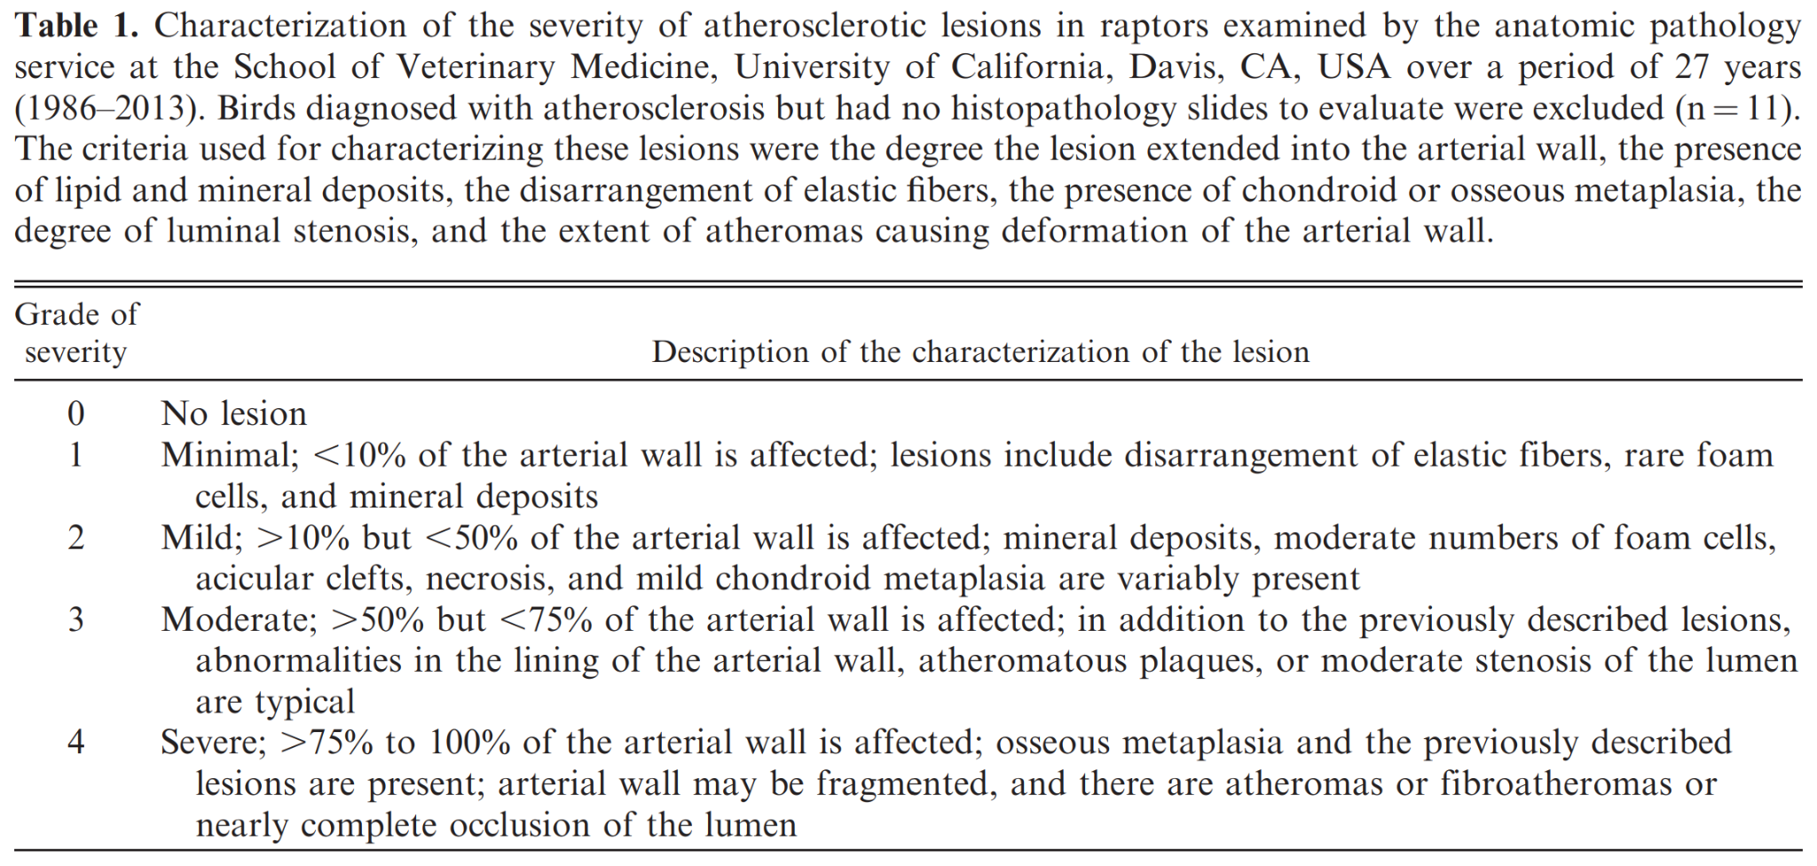

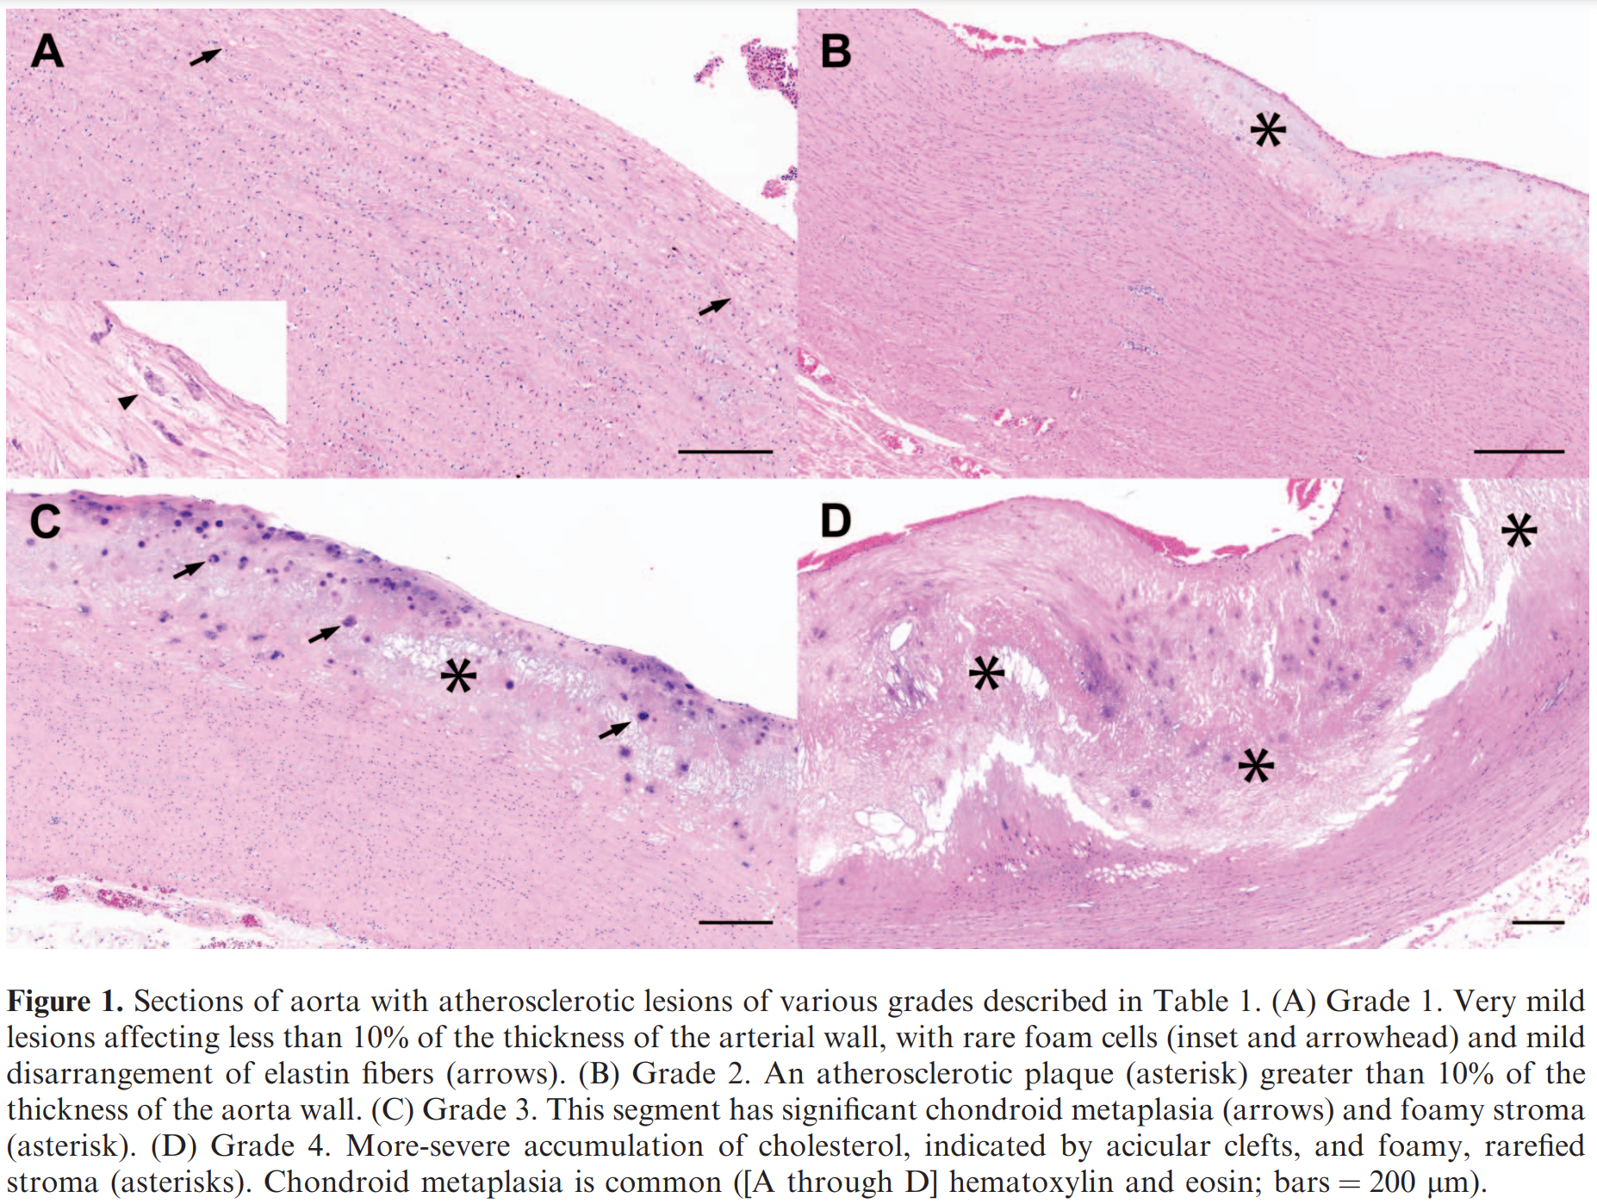
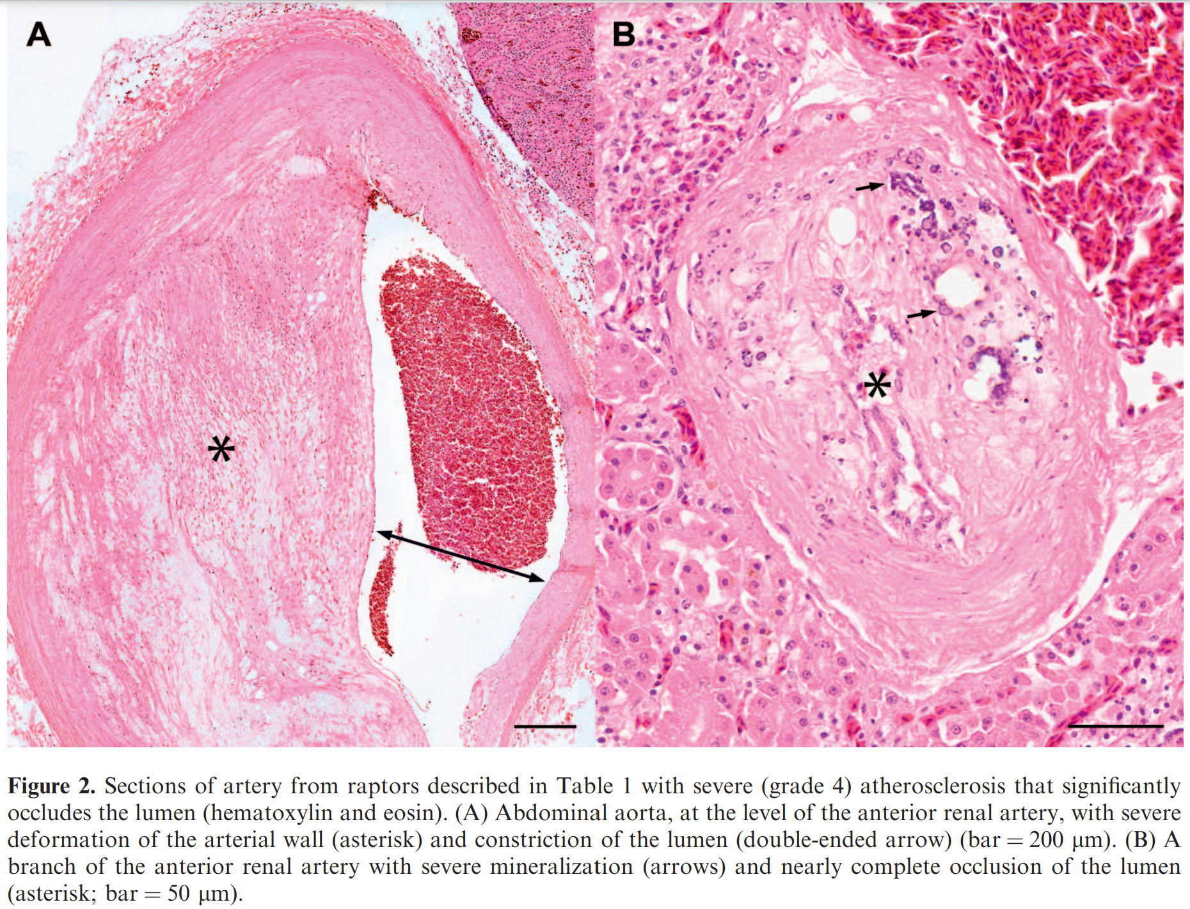

Cardiac Disease of Raptors
Seth C. Oster, DVM, and Romain Pariaut, DVM, Dipl ACVIM, Dipl ECVIM-CA
JAMS 201;35(4):382-389

Cardiac disease, in its various presentations, is being recognized as a common raptor health problem. Evidence suggests that the prevalence of cardiac disease varies between captive and wild bird of prey populations, probably because of differences in activity levels and diet. However, a wide variety of cardiovascular diseases have been reported to affect raptor species (captive and free living), including atherosclerosis, pathogenic arrhythmias, infectious cardiomyopathies, and endocarditis. Diagnostic testing used to identify cardiac abnormalities include radiographic imaging, electrocardiogram, echocardiogram, and computed tomography angiograms. Information pertaining to therapeutic treatment for raptor cardiac disease patients is inadequate or has not been investigated. This review of cardiac disease will provide current information regarding cardiac diseases that are diagnosed in birds of prey, diagnostic testing, and treatment options.

Intro:
- CV disease commonly diagnosed in companion birds, but little data available for raptor species.
- Retrospective study in northern California wild raptors 1983-1994, only form of cardiac disease reported was atherosclerosis, of which 1.2% reported. Because this paper did not include age, sex or species, direct comparisons to other studies not possible as these can significantly factor into cardiac disease
- Other retrospective studies reported myofiber degeneration, myocarditis, endocarditis, pericarditis and atherosclerosis- 24% had cardiac lesions
Diseases:
- Atherosclerosis- included as heart disease because it affects the great vessels of the heart.
Suggested decreased activity, high fat diets, and increased age predisposing factors
Genetic variation b/t species
Brahminy kite (Haliastur indus) study= significantly higher conc of serum lipids when compared to other raptor species of the same age/diet, suggested increased lipid levels could predispose this raptor species to atherosclerosis
Clinical signs vary- many show no clinical signs
Black kites= no observable clinical signs, died acutely and on postmortem, all had advanced atherosclerosis
Lesions at brachiocephalic trunk and ascending aorta, some had coelomic hemorrhage, and aortic rupture
Some cases reported clinical signs= 19yo male RT hawk, depressed, lethargic, cold feet
19yo golden eagle- supraventricular premature complexes, arrhythmia, enlarged left ventricle and atrium with poor contractility. CT angiogram confirmed lesion in right brachiocephalic artery- treatment w/sotalol, pimobendan, and isoxsuprine
Transient weakness, numbness, or paresis of wing could occur
Intermittent hindlimb weakness observed in an amazon parrot
- Arrhythmias- eagles have been reported to develop w/isoflurane
Second degree AV-block diagnosed most often in a study of anesthetized bald eagles- not present in while awake
Second degree AV-block reported in awake black vultures
- Myocarditis- often diagnosed in BOP, frequently associated with WNV
reported cause of arrhythmias
association of sarcocystosis with myocarditis unknown, was implicated as cause of myocarditis in Eurasian sparrowhawks
- Endocarditis- reported in raptors, septicemia caused by pododermatitis implicated as causative agent
- Cardiomyopathy- reported in several species, limited data. Reported in bearded vultures and bald eagles diagnosed with lead toxicity
Diagnostic Testing:
- Serum cholesterol levels- suggested as a risk factor, however direct correlation high serum cholesterol and atherosclerosis not established for raptors
- Cardiac troponin- unknown applications
- Radiography, ECG and Echo- utility of these standard testing methods unknown for raptor patients as lack of established reference normals
- Measurements of cardiac silhouettes studies:
Peregrine falcons: Sternal width was most accurate predictor of cardiac width- formula derived could be used to determine anticipated normal CW of a peregrine falcon
Harris hawks/peregrine falcons/saker falcons/lanner falcons: no significant difference in heart length on lateral projections, whereas on VD, 3 falcon species had no significant difference in heart width while Harris hawks had a narrower heart width
Screech owls/RT Hawks: compared the heart width on VD compared with sternal width and thoracic width – established significant differences b/t the species.
Osprey: birds age relative to CW- established a new formula to determine normal CW with TW, SW and a correction factor for age
Bonelli’s eagles: SW in VD compared with SW, TW, coracoid width and hepatic width- use of SW and TW preferred method to evaluate CW in that eagle species, in which CW should be 81%-93% of the SW or 48%-57% of the TW
Falcons have relatively larger cardiac silhouette than other BOP, interspecies variation likely when using this method to evaluate raptor species
- Echocardiography- transcoelomic, transesophageal reported
Presence of air sacs limits acoustic window to the ventral medial approach caudal to the keel
Rapid heart rates limits accuracy of measurement obtained from 2D imagines with standard transcoelomic, left ventricular systolic function may be underestimated
Birds that weighed b/t 190 and 2300g, diastolic flow in ventricles was detectable in 80% of patients independent of body positioning and fasting
Poor image quality- placing patient in dorsal recumbency was most consistent finding, improved when moved to lateral or ventral recumbency, and occurred primarily in birds that weighed more than 3000g
RT hawk study- transcoelomic, contrast transcoelomic and transesophageal echo showed that these were not interchangeable, and different among operators
- Electrocardiography: more widely studied in raptors, normal established
b/c iso associated with arrhythmias in bald eagles, avoid general anesthesia
Treatment:
- No PK or PD studies of CV drugs in raptors exist
- Ex: harris hawk had higher plasma conc of pimobendan than Hispaniolan Amazon parrots derived from PK study in HAP. Need for cardiac drug PK in BOP
JWD 2022 58(2):348-355
Anticoagulant exposure in golden eagle (Aquila chrysaetos) power line electrocution and wind turbine mortalities
Viner TC, Kagan RA, Lehner A, Buchweitz JP

ABSTRACT: Golden Eagles (Aquila chrysaetos) are susceptible to anthropogenic mortality factors, including toxic compounds in the environment such as anticoagulant rodenticides (AR) and sources of man-made energy. The physical and behavioral effects of some toxins may predispose eagles to certain causes of death (COD). To investigate the influence of ARs on mortality of Golden Eagles at wind turbine farms, we randomly tested liver samples from 31 eagles found dead on wind farms and submitted to the National Fish and Wildlife Forensic Laboratory from 2013-20. The comparison group was composed of 31 Golden Eagles sampled during the same time frame with a COD of power line electrocution as a proxy for a relatively lower effort and altitude activity. Associations between COD, AR exposure, sex, and life stage were assessed. In each group, 12 birds (35%) were found to have been exposed to brodifacoum or bromadiolone prior to death. Logistic regression showed no significant association between COD and sex (P=0.194) or life stage (P=0.895). Across both mortality types, life stage was not a significant predictor of AR exposure (P=0.725), but males were more likely to have been exposed to ARs (P=0.032). These findings suggest that there is no difference in the influence of anticoagulant exposure on higher and lower altitude activity in Golden Eagles.

Key Points:
- Toxicants may affect eagle behavior and flight capability
  - Studies have suggested that exposure to lead predisposes birds to collision trauma
  - However, recently shown to NOT be a predisposing factor in wind turbine mortalities
    - Subclinical lead toxicosis may inhibit soaring and hunting behavior
- Anticoagulant rodenticides classified as 1st or 2nd generation
  - 1st generation: developed earlier, require multiple feedings for rodenticide effectiveness
    - Ex: warfarin, chlorphacinone, and diphacinone
  - 2nd generation: may kill rodents after a single feeding
    - Ex: difenacoum, brodifacoum, bromadiolone, and difenthialone
  - MOA for both generations: vitamin K antagonist
  - In 2008, US EPA restricted 2nd generation use to agriculture and professionals
- Anticoagulant exposure didn’t differ between power line and wind turbine mortalities
  - Only two anticoagulants were detected in the eagles (brodifacoum and bromadiolone)
- Similar anticoagulant exposure across life stages indicates opportunity for exposure is constant
  - Anticoagulants may have similar effects, or lack thereof, on soaring/perching behaviors

TLDR: Anticoagulant or lead exposure does not predispose golden eagles to wind turbine mortalities

Related Articles:
Not on the current ACZM reading list, but of interest:
- Viner TC, Kagan RA. 2021. Lead exposure is unrelated to wind turbine mortality in golden eagles. Wildl Soc Bull 45:244–248.

JAMS 2021 35(1):2-27
Ophthalmic Evaluation of Raptors Suffering From Ocular Trauma
Carter RT, Lewin AC

ABSTRACT: Ocular problems are often associated with traumatic injury in raptors. A comprehensive evaluation, including a complete ophthalmic examination, is vital in determining the patient's overall health and suitability for release. Steps for conducting ocular examination and diagnostic testing in raptors is discussed. Additionally, common clinical findings after trauma, as well as the mechanisms by which ocular injury occurs, are outlined. An overview of medical treatments recommended for commonly diagnosed ocular diseases and the utility of ancillary diagnostic procedures is also presented.

Background:
- Trauma has been reported as the most common cause of ocular morbidity in raptors
- Severity and type of traumatic ocular injury is influenced by multiple factors:
  - Gunshot wounds & window strike more common in larger, diurnal raptor
  - Vehicle collisions more common in nocturnal birds
  - Juveniles may have less serious injuries and better prognosis than adults
    - However, juvenile diurnal birds still learning to fly or hunt may suffer more self-injury vs. adults
- Ocular trauma has a negative influence on a successful release from rehabilitation
  - Anterior chamber lesions > posterior chamber lesions > corneal injuries
Anatomy:
- Many features of the avian eye increase the risk for traumatic injury:
  - Frontal location & relatively large
  - Minimal periocular cushion
  - Temporal and dorsal aspects unprotected by the bony orbit
    - Especially in nocturnal birds
  - A protective supraorbital ridge is present in diurnal raptors
    - Absent in nocturnal species, increasing their risk of blunt ocular trauma
- Scleral ossicles surround area of the eye extending beyond the orbit and provide:
  - Protection, shape, rigidity, and a firm site of origin for striated ciliary muscles
- Minimal extraocular muscle movement (they lack significant extraocular muscles)
  - Species differences exist in extraocular muscle development and function
- Primary pupillary sphincter composed of striated circumferential muscle
  - Allows for normal, rapid, voluntary control of the iris (hippus)
  - Likely an adaptive mechanism to assist with hunting during flight
  - Prevents use of topical dilating agents (e.g., tropicamide, atropine)
- Harderian and lacrimal glands responsible for tear production in most raptors
  - Harderian gland -> base of the third eyelid within the orbit
  - Lacrimal gland -> inferior-temporal aspect of the globe within the orbit
    - Main source of tear production in birds
- Two primary muscles required for normal third eyelid function:
  - Pyramidalis and quadratus muscles innervated by the abducens nerve
- Lens encompasses approximately 1/3 of the intraocular volume of the avian eye
Ophthalmic Exam
- Ophthalmic examination in raptors is similar to other small animal patients
- Palpebral reflexes are often incomplete, whereas the third eyelid reflex is complete
- Direct PLR and dazzle reflex possible in a normal patient
  - Differences in the menace response exist among raptors
    - Usually, third eyelid movement instead of closure of the palpebrae
    - Little clinical benefit in determining visual status
  - Significant anisocoria or marked mydriasis is suggestive of severe retinal dysfunction, a primary lesion of the iris, or oculomotor nerve dysfunction
  - A slow direct pupillary light reflex may be indicative of profound cranial injury
- Horner syndrome has been reported in birds, often includes:
  - Ptosis, anisocoria, and erect ear-tuft feathers on the affected side
  - Miosis s typically not as severe as in companion animal species
  - Enophthalmos & secondary protrusion of the third eyelid is not usually present
- Typically, a head tilt without other neurol signs have severe unilateral ocular disease
- Bilateral severe miosis often indicative of severe CNS trauma & increased ICP
- Nystagmus is often demonstrated by complete movement of the head
Tear Production
- Tear production -> Schirmer tear test (STT), modified STT, or phenol red thread test
  - mSTT ideal for raptor species with a small palpebral
  - However, only recommended to compare eyes of the same bird
  - Phenol red thread test can be a useful alternative
- Decreased tear production r/o neurologic, keratitis, or hypovitaminosis A
- Increased tear production r/o ocular pain or lacrimal drainage obstruction
- Nocturnal raptors may have lower tear production
  - Harderian gland is less developed and may be absent
  - Owls are reported to have vestigial or absent lacrimal glands
- Adult raptors may have lower tear production
Intraocular Pressure (IOP)
- Applanation (Tonopen) vs. rebound tonometry (Tonovet)
  - Applanation requires topical anesthetic
  - Rebound tonometry better suited for small corneal diameter
- Increased IOP r/o ocular trauma
  - Secondary glaucoma caused by hemorrhage, chronic uveitis, lens luxation
  - Primary glaucoma rarely diagnosed
- Decreased IOP r/o anterior uveitis
Fundic Exam
- Evaluates the vitreous body, the retina (including the fovea), pecten, and choroid
  - Owls have a single fovea dorsal and temporal to the pecten
  - Diurnal raptors have 2 fovea temporal and dorsal/medial to the pecten
  - The retina is anangiotic (without the presence of intraretinal blood vessels)
    - Nourishment is reliant on the highly vascularized pecten
    - A choroidal tapetum is absent in avian species
- B/c of patient stress, the pupils will sufficiently dilate for fundic exam
  - Most prominent in nocturnal species
- Intracameral drugs such neuromuscular blocking agents are typically reserved for mydriasis of patients undergoing intraocular surgery
Traumatic Ocular Lesions
- Orbit
  - Bones of the orbit are pneumatic and surrounded by the infraorbital sinus
    - Periorbital fx -> facial asymmetry, palpable fractures, and crepitus
    - Scleral ossicle fx -> globe rupture may feel soft/deformed, have free air
- Periocular Tissues
  - Facial nerve damage -> reduced palpebral reflexes -> secondary exposure keratitis from lagophthalmos (incomplete coverage of the globe)
    - Treatment: topical lubricating ointments or temporary tarsorrhaphy
  - Nictitans dysfunction may be diagnosed in birds that present with head injury
  - Blunt traumatic injuries -> eyelid contusions/abrasions/swelling (blepharoedema)
  - Ectoparasites (eg, lice, mosquitoes, black flies, hippoboscid flies, keds)
    - Knemidokoptes pilae mites cause proliferative, hyperplastic, and scaly lesions
      - Significant blepharoconjunctivitis and hyperkeratosis are common
      - Treatment: ivermectin
  - Partial- or full-thickness lacerations
  - Commonly reinjured in flight enclosures before release
- Cornea
  - Focal corneal ulceration more often in adults due to larger globe size
  - Complex corneal ulcers have 1 or more of the following characteristics:
    - Stromal loss (contour change to the corneal surface)
    - Melting (soft, grey appearance)
    - Infiltrate (hallmark of infectious keratitis)
  - Subconjunctival antibiotic injections may used in severe corneal ulcer cases
  - Corneal malacia (keratomalacia) is best managed w/ topical antiproteolytic agents
    - Heterologous serum safe and effective if autologous or homologous unavailable
  - Corneal perforation found infrequently
  - Recurrent corneal ulceration
    - Trauma is thought to be a common etiology
    - However, may be caused by a novel herpes virus in great horned owl
  - Chronic sequalae = corneal scars, lipid degeneration
- Anterior Chamber/Uvea
  - Hyphema = most commonly identified ocular lesion following trauma
    - Typically have concurrent severe intraocular abnormalities
    - Unfortunately, often precludes a complete ophthalmic exam
  - Anterior uveitis = most common abnormality
    - Numerous clinical signs with anterior uveitis: iridal hyperemia, fibrin formation, pigment dispersion, aqueous flare, hyphema, hypopyon, miosis, and low IOP
  - Shallow anterior chamber r/o lens lux, synechiation (iris adhesions), globe collapse
  - Deeper anterior chamber r/o lens lux, hypermature (resorptive) cataracts, iridial tear
  - Iridial or ciliary body tear from attachments to the sclera = irido/cyclodialysis
- Lens
  - Lens luxation
    - Rarely occurs in raptors b/c of direct fusion of ciliary processes to equatorial region of the lens
  - Anterior or posterior cortical cataracts may develop secondary to previous inflammation
- Vitreous
  - Vitreal hemorrhage = second most common ocular abnormality identified in raptors
    - Pecten = likely source after a traumatic incident due to vascular nature
    - Pecten likely functions as a source of nutrients for the avascular retina
- Retina
  - Acute lesions include avulsion of the pecten, chorioretinitis, retinal tears, retinal detachment, and chorioretinal or scleral rupture
  - Retinal tears and detachment are a common b/c of contrecoup forces associated with trauma and are typically unilateral
    - Lack of retinal vasculature makes retinal detachments difficult to appreciate
    - Ocular ultrasound is recommended
Advance Diagnostics
- Ocular ultrasound
  - Corneal contact method using a gel standoff sufficient to visualize the entire globe
  - Scleral ossicles appear as hyperechoic stripes, causing a distal shadow effect
    - Shadowing limits evaluation of the orbit, optic nerve, and fibrous tunics fully
  - Ultrasound measurements have been used to evaluate pecten size in multiple raptors
  - Ocular ultrasound can also be used to confirm lens subluxation
- Electroretinogram
Considerations For Release
- Non-releasable when significant vision-threatening, bilateral ocular lesions are present
- Lesions that involve the fovea are expected to have a greater reduction of vision
- Changes centrally located vs. peripheral lesions also have a more significant effect on vision
- Flight and food testing of raptors with ocular injury should be performed before release
  - Raptors found to be in good body condition with a chronic ophthalmic lesion may have possibly learned to compensate

Related Articles: None on the current ACZM reading list

