- Which amputation site was found to be least traumatized by birds that underwent wing amputations?
  - Distal humerus
  - Mid humerus
  - Proximal humerus
  - Distal Antebrachium
  - Proximal Antebrachium

Answer: C. Proximal Humerus

- Which amputation site is found to have a more guarded prognosis in birds of prey?
  - Distal Antebrachium
  - Proximal Antebrachium
  - Distal humerus
  - Mid humerus
  - Proximal humerus

Answer: B. Proximal Antebrachium

"Predisposing Anatomical Factors of Humeral Fractures in Birds of Prey: A Preliminary Tomographic Comparative Study." Journal of Avian Medicine and Surgery 35.2 (2021): 123-134. Bertuccelli, Tiziana, et al.

QUESTION: Which bird of prey may be most resistant to humeral fractures from impact trauma?
- Peregrine falcon
- European honey-buzzard
- Common buzzard
- Barn owl
- Tawny owl
Answer: A – peregrine falcon; high trabeculae number, high trabeculae size, high bone density

"Risk Factors and Prognosis for Humeral Fractures in Birds of Prey: A Retrospective Study of 461 Cases from 2000 to 2015." Journal of Avian Medicine and Surgery 36.1 (2022): 2-13. Coutant, Thomas, et al.

QUESTION:
Which is a risk factor for a compound humeral fracture in birds of prey?
- Female sex
- Weight of <300 grams
- Low humeral width to wingspan ratio
- Young age group
- Geriatric age group
Answer: C - slender humeri

Compare and contrast the use of an IM pin alone (IMP) versus and an external skeletal fixator-intramedullary pin tie-in fixator (ESFIMPTIF) in repairing femoral fractures in birds of prey

IMP: inexpensive, provide axial alignment, and require minimal tissue exposure for placement.

ESF IMP TIF: Provides more stability but is more time consuming, can create iatrogenic fissures, result in premature loosening of pins due to thin avian cortices

Name three indications for conservative (non-surgical) management of an ulna fracture (with an intact radius) in a raptor.

- Chronic fracture (>7 days)
- Good alignment
- Proximal fracture (pin placement increases risk of malalignment)
- Closed fracture

Evaluation of Atherosclerotic Lesions and Risk Factors of Atherosclerosis in Raptors in Northern California.
Lujan-Vega C, Keel MK, Barker CM, Hawkins MG.
Journal of Avian Medicine and Surgery. 2021;35(3):295-304.

Which of the following are risk factors for development of atherosclerotic lesions in raptors?
A. Adult, female
B. Female, Strigiformes
C. Juvenile, Accipitridae
D. Juvenile, male
E. Adult, Pandionidae

Answer: A. Adult, female

Cardiac Disease of Raptors
Seth C. Oster, DVM, and Romain Pariaut, DVM, Dipl ACVIM, Dipl ECVIM-CA
JAMS 201;35(4):382-389

Which of the following is true regarding cardiac disease in birds of prey?
A. Strigidae and Tytonidae are overrepresented in the postmortem diagnosis of atherosclerosis.
B. Sevoflurane has a higher risk of arrhythmias in bald eagles compared to isoflurane
C. The width of the cardiac silhouette in osprey is relatively larger than many other raptor species.
D. Transesophageal echocardiography has improved repeatability over transcoelomic approach.
E. Harris hawks administered pimobendan had similar plasma concentrations to psittacines.

Answer: D
A. Kites (Accipitridae) and Falconidae are overrepresented in studies assessing atherosclerosis prevalence
Lujan-Vega C, Keel MK, Barker CM, Hawkins MG. Evaluation of Atherosclerotic Lesions and Risk Factors of Atherosclerosis in Raptors in Northern California. Journal of avian medicine and surgery. 2021 Sep;35(3):295-304.
B. Isoflurane was associated with more arrhythmias
Joyner PH, Jones MP, Ward D, Gompf RE, Zagaya N, Sleeman JM. Induction and recovery characteristics and cardiopulmonary effects of sevoflurane and isoflurane in bald eagles. American journal of veterinary research. 2008 Jan 1;69(1):13-22.
C. Cardiac width in falcons is relatively larger than many other raptor species
Barbon AR, Smith S, Forbes N. Radiographic evaluation of cardiac size in four falconiform species. Journal of avian medicine and surgery. 2010 Sep;24(3):222-6.
E. A Harris hawk administered the same dose of pimobendan as described in the Hispaniolan Amazon Parrot PK study had plasma concentrations several hundred times higher than the parrots in the study.
Guzman DS, Beaufrère H, KuKanich B, Barker SA, Brandão J, Paul-Murphy J, Tully Jr TN. Pharmacokinetics of single oral dose of pimobendan in Hispaniolan Amazon parrots (Amazona ventralis). Journal of Avian Medicine and Surgery. 2014 Jun;28(2):95-101.

Practice Question: What is the difference between 1st and 2nd generation anticoagulant rodenticides?

Answer: 1st generation = developed earlier, require multiple feedings for rodenticide effectiveness; 2nd generation = may kill rodents after a single feeding

Practice Question: What is your top differential for the ocular lesions indicated by the yellow arrows?
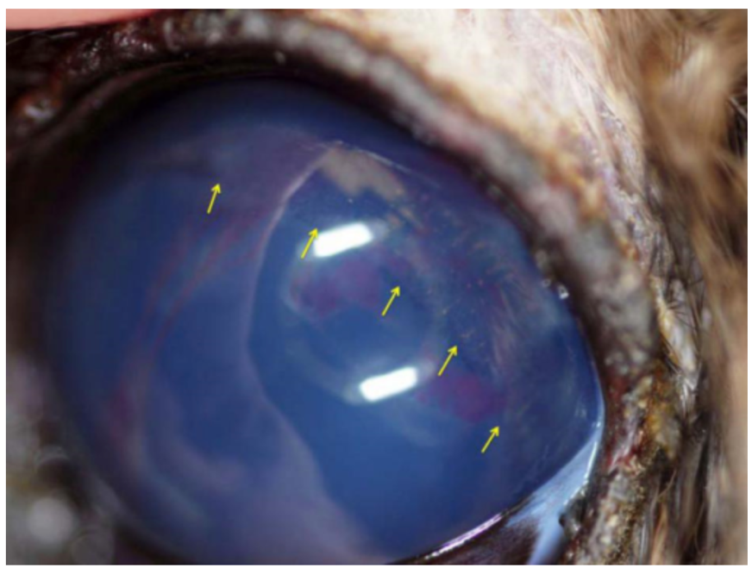

Answer: Anterior lens luxation in a great horned owl resulting in a shallow anterior chamber, hyphema, and corneal edema. A pigmented ring of tissue (yellow arrows) can be visualized at the equator of the lens representing avulsion of the lens from the ciliary body

