Practice Question: In a population of American Black Bears in New Mexico, antibodies to which disease were the most prevalent?
- Canine distemper virus
- Canine parvovirus
- Francisella tularensis
- West Nile Virus
- Yersinia pestis

Practice Question: Which pathogen showed evidence of cumulative exposure in Alaskan brown bear populations?
- Canine distemper virus
- Toxoplasma gondii
- Influenza A virus
- Francisella tularensis
- Canine adenovirus-1

Which of the following was found in a recent retrospective on morbidity and mortality in American black bears (ursus amerianus) undergoing rehabilitation?

- Bears were most likely to present in the fall or winter
- The majority of bears that presented died or were euthanized
- Orphaned neonates were more likely to return to the wild than malnourished yearlings
- Male bears were more likely to present for traumatic injury
- Trauma was the most common cause of death

Answer: e

- Which of the following is true regarding the most significant side effect of chemical immobilization in captive black bears receiving a combination of nalbuphine, medetomidine, and azaperone?
  - Severe Hypothermia
  - Respiratory Acidosis
  - Prolonged Hypocapnia
  - Mild Hypoxemia
  - Moderate Hypotension

Answer: D- mild hypoxemia and was corrected with supplemental oxygen

- Which of the following animals is considered a low antibody prevalence for Leptospirosis?
  - Racoons
  - Skunks
  - Bears
  - Rats
  - Squirrels
Answer: C- bears

“Fluoxetine therapy to decrease stereotypic behavior in the asiatic black bear (ursus thibetanus)." Journal of Zoo and Wildlife Medicine 50.3 (2019): 718-722.

Which of the following is true regarding use of fluoxetine in Asiatic black bears for stereotypic behaviors?
- Fluoxetine had significant side effects and is not considered sage
- Fluoxetine will allow cessation of stereotypic behaviors in all black bears
- Fluoxetine may reduce stereotypies but is less effective on well-established behaviors
- Fluoxetine is ineffective in all species of ursids
- Fluoxetine alone alleviates necessitation for multifactorial intervention
Answer: C

"Ursid γ-herpesvirus type 1–related virus in captive bornean sun bears (helarctos malayanus euryspilus) in sabah, malaysia." Journal of Zoo and Wildlife Medicine 53.1 (2022): 92-99.

Which herpesvirus has not been detected in ursids?
- Equine alpha-herpesvirus 1
- Bovine alpha-herpesvirus 1
- Suid alpha-herpesvirus 1
- Ursid gamma-herpesvirus 1
- Canine alpha-herpesvirus 1

Answer: E – refer to Table 1

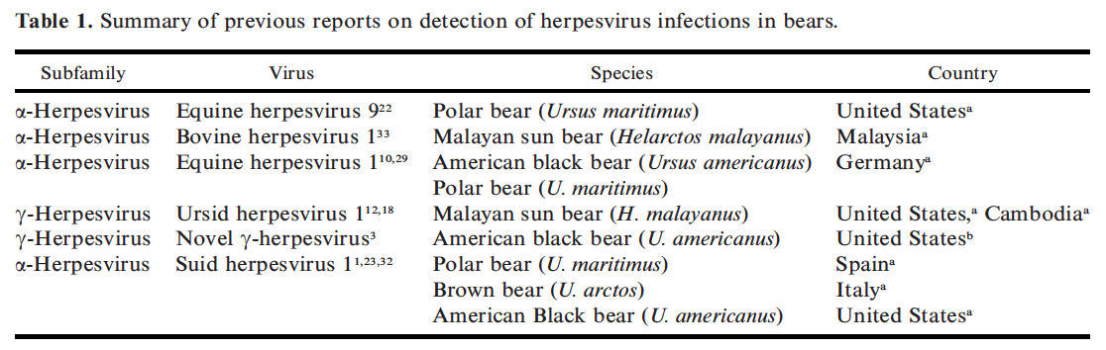

Comparison of isoflurane gas versus a guaifenesin, ketamine, and medetomidine constant-rate infusion for maintenance anesthesia in american black bears (ursus americanus).
Siegal-Willott JL, Bauer KL, Hayek LA, Luensman NM, Cross TN, Sajecki JL, McRuer DL.
Journal of Zoo and Wildlife Medicine. 2019;50(3):570-578.

Which of the following was affected by maintaining anesthesia with guaifenesin, medetomidine, and ketamine compared to isoflurane in American black bears?
A. Heart rate
B. Mean arterial pressure
C. Palpebral reflex
D. Time to full recovery
E. Post-procedure emesis

Answer: C - GMK bears maintained a palpebral reflex despite appropriate depth while isoflurane bears did not.

Pharmacokinetics of a single dose of fluralaner administered orally to american black bears (ursus americanus).
Van Wick P, Papich MG, Hashem B, Dominguez-Villegas E.
Journal of Zoo and Wildlife Medicine. 2020 Nov;51(3):691-5.

Which of the following is a potential disadvantage of using fluralaner to treat sarcoptic mange in rehabilitated black bears?
A. Poor palatability
B. Repeated dosing
C. Low peak plasma concentration
D. Risk of seizures
E. Long withdrawal time

Answer: E

