ARTICLE: Shell Lesions Associated With Emydomyces testavorans Infection in Freshwater Aquatic Turtles. Woodburn DB, Kinsel MJ, Poll CP, Langan JN, Haman K, Gamble KC, Maddox C, Jeon AB, Wellehan JFX, Ossiboff RJ, Allender MC, Terio KA. Vet Pathol. 2021 May;58(3):578-586.
Abstract: A newly described onygenalean fungus, Emydomyces testavorans, has been isolated from ulcerative shell and skin lesions of freshwater aquatic chelonians. To investigate the shell lesions associated with infection and determine if any lesional features were unique to E. testavorans, tissues from turtles housed in zoological institutions (n = 45) in the United States and free-living turtles (n = 5) submitted for diagnostic biopsy or necropsy were examined. Free-living turtles were from geographically distinct habitats in Florida (n = 1) and Washington (n = 4) at the time of sampling. Histologic shell sections were evaluated for the presence or absence of specific lesional features. Infection with E. testavorans was evaluated in all cases by screening GMS (Grocott-Gomori’s methenamine silver)-stained histologic sections for the presence of morphologically consistent fungi and by quantitative PCR (polymerase chain reaction) on representative frozen tissue or formalin-fixed paraffin-embedded sections. Additionally, culture was performed for 15 cases with available fresh/frozen tissue. In total, there were 17 PCR-confirmed E. testavorans cases, 29 cases with morphologically consistent fungi on GMS-stained sections, and 21 cases of shell lesions without histologic or molecular evidence of E. testavorans infection. Epithelial inclusion cysts, defined as cystic structures within the dermis lined by keratinized stratified squamous epithelium and containing necrotic bone and keratin debris, were significantly (P < .01) associated with E. testavorans infection. Other significantly associated shell lesions included squamous metaplasia, hyperkeratosis, inflammation, and osteonecrosis (P < .05). This study identified characteristic shell lesions associated with E. testavorans infection. Further studies to prove causality are needed.

Background
- Shell disease is common cause of morbidity and mortality in wild and captive chelonians; i.e. septicemic cutaneous ulcerative disease (SCUD) = shell disease in aquatic turtles of bacterial dermatitis and osteomyelitis secondary to superficial trauma and poor water quality
- Emydomyces testavorans = onygenalen fungus; new disease of concern associated with unusual ulcerative lesions in freshwater aquatic turtles, specifically Pacific pond turtles (Actinemys marmarota)
  - Onygenales order of fungi like genera Nannizziopsis, Paranannizziopsis, Ophidiomyces

Goal of Study
- Investigate gross and histopathologic shell lesions associated with infection of Emydomyces testavorans
  - 62 samples (24 biopsies, 38 necropsies) from 50 animals (45 zoo, 5 wild) and 27 species
- Presence/absence of E. testavorans determined with 3 modalities: GMS-stain, culture, PCR and sequencing

KEY POINTS
- Gross: Most cases with gross lesions (24/31) had multifocal ulcerations affecting carapace and plastron
  - 7/31 cases had firm-hard, expansile, nodular masses within the shell that were not detected externally (fig 1) that displaced membrane/viscera but did not penetrate coelomic cavity
- Histopath: Epithelial inclusion cysts = significantly associated (not causative) with E. testavorans infection; detected in 28/50 animals, including all 7 cases with grossly nodular lesions and in 27/29 cases with E-testavorans consistent fungi
  - Characterized as cystic structures within dermis lined by keratinized stratified squamous epithelium and containing necrotic bone and keratin debris
  - Highly suggestive though not pathognomonic for E. testavorans
- Other significantly associated lesions in GMS positive animals: squamous metaplasia, hyperkeratosis, osteonecrosis, inflammation
- Uncertain if E. testavorans can cause disease on own or requires facilitation by other risk factors/co-pathogens due to presence of other bacteria/fungi in some cases

ARTICLE: Pharmacokinetics of Nebulized Terbinafine in Plasma and Keratin of Northwestern Pond Turtles ( Actinemys marmorata ) Associated with Emydomycosis
Kelly P. Flaminio, Sherry Cox, Katherine Haman, Matthew Allender, Bethany Groves et al. Journal of Herpetological Medicine and Surgery (2022) 32 (1): 48–55.

Abstract: The Northwestern pond turtle (Actinemys marmorata) is native to Washington State, USA and has developed a grossly evident form of shell disease affecting a large percentage of the free-ranging population in this state. Emydomyces testavorans is a novel fungus in the order Onygenales that is the presumed causative agent for shell disease in the Northwestern pond turtle. Terbinafine hydrochloride is a lipophilic allylamine broad-spectrum antifungal that penetrates keratin and concentrates in the stratum corneum. This study evaluated the drug concentration in the plasma and keratin of 18 Northwestern pond turtles after nebulization with 18 mg terbinafine solution (2 mg/ml) once a day for 28 days. Blood and keratin samples were collected serially during the course of treatment, and for 14 days following the last dose. Plasma and keratin were analyzed by high-performance liquid chromatography. No significant concentrations of terbinafine were found in the plasma of the turtles. Terbinafine in turtle keratin peaked after 16 days of treatment and maintained therapeutic concentrations for 14 days posttreatment. Turtle shell lesions also showed signs of clinical improvement posttherapy. Nebulization of terbinafine is recommended for the treatment of shell disease secondary to Emydomyces testavorans; however, pulse antifungal therapy is likely needed to prevent disease from reoccurring.

Background
- Northwestern pond turtles in Washington state have a high prevalence (84%) of shell disease characterized by bleaching, abnormal scute texture, and in severe cases deep pitting lesions filled with necrotic debris that can penetrate coelomic cavity
  - Lesions and disease are best evaluated/diagnosed by CT
  - Cultures collected from shell/keratin have identified novel Onygenales fungus - now known as Emydomyces testavorans
  - MIC values for E. testavorans were developed for terbinafine, itra-, flu-, and voriconazole in vitro
- Teribinafine hydrochloride = lipophilic allylamine that inhibits squalene epoxidase, halting the synthesis of ergosterol and thus interfering with membrane function, giving it both fungicidal and fungistatic activity
  - Can penetrate skin and concentrate in stratum corneum

Goal of Study
- Evaluate PK of nebulized terbinafine in plasma and keratin in NWPT with presumed Emydomycosis
- Study design: free-ranging NWPT (n=18) in WA that had shell lesions characteristic of E. testavorans
  - Performed initial CT to characterize lesions, followed by surgical debridement under anesthesia
  - Nebulized with 18mg (9ml) of terbinafine solution every 24h for 28 days
  - Collected blood and carapace keratin samples for PK analysis before, during, and after treatment

KEY POINTS
- Terbinafine via serial nebulizations remained above therapeutic concentrations (MIC>0.06 ug/ml) in keratin and may remain adequate for 7-14 days, thus may be an adequate therapy for this disease
  - All turtles had concentrations of terbinafine above MIC for E. testavorans in their keratin 7d after final administration and majority (75%) still did 14d after final administration
- Terbinafine did not reach adequate concentrations in plasma via serial nebulization
  - Different than parrots/snakes in which it was consistently present in plasma after nebulizations
- All turtles lesions were clinically healing 7 mo after surgical debridement and 28d of nebulized terbinafine therapy

Successful Treatment of Nannizziopsis guarroi Infection Using Systemic Terbinafine in a Central Bearded Dragon ( Pogona vitticeps )Journal of Herpetological Medicine and Surgery (2022) 32 (1): 20–25.
ABSTRACT: Nannizziopsis guarroi infection in lizards presents therapeutic challenges, with reports of poor clinical outcomes, including antifungal toxicity, incomplete clearance of infection, and recrudescence of infection being common. The case presented here describes the successful treatment of an N. guarroi infection using systemic terbinafine and environmental disinfection in a captive-bred central bearded dragon (Pogona vitticeps). The lizard presented with darkly colored cutaneous lesions, and mycologic culture samples were identified as N. guarroi using matrix-assisted laser desorption/ionization–time of flight. Based upon the lack of clinical resolution of cutaneous lesions, weight loss, and reduced appetite, initial treatment with voriconazole was discontinued. Terbinafine was prescribed, and weekly environmental disinfection with sodium hypochlorite was initiated until cutaneous clearance of the fungus was confirmed by negative culture, histopathology, and N. guarroi quantitative polymerase chain reaction from cutaneous swab. Terbinafine treatment was discontinued after 80 days. There were no clinical signs of toxicity associated with the prolonged treatment, and the lizard has not developed any cutaneous lesions or illness in more than 2 yr of clinical follow-up. Although the ideal treatment of N. guarroi is still being investigated, this case demonstrates a promising and safe treatment option for an increasingly common and devastating disease.

Key Points:
- N. guarroi = onygenalean fungi and causative agent of “yellow fungus disease”
  - Previously classified as Chrysosporium anamorph of N. vriessii (CANV)
  - Species affected include bearded dragon, green iguana, common agama
  - Despite colloquial name, lizards often exhibit darkly pigmented cutaneous lesions
- Terbinafine = allylamine antimycotic agent
  - MOA: inhibition of ergosterol biosynthesis
  - Keratinophilic and is deposited into keratinized tissues
  - Unlike azoles, not reported to be associated with adverse effects
- Disinfection of the environment important part of therapy
  - In a recent study, N. guarroi isolates exhibited environmental persistence up to 14 days
  - Sodium hypochlorite (bleach) completely inhibited growth of all isolates
  - Recommended weekly disinfection of the enclosure in this case

Takehome: Successful treatment of N. guarroi using systemic terbinafine and environmental disinfection
Single-dose pharmacokinetics of orally administered terbinafine in bearded dragons (Pogona vitticeps) and the antifungal susceptibility patterns of Nannizziopsis guarroi. .Am J Vet Res. 2021 Dec 22;83(3):256-263. doi: 10.2460/ajvr.21.02.0023.
Objective: To identify the antifungal susceptibility of Nanniziopsis guarroi isolates and to evaluate the single-dose pharmacokinetics of orally administered terbinafine in bearded dragons.
Animals: 8 healthy adult bearded dragons.
Procedures: 4 isolates of N. guarroi were tested for antifungal susceptibility. A compounded oral solution of terbinafine (25 mg/mL [20 mg/kg]) was given before blood (0.2 mL) was drawn from the ventral tail vein at 0, 4, 8, 12, 24, 48, 72, and 96 hours after administration. Plasma terbinafine concentrations were measured with high-performance liquid chromatography.
Results: The antifungal minimum inhibitory concentrations against N. guarroi isolates ranged from 4,000 to > 64,000 ng/mL for fluconazole, 125 to 2,000 ng/mL for itraconazole, 125 to 2,000 ng/mL for ketoconazole, 125 to 1,000 ng/mL for posaconazole, 60 to 250 ng/mL for voriconazole, and 15 to 30 ng/mL for terbinafine. The mean ± SD peak plasma terbinafine concentration in bearded dragons was 435 ± 338 ng/mL at 13 ± 4.66 hours after administration. Plasma concentrations remained > 30 ng/mL for > 24 hours in all bearded dragons and for > 48 hours in 6 of 8 bearded dragons. Mean ± SD terminal half-life following oral administration was 21.2 ± 12.40 hours.
Clinical relevance: Antifungal susceptibility data are available for use in clinical decision making. Results indicated that administration of terbinafine (20 mg/kg, PO, q 24 to 48 h) in bearded dragons may be appropriate for the treatment of dermatomycoses caused by N guarroi. Clinical studies are needed to determine the efficacy of such treatment

Key Points:
- Nannizziopsis guarroi = causative agent of yellow-fungus disease
  - Nannizziopsis = genus of keratinophilic fungi that cause cutaneous lesions in lizards
  - Recent molecular characterization has led to several nomenclature changes
    - Previously reported under the names Chrysosporium guarroi and Chrysosporium anamorph of Nannizziopsis vriesii (CANV)
  - Sequencing suggests most cases of CANV in companion reptiles are caused by N guarroi
- Azole class of antifungals are commonly used, but have been associated with hepatotoxicity
  - Voriconazole = most efficacious and the least toxic of this group
  - High rate of recurrence of latent infections following treatment azole class of antifungals
- Terbinafine is fungicidal; inhibits squalene epoxidase required for ergosterol synthesis
  - Accumulation of squalene within fungal cells leads to cell death
  - Rare reports of toxicosis in other species owing to its keratinophilic nature
  - Accumulation within keratinized tissues makes it ideal option for dermatomycoses
- 20 mg/kg terbinafine exceeded the MIC of terbinafine (30 ng/mL) for N guarroi for at least 24h
- All dragons tolerated terbinafine well and no signs suggestive of toxicosis were observed
- Nannizziopsis guarroi antifungal susceptibility:
  - Terbinafine > voriconazole > posaconazole > ketoconazole & itraconazole > fluconazole
  - Ophidiomyces ophidiocola (snake fungal disease) has similar susceptibility pattern
    - Terbinafine > voriconazole > ketoconazole > posaconazole > itraconazole
  - Emydomyces testavorans (shell mycosis in aquatic freshwater turtles) is different though
- In mammals, terbinafine is highly protein bound
  - No published data on the protein affinity of terbinafine in any reptile species
  - Vitellogenesis -> elevated protein concentrations in reproductively active females
  - Study was performed in March; female dragons may have experienced vitellogenesis
  - Higher plasma terbinafine concentrations in females may have represented sex differences associated with seasonal plasma protein levels

Takehome: Terbinafine 20 mg/kg PO q 24-48h may be useful in treating N guarroi in bearded dragons

JZWM 2019 50(3):672-677
Postnatal Mortality In Neonate Rattlesnakes Associated With Ophidiomyces ophiodiicola
Britton M, Allender MC, Hsiao SH, Baker SJ

ABSTRACT: Ophidiomycosis, historically referred to as snake fungal disease (SFD), caused by Ophidiomyces ophiodiicola, is a significant disease of snakes characterized by crusty scales, pustules, subcutaneous nodules, and death. Ophidiomycosis is a proposed threat to sustainability of free-ranging snake populations throughout the United States and Europe, but the clinical progression during periods of reproductive activity (gravid females, neonates) is unknown. In spring 2012, five apparently healthy gravid eastern massasauga (Sistrurus catenatus) rattlesnakes from Clinton County, Illinois, were brought into captivity to give birth and be returned into the population. While in captivity, one adult female and 21 neonates died. Five individuals were subsequently confirmed positive for O. ophiodiicola by using quantitative polymerase chain reaction (qPCR). In 2016, a gravid timber rattlesnake (Crotalus horridus) with ophidiomycosis from Jackson County, Illinois, gave birth in captivity to 13 neonates. Skin swabs were taken from all neonates immediately after birth and confirmed negative for O. ophiodiicola by using qPCR. The neonates remained housed with the positive female for 10 days before all animals were reswabbed and released back into the wild. One neonate was O. ophiodiicola positive at time of release. The initial negative result followed by a positive result several days postpartum suggests that the neonate was infected by the female after direct contact. Both case series represent natural infection of neonates after parturition and highlight the importance of this disease in a demographically important age class.

Background:
- O. ophiodiicola has been documented in more than 30 species of snakes
  - Presents as fungal dermatitis on the head, body, and tail
  - Wild adult eastern massasaugas may have a mortality rate greater than 90%
- Pygmy rattlesnakes found gravid/vitellogenic had less severe infections vs. non-repro females
Key Points:
- Case series (n = 5 gravid eastern massasauga and 1 gravid timber rattlesnakes)
- First observation of transmission of O. ophiodiicola after parturition in two species of pit vipers
  - Clinical signs in adults consistent with previous reports
  - Clinical signs in neonates were subtle
- Mortality of eastern massasauga neonates occurred rapidly; possible increased susceptibility
- Recommendations for captive management
  - Test wild snakes for O. ophiodiicola by using qPCR upon arrival
  - Neonates born to wild gravid females in captivity should be immediately separated
    - Neonates should be tested regardless of the female's disease status
    - Monitor closely for clinical signs and re-test if changes occur
  - If qPCR-positive status persists with absence of clinical signs, animal should be considered at risk for developing lesions or serving as a source
  - Practice strict biosecurity (wear gloves, changes gloves, separate tools)

TLDR: Oo can be transmitted between females and neonates

Related Articles: None on the current ACZM reading list

JZWM 2021 52(3):997-1002
Retrospective Review Of Ophidiomycosis (Ophidiomyces ophiodiicola) At The Smithsonian's National Zoological Park (1983-2017)
Anderson KB, Steeil JC, Neiffer DL, et al

ABSTRACT: A retrospective review of systemic or localized mycotic infections in captive snakes confirmed via biopsy or necropsy from 1983 to 2017 was performed at the Smithsonian's National Zoological Park. Quantitative polymerase chain reaction (qPCR) confirmed infection with Ophidiomyces ophiodiicola (Oo) in 36.8% (n = 14) of the 38 mycotic infections. Infections with Oo were evenly distributed over the 35-y period and lacked a sex predilection. There was a period prevalence of 4.5% of completed snake necropsy or biopsy cases that were Oo positive. Species affected included green anaconda (Eunectes murinus, n = 4), garden tree boa (Corallus hortulanus, n = 1), false water cobra (Hydrodynastes gigas, n = 5), yellow anaconda (Eunectes notaeus, n = 1), eastern milksnake (Lampropeltis triangulum, n = 1), Brazilian rainbow boa (Epicrates cenchria cenchria, n = 1), and eastern diamondback rattlesnake (Crotalus adamanteus, n = 1). Histopathology demonstrated one or more of the following: heterophilic to necrotizing epidermitis with or without granulomatous dermatitis (n = 12), granulomatous pneumonia (n = 5), granulomatous endophthalmitis (n = 1), and subcutaneous-intramuscular fungal granuloma (n = 1). This study documents the presence of ophidiomycosis in a captive collection for almost 40 years, despite current literature designating it a recently emerging pathogen.

Background:
- Oo associated with declines in several North American snake species including timber rattlesnakes, eastern massasauga, and pygmy rattlesnakes
  - Saprophytic, ubiquitous environmental presence
  - Optimally grows at 25°C (inhibited at 37°C) and at a water pH of 9
  - Nonsignificant association with higher
  - In free-ranging species, more cases occur in winter
  - Snakes develop cutaneous disease and/or systemic granulomas
- While Oo can be fatal, some animals clear the superficial dermatitis without treatment
Key Points:
- Single center retrospective study from 1983-2017 (n = 873 snake necropsies or biopsies)
- Oo first documented in 2009 and is considered an emerging pathogen
  - However, study found 6 cases of confirmed Oo existed prior to its “discovery”
  - Oo likely has existed as a snake pathogen for around 40 years
- Increase in Oo globally may indicate increased prevalence, pathogenicity, or diagnostics
  - Climate change may also be causing environmental changes that favor pathogenesis
- Most common diagnosis = necrotizing epidermitis with fungal hyphae present
  - 2nd most common = granulomatous pneumonia w/ intralesional fungal hyphae
- Study found large gaps in time between confirmed infections in animals that shared enclosures
  - This could be due to multiple introduction events, a persistent environmental source, or a slow progression of subtle lesions that superficially resolve with ecdysis
  - Conversely, certain individuals may experience a carrier state (e.g., cottonmouths)

TLDR: Despite its recent “discovery” Oo existed for almost 40 years in the collection at the National Zoo

Related Articles:
- Britton M, Allender MC, Hsiao SH, Baker SJ. Postnatal mortality in neonate rattlesnakes associated with Ophidiomyces ophiodiicola. J Zoo Wildl Med. 2019; 50(3):672–677
- Lind CM, McCoy CM, Farrell TM. Tracking outcomes of snake fungal disease in free-ranging pygmy rattlesnakes (Sistrurus miliarius). J Widl Dis. 2018
- Picquet P, Heckers KO, Kolesnik E, Heusinger A, Marschang RE. Detection of Ophidiomyces ophiodiicola in two captive Bocourt's water snakes (Subsessor bocourti) and one captive Pueblan milk snake (Lampropeltis triangulum campbelli). J Zoo Wildl Med. 2018; 49(1):219–222
- Snyder SD, Sutton WB, Walker DM. Prevalence of Ophidiomyces ophiodiicola, the causative agent of snake fungal disease, in the interior plateau ecoregion of Tennessee, USA. J Wildl Dis. 2020
- Steeil JC, Hope KL, Evans M, Peters A, Cartoceti AN. Multifocal Ophidiomyces ophiodiicola infection in an eastern diamondback rattlesnake (Crotalus adamanteus) without the presence of skin lesions. J Herpetol Med Surg. 2018;28(3–4):76–80
- Stengle AG, Farrell TM, Freitas KS, Lind CM, Price SJ, Butler BO, Tadevosyan T, Isidoro-Ayza M, Taylor DR, Winzeler M, Lorch JM. Evidence of vertical transmission of the snake fungal pathogen Ophidiomyces ophiodiicola. J Wildl Dis. 2019;55(4):961–964

MYCOTIC DERMATITIS IN JUVENILE FRESHWATER CROCODILES (CROCODYLUS JOHNSTONI) CAUSED BY NANNIZZIOPSIS CROCODILI.
Hill AG, Sandy JR, Begg A.
J Zoo Wildl Med. 2019;50(1):225-230.

Nannizziopsis crocodili, a contagious, keratinophilic fungus, was identified from biopsied tissue in a captive juvenile freshwater crocodile during an outbreak of severe multifocal dermatitis affecting four of five crocodiles. Lesions progressed from superficial, well-demarcated ulceration of scales, to black pigmentation, localized edema, erythema, and flattening of the scales. Treatment with topical enilconazole provided clinical improvement in three of four crocodiles but all developed terminal gout. One crocodile did not develop clinical disease despite long-term exposure. This is the first report of N. crocodili in freshwater crocodiles and in a location remote to the index Australian case.

Background
- Nannizziopsis crocodili: subclass of fungal group formerly Chrysosporium anamorph of Nannizziopsis vriesii (CANV) (now family Onygenaceae)
  - Contagious, keratinophilic, ascomycetous fungus, small subglobose conidia, pseudogymnotheca
  - Preferred temp range 30-37C; overcrowding, stress, suboptimal temps may predispose
- Outbreaks in juvenile commercially farmed saltwater crocodiles in Australia
  - Multifocal lichenification of skin progressing to severe lesions and death
  - Resolution with topical betadine and in-water formaldehyde
Case reports
- 4/5 juvenile freshwater captive-born crocodiles in an indoor, mixed species exhibit
- Chronic multifocal skin ulcerations that abruptly progressed to pitting, black-to-gray scale discoloration, irregular subcutaneous swelling, erythematous margins →
  - Atrophy, loss of scale definition → shiny smooth scales → translucent, rubbery texture
  - +/- lethargy, neutrophilia, anemia
  - Typically starting on ventrum and spreading to limbs, snout, face
- Cytology unremarkable, cultured Chryseobacterium indologenes and Clostridium sordellii, treated with enro
- Skin biopsy - epidermal hyperplasia and hyperkeratosis, mild heterophilic dermatitis with mononuclear perivascular infiltrate, mixed bacteria and fungal hyphae (parallel walled, rare branching, occasional septae)
- Fungal culture of skin biopsy with sequencing: Nannizziopsis crocodili
- All treated with topical enilconazole, 4/5 died
  - Mild to complete clinical resolution after shed 2-3 weeks later
  - All died with articular and/or visceral gout within 1-4 weeks after starting treatment
  - 1 survived that was clinically normal the entire time and received no treatment
- 6 days after first croc progressed, 2 turtles in the exhibit developed acute severe dermatitis, cultured Staph and Aeromonas, removed from exhibit, resolved with amikacin.
Discussion
- Expands the known host range to include freshwater crocodiles (previously just saltwater)
- Difficult to get answer from fungal culture due to contaminants and morphology similar to Trichophyton
- Origin of infection remains unclear
- 1 asymptomatic animal despite direct contact - unclear if carrier vs innate resistance
Conclusions
- Nannizziopsis crocodili should be a differential for any salt or freshwater crocodile with ulcerative or progressive dermatitis (only reported so far in Australia).
- PCR from fungal culture of skin biopsy was effective for diagnosis.
- All crocodiles treated with enilconazole died of systemic gout despite clinical resolution of lesions after shed.
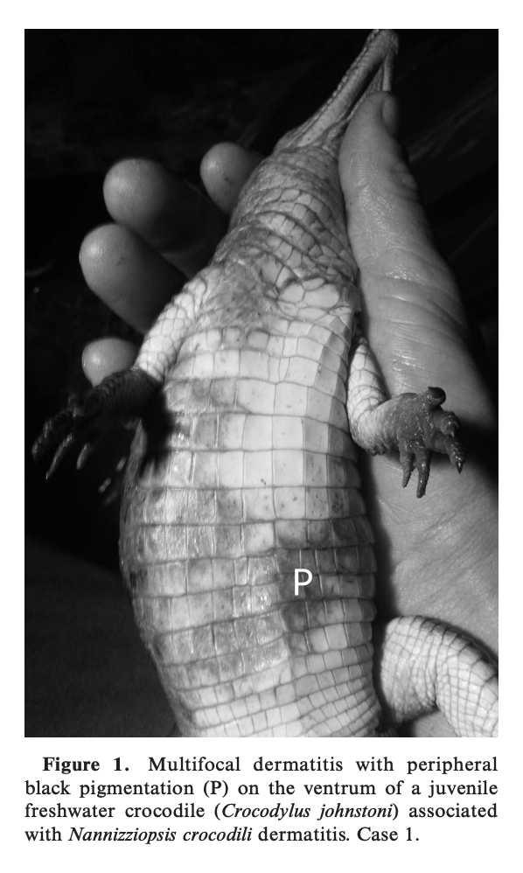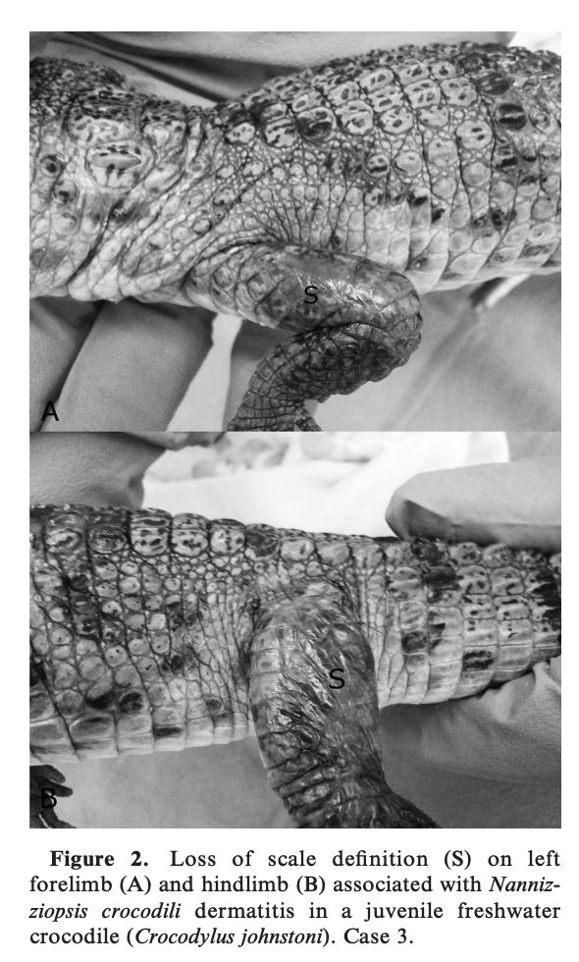
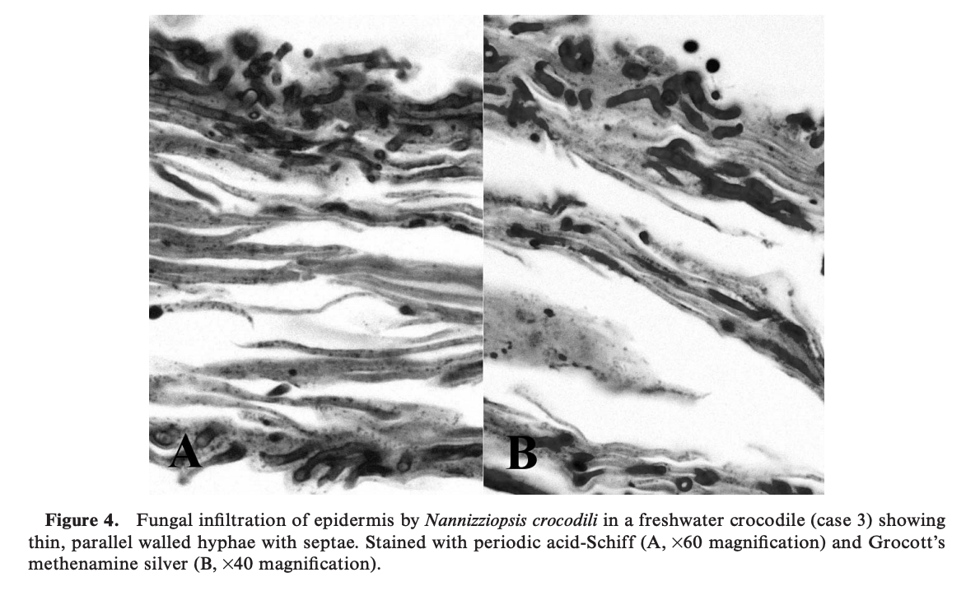

Successful Treatment of Nannizziopsis guarroi Infection Using Systemic Terbinafine in a Central Bearded Dragon (Pogona vitticeps)
Foltin ET, Keller KA
J Herp Med Surg 2022;32(1):20-25

Nannizziopsis guarroi infection in lizards presents therapeutic challenges, with reports of poor clinical outcomes, including antifungal toxicity, incomplete clearance of infection, and recrudescence of infection being common. The case presented here describes the successful treatment of an N. guarroi infection using systemic terbinafine and environmental disinfection in a captive-bred central bearded dragon (Pogona vitticeps). The lizard presented with darkly colored cutaneous lesions, and mycologic culture samples were identified as N. guarroi using matrix-assisted laser desorption/ionization–time of flight. Based upon the lack of clinical resolution of cutaneous lesions, weight loss, and reduced appetite, initial treatment with voriconazole was discontinued. Terbinafine was prescribed, and weekly environmental disinfection with sodium hypochlorite was initiated until cutaneous clearance of the fungus was confirmed by negative culture, histopathology, and N. guarroi quantitative polymerase chain reaction from cutaneous swab. Terbinafine treatment was discontinued after 80 days. There were no clinical signs of toxicity associated with the prolonged treatment, and the lizard has not developed any cutaneous lesions or illness in more than 2 yr of clinical follow-up. Although the ideal treatment of N. guarroi is still being investigated, this case demonstrates a promising and safe treatment option for an increasingly common and devastating disease.

Background
- Nannizziopsis guarroi: onygenalean fungi, causative agent of “yellow fungus disease”
  - Previously classified as Chrysosporium anamorph of N. vriessii (CANV)
  - Species reported: bearded dragon, green iguana, common agama
  - Despite colloquial name, lizards often exhibit darkly pigmented cutaneous lesions
  - Cutaneous crusting lesions progressing to muscle, bone, and multiorgan involvement
  - Grows readily on standard fungal media but colony and microscopic morphology is not specific so speciation with mass spec or PCR is recommended
- Current treatment recommendations: systemic voriconazole due to high incidence of mortality with itraconazole tx in bearded dragons
  - However many reports of recrudescence with voriconazole tx
- Terbinafine: allylamine antimycotic agent, acts through inhibition of ergosterol biosynthesis
  - Keratinophilic and is deposited into keratinized tissues
  - Unlike azoles, not reported to be associated with adverse effects
  - McEntire et al 2021 (J Vet Res) Single dose pharmacokinetics of orally administered terbinafine in bearded dragons (Pogona vitticeps) and the antifungal susceptibility patterns of N. guarroi
- Disinfection of the environment important part of therapy
  - In a recent study, N. guarroi isolates exhibited environmental persistence up to 14 days
  - Sodium hypochlorite (bleach) completely inhibited growth of all isolates
    - Rinse copiously and avoid inhalation of fumes
Case report
- 9 mo old female central bearded dragon with N. guarroi infection that started at 4 mo old
  - Lesions persisted despite PO compounded voriconazole
- Treated with compounded PO terbinafine (25 mg/kg q24hr), scrubbing of lesions, and enclosure deep cleaning once weekly with sodium hypochlorite (10-15 min contact time)
  - Systemic improvement in 4 weeks, cutaneous lesions resolved at 11 weeks
  - Stopped terbinafine and weekly enclosure cleaning 80d after initial presentation
  - No recurrence almost 2 years after stopping terbinafine
- No adverse effects and normal CBC/Chem throughout terbinafine tx in this beardie
Conclusions
- Successful treatment of N. guarroi using systemic terbinafine and environmental disinfection

TERBINAFINE PHARMACOKINETICS FOLLOWING SINGLE-DOSE ORAL ADMINISTRATION IN RED-EARED SLIDER TURTLES (TRACHEMYS SCRIPTA ELEGANS): A PILOT STUDY
Authors: Eshar, David, KuKanich, Butch, Avni-Magen, Nili, and Joo, Hyun
Abstract: In this pilot study, the pharmacokinetics of terbinafine were determined in six apparently healthy red-eared slider turtles (Trachemys scripta elegans) after a single PO administration. Terbinafine suspension (15 mg/kg, once) was administered via gavage tube to all turtles. Blood samples were collected immediately before (time 0) and at 1, 2, 4, 8, 24, and 48 h after drug administration. Plasma terbinafine concentrations were quantified by ultra-performance liquid chromatography–mass spectrometry, and noncompartmental pharmacokinetic analysis was performed. None of the animals showed any adverse responses following terbinafine administration. Mean area under the curve from time 0 to 24 h was 1,213 h 3 ng/ml (range 319–7,309), mean peak plasma concentration was 201.5 ng/ml (range 45.8–585.3), mean time to maximum plasma concentration was 1.26 h (range 1–4), mean residence time was 7.71 h (range 3.85–14.8), and mean terminal half-life was 5.35 h (range 2.67– 9.83). The administration of terbinafine (15 mg/kg, PO) may be appropriate for treatment of select fungal organisms with low minimum inhibitory concentrations in red-eared slider turtles but may require q12h administration even for organisms with low minimum inhibitory concentrations. Multiple-dose studies as well as clinical studies are needed to determine ideal dosages and efficacy.
Background:
- Systemic mycotic infections affect respiratory and GI systems- BUT also show as ulcerative skin or shell lesions in many aquatic chelonians
- In an aldabra tortoise terbinafine was administered topically and orally (3.3 mg/kg) along and with other treatments and successfully resolved Exophiala oligosperma phaeohyphomycosis carapace infection
Study
- 6 healthy adult female zoo kept red eared slider turtles
- Objective: determine the PK of terbinafine in red eared slider turtles after administration of a single dose of 15 mg/kg
- Kept in current location under direct supervision for up to a year prior to study starting
- PE, PCV/TS, and biochem was used to determine health; no drugs were administered in the year prior to study
- During the study animals were kept indoors in dechlorinated, clean water containers and fed usual diet; ambient temps 73-81F
- Turtles were administered this via intragastric gavage stainless steel feeding tube and flushed with 3 ml diluted Hills a/d
- Venous samples were collected from the subcarapacial venous plexus and placed in heparin coated blood collection tubes: immediately before time 0, 1 h, 2h, 4h, 8h, 24h, and 48j after drug administration- samples with obvious lymph dilution or hemolysis were discarded and a new sample was obtained
- Used Ultra-performance liquid chromatography and triple quadrupole mass spectrometry to evaluate
- The 12h plasma concentration was estimated using log linear regression between the 8 and 24h time points
Key Points
- There was variability in the Cmax - some animals may not achieve effective concentrations, (did these animals have parasites?)
- Terbinafine was cleared rapidly from the blood- the T1/2 of 5.35h (faster than the Hispaniolan parrot, dog, cat, and horse) BUT this T1/2 showed a wide variety (2.67-9.83h)
- Terbinafine can be an alternative systemic antifungal treatment for fungal infections that are highly susceptible (low MICs)

Ultraviolet Fluorescence as a Field-Applicable Screening Tool for Lesions Consistent with Ophidiomycosis in Lake Erie Watersnakes (Nerodia sipedon insularum)

Authors: Vivirito, Kathryn, Haynes, Ellen, Adamovicz, Laura, Wright, Allison, Durante, Kennymac, et al.

ABSTRACT: Ophidiomycosis, commonly called snake fungal disease, has been linked to signifi cant morbidity of free-ranging snakes in North America and Europe. Diagnosis of ophidiomycosis currently requires detection of skin lesions via physical exam or characteristic histopathology as well as detection of the causative agent, Ophidio myces ophidiicola, through quantitative (q)PCR or fungal culture of a skin swab or tissue sample. While reliable, these methods require specialized training, invasive procedures (e.g., biopsy), and several days or weeks to receive results. Additionally, screening entire populations can quickly become costly. A fast, easy-to-use, cost-efficient, and sensitive screening tool is needed to optimize conservation strategies and treatment intervention. Our objective was to investigate the association between skin fluorescence under long-wave ultraviolet (UV) light (365 nm) and the detection of Ophidiomyces ophidiicola DNA using qPCR. Fifty-eight Lake Erie watersnakes (Nerodia sipe don insularum) collected in June of 2018 and 2019 from islands in western Lake Erie, Ottawa County, Ohio, US were visually inspected for skin lesions, photographed under natural light and UV light, and swabbed for qPCR analysis. Fluorescence was highly associated with the presence of skin lesions, and the presence of at least one fluorescent skin lesion was 86% sensitive and 100% specific for identifying animals with apparent ophidiomycosis, with a positive predictive value of 100%. While we recommend performing standard diagnostics along with fluorescence, our study supports the use of visual UV fluorescence identification as a preliminary, affordable, noninvasive, and field-applicable method to screen populations for ophidiomycosis.

Background:
- Ophidiomyces infection typically causes skin swelling, crusts, and ulcerations- severe infections can invade deeper into muscle and bone and cause fatal systemic disease
- Diagnosis: detection of skin lesions (PE or histopath) and a positive quantitative PCR results or culture (from skin swab or tissue sample
- UV light can detect dermatophyte infection in domestics as well as white nose syndrome in bats

Study
- Objective: develop a protocol to detect skin UV fluorescence in Lake Erie water snakes and to determine if skin UV fluorescence is associated with lesion presence and detection of Ophidiomyces ophidiicola DNA by qPCR
- June 2018 and 2019- wild snakes were captured- total 58 snakes
- 15 had no lesions and 43 had at least one lesions consistent with ophidiomycosis
- Odds of a swab testing positive for qPCR was 15 times higher if a skin lesion was present and threefold higher if the skin fluoresced- Island, sex, lesion type and lesion location were not significantly associated with qPCR status or fluorescence
- Low fungal burdens are less likely to fluoresce under UV light
- Presence of any fluorescent lesion was 86% sensitive and 100% specific for IDing animals with apparent ohidiomycosis with a positive predictive value of 100% and a negative predictive value of 71%
- Study discussed that they did not perform histopath which would be the next step in validating UV fluorescence

Keypoint
- UV fluorescence is a preliminary, immediate, and affordable population screening tool for ophidiomycosis
- These lesions are commonly subtle and UV fluorescence can help to train observers who are unfamiliar with IDing lesions and to target diagnostics swabbing toward areas with skin disease- FALSE POSITIVES are possible because urates, loose unshed skin and All-Weathere Paint stik (livestock marker used to distinguish recently captured snakes) also fluoresced under UV light

