ARTICLE: Shell Lesions Associated With Emydomyces testavorans Infection in Freshwater Aquatic Turtles.

Which infectious disease should you be most suspicious of when you find these pathologic findings at necropsy of a freshwater turtle? What other histopathologic lesions may you expect to see?
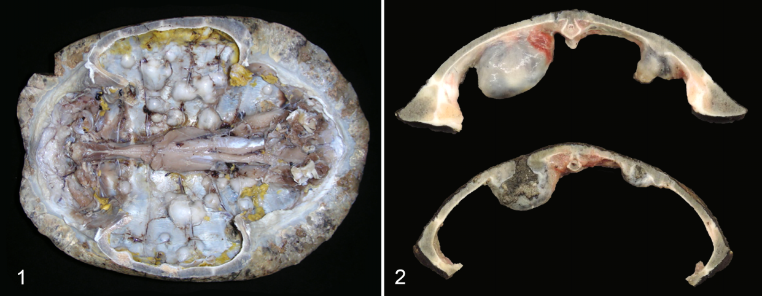
- Emydomyces testavorans
- Mycobacterium chelonae
- Fusarium incarnatum
- Aphanoascella galapagosensis
- Purpureocillium lilacinum

ANSWER: A - Figure 1. The internal surface of carapace with multiple coalescing firm and expansile nodules. Figure 2. Nodules are cystic, and filled with brown caseous to granular debris. Some lumens communicate with overlying scute ulcerations.

Other statistically significant lesions: squamous metaplasia, hyperkeratosis, osteonecrosis, inflammation

ARTICLE: Pharmacokinetics of Nebulized Terbinafine in Plasma and Keratin of Northwestern Pond Turtles ( Actinemys marmorata ) Associated with Emydomycosis

Which therapy has shown to reach therapeutic concentrations in the keratin and have potential for treatment of presumed Emydomycosis shell lesions in Northwestern pond turtles?

- Subcutaneous voriconazole
- Nebulized terbinafine
- Topical clotrimazole
- Oral itraconazole
- Intracelomic amphotericin B

Answer: B

Practice Question: Which of the following antifungals has been shown to successfully treat Nannizziopsis guarroi in bearded dragons (Pogona vitticeps)?

- Voriconazole
- Posaconazole
- Ketoconazole
- Fluconazole
- Terbinafine

Answer: E

Practice Question: Briefly discuss how to prevent an outbreak of Ophidiomyces ophiodiicola after bringing a gravid snake into a managed care environment.

Answer:
- Test wild snakes for O. ophiodiicola by using qPCR upon arrival
- Neonates born to wild gravid females in captivity should be immediately separated
  - Neonates should be tested regardless of the female's disease status
  - Monitor closely for clinical signs and re-test if changes occur
- If qPCR-positive status persists with absence of clinical signs, animal should be considered at risk for developing lesions or serving as a source
- Practice strict biosecurity (wear gloves, changes gloves, separate tools)

Practice Question: Briefly discuss possible causes for multiple periodic Ophidiomyces ophiodiicola infections in a herpetological collection that reuses enclosures

Answer: Multiple introduction events, a persistent environmental source, slow progression of subtle lesions that superficially resolve with ecdysis, or individuals may be asymptomatic carriers

MYCOTIC DERMATITIS IN JUVENILE FRESHWATER CROCODILES (CROCODYLUS JOHNSTONI) CAUSED BY NANNIZZIOPSIS CROCODILI.
Hill AG, Sandy JR, Begg A.
J Zoo Wildl Med. 2019;50(1):225-230.

What was the reported cause of death or reason for euthanasia in Nannizziopsis crocodili infected freshwater crocodiles treated with topical enilconazole?

- Visceral gout
- Deep cutaneous lesions
- Anaphylaxis
- Hepatic necrosis
- Recrudescence

Answer: A

Successful Treatment of Nannizziopsis guarroi Infection Using Systemic Terbinafine in a Central Bearded Dragon (Pogona vitticeps)
Foltin ET, Keller KA
JHMS 2022 32(1):20-25

A bearded dragon presents with multifocal crusted, darkly pigmented cutaneous lesions on multiple parts of the body. Name a common fungal etiology (genus and species) for this presentation in this species, your preferred diagnostic, your preferred treatment agent, and one possible adverse effect of two alternative agents.

Answer:
- Nannizziopsis guarroi (formerly Chrysosporium anamorph of Nannizziopsis vriessii)
- PCR of skin swab, biopsied skin lesion, or following fungal culture
- Systemic terbinafine (20-25 mg/kg PO SID x 2-3 months) + enclosure disinfection
- Voriconazole - recrudescence reported, hepatocellular necrosis in other taxa, 1 unexplained death in a voriconazole clinical trial of bearded dragons with N. guarroi
- Itraconazole - high incidence of mortalities in N. guarroi infected bearded dragons during a tx trial comparing itraconazole to voriconazole

- Terbinafine antifungals are a synthetic allylamine antifungal drug that inhibits fungal growth by interfering with ergosterol synthesis. Ergosterol is an essential component of what?
  - Mitochondrial Function
  - Golgi Complex
  - Smooth Endoplasmic Reticulum
  - Cell Membrane
  - Nuclear Envelope

Answer: D- cell membrane: it also has a fungicidal activity in inhibiting of squalene epoxidase which results in the intracellular accumulation of squalene which is toxic to the fungal cells.

- Which of the following is true in regards to using UV fluorescence to detect Ophidiomycosis in snakes?
  - UV fluorescence is found to be significantly associated with lesion type which correlated with qPCR testing
  - A released snake that was marked using Paintstik livestock markers will not interfere with UV fluorescence
  - False positives for UV fluorescence include urates, loose unshed skin, and previous full thickness wounds
  - A screening tool for identifying lesions to be swabbed for qPCR in wild snakes includes UV fluorescence
  - Presence of any fluorescent lesion was 50% sensitive but 100% specific for identifying ophidiomycosis

Answer: D- UV fluorescence was found to be a preliminary, immediate and affordable population screening tool especially since ophidiomycosis lesions can be subtle. UV fluorescence can help direct swab samples.

