JZWM 2021 51(4):958-969
Clinical And Pathologic Findings Of An Outbreak Of Vitamin D₃-Responsive Metabolic Bone Disease In Heron And Egret (Family Ardeidae) Chicks Fed Capelin (Mallotus villosus)
Horgan M, Duerr R, Murphy B

ABSTRACT: An increase in cases of metabolic bone disease (MBD) in chicks of six species of heron and egret (family Ardeidae) was identified at a wildlife rehabilitation center in the spring and summer of 2018. The outbreak affected 34.3% of birds in care for four or more days during the first 3 mo of the study and was the most common reason for euthanasia during that time. Cases were characterized by lameness, increased flexibility of multiple long bones, angular deformities, and bone fractures. Gross postmortem examinations were conducted on 145 nestlings and fledglings that died or were euthanatized either because of MBD or for unrelated conditions. Histology was performed in four cases and three controls. Histologic findings were characterized by multiple lesions in the appendicular long bones, including variable elongation of the physis, retention of cartilage cores in the metaphyseal primary spongiosa, poorly mineralized osteoid seams within the primary spongiosa, thinning or lack of diaphyseal cortical bone compaction, and folding fractures typically propagating through the physis-metaphyseal interface. Folding fractures were often associated with focal metaphyseal fibroplasia. The parathyroid gland diameter of birds diagnosed postmortem with MBD in care was significantly larger than that of unaffected birds. The authors hypothesized that a dietary deficiency of vitamin D₃ because of low levels in the bird's captive diet of capelin (Mallotus villosus) was the cause of the MBD. Starting in mid-July every chick's diet was supplemented with 714 IU oral vitamin D₃/kg body weight per day, after which the number of birds developing MBD declined to a rate of 4.3%. This study characterizes the clinical, gross, radiographic, and histologic features of vitamin D₃-responsive MBD in young herons and egrets and provides evidence to support the recommendation that captive birds on a diet of capelin be supplemented with vitamin D₃, especially during growth.

Background:
- MBD = family of disorders resulting from disturbances in Ca & P homeostasis
  - Variety of genetic, nutritional, toxic, or endocrine etiologies
  - In mammals, MBD divided into 4 subtypes:

    - Osteoporosis
    - Rickets
    - Osteomalacia
    - Fibrous osteodystrophy

  - However, MBD often presents with features of multiple concurrent subtypes
- PTH and vitamin D₃ (cholecalciferol) play key roles in Ca & P homeostasis
  - Low iCa -> increased PTH -> calcium resorption from bone, renal-mediated calcium resorption, & vitamin D₃ (cholecalciferol) activation in the kidney
  - Vitamin D₃ (cholecalciferol) required for absorption of Ca & P from GI tract, augments renal Ca reabsorption, and has a role in normal bone formation
  - Ingestion or skin absorption of vitamin D₃ -> hepatic metabolism by enzyme 25-hydroxylase -> renal metabolism by the enzyme 1α-hydroxylase -> biologically active form (calcitriol)
- Inadequate dietary Ca, P, or vitamin D₃ (w/ or w/out a low Ca:P ratio) can lead to MBD in birds
  - In mammals with renal insufficiency, renal secondary hyperparathyroidism -> MBD
    - Not reported in birds to date
Key Points:
- In spring/summer 2018, marked increase in heron/egret chicks w/ MBD at wildlife rehab center
  - In 2017, birds were raised on diet of night smelt; diet changed to capelin in 2018
    - Capelin is an inexpensive commercially available feeder fish vs. night smelt
  - Chicks supplemented with calcium carbonate due to capelin’s low Ca:P ratio (0.88)
    - Targeted Ca:P ratio of 1.5: 1, suggested levels to support growth of ardeids
  - Low vitamin D₃ in capelin -> hypovitaminosis D likely cause for increased MBD cases
    - Cases decreased after an oral vitamin D₃ supplement was added
- Multiple reports cite a low vitamin D₃ content in capelin relative to other fish
  - MBD & low serum vitamin D₃ reported in penguins fed capelin exclusively
- Bone pathology centered around the proximal 1/3 of long bones, especially the tarsometatarsus
  - Leg bones of heron and egret chicks can grow up to 3–5 mm/day
  - Rapid skeletal growth likely increases their susceptibility to developing bone deformities
  - In chickens, the proximal growth plates of the tibiotarsus and tarsometatarsus grow at twice or more the rates of the distal growth plates
- Bone fractures/deformities & increased metaphyseal radiolucency were evident radiographically
  - Fracture calluses not appreciated (not enough time vs. Ca to form)
  - Rib fractures were common in birds with MBD and controls
    - Species build nests in high trees
    - Rib fractures may be due to trauma of chicks falling onto hard surfaces
- Parathyroid glands enlarged in birds w/ MBD (i.e., nutritional secondary hyperparathyroidism)
- Disagreement was seen between angular deformities noted clinically vs. radiographically
  - Deformities noted clinically but not radiographically were likely a result of extending limbs for radiographic positioning
  - Deformities noted radiographically but not clinically were likely a result of infrequent whole-body palpations in a busy rehabilitation setting
  - Agreement between clinical vs. postmortem diagnosis of MBD was generally good
- Most birds didn’t exhibit pathology in other organ systems known to affect bone development
  - 4 cases in which the kidneys were grossly pale, visceral gout also present in 1 of the 4
  - Renal disease thought to be linked to NSAID therapy initiated after MBD developed

TLDR: Piscivorous captive birds fed a diet of primarily capelin be supplemented with vitamin D₃

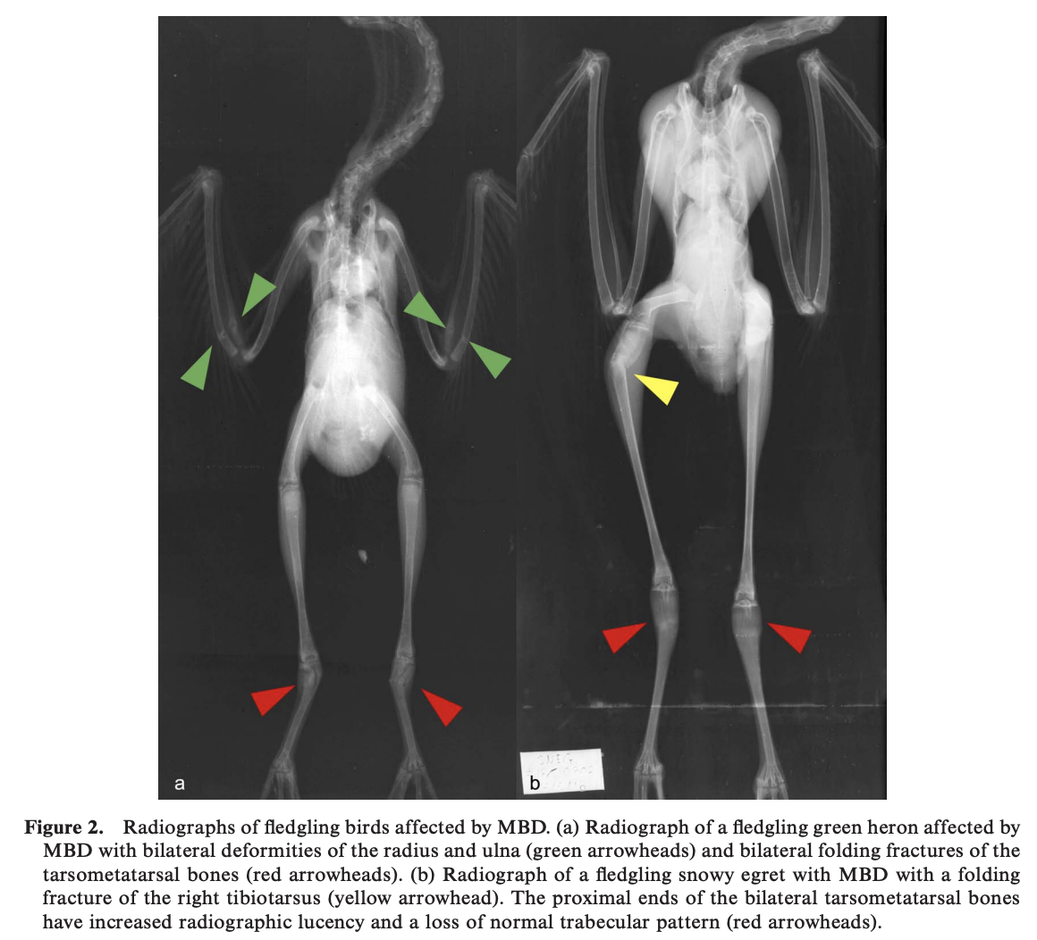
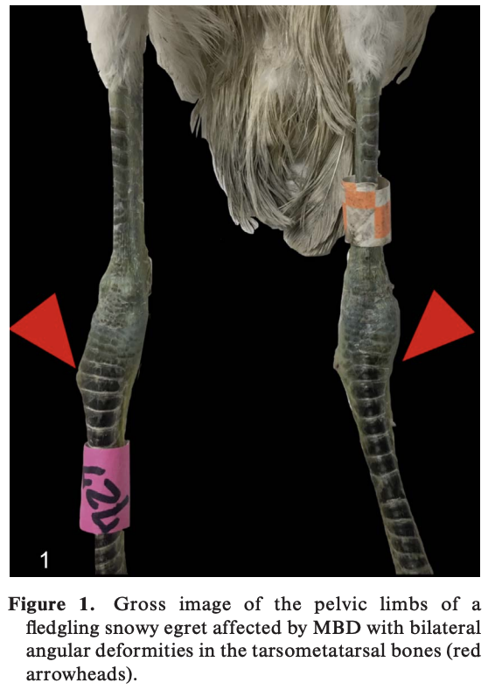
Useful Figures:

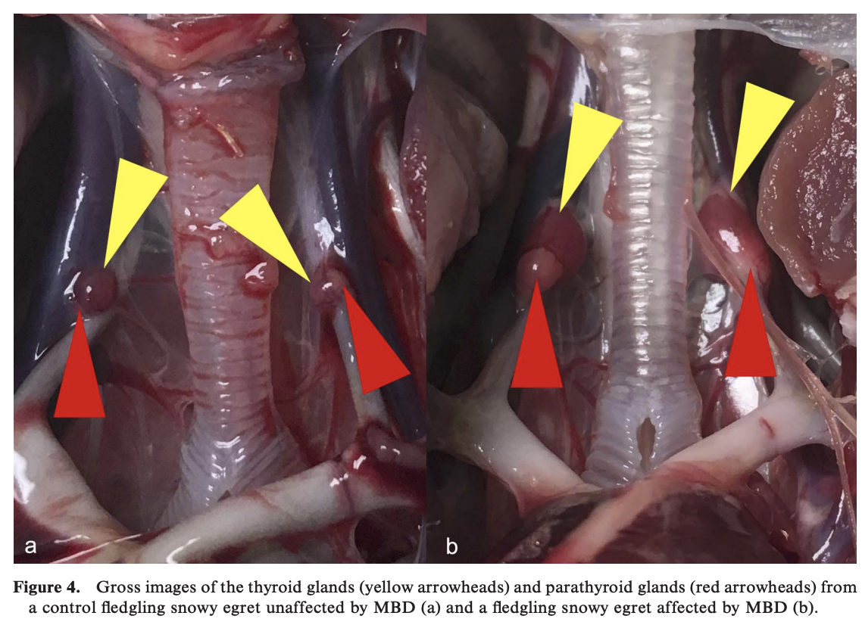
Related Articles: None on the current ACZM reading list

JAMS 2020 34(3):229-236
Immunogenicity of Newcastle Disease Vaccine in Southern Ground-hornbill (Bucorvus leadbeateri)
Koeppel KN, Kemp LV, Maartens LH, Thompson PN

ABSTRACT: The southern ground-hornbill (Bucorvus leadbeateri; hereafter SGH) is endangered in South Africa, Namibia, and Swaziland. Through a conservation program established in South Africa by the Mabula Ground Hornbill Project, wild populations are being re-established by the reintroduction of captive-reared birds. The SGH is susceptible to infection with avian avulavirus 1, which causes Newcastle disease (ND). Four different vaccines to protect against ND were administered through various vaccination schedules and evaluated by serologic monitoring to assess the efficiency and safety of various combinations of vaccines (live versus inactivated/killed), vaccine strains (Ulster strain, live; Avivac Cellimune, live; VG/GA strain, live; and Avivac Struvac, killed), and administration routes (intraocular versus subcutaneous versus intramuscular injection versus oral). We vaccinated 75 individuals and evaluated antibody titers in 53 individuals (24 juveniles, 13 subadults, and 16 adult SGH; 26 males and 27 females) over a period of 9 years. Antibody titers to avian avulavirus 1 in sera were monitored by a hemagglutination inhibition test. Protective titers were generated with 3/6 vaccine regimes tested in the SGH. The highest vaccine titers were established in birds vaccinated with the Ulster strain in the conjunctiva and followed with an intramuscular Struvac injection (mean log₂ titer 8.6 ± 2.6) booster. Our aim was 1) to assess whether optimal vaccination protocols could be developed and 2) to then be able, by oral administration, to remove the need to recapture free-roaming, reintroduced birds to administer the initial vaccine or booster, thus remove the threat or mortality associated with ND to this endangered avian species in both captive birds and birds released back into the wild.

Background:
- Endangered SGH exhibit obligate brood reduction
  - Normally second-hatched chicks die in the nest due to parental neglect
  - Primary conservation tool is reintroduction using harvested second-hatched chicks
- Newcastle disease is caused by multiple strains of avian avulavirus 1 (AAvV1)
  - Formally known as avian paramyxovirus type 1
  - Causes an acute, highly contagious, pneumoencephalitis
  - Widely distributed geographically & endemic in southern African wild bird populations
  - Strains categorized by virulence using a cerebral pathogenicity index
- ND vaccines are available in live, inactive, or attenuated commercial products
  - In poultry, live vaccine is usually administered first to increase mucosal immunity
    - This is usually then followed by an inactivated vaccine to boost titers
  - Hemagglutination inhibition is used to evaluate serological response to ND vaccines
Key Points:
- Prospective longitudinal study (n = 53 second-hatched wild SGH) with 4 locally available vaccines
  - Live Ulster strain administered OD/OS or PO
  - Live Avivac Cellimune strain administered IM
  - Live VG/GA strain administered PO
  - Killed Avivac Struvac administered SC or IM
- Compared 6 different initial vaccine schedules and 3 different booster vaccine types over 9 years
- None of the vaccine protocols showed any adverse side effects
- Recommend vaccination schedule for SGHs:
  - Live Ulster strain OD/OS followed by killed Avivac Struvac SC three weeks later
    - Provided titers considered protective against natural AAvV1 infection
  - However, birds required annual killed Avivac Struvac boosters to maintain titers
    - IM boosters were superior to SC boosters
- In practice, the oral vaccine provided in a food item is superior to injectable vaccine
  - However, oral vaccines alone did not provide adequate titers and required IM boosters
- Perform vaccination as early as possible in SGHs (ideally 3-4mo, but at least < 1yo)
  - Chicks shouldn’t be vaccinated until 3wo to prevent interference of maternal antibodies
  - Vaccinate prior to breeding season to ensure immunity at the time of highest risk
- ND vaccines previously investigated in endangered houbara bustard
  - Three ND vaccines (2 live, 1 killed) were tested and resulted in immunity for > 9 months
  - Killed vaccine w/ adjuvant produced highest titers after 2 SC doses 4 weeks apart

TLDR: Establishes Newcastle Disease vaccination protocol in endangered southern ground-hornbills

Related Articles:
Facon C, Guerin J-L, Lacroix F. Assessment of Newcastle disease vaccination of houbara bustard breeders (Chlamydotis undulata undulata). J Wildl Dis. 2005;41:768–774

ARTICLE: Bahnson, Charlie S., et al. "Experimental infections and serology indicate that American White Ibis (Eudociumus albus) are competent reservoirs for type A influenza virus." Journal of Wildlife Diseases 56.3 (2020): 530-537.

Abstract: The American White Ibis (Eudocimus albus) is a nomadic wading bird common to wetland habitats in the southeastern US. In south Florida, US, habitat depletion has driven many ibis to become highly urbanized. Although they forage in neighborhood parks, artificial wetlands, backyards, and golf courses, the majority continue to nest in natural wetlands, often in dense, mixed species colonies. Adults and juveniles commonly disperse thousands of kilometers to other breeding colonies along the Gulf and southeast Atlantic coasts, presenting the potential for close contact with humans, domestic animals, and other wild bird species. Historically, wading birds were not considered to be significant hosts for influenza A virus (IAV), yet as ibis regularly move among various human, domestic animal, and wildlife interfaces, their potential to be exposed to or infected with IAV deserves attention. We experimentally challenged wild-caught, captive-reared White Ibis (n=20) with IAV, tested wild White Ibis for IAV, and serologically tested wild White Ibis for antibodies to IAV. White Ibis were highly susceptible to experimental challenge with H6N1 and H11N9 IAVs, with cloacal shedding lasting an average of 6 d. All 13 infected birds seroconverted by 14 d postinfection as determined by microneutralization. In contrast, no birds challenged with H3N8 were infected. We tested 118 swabs and 578 serum samples from White Ibis captured in southeastern Florida for IAV infection and antibodies to IAV, respectively. Although no IAVs were isolated, 70.4% serum samples were antibody positive by blocking enzyme-linked immunosorbent assay (bELISA). Neutralizing antibodies to H1–H12 were detected in 96.0% of a subset of bELISA positive birds (n=196) and 81.0% tested antibody positive to two or more hemagglutinin subtypes, indicating that exposure to multiple IAVs is common. These results provide evidence that White Ibis are susceptible and naturally infected with IAV and may represent a component of the IAV natural reservoir system.

Goal of Study/Study Design: Determine if White Ibis are susceptible to avian influenza type A

Background:
- Anseriformes (waterfowl) and Charadriiformes (shorebirds) well recognized components of IAV reservoir system; historically Pelicaniformes (herons, egrets, ibis) have not been

Key Points:
- Experimental: wild-caught, captive reared ibis (n=20) inoculated with H3N8, H6N1, or H11N9
  - Result: Highly susceptible to H6N1 and H11N9, but none positive with H3N8
  - All infected birds seroconverted by 13 days and none developed clinical signs
  - Cloacal shedding (lasted ~6 days) lasted longer than oropharyngeal shedding
  - IAV was isolated from water samples that birds were exposed to
- Wild White Ibis: tested for Ag (n=118 cloacal swabs), and Ab (n=578 serum samples)
  - No Ag positive birds
  - 70% positive Ab by ELISA exposure to AI is common in White Ibis
    - Exposure to multiple subtypes is common (in subset, 81% positive for 2+ subtypes)
    - Highest Ab prevalence in Spring > Fall > Summer
    - Ab to H6, H12, H9, H5, H1 were most commonly detected
      - Different than ducks in northern latitudes with H3 and H4 most common
- TAKE AWAY: White Ibis can be experimentally infected with avian influenza type A and a high proportion have serologic evidence of previous natural infections/exposure suggesting this species may represent a natural reservoir for AI

Useful figures: Most common Ab prevalence in wild white ibis: H6, H12, H9, H5, H1
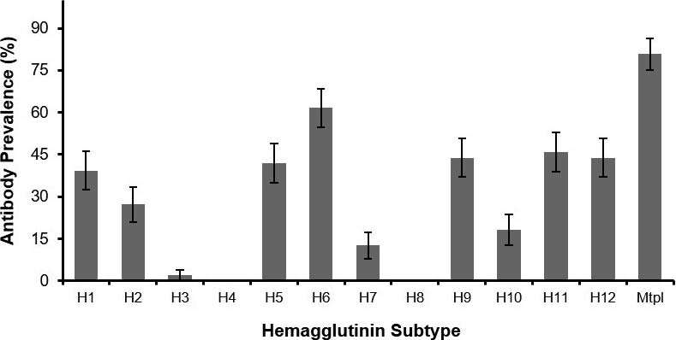

ARTICLE: Wonn, Amanda M., et al. "Hypocoagulability effect of adequan in domestic chickens (gallus gallus) and chilean flamingos (phoenicopterus chilensis)." Journal of Zoo and Wildlife Medicine 53.1 (2022): 126-132.

Abstract: Effective management of articular injuries in avian species is a known and frequent challenge.
Potential treatments include many domestic animal therapeutics, such as Adequan, which is used widely in dogs and horses. However, clinical reports have described hemorrhagic diatheses in a variety of avian species treated with varying doses and administration frequency of Adequan. This study investigated the hypocoagulability associated with parenteral administration of Adequan in avian species. Following a pilot dosing study in domestic chickens (Gallus gallus), citrated plasma from Chilean flamingos (Phoenicopterus chilensis) (n = 42) was spiked with Adequan to represent three dosing regimens (1 mg/kg, 5 mg/kg, 10 mg/kg). The fibrinogen content of plasma samples was determined and thrombin-clotting times (TCTs) were compared for the untreated (control) and spiked flamingo samples. The TCT for control and 1-mg/kg spiked plasma were not significantly different; however, both 5 mg/kg and 10 mg/kg spiked samples demonstrated significantly prolonged TCT (P-value, 0.0001) indicating hypocoagulability. These results support that Adequan given parenterally at 1 mg/kg can be utilized safely in clinical case management as an adjunctive treatment for osteoarthritis in flamingos and potentially other avian species.

Goal of study: Evaluate safety of Adequan in flamingos (chicken pilot study) due to previous reports associated with hemorrhagic diathesis in birds

Background:
- Adequan (Elanco) = parenteral polysulfated glycosaminoglycan labeled as adjunctive treatment for NI degenerative or traumatic synovial arthritis in domestic canines and equines
  - Active ingredient of glycosaminoglycan is chondroitin sulfate - protein naturally found within synovial fluid which improves lubrication and reduces cartilage-wearing injury
  - Formulation is injectable with weekly-monthly dosing
  - Reported hemorrhagic diathesis in birds suspected from heparinoid anticoagulant action
- Avian coagulation pathway: lack intrinsic factor XI and XII of mammals
  - Generate thrombin via tissue factor pathway (extrinsic), and intrinsic pathway amplified by thrombin-mediated feedback activation of factor IX and co-factor VIII
- ACT = activated clotting time = intrinsic pathway screening test in mammals
- TCT = thrombin clotting time = prolonged indicates fibrinogen deficiency/dysfunction or presence of coagulation inhibitors i.e heparin

Key Points:
- Chicken pilot (n=6): determined TCT more reliable than ACT; no birds developed clinical coagulopathy (abnormal bleeding, signs of excessive hemorrhage at injection/phlebotomy sites, transient ecchymosis)
- Chilean flamingos in vitro study (n=42): spiked plasma samples with different doses of Adequan
  - Evaluated fibrinogen and TCT pre-Adequan and post-Adequan administration
    - Fibrinogen can rule out pre-existing hypofibrinogenemia and risk for bleeding prior to Adequan administration
    - TCT can be used to monitor anticoagulant action of Adequan
    - Inverse relationship between plasma fibrinogen and clotting time in TCT
  - **Adequan 1 mg/kg is safe and not expected to cause hypocoagulation in flamingos
  - **Adequan 5 mg/kg and 10 mg/kg causes significantly prolonged thrombin-clotting times consistent with hypocoaguability

Useful figures:
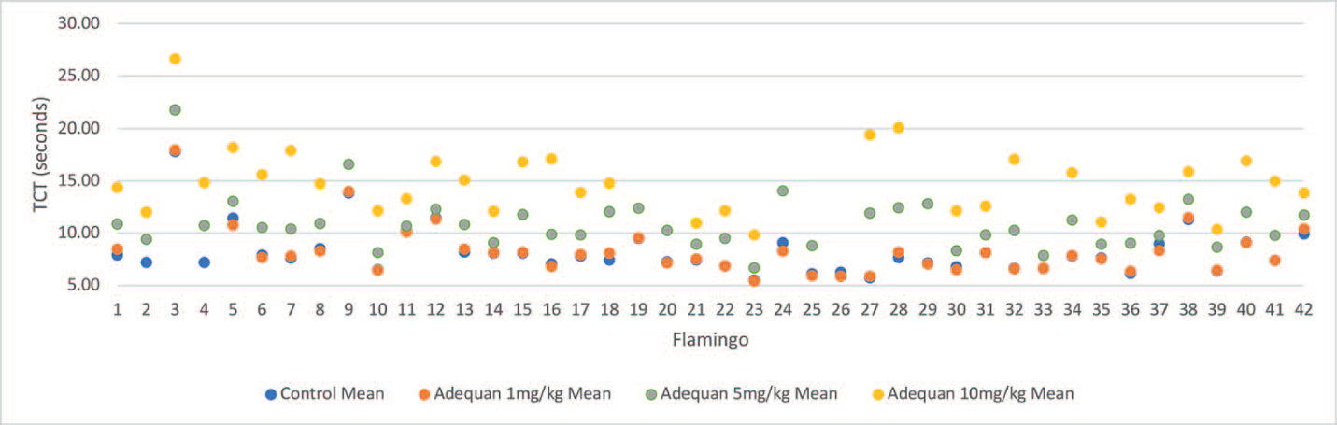
No significant difference in TCT between control and Adequan 1 mg/kg
Statistically significant prolonged TCT with Adequan 5 mg/kg and 10 mg/kg compared to control

COMPARISON OF CLINICAL CHEMISTRY ANALYTES IN GREATER FLAMINGOS (PHOENICOPTERUS ROSEUS) AND AMERICAN FLAMINGOS (PHOENICOPTERUS RUBER) IN A ZOO IN EUROPE
Authors: Leineweber, Christoph, Lücht, Maike, Reese, Lukas, Marschang, Rachel E., and Gohl, Christine
Abstract: Reference intervals for clinical chemistry analytes are important for the interpretation of blood results, but reference intervals available in journal articles for specific flamingo collections are often based on a small number of individuals or are only available for a limited number of analytes. Differences in husbandry and nutritional conditions may impact reference intervals. The goal of this study was to establish reference intervals from a mixed population of greater (Phoenicopterus roseus) and American (Phoenicopterus ruber) flamingos when husbandry parameters are equal and to compare the results between the different species, sexes, and age groups in order to evaluate differences between these factors. Lithium-heparinized plasma samples from 93 animals were analyzed for the following: amylase, cholinesterase (CHE), bile acids (BA), total protein (TP), glutamate dehydrogenase (GLDH), aspartate aminotransferase (AST), creatine kinase (CK), lactate dehydrogenase (LDH), uric acid (UA), inorganic phosphorus (P), total calcium (Ca), sodium (Na), and potassium (K). The results show many differences between the species and a few between the different age groups but no differences between males and females of either species. Amylase (P ¼ 0.0010), AST (P ¼ 0.0090), CK (P ¼0.0011), and Ca (P ¼ 0.0217) differed significantly between greater and American flamingos. The age group significantly impacted blood levels of CK (P ¼ 0.0299) and LDH (P ¼ 0.0165) in greater flamingos and BA (P ¼ 0.0495), P (P ¼ 0.0422), and Ca (P ¼ 0.0006) in American flamingos. The results show the importance of species-specific reference intervals and the consideration of age-related variations in order to facilitate correct interpretation of blood results.
Background:
- 161 Birds in a zoo in Southern Germany (61 greater flamingos and 52 American flamingos)
- All had identical housing and feeding; all were sexxed by genetic analysis of feathers
- Lithium-heparinized blood samples were collected from the right jugular vein- all lipemic or hemolyzed samples were discarded; if the species could not be accurately determined (20 flamingos) they were excluded
Results
- Between the two species- significant differences were noted in amylase, AST, CK and Ca
- No differences were found due to sex in either species (collected outside of breeding months)
- Greater and American flamingos in this study show significant difference for TP, UA, AST, LDH, CK, P, Na and K in comparison to reference intervals previously published
  - Compared to ZIMS- lower TP, AST, LDH and NA; Higher- P
    - American flamingos additionally had lower amylase and BA
    - Greater flamingos- lower UA and greater K
- BA, Ca and P differed significantly between the different age classes in american flamingos (suspect due to bone metabolism between younger and adults)
- CK and LDH differed significantly in greater flamingos in age (suspect younger ones were more active/excited)
- GLDH was measured (increased is indicator for liver cell damage in avians): low levels
- CHE (help determine intoxication due to organophosphours herbicides): showed a strong decrease in baseline level

\

NEOPLASIA IN CAPTIVE CRANES
Authors: Hawkins, Shawna, Garner, Michael M., and Hartup, Barry K.
Abstract: A retrospective study of neoplasia was conducted from necropsy and histologic reports of 446 cranes representing all 15 extant species. Cases were obtained from the International Crane Foundation (ICF), Northwest ZooPath (NWZP), and six other zoologic institutions in the United States during 1993 to 2019. Only reports from ICF (n ¼ 61) and NWZP (n ¼ 374) were used for estimates of disease prevalence. Overall prevalence of neoplasia was 7.35% (32 of 435), with a metastasis rate of 31.8%. Seventeen types of neoplasms were identified. Geriatric cranes were the most common age class affected (60%). The digestive system was most frequently involved (n ¼ 12; 27.3%), followed by urinary (n ¼ 8; 18.2%) and integumentary systems (n ¼ 6; 13.6%). Carcinoma was the most common tumor type across all species (n ¼ 15; 34.0%) followed by benign epithelial tumors (adenomas; n ¼ 11; 25.0%). Multiple neoplasms were observed in only one crane. Of the cases with metastasis, hematopoietic, reproductive, and respiratory tumors had 100% metastasis (2 of 2, 2 of 2, and 3 of 3, respectively), whereas tumors of the integumentary, nervous, and musculoskeletal systems had no evidence of metastasis (0 of 7, 0 of 3, and 0 of 1, respectively). Overall, Gruidae species were found to have a high prevalence of neoplasia but a low rate of metastasis compared with other avian species with the highest species-specific rates in Eurasian (Grus grus), demoiselle (Anthropoides virgo), and wattled cranes (Bugeranus carunculatus) (40.0%, 21.4%, and 19.0%, respectively). This is the first large-scale study of neoplasia in cranes.
Background:
- Retrospective study of neoplasia conducted from necropsy and histologic reports of 446 cranes representing all 15 species
- Complete necropsy performed with histopath of all major organs performed by NWZP to be included
- Assessed species, sex, age and neoplastic characteristics (type of cancer, involved organs, and metastasis
Results
- 44 cases were found in 43 individuals (one crane had two different neoplasms)
- Tumors IDed were 63.6% malignant but had a rate of metastasis of 31.8%
- Most affected organ systems (in decreasing order): digestive, urinary, integument, reproductive, endocrine, nervous, respiratory, hematopoietic and musculoskeletal
- Kidney was the only organ in the urinary tract were neoplasia was found
- Carcinoma was the most common tumor type, then benign epithelial tumors (adenomas).
- Adenocarcinoma was the most common carcinoma followed by hepatocellular carcinoma and then squamous cell carcinoma
- The most common location for adenoma was the kidney or the hepatobiliary system
- Eurasian crane had the highest prevalence of neoplasia by species, then the demoiselle crane, wattled crane, black crowned crane, siberian crane and whooing crane.
- Blue, sandhill and white naped cranes had 10% prevalence
- Grey crowned, sarus, red crowned, hooded and brolga species had no evidence
- Of the malignant neoplasia: reproductive, respiratory and hematopoietic cases had 100% metastasis BUT overall there was a lower rate of metastasis
Other Key Points:
- Neoplasia prevalence in cranes is relatively high compared with other avian species
- This study contrasted previous findings that avian neoplasia have identified lymphoma as the most common type of malignant neoplasia and lipoma as the most common benign neoplasm across multiple avian orders.
- This study found no discernible malignancy trends
- Recommend more frequent health screening for Eurasian, demoiselle, and wattled cranes
- NOTED: for NWZP only histo was performed on submitted tissues- and not every orange was sampled ( prevalence of neoplasia may be underestimated)
Paired biochemical analysis of pigmented plasma samples from zoo-kept american flamingos (phoenicopterus ruber) using a point-of-care and a standard wet chemistry analyzer.
Gancz, A.Y., Eshar, D. and Beaufrère, H.
Journal of Zoo and Wildlife Medicine, 2019;50(3):619-626.

American flamingos (Phoenicopterus ruber) are commonly kept in zoological collections, making health monitoring essential. Use of point-of-care (POC) blood analyzers that require small volumes of whole blood samples produces prompt results allowing for rapid clinical decision-making. To evaluate and compare blood biochemistry analysis results analyzed by a POC biochemistry analyzer (VetScan/Abaxis) and a laboratory wet biochemistry analyzer (Cobas), blood was collected from 17 apparently healthy zoo-kept American flamingos. Analyzer agreement was investigated using the Passing–Bablock regression analysis and Spearman correlation coefficients. Plasma samples from all birds were bright yellow in color. The results from the POC analyzer used in this study were found to be outside acceptance and clinical allowable error limits when compared with the laboratory analyzer for phosphorus (Phos), total protein (TP), albumin (Alb), glucose (Glu), creatine kinase (CK), and potassium (K). For aspartate aminotransferase (AST), results were within clinical allowable error but outside the acceptance limits, and for calcium (Ca) and sodium (Na), results were within both limits. The POC analyzer failed to measure the uric acid (UA) concentrations of all the samples, and reported all bile acids (BA) concentrations as below its minimal measurable limit. The use of analyzer-specific reference intervals is recommended for most analytes tested. The POC analyzer used in this study cannot be recommended for measuring UA concentrations in brightly colored samples from American flamingos.

Background
- Other species have variable agreements and significant proportional errors or bias between POC analyzers and reference values for several analytes
- Canthaxanthine in diet (fed for pink feather coloration) causes bright yellow coloration of flamingo plasma samples
  - May interfere with biochemical analysis that relies on colorimetric enzymatic reactions
Key points
- Objective: validate VetScan VS2 Analyzer (Abaxis) in American flamingo
- All plasma samples were bright yellow
  - All reported as icterus 2+ by VSARR
  - 13/17 were lipemia 1+ but no suppression by Vetscan which happens when it expects >10% effect of lipemia on results so likely didn’t affect results
- Unable to read UA in any sample
  - Vetscan reads Trinder reaction results at 515 nm and 600 nm
  - Cobas reads at 546 nm and 700 nm
  - Canthaxanthine peak light absorbance is at 470 nm up to 515 nm so could interfere with UA reading in Vetscan (also likely cause of icterus and lipemia readings)
- BA levels below measurable limit (<35 uM/L) in all samples
- Phos, TP, Alb, Glu, CK, K all outside acceptance limits and clinical allowable error limits
  - Higher K on Vetscan - different methodology (Vetscan is enzymatic, Cobas is ion selective electrode) or lag time of sample to Cobas (less than 4 hrs) allowing K to move into cells
  - Higher Alb on Vetscan - similar to Amazons and owls *bromocresol green dye-binding method is considered inaccurate in avian species anyway, protein electrophoresis is gold standard
- AST within clinical allowable error limits but outside acceptance limits
- Ca and Na within both acceptance and clinical allowable error limits
- Fewer analytes in acceptable agreement compared to Hispaniolan Amazon and owl studies
  - Including Ca and AST which were reported as good or close agreement in other studies
  - Other studies had Na as poor agreement (Spearman correlation was low in this study)
Conclusions
- Biochemistry values on VetScan and Cobas should not be directly compared due to variable disagreement in American flamingos
  - Phos, TP, Alb (VetScan higher), Glu, CK, K (VetScan higher) in disagreement
  - Ca and Na were in agreement
  - UA not read and bile acids read out as low
- Cannot recommend VetScan for analyzing plasma UA in American flamingos or potentially other species with pigmentation of the plasma.

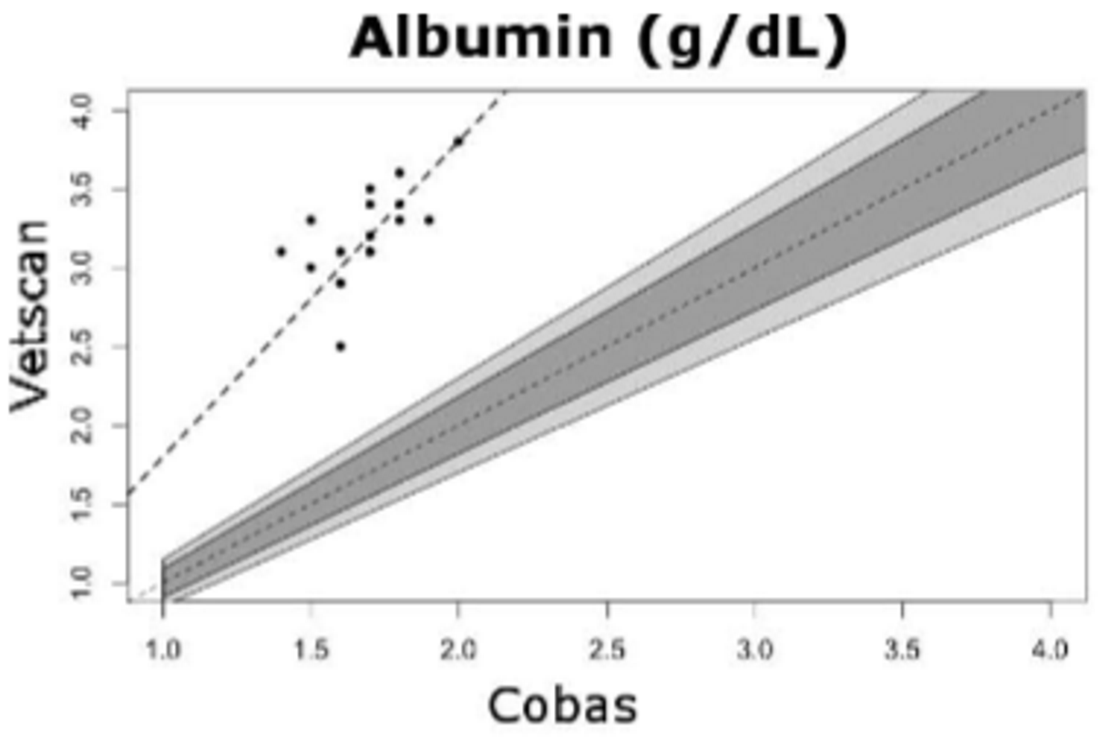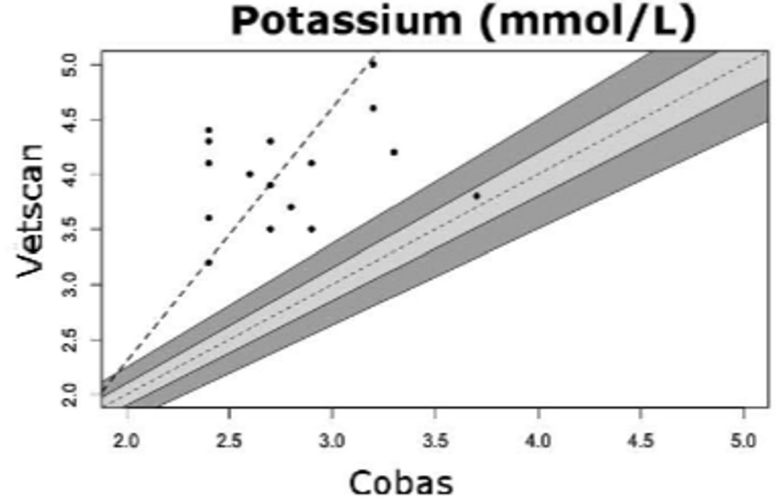

EVALUATION OF THE INTER-AND INTRAINDIVIDUAL AGREEMENT OF A PODODERMATITIS SCORING MODEL IN GREATER FLAMINGOS (PHOENICOPTERUS ROSEUS).
Webb, J.K., Keller, K.A., Welle, K. and Allender, M.C.
Journal of Zoo and Wildlife Medicine, 2020;51(2):379-384.

Pododermatitis is an important cause of morbidity and mortality in flamingos under human care; management and treatment options vary widely based on subjective assessment from veterinarians or animal care staff (ACS). The objective of this study was to evaluate the agreement of pododermatitis severity scores assigned by veterinarians, ACS, and veterinary students when given a standardized rubric. Twenty-four greater flamingos (Phoenicopterus roseus) from a single zoo-managed flock were evaluated over time for pododermatitis. The individual feet of each bird were imaged, blinded, randomized, and scored for hyperkeratosis, fissures, nodules, papillomatous growth, and overall subjective score by seven evaluators (three veterinary specialists, two ACS, and two veterinary students) using a previously established flamingo pododermatitis scoring rubric. Interindividual reliability between evaluators and intraindividual agreement among specialists was determined. Reliable interindividual agreement was seen for fissures (Krippendorff's α [KA] = 0.807) between all seven evaluators, whereas the other individual lesions had very low reliability. Between the specialists, fissures had low interindividual reliability (KA = 0.782). Two specialists had strong intraindividual agreement for fissure score and one specialist had strong intraindividual agreement for overall subjective score (Cohen's κ [CK] 0.8–0.9, P < 0.01). Hyperkeratosis, papillomatous growth, nodules, and overall subjective score had low to moderate inter- and intraindividual reliability or agreement (KA, 0.06–0.49; CK, 0.02–0.8). In conclusion, the current scoring method for flamingo pododermatitis does not supply a reliable method for tracking foot health based on images alone across timepoints, except for fissures. Further analysis of the scoring system being used during a physical examination is warranted.

Background
- Pododermatitis reported to affect 95-100% of zoo-managed flamingos
  - Factors: low dietary zinc, concrete floor housing, obesity, exposure to cooler temps, housing in northern latitudes, advanced age
  - Rubric - 4 categories: hyperkeratosis, fissures, nodules, papillomatous growths
Key Points
- Lack of intra- and interindividual agreement and reliability with the use of the current published pododermatitis score when evaluating photographs of feet
  - Even among specialists and when dividing the foot into 7 parts as described in that publication
  - Fissures: only category with reliable agreement and intraindividual agreement among specialists
- Possibly lack of negative control images (of healthy feet)
Conclusions
- The current flamingo pododermatitis scoring system is not recommended for tracking foot health via image-based evaluation except for fissures
  - Lack of intra- and interindividual agreement and reliability among evaluators
- Image keys for scoring system may improve the use of the current rubric

Perrin, Kathryn L., et al. "Investigation into cardiovascular assessment of captive adult scarlet ibis (Eudocimus ruber)." Journal of Zoo and Wildlife Medicine 50.1 (2019): 190-198.

Abstract: Cardiovascular lesions are commonly diagnosed postmortem in scarlet ibis (Eudocimus ruber), but antemortem diagnosis is rare. The aim of this study was to evaluate the cardiovascular health of a zoo population (n = 44) of apparently healthy, adult, scarlet ibis. A cross-sectional study design was employed whereby each animal was manually restrained for physical examination, phlebotomy, and echocardiographic examination performed with a 12-MHz transducer and a ventromedial approach, and observed intervals were calculated for 12 parameters. Seven individuals from the study population had high left-sided mid-ventricular velocities (2.59–5.89 m/sec) compared with values in other species. Follow-up examination suggested that these mid-ventricular obstructive lesions were dynamic and transient in nature rather than caused by fixed lesions within the outflow tract and may therefore be associated with stress. Conscious echocardiography proved to be feasible, although, unsurprisingly, the stress response in nonhabituated birds appeared to increase blood flow velocities. Handling protocols likely have a significant effect on echocardiographic parameters and should be taken into consideration when interpreting findings. Serum cholesterol concentrations were generally high (7.4–13.0 mmol/L), and further work is required to investigate the relationship between circulating cholesterol and the development of atherosclerosis in scarlet ibis. Serum cardiac troponin I concentrations were measured, and four animals were identified with suspected elevated levels, likely indicative of myocardial damage.
Background:
- Cardiovascular lesions are common in captive scarlet ibis - Endocarditis, myocarditis, myocardial degeneration and atherosclerosis
- Avian echo - Ventromedial approach via liver most commonly employed to avoid air sac interference
- Cardiac troponin I point of care test unreliable, immunoassay may be more useful in the early diagnosis of avian myocardial disease
- Atherosclerosis typically noted in the large blood vessels at the heart base
  - Antemortem diagnosis is difficult
  - Elevated circulating cholesterol associated with atherosclerosis in psittacines
Discussion:
- Highest left-sided velocity was located in the left ventricle, not in the aortic outflow tract in some individuals
- When rechecked 13mo later was normal. Presume that due to dynamic nature may be response to handling stress. Attempted to reduce stress in the recheck, which may explain findings
- Cholesterol higher in females than males as with other species
Take home: Handling likely to affect echocardiographic examinations. Should repeat echos before making definitive clinical decisions

Guthrie, Amanda L., et al. "Diagnosis and Treatment of Heavy Metal Toxicosis in Six Waldrapp Ibis (Geronticus eremita)." Journal of Avian Medicine and Surgery 34.4 (2020): 371-380.

Abstract: Six adult Waldrapp ibis (Geronticus eremita) were presented with heavy metal toxicosis secondary to paint chip ingestion after being placed in an indoor confinement enclosure because of a regional highly pathogenic avian influenza epornitic and government restrictions. Four of the ibis developed clinical disease signs between 45 and 64 days of confinement, including weakness, lethargy, inability to fly, low body condition, and bilateral wing droop while 2 birds appeared to remain normal during that period. Common clinicopathological findings included elevated plasma aspartate aminotransferase, creatine kinase, glutamate dehydrogenase, and bile acids values. Erythrocyte morphological changes included prominent hypochromasia, decreased size of polychromatophils with occasional cytoplasmic stippling, abnormal shapes, and D cells. Whole-body radiographic imaging revealed particulate radio-opaque material in the ventriculus of all affected birds. One bird died before chelation therapy could be instituted and heavy metal testing of the liver revealed increased concentrations of lead and zinc. Lead toxicosis was diagnosed in the 5 remaining birds by plasma lead analysis. These 5 birds were hospitalized for an average of 40 days and treated with sodium calcium edetate and fluid therapy, which resulted in resolution of the toxicosis. Plasma biochemistry, complete blood counts, and blood lead values were performed repeatedly on all 5 birds and were used to guide therapy and monitor treatment response. This case series emphasizes the importance of early contingency planning and reviews the treatment of lead toxicosis in birds with a focus on long-term clinical monitoring and hematology.

Case series
· 6 adult waldrapp ibis presented with heavy metal toxicosis
· Paint chip ingestion after being house indoors due to a regional high path AI outbreak
· Clinical signs in 4 of the birds—weakness, lethargy, low BCS, bilateral wing droop
· 2 birds unaffected clinically
· Hematology: inc AST, CK, GLDH and bile acids. Hypochromasia
o Changes in muscle enzymes occurred during treatment – thought to be due to repeated IM injections
· Rads showed particulate opaque material in the ventriculus of all birds
· Blood zinc and lead levels were both high
· One bird died prior to chelation, the other 5 were treated with fluids and CaEDTA for an average of 40 days
· Complete resolution of toxicosis
· Calcium levels remained stable in all birds during therapy
· No clinical signs of zinc toxicosis were observed despite elevated serum levels

Conclusions: Waldrapp ibises with lead toxicity were successfully treated with Ca EDTA injections.
