Plasma Biochemistry and Hematologic Values of Cold Stunned Loggerhead Sea Turtles (Caretta caretta)
Authors: McNally, Kerry L., and Innis, Charles J.
Abstract: Cold-stunned loggerhead sea turtles (Caretta caretta) strand annually in the northeastern United States and are admitted to rehabilitation facilities when rescued alive. Hematologic and plasma biochemical data were retrospectively evaluated from 133 cold-stunned loggerhead turtles that were admitted for rehabilitation between 2008 and 2016. Convalescent data were compared with initial data for 24 turtles for which paired data were available. Convalescent values for white blood cell count, heterophil count creatine kinase, lactate dehydrogenase, glucose, and uric acid were significantly lower than initial values, whereas convalescent eosinophil count, alanine aminotransferase, aspartate aminotransferase, albumin, gamma-glutamyl transferase, total protein, globulin, blood urea nitrogen, calcium, phosphorus, chloride, and potassium were significantly higher. Results indicate that cold-stunned loggerhead turtles may be affected by dehydration, reduced renal function, cellular injury, deranged metabolic status, and activation of the adrenocortical stress response. Specific derangements associated with mortality could not be statistically characterized because only four turtles died.

Background:
- Reviewed 194 records of loggerhead sea turtles that stranded between 2008-2016 and included 133 in the study
- Initial data: stranding date, carapace length, weight, environmental temp, success of rehab, gross necropsy with histo results
- Found for convalescent hematologic values:
  - WBC and absolute and relative heterophil counts were significantly lower than initial values
  - Absolute and relative eosinophil counts were higher
  - Absolute lymphocyte counts were not significantly different BUT relative lymphocyte counts were higher in convalescent turtles
  - There was no significant difference in HCT between convalescent and initial values
- Found for convalescent biochem values:
  - CK, LDH, glucose and uric acid were significantly lower than initials
  - ALT, AST, GGT, total protein, globulin, BUN, calcium, phosphorus, chloride, and potassium were all significantly higher than initials
- Four turtles died within 3 days: histo found: severe ulcerative gastritis, colitis, nephritis and cystitis, with intralesional bacteria; necrotizing pneumonia and intralesional fungal hyphae; as well as intravascular fibrin thrombi in the heart and liver (consistent with sepsis)
- On average the turtles had initial values that were within or only slightly outside of RI for healthy individuals
- The protocol of NEAq (New England Aquarium sea turtle rehabilitation program) were with-holding blood analysis until 3-4 days of hospitalization- so data was biased by clinical improvements that occurred during the first few initial days as well as excluded turtles that died within the first few days.
Conclusion:
- Overall prognosis for the turtles that survived past day 3 of hospitalization was excellent with common initial findings being hypoglycemia, hyperglycemia, stress leukogram, anemia, hemoconcentration, dehydration, decreased renal function, and generalized tissue injury

Ophthalmic lesions in a population of cold‐stunned sea turtles (Chelonia mydas, Lepidochelys kempii, Caretta caretta)
Melissa J. Lively¹ | Hans D. Westermeyer¹ | Craig A. Harms^{1,2} | Emily F. Christiansen^{1,3}

Abstract
Objective: To document ocular lesions present in cold‐stunned sea turtles and deter mine the impact of these lesions on their release.
Animals: All sea turtles (Caretta caretta, Chelonia mydas, and Lepidochelys kempii) presenting to rehabilitation centers in North Carolina over two cold stun seasons.
Procedures: Complete ophthalmic examination using slit‐lamp biomicroscopy, flu orescein stain, rebound tonometry, and occasionally binocular indirect funduscopy was performed within 1 week of presenting to the rehabilitation centers. A second examination was performed 2 weeks after the first examination in animals with ocu lar lesions and still present at the center.
Results: One hundred and sixty‐four turtles (121 Chelonia mydas, 26 Lepidochelys kempii, 17 Caretta caretta) were evaluated over two cold stun seasons (2016‐2017 and 2017‐2018). Ocular or periocular lesions were identified in 78 of 164 (47.5%) turtles examined with 37 of 164 (22.5%) having bilateral disease. The most common ocular lesion was superficial corneal ulceration, accounting for 21.3% of all lesions. Adnexal lesions were also common, while intraocular abnormalities were overall rare. Most resolved uneventfully. Though some blinding lesions were noted, these were not present bilaterally in any one turtle, and thus, ocular findings did not affect release.
Conclusion: Ocular lesions in cold‐stunned sea turtles are common. Some of these lesions are potentially blinding or require appropriate care, so evaluation of cold‐ stunned turtles should include a complete ophthalmic examination.
Take Home:
- Intraocular lesions were uncommon and often incidental with Dyscoria being the most common intraocular lesion (71.4%)
- Aqueous flare was not appreciated on any examination
- Nearly ALL corneal ulcers were located axillary or dorsal-temporally- which points to exposure as the cause of the ulcers
- Authors suspect that plaques are normal response to tissue damage in turtles
- Found marked difference intraocular pressures between systemically stable and markedly sick turtles
- Examination of cold-stunned sea turtles should include fluorescein staining since the most common ocular finding was corneal ulceration BUT they tend to be superficial and resolve with minimal treatment
- Pointed out: some ocular lesions (like adnexal abnormalities and penetrating corneal injuries) can be severe but they actually rarely result in non release and were not the cause of non release in any of the evaluated turtles
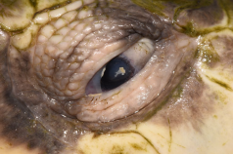
Plaque on the temporal paraxial cornea of the left eye of a green sea turtle (Chelonia mydas). Similar plaques are present on the leading edge of the third eyelid and on the nasal portion of the lower eyelid

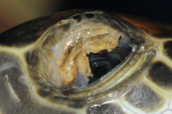Typical healing response of eyelid tissue in green sea turtles following damage to the upper and third eyelids. Once healed- eyelid tissue regains function and often appears normal

J Exp Mar Biol Ecol 2017 490:42-51
Relating cold tolerance to winterkill for spotted seatrout at its northern latitudinal limits
Ellis TA, Buckel JA, Hightower JE, Poland SJ

ABSTRACT: In the absence of winter thermal refugia, acute cold stress can lead to episodic mass mortality (winterkill) in fishes. Populations existing near the northern extent of a species' latitudinal range, such as spotted seatrout, Cynoscion nebulosus (Cuvier, 1830), in North Carolina, USA, are particularly vulnerable to winterkill. Information on cold tolerance for spotted seatrout is incomplete, which limits understanding of a likely important source of natural mortality for this species. In this study, two laboratory experiments for controlled exposure of spotted seatrout to dynamic decreases in water temperature were conducted in order to determine cold tolerance as affected by either rapid or prolonged exposure to low-temperature extremes across upper- (10) and lower-estuarine (30) salinities. Under rapid exposure, spotted seatrout were unable to maintain equilibrium at temperatures ≤ 4°C, with a small but measured mitigating effect of high salinity on the onset of observed physiological stress. No fish survived prolonged exposure (2 d) to 3 °C but spotted seatrout were tolerant of exposures to 5 °C for approximately 5 d, after which survival precipitously declined. Survival after 10-d exposure to 7 °C was high but not absolute. Salinity had no measured effect on mortality rates in the prolonged exposure trials. These empirical estimates of low-temperature thresholds, along with previously determined field estimates of instantaneous winter natural mortality rate (M), were used to develop models for predicting M. Historic daily water temperatures were used to estimate winter M of spotted seatrout from 1994 to 2015. Predictions of M suggest winterkill (≥ 50% population loss) in eight of the last 22 years; these years correspond to anecdotal and fishery-independent observations of winterkill events in North Carolina. The results of this study provide strong evidence for thermally-limited overwinter survival of spotted seatrout at its northern latitudinal limits, where winterkill events can have population-level impacts.

Background:
- Widely viewed that winter mortality in fishes is most severe at a species' northern boundary
  - Arctic cold fronts periodically expose fishes in relatively shallow temperate estuarine ecosystems to rapid temperature declines
  - In absence of thermal refugia, fish subject to acute cold stress often results in mortality
- Acute cold stress of spotted seatrout has been observed for at least three centuries in NC
  - Periodic declines in the state's abundance of spotted seatrout over the last two decades were suspected to be a result of winterkill
- When exposed to low temp, osmotic and ionic regulation in fishes is compromised
  - Thus, cold tolerance has the potential to vary across salinity gradients
Key Points:
- Two methods for exposing spotted seatrout to dynamic decreases in water temp were used:
  - 1) Stressful (but sublethal) low temps were determined across two overwinter salinities
  - 2) Acclimated chronic exposure was used to examine survival at prolonged exposure across the same two overwinter salinities
  - Low-temperature thresholds were then used to build predictive models estimating winter natural mortality rates
- In general, when exposed to water temp ≤ 5 °C at both artificial and natural rates of decline, spotted seatrout experienced thermal stress
  - When fish were allowed to reacclimate to declining temp and subjected to prolonged exposure, 100% mortality at 3 °C within 2 d and ~ 85% mortality at 5 °C within 10 d
  - Interestingly, there was ~93% survival at 5-d exposure to 5 °C and ~83% survival at 10-d exposure to 7 °C
  - Therefore, the lethal limit of cold tolerance for spotted seatrout is likely relative to the duration of exposure
- Reduced survival in the chronic 7 °C trials at low salinity relative to no mortality at high salinity suggests that salinity may have had an ancillary effect on prolonged exposure
- Fishery-independent data indicate declines in the relative abundance of spotted seatrout following the harsh-winter years corroborate the high winter mortality predictions generated

TLDR: Strong evidence for thermally limited overwinter survival of spotted seatrout at its northern latitudinal limits, where winterkill events can have population-level impacts

Related Articles: None on the current ACZM reading list

J Fish Biol 2022 100(5):1102–1137
An updated review of cold shock and cold stress in fish
Reid CH, Patrick PH, Rytwinski T, Taylor JJ, Willmore WG, Reesor B, Cooke SJ

ABSTRACT: Temperature is critical in regulating virtually all biological functions in fish. Low temperature stress (cold shock/stress) is an often-overlooked challenge that many fish face as a result of both natural events and anthropogenic activities. In this study, we present an updated review of the cold shock literature based on a comprehensive literature search, following an initial review on the subject by M.R. Donaldson and colleagues, published in a 2008 volume of this journal. We focus on how knowledge on cold shock and fish has evolved over the past decade, describing advances in the understanding of the generalized stress response in fish under cold stress, what metrics may be used to quantify cold stress and what knowledge gaps remain to be addressed in future research. We also describe the relevance of cold shock as it pertains to environmental managers, policymakers and industry professionals, including practical applications of cold shock. Although substantial progress has been made in addressing some of the knowledge gaps identified a decade ago, other topics (e.g., population-level effects and interactions between primary, secondary and tertiary stress responses) have received little or no attention despite their significance to fish biology and thermal stress. Approaches using combinations of primary, secondary and tertiary stress responses are crucial as a research priority to better understand the mechanisms underlying cold shock responses, from short-term physiological changes to individual- and population-level effects, thereby providing researchers with better means of quantifying cold shock in laboratory and field settings.

Key Points:
- Many experiments have quantified cortisol concentrations following cold shock/stress
  - Most report increases in cortisol and delayed recovery in cold-stressed fish
- Clinicopathologic changes following cold stress are highly variable across species, life-history stages, diurnal variations, and other environmental parameters
- There appear to be two general trends in cold-induced oxidative stress:
  - 1) Oxidative stress tends to increase in most cases of cold shock or stress
  - 2) Antioxidant defenses may be initially elevated if temp decreases are minor, but with great and/or rapid drops and lengthening exposure, antioxidant defenses are likely to be impaired while oxidative damage rate remains high
- The survival of fish under cold stress are dependent on both the severity and duration
  - Tolerance to acute temp change in general varies considerably across taxa
- Low temp stress may worsen various fish disease outbreaks, especially in aquaculture where large homogenous communities may be kept in suboptimal conditions
- Cold tends to delay or prolong growth and development, reduce swimming activity and performance, cause reflex impairment, and reduce or even cease food intake
Anthropogenic Cold Shock/Stress
- Release of cold water from bottom-release dams and reservoirs at hydroelectric facilities is of significant concern for fish species downstream of the release point
- Fish may experience cold shock when rapidly transferred from water to colder air or to colder water in storage facilities, during recreational and commercial fisheries
  - Non-target species or fishes outside of the desirable size ranges for commercial fishing vessels frequently undergo unnecessary handling
  - Some commercial fishing vessels practice live chilling (e.g., immersing caught fish in an ice slurry) and do not sort through individuals until they return to port
- Winter stress syndrome (“winter disease”) refers to the predictable lethal and sublethal consequences of seasonal cold stress
  - Particular relevance to aquaculture industries
- Low temperatures may be used to slaughter (or assist with the slaughter of) fish in aquaculture
  - Nonetheless, hypothermia is regarded as controversial as it does little to minimize the stress response or potentially adverse conscious experience of fish being euthanized
  - Time-to-euthanasia differences may be attributable to interspecific variation in thermal stress tolerance
  - Hypothermia may only be suitable as a means of preventing recovery following the administration of a more effective, humane euthanasia technique

TLDR: Cold shock/stress is a challenge many fish face due to natural events and anthropogenic activities

Related Articles: None on the current ACZM reading list

Esophageal measurement of core body temperature in the florida manatee (trichechus manatus latirostris).
Martony, M.E., Isaza, R., Erlacher-Reid, C.D., Peterson, J. and Stacy, N.I.
Journal of Wildlife Diseases, 2020;56(1):27-33.

Cold-stress syndrome (CSS) is one of the leading natural threats to free-ranging Florida manatees (Trichechus manatus latirostris). Cold water exposure below the species’ acceptable physiologic range is a frequent occurrence for manatees during cold weather months causing CSS induced systemic illness and significant annual mortality. Although CSS is a commonly presented condition at manatee rehabilitation facilities, the core body temperatures in CSS manatees are currently unknown due to the lack of clinically applicable and accurate temperature measurement methodologies. Our objective was to establish a clinically applicable measurement methodology of core body temperature in manatees. A novel, minimally invasive temperature technique to obtain esophageal temperature by placing a temperature sensor through an oro-gastric tube was compared to current oral and nasal methods in 20 clinically healthy manatees. Results identified the esophageal measurement as the best performing and most precise temperature methodology. The superior performance of esophageal temperature measurements differed significantly from both nasal and oral measurements, while nasal and oral measurements did not differ when compared with each other. The esophageal measurements were consistent with manatee core body temperature, facilitating generation of a reference interval for core body temperature in healthy manatees (35.0– 35.8 C). Four CSS medical cases were evaluated with the newly validated esophageal temperature method, facilitating diagnosis of hypothermia. The application of this temperature measurement technique to CSS manatees in field or rehabilitation settings will help in understanding CSS pathophysiology, improve medical assessments during rehabilitation, and contribute to conservation efforts.

Background
- Florida manatee - adapted to warm climates: high thermal conductance, low metabolic rate, limited ability to generate heat
- Cold stress syndrome when exposed to temps < 20C (68F)
  - 2010 mass mortality from water temps < 50F
- Chronic CSS: hallmark cutaneous lesions - pustular dermatitis, epidermal bleaching, hyperkeratosis; inflammatory disease; emaciation
- Acute CSS: possibly nonspecific + congestion, acute respiratory pathology
- Subadult and orphaned calves at higher risk - higher surface area to volume ratio an slack of maternal care
  - Immature life stages with smaller bodies unable to raise metabolic rate when exposed to cold water, presumed highly susceptible even with short exposures
- Stomach temp was strongly influenced by feeding, decreased almost 5C for up to 6 hr
Key Points
- The esophageal measurement was significantly different (higher) from oral and nasal
  - Also consistent with core body temperatures measured in research settings with more invasive techniques
- Oral and nasal were not significantly different from each other
  - Both consistently underrepresented core body temp, highly variable, negatively influenced by environmental temp
- The reference interval for core body temperature as measured by esophageal temperature for the healthy manatees was 35.0–35.8 C
- The esophageal temperatures of all 4 CSS manatees were below this reference range (31.8-33.8)
  - Single adult, large and in good BCS expands animal susceptibility (not just small, poor BCS)
- Well tolerated, rapid, readings stabilized within less than 2 min, mild-moderate restraint for tubing
  - No overt effect of environmental conditions (all out of the water, no control group)
Takeaway: Esophageal temperature measurements (probe through an orogastric tube) is an accurate and non-invasive way to measure core body temperature in Florida manatees
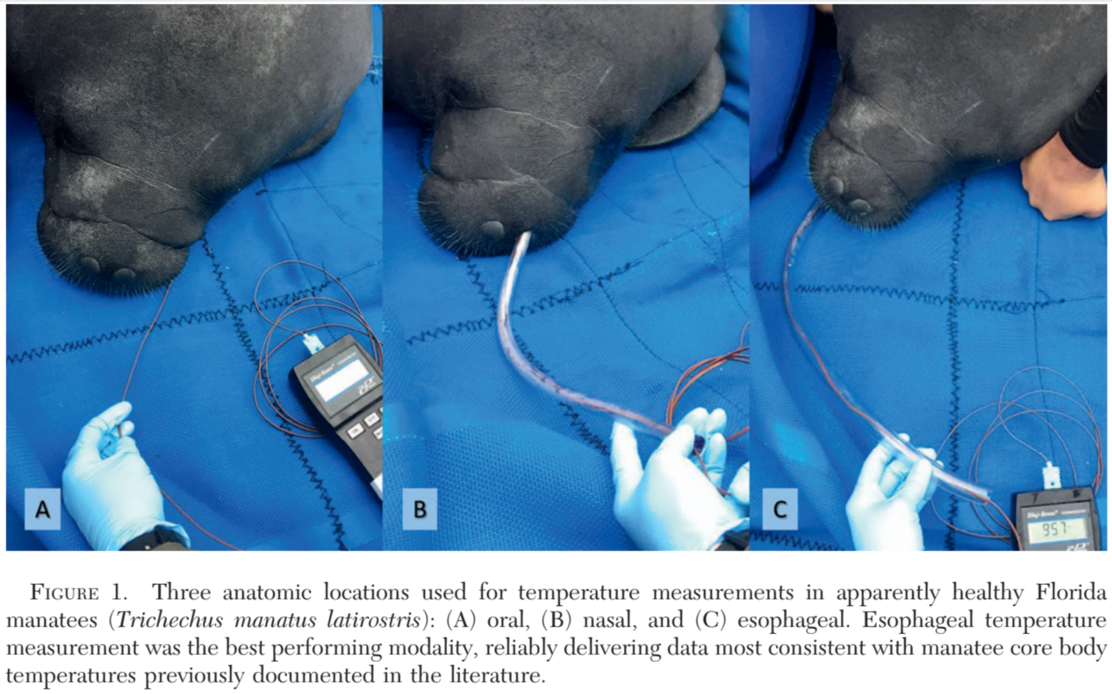
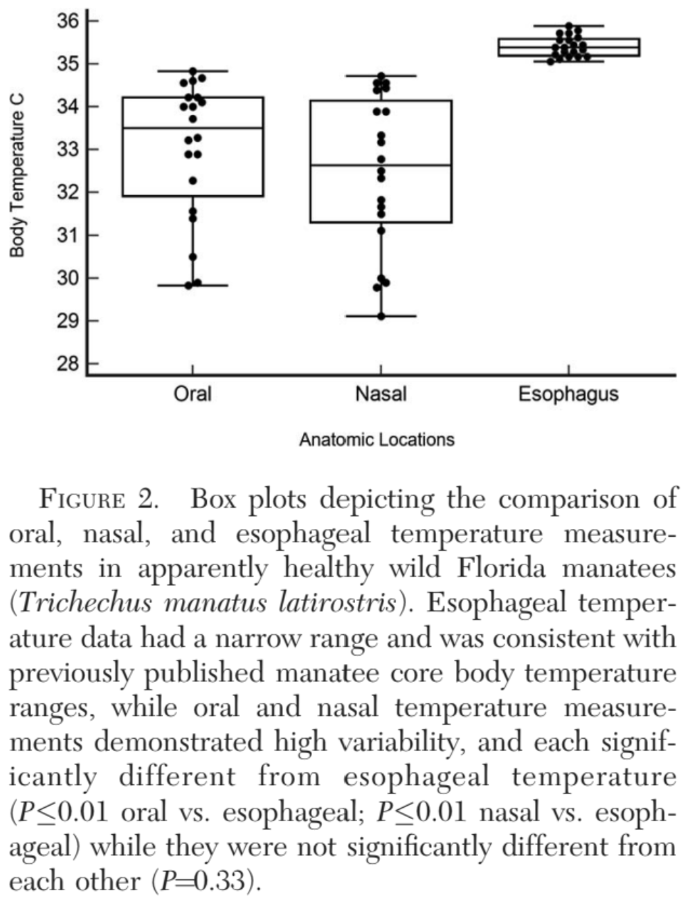

Clinicopathological prognostic indicators of survival and pathological findings in cold-stressed Florida manatees (Trichechus manatus latirostris).
Martony M, Hernandez JA, de Wit M, Leger JS, Erlacher-Reid C, Vandenberg J, Stacy NI.
Diseases of Aquatic Organisms. 2019;132(2):85-97.

Cold-stress syndrome (CSS) is a leading natural cause of mortality in free-ranging Florida manatees Trichechus manatus latirostris, but comprehensive investigations into blood analyte derangements and prognostic indicators in CSS are lacking. The objectives of this study were to (1) compare admission blood analyte data of manatees pre and post rehabilitation for CSS to identify clinicopathological derangements, (2) identify blood analyte prognostic indicators for survival, and (3) correlate post-mortem anatomic pathological changes with clinicopathological findings to improve the understanding of CS pathophysiology. CSS manatees admitted to a rehabilitation facility between 2007 and 2017 were included: 59 manatees with data for clinicopathological analysis (7 non-survivors and 49 survivors) and 14 manatees with necropsy data (7 with and 7 without blood analyte data). Main interpretive clinicopathological findings indicated systemic inflammation, bone marrow damage, diuresis, malnutrition, tissue necrosis, fat mobilization, hepatic impairment, acid–base imbalances, and gastrointestinal ulceration. The best diagnostically performing prognostic indicators for survival included platelet concentration, aspartate aminotransferase, calcium, and blood urea nitrogen. The main anatomic pathological findings were cutaneous lesions (n = 14), lipid depletion (n = 12), upper gastrointestinal ulceration and/or hemorrhage (n = 9), and pneumonia (n = 5). Based on the identified blood prognostic indicators interpreted in the context of anatomic pathological findings, multi-organ tissue injury, gastrointestinal ulceration and/or hemorrhage, and hemodynamic and platelet derangements are the presumptive major factors of CSS manatee mortality. These results contribute to the understanding of the complex CSS pathophysiology and offer the use of blood analyte prognostic indicators as a clinically applicable tool for the medical care of manatees during rehabilitation, thereby contributing to increased rehabilitation success and conservation of the Florida manatee.

Background
- Florida manatee: threatened in US, endangered IUCN
- Cold-intolerant species: high thermal conductance, low metabolic rate, limited ability to generate body heat
- Continuous exposure to water < 20°C → complex metabolic, nutritional, immunological cascade → cold-stress syndrome (CSS) (acute and chronic)
  - Opportunistic infection (enterocolitis, bronchopneumonia), derm lesions: epidermal bleaching, hyperkeratosis, pustular ulcerative dermatitis, weight loss/emaciation, lymphoid depletion, myocardial degeneration
  - Increased risk - thromboembolic disease, decreased immune function via reduced lymphocyte proliferation, systemic inflammation
- Marked serum amyloid A elevation >1200mg/L potential nonspecific prognostic indicator for species
Key points
- 20% mortality; no difference between survivors and nonsurvivors for length and weight
- BW findings at admission compared to pre-release:
  - High SAA, fibrinogen, ESR, glob
  - Low albumin, alb:glob, iron
  - High Hb, Hct, RBC, NRBC, nRBC, MPV MCHC
  - High WBC, het, bands, monos
  - High gluc, AST, GGT, LDH, CK, P, trig, chol
  - Low ALP, crea, Ca, Ca:P, Na, Cl, CO2
- Survivors: higher plt, TP, Ca and lower BUN, CK, AST than non-survivors
  - Prognostic indicators for survival: higher plt, Ca and lower AST, BUN
  - Cut-off values for predicting survival with CSS (96%)
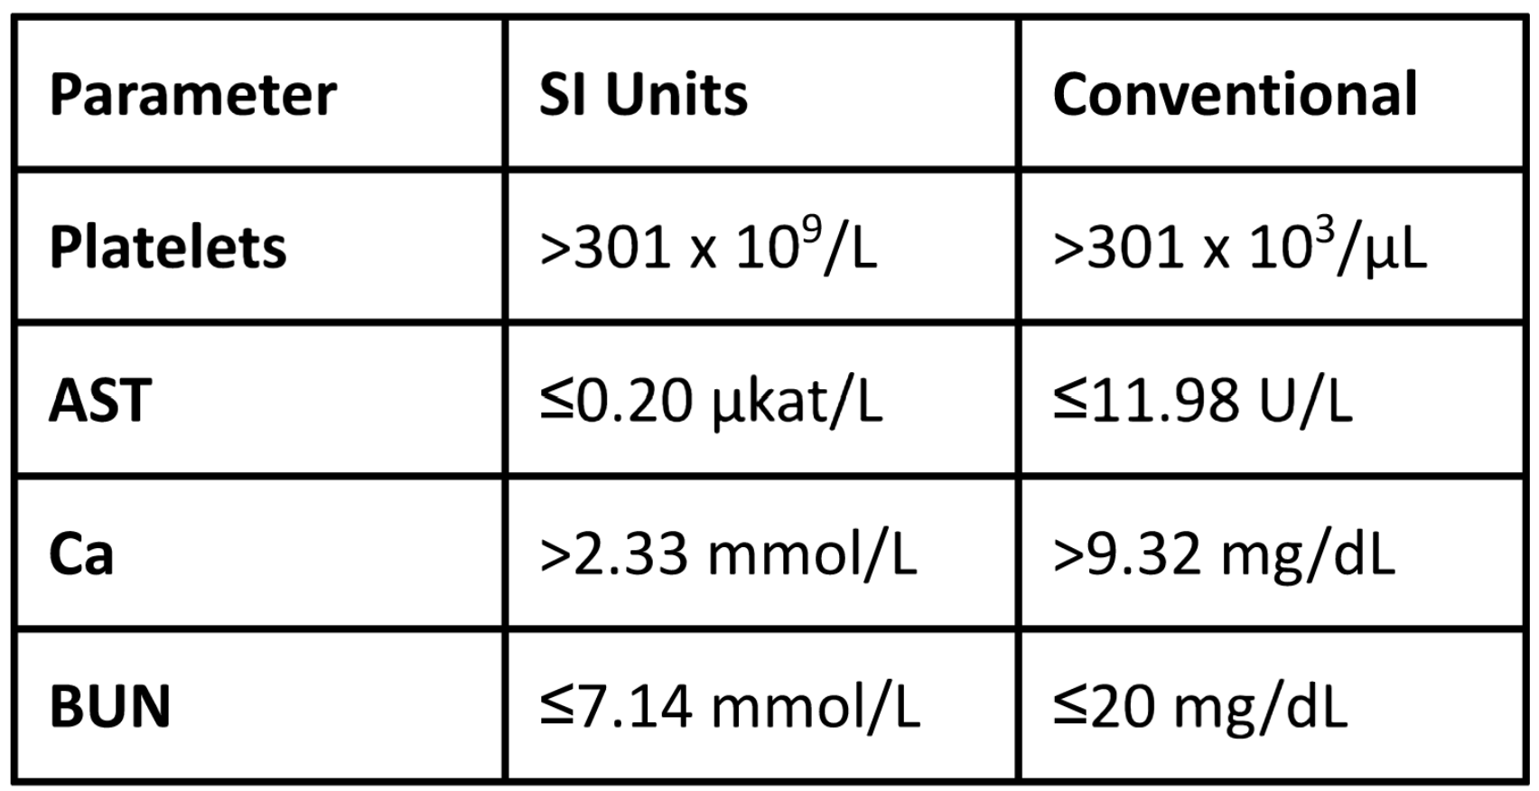
- Common path findings: cutaneous lesions (bleaching, ulceration), lipid depletion/starvation, pulmonary edema, GI hemorrhage of ucleration, skeletal muscle necrosis or abscessation, hepatic congestion
- Common histopath: cutaneous lesions (epidermal ulceration, hyperplasia, dermatitis), pancreatic zymogen depletion from starvation, intravascular thrombosis, GI hemorrhage or ulceration, pneumonia, cerebral meningeal edema
- Immunosuppression supported by lymphoid depletion in spleen and lymph nodes
  - Leukogram was not predictive of survival, inflammatory response is confounded by hypothermia, inflammatory markers may become evident during rewarming
- Plt predictor of survival, lower in non-survivors, majority were thrombocytopenic at admission
  - Hypothermia induced coagulopathies from direct inhibition of temperature-dependent enzymatic activity of extrinsic and intrinsic clotting cascade and from facilitation of platelet aggregation and thrombosis due to prostacyclin
  - Bone marrow damage may contribute to thrombocytopenia
  - Splenic sequestration in other species but limited by small spleen size in manatees
  - Intravascular thrombosis and hemorrhage found in skin and lungs
- Hemoconcentration mediated by plasma loss into extravascular space due to increased vascular permeability and cold-renal diuresis (humans) - assume anemia with normal Hct
  - Inappropriate rubricytosis (in the absence of anisocytosis and polychromasia) - rewarming may result in release of metarubricytes from reperfusion and endothelial damage
- Decreased albumin, increased globulin and alb:glob ratio consistent with inflammation
  - EPH high sensitivity and specificity for inflammatory disease in manatees
  - Albumin is reportedly over-estimated with bromocresol green due to inadvertent measurement of globulins
- SAA high at admission but not a prognostic indicator found in this study
  - SAA may be more useful in acute cases than chronic - where fibrinogen might be better
  - May increase and be more informative on rewarming
- Hyperglycemia seen but serum glucose not a predictor of survival
  - Hypothermia affects islets of Langerhans directly and decreases insulin secretion and tissue insulin sensitivity
  - Induction of sympathetic nervous system causes catecholamine-induced glycogenolysis and gluconeogenesis
- BUN predictor of survival, higher in non-survivors
  - Prerenal azotemia from cold-induced diuresis and hemoconcentration, and/or GI hemorrhage - 75% CSS had GI ulceration and high BUN
  - Wischnewski posts - punctate hemorrhages or ulcerations throughout GI tract, reliable indicator of reduced core body temp in humans
  - May benefit from presumptive treatment of GI ulceration
  - Crea - lower on admission likely from starvation/malnutrition, not a predictor of survival probably from confounding influence of hemoconcentration or renal insufficiency
  - Histopath changes in kidneys were not consistent from case to case (tubular vs glomerular)
- Ca predictor of survival, lower at admission - neuron necrosis and brain injury with rewarming due to electrolyte shifts into intracellular space associated with hypocalcemia in humans; renal or GI damage, cold diuresis (decreased renal tubular function)
  - Increased P seen with metabolic/respiratory acidosis due to decreased tissue perfusion, lactate generation, impaired hepatic metabolism and acid secretion, renal insufficiency, myositis/necrosis/abscess
- AST - predictor of survival, higher at intake likely from cellular damage especially muscle (skeletal and cardiac) - hypothermic hypoxia and lactic acidosis from reduced perfusion (vasoconstriction/thrombosis)
- Expect blood gas alterations - hypothermia causes reduced CO2 production, tachypnea, increase in pH and reduction in pO2
- Increased chol, trig at intake - likely from increased fat mobilization raising plasma lipids during starvation and emaciation
Conclusions
- Hypothermia-induced diuresis, fluid imbalance, bone marrow damage, negative energy balance, GI ulceration, tissue necrosis, hepatic impairment, and acid-base disturbance play significant roles in cold stress syndrome pathophysiology in the Florida manatee
- Prognostic indicators: survivors had lower BUN and AST, higher platelets and Ca than non-survivors
  - Multi-organ tissue injury, gastrointestinal ulceration and/or hemorrhage, hemodynamic and platelet derangements are the presumptive major factors involved in mortality of cold-stress syndrome manatees.

Innis, Charles J, et al. "Cold-stunned loggerhead sea turtles (Caretta caretta): initial vs. convalescent physiologic status and physiologic findings associated with death." Journal of Herpetological Medicine and Surgery 29.3-4 (2019): 105-112.
Abstract: This study evaluated the physiologic status of 155 loggerhead sea turtles (Caretta caretta) that stranded on Cape Cod, Massachusetts, between 2008 and 2016 after exposure to naturally cold temperatures. One hundred thirty-five turtles (87%) survived to be released into the wild, whereas 20 turtles (13%) died during the first week of hospitalization. Comparisons of the initial data for turtles that died vs. those that survived indicated that turtles that died had significantly higher blood glucose, potassium, lactate, and partial pressure of carbon dioxide as well as significantly lower pH, partial pressure of oxygen (pO₂), heart rate, and respiratory rate. Convalescent data for 80 turtles were acquired 10.5 days (median) after admission (interquartile range: 6–17 days; range: 5–66 days). Convalescent turtles had significantly higher body temperature, blood urea nitrogen (BUN), sodium, chloride, pH, pO₂, and ionized calcium (iCa), as well as significantly lower glucose, lactate, and bicarbonate. BUN, pH, and iCa were positively correlated with the number of days in the hospital, whereas glucose and lactate were negatively correlated. Results of this study indicate that the majority of cold-stunned loggerhead sea turtles had a favorable prognosis with medical management. More severely affected turtles showed a variety of physiologic derangements and had a worse prognosis.

- Introduction:
  - Goal of study – evaluation of initial and convalescent physiologic status of loggerhead sea turtles that survived cold-stunning as well as initial status of turtles that did not survive.
  - Hypothesized initial status of survivors would be significantly different than that of turtles that died and that convalescent data for survivors would demonstrate significant changes from their initial values.
- M+M:
  - Retrospective, loggerheads NEAq 2008-2016.
    - Data – body temp, weight, straight carapace length, HR, RR, BUN, iCa, iMg, Cl, Cr, Glu, K, lac, Na, pCO2, pO2, pH, bicarbonate.
  - For survivors, convalescent data defined as last available data acquired at least 5 days after admission to the hospital.
  - Turtles medically assessed, gradually warmed. Treated for physiologic derangements and pathologic conditions.
  - Surviving turtles introduced into rehabilitation pools, health status serially evaluated.
  - Majority transferred to secondary facilities for completion of rehabilitation before release.
- Results and Discussion:
  - 155 turtles met inclusion criteria.
  - 135 (87%) survived to be released.
  - Turtles that died – significantly higher glucose, K, lactate; significantly lower pH, pO2, HR, RR.
  - Convalescent turtles had significantly higher body temp, BUN, Na, Cl, pH, pO2, iCa; significantly lower Glu, lactate, bicarb.
  - BUN and iCa positively correlated with number of days in hospital.
  - Glucose and lactate negatively correlated with number of days in hospital.
  - Aside from relatively low BUN and hyperglycemia, average initial data for survivors consistent with previously published data for healthy conspecifics.
  - Prognosis for cold-stunned loggerheads good overall (87%).
  - Turtles that died showed more severe physiologic derangements.
    - Severe respiratory acidosis, hypoxia, hyperkalemia, hypermagnesemia.
    - More severe derangements than other studies in response to anesthesia, pound net capture, oil exposure, debilitation, general stranding, slightly less severe than trawl net capture and forced submergence.
  - Initial vs convalescent data showed improvement over time.
    - pH, pO2, BUN, most electrolytes, glucose, lactate changed over time and converged on values typical of healthy individuals.
    - Many convalescent turtles were still under medical management and may not yet have been eating.
    - Convalescent data may not be representative of final physiologic status prior to release.
  - Glucose highly variable, consistent with previous reports in Kemp’s and greens.
    - In this study, higher in turtles that died.
    - Cautious insulin therapy may be considered for loggerheads with persistent hyperglycemia.
      - Increased glucose has been correlated to increased corticosterone during transport of Kemp’s.
  - Low BUN on intake be due to anorexia, although clinical observations indicate BUN increased during convalescence before resumption of feeding.
    - Reduced hepatic function due to low body temperature or illness also possible.
  - Due to time period of this study, different analyzer used vs previous study.
    - Author suggests analyzer results can be considered valid regardless of whether or not they are in numerical agreement with another gold-standard analyzer if reflective of patient status clinically and outcome.

Barratclough, Ashley, et al. "Baseline plasma thromboelastography in Kemp's ridley (Lepidochelys kempii), green (Chelonia mydas) and loggerhead (Caretta caretta) sea turtles and its use to diagnose coagulopathies in cold-stunned Kemp's ridley and green sea turtles." Journal of Zoo and Wildlife Medicine 50.1 (2019): 62-68.

Cold-stunning in sea turtles is a frequent natural cause of mortality and is defined as a hypothermic state due to exposure to water temperatures <12°C. Derangements of biochemistry and hematology data by cold stunning have been well documented, although the effects on coagulation have not yet been investigated. The objectives of this study were to characterize the hemostatic state of non–cold-stunned sea turtles and to compare cold-stunned sea turtles at admission and after successful rehabilitation via a sea turtle–specific thromboelastography (TEG) protocol. TEG enables evaluation of the entire coagulation process, and the methodology has recently been established in sea turtles. Initially, 30 wild and apparently healthy sea turtles were sampled as controls: loggerhead sea turtles (Caretta caretta), n =17; Kemp's ridley sea turtles (Lepidochelys kempii), n = 8; and green turtles (Chelonia mydas), n = 5. In addition, paired TEG samples were performed on 32 Ch. mydas and 14 L. kempii at admission and prerelease after successful rehabilitation from cold stunning. Statistically significant differences in reaction time, kinetics, angle, and maximum amplitude parameters in L. kempii and Ch. mydas species demonstrated that the time taken for blood clot formation was prolonged and the strength of the clot formed was reduced by cold stunning. These findings indicate that cold stunning may cause disorders in hemostasis that can contribute to the severity of the condition. Early diagnosis of coagulopathies in the clinical assessment of a cold-stunned sea turtle may influence the treatment approach and clinical outcome of the case.
- Introduction:
  - Cold stunning – Hypothermia resulting in lethargic/moribund clinical state.
    - Exposure to cold water temps < 12 deg C.
  - Thromboelastography (TEG).
    - Clotting in reptiles – lack of intrinsic system and factors XI and XII.
    - TEG only coag test to provide global evaluation of the hemostatic process vs single pathway.
    - Four main parameters:
      - R – reaction time.
      - K – clot formation time.
      - Angle alpha – clot formation rate.
      - MA – maximum amplitude (clot strength).
- M+M:
  - Sampled wild/apparently healthy turtles; also paired samples before and after rehab for cold stunned turtles.
  - Developed TEG protocol from frozen sea turtle brain thromboplastin.
- Results/Discussion:
  - NSD between acute and chronic turtles. Both acute and chronic had similar results vs controls.
  - Clot strength (MA) reduced in cold stunned individuals.
  - Clot formation rate (alpha angle) significantly reduced in cold stunned individuals.
  - Greens – had significant differences in R and K, demonstrating time to initiate clot formation was also affected by cold stunning in this species.
  - Only coagulation factors and functional fibrinogen could be assessed because used plasma instead of whole blood (no effect from thrombocytes).
  - Improvement in TEG observed in initial cold stun presentation vs release.
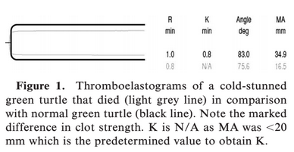

COLD STUNNING - SEA TURTLES
Sea Turtle Health and Rehabilitation. Chapter 26: Cold Stunning. Pp 675-687.

Key Points
- Cold-stunning = lethargic to moribund condition of sea turtles due to cold water (below 54F)
- Primary exposure to cold temps, secondary exposure due to underlying debilitating disease
- Acute vs. chronic presentation:
  - Acute: southern US during abnormally cold weather, <2 weeks duration, high # of turtles, shallow water, primarily green sea turtles, primarily class I-II, release rate 70-90%
  - Chronic: high latitude temperate zones, annually in late autumn, >2 weeks duration, primarily juvenile Kemps and greens, and subadult loggerheads, release rate 50-70%
- Initial PE findings: bradycardia, apnea/bradypnea, sand in mouth/pharynx, corneal damage, plastron bruising common in chronic CS, scavenge damage, primary cause of CS (FP, FB, trauma)
- Negative temporal prognostic parameters: persistent/exacerbation of acidosis, hypercarbia, hyperkalemia, hypernatremia, hyperphosphatemia, and hyperuricemia
- Therapy: gradual warming (5F per day until 78F), fluid therapy, treatment of bradycardia (atropine, epi) and apnea (doxapram, manual ventilation if needed), parenteral abx/antifungals for chronic cases, feeding after hydration, electrolytes, and body temp normalized
- Pathology: sepsis, osteomyelitis, GI stasis, pneumonia (bacterial/fungal), hemolytic syndrome/DIC
- Release: acute often released in 10 days with 90%, chronic release rate of 50-70%

Mader’s Reptile and Amphibian Medicine and Surgery, 3rd edition: Medical management of sea turtles - Management of hypothermic (cold-stunned) turtles. Pp 1387-1388.

Key Points:
- Acute cold-stunned turtles: rewarming, supportive care, released ASAP
- Chronic in higher latitude zones during late autumn/early winter
  - Acidosis, respiratory and cardiac failure, decreased renal function, pneumonia, sepsis
  - Increased core temperature to 55F over first 24 hours; then 5F per day until 78F
  - SQ fluid support, shallow freshwater/brackish water baths
  - Atropine or epinephrine if bradycardia, doxapram if apneic
  - Feeding initiated after hydration, electrolytes, body temp normalized
  - 50-80% success in rehab and release

COLD STRESS SYNDROME - MANATEES
CRC Handbook of Marine Mammal Medicine, 3rd ed: Sirenian Medicine - Cold Stress Syndrome. Pp 959-960

Key Points:
- Cold stress syndrome (CSS): disease process resulting from temps below 68F (20C) in manatees (and potentially dugongs); common cause of mortality in this species
- Subadults most commonly affected
- Acute: lethargy, fatal hypothermia
- Chronic: cascade of compromised metabolism and immune systems
  - Emaciation, depletion of fat stores/serous fat atrophy, lymphoid depletion, epidermal hyperplasia, pustular dermatitis, enterocolitis, myocardial degeneration
  - Leads to secondary opportunistic and idiopathic diseases: bacteremia/fungal infections, dehydration, hypoglycemia, renal failure, hypercoagulability and thromboembolic disease, GI stasis/constipation, necrotic enteritis, septic arthritis, sloughing of flippers
- Clinical signs: skin lesions, poor BCS
  - Early epidermal bleaching of extremities/muzzle → chronic hyperkeratosis, diffuse pustules, ulcerations
- Treatment: administration of water and food/gruel via stomach tube, acidosis, electrolyte abnormalities, secondary infections, mineral oil and/or enemas for constipation

Pathology of Wildlife and Zoo Animals. Chapter 24: Sirenia (cold stress syndrome). Pp 597-598.

Key Points:
- Lymphatic*: mod-severe lymphoid depletion particularly in LN, spleen, gut, respiratory mucosa
- GI*: heterophilic and histiocytic colitis or enterocolitis
- Integ acute*: vasculitis and vascular necrosis with fibrin thrombi
- Integ chronic*: marked epidermal hyperplasia; multifocal to locally extensive cutaneous ulcerations, pustules and/or abscesses
- Resp: chronic-active, suppurative bronchopneumonia in some
- Heart: myocardial degeneration characterized by wavy, attenuated myofibers with loss of cross striations, karyomegaly, and occasional fibrosis in some

