JZWM 2021 52(1):38-48
Classification and regression tree analysis for predicting prognosis in wildlife rehabilitation: a case study of leptospirosis in California sea lions (Zalophus californianus)
Whitmer ER, Borremans B, Duignan PJ, et al

ABSTRACT: The spirochete bacterium Leptospira interrogans serovar Pomona is enzootic to California sea lions (CSL; Zalophus californianus) and causes periodic epizootics. Leptospirosis in CSL is associated with a high fatality rate in rehabilitation. Evidence-based tools for estimating prognosis and guiding early euthanasia of animals with a low probability of survival are critical to reducing the severity and duration of animal suffering. Classification and regression tree (CART) analysis of clinical data was used to predict survival outcomes of CSL with leptospirosis in rehabilitation. Classification tree outputs are binary decision trees that can be readily interpreted and applied by a clinician. Models were trained using data from cases treated from 2017 to 2018 at The Marine Mammal Center in Sausalito, CA, and tested against data from cases treated from 2010 to 2012. Two separate classification tree analyses were performed, one including and one excluding data from euthanized animals. When data from natural deaths and euthanasias were included in model-building, the best classification tree predicted outcomes correctly for 84.7% of cases based on four variables: appetite over the first 3 days in care, and blood urea nitrogen (BUN), creatinine, and sodium at admission. When only natural deaths were included, the best model predicted outcomes correctly for 87.6% of cases based on BUN and creatinine at admission. This study illustrates that CART analysis can be successfully applied to wildlife in rehabilitation to establish evidence-based euthanasia criteria with the goal of minimizing animal suffering. In the context of a large epizootic that challenges the limits of a facility's capacity for care, the models can assist in maximizing allocation of resources to those animals with the highest predicted probability of survival. This technique may be a useful tool for other diseases seen in wildlife rehabilitation.

Key Points:
- Leptospira interrogans serovar Pomona is endemic to California sea lions (CSLs)
  - Causes large epizootics q 3-5yrs
  - Clinical signs: PU/PD, lethargy, anorexia, melena, abdominal pain
  - Clinical pathology:
    - Azotemia hyperphosphatemia, hypernatremia, +/- leukocytosis
  - Histopathology: leptospiral nephritis, pneumonia, GI ulcers
  - 71% mortality rate for CSLs in rehab
- California sea lions with leptospirosis had improved survival with:
  - Juvenile age (compared to adults, subadults, yearlings)
  - Voluntarily eating once within the first three days
  - Eating consistently after starting to eat voluntarily
  - BUN < 280 mg/dL
  - Sodium < 178 mmol/L
  - Creatinine < 3.5 mg/dL (or < 7.9 mg/dL, depending on model)
- No difference with sex
- Hypenatremia → seizures → euthanasia

TLDR: BUN, creatinine, sodium, age, and appetite can be used to predict survival in California sea lions with leptospirosis.

Related Articles: None on the current ACZM reading list

Journal of Wildlife Diseases, 57(4), 2021, pp. 808–819
ANTIBODIES AGAINST INFLUENZA VIRUS TYPES A AND B IN CANADIAN SEALS
Lena N. Measures and Ron A. M. Fouchier

ABSTRACT: Influenza viruses have been reported from marine mammals worldwide, particularly in pinnipeds, and have caused mass mortalities of seals in North America and Europe. Because influenza viruses in marine mammals can be zoonotic, our objective was to examine Canadian phocids for exposure to influenza A and B viruses in order to understand health risks to wild populations as well as to humans who consume or handle these animals. Blood was collected from 394 seals in eastern Canada from 1994 to 2005. Sera were screened for exposure to influenza viruses in three resident species of seals: harbour, Phoca vitulina (n=66); grey, Halichoerus grypus (n=82); ringed, Phoca hispida (n=2); and two migrant species: harp, Pagophilus groenlandica (n=206) and hooded, Cystophora cristata (n=38). Included were samples from captive grey (n=1) and harbour seals (n=8) at two aquaria. Sera were prescreened using indirect enzyme-linked immunosorbent assay (ELISA), and antibodies against influenza A virus were confirmed using a commercial competitive ELISA (IDEXX Europe B.V.). A subset of influenza A virus positive sera was used to determine common virus subtypes recognized by sera using reference strains. All positive sera in the indirect ELISA reacted with influenza A virus subtypes H3, H4, and H10 using a hemagglutination inhibition assay. Sera from harbour, grey, harp, and hooded seals had antibodies against influenza A and influenza B viruses (some cross-reactivity occurred). Overall, 33% (128/385) of wild seals were seropositive to influenza viruses, with the highest seroprevalence in harp (42%) followed by harbour (33%), grey (23%), and hooded (11%) seals. Antibodies were detected in both sexes and most age classes of wild seals. Two of eight captive harbour seals were seropositive to influenza B virus and four had cross-reactions to influenza A and B viruses. This study reports antibodies against influenza A and B viruses in four seal species from the same geographic area in eastern Canada

Study Design: Retrospective cross sectional serosurvey

Key Points:
- Mass mortalities of pinnipeds due to pneumonia associated with influenza virus infection
  - Epizootics, primarily involving harbour seals have been caused by Influenza A subtypes H3, H4, and H10 in the eastern US and northeastern Europe
  - Dense aggregations of seals, unusual environmental conditions, and secondary infections may play a role
- IAV infection in -> respiratory distress, nasal discharge, and swollen neck and thorax
  - Histopathology reveals diffuse hemorrhagic pneumonia with necrotizing bronchitis and bronchiolitis as well as hemorrhagic alveolitis and subcutaneous emphysema of the thorax and neck
- IAVs are widespread in Anseriformes and Charadriiformes, which are the natural reservoirs
  - Classified based on variable surface antigens, hemagglutinin and neuraminidase
  - IAVs reported in marine mammals are of avian origin
- Influenza B and C viruses are human influenza viruses with no known wildlife reservoir
  - Not observed in aquatic birds
  - Influenza B virus identified in harbour, gray, Caspian, and South American fur seals were circulating in adjacent human populations before identification in seals
- Influenza D viruses are found in livestock
- Generally good agreement between the three assays (indirect ELISA, commercial competitive ELISA, and HI assay)
- Seroprevalence varied annually in all four seropositive species of seals, particularly in harp seals
- No effect of age or sex with seroprevalence of influenza A virus except for harp seals
  - Seroprevalence was greater in adults than in juveniles or pups
  - Seroprevalence declined with increasing age among adults
  - It is unknown how long seals retain antibodies against influenza viruses and whether antibodies are protective against subsequent infection

TLDR:
- Canadian seals within the St. Lawrence ecosystem were exposed to influenza A and B viruses
- Seroprevalence of influenza A virus relatively high (harp > harbour seals > grey > hooded seals) and seronegative in ringed seals

Related Articles
- Bahnson CS, Poulson RL, Krauss S, Webster RG, Stallknecht DE. 2018. Neutralizing antibodies to type A influenza viruses in shorebirds at Delaware Bay, New Jersey, USA. J Wildl Dis 54:708–715
- Capuano AM, Miller M, Stallknecht DE, Moriarty M, Plancarte M, Dodd E, Batac F, Boyce WM. 2017. Serologic detection of subtype-specific antibodies to influenza A viruses in southern sea otters (Enhydra lutris nereis). J Wildl Dis 53:906–910
- Duignan PJ, van Bressem M-F, Corte´s-Hinojosa G, Kennedy-Stoskopf S. 2018. Viruses. In: CRC Handbook of marine mammal medicine, 3rd Ed., Gulland FMD, Dierauf LA, Whitman KL, editors. CRC Press, Boca Raton, Florida, pp. 331–365

Field, Cara L., et al. "Pharmacokinetics of subcutaneous alpha lipoic acid, a proposed therapeutic aid for domoic acid intoxication in california sea lions (zalophus californianus)." Journal of Zoo and Wildlife Medicine 52.3 (2021): 872-879.

Abstract: Domoic acid (DA) is a potent neurotoxin produced by certain marine algae that can cause neurologic and cardiac dysfunction by activating glutamate receptors. Glutamate receptor overexcitation results in continuous cellular activation, oxidative damage, and cell death. DA toxicosis causes disorientation and seizures, and antiseizure medications are the primary treatment. Alpha lipoic acid (ALA), a powerful antioxidant and glutathione precursor widely used in humans and dogs, can cross the blood-brain barrier to provide antioxidant availability to brain tissue. Hundreds of stranded California sea lions (CSL; Zalophus californianus) are diagnosed annually with DA toxicosis and thus are an appropriate animal in which to establish ALA dosing recommendations for treatment. The objective of this study was to determine the population pharmacokinetics of a single 10- or 20-mg/kg dose of ALA administered subcutaneously into the interscapular region to healthy rehabilitated CSL. Blood was collected at two time points between 15 min and 24 h after administration. Serum ALA concentrations were measured by liquid chromatography-mass spectrometry, and parameters were evaluated using a nonlinear mixed effects model. ALA was rapidly absorbed for each dose, peaking within 20 to 30 minutes, and t1/2 of 40 and 32 min (10 and 20 mg/kg, respectively), followed by an initial steep distribution phase and prolonged elimination phase. Peak concentration (CMAX) was 1,243 ng/ml (10-mg/ml dose) and 5,010 ng/ml (20-mg/ml dose). Serum from 13 CSLd with DA toxicosis treated with 10 mg/kg ALA for 1 to 9 d had measurable levels, and ALA was also measurable in cerebrospinal fluid from two treated CSLs. Therapeutic effects are noted with a CMAX of 4,000 to 5,000 ng/ml in humans; thus in CSLs, 20 mg/kg administered subcutaneously once daily may be sufficient to achieve a therapeutic level in this species. Determination of efficacy and optimal dosing interval and duration require additional investigation.

Key Points:
· Domoic acid (DA)
o Produced by marine diatoms (Pseudo-nitzchia) and bioaccumulates in the food chain
o CS in sea lions – disorientation, seizures, coma, nausea, vomiting, diarrhea
o Known to cause neurologic dysfunction, cardiotoxicity, and GI upset when ingested
o Binds to Kainite & alpha-amino-5-methyl-3-hydroxyisoxazolone-4-propionate (AMPA) subclasses of ionotropic glutamate receptors resulting in excitotoxic effects
§ Glutamate binding normally has a rapid desensitizing response, however DA results in slow or nondesensitizing overexcitation that leads to oxidative damage and cell death
o DA is rapidly excreted – most of the damage is done by the secondary excitotoxic effects
o Common pathologies include hippocampal atrophy, long-term cognitive impairment, and cardiomyopathy
· Alpha lipoic acid is a precursor of the antioxidant glutathione. It is both amphiphilic so it easy crosses the BBB.
· This study resulted in sufficient levels to be therapeutic in humans
· Future studies to be performed on its efficacy in treating the secondary excitotoxic effects of DA toxicity

Take Home: ALA given subcutaneously achieves levels that may be sufficient to reduce the secondary excitotoxic effects of DA in sea lions

Trumbull, Emily J., et al. "The use of ephedrine to treat anesthesia-associated hypotension in pinnipeds." Journal of Zoo and Wildlife Medicine 52.3 (2021): 1054-1060.

ABSTRACT: Hypotension is a common adverse effect of general anesthesia that has historically been difficult to measure in pinniped species due to technical challenges. A retrospective case review found seven pinniped cases that demonstrated anesthesia-associated hypotension diagnosed by direct blood pressure measurements during general anesthesia at The Marine Mammal Center (Sausalito, CA) between 2017 and 2019. Cases included five California sea lions (CSL: Zalophus californianus), one Hawaiian monk seal (HMS: Neomonachus schauinslandi), and one northern elephant seal (NES: Mirounga angustirostris). Patients were induced using injectable opioids, benzodiazepines, and anesthetics including propofol and alfaxalone. Excluding the HMS, all patients required supplemental isoflurane with a mask to achieve an anesthetic plane allowing for intubation. Each patient was maintained with inhalant isoflurane in oxygen for the duration of the anesthetic event. Each patient was concurrently administered continuous IV fluids and four patients received fluid boluses prior to administration of ephedrine. All hypotensive anesthetized patients were treated with IV ephedrine (0.05–0.2 mg/kg). The average initial systolic (SAP) and mean (MAP) arterial blood pressures for the CSL prior to ephedrine administration were 71 +/- 14 mmHg and 48 +/- 12 mmHg respectively. The average SAP and MAP for the CSL increased to 119 +/- 32 mmHg and 90 +/- 34 mmHg respectively within 5 m of ephedrine administration. The NES initial blood pressure measurement was 59/43 (50) (SAP/diastolic [MAP]) mmHg and increased to 80/51 (62) mmHg within 5 m. The initial HMS blood pressure was 79/68 (73) mmHg and increased to 99/78 (85) mmHg within 5 m following ephedrine administration. All patients recovered from anesthesia. These results support the efficacy of IV ephedrine for the treatment of anesthesia-associated hypotension in pinnipeds.

Study Design: Case series (n = 7): five California sea lions, one Hawaiian monk seal, and one northern elephant seal

Goal: Reviews the diagnosis and management of suspected anesthesia-associated hypotension in three pinniped species

Key Points:
- Noninvasive indirect blood pressure cannot be reliably measured due to technical challenges of using oscillometric cuffs on pinniped extremities
- The placement of arterial catheters in pinnipeds can be achieved in the median artery in otariids and the superficial plantar metatarsal artery in phocids using ultrasound guidance
- Currently there are no published reference data for baseline blood pressure of conscious pinnipeds
- Free-ranging CSLs undergoing rehabilitation have a higher reported perianesthetic mortality rate compared with other species
  - The exact cause of perianesthetic death in pinnipeds is not always identified, but we speculate that hypotension contributes to poor anesthetic outcomes
- Treatment options for anesthetic-induced hypotension includes reducing anesthetic depth; fluid therapy; blood products; and anticholinergic, vasopressor, and inotrope drugs
  - Anticholinergics such as atropine or glycopyrrolate can be used to decrease vagally mediated bradycardia, however in some species such as rabbits, the response is limited
    - The response of pinnipeds to anticholinergics also seems to be minimal and therefore is not utilized by the authors
  - In hypotensive human patients under general anesthesia, the use of inotropes in addition to fluids is associated with lower morbidity and mortality compared with fluid administration alone
  - Previously described treatment of hypotension in pinnipeds includes dobutamine (0.2–2.0 mcg/kg/m IV) and dobutamine combined with ephedrine (0.05 mg/ kg IV)
    - Dobutamine is a synthetic catecholamine that acts as a positive inotrope increasing forward cardiac flow by acting predominantly on beta-1 cardiac receptors
    - Ephedrine is a sympathomimetic amine that acts directly on alpha and beta cardiac receptors, as well as indirectly by decreasing the re-uptake of norepinephrine at the synaptic junction
      - These combined actions increase systemic vascular resistance and cardiac output, and therefore raise blood pressure
- Maintaining normothermia can be a challenge for debilitated pinniped patients under prolonged general anesthesia despite utilizing multiple modes of thermal support
  - Two patients had a prolonged recovery to which a low body temperature may have contributed
- Sternal recumbency appears to allow for greater lung excursion and improved peripheral perfusion and therefore was the preferred position for pinnipeds during these procedures
  - Pinnipeds commonly exhibit hypercapnia or apnea during general anesthesia, especially during longer procedures or during deep planes of anesthesia, and therefore are regularly mechanically ventilated
- Ephedrine is typically administered by bolus dosing due to its longer duration of action compared with other inotropes and vasopressors
  - The pinniped cases reviewed here suggest ephedrine can result in sustained normotension following a single bolus dose of 0.1-0.2 mg/kg IV
  - This dose range is similar to published effective doses in humans (0.05–0.1 mg/kg IV) as well as canine and equine patients (0.2 mg/kg IV)
  - The duration of effects were more similar to horses, which have demonstrated normotension for 90 m post infusion, unlike canine and human patients where effects generally only last for a few minutes
- Both phocid patients in this case series required multiple doses of ephedrine, though it is unknown if this was necessarily due to the lower doses they received (0.05–0.07 mg/kg IV), differing vascular access points, or other species variation
  - Tachyphylaxis, or a diminished response due to depleted synaptic norepinephrine, can occur with patients with low catecholamine stores or in patients receiving multiple doses of ephedrine
  - Tachyphylaxis was not considered to have occurred in the current small sample of pinniped cases due to each dose administered resulting in increased blood pressure

Takehome
- Hypotension was documented in a single otariid species and two phocid species
  - Hypotension occurred despite differing anesthetic protocols and across varying age ranges
- The use of ephedrine in this limited group of pinniped patients demonstrates its potential as a single agent to treat anesthetic-associated hypotension
  - The effective single dose of ephedrine among the seven treated patients presented here was 0.1–0.2 mg/kg IV

Related Articles
- Haulena M, Schmitt T. Anesthesia. In: Gulland FMD, Dierauf LA, Whitman KL (eds.). CRC hand- book of marine mammal medicine. 3rd ed. Boca Raton (FL): CRC Press; 2018. p. 567–606

Cardiac examinations of anesthetized Steller sea lions (Eumetopias jubatus), northern fur seals (Callorhinus ursinus), and a walrus (Odobenus rosmarus).
Storlund RL, Rosen DA, Margiocco M, Haulena M, Trites AW.
Journal of Zoo and Wildlife Medicine. 2021;52(2):507-519.

Pinniped hearts have been well described via dissection, but in vivo measurements of cardiac structure, function, and electrophysiology are lacking. Electrocardiograms (ECGs) were recorded under anesthesia from eight Steller sea lions (Eumetopias jubatus), five northern fur seals (Callorhinus ursinus), and one walrus (Odobenus rosmarus) to investigate cardiac electrophysiology in pinnipeds. In addition, echocardiograms were performed on all eight anesthetized Steller sea lions to evaluate in vivo cardiac structure and function. Measured and calculated ECG parameters included P-wave, PQ, QRS, and QT interval durations, P-, R-, and T-wave amplitudes, P- and T-wave polarities, and the mean electrical axis (MEA). Measured and calculated echocardiographic parameters included left ventricular internal diameter, interventricular septum thickness, and left ventricular posterior wall thickness in systole and diastole (using M-mode), left atrium and aortic root dimensions (using 2D), and maximum aortic and pulmonary flow velocities (using pulsed-wave spectral Doppler). ECG measurements were similar to those reported for other pinniped species, but there was considerable variation in the MEAs of Steller sea lions and northern fur seals. Echocardiographic measurements were similar to those reported for southern sea lions (Otaria flavenscens), including five out of eight Steller sea lions having a left atrial to aortic root ratio <1, which may indicate that they have an enlarged aortic root compared to awake terrestrial mammals. Isoflurane anesthesia likely affected some of the measurements as evidenced by the reduced fractional shortening found in Steller sea lions compared to awake terrestrial mammals. The values reported are useful reference points for assessing cardiac health in pinnipeds under human care.

Background
- Pinniped hearts have dorsoventral compression, tendency towards a bifid apex, enlarged ascending aortas (aortic bulbs) compare to terrestrial mammals
Key Points:
- All animals under isoflurane (Stellers +/- diazepam, Northern FS) or sevoflurane (walrus)
- Sternal recumbency for 6-lead ECG, clips in axilla or webbing of caudal foreflipper; and in webbing of caudal hind flipper; walrus used clips attached to subcutaneous needles
- All species displayed typical PQRST; sinus arrythmia in 5/8 Stellers, not NFS or walrus
- Highly variable mean electrical axis (MEA) (right cranial, left cranial, left caudal orientations)
  - Other species of pinnipeds tend to have left cranial MEA orientations
  - Mean HR was near expected range based on body mass (general mammalian model)
  - Mean electrical axis: 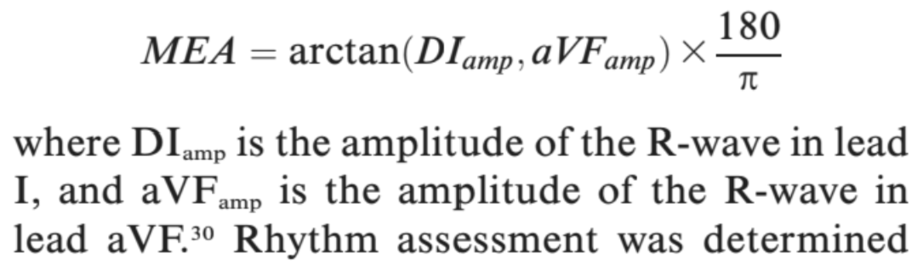
- Best position for echo: right lateral recumbency on a custom table, imaged from below
  - Best for flow measurements: left lateral recumbency, measurements from below
  - Convex probe (2-5.5 Mhz)
  - Fractional shortening: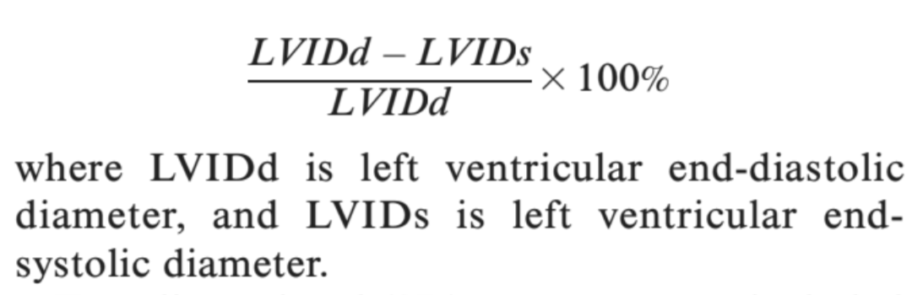
- Right parasternal long axis: heart structure
  - No evidence of structural cardiac disease
- Right parasternal short axis: wall thickness and fractional shortening, LA:Ao, maximum pulmonary flow velocity
  - Anesthesia (iso - negative inotrope) likely affected fractional shortening
  - SSL had larger aortic root diameter than left atrial diameter (LA:Ao < 1 normal range for many terrestrial mammal species but could be reflective of enlarged ascending aorta)
- Left parasternal apical views: maximum aortic flow velocity
Take home message:
- ECG waveforms and echo findings in Steller sea lions, Northern fur seals and a walrus were similar to terrestrial mammals except for an enlarged aortic root diameter in SSL
- Best echo images from right lateral on a purpose-made echo table with a window to image from below

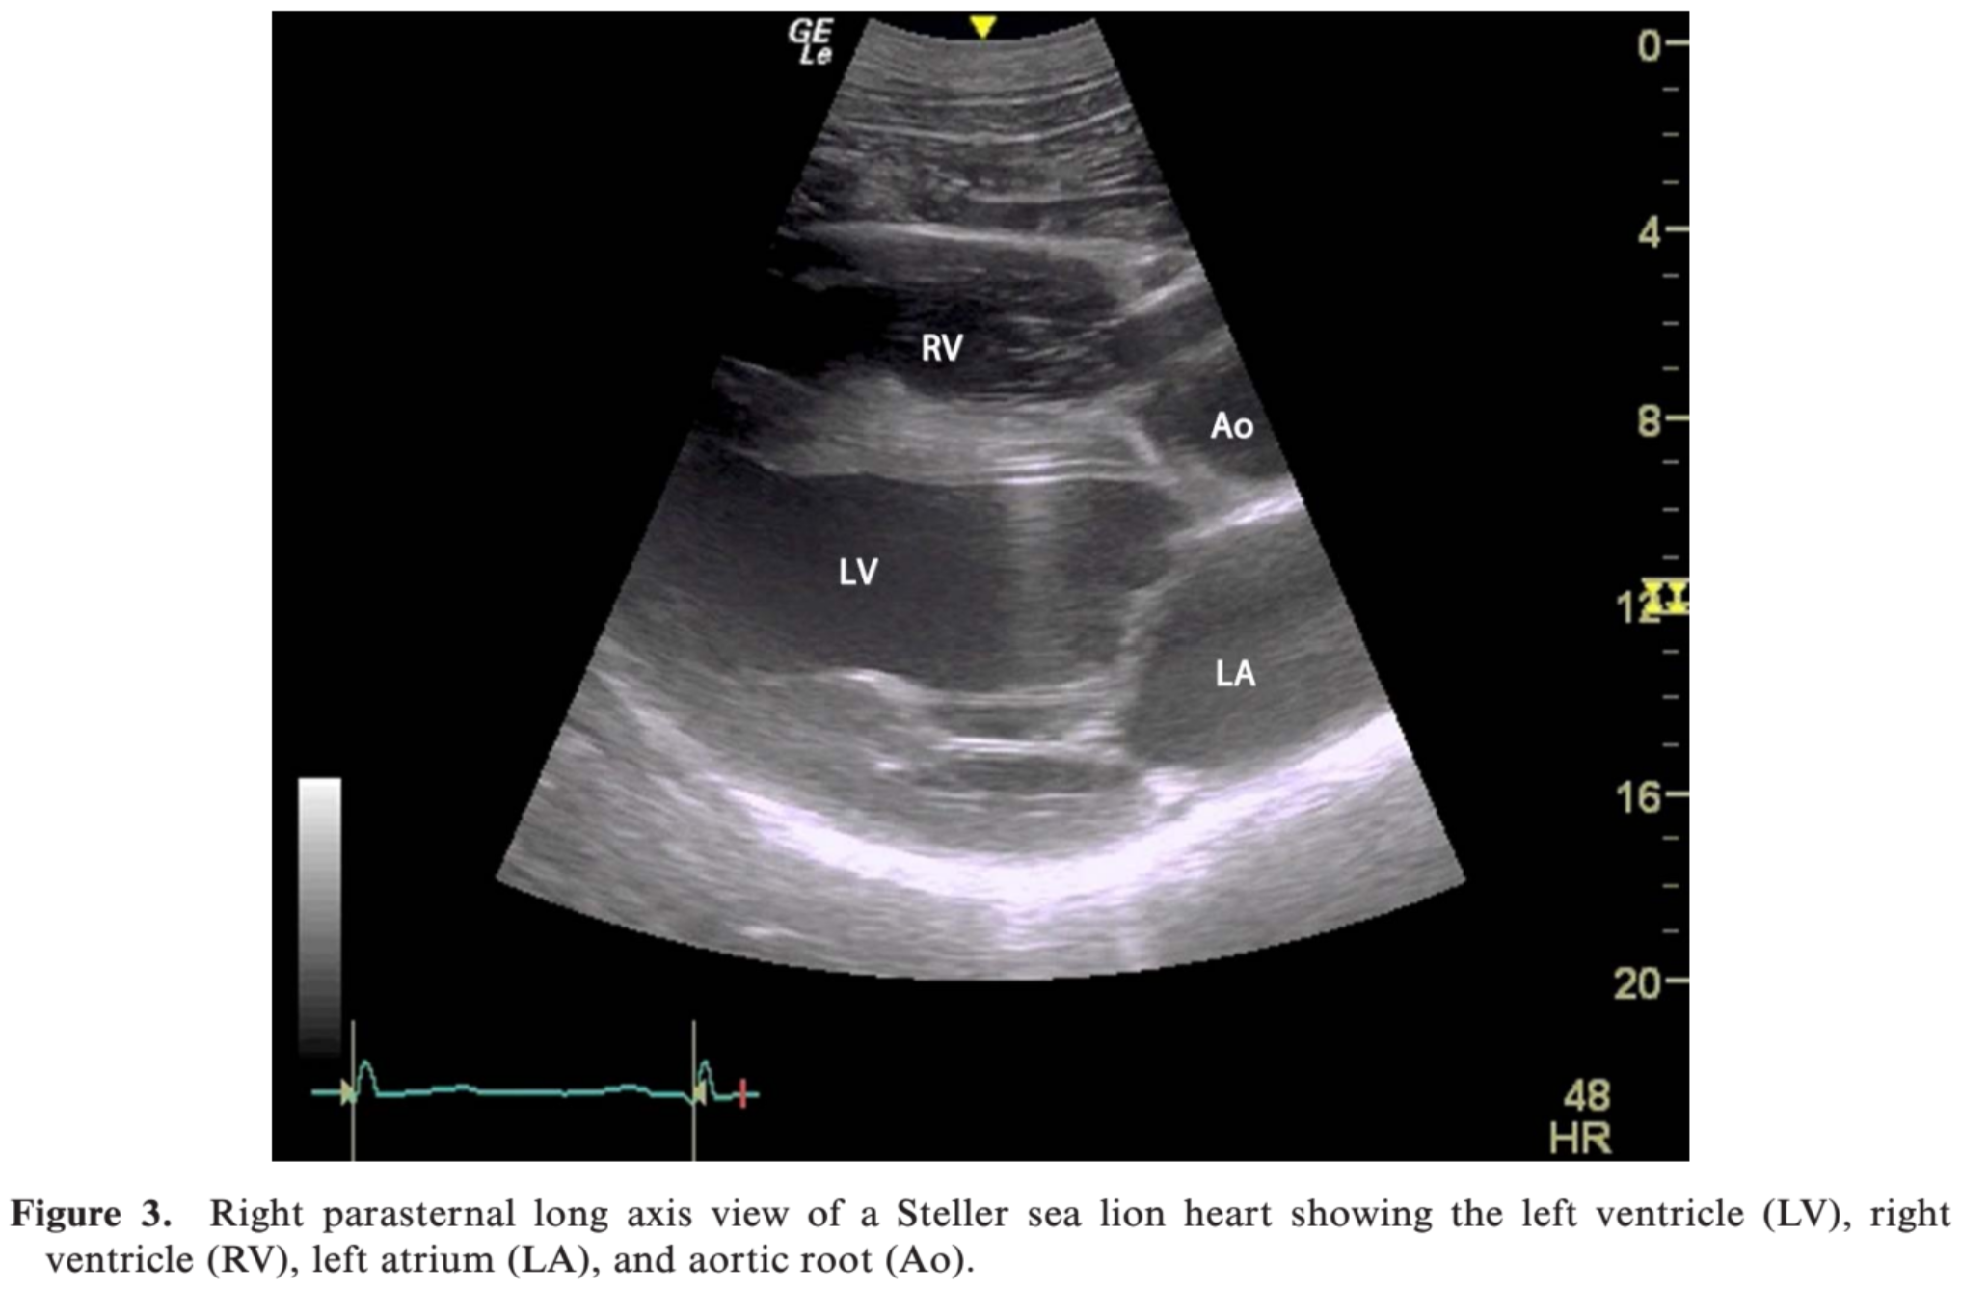
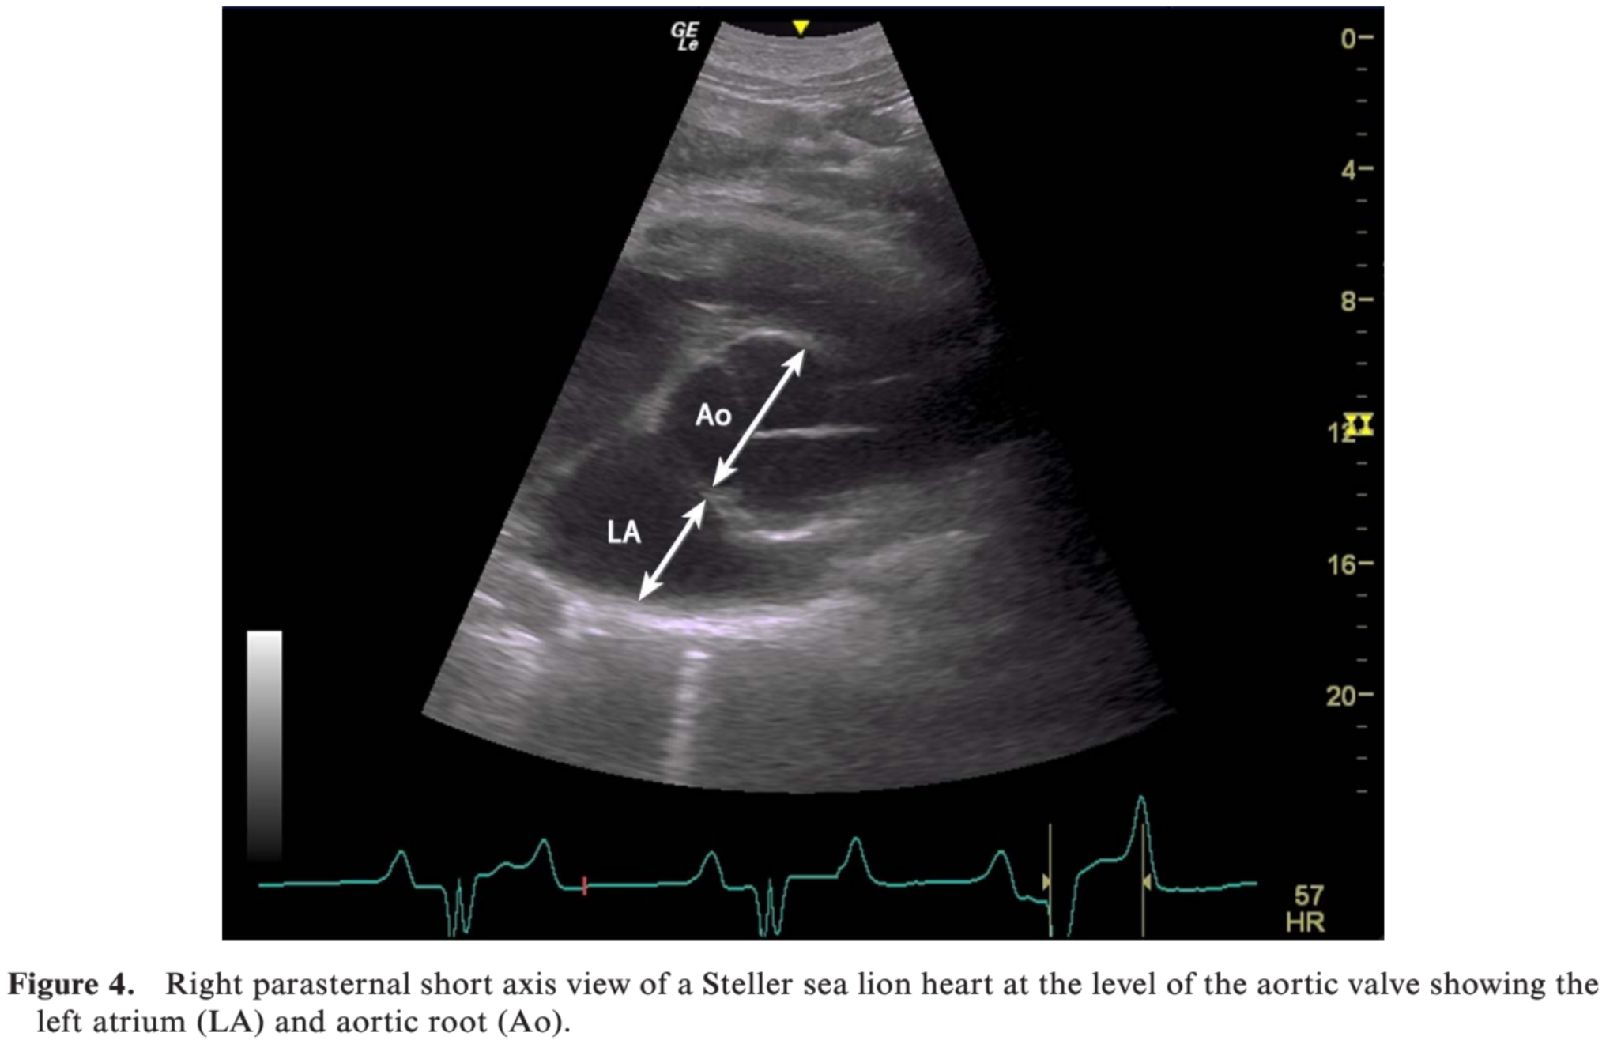
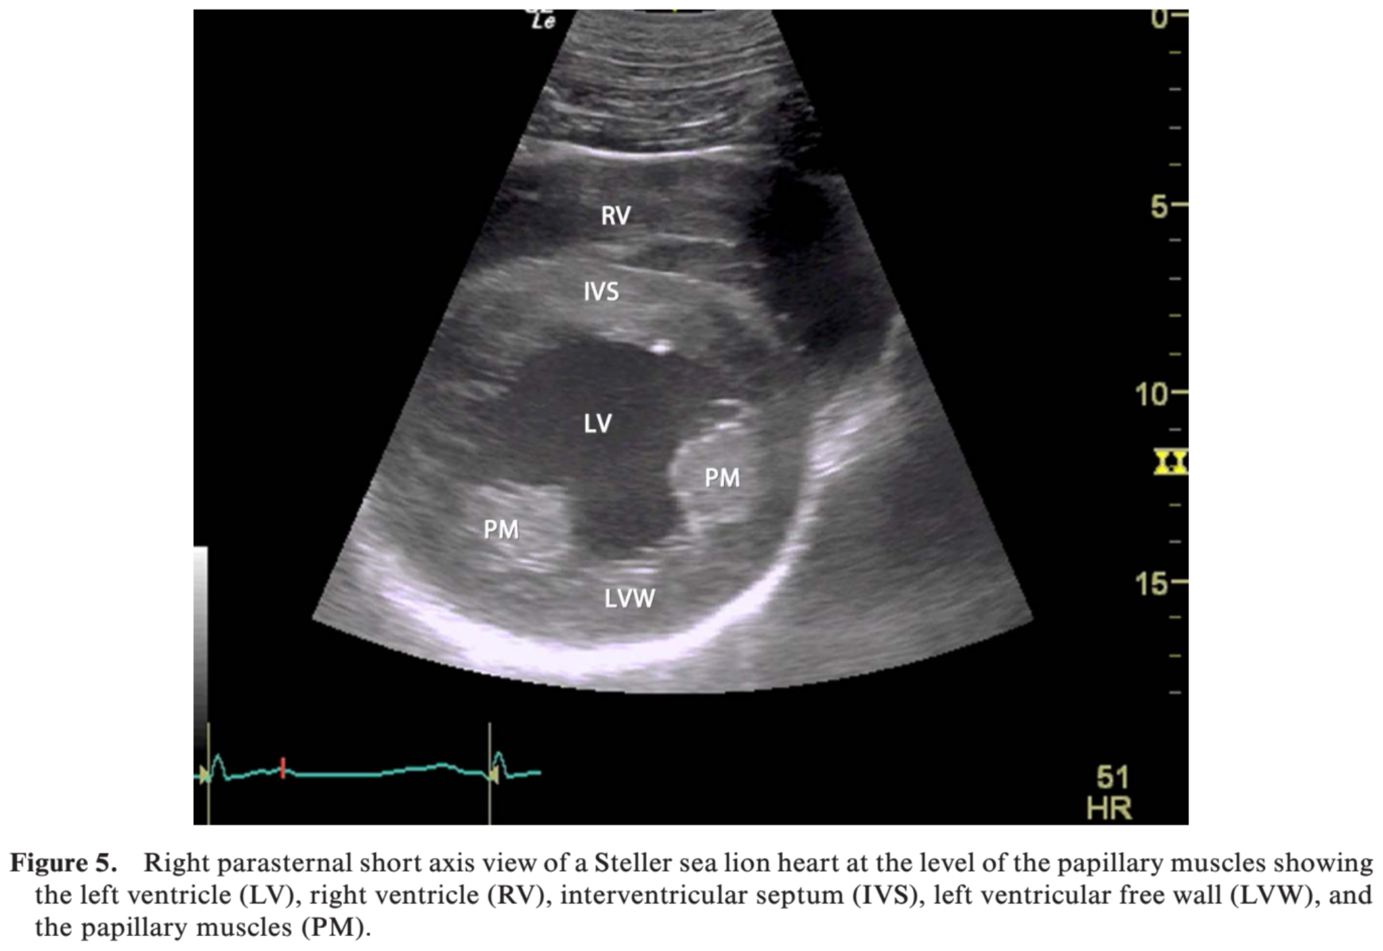
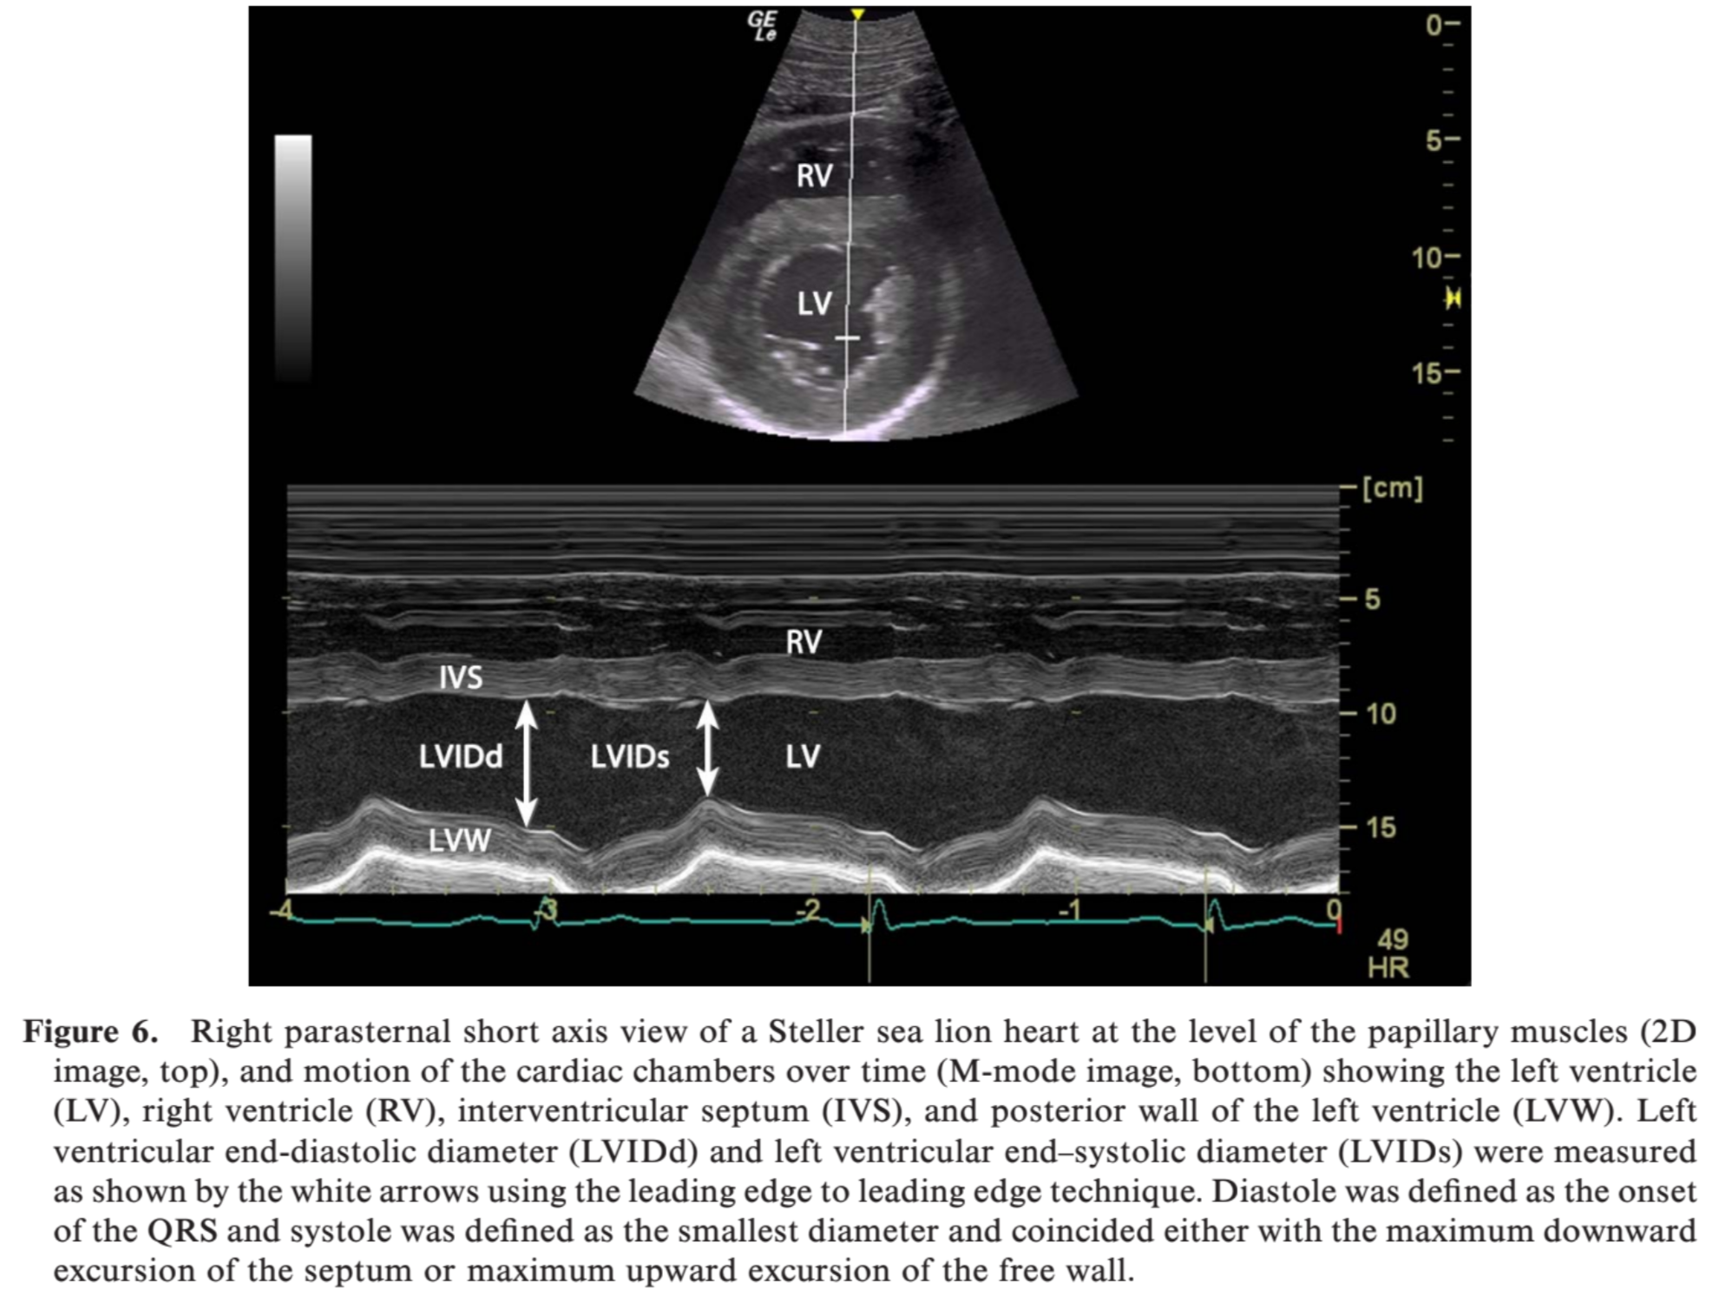
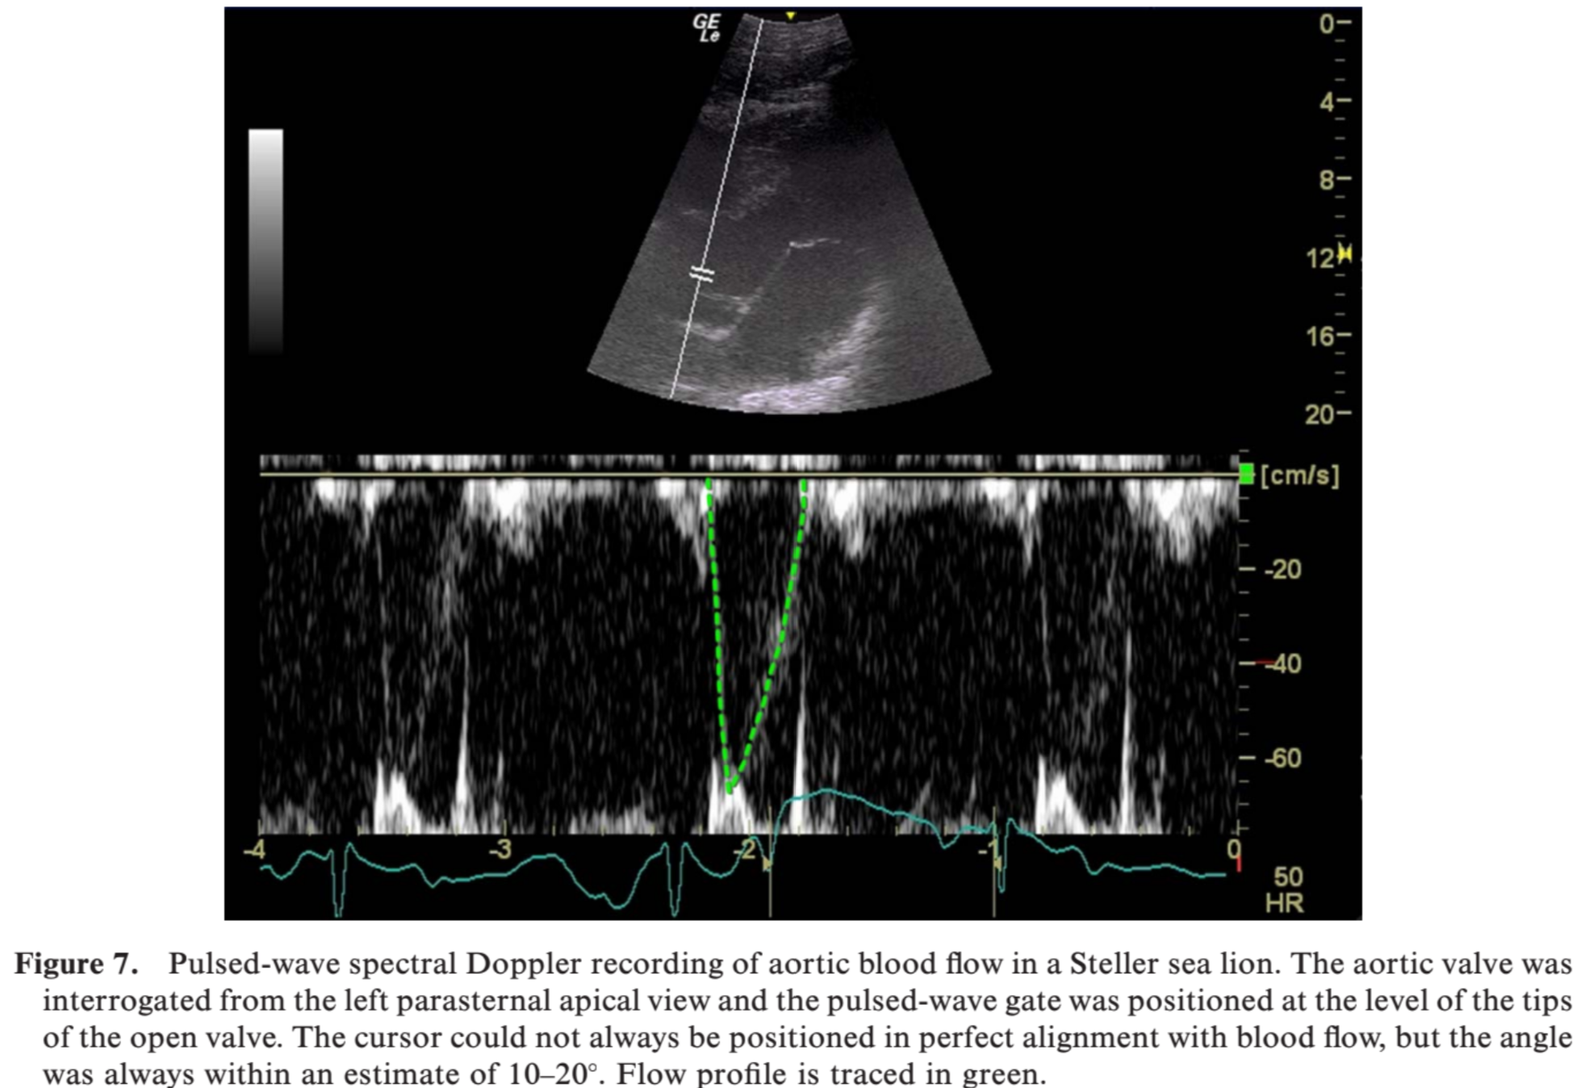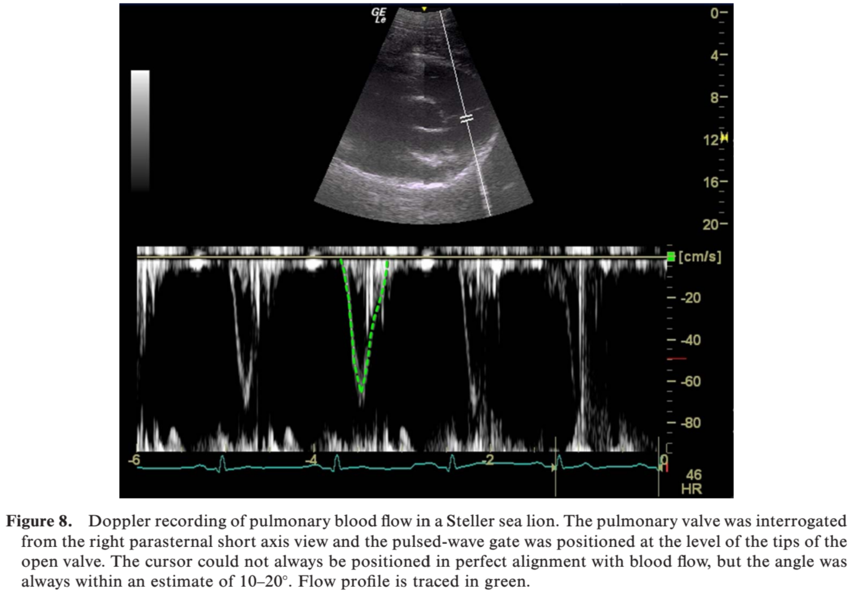
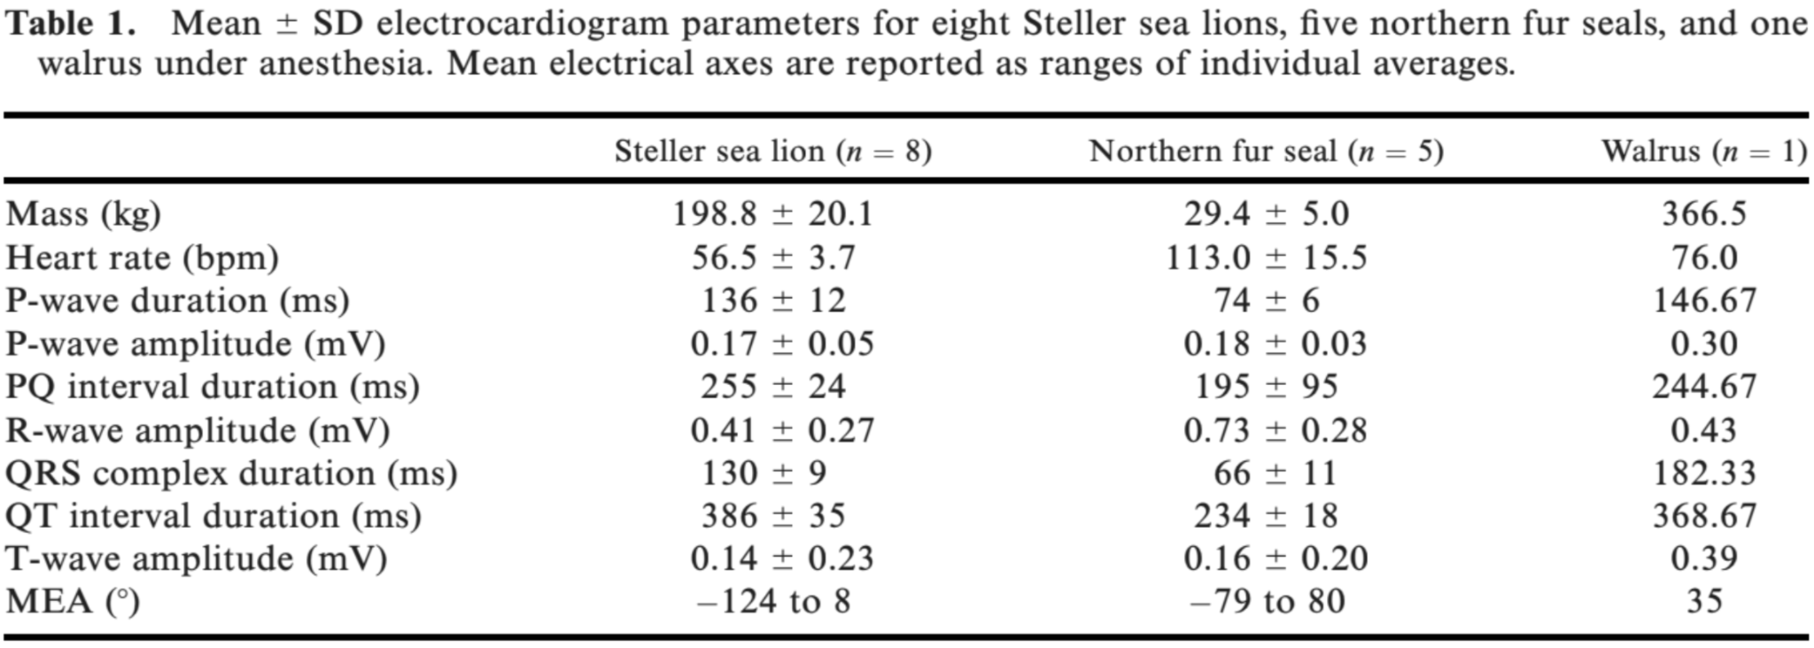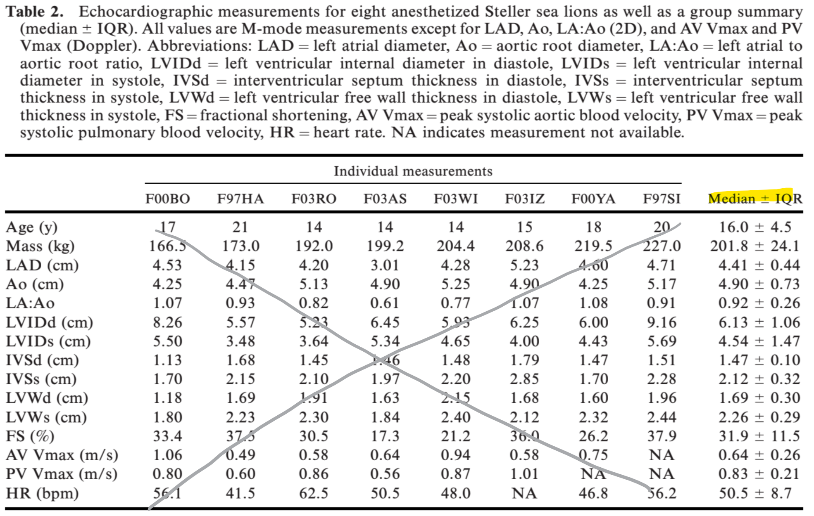

Investigation of the use of serum biomarkers for the detection of cardiac disease in marine mammals.
Joblon MJ, Flower JE, Thompson LA, Biddle KE, Burt DA, Zabka TS, Adkesson MJ, Halaska B, Goertz CE, Rouse N, Cahoon SN.
Journal of Zoo and Wildlife Medicine. 2022;53(2):373-382.

Cardiac disease has been extensively documented in marine mammals; however, it remains difficult to diagnose antemortem. Assays measuring cardiac troponin I (cTnI) and N-terminal pro-brain natriuretic peptide (NT-proBNP) are used as sensitive and specific biomarkers of cardiac disease in many species, but have not been widely investigated in marine mammals. This study aimed to provide a set of reference values for cTnI and NT-proBNP in belugas (BW) (Delphinapterus leucas), sea otters (SO) (Enhydra lutris), Steller sea lions (SSL) (Eumetopias jubatus), and California sea lions (CSL) (Zalophus californianus) with and without cardiac disease (banked samples), and to determine if these biomarkers are useful indicators of cardiac disease in these species. First, existing immunoassays for cTnI and NT-proBNP were successfully validated utilizing species-specific heart lysate spiked serum. Cohorts were defined by histopathology as animals with no evidence of cardiac disease (‘‘control’’), with confirmed cardiac disease (‘‘disease’’), and with concurrent renal and cardiac disease (‘‘renal’’) for which serum samples were then analyzed. Serum concentration ranges for cTnI (ng/ml) and NT-proBNP (pmol/L) were determined for control and disease cohorts. There was significantly higher cTnI (P = 0.003) and NT-proBNP (P = 0.004) concentrations in the CSL disease cohort, as well as positive trends in BW, SO, and SSL disease cohorts that did not reach statistical significance. NT-proBNP concentrations were significantly higher in the CSL renal cohort compared with the control (P , 0.001) and disease (P = 0.007) cohorts. These results suggest that cTnI and NT-proBNP may be clinically useful in the antemortem diagnosis of cardiac disease in CSL, and warrant further investigation in BW, SO, and SL.

Background
- Cardiac troponin subunit I (cTnI) – released after myocardial injury, specifically
  - Gold standard, diagnostic and prognostic value
  - Canine - normal <0.07 ng/mL, high >0.1 ng/ml, highly suggestive of cardiac disease >2
- N-terminal pro-B-type Natriuretic Peptide (NT-proBNP) – prohormone increases with myocardial stretch, concentration correlates with degree of disease (LV dyfunction, heart size, CHF)
  - Prohormone has similar sensitivity but longer halflife than BNP
  - Canine - normal < 800 pmol/L, high 800-1800, indicative of CHF > 2700 pmol/L
  - Elevated with renal disease - suspected due to decreased renal excretion and potentially renal hypertension leading to ventricular hypertrophy and cardiomyocyte stretch
- Heart disease reported in marine mammals: myocardial fibrosis, myocarditis, DA, HW, bacterial endocarditis, acute stranding, capture myopathy, Sarcocystis neurona in southern sea otters
  - cTnI promising in sea otters (Gunther-Harrington 2021, Moriarty 2021)
Key Points
- Validated assays for cTnI and NT-proBNP in all four species
- No difference in either with sex or age class in any species, all control samples below LLOQ
- In CSL cTnI was significantly higher with cardiac disease, acute cardiac disease, and moderate cardiac disease
  - Trends: cardiac disease in SO, SSL, BW, chronic cardiac disease, severe cardiac disease
  - No effect of renal disease
- In CSL NT-proBNP was higher with cardiac disease, acute and chronic cardiac disease, mild cardiac disease, cardiac disease with concurrent renal disease, cardiac disease without concurrent renal disease.
  - Not high in SSL, BW, SO
Conclusions
- Successful validation of highly sensitive, commercially available cTnI and NT-proBNP immunoassays, ranges provided for beluga whales, California sea lions, Stellar sea lions, and sea otters with and without cardiac disease
- Both cTnI and NT-proBNP were significantly higher in CSL with confirmed cardiac disease
  - Unable to associate with chronicity or severity of cardiac disease
- NT-proBNP was higher in CSL and SSL with concurrent renal disease so interpret with caution
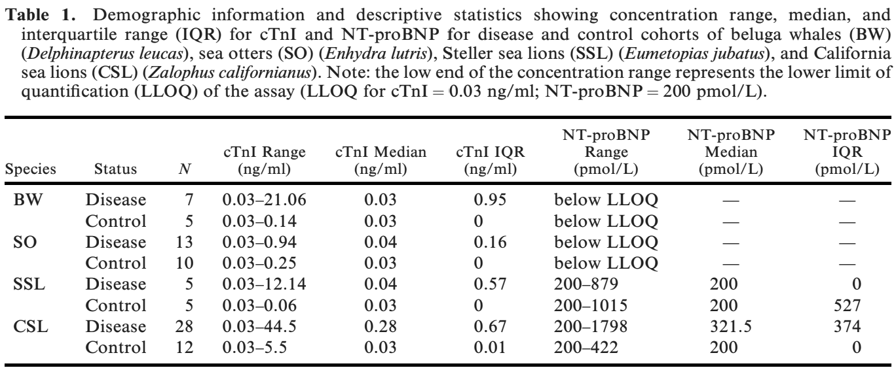
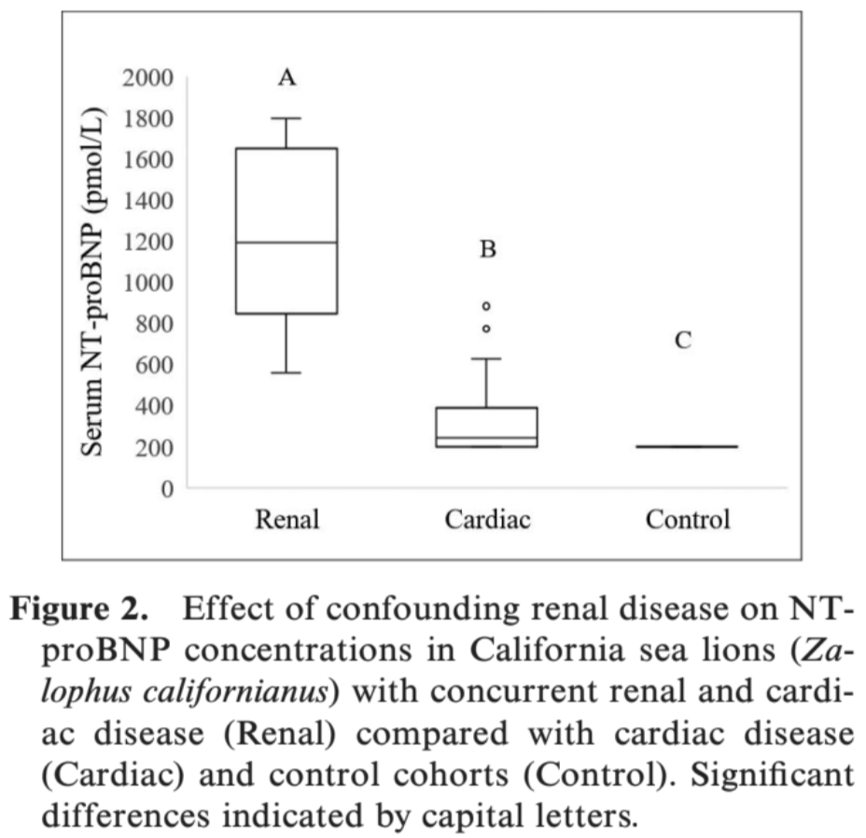

References
- Gunther-Harrington CT, Moriarty ME, Field CL, et al. Transthoracic echocardiographic evaluation and serum cardiac troponin values in anesthetized healthy female southern sea otters (Enhydra lutris nereis). J Zoo Wildl Med 2021;52:in press.
- Moriarty ME, Miller MA, Murray MJ, Duignan PJ, Gunther-Harrington CT, Field CL, Adams LM, Schmitt TL, Johnson CK. Exploration of serum cardiac troponin I as a biomarker of cardiomyopathy in southern sea otters (Enhydra lutris nereis). American journal of veterinary research. 2021 Jul 1;82(7):529-37.
EVALUATION OF SERIAL BLOOD LACTATE AND THE USE OF A POINT-OF-CARE LACTATE METER IN LIVE STRANDED PINNIPEDS
Authors: Marinkovich, Matt, Wack, Raymund F., Field, Cara L., Whoriskey, Sophie T., Kass, Philip H., et al.
Abstract: Live-stranded pinnipeds often present to rehabilitation centers systemically debilitated with dehydration and poor perfusion. In many terrestrial mammals, blood lactate elevation has been correlated with global tissue hypoxia and decreased circulating blood volume. Serial blood lactate measurements in companion animals and humans have been used to guide fluid resuscitation therapy and evaluate prognosis. The primary objective of this study was to evaluate the prognostic value of serial blood lactate levels in live-stranded pinnipeds in a rehabilitation setting. The secondary objectives were to evaluate the use of a point-of-care lactate meter, and potassium oxalate–sodium fluoride (gray-top) tubes for storing samples for lactate analysis in pinniped patients. Fifty-five live-stranded pinnipeds (30 northern elephant seals [Mirounga angustirostris], 21 Pacific harbor seals [Phoca vitulina richardsi], and four California sea lions [Zalophus californianus]) that presented to a rehabilitation center were manually restrained for blood collection and lactate measurement using a point-of-care analyzer (Lactate PlusTM) prior to fluid or other medical therapy. Lactate measurements were repeated 72 hr post admission and prior to euthanasia or release. Plasma samples from gray-top tubes were frozen for 30–100 days at 808C, then thawed and evaluated using both the LactatePlus and bench-top (ABL 815) analyzers. The point-of-care analyzer was successful in measuring lactate in pinnipeds. Gray-top tubes were effective at preserving lactate levels in frozen plasma samples for up to 100 days. Released animals had significantly greater lactate clearance at 72 hr (P¼ 0.039) than animals that died or were euthanized. Therefore, lactate clearance, determined by serial blood lactate measurements, may be useful for evaluating prognosis in live-stranded pinnipeds. Initial lactate and lactate values prior to euthanasia or release were not significantly associated with outcome. Given these findings, clinicians should interpret isolated lactate values in pinnipeds with caution.

Background:
- Study looked at Harbor Seals, Northern elephant seals, california sea lions at TMMC
  - NES had high HCT and needed to be spun down prior to reading on Lactate meter
- Initial lactate sample and then supportive care was given (fluids, enteral tube feedings) for 3 days
- The prefreezing and post-thaw Lactate plus values were compared to determine the effectiveness of gray top tubes (potassium oxalate -sodium fluoride tubes)
- Recheck of lactate at 72 hours post supportive care and prior to euthanasia
- Post thaw lactate (PoC analyzer) positively correlated with post thaw benchtop lactate values
Key Points:
- Lactate Plus (PoC analyzer) was successful in measuring lactate in pinnipeds
- Released animals had significantly greater lactate clearance at 72 hours than animals that were died or euthanized
  - Those that survived had a mean lactate decrease by 2.6% and those that died or were euthanized had an increase by 48.4%
- Patients that fail to show a decrease in lactate values 72 hours post supportive care may have a worse prognosis for release
- INITIAL lactate values was NOT associated with a positive or negative outcome
- Gray top tubes can preserve lactate levels in frozen plasma up to 100 days
- Use caution in evaluating a single lactate value- whereas serial values will give a better clinical picture to a possible overall prognosis
HAIR, WHOLE BLOOD, AND BLOOD-SOAKED CELLULOSE PAPER-BASED RISK ASSESSMENT OF MERCURY CONCENTRATIONS IN STRANDED CALIFORNIA PINNIPEDS
Authors: McHuron, Elizabeth A., Castellini, J. Margaret, Rios, Carlos A., Berner, James, Gulland, Frances M. D., et al.
ABSTRACT: Mercury (Hg) poses a health risk to wildlife populations and has been documented at relatively high concentrations in many marine mammals, including wild-caught pinnipeds along the central California, US coast. We measured total Hg concentrations ([THg]) in hair and blood of live stranded harbor seals (HS; Phoca vitulina), California sea lions (CSL; Zalophus californianus), and northern elephant seals (NES; Mirounga angustirostris) in California to quantify species, temporal, and spatial variability in [THg] and assess the relationships between [THg] measured by different methods (blood vs. filter paper) and in different matrices (blood vs. hair). We compared [THg] with toxicologic thresholds of concern to aid in identification of at-risk individuals or groups and better understand how the use of different methods and matrices affects assumed toxicologic risk. There was a wide range of [THg] in blood (,0.01–1.13 lg/g) and hair (0.45–81.98 lg/g), and NES had higher [THg] compared with HS and CSL. All three species had individuals with [THg] that exceeded the lower threshold for one or both matrices, but only HS pups had [THg] exceeding upper thresholds. Spatial differences in [THg] were detected, with higher concentrations in HS pups from areas surrounding San Francisco Bay, but differences were dependent on sampling year and matrix. The relationship between [THg] in blood and filter paper (r²¼0.98) was strong, and differences had little influence on comparisons with toxicologic thresholds. Blood and hair [THg] were generally in agreement (r²¼0.72), but large mismatches for a few seals underscore the importance of combined sampling in adverse effects studies where accurate assessment of Hg exposure is crucial. The wide range of [THg] in stranded HS pups that exceeded published thresholds of concern makes them a promising candidate for adverse effects studies, particularly because different matrices represent Hg exposure across key developmental stages.
Background:
- Hair and blood samples were collected in live stranded harbor seal pups in 2008 and 2012-1015, northern elephant seals in 2013, and California sea lions in 2013 admitted to TMMC
- Blood was prepared two ways (applied to Advantec Nobutoe FP and air dried OR stored frozen at 20C) and then hair was stored at 20C in polyethylene bags until analysis
- Hair samples were also collected from wild caught harbor seal pups in the Bay area (lanugo coat- ahir grown in utero; because mercury can cross the placenta and blood brain barrier)
- Used a direct mercury analyzer for hair and blood samples
Findings:
- Total mercury concentration in hair was a moderately good predictor of blood mercury in harbor seal pups
- Northern elephant seals had higher blood mercury compared to harbor seals and california sea lions
- Harbor seals had the highest maximum mercury across all species
- Harbor seals had higher mean mercury levels in hair than the california seal lions
- FP has shown promise as an alternative sampling and storage method for measurements of blood mercury (and it was not different among the species)
- The strength of the relationship between mercury in blood and hair of harbor seal pups was relatively strong with similar predictive power to adult and juvenile harbor seals- BUT there were several individuals that displayed discrepancies in mercury between hair and blood that affected classification with respect to toxicology thresholds.
- Presence of lanugo had no influence on the relationship between blood and hair- potentially meaning that exposure to mercury from the dam’s diet is constant throughout gestation
- Stranding location did not exclude harbor seal pups from having mercury exceeding toxic thresholds- stranding location alone should not be used to ID high risk individuals
- Stranded harbor seal pups had higher hair mercury than wild caught seals from the same geographical region and year
- This finding shows the importance of using this group in adverse effect studies because they are most likely to demonstrate the effects of exposure.

Article: Chatterton, James, et al. "Mycobacterial disease and subsequent diagnostic investigations in a group of captive pinnipeds in New Zealand." Journal of Zoo and Wildlife Medicine 51.1 (2020): 177-187.
Abstract: This case series includes a single case of disseminated tuberculous disease due to Mycobacterium
pinnipedii in a New Zealand fur seal (Arctocephalus forsteri), which was being cared for by a zoo in New Zealand.
The remaining five pinnipeds in the colony underwent extensive mycobacterial disease surveillance over the
following 4 yr, involving a total of 26 anesthetic procedures and numerous diagnostic tests that included
comparative intradermal tuberculin skin tests, mycobacterial antibody serology, respiratory and gastric lavages,
and computed tomography (CT) scans. An additional case of chronic sinusitis due to Mycobacterium marinum and
Pseudomonas aeruginosa was identified in a California sea lion (Zalophus californianus). Results from CT and the
respiratory lavages were the most helpful antemortem diagnostic tests for active mycobacterial disease in this case
series. Of the remaining four animals, two were euthanatized and two remain alive, and none of them had evidence
of active mycobacterial disease. Further mycobacterial disease surveillance in staff and animals was performed,
and no other case was identified. There are no validated mycobacterial surveillance tests available for pinnipeds
and so it remains unknown whether the two surviving pinnipeds are truly negative or whether they have latent
mycobacterial infection that could develop into active mycobacterial disease in the future. For this reason,
increased levels of biosecurity and quarantine remain permanently in place for the pinniped colony.

Background
- M. pinnipedii = aerobic, nonmotile, slow-growing, acid-fast bacillus of zoonotic Mycobacterium tuberculosis complex (MT-B) and closely related to M. bovis
  - Pinnipeds can be asymptomatic or have nonspecific signs (lethargy, weight loss, anorexia)
- M. marinum = non-tuberculous mycobacterium, common opportunistic pathogen of aquatic ectotherms (both freshwater and marine) that occasionally causes dermal or lower resp disease in marine mammals

Goal of Study
- Case report of M. pinnipedii in a fur seal, and case of M. marinum in a CA sea lion, and make recommendations for subsequent surveillance monitoring for active Tb in pinnipeds

Key Points
- cITST (intradermal) and DPP Vet-TB (blood Ab serology) for M. pinnipedii testing: limited use, can not differentiate latent and active infections, low sensitivity/specificity, should only be interpreted with others
- Resp lavages (tracheobronchial > BAL, case 1) antemortem or fresh-frozen tissues post-mortem**
  - Mycobacterial culture: gold standard, 100% specificity
  - M-TB PCR: similar sensitivity and increased specificity than culture
  - AFB stain with Ziehl-neelsen: lower sensitivity/specificity than culture and PCR
- CT imaging: useful in ruling out active M-TB (i.e. cases 4-6) but can not distinguish if lesions are mycobacterial in origin (case 2); lesions without positive culture has low specificity
- Surveillance recommendations for active Tb in pinnipeds:
  - Two tracheobronchial lavages submitted to dedicated TB lab for AFB, M-TB PCR, and culture
  - Two DPP Vet-TB tests, 8 weeks apart
  - One CT scan

Article: Conway, Rachel, et al. "Histologic lesions in placentas of northern fur seals (callorhinus ursinus) from a population with high placental prevalence of coxiella burnetii." The Journal of Wildlife Diseases 58.2 (2022): 333-340.
Abstract: Coxiella burnetii is an intracellular bacterial pathogen that can be associated with significant reproductive disease or acute mortality in livestock and wildlife. A novel marine mammal–associated strain of C. burnetii has been identified in pinnipeds of the northwestern Pacific Ocean. Little is known about C. burnetii infection in regard to reproductive success or population status. Our objective was to characterize the severity and extent of histologic lesions in 117 opportunistically collected placentas from presumed-normal northern fur seals (Callorhinus ursinus) in July 2011 on St. Paul Island, Alaska, US, where a high placental prevalence of C. burnetii had been reported. Sections were examined by histology and immunohistochemistry and impression smears with modified acid-fast stain. The nature and frequency of histologic changes were compared with target COM1 PCR-confirmed C. burnetii positive and negative placentas. Overall, histologic changes were similar to placental lesions described in aborting ruminants; however, changes were variable within and between placentas. Vasculitis and occasional intracellular bacteria were seen only in C. burnetii PCR-positive placentas. Dystrophic mineralization, edema, and inflammation were seen in PCR-positive and negative placentas, although they were statistically more common in PCR-positive placentas. Results suggest that C. burnetti and associated pathologic changes are multifocal and variable in placentas from these presumably live-born pups. Therefore, multiple sections of tissue from different placental areas should be examined microscopically, and screened by PCR, to ensure accurate diagnosis as the genomes per gram of placenta may not necessarily represent the severity of placental disease. These limitations should inform field biologists, diagnosticians, and pathologists how best to screen and sample for pathogens and histopathology in marine mammal placental samples.

Background
- C. burnetii causes repro failure and abortion storms in sheep/goats, and sporadic abortions in dairy cattle
- Marine mammals strain of C. burnetii suspected to be significantly different than that in terrestrial mammals suggesting marine mammal-specific adaptations; no dead feti with diseased placenta

Goal of Study/Methods
- Evaluate histologic lesions in opportunistically collected placentas from presumed-normal fur seals from region with declining population and a high prevalence of Coxiella burnetii reported (St. Paul Island, AK)
- 117 placentas were evaluated with histology, IHC, impression smears with acid-fast stain
- Histologic changes were compared with COM1 (target gene for C. burnetii) PCR-confirmed C. burnetii positive and negative placentas

Key Points
- 0/117 had gross lesions, but 76% positive PCR
- Histologic changes in PCR(+) placentas were similar to those described in aborting ruminants
  - Changes were variable within and between placentas
- Vasculitis and occasional IC bacteria were ONLY seen in PCR(+) placentas
  - IC bacteria (IHC confirmed C. burnetii) observed in 4% of placentas (but not every site and in variable sections) - variable inflammation/necrosis associated with bacteria
  - All sites without bacteria were IHC negative
- Dystrophic mineralization, inflammation, necrosis, and edema were seen in PCR(+) and PCR(-) placentas
  - Statistically more common in PCR(+)
- Severity of histologic pathology and load of bacteria do not always correlate
- Impression smears did not identify any bacteria → not a good screening tool (different than cattle)
- Coxiella burnetii and associated pathologic changes are multifocal and variable in placentas of Northern fur seals thus, multiple sections of tissue from different placental areas should be examined microscopically and screened by PCR for the most accurate diagnosis

