Practice Question: Which parameter was associated with increased survival in California sea lions with leptospirosis?
- Juvenile age
- Hypernatremia
- Azotemia
- Leukocytosis
- Male sex

Answer: A

Practice Question: Which of the following phocids has experienced periodic epizootics and mass mortalities caused by influenza A viruses?
- Harp seals (Pagophilus groenlandica)
- Grey seals (Halichoerus grypus)
- Hooded seals (Cystophora cristata)
- Harbor seals (Phoca vitulina)
- Ringed seals (Phoca hispida)

Answer: D

On which of the following receptors does ephedrine’s mechanism of action occur?
- Alpha cardiac receptors
- Beta cardiac receptors
- Cholinergic receptors
- Alpha and beta cardiac receptors
- Cholinergic, alpha and beta cardiac receptors

Answer: D

What is the mechanism of action by which alpha lipoic acid can be used in the treatment of domoic acid toxicity in California sea lions (zalophus californianus)?

Answer: powerful antioxidant and glutathione precursor, can cross the blood-brain barrier to provide antioxidant availability to brain tissue

Cardiac examinations of anesthetized Steller sea lions (Eumetopias jubatus), northern fur seals (Callorhinus ursinus), and a walrus (Odobenus rosmarus).
Storlund RL, Rosen DA, Margiocco M, Haulena M, Trites AW.
Journal of Zoo and Wildlife Medicine. 2021;52(2):507-519.

Label the four hypoechoic structures of this Stellar Sea Lion heart on echocardiogram. Name this view and the preferred recumbency to best achieve this view.
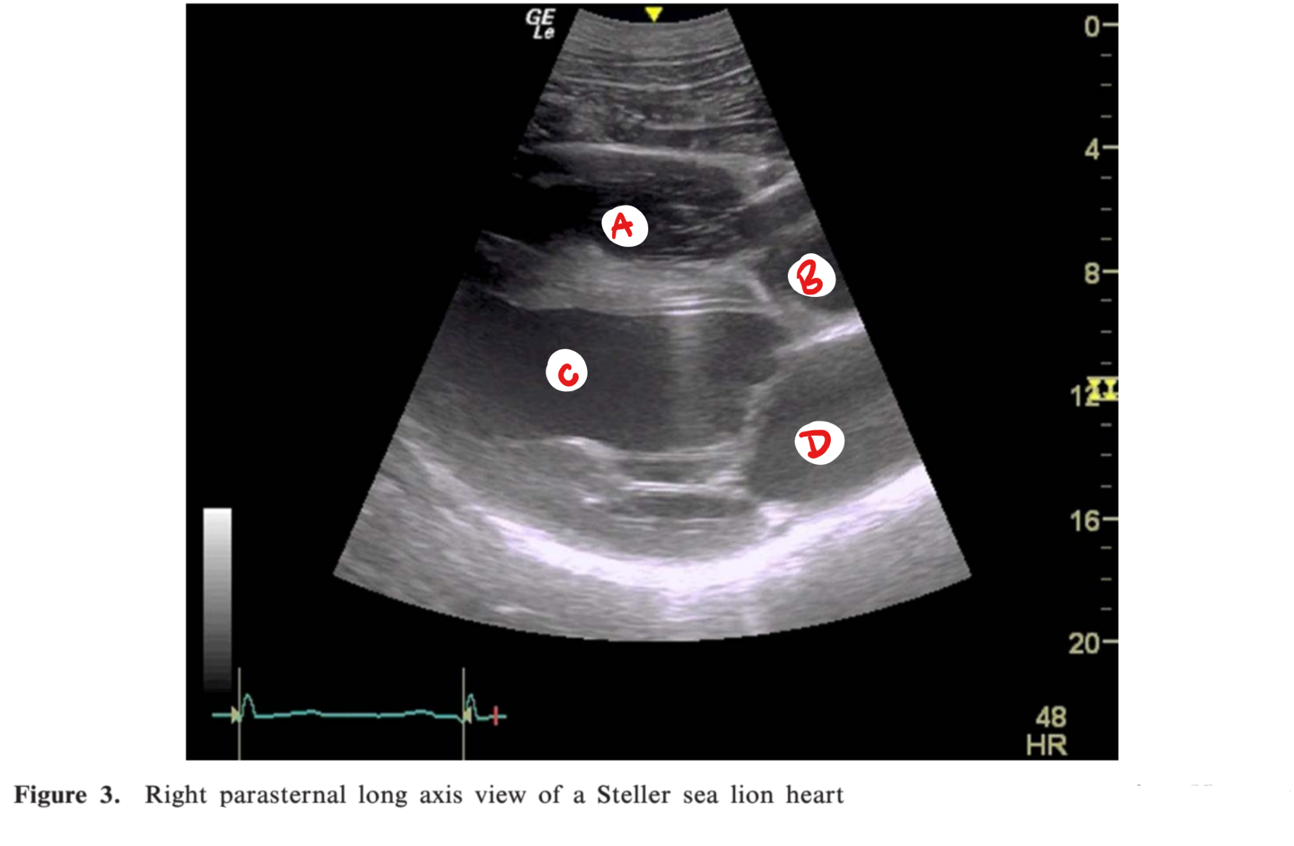

Answer:
A - Right ventricle
B - Aortic root
C - Left ventricle
D - Left atrium
Right parasternal long axis view.
Right lateral recumbency, imaged from below.

Investigation of the use of serum biomarkers for the detection of cardiac disease in marine mammals.
Joblon MJ, Flower JE, Thompson LA, Biddle KE, Burt DA, Zabka TS, Adkesson MJ, Halaska B, Goertz CE, Rouse N, Cahoon SN.
Journal of Zoo and Wildlife Medicine. 2022;53(2):373-382.

Cardiac troponin I was significantly elevated in which cohort of California sea lions?
- Acute cardiac disease
- Severe cardiac disease
- Acute renal disease
- Juvenile females
- Adult males

Answer: A
Unable to correlate cTnI with severity of cardiac disease.
Only NT-proBNP was elevated with renal disease.
No difference between sex or age classes.

1. Which of the following is true in regards to lactate on a stranded pacific harbor seal that presents to a rehabilitation facility?
- Initial lactate value on this animal will give an overall idea of prognosis
- LactatePlus meter is an inefficient way to measure lactate values in pinnipeds
- Gray top tubes can be frozen and lactate read accurately at two hundred days
- Lactate values three days after therapy will give an overall idea of prognosis
- Initial lactate levels in this animal will be higher than compared to an ill canine
D. Lactate values three days after therapy will give and overall idea of prognosis
- Caution should be used in a single lactate value
- LactatePlus meter is successful at measuring lactate values
- Gray top tubes can be read accurately after being frozen/thawed up to 100 days
- Initial lactate levels in a dehydrated pinniped is actually LOWER than compared to an ill canine
2. Which group of pinnipeds (if stranded) would be important in evaluating in an adverse effect study?
- Northern elephant seal pups
- Northern fur seal pups
- California sea lion pups
- Harbor seal pups
- Hawaiian monk seal pups
D. Harbor seal pups

Article: Chatterton, James, et al. "Mycobacterial disease and subsequent diagnostic investigations in a group of captive pinnipeds in New Zealand." Journal of Zoo and Wildlife Medicine 51.1 (2020): 177-187.

What is the gold standard for diagnosis for Mycobacterium pinnipedii in pinnipeds?
- Acid fast stain
- M-TB PCR
- Mycobacterial culture
- CT scan
- cITST
Answer: C

Article: Conway, Rachel, et al. "Histologic lesions in placentas of northern fur seals (callorhinus ursinus) from a population with high placental prevalence of coxiella burnetii." The Journal of Wildlife Diseases 58.2 (2022): 333-340.

Which statement is true regarding Coxiella burnetii in Northern fur seals?
- Diagnosis can often be made from gross lesions in the placenta
- PCR (+) placentas are more likely to have vasculitis than PCR (-) placentas
- Impression smears of placental endothelium is a good screening tool in pinnipeds
- Placental sites without histologic bacteria are still likely to be IHC positive
- Severity of histologic pathology and bacterial load always correlate
Answer: B – vasculitis and intracellular bacteria were only seen in PCR (+) placentas

