Innis, Charles, et al. "Effect of Bone Morphogenetic Protein on Experimental Carapace Defects in Turtles." Journal of Herpetological Medicine and Surgery 31.1 (2020): 48-58.

Abstract
Anecdotal reports suggest that bone morphogenetic protein (BMP) may be useful for treating chelonian shell defects, but controlled studies are lacking. Under general anesthesia, 2-cm-diameter, full-thickness carapace defects were created bilaterally in the second costal scute of 12 red-eared slider turtles (Trachemys scripta elegans). Defects were managed for 10 days by using negative pressure wound therapy, followed by bandages. Three weeks postoperatively, one defect on each turtle was injected with 0.1 mg of recombinant human BMP-2 carried in bovine type 1 collagen, whereas the contralateraldefect was injected with only collagen. Four turtles were euthanized at each of three time points (2, 4,and 12 wk posttreatment). Defects were evaluated by gross appearance, computed tomography, and histology. No difference was noted between the treated and untreated defects. Nonetheless, histologic assessment provided novel characterization of the progression of chelonian shell healing under controlled conditions. Examination indicated that margins of exposed carapace bone underwent osteonecrosis. Re-epithelialization and osteoclastic activity undermined necrotic bone, which was
eventually sloughed. Inflammation of the deep wound bed, including the pericoelomic membrane, resolved with completion of re-epithelialization and was associated with the transition of granulation tissue into mature fibrous connective tissue. Osteoid and woven bone formed along remodeled margins and began to bridge the wound along its deep surface within this fibrous connective tissue. Although this study did not demonstrate BMP efficacy, the surgical model described here may be useful for future studies of chelonian shell repair and healing, including studies that evaluate alternative formulations of BMP.

- Bone morphogenic proteins (BMP) facilitate osteoblast function and stimulate differentiation of mesenchymal cells and other osteogenic cells
  - BMP-2 accelerates bone healing, carried in a carrier agent, usually bovine collagen
  - BMP-2 expressed in turtle embryonic carapace development, suggesting may be useful in fracture healing
- 2 osteotomy sites in 12 RES
  - negative pressure wound therapy and topical therapy x 3 weeks
  - Then BMP-2 in bovine collagen in one site and collagen alone (control) in other site
- No difference in healing between BMP and control
  - All had bone necrosis, all healed
- Established successful model for studying shell healing and regeneration

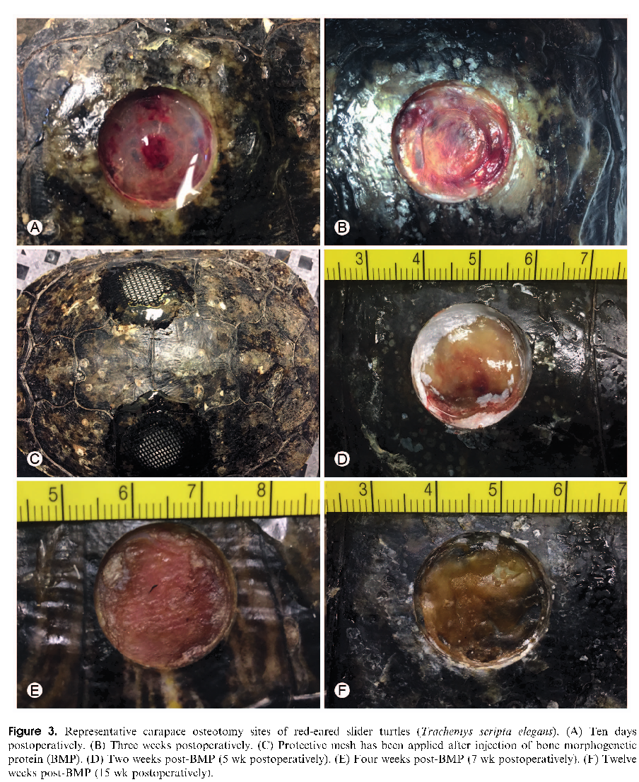
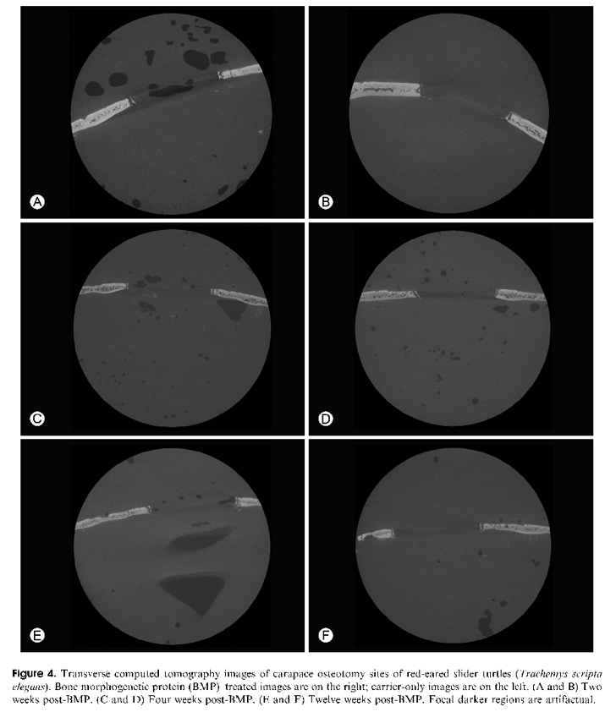
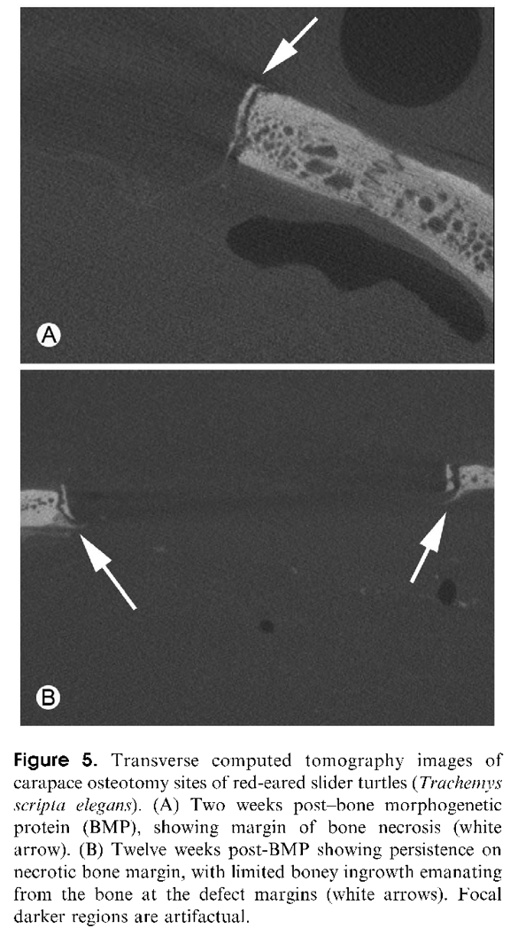

Araújo, Géssica Giselle Almeida Silva, et al. "Osteodensitometry and tomographic findings in four captive giant south american turtles (podocnemis expansa) with metabolic bone disease." Journal of Zoo and Wildlife Medicine 50.2 (2019): 447-452.

Abstract: Giant South American turtles (Podocnemis expansa) are at a risk of extinction because of the rapid decline in their population over the last few decades. Metabolic bone disease (MBD) is common in captive testudines, but is often not diagnosed until a later stage. The authors present the cases of four captive giant South American turtles with carapace deformity secondary to MBD that underwent computed tomography (CT) scans of the carapace bones and vertebral column. Findings indicative of changes in geometry were found in both. The cancellous bone pattern was characterized by varying degrees of increased trabecular spacing and cortical
thinning of the pleural bones. Bone densitometry analysis of the pleural and neural bones and at the level of the body of the third, fourth, and fifth dorsal vertebrae showed mean density values much lower than those found in two adult specimens of the same species that were considered healthy. In conclusion, CT contributed important information on the degree of demineralization and possible structural changes due to MBD and should be considered a relevant tool for diagnosis of this condition.

Introduction/discussion:
- Testudines = tortoises, turtles, terrapins
- MBD = metabolic bone disease = multifactorial disease that normally occurs due to unbalanced diet and/or insufficient UV light
  - Increase in bone resorption → osteoporosis, osteomalacia, rickets, fibrous osteodystrophy, secondary nutritional parathyroidism
  - Diagnosis usually made from history, clinical signs
    - Radiographs very subjective when looking at bone density, bone changes only seen at later stages of disease progression (ie pathologic fractures)
- Studies performed on CT images show earlier ID and better precision
- Densitometry- quantitative measurement of bone density using x-ray
- Tools- Dual x-ray absorptiometry (DXA) vs. quantitative computed tomography
  - DXA considered the “exam of choice” for densitometric analysis, but QCT has high precision and can help measure isolated areas of bone
  - More availability of QCT
  - Analysis of bone done by QCT of TRABECULAR bone could be important for early diagnosis of bone density changes- more metabolically active than cortical bone, more susceptible to loss of bone mass
- Bone changes associated with MBD considered irreversible- can lead to limitation of reproduction, pathologic fractures (less common in chelonians than other reptiles), neurologic concerns due to vertebral changes
  - Possibility of reversing the demineralization reported in other species

Case Reports:
- Four cases of captive adult turtles with carapace deformities (rescued from illegal captivity, likely poor husbandry previously)
- CT findings showed cortical thinning, altered bone geometry (compared to healthy turtles), angular deviation of the vertebral column, osteophyte formation

Take home points:
- CT can provide good information for skeletal changes in chelonians secondary to MBD
- Need more studies on normal values in healthy animals of densitometry, but could eventually help with early diagnosis of changes in mineral bone metabolism

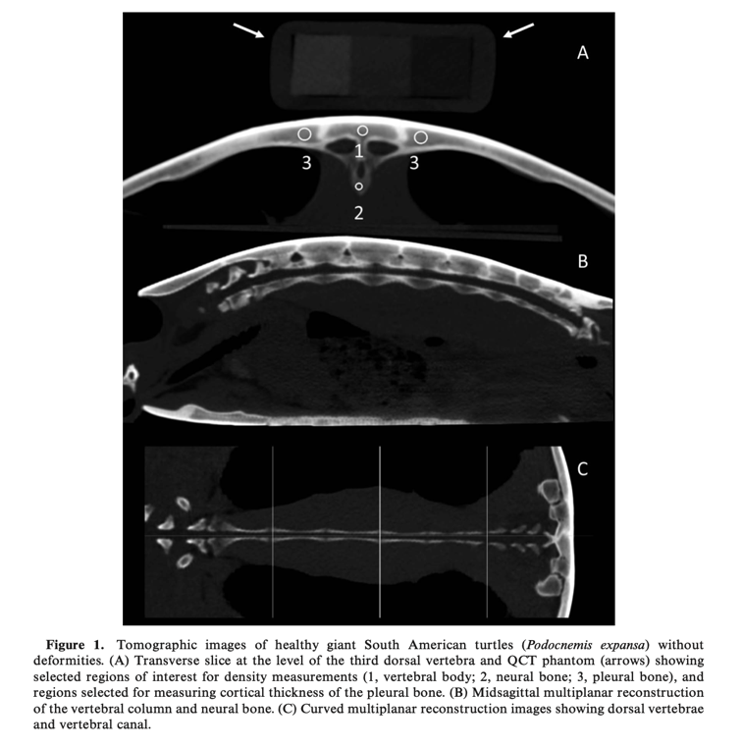
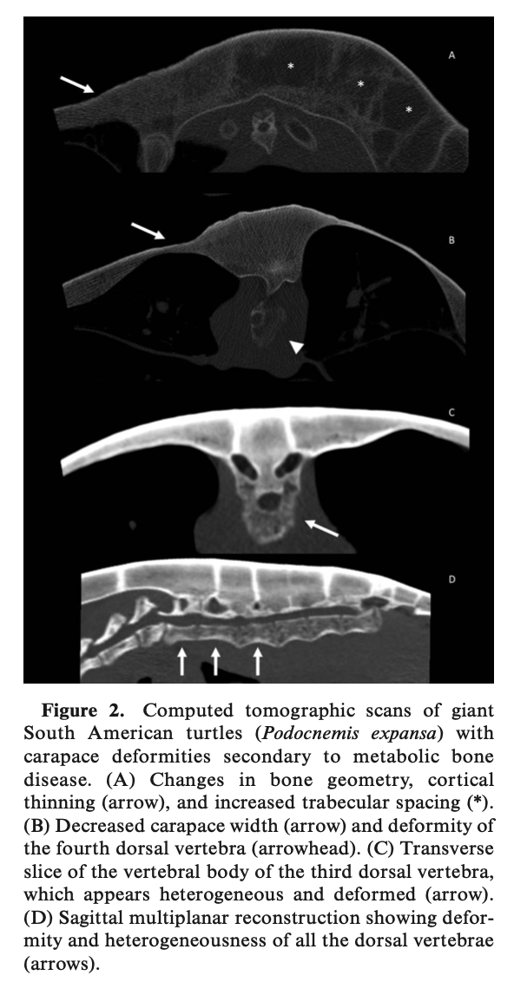

Musgrave, Kari E., and Christoph Mans. "Retrospective evaluation of bacterial isolates from clinically ill chelonians: 155 cases." Journal of Herpetological Medicine and Surgery 29.1-2 (2019): 49-54.

ABSTRACT: A wide variety of bacterial organisms can be cultured from captive reptiles and their environments; however, the pathogenicity of these organisms can be difficult to determine. One-hundred fifty-five aerobic bacterial cultures collected from affected sites of clinically ill chelonian patients (114 aquatic, 41 terrestrial) were reviewed and categorized into eight different anatomic locations based on culture site, yielding a total of 183 bacterial isolates. More than 50% of the samples collected were from the integument category (56.1%, 87/155), followed by joints (9.7%, 15/155) and the upper respiratory tract (9 %, 14/155). Integument (80.5%, 70/87), joint (93.3%, 14/15), ocular (100%, 8/8), and lower respiratory samples (100%, 8/8) were predominately collected from aquatic species, whereas upper respiratory samples were predominately collected from terrestrial species (85.7%, 12/15). Gram-negative bacteria predominated, representing 86.3% (158/183) of all isolates and more than 50% of all sampling locations. The most prevalent isolates were Pseudomonas (36%, 66/183) and Escherichia (10.9%, 20/183). Pseudomonas sp. were the most commonly isolated organisms from five of the eight sampling location categories. Pseudomonas and Escherichia were found to be most susceptible to fluoroquinolones and aminoglycosides, respectively. Varying levels of multiple antibiotic resistance were seen in all genera cultured.
BACKGROUND INFO:
- Infections with gram negative bacteria more common and are frequently cultured from diseased and healthy reptiles
- Surgical debridement may be necessary to prevent sample contamination
- Nasal and oral discharges can contain exudates passed thru other locations that are colonized with normal flora
STUDY DESIGN: Retrospective records review of aerobic bacterial cultures and locations isolated
RESULTS:
- Majority of samples from integument
- Integument, joint, ocular and lower respiratory samples predominated in aquatic spp, upper respiratory samples predominantly from terrestrial species
- Majority gram negative isolates across categories (87%)- Pseudomonas and Escherichia common
- Susceptibility panels summarized (likely not testable)
DISCUSSION:
- Most common isolate Pseudomonas, contrast to prior study. Due to propensity to form biofilms, treated with limited antibiotics
- Resistance in this study differs from other studies
- E. coli second most commonly isolated (20% of joint infections). Higher resistance in this study
- Most prevalent integument isolates: Pseudomonas Proteus, Morganella
- Majority from respiratory tract gram negative- consistent with other studies
- Ocular samples: aquatic species only, gram negative bacteria
TAKE HOME:
- Psueudomonas and E. coli commonly isolated from sick chelonians
- Gram negative infections most common

Article: Ready, Zachary C., Emile P. Chen, and Gregory A. Lewbart. "Temporal patterns in admission of eastern box turtles (terrapene carolina carolina) at a north carolina wildlife clinic as a reflection of climate." Journal of Zoo and Wildlife Medicine 51.2 (2020): 363-370.
Abstract: Significant impacts of global climate change on wildlife have been documented and are projected to
continue. Reptiles have been suggested as being especially susceptible to these effects along with other
anthropogenic impacts on their environment. A retrospective review of medical records for 2,356 wild eastern box
turtles (Terrapene carolina carolina) admitted to the Turtle Rescue Team (TRT) at the North Carolina State
University College of Veterinary Medicine between 1996 and 2017 was performed in order to: 1) report common
presenting complaints, 2) describe the timeline of when box turtles were admitted to the TRT for each year of the
study, and 3) investigate temporal shifts in turtle admissions and associations with changes in environmental
temperature over a 22-yr period. The most common presenting complaint was vehicular trauma (n = 1,195) with
over 70% of the caseload associated with anthropogenic impacts. Average monthly temperatures from 1996 to
2017 for Raleigh, North Carolina, USA, were extracted from the National Oceanic and Atmospheric
Administration climate database. By comparing the pre- and post-2006 years using the Mann–Whitney test, we
found that both the annual peak temperature and the annual timing of admission to the TRT have shifted
significantly or with a strong tendency towards significance (P ¼ 0.0008 and 0.052, respectively). Annual peak
temperature has increased by 1.38C, and timing of admission has shifted 18 days earlier between pre- and post-
2006 years. This supports the hypothesis that box turtle activity patterns are shifting and that these changes are
potentially related to climate.

Goal of Study
- Assess common presenting complaints, describe timeline of admittance, and investigate temporal shift/environmental temperature associated with EBTs admitted to a wildlife center

Study Design/Methods
- Retrospective review of records from 2,356 wild EBTs presented to NC State from 1996-2017 (22 yrs)

Key Points
- Absolute intake: 2356 in 22 years with an annual increase in case admission from 1996-2017
- Most common presenting complaint: human induced/suspected trauma 64% → vehicular trauma 51%, other trauma 9%, horticulture-equipment related trauma 4%
  - “Trauma” number higher as almost all animal attacks (7%) were from domestic dog/cats
  - Suspected to be due to natural terrestrial movement patterns and longevity, and increasing urban development in NC
  - Next most common complaints: (2) infection 12%; (3) aural abscessation 10%
- Increased annual median peak temperature in cases admitted >2006
  - Before 2006 = 25.0C; after 2006 = 26.38C
- Months of highest case admission: April-October (refer to Figure 1 for visual)
- Earlier annual timing of admission in cases admitted >2006 (18 day shift)
  - Before 2006 = July 22; after 2006 = July 4
  - Combined with increasing peak temperature suggests that EBT activity patterns are shifting related to detectable temperature changes

Article: Gregory, Taylor M., et al. "Evaluation of prognostic indicators for injured turtles presenting to a wildlife clinic." Journal of Zoo and Wildlife Medicine 53.1 (2022): 209-213.
Abstract: Mortality events in eastern box turtles (Terrapene carolina carolina) threaten conservation efforts across the species range. These events are often under-diagnosed and, when observed, predictive health factors are unavailable prior to death. At Kickapoo State Park in central Illinois, USA, ranaviruses caused observed mortality events in amphibians and chelonians in 2014 and 2015. Following these outbreaks, eastern box turtles (n¼36) were affixed with radio transmitters and temperature data loggers to obtain repeated location and temperature data from spring 2016–spring 2018. Bimonthly, samples of blood and oral and cloacal swabs were collected to investigate health parameters (hematology and cytokine transcription) and presence of multiple pathogens. Deaths of instrumented turtles occurred in 2016 (n¼5), 2017 (n¼15), and 2018 (n¼2). The largest single die-off occurred in February 2017 (n¼7). Seventeen turtles were necropsied and multiple pathologic processes were identified, most frequently decreased adipose stores (n¼6). Two turtles had pathologic findings consistent with multisystemic inflammation. In addition, infectious pathogens were identified in turtles prior to death, but no single agent was associated with each mortality event. Ranavirus was not detected in any turtle. Hot spot analysis revealed spatial clustering at the center and edges of the study area for body temperature as well as for relative cytokine transcription of interleukin-1 beta, tumor necrosis factor alpha, and interleukin-10 associated with turtle death. Though no single causal factor could be identified, the information from this mortality event can direct future chelonian mortality investigations by providing baseline longitudinal data prior to death and in surviving turtles.

Goal of Study
- Evaluate several parameters (lactate, PCV, TS, BG, HR, body temp) as prognostic indicators for injured wild chelonians presented to TRT and determine how change in lactate over 24 hours affects prognosis
  - Species evaluated: EBT, yellow-bellied sliders, river cooters, painted, snappers
- Increases in patient load limits availability of resources to allocate for individuals thus prioritizing resources for animals with better prognosis is optimal

Study Design/Methods (n=115)
- Inclusion criteria: turtles >100g, not euthanized on presentation, species, date and time of admission
- Venipuncture sites: femoral, dorsal coccygeal, jugular, brachial

Key Points
- Poor prognostic indicators:
  - Initial hyperlactatemia, anemia on presentation
  - Initial hypoglycemia in male turtles
  - Increased lactate over 24h period when initial lactate was >5 mM/L
- Presenting TS, HR and body temperature were not significantly associated with prognosis

Article: Rayl, Jeremy M., et al. "Mortality investigation of monitored eastern box turtles (terrapene carolina carolina) in central illinois, usa, from 2016–18." The Journal of Wildlife Diseases 56.2 (2020): 306-315.
Abstract: Mortality events in eastern box turtles (Terrapene carolina carolina) threaten conservation efforts across the species range. These events are often under-diagnosed and, when observed, predictive health factors are unavailable prior to death. At Kickapoo State Park in central Illinois, USA, ranaviruses caused observed mortality events in amphibians and chelonians in 2014 and 2015. Following these outbreaks, eastern box turtles (n=36) were affixed with radio transmitters and temperature data loggers to obtain repeated location and temperature data from spring 2016–spring 2018. Bimonthly, samples of blood and oral and cloacal swabs were collected to investigate health parameters (hematology and cytokine transcription) and presence of multiple pathogens. Deaths of instrumented turtles occurred in 2016 (n=5), 2017 (n=15), and 2018 (n=2). The largest single die-off occurred in February 2017 (n=7). Seventeen turtles were necropsied and multiple pathologic processes were identified, most frequently decreased adipose stores (n=6). Two turtles had pathologic findings consistent with multisystemic inflammation. In addition, infectious pathogens were identified in turtles prior to death, but no single agent was associated with each mortality event. Ranavirus was not detected in any turtle. Hot spot analysis revealed spatial clustering at the center and edges of the study area for body temperature as well as for relative cytokine transcription of interleukin-1 beta, tumor necrosis factor alpha, and interleukin-10 associated with turtle death. Though no single causal factor could be identified, the information from this mortality event can direct future chelonian mortality investigations by providing baseline longitudinal data prior to death and in surviving turtles.

Goal of Study
- Evaluate natural ranavirus exposure (FV3), and document hematology, pathogen presence, and cytokine transcription in a cohort of wild EBT in area of central IL with known FV3 (turtles and amphibians)
  - Due to high level mortality (22/36 individual deaths) it was further investigated if FV3 was cause of mortalities and other variables related to mortality

Study Design/Methods
- Located telemetered turtles with temp data loggers 2-4 times per week over two years
- Field sampling q2 weeks: blood for hematology + OC swabs for DNA extraction/qPCR pathogen testing
  - FV3, terrapene herpes-1, mycoplasma, box turtle adenovirus
- Necropsy of all deaths including pathogen testing

Background
- Ranavirus: iridoviridae, large non-enveloped dsDNA virus, infects ectothermic verts and inverts
- mRNA transcription cytokines observed in African clawed toads with FV3 infections:
  - Inflammatory cytokines: Interleukin-1 beta (IL1B), tumor necrosis factor alpha (TNF)
- General anti-inflammatory cytokine: Interleukin-10 (IL10)

Key Points
- Survivability: 22/36 deaths, 15 deaths in Feb 2017 after unseasonably warm weather followed by rapid drop in temperature
  - Survivorship through winter was 65% for first year, and 87% for second winter
- Hematology, pathogen presence, cytokines (table 2): none were significant predictors of survivability
- Necropsies (n=19): decreased adipose stores (n=6) was most common finding
  - Other findings: non-specific multisystemic inflammation, nematodiasis, egg binding/ectopic eggs, coelomitis, meningoencephalitis etc.
- Spatial patterns overwinter/hot spot analysis
  - Spatial clustering at center: more turtles, warmer temperatures, higher avg inflammatory cytokines (IL1B, TNF); authors suggest mortality in these turtles may be due to depressed immune response and alternate stressors not evaluated for i.e. pathogens not tested for
  - Spatial clustering at edges: less turtles, colder temperatures, higher avg anti-inflammatory cytokines (IL10); authors suggest mortality in these turtles may be due to overexposure to cold

Evaluation of the effects of a dexmedetomidine midazolam-ketamine combination administered intramuscularly to captive red-footed tortoises (Chelonoidis carbonaria)
Authors: David Eschar, Thersea Rooney, Sara Gardhouse, Hugues Beaufrere

OBJECTIVE
To evaluate the effects of a dexmedetomidine-midazolam-ketamine (DMK) combination administered IM to captive red-footed tortoises (Chelonoidis carbonaria).
ANIMALS
12 healthy adult red-footed tortoises.
PROCEDURES
In a prospective experimental study, DMK (0.1, 1.0, and 10 mg/kg, respectively) was administered IM as separate injections into the right antebrachium. Atipamezole (0.5 mg/kg, IM) and flumazenil (0.05 mg/kg, SC) were administered into the left antebrachium 60 minutes later. Times to the first treatment response and maximal treatment effect after DMK administration and time to recovery after reversal agent administration were recorded. Vital signs and reflexes or responses to stimuli were assessed and recorded at predetermined intervals.
RESULTS
DMK treatment produced deep sedation or light anesthesia for ≥ 20 minutes in all tortoises. Induction and recovery were rapid, with no complications noted. Median times to first response, maximum effect, and recovery were 4.5, 35, and 14.5 minutes, respectively. Two tortoises required additional reversal agent administration but recovered < 20 minutes after the repeated injections. Mean heart and respiratory rates decreased significantly over time. All animals lost muscle tone in the neck and limbs from 35 to 55 minutes after DMK injection, but other variables including palpebral reflexes, responses to mild noxious stimuli (eg, toe pinching, tail pinching, and saline ([0.9 NaCl] solution injection), and ability to intubate were inconsistent.
CONCLUSIONS AND CLINICAL RELEVANCE
DMK administration produced deep sedation or light anesthesia with no adverse effects in healthy adult red-footed tortoises. At the doses administered, deep surgical anesthesia was not consistently achieved. Anesthetic depth must be carefully evaluated before performing painful procedures in red-footed tortoises with this DMK protocol.

Take Home Points:
- DMK combination considered successful when stable plane of deep sedation and immobilization or surgical plane of anesthesia was produced
- Tortoise was deemed recovered when all tested reflexes or responses (neck, jaw, limb muscle tone) were present and animal was able to hold its head above ground and initiate spontaneous movement
- Intubation was considered unsuccessful if jaw contraction or gag reflex was seen (only 6 of 12 could be successfully intubated with this protocol)
- No significant effect of sex, age, or weight on any measured variables
- Induction and recovery was smooth; no animals had adverse effects during or after procedure
- Mean heart rate and respiratory rate decreased significantly
- Cloacal temperature actually went up instead of animals becoming hypothermic (slight and nonsignificant) but temperatures continued to increase after reversal agent
- All tortoises had complete muscle relaxation of the neck and limbs from 35-55 minutes after DMK injection- the other results for the tested variables were mixed and inconsistent
- Found that tail pinch was the only variable that remained present and therefore might be the most sensitive indicator of peripheral nociception than the other variables tested
- Limitations included lack of blood pressure monitoring and assessment of the cardiorespiratory effects of the DMK protocol: recommend blood gas analysis and capnography or closed chamber plethysmography
- DMK protocol is not recommended for surgical procedures

Bacterial Identification and Antibiotic Sensitivity from the Abscesses of Captive Tortoises- Clinical Antibiotic Recommendations
Authors: Yo-Wen Wang, Han- You Lin, Jane-Fang Yu, Lih Chiann Wang

Abstract: Bacterial abscesses are commonly seen in tortoises. The morbidity and the resultant mortality are high. Multifactorial problems, antibiotics misapplication. and antibiotic-resistant bacteria make abscess treatment complicated and ineffective. This study identifies the etiological bacterial species and determines the best antibiotics for abscess treatment in captive tortoises. Sterile swab specimens from 40 tortoises with abscesses were analyzed using the Analytical Profile Index (API) system. Sixty-five bacteria species were identified covering facultative anaerobic gram-negative (n ¼ 30, 46.2%), facultative anaerobic gram-positive (n ¼ 19, 29.2%), and aerobic gram-negative bacteria (n ¼ 16, 24.6%). The antibiotic sensitivity of these bacteria to 30 antibiotics was assessed using the Kirby–Bauer disk-diffusion method. Greater than 80% anaerobic gram-negative bacterial species showed sensitivity to amikacin and ceftazidime. Greater than 80% anaerobic gram-positive bacterial species were sensitive to amoxicillin, ampicillin, carbenicillin, and penicillin. In addition, more than 80% aerobic gram-negative bacterial species were sensitive to ceftazidime, colistin sulphate, amikacin, gentamicin, kanamycin, polymyxin B, and tobramycin. This study provides clinicians significant information for initial antibiotic options, which could elevate the abscess therapy success rate and improve the life quality of tortoises.
Take Home Points:
- Important note: most bacterial infections are influenced by multifactorial problems: malnutrition, weather, organochlorine toxicity; note hypovitaminosis A causes squamous metaplasia in the epithelium which predisposes turtles to abscesses.
- 65 bacteria: almost half the IDed bacteria were facultative anaerobic gram negative bacteria (46.2%); the next most common was facultative anaerobic gram positive bacteria (29.2%) and then aerobic gram negative bacteria (24.6%)
  - 75% of IDed bacteria from tortoise abscesses were anaerobic bacteria: gram negative (46.4%) or gram positive (29.2%)
- This study notes that penicillins would be a good first line choice; however, amikacin would be superior as long as tortoises are kept hydrated
- Anaerobic gram negative: treat with amikacin, ceftazidime, and ceftiofur
- Anaerobic gram positive: treat with amoxicillin, ampicillin, penicillin, carbenicillin
- Highest IDed species in shell: Proteus mirabilis (gram negative) and then Enterococcus spp. (gram positive) And then E. coli (gram negative): NOTE: might need two antibiotics
  - Proteus: tx amikacin, ceftazidime, gentamicin, TMS, tobramycin, kanamycin, streptomycin and carbenicillin: study suggests streptomycin as first line
  - Enterococcus: amoxicillin and ampicillin
  - E.coli: tx ceftazidime, colistin sulphate, amikacin, polymyxin B and ceftiofur
- Highest IDed species in skin wounds were Pseudomonas aeruginosa and Klebsiella pneumonia (gram negatives) and then Aeromonas hydrophila (gram negative)
  - Pseudomonas: amikacin, ceftazidime, kanamycin, ceftiofur, colistin sulphate, gentamicin, tobramycin, enrofloxacin, and polymyxin B
  - Klebsiella: 75% were sensitive to polymyxin B, amikacin, ceftazidime, colistin sulphate, kanamycin, ceftiofur, gentamicin, and enrofloxacin.
  - Aeromonas: tx with amikacin and gentamicin; could also use ceftazidime, cefuroxime, kanamycin, neomycin, ceftiofur, tobramycin, and polymyxin B
- Successful treatment of abscesses: surgical debridement, daily lavage, and effective antimicrobial treatment
- Limits of this study included small sample size, less common bacteria may have been missed
- Bacterial culture and antibiotic sensitivity testing are essential for an effective treatment protocol
- Acinetobacter Iwoffii: commonly has multidrug resistance- this study found that amikacin, colistin sulphate, kanamycin, polymyxin B, ceftazidime, gentamicin and tobramycin to treat abscesses

Field Anesthesia and Gonadal Morphology of Immature Western Santa Cruz Tortoises (Chelonoidis porteri)
Authors: Evan S. Emmel, Samuel Rivera, Freddy Cabrera, Stephen Blake, Sharon L. Deem

Abstract: Evaluation of sex ratios is a critical component of chelonian captive breeding programs and may become increasingly useful to assess the demographics of free-living populations. In many reptile species, the sex of immature animals cannot be determined based on external features. Endoscopic sex identification is an accurate and safe method to identify the sex of immature individuals of some chelonian species. A number of studies describe this technique in controlled, hospital settings and report significant interspecies variations in gonad morphology; however, there are few reports describing this technique in field conditions. In the current study, the gonadal morphology of 40 immature Western Santa Cruz tortoises (Chelonoidis porteri) on Santa Cruz Island in Galapagos, Ecuador, was assessed. A previously described endoscopic protocol was used to perform sex identification under field conditions. Tortoises were anesthetized using an intramuscular injection of ketamine (10 mg/kg) and medetomidine (0.1 mg/kg), which provided an adequate plane of anesthesia. The medetomidine was reversed with atipamezole (0.5 mg/kg). Field conditions presented challenges such as limited control over lighting, suboptimal patient positioning, and restricted power supply for endoscopy equipment. The immature testicle in Western Santa Cruz tortoises was oval, reddish pink, and tightly adhered to the coelomic membrane ventral to the kidney. The surface of the gonads resembled other species with the notable exception that the ovaries lacked a significant number of primordial follicles. These gonadal characteristics were consistent, with only one individual identified as undetermined sex of the 40 samples. This field-based endoscopic gonadal evaluation was a safe and sensitive technique for determining the sex of free-living immature Western Santa Cruz Galapagos tortoises.

Take Home Points:
- Evaluation of Western Santa Cruz tortoises, PE was performed prior to anesthesia
- Ketamine 10 mg/kg and medetomidine 0.1 mg/kg used IM; with lidocaine 1 mg/kg SC as a local block prior to incision in left femoral fossa
- Testicle: located at the ventral surface of the cranial portion of the kidney; oval, reddish pink and tightly adhered. Highly vascular along surface
- Ovary: elongated shape and less prominent surface vascularization; near the ventral surface of the kidney, loosely attached by a suspensory ligament; elongated, cream colored, and extended pass the caudal portion of the kidney- lacked vascularization and primordial follicles were not consistently evident
- Oviduct: located ventral to the ovary and it extended from the point cranial to the ovary past its caudal edge
- The morphology of the gonads varied from other studies BUT the testicle was vascular and the ovary was not on surface remained similar; however, differences should be noted because of the difference in morphology across juvenile chelonians
- Cloacoscopy and cystoscopy have been used in the past (successful) these are less invasive
  - Colonoscopy: not reliable method to differentiate phallus vs clitoris because they are almost identical in sexually immature chelonians
  - Cystoscopy: discomfort, difficulty identifying gonads because of distended intestinal loops, impaired visualization through bladder wall (inflammation secondary to infectious diseases and presence of yolk sacs in individuals less than 6 months old; concerning complication includes cloacal or bladder rupture (7 of 30 individuals in one study)
- AMH: protein identification: age is found to influence when this test is most useful
- Coelioscopy: well established safety and efficacy
- In the field complications: irregular ground surfaces, lack of an examination table, and little control over environmental lighting; also had inconsistent positioning of patients and limited battery life for endoscopy equipment; recommended bringing a solar charge unit

JZWM 2022 53(2):424-432
Bacterial Identification And Antibiotic Sensitivity From The Abscesses Of Captive Tortoises-Clinical Antibiotic Recommendations
Wang YW, Lin HY, Yu JF, Wang LC

ABSTRACT: Bacterial abscesses are commonly seen in tortoises. The morbidity and the resultant mortality are high. Multifactorial problems, antibiotics misapplication. and antibiotic-resistant bacteria make abscess treatment complicated and ineffective. This study identifies the etiological bacterial species and determines the best antibiotics for abscess treatment in captive tortoises. Sterile swab specimens from 40 tortoises with abscesses were analyzed using the Analytical Profile Index (API) system. Sixty-five bacteria species were identified covering facultative anaerobic gram-negative (n = 30, 46.2%), facultative anaerobic gram-positive (n = 19, 29.2%), and aerobic gram-negative bacteria (n = 16, 24.6%). The antibiotic sensitivity of these bacteria to 30 antibiotics was assessed using the Kirby-Bauer disk-diffusion method. Greater than 80% anaerobic gram-negative bacterial species showed sensitivity to amikacin and ceftazidime. Greater than 80% anaerobic gram-positive bacterial species were sensitive to amoxicillin, ampicillin, carbenicillin, and penicillin. In addition, more than 80% aerobic gram-negative bacterial species were sensitive to ceftazidime, colistin sulphate, amikacin, gentamicin, kanamycin, polymyxin B, and tobramycin. This study provides clinicians significant information for initial antibiotic options, which could elevate the abscess therapy success rate and improve the life quality of tortoises.

Background:
- Common causative agents of abscesses in reptiles:
  - Pseudomonas, Proteus, Aeromonas, Serratia, Providencia spp., & Escherichia coli
  - Most are opportunistic microorganisms
- Abscesses can be multifactorial (infection + malnutrition, weather, or organochlorine toxicity)
  - Hypovitaminosis A causes squamous metaplasia which predisposes to abscesses
  - Excessive winter rainfall is associated with aural abscesses in Florida box turtles
  - Abscesses in tortoises can be treated by surgical excision and antibiotics
Key Points:
- Single-center retrospective study covering 9 species (n = 40 tortoises) in Taiwan
- ¾ of tortoise abscesses were anaerobic bacteria [Gram-negative > Gram-positive]
  - Escherichia coli and Proteus mirabilis were the most common isolates
- Good empirical antibiotic options:
  - Amikacin, ceftazidime, & ceftiofur recommended for Gram-negative infections
  - Penicillins recommended for Gram-positive infections
  - Cephalosporins aren’t recommended, only ceftazidime effective against Gram-negative
  - Macrolides, sulfonamides, fluoroquinolones, & tetracyclines aren’t good 1st line choices
- Most common bacteria in shells were Proteus mirabilis, Enterococcus spp., and E. coli
  - Amikacin showed efficacy for both Proteus mirabilis and Escherichia coli
  - Amoxicillin and ampicillin were efficacious for Enterococcus spp.
- Most common bacteria in skin wounds were Pseudomonas aeruginosa, Klebsiella pneumonia, and Aeromonas hydrophila
  - Amikacin showed great effectiveness for all of them

TLDR: Majority of tortoise abscesses were anaerobic bacteria [Gram-negative > Gram-positive]. Amikacin, ceftazidime, & ceftiofur recommended for Gram-negative infections. Penicillins recommended for Gram-positive infection

Related Articles:
- Tang PK, Divers SJ, Sanchez S. Antimicrobial susceptibility patterns for aerobic bacteria isolated from reptilian samples submitted to a veterinary diagnostic laboratory: 129 cases (2005–2016). J Am Vet Assoc. 2020;257(3):305–312
- Scheelings TF, Hellebuyck T. Dermatology-skin. In: Divers S, Stahl S (eds.). Mader's reptile and amphibian medicine and surgery. 3rd ed. St Louis (MO): Elsevier; 2019. p. 703
- Schmidt V. Abscesses/fibriscesses. In: Divers S, Stahl S (eds.). Mader's reptile and amphibian medicine and surgery. 3rd ed. St Louis (MO): Elsevier; 2019. p. 1288–1289

JZWM 2021 51(4):999-1006
Comparing The Effects Of Lithium Heparin And Dipotassium Ethylenediaminetetraacetic Acid On Hematologic Values In Eastern Box Turtles (Terrapene carolina carolina)
Klein K, Gartlan B, Doden G, Fredrickson K, Adamovicz L, Allender MC

ABSTRACT: Anticoagulants are employed to prevent clotting and preserve cellular morphology for clinical pathology tests. Lithium heparin (LH) is the most frequently used anticoagulant in chelonians; however, dipotassium ethylenediaminetetraacetic acid (EDTA) may be superior in some species. Although eastern box turtles' (Terrapene carolina carolina) hematologic parameters are well studied, the effects of different anticoagulants on hematology in this species are unknown. This study evaluated the effects of LH and EDTA on hematologic values in free-living eastern box turtles (N = 59). Blood samples were collected from eastern box turtles in Illinois and immediately divided between LH and EDTA microtainers, and complete blood counts were performed on each sample. Grossly, plasma from EDTA blood samples was frequently and significantly hemolyzed. Blood mixed with LH had higher packed cell volume (PCV) (P = 0.04), white blood cell count (WBC) determined by Leukopet (P < 0.0001), WBC determined by blood film estimate (P < 0.0001), absolute heterophils (P = 0.007), absolute lymphocytes (P < 0.0001), and lower total solids (P < 0.0001) and absolute monocytes (P = 0.0001) than blood mixed with EDTA. All relative leukocyte counts were significantly different between the anticoagulants (P < 0.0001). EDTA apparently lysed turtle erythrocytes in this study, making it difficult to accurately count white blood cells and artificially lowering PCV. These findings demonstrate that EDTA should not be used in eastern box turtles.

Background:
- Lithium heparin is the preferred anticoagulant in chelonians
  - EDTA can lyse RBCs in some chelonian species (Russian tortoises, Hermann’s, spiny softshell turtles, Aldabra, Galapagos)
Key Points:
- Prospective anticoagulant comparison study (n = 59 free-living eastern box turtles)
- Plasma from EDTA blood samples was frequently and significantly hemolyzed
- Lithium heparin had:
  - Higher PCV, WBC (Leukopet & Est), absolute heterophils, absolute lymphocytes
  - Lower TS and absolute monocytes
- Relative lymphocytes higher in lithium heparin
  - All other relative leukocyte percentages higher in EDTA
- Higher WBC values obtained by leukopet method
  - Leukopet can overestimate WBC in lymphocyte dominant species (e.g., EBTs)
- Good agreement between leukopet and estimate counts for EDTA samples
  - May be due to predominance of heterophils and eosinophils in EDTA samples

TLDR: EDTA causes severe and unpredictable hemolysis of EBT blood

Related Articles: None on the current ACZM reading list

JZWM 2022 53(2):402-411
Extravasation Of Contrast Media After Subcarapacial Vessel Injection In Three Chelonian Species
Rockwell K, Rademacher N, Osborn ML, Nevarez JG

ABSTRACT: The subcarapacial vessel is a popular site for venipuncture and intravenous medication administration in chelonians. Reports of adverse effects when using this site have increased, prompting evaluation of its safety. This study aimed to evaluate the anatomy of the subcarapacial vessel in 25 individual chelonians (2 box turtles, 3 red-eared sliders, and 20 red-footed tortoises) using computed tomography (CT). Individuals were sedated and administered contrast in the subcarapacial vessel. The vessel was visualized in 50% of the box turtles and red-footed tortoises, and 100% of the red-eared sliders. All species had contrast extravasation in the subarachnoid space, with red-footed tortoises having the largest percentage (70% compared to 50% and 33% of box turtles and red-eared sliders, respectively). Extravasation of contrast in the trachea or bronchi (70%) and lungs (80%) was seen in the red-footed tortoises only. Higher prevalence of contrast extravasation in the red-footed tortoises is likely because of anatomical differences, including a more cranially extending lung field and domed-shaped carapace compared to the other species. These findings highlight the risk associated with using the subcarapacial vessel for intravenous medication administration in certain species of chelonian.

Background:
- Subcarapacial sinus/vessel
  - Anastomosis of caudal branch of external jugular & common intercostal veins
  - Along midline just cranial to the eighth cervical vertebrae
  - Lymphatic structures run in close relationship, creating a high risk of lymph dilution
- Repeated sampling and IV injections have resulted in temporary to permanent paresis of the tail or hindlimbs, unilateral or bilateral forelimb paresis, and contamination of CSF
- Chelonians lack an epidural space; well-developed intrathecal or subarachnoid (or subdural) space surrounding the spinal cord filled with CSF
Key Points:
- Majority of red-footed tortoises had contrast extravasation into unintended sites
  - Incidence of extravasation was higher compared to box turtles and red-eared sliders
- Lungs of terrestrial chelonians occupy approximately 2/3 of the body cavity, whereas in loggerhead sea turtles their lungs only occupy the dorsal 1/3 of the body cavity
  - The lungs of tortoises may take up a larger space in the cranial coelom compared to aquatic turtle species, providing a greater risk of accidental injury or injection
- Successful administration was seen in 100% of sliders vs. 50% of tortoises
  - A higher success rate may be attributed to the shape of their carapace
- Iohexol is indicated for intrathecal use
  - The dose of iohexol contrast used in this study was 300 mg/kg
  - This resulted in a substantial volume to be administered to each individua
  - Given the small relative vasculature anatomy, possible leakage was probable
TLDR: Caution is advised with phlebotomy and IV administration in chelonian species with more dome-shaped carapaces

Related Articles:
Silva ICC, Bonelli MA, Rameh-de-Albuquerque LC, Zanotti AP, Siqueira DB, Fernandes THT, Costa FS. Computed tomography of the lungs of healthy captive red-footed tortoises (Chelonoidis carbonaria). J Exot Pet Med. 2020;34(July):27–31

ASSESSMENT OF DISEASE RISK ASSOCIATED WITH POTENTIAL REMOVAL OF ANTHROPOGENIC BARRIERS TO MOJAVE DESERT TORTOISE (GOPHERUS AGASSIZII) POPULATION CONNECTIVITY
Burgess TL, Braun J, Witte CL, Lamberski N, Field KJ, Allison LJ, Averill-Murray RC, Drake KK, Nussear KE, Esque TC, Rideout BA.
Journal of Wildlife Diseases 2021;57(3):579-589

The Mojave Desert tortoise (Gopherus agassizii), federally listed as threatened, has suffered habitat loss and fragmentation due to human activities. Upper respiratory tract disease (URTD), a documented health threat to desert tortoises, has been detected at the Large-Scale Translocation Study Site (LSTS) in southwestern Nevada, US, a fenced recipient site for translocated animals. Our study aimed to 1) estimate prevalence of URTD and Mycoplasma infection at LSTS and three nearby unfenced sites; 2) assess whether Mycoplasma infection status was associated with developing clinical signs of URTD; and 3) determine whether such an association differed between LSTS and unfenced areas. We sampled 421 tortoises in 2016 to describe the current status of these populations. We evaluated three clinical signs of URTD (nasal discharge, ocular discharge, nasal erosions) and determined individual infection status for Mycoplasma agassizii and Mycoplasma testudineum by quantitative PCR and enzyme-linked immunosorbent assay. In 2016, LSTS had the highest prevalence. of M. agassizii (25.0%; 33/132), M. testudineum (3.0%; 4/132), and URTD clinical signs (18.9%; 25/132). Controlling for other factors, clinical sign(s) were positively associated with M. agassizii infection (odds ratio [OR]=7.7, P=0.001), and this effect was similar among study sites (P>0.99). There was no association with M. testudineum status (P=0.360). Of the 196 tortoises in a longitudinal comparison of 2011–14 with 2016, an estimated 3.2% converted from M. agassizii-negative to positive during the study period, and incidence was greater at LSTS (P=0.002). Conversion to positive M. agassizii status was associated with increased incidence of clinical signs in subsequent years (OR=11.1, P=0.018). While M. agassizii and URTD are present outside the LSTS, there is a possibility that incidence of Mycoplasma infection and URTD would increase outside LSTS if these populations were to reconnect. Population level significance of this risk appears low, and any risk must be evaluated against the potential long-term benefits to population viability through increased connectivity.

Background
- Mojave Desert tortoise threatened, in SW US
  - Most serious infection concern: upper respiratory tract disease
  - Mycoplasma agassizii and testudineum believed to play important roles
  - Testudinid herpesviruses also detected
- Desert tortoises infected with M agassizii may take up to 2 yrs to seroconvert
  - Intermittent shedding is expected and appreciated
Key Points
- Most frequent clinical sign was nasal erosions
  - Tortoises in the enclosed release area (LSTS) had highest prevalence of clinical signs
  - Testudinid herpesvirus-2 detected in only 1 animal in the release area
- Mycoplasma: ELISA had more positives than PCR, few PCR positive animals were ELISA neg but majority of ELISA positive animals were PCR negative
- M agassizii infection was significantly associated with presence of clinical signs
  - Odds of clinical signs increased with increasing tortoise size (midline carapace length)
  - Present of clinical signs was not associated with sex or translocation status
- Incidence of M agassizii was greater inside the release area than outside the fence and risk of conversion from negative to positive status was higher inside than out
  - Low incidence of M testudineum
- Longitudinal study: no significant association with M agassizii infection at initial health assessment and presence of clinical signs at follow-up
  - Odds of clinical signs in 2016 were greater for tortoises that converted from negative to positive at initial and follow-up exams
Conclusions
- If tortoise populations inside the release area and outside are allowed to mix there is a reasonable expectation of increased transmission risk for Mycoplasma agassizii based on higher prevalence inside the fence and higher risk of seroconversion inside the fence.
  - Mycoplasma prevalence and URTD are not restricted to the release site
- M agassizii prevalence (PCR or ELISA) and incidence of new infection were associated with presence of URTD clinical signs
  - M testudineum and TeHV-2 had very low prevalence in these populations of desert tortoises

EMYDID HERPESVIRUS 1 INFECTIONS IN WESTERN POND TURTLES (ACTINEMYS MARMORATA) AND A RED-EARED SLIDER (TRACHEMYS SCRIPTA ELEGANS) WITH FATAL AND NONFATAL OUTCOMES
Sim RR, Ossiboff RJ, Nelson J, Oddo T.
Journal of Zoo and Wildlife Medicine 2021;52(4):1275–1279

Herpesviruses are important pathogens in zoologic chelonian collections and have been associated with fatal disease in turtles of the family Emydidae. In this report, three western pond turtles (Actinemys marmorata), living in a mixed-species freshwater turtle exhibit, presented with varying degrees of lethargy, pallor, generalized edema, and cloacal hemorrhage before death within a 2-wk period. Postmortem findings included necrohemorrhagic enterocolitis, necrotizing splenitis, hepatic necrosis, esophagitis, thymic necrosis, and pneumonia with epithelial necrosis and degeneration of the trachea and kidneys. Intraepithelial, intranuclear, amphophilic to eosinophilic, Cowdry type A viral inclusion bodies were identified in the intestinal tract, liver, spleen, kidney, trachea, lung, and thymus. PCR amplification and sequencing of liver tissue produced amplicons that were 100% homologous with emydid herpesvirus 1 (EmyHV-1). Molecular screening of cohoused emydid turtles revealed that a red-eared slider (Trachemys scripta elegans) and a western pond turtle, both asymptomatic, were PCR-positive for EmyHV-1 on combined oral–cloacal swabs. This report describes, for the first time, EmyHV-1–associated disease in western pond turtles and molecularly identifies EmyHV-1 in an asymptomatic red-eared slider.

Background
- Western pond turtle: range CA to WA
  - Testudinid herpesvirus and Emydid herpesvirus - Alphaherpesvirinae genus Scutavirus
Key Points:
- 3 cohoused western pond turtles in central Oregon presented with lethargy (limp tone to head and limbs), pallor (grey-pink skin), generalized edema/coelomic effusion, ocular discharge, and perimortem cloacal hemorrhage – all died within 2 weeks of presentation
- Intraepithelial, intranuclear, amphophilic to eosinophilic, Cowdry type A viral inclusion bodies were identified in the liver (3/3, Fig. 1B), intestinal tract (3/3), spleen (2/2, Fig. 1C), lung (2/2, Fig. 1D), kidney (1/2), thymus (1/2), and trachea (1/2).
- Postmortem: hepatocellular degeneration and necrosis, necrotizing splenitis, and interstitial pneumonia.
  - Novel lesions in this case: necrohemorrhagic enterocolitis, esophagitis, epithelial degeneration of the trachea, and thymic necrosis.
- Oral-cloacal swabs collected of all other tankmates – red eared slider and western pond turtle (both clinically normal) tested positive
- Necrohemorrhagic enterocolitis with perimortem cloacal hemorrhage may be important clinical features of EmyHV-1 infection in western pond turtle.
- EmyHV-1 has an expanded tissue tropism in WPT compared with prior reports
- EmyHV-1 can cause significant disease in some WPT, but some are asymptomatic.
- One WPT did not develop disease, so onset of disease associated with EmyHV-1 in WPT may be conditional on other factors, like stress
- Be careful with multi-species chelonian exhibits to limit cross-species infection. Alphaherpesvirus infection more severe when occurs in nondefinitive host species.
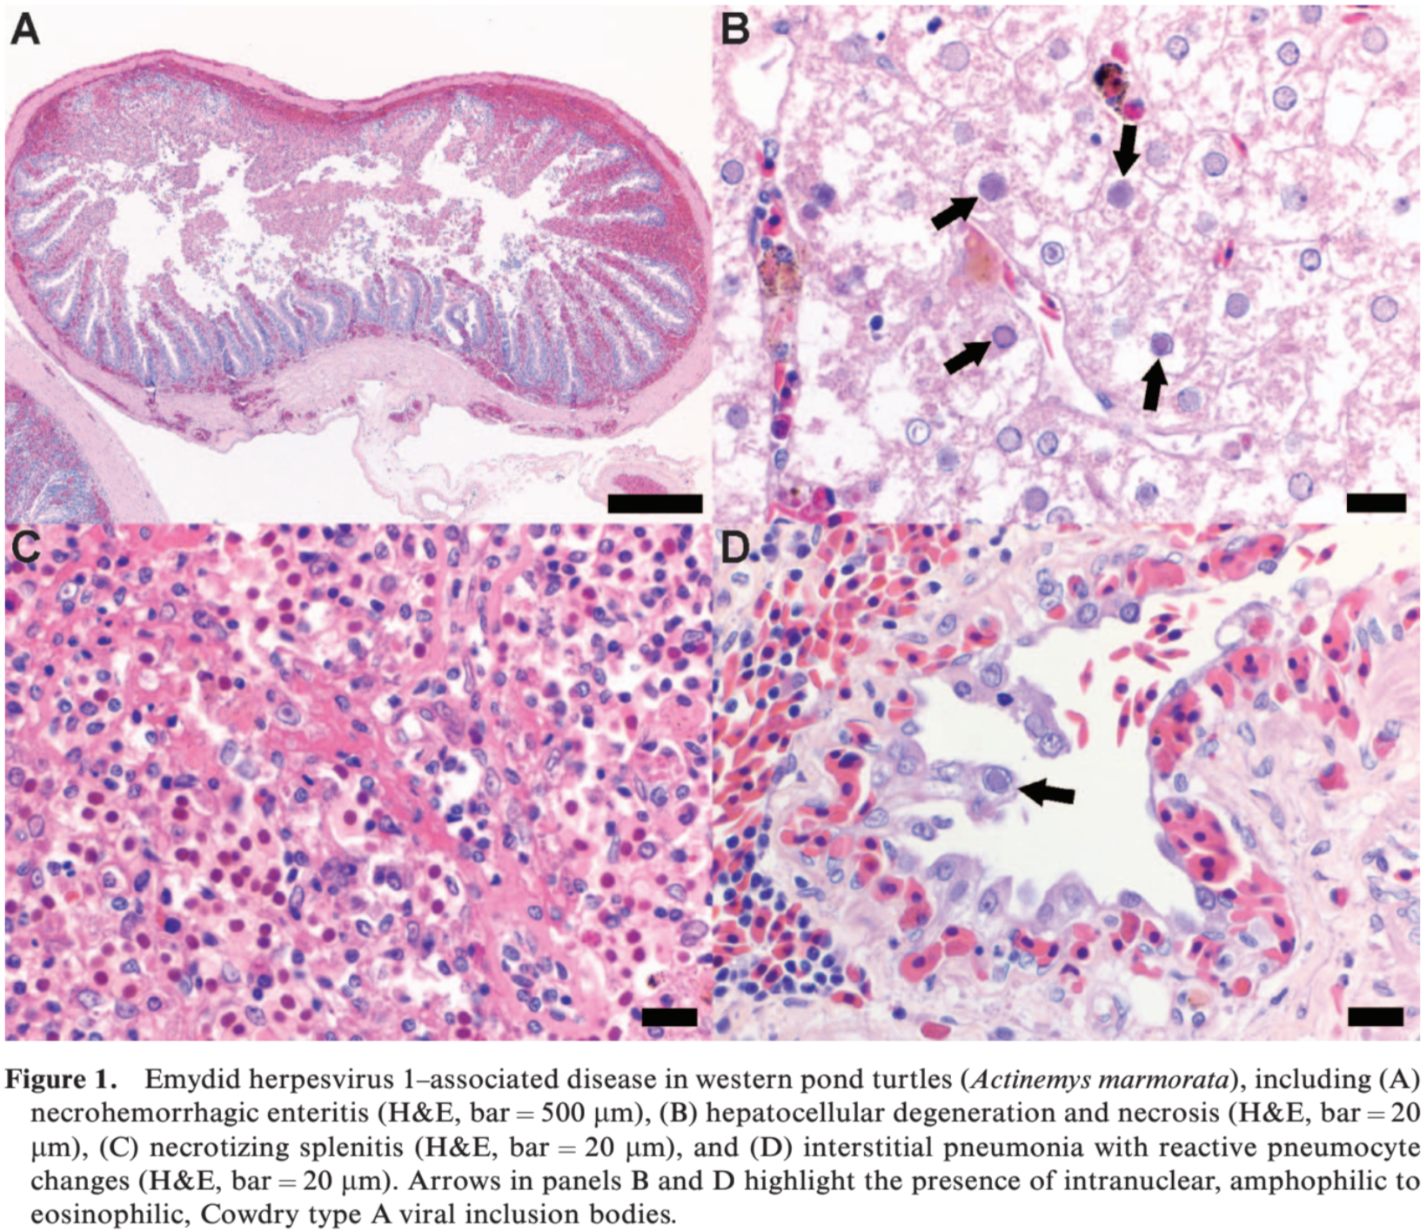

Epidemiology of Emydoidea herpesvirus 1 in free-ranging Blanding's turtles (Emydoidea blandingii) from Illinois.
Lindemann DM, Allender MC, Thompson D, Glowacki GA, Newman EM, Adamovicz LA, Smith RL.
Journal of Zoo and Wildlife Medicine. 2019;50(3):547-556.

Herpesvirus infections have been associated with high morbidity and mortality in populations of captive emydid chelonians worldwide, but novel herpesviruses have also recently been identified in apparently healthy free-ranging emydid populations. Blanding’s turtle (Emydoidea blandingii), an endangered species in Illinois, has experienced range-wide declines because of habitat loss, degradation, and fragmentation. A novel herpesvirus, Emydoidea herpesvirus 1 (EBHV1), was identified in Blanding’s turtles in DuPage County, IL, in 2015. Combined oral-cloacal swabs were collected from radio transmitter–fitted and trapped (n = 54) turtles multiple times over the 2016 activity season. In addition, swabs were collected at a single time point from trapped and incidentally captured (n = 84) Blanding’s turtles in DuPage (n = 33) and Lake (n = 51) counties over the same field season. Each sample was tested for EBHV1 using quantitative polymerase chain reaction (qPCR). EBHV1 was detected in 15 adult females for an overall prevalence of 10.8% (n =15/138; 95% confidence interval [CI]: 6.2– 17.3%). In radio transmitter–fitted females, there was a significantly higher prevalence of EBHV1 DNA in May (23.8%, n = 10/42) than June (3.6%, n = 1/28), July (0%, n = 0/42), August (0%, n = 0/47), or September (7.7%, n = 3/39) (odds ratio: 12.19; 95% CI: 3.60–41.30). The peak in May corresponds to the onset of nesting and may be associated with increased physiologic demands. Furthermore, all positive turtles were qPCR negative in subsequent months. There were no clinical signs associated with EBHV1 detection. This investigation is the critical first step to characterizing the implications of EBHV1 for Blanding’s turtle population health and identifying management changes that may improve sustainability.

Background
- Herpesviruses widespread in apparently healthy free-ranging emydid chelonian populations
  - Monophyletic cluster genus Scutavirus or Chelonivirus
  - 4 genetically distinct tortoise herpesviruses (Testudinid herpesvirus 1-4)
  - Also Emydid herpesvirus 1,2; Glyptemys herpesvirus 1,2; Terrapene herpesvirus 1,2
  - Lifelong infections and latency
  - Oral swabs suggested as best sample due to tropism for epithelial tissue
- Blanding’s turtles - endangered IUCN
  - Novel herpesvirus Emydoidea herpesvirus 1 in free-ranging Blandings turtles from IL - validated TaqMan quantitative PCR, sensitive and specific for this virus
  - Reported clinical signs: nasal discharge, ocular discharge, oral plaques, open-mouth breathing, skin lesions
Key Points
- Overall prevalence of EBHV1 on qPCR of apparently healthy Blanding’s turtles was 11%
- May had the highest prevalence - corresponds to onset of nesting, may be associated with increased physiologic stress during reproduction or increased turtle interaction during breeding or changes in temperature affected virus or immune system dynamics
- County was not related to qPCR results, interaction of county and month was not significant
- No clinical signs associated with EBHV1, all positive turtles were negative in every other month
- Median body mass, straight carapace length, total plastron length were larger for males than females
Conclusions
- Emydoidea herpesvirus 1 detected in healthy free-ranging Blanding’s turtles in IL on validated qPCR with highest prevalence in May and not dependent on county location
- Variable positive and negative samples in longitudinal study suggests subclinical shedding of a host-adapted virus with recrudescence from latency

