A comparison of laparoscopic and open ovariectomy techniques in rabbits showed which of the following differences?

- Open ovariectomies had a longer surgical time
- Laparoscopic ovariectomies had more intra-operative complications
- Open ovariectomies had smaller incisions
- Laparoscopic ovariectomies resulted in lower post-operative grimace score
- Open ovariectomies had decreased post-operative food consumption

Answer: B

A wild jack rabbit (Lepus alleni) presents with lethargy and epistaxis and dies shortly after intake. The gross lesions below are seen on necropsy, and histology reveals hepatocellular dissociation and necrosis, pulmonary edema and acute renal tubular injury. What is your top differential?

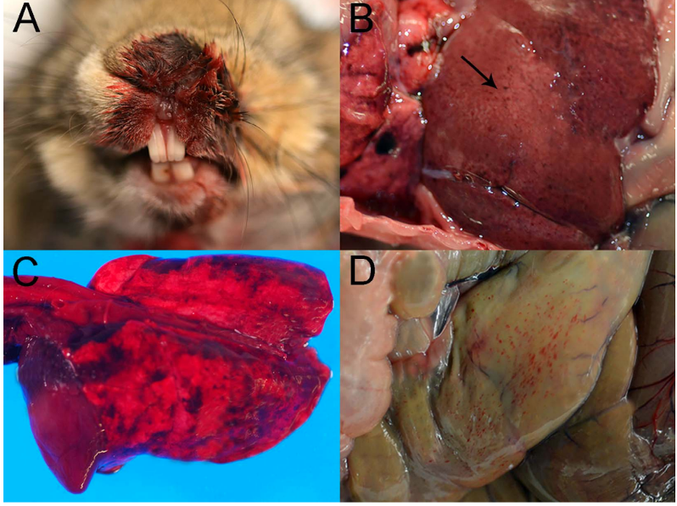

Answer: Rabbit hemorrhagic disease/RHDV2/b/GI.2

Practice Question: What is the most common uterine neoplasia in rabbits?

Answer: Endometrial adenocarcinoma

Practice Question: Which of the following is true regarding appendicitis in rabbits?
- More frequent in summer and fall
- Associated with severe hyperglycemia
- Associated with marked abdominal pain
- Appendectomy is not a viable treatment
- Causes chronic intermittent clinical signs

Answer: A

McLean, Euan J., Andrew P. Woodward, and Stewart D. Ryan. "Comparison of the use of a vessel-sealing device versus ligatures for occlusion of uterine tissues during ovariohysterectomy or ovariectomy in rabbits (Oryctolagus cuniculus)." American Journal of Veterinary Research 81.9 (2020): 755-759.
Practice Question - general rabbit uterine pathology
What is the most common reproductive pathology in domestic rabbits?
- Uterine inflammation
- Endometrial hyperplasia
- Ovarian cysts
- Uterine adenocarcinoma
- Hydrometra

Answer: D

Peña, Taryn, Luis Campoy, and Ricardo de Matos. "Investigation of a maxillary nerve block technique in healthy New Zealand White rabbits (Oryctolagus cuniculus)." American Journal of Veterinary Research 81.11 (2020): 843-848.

Practice Question – general rabbit dental disease
Which breed of rabbit is most likely to have congenital jaw mismatch?
- Flemish giant
- Standard rex
- New Zealand white
- Angora
- Netherland dwarf

Answer: E – dwarf breeds anatomically more prone to congenital dental disease which can warrant tooth extraction

Which of the following was found to be a negative prognostic indicator in domestic rabbits with liver lobe torsion?

- High Heart Rate
- Mild to Moderate Anemia
- Caudate Lobe Torsion
- High Blood Creatinine
- Low Blood BUN

Answer: A

The most commonly reported urolith in rabbits is

- Calcium phosphate
- Calcium oxalate
- Magnesium calcium phosphate
- Calcium carbonate
- Struvite

Answer: D

Investigation for correction formulas on the basis of packed cell volume for blood glucose concentration measurements obtained with portable glucometers when used in rabbits.
Cutler DC, Koenig A, Di Girolamo N, Mayer J.
American Journal of Veterinary Research. 2020;81(8):642-650.

Which of the following portable glucometers (PG) is expected to produce the most accurate measurement of blood glucose in a rabbit?

- Veterinary PG, canine setting, formula-corrected for hemoconcentration
- Veterinary PG, canine setting, with hematocrit within reference range
- Veterinary PG, feline setting, formula-corrected for hemodilution
- Human PG formula-corrected for hemoconcentration
- Human PG with hemodilution, without formula-correction

Answer: D
Human portable glucometer is more accurate in rabbits than veterinary portable glucometer on either setting and formula-correction improved accuracy of human PG in the face of abnormal PCV.

Prognostic indicators for survival of orphaned neonatal and juvenile eastern cottontail rabbits (Sylvilagus floridanus): 1,256 Cases (2012–17).
Principati, S.L., Keller, K.A., Allender, M.C., Reich, S. and Whittington, J.
Journal of wildlife diseases, 2020;56(3):523-529.

Which of the following factors predicts survival in orphaned neonatal eastern cottontail rabbits (Sylvilagus floridanus)?
- Number of neonates in the litter
- Hydration status
- Weight class
- Respiratory abnormalities
- Tube feeding requirements

Answer: A (singletons twice as likely to be nonsurvivors)

