Kabakchiev, Claudia, et al. "Comparison of intra−and postoperative variables between laparoscopic and open ovariectomy in rabbits (Oryctolagus cuniculus)." American Journal of Veterinary Research 82.3 (2021): 237-248.
OBJECTIVE To compare intraoperative and short-term postoperative variables pertaining to laparoscopic ovariectomy (LapOVE) and open ovariectomy (OVE) in rabbits (Oryctolagus cuniculus).
ANIMALS Twelve 4− to 5-month-old female New Zealand White rabbits.
PROCEDURES Rabbits were randomly assigned to undergo LapOVE (n = 6) or OVE (6), with a vessel-sealing device used to seal and transect the ovarian pedicles. Laparoscopic ovariectomy was performed with a 3-port approach. Variables were measured during surgery (surgery and anesthesia times and incision lengths) and for up to 7 days after surgery (food consumption, feces production, body weight, vital parameters, blood glucose and cortisol concentrations, abdominal palpation findings, facial grimace scale scores, and ethograms).
RESULTS Mean surgery (43.2 vs 21.7 minutes) and anesthesia (76.2 vs 48.8 minutes) times were longer and mean incision length was shorter (24.0 vs 41.5 mm) for LapOVE versus OVE. No significant differences in postoperative variables were identified between groups. During LapOVE, small intestinal perforation occurred in 1 rabbit, which was then euthanized. Postoperative complications for the remaining rabbits included superficial incisional dehiscence (LapOVE, 1/5; OVE, 2/6), subcutaneous emphysema (LapOVE, 1/5; OVE, 0/6), and seroma formation (LapOVE, 1/5; OVE, 0/6).
CONCLUSIONS AND CLINICAL RELEVANCE Surgery time for LapOVE was twice that of OVE, and LapOVE resulted in unique complications in rabbits. No evidence of a reduction in pain or faster return to baseline physiologic status was found for LapOVE. Further evaluation of LapOVE in rabbits is warranted, with modification to techniques used in this study or a larger sample size.

- Laparoscopic ovariectomy in rabbits (compared to traditional ovariectomy) had:
  - Longer surgical time and anesthesia time
  - Smaller incision
  - More difficulty removing the right ovary
  - More complications (intestinal perforation, superficial incisional dehiscence, SC emphysema, seroma)
- Traditional ovariectomy also had superficial incisional dehiscence
- No post op differences (food consumption, feces, weight, vitals, BG, cortisol, palpation, grimace, ethograms)

Conclusions: Longer surgery and anesthesia times and more complications for laparoscopic ovariectomies in rabbits but no difference from traditional post-op monitoring.

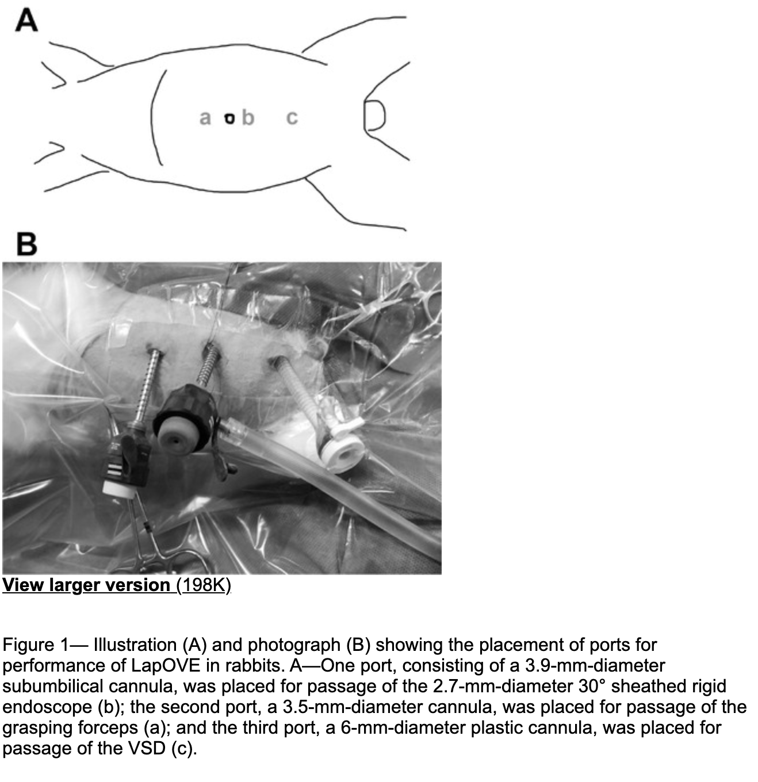
Pathology of Lagovirus europaeus GI.2/RHDV2/b (Rabbit Hemorrhagic Disease Virus 2) in Native North American Lagomorphs
Journal of Wildlife Diseases, 57(3), 2021, pp. 694–700

ABSTRACT: Rabbit hemorrhagic disease, a notifiable foreign animal disease in the US, was reported for the first time in wild native North American lagomorphs in April 2020 in the southwestern US. Affected species included the desert cottontail (Sylvilagus audubonii), mountain cottontail (Sylvilagus nuttallii), black-tailed jackrabbit (Lepus californicus), and antelope jackrabbit (Lepus alleni). Desert cottontails (n=7) and black-tailed jackrabbits (n=7) collected in April and May 2020 were necropsied at the US Geological Survey National Wildlife Health Center and tested positive for Lagovirus europaeus GI.2, also known as rabbit hemorrhagic disease virus 2 (GI.2/RHDV2/b), by real-time PCR at the US Department of Agriculture’s Foreign Animal Disease Diagnostic Laboratory. Gross and microscopic lesions were similar to those reported in European rabbits (Oryctolagus cuniculus) and other hare (Lepus) species with GI.2/RHDV2/b infection; they included epistaxis (12/13; 92%); massive hepatocellular dissociation (14/14; 100%) and necrosis or apoptosis (11/11; 100%); pulmonary congestion (12/12; 100%), edema (12/13; 92%), and hemorrhage (11/12; 92%); and acute renal tubular injury (3/8; 38%). As in previous reports, massive hepatocellular dissociation and necrosis or apoptosis was the most diagnostically distinct finding. As North American Sylvilagus and Lepus species appear to be susceptible to fatal GI.2/RHDV2/b infection, additional work is needed to understand the host range, pathogenicity, and potential population effects of GI.2/ RHDV2/b in North America

Key points
- Rabbit hemorrhagic disease virus (Lagovirus europaeus GI.1/RHDVa) is a Lagovirus in the family Caliciviridae, with a host range primarily limited to the European rabbit
  - First detected in China in 1984
- A second pathogenic Lagovirus, rabbit hemorrhagic disease virus 2 (Lagovirus europaeus GI.2/RHDV2/b), emerged in France in 2010
- This strain also exhibits high virulence in O. cuniculus and has spread rapidly throughout the world
- Compared to GI.1/RHDVa, GI.2/RHDV2/b shows: a broader host range, including multiple hare species
- Here, we report postmortem findings in desert cottontails and black-tailed jackrabbits naturally infected with GI.2/RHDV2/b and compare them to findings in Old World lagomorph species.
- n=14
- Adults were more common than juveniles (9/14 adult; 64%), and females were overrepresented (10/14 female; 71%)
- Most animals (10/14; 71%) were in poor body condition with depleted fat stores
- Consistent gross findings included epistaxis (12/13; 92%); a tan friable liver with an enhanced reticular pattern or pinpoint red capsular foci (13/14; 93%); and wet and heavy lungs that were mottled pink to red or red to dark red (14/14; 100%)
- Microscopic findings: dissociation (14/14; 100%) and necrosis or apoptosis (11/11; 100%) of hepatocytes, lung congestion (12/12; 100%), edema with increased numbers of intra-alveolar macrophages (12/ 13; 92%), intra-alveolar hemorrhage (11/12; 92%)
- In the kidney, there was frequent accumulation of hemoglobin, red blood cells, or protein in renal tubules (9/14; 64%) and acute tubular injury (3/8; 38%)
- All animals tested positive for GI.2/ RHDV2/b and negative for GI.1/RHDVa by real-time PCR
- Disease severity subjectively worse in jackrabbits (grossly and microscopically)
- Comparing microscopic lesion prevalence in adults vs. juveniles, renal lesions were more common in adults
- Pathologic findings associated with GI.2/RHDV2/b infection in cottontails and jackrabbits are consistent with those reported in European lagomorphs
- Other lesions reported with GI.2/RHDV2/b infection in O. cuniculus that were not found in our cases include glomerular or pulmonary fibrin thrombi ; significant heterophilic inflammation in the liver associated with areas of necrosis and various splenic lesions
- the presence of massive hepatocellular dissociation with necrosis or apoptosis was the most diagnostically distinct feature of GI.2/ RHDV2/b infection, as both epistaxis and pulmonary edema or congestion were common postmortem findings in GI.2/RHDV2/b–negative animals

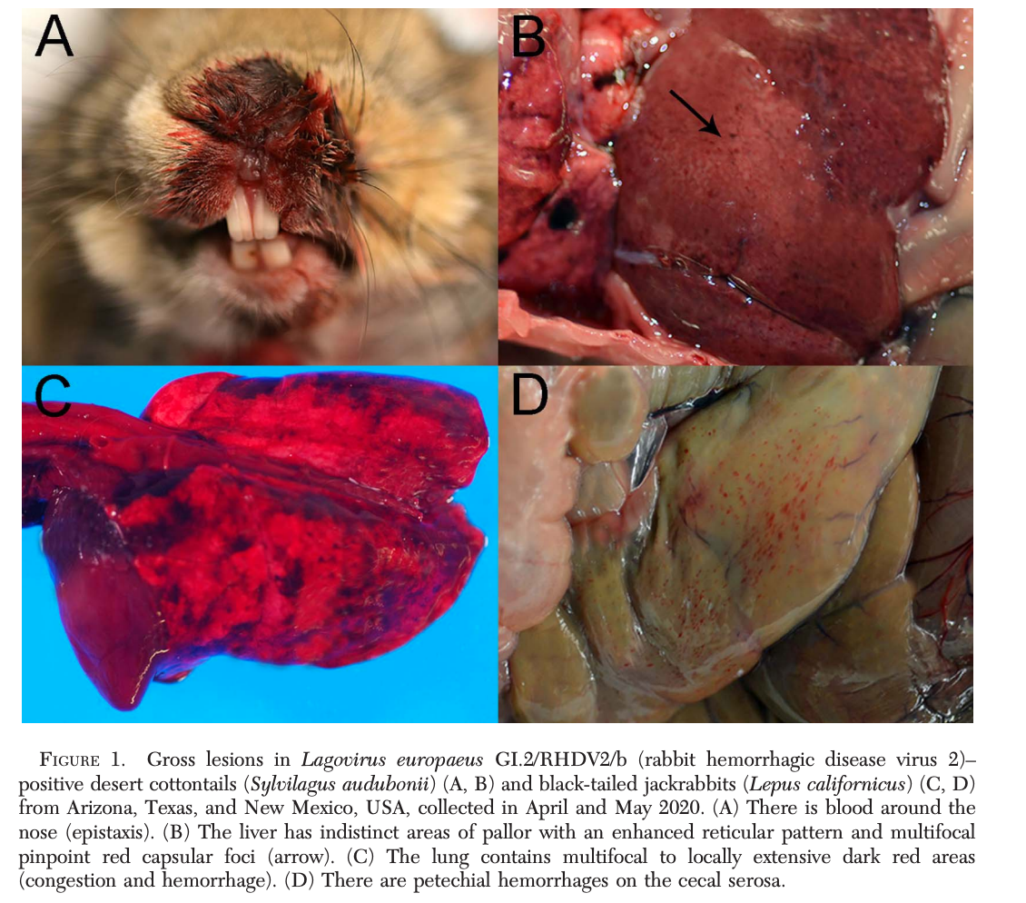

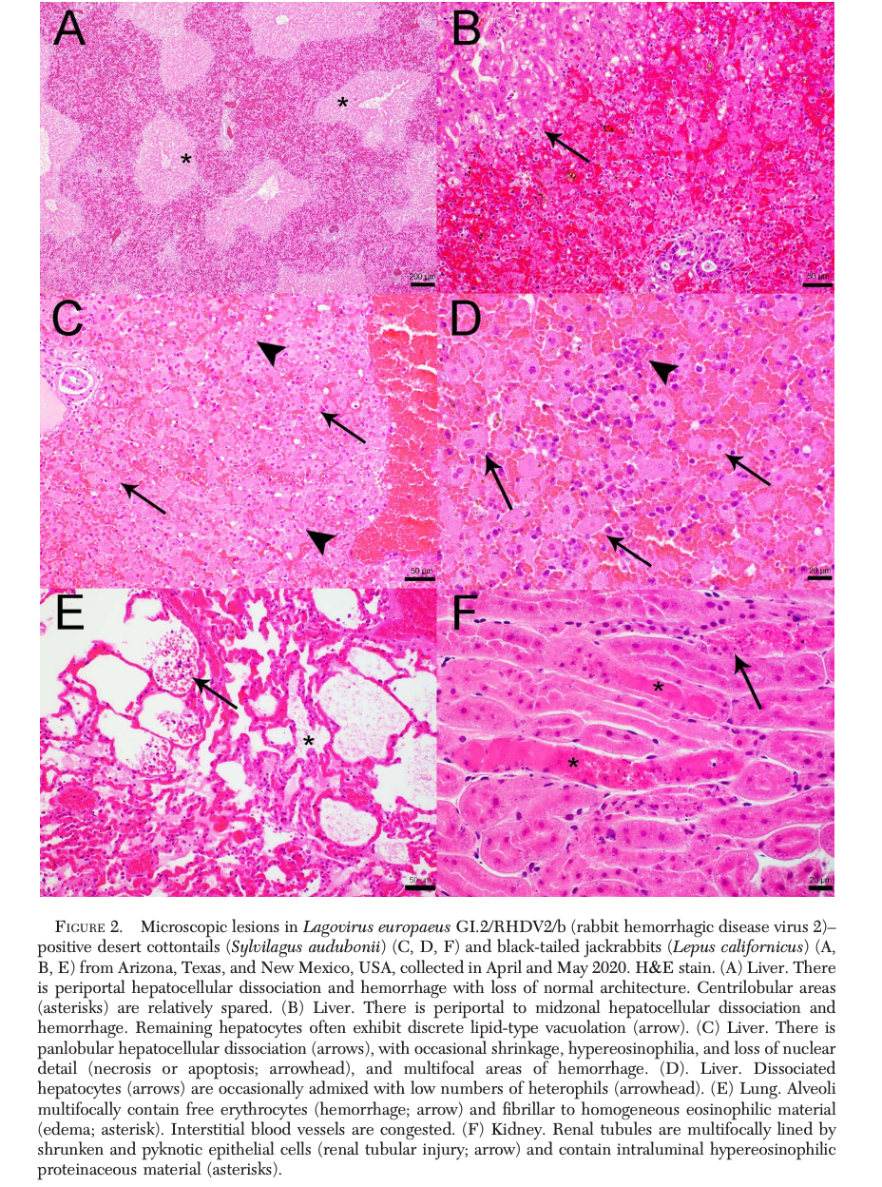

JAVMA 2020 257(10):1045-1050
Assessment of reported uterine lesions diagnosed histologically after ovariohysterectomy in 1,928 pet rabbits (Oryctolagus cuniculus)
Settai K, Kondo H, Shibuya H

ABSTRACT:
Objective: To assess variations in age, breed, and clinical signs in rabbits with neoplastic or nonneoplastic uterine lesions and to investigate potential relationships between endometrial adenocarcinoma and age at ovariohysterectomy or breed in rabbits.
Animals: 1,928 rabbits that underwent ovariohysterectomy for treatment or prevention of possible uterine disease.
Procedures: With an online questionnaire distributed to 441 veterinary hospital members of the Japanese Society of Exotic Pet Medicine, data were retrospectively collected regarding age, breed, and findings on physical and histologic examinations for pet rabbits that underwent ovariohysterectomy between January 1, 2009, and April 30, 2018. Rabbits were grouped by reported age, breed, clinical signs, and uterine lesions, and results were assessed across groups. Logistic regression analysis was used to identify potential relationships between endometrial adenocarcinoma and breed or age at ovariohysterectomy in rabbits.
Results: The questionnaire response rate was 9.8% (43/441), with data reported for 1,928 rabbits (mixed breed, 600 [31.1%]; Netherland Dwarf, 520 [27.0%]; Holland Lop, 286 [14.8%]; or various other breeds, 522 [27.1%]). The most commonly reported neoplastic and nonneoplastic lesions were endometrial adenocarcinoma (1,035/1,928 [53.7%]) and endometrial hyperplasia (842 [43.7%]), respectively, and the most commonly reported clinical sign was hematuria or serosanguineous vaginal discharge (1,020/1,928 [52.9%]). As age at ovariohysterectomy increased, so did the odds (OR, 1.826; 95% CI, 1.640 to 2.033) of uterine adenocarcinoma.
Conclusions and clinical relevance: Results supported ovariohysterectomy in rabbits before 2 years of age as a key preventative measure to mitigate uterine disease, particularly endometrial adenocarcinoma.
Background:
- Uterine disease in rabbits generally progresses slowly
  - Clinical signs: lethargy, anorexia, hematuria, serosanguineous vaginal discharge, mammary gland abnormalities, or urethral obstruction
- Uterine tumors in rabbits may metastasize in 1-2 years
Key Points:
- Multi-center retrospective study in Japan (1,928 cases) over 9-year period
- Most common neoplastic uterine lesion: endometrial adenocarcinoma
  - 2nd, 3rd, 4th: leiomyoma, leiomyosarcoma, endometrial adenoma
- Most common non-neoplastic uterine lesion: endometrial hyperplasia
  - 2nd & 3rd: adenomyosis and venous aneurysms
- Age at ovariohysterectomy was associated with endometrial adenocarcinoma
  - As age increased, so did the odds of endometrial adenocarcinoma
- Most common signs of uterine lesions: hematuria or serosanguineous vaginal discharge

TLDR: Spay rabbits < 2yo to prevent uterine disease, especially endometrial adenocarcinoma or hyperplasia

Related Articles: None on the current ACZM reading list
JAVMA 2021 260(1):82-93
Clinical, surgical, and pathological findings in client-owned rabbits with histologically confirmed appendicitis: 19 cases (2015-2019)
Di Girolamo N, Petrini D, Szabo Z, et al

ABSTRACT:
Objective: To report clinical, surgical, and pathological findings in client-owned rabbits with histologically confirmed appendicitis.
Animals: 19 rabbits.
Procedures: Medical records for client-owned rabbits that had a histologic diagnosis of appendicitis were reviewed.
Results: Median age of the rabbits at presentation was 24.0 months (range, 4 to 84 months). Seventeen cases occurred during the summer and fall seasons. Decreased appetite (17/19 rabbits), abnormal rectal temperature (hyperthermia, 9/16 rabbits; hypothermia, 4/16 rabbits), hypocalcemia (8/11 rabbits), and hypoglycemia (7/15 rabbits) were common signs. Abdominal ultrasonography and CT findings were suggestive of appendicitis in 6 of 8 rabbits and in 1 of 2 rabbits, respectively. Of the 6 rabbits that received medical treatment, 3 died at 48 hours, 1 died at 24 hours after hospitalization, and 1 died at 10 days after presentation; 1 rabbit was alive at 1,030 days after presentation. Of the 8 rabbits that underwent appendectomy, 3 died before discharge from the hospital and 1 died 113 days after surgery; 4 rabbits were alive at 315, 334, 1,433, and 1,473 days after presentation. The remaining 5 rabbits either died or were euthanized before treatment could be instituted. In each of the 19 rabbits, the appendix had evidence of severe inflammation with mucosal ulceration, heterophilic inflammation, and necrotic debris.
Clinical relevance: For rabbits with decreased appetite and an apparently painful abdomen, hyperthermia, hypocalcemia, or hypoglycemia, appendicitis should be considered as a differential diagnosis. Further comparisons of medical and surgical treatments are required to establish treatment recommendations for rabbits with appendicitis.

Key Points:
- International, multi-center retrospective study (19 cases) over 4-year period
- Unique anatomic feature of rabbits = distinct vermiform appendix at apex of the cecum
  - Other species with a well-developed appendix:
    - Humans, some primates, other lagomorphs, wombats, and selected rodents
  - Part of GALT alongside Peyer patches, ileocecal plaque, and sacculus rotundus
    - Predominantly B-cell production in the appendix
  - Inconsistent use of nomenclature in the literature
- Except for 2 rabbits, all cases occurred in summer and fall
  - Possible higher environmental temp is a factor in acute appendicitis
- Median age = 2yo; appendicitis could be more common in young rabbits
- Majority of cases were anorexic and/or lethargic (non-specific clinical signs)
  - Clinical signs were acute (< 48 hours) or non-existent
  - Over half of the cases were hyperthermic, the rest were hypothermic to normothermic
- Key clinicopathologic findings: hypocalcemia (8/11) and hypoglycemia (7/15 rabbits)
  - Anemia was the most common hematologic abnormality (7/12 rabbits)
  - Most likely cause of anemia in association with appendicitis was systemic inflammation
- US and CT = only diagnostics that resulted in antemortem diagnosis
  - Possible suggestive imaging findings: increased wall thickness, loss multilayered structure, increased overall diameter of the appendix, presence of fluid or mucoid content rather than alimentary content
- Ileocecal fold = short mesenteric ligament connecting the ileum to the appendix in rabbits
  - Must excise ileocecal fold to isolate the appendix from rest of GI tract
  - Radiosurgery advised given large number of small vessels
  - Ligation of the appendix in 8 rabbits was performed with 2 distinct approaches
    - First half underwent circumferential ligation of the appendix at point of origin in the cecum -> placement of an intestinal clamp distal to the sutures -> subsequent excision of the appendix
    - Other half underwent excision of the appendix after placement of intestinal clamps or application of digital pressure by an assistant at the base of the appendix -> closure of the cecum with simple interrupted suture
    - All the rabbits treated with the first approach survived, whereas 3/4 rabbits treated with the second approach died before hospital discharge
  - Safer to ligate the appendix with a simple or double ligature before its excision
- In humans, controversy over exact pathophysiology of appendicitis
  - Debate whether bacterial flora differs between patients with and without appendicitis
  - Unclear bacteria isolated from the rabbits of the present study were responsible for the development of appendicitis or proliferated as a consequence of the intestinal dysbiosis

TLDR:
- Appendicitis is associated with unspecific clinical signs, may be an acute or chronic clinical condition, and may develop more frequently in younger rabbits and/or during warmer months. Anemia, hypocalcemia, and hypoglycemia may be present. US and CT are preferred antemortem diagnostics. Appendectomy may be a viable treatment; ligate the appendix before its excision.

Related Articles:
- Oparil KM, Gladden JN, Babyak JM, Lambert C, Jennifer E Graham JE. Clinical characteristics and short-term outcomes for rabbits with signs of gastrointestinal tract dysfunction: 117 cases (2014–2016). J Am Vet Med Assoc. 2019;255(7):837–845
- Quesenberry KE, Carpenter JW. Ferrets, Rabbits and Rodents: Clinical Medicine and Surgery. 4th ed. Saunders Elsevier; 2020.

Useful Figures:
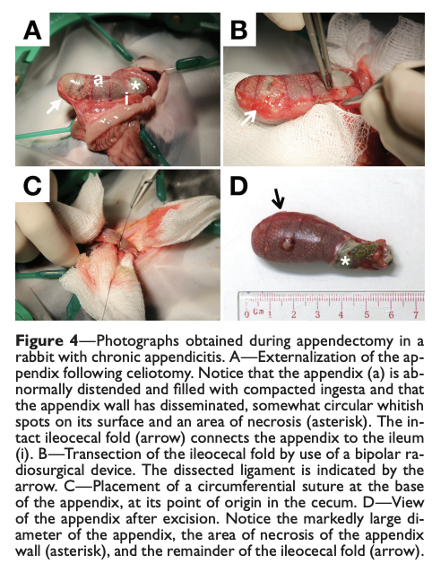
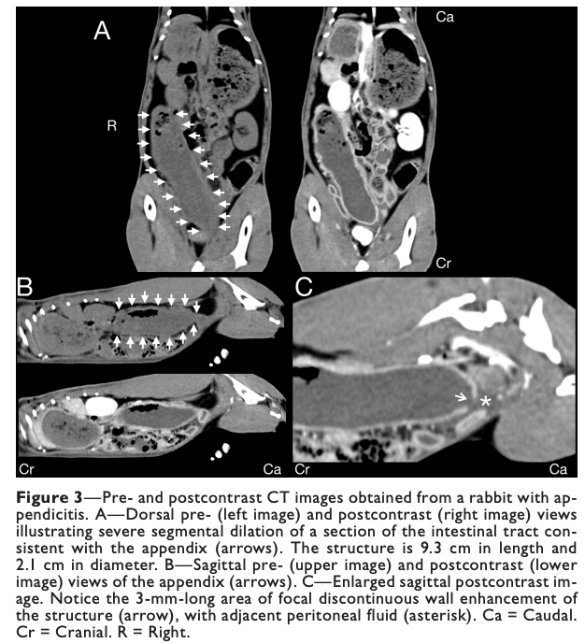
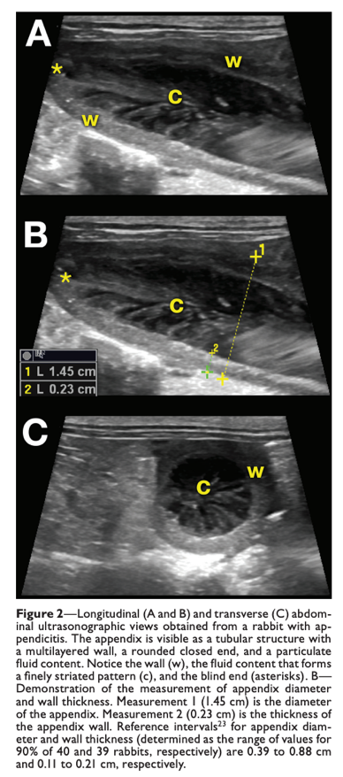
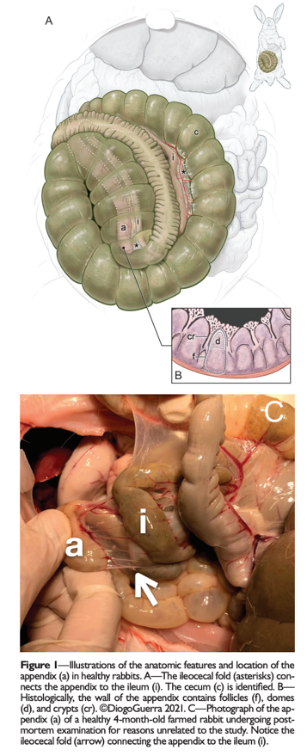
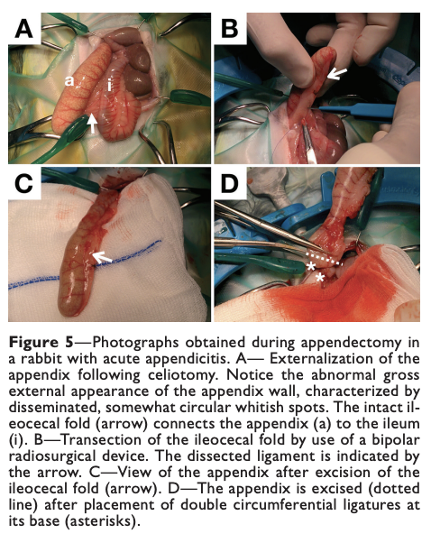

McLean, Euan J., Andrew P. Woodward, and Stewart D. Ryan. "Comparison of the use of a vessel-sealing device versus ligatures for occlusion of uterine tissues during ovariohysterectomy or ovariectomy in rabbits (Oryctolagus cuniculus)." American Journal of Veterinary Research 81.9 (2020): 755-759.

Abstract
OBJECTIVE: To compare the bursting strength of the uterine horns (UHs) and cervical-vestibule junction (CVJs) of rabbits following sealing with a vessel-sealing device (VSD) or encircling ligatures.
SAMPLE: UHs and CVJs collected from 30 rabbit (Oryctolagus cuniculus) cadavers.
PROCEDURES: UHs and CVJs were randomly assigned to sealing with encircling Miller knot ligatures (LIG; n = 10 CVJs and 20 UHs) or a VSD (12 CVJs and 24 UHs). Lumens were infused with saline (0.9% NaCl) solution under pressure until seals burst or to a maximum pressure of 300 mm Hg.
RESULTS: For CVJs, median (range) bursting pressure of the LIG and VSD groups was > 300 mm Hg (224 to > 300 mm Hg) and 35 mm Hg (0 to 60 mm Hg), respectively. Five of 12 CVJs in the VSD group failed at pressures < 33 mm Hg. For UHs, median (range) bursting pressure of the LIG and VSD groups was 255 mm Hg (120 to > 300 mm Hg) and 154 mm Hg (range, 44 to 202 mm Hg), respectively.
CONCLUSIONS AND CLINICAL RELEVANCE: The evaluated VSD was effective in sealing UHs at bursting pressures well in excess of expected physiologic pressures, indicating that the VSD may be useful for ovariectomy procedures in rabbits. However, CVJ seals created with the VSD were ineffective and could potentially burst at low pressures, which could predispose to urine entering the abdomen. Given these results, we do not recommend sealing of the CVJ with a VSD for ovariohysterectomy in rabbits.

Goal of Study
- To determine if vessel-sealing device could create strong enough seal for OHE or OVE in rabbits

Study Design/Methods
- Pressure tested cadaver uterine horns (UH, n=44) and cervical-vestibule junctions (CVJ, n=22) with vessel-sealing device vs. circumferential miller knot ligation

Background
- 80% of rabbits develop uterine pathology by 6 years of age and can develop as young as 2 years of age
- Anatomy: two separate bicornuate UGs → 2 cervices (with no uterine body) → vaginal vestibule
- Perioperative mortality rate for rabbits anesthetized for routine procedures is 5x other animals
- Mean maximal intrauterine pressure during parturition is 33.0 mmHg
- Advantages of VSD: reduced anesthesia time, less tissue handling, no foreign material/sutures
- Major determining factor in the efficacy of bipolar vessel-sealing devices is collagen-to-elastin ratio of tissue because sealing is achieved by denaturation and cross-linking of collagen and elastin fibers

Key Points
- Cervical-vestibule junction had much higher bursting pressure with ligature (med >300 mmHg) compared to sealing device (med 35 mmHg) suggesting sealing device should not be used at this site
- Uterine horn had much higher bursting pressure with ligature (255 mmHg) than vessel-sealing device (154 mmHg) but withstood pressures higher than physiologically expected (<33.0 mmHg) and could be utilized at this site
- The VSD failed to achieve a reliable seal in the CVJ of rabbits but did produce a reliable seal in the UHs**

Peña, Taryn, Luis Campoy, and Ricardo de Matos. "Investigation of a maxillary nerve block technique in healthy New Zealand White rabbits (Oryctolagus cuniculus)." American Journal of Veterinary Research 81.11 (2020): 843-848.

Abstract:
OBJECTIVE: To investigate use of a candidate maxillary nerve block in rabbits.
ANIMALS: 13 healthy New Zealand White rabbits (Oryctolagus cuniculus).
PROCEDURES: In phase 1, the maxillary nerve block procedure was performed in 7 sedated rabbits with 2 volumes (0.25 and 0.5 mL) of a saline (0.9% NaCl)–tissue marker dye solution (1 injection/side by random assignment). Rabbits were euthanized and dissected; numeric scales were used to rate injection accuracy and extent of staining. In phase 2, the nerve block was performed with articaine hydrochloride–epinephrine solution (0.5 mL) on a randomly assigned side in 6 sedated rabbits, with the contralateral side used as a control. Sensory function of the relevant dermatome was tested in triplicate with an algesiometer 0, 30, and 90 minutes after recovery from sedation. Statistical methods were used to compare results between injection volumes (phase 1) and between treated and control sides (phase 2).
RESULTS: In phase 1, dye was in contact with the targeted nerve after 13 of 14 injections. Accuracy and extent of staining did not differ significantly between volumes. In phase 2, algesiometer-applied force tolerance differed significantly between treated and control sides 30 minutes after recovery from sedation (56 to 145 minutes after the nerve block procedure). No adverse effects were detected in either study phase.
CONCLUSIONS AND CLINICAL RELEVANCE: The described technique for a maxillary nerve block was accurate and effective for desensitization of the relevant dermatome as assessed by algesiometry in healthy rabbits. Additional studies are needed to assess use of this procedure in rabbits of other breeds and its efficacy for clinical use.

Goal of Study
- Investigate novel approach for maxillary nerve block in rabbits

Study Design/Methods
- Phase I: assessed injection technique by injecting two different volumes of dyed saline and evaluating accuracy and extent of staining post-mortem
- Phase II: tested analgesic efficacy by performing unilateral nerve block (0.5 mL; 4% articaine hydrochloride + epinephrine) and testing with algesiometer (tests sensory function of relevant dermatome)

Background
- Elodont (continuous eruption) and hypsodont (long crowns) dentition
- Normal approaches in dogs not technically successful in rabbits due to maxillofacial anatomy - (1) infraorbital approach - infraorbital n branch of maxillary n occupies most of infraorbital canal which risks direct damage to the nerve; (2) retrograde infraorbital approach - bone plate between infraorbital canal and nasal cavity is thin and cavitated which risks nasal cavity puncture

Key Points
- Landmarks for block = facial tubar + zygomatic arch
- Significant difference between blocked side and non-blocked side at 77 minutes post-injection (30 minutes after recovery) thus suspect this method can provide short term analgesia
- Note: there was no difference at time of recovery (~41 minutes post-injection) which they suspect is due to low sample size or prolonged analgesia from initial sedation
- No adverse effects reported in these 6 rabbits
- Maxillary nerve block via the novel candidate maxillary approach was accurate and effective for desensitization**
- Do not recommend at this time due to need to assess effectivity/adverse effects when disease is present

Useful figures
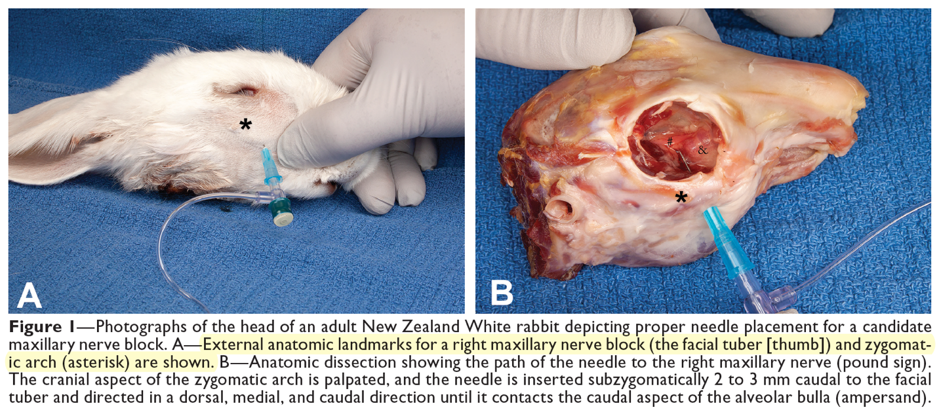

Ozawa, Sarah M., et al. "Clinicopathological findings in and prognostic factors for domestic rabbits with liver lobe torsion: 82 cases (2010–2020)." Journal of the American Veterinary Medical Association 1.aop (2022): 1-9.

OBJECTIVE: To document clinicopathologic findings in domestic rabbits with liver lobe torsion and identify prognostic factors.
ANIMALS: 82 rabbits.
PROCEDURE: Medical records of 4 institutions were reviewed to identify rabbits with an antemortem diagnosis of liver lobe torsion that were examined between 2010 and 2020.
RESULTS: The prevalence of liver lobe torsion was 0.7% (82/11,402). In all 82 rabbits, the diagnosis was made by means of abdominal ultrasonography. Fifty (60.1%) rabbits underwent liver lobectomy, 23 (28%) received medical treatment alone, and 9 (10.9%) were euthanized or died on presentation. Overall, 32 (39%) rabbits died within 7 days of initial presentation and 50 (61%) survived. Seven-day survival rate did not differ significantly between medical treatment alone and surgical treatment. However, median survival time following medical treatment (530 days) was shorter than that following surgical treatment (1,452 days). Six of 14 rabbits had evidence of systemic inflammatory disease on necropsy. Rabbits with right liver lobe torsion were less likely to survive for 7 days than were those with caudate torsions (P = 0.046; OR, 3.27; 95% CI, 1.04 to 11.3). Rabbits with moderate to severe anemia were less likely to survive for 7 days than were rabbits that were not anemic or had mild anemia (P = 0.006; OR, 4.41; 95% CI, 1.55 to 12.51). Other factors associated with a decreased 7-day survival rate were high heart rate at admission (P = 0.013) and additional days without defecation after admission (P < 0.001). Use of tramadol was associated with an increased survival rate (P = 0.018).
CLINICAL RELEVANCE: The prognosis for rabbits with liver lobe torsions was more guarded than previously described. Rabbits that underwent liver lobectomy had a longer median survival time than did rabbits that only received medical treatment.

Key Points:
- 31.7% of rabbits were diagnosed between 2010-2015; 68.3% made between 2016-2020
- Lops were the most common breed
- Most common complaints: hyporexia, anorexia, lethargy, decreased defecation: NEED FURTHER WORKUP
- Most rabbits were normoglycemic, 11.3% had high creatinine, 77.5% had high BUN
- ALT elevated in 94.5% of rabbits: normal hepatic enzyme activities with other compatible clinical signs does not rule out liver lobe torsion
- TB was elevated in 4.4%
- Surgery 72% survived at least 7 days, Medical management 60.9% survived BUT mean survival time was much longer with surgery 1,452 days compared to medical management 530 days
- 15 rabbits never defecated and all died
- Caudate lobe affected 74% and right liver lobe 20.1%- right liver lobe associated with less likely survival
- Higher HR=poor prognosis
- Severe anemia= poor prognosis
- Suspect tramadol had a higher survival rate because it was sent home with stable rabbits
- Prognosis is less favorable than previously described
- Rabbits with higher HR, increasing number of days without defecation, right liver lobe torsion, or moderate to severe anemia were less likely to survive

Wong, A. D., et al. "Associations between biochemical parameters and referral centre in pet rabbits with urolithiasis." Journal of Small Animal Practice 62.7 (2021): 554-561.

Objectives: To determine the association between signalment, selected haematologic and biochemical parameters and referral centre in pet rabbits with imaging evidence of urolithiasis presented to two veterinary teaching hospitals in North America.

Materials and Methods: The medical record database of two veterinary teaching hospitals was searched from 2009 to 2019 for records of pet rabbits that received both imaging studies and plasma biochemistry profiles. Information regarding signalment, bodyweight, packed cell volume, total solids, and plasma biochemistry profiles was obtained. Univariable and multivariable logistic regression models were performed to identify statistically significant parameters associated with imaging evidence of urolithiasis.

Results: Of the 324 examined rabbits, 33 (10.2%) had confirmed evidence of urolithiasis on imaging. Increasing plasma calcium and sodium concentrations and referral centre were significantly associated with the presence of urolithiasis on the univariable logistic regression model. However, only plasma calcium concentration and the referral centre demonstrated significant associations on the multivariable logistic regression model.

Clinical Significance: Results indicate that urolithiasis in pet rabbits that receive imaging is associated with mildly increasing plasma calcium concentration and referral centre. The association with referral centre may indicate there are geographic influences on urolithiasis or on imaging. However, the identified associations have low predictive value for the diagnosis of urolithiasis, indicating the need for additional diagnostic modalities.
Key Points:
- Rabbits filter a large amount of calcium through kidneys and excrete calcium through the urine
- Most common stone (69.4%) is calcium carbonate
- Three variables were significantly associated with the presence of urolithiasis in rabbits
  - Sodium- increased
  - Calcium- Increased
  - Referral Center- Institution 2 over 1
- Plasma calcium though positively associated with urolithiasis- determined to have low predictive value to discriminate between rabbits with positive or negative imaging evidence of uroliths. Calcium was only mildly increased compared to rabbits without uroliths (0.125 mmol/L)
- Imaging needed to confirm uroliths
- Other risk factors for uroliths include: dehydration, inactivity and urine retention
- As far as referral center: possible water differences (hard vs soft); geographical influence on disease process, decision for imaging, husbandry of rabbits, diets, socioeconomic ability and motivation of owners
- Recommend looking further into ionized calcium, validating an SDMA assay for rabbits

Investigation for correction formulas on the basis of packed cell volume for blood glucose concentration measurements obtained with portable glucometers when used in rabbits.
Cutler DC, Koenig A, Di Girolamo N, Mayer J.
American Journal of Veterinary Research. 2020;81(8):642-650.

OBJECTIVE: To determine effects of PCV on blood glucose (BG) concentration measurements obtained with a human portable blood glucometer (HPBG) and a veterinary portable blood glucometer (VPBG) on canine (cVPBG) and feline (fVPBG) settings (test methods) when used in rabbits and to develop correction formulas to mitigate effects of PCV on such measurements.
SAMPLE: 48 resuspended blood samples with known PVCs (range, 0% [plasma] to 92% [plasma and packed RBCs]) from 6 healthy research rabbits (experimental sample set) and 252 historic measurements of BG concentration and PCV in 84 client-owned rabbits evaluated at a veterinary hospital (validation data set).
PROCEDURES: Duplicate measurements of BG concentration with each test method and of PCV were obtained for each sample in the experimental sample set, and the mean results for each variable for each test method and sample were compared with results from a clinical laboratory analyzer (reference method) used to determine the true BG concentration for each sample. Mean ± SD differences in measurements between the reference and test methods were calculated. Linear regression and modified Clarke error grid analysis were used to develop correction formulas for the test methods given known PCVs, and these formulas were evaluated on the validation data set with linear regression and a modified Clarke error grid.
RESULTS: Blood glucose concentrations were falsely low for cVPBG and fVPBG used on samples with PCV < 31% and were falsely high for all test methods used on samples with PCV > 43%. Compared with original measurements, formula-corrected measurements overall had better agreement with reference method measurements for the experimental sample set; however, only the formula-corrected HPBG measurements had improved agreement for the validation data set.
CONCLUSIONS AND CLINICAL RELEVANCE: Findings indicated that, in rabbits, HPBG measurements had improved accuracy with the use of the correction formula HPBG measurement of BG concentration + ([0.75 × PCV] − 15); however, the correction formulas did not improve the accuracy of VPBG measurements, and we believe that neither the cVPBG nor fVPBG should be used in rabbits.

Background
- Vet portable glucometers account for different proportions of glucose inside vs outside RBCs with internal proprietary algorithms
  - Humans, NHP, and odontocetes have higher glucose conc in RBC’s compared to other mammals
  - Rabbit % gluc in RBC’s is most similar to dogs
- Hemoconcentration falsely lowers portable BG measurements, hemodilution falsely increases
  - Thought to be related to the degree of plasma displacement by RBCs
  - Coulometric technology is least affected by Hct interference
- Selleri P, Di Girolamo N, Novari G. Performance of two portable meters and a benchtop analyzer for blood glucose concentration measurement in rabbits. Journal of the American Veterinary Medical Association. 2014 Jul 1;245(1):87-98.
  - Human portable BG underestimated BG, decreased accuracy at high Hct, had lowest error
  - Vet portable BG overestimated BG, decreased accuracy at low an dhigh Hct, highest error
    - Canine setting had most potential for clinical errors, followed by feline
- BG >360 mg/dL in rabbits has worse prognosis, BG is higher with GI obstruction than stasis (450 vs 150)
- Na <129 mEq/L in rabbits had 2.3-fold increased risk of death within 7 days of clinical presentation
Key Points
- Human - Accu-Chek Aviva (glucose dehydrogenase, amperometric method to measure BG)
- Vet - AlphaTRAK 2 (glucose dehydrogenase, coulometric biosensor to measure BG)
- Benchtop - Hitachi (hexokinase oxidase reaction)
- Human portable BG was more consistent with benchtop than Vet portable on either setting
- PCV affected BG, correction formulas were created
  - Agreement was improved for human portable BG but not for Vet on feline setting (canine not evaluated due to variability in results)
  - Inherent random error of Vet portable BG likely reduced improvement with correction formulas
- 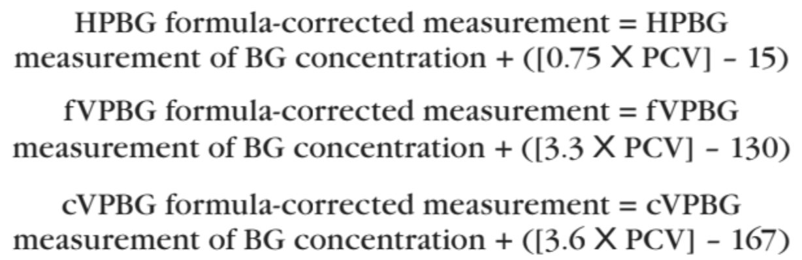
Conclusions
- Correction formulas were created and validated that mitigated effect of PCV on BG and improved accuracy of human portable glucometer (but not veterinary portable glucometer) when used in rabbits
- Human portable BG is preferred over Vet portable BG on either setting in rabbits

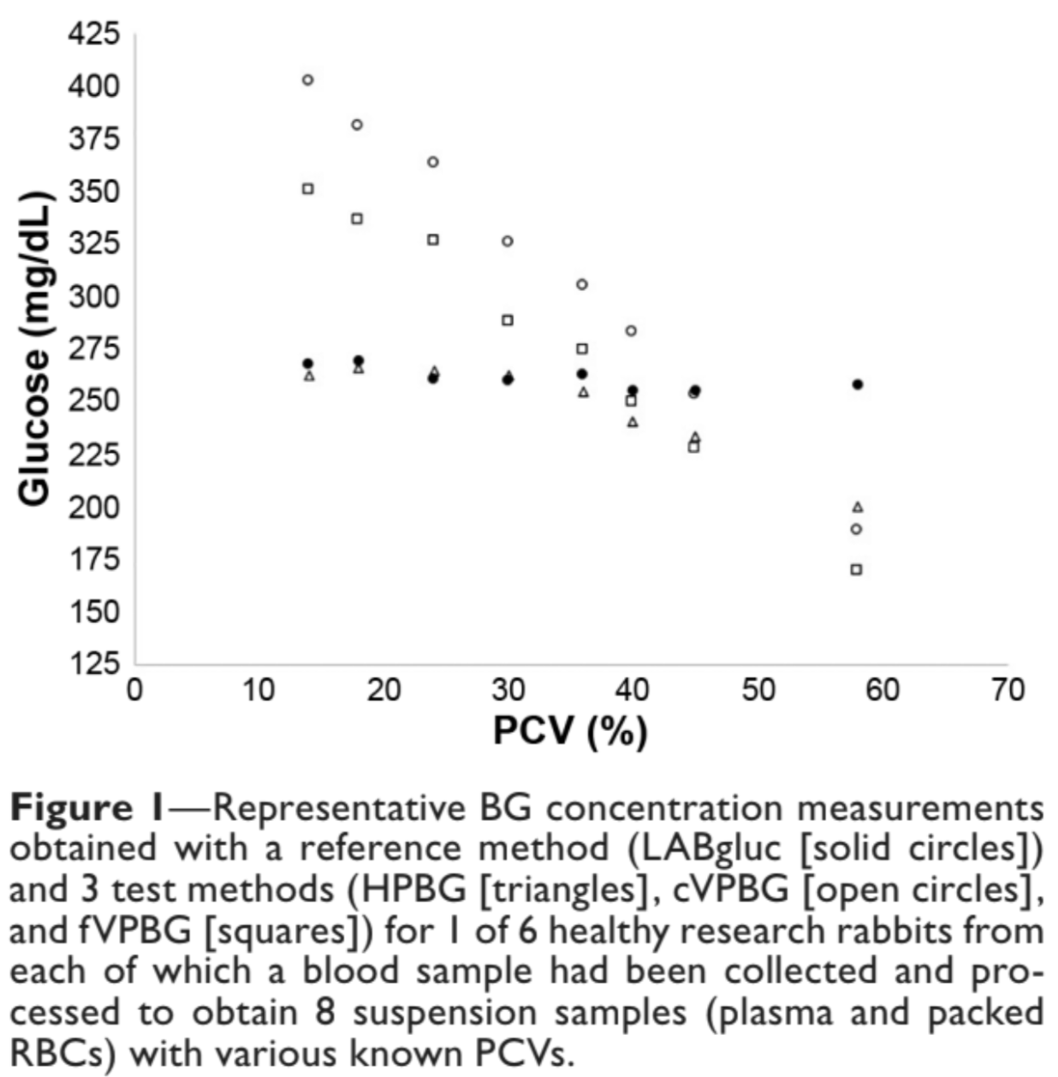
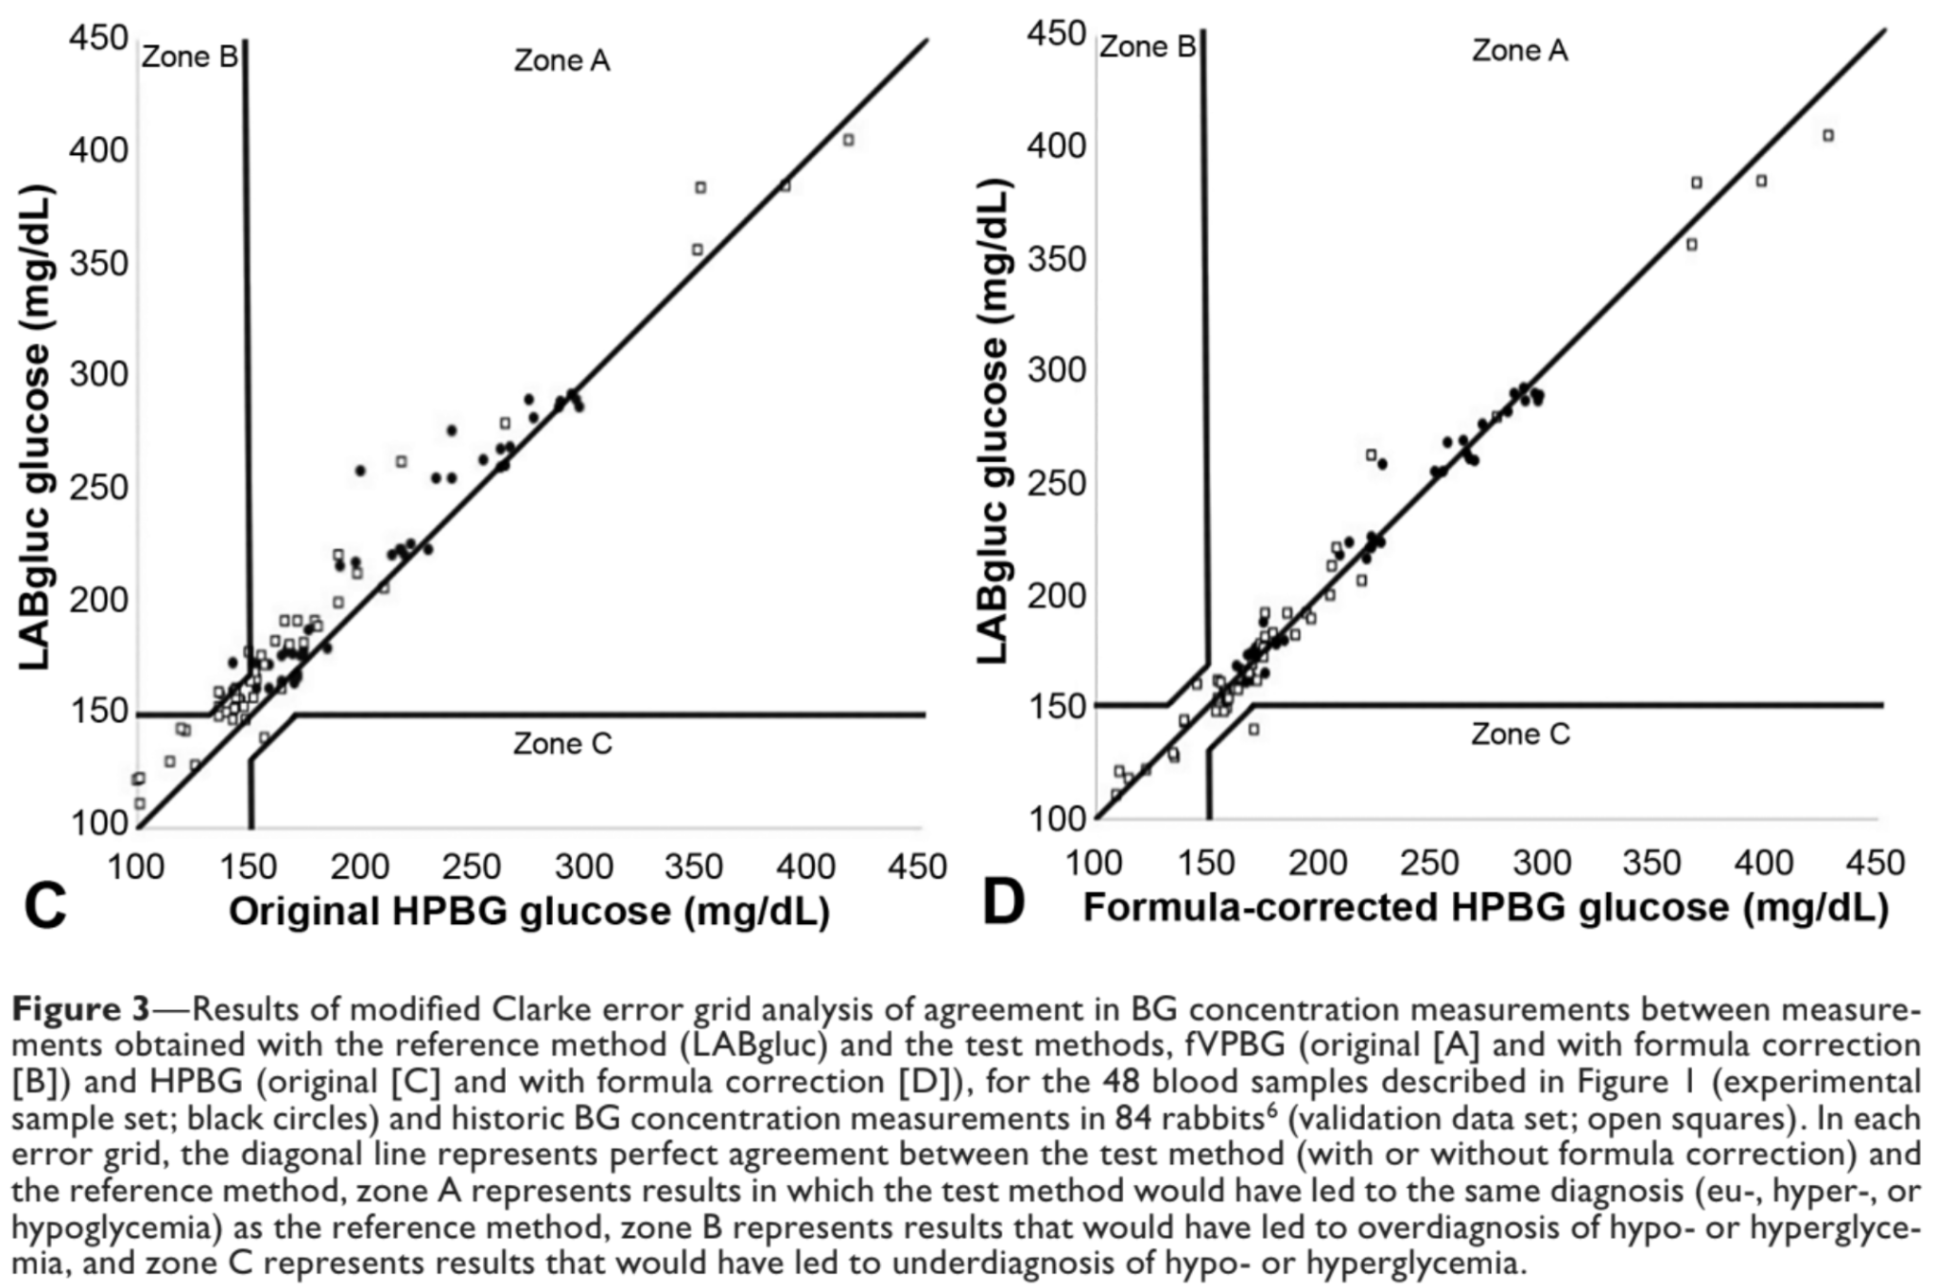

Prognostic indicators for survival of orphaned neonatal and juvenile eastern cottontail rabbits (Sylvilagus floridanus): 1,256 Cases (2012–17).
Principati, S.L., Keller, K.A., Allender, M.C., Reich, S. and Whittington, J.
Journal of wildlife diseases, 2020;56(3):523-529.

Orphaned eastern cottontail rabbits (ECRs; Sylvilagus floridanus) often present to wildlife clinics within their geographic range and require considerable dedication of time and resources. The objective of this analytical cross-sectional study was to assess initial examination findings to be used as prognostic indicators for orphaned neonatal and juvenile ECRs. The medical records of the University of Illinois Wildlife Medical Clinic were searched for ECRs presenting between 2012 and 2018. This criterion identified 1,256 ECRs that were then classified as survivors (survived and released) or as nonsurvivors (euthanized or natural death) within 72 h of admission. Presenting weight, body system abnormalities, hydration status, intervention prior to presentation, and singleton versus group presentation were categorically recorded for each individual ECR. The data were modeled using a series of logistic regression models fitted using the general linear model. Individuals were significantly more likely to be nonsurvivors if they presented as singletons (P<0.0001), presented with moderate/severe (P<0.001) or mild integumentary signs (P=0.0261), presented with multi-organ disease (P<0.001), presented with neurologic signs (P<0.0003), or had treatment provided prior to presentation (P=0.031). Factors that did not predict survival status in ECRs included body weight (P=0.210), presence of respiratory signs (P=0.674), and presence of dehydration (P=0.356). These findings may be used at wildlife medical clinics to make triage criteria for euthanasia as well as dedicate limited funds and labor to cases with the best prognosis for survival.

Background
- <40g euthanized on arrival, >120g released or sent to rehab because usually weaned
  - <70g typically tube fed
- Nonsurvivors: euthanized or died within 72hr of intake
- High risk due to less acidic neonatal stomach, lack of protective milk enzymes from dam
  - E. coli
- Common bacteria isolated from dog and cat bite wounds: Pasteurella, Staphylococcus intermedius, Enterococcus, Bacillus, Streptococcus
Key Points
- 1256 individual Eastern cottontails, overall mortality rate within 72hr 18.9%
  - Causes: severe trauma, aspiration, esophageal perf from tube feeding, persistent neurologic signs, open
- Mild integument abnormalities: almost 2x more likely to be nonsurvivor, mod-severe 4.5x
- Neurologic abnormalities and multiple system abnormalities more likely to be nonsurvivors
- Treatment prior to intake more likely to be nonsurvivors
- Singletons twice as likely to be nonsurvivors
- Factor that didn’t predict survival: weight class, hydration status, respiratory abnormalities
Conclusions
- Factors associated with nonsurvival in eastern cottontails <120g: integument, neurologic abnormalities, treatment prior to intake, singletons.
- Consider aggressive medical intervention or re-examine euthanasia guidelines

