Retrospective Review of Mycobacterial Conjunctivitis in Cockatiels (Nymphicus hollandicus). Journal of Avian Medicine and Surgery, 34(3), 250-259.
Lamb, S. K., Reavill, D., Wolking, R., & Dahlhausen, B. (2020).

Abstract: The etiologic disease organism responsible for causing mycobacteriosis in avian species is an acid-fast gram-positive bacterium. This bacterium causes granulomatous disease in various internal organs, but in cockatiels (Nymphicus hollandicus) it has been commonly identified within the conjunctival tissues. Twenty-six cases of mycobacterial conjunctivitis in cockatiels were diagnosed through histopathologic assessment of diseased tissue samples, Fite acid-fast staining, and polymerase chain reaction in this retrospective study. Clinicians who saw these cases were contacted, and information was obtained regarding recommended treatment protocols prescribed for the patients, the Mycobacterium species identified, and case outcomes. All patients in this retrospective study had a biopsy performed on the affected conjunctival tissue, and because of the small size of the patients, this excisional biopsy removed the affected tissue in its entirety or significantly debulked the lesion. Of the 26 cases, 10 were lost to follow-up, 4 were euthanatized, 7 died, and 5 were alive at the time this information was submitted for publication.
Key Points:
- Mycobacteriosis – Acid-fast bacilli, aerobic, slow growing, resistant to environmental extremes.
  - Devastating, chronic, systemic disease in avian spp.
  - Also zoonotic.
  - Avian mycobacterial infections have been isolated from virtually every order.
  - M. avium subsp avium
  - M. genavense – Recognized as relatively common.
  - M. tuberculosis, M. bovis, M. gordonae, M. nonchromogenicum, M. fortuitum subsp fortuitum, M. avium subsp hominissuis, M. peregrinum, M. intermedium, M. celatum.
  - M. intracellulare, M. avium subsp paratuberculosis, M. africanum, M. simiae.
- Postmortem surveys have found Amazon parrots and cockatiels to be the most commonly affected psittacines.
- Lesions can occur in any organ but are most common in intestines, liver, spleen, BM.
  - Alsso conjunctiva, kidney, muscles, gonads, endocrine organs.
  - Typically granulomatous with necrotic center surrounded by MP, giant cells, heterophils.
  - Granulomas of conjunctiva of cockatiels common although not reported in literature.
- Treatment regimens extrapolated form humans and other case reports.
  - Euthanasia often recommended.
  - Effective drugs include macrolides, fluoroquinolones, rifamycins, tetracyclines, aminoglycosides, ethambutol, dapsone, ethionamide, cycloserine, and clofazimine.
- Retrospective of cockatiels with conjunctival mycobacteriosis determined by histo biopsy and acid-fast, PCR.
  - Chemosis most common clinical sign but not all patients had overt disease.
  - All lesions described as granulomatous conjunctivitis.
  - Mycobacterium spp identified in all spp, M. genavense majority, M. avium 1 sample.
- Other ophthalmologic lesions in birds with mycobacteriosis include granulomatous nodules in conjunctiva, eyelids, and cornea.
  - Corneal vascularization and edema also noted.
  - Swellings in periocular region also described with serous to gelatinous discharge observed.
  - Ddx include mycoplasmosis, chlamydiosis, pasteurellosis, poxvirus, trauma, and postorbital masses.
- With improvement in molecular analysis and culture techniques, M. genavense has been found to be the most common causative agent (no longer M. avium).
- Tx controversial and complicated, often euthanasia.
  - Infected birds may be shedding organisms and exposing other birds.
  - Zoonotic risk.
  - Poor responses to therapy with drug resistance and prolonged courses of treatments, issues with owner compliance and drug administration difficulties.
  - Benefit to treating with a drug cocktail is to decrease likelihood of resistance to all of the treatments.
    - i.e. rifabutin, ethambutol, clarithromycin, enrofloxacin tx for 1 year.
- This study – Some patients received topical abx including terramycin, tobramycin, ofloxacin, Cipro, gentocin, neo poly bac with and without dexamethasone. Oral abx included enro, ethambutol, rifampin, isoniazide, ciprofloxacin. Doxy injectable. NSAIds in some, meloxicam or topical flurbi or kerolac.
  - Response to tx not great, most still died, no conclusions about best options.
Takeaways: Conjunctival mycobacteriosis = granulomatous, chemosis, most M. genavense. Zoonotic.
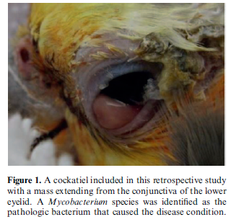
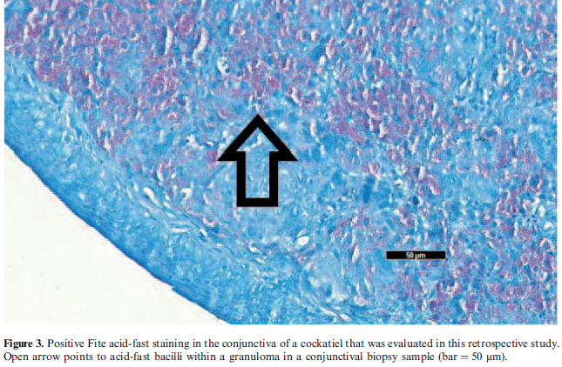

Comparison of In-Clinic Diagnostic Testing Methods for Macrorhabdus ornithogaster
Journal of Avian Medicine and Surgery 35(1):37–44, 2021
Hamish R. Baron, BVSc (Hons), FANZCVS (Avian Medicine and Surgery), Ben C. Stevenson, BSc (Hons), MSc, PhD, and David N. Phalen, DVM, PhD – Reviewed by MSM
Abstract: Macrorhabdus ornithogaster is an ascomycete yeast often found at the isthmus of the ventriculus and proventriculus of infected birds. Antemortem diagnosis has traditionally involved direct visualization of organisms on wet-mount or gram-stained fecal preparations, cloacal and crop swabs, or by both methods; however, different in-clinic diagnostic techniques have never been compared to establish an optimum test for the identification of M ornithogaster in an avianpatient. We compared 5 microscopically evaluated diagnostic testing methods: fecal Gram’s stain, direct fecal wet preparation, macro suspension technique, macro suspension with Gram’s stain, and macro suspension stained with new methylene blue. Each technique was performed on 96 fecal samples collected during the treatment of M ornithogaster–infected budgerigars with water-soluble amphotericin B. The macro suspension technique produced statistically higher organism counts than the other 4 techniques and was always estimated to have the largest detection probability. We recommend that the macro suspension technique be implemented as the most efficacious diagnostic test for in-clinic assessment of avian patients possibly infected with M ornithogaster.
Key Points:
Intro
- Macrohabdus ornithogaster
o Yeast found primarily in the isthmus between proventriculus & ventriculus
o 20-80 micrometer long, strait rods with rounded ends and a refractile nuclei
o Typically present on the surface of the isthmus, but can penetrate the glands of the proventriculus and the koilin of the ventriculus in severe cases using in a lymphoplasmacytic ventriculitis
o CS – vomiting, dark tarry feces, chronic wasting, death – or asymptomatic
o Diagnostics – PCR is better than gram stain, mini-FLOTAC is comparable to gram stain
M&M
- compared 5 microscopically evaluated diagnostic testing methods: fecal Gram’s stain, direct fecal wet preparation, macro suspension technique, macro suspension with Gram’s stain, and macro suspension stained with new methylene blue.
- N=96 budgerigars
Results and Discussion
- The macro suspension technique provided the clearest identification field for visualizing MO compared with all other techniques because the preparations contained little background debris.
  - The same technique with methylene blue stain as a contrast agent resulted in, on average, fewer organisms being visualized.
- This technique consistently visualized more MO organisms when compared with all other techniques
Take Home: Macrosuspension technique is the best in-clinic testing for macrorhabdus detection
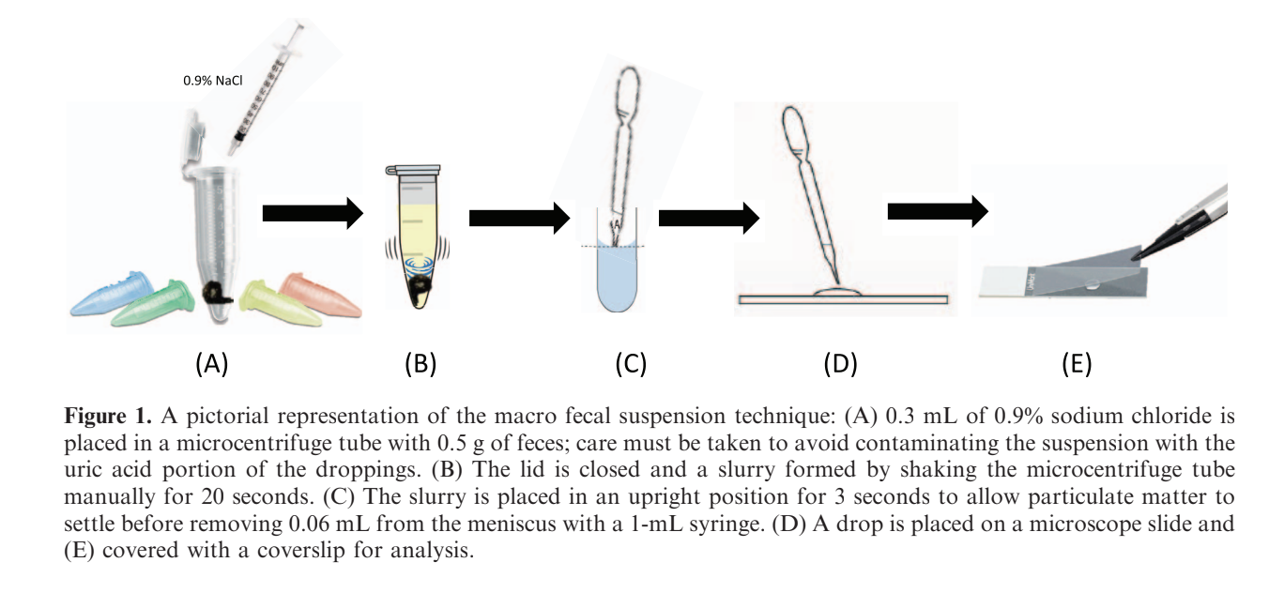

References:
· Sullivan PJ, Ramsay EC, Greenacre CB, et al. Comparison of methods for determining prevalence of Macrorhabdus ornithogaster in a ﬂock of captive budgerigars (Melopsittacus undulatus). J Avian Med Surg. 2017;31(2):128–131.

ARTICLE: Flach, Edmund J., et al. "Systemic isosporiasis (atoxoplasmosis) in passerine birds at the zoological society of london, london zoo." Journal of Zoo and Wildlife Medicine 53.1 (2022): 70-82.
Abstract: Infection with systemic Isospora species (systemic isosporiasis [SI]) is common in passerine birds and may cause substantial mortality in zoological collections. Ten years of postmortem records of 26 species of captive, nonnative passerine birds maintained at the Zoological Society of London, London Zoo, plus seven freeranging species found dead within the zoo, were reviewed to assess cause of death and occurrence of SI (presence of merozoites in tissue impression smears and/or polymerase chain reaction [PCR] testing for Isospora DNA). The records of 287 juveniles and adults were reviewed, of which 161 had SI test results. The most common cause of death was physical (trauma, predation, drowning, and hypothermia), diagnosed in 39.0% of cases. Virulent SI was considered the cause of death in only nine individuals from five species (3.1% of all cases, 5.6% of tested birds). However, merozoites were recorded in 36.0% of the 150 individuals examined cytologically (representing 18 of the 33 species), while 45.3% of 53 spleen samples (14 species) were positive for Isospora DNA. Test agreement for the 42 birds tested by both methods was 69.0%. Assuming that the PCR result was correct in these, 37.9% of the 161 birds (21 species) were positive for SI at the time of death. These figures might underestimate prevalence because of poor DNA preservation and low numbers of individuals of some species tested. Eight new 28S rDNA sequences and 12 new internal transcriber spacer 1/2 sequences were amplified. Sequences from individuals of the same host species clustered together, suggesting a single Isospora species, and there was no evidence of overlap among hosts. These results confirm that systemic infection with Isospora species in zoo passerines is generally of low pathogenicity and most likely coevolved with their hosts. Severe disease may occur, however, with overwhelming exposure, secondary to immunosuppression, or following coinfection with another pathogen.

Goal of Study
- Review causes of death in passerines to identify how many were associated with systemic isosporiasis infection and compare cytology and PCR methods in positive cases

Study Design/Methods
- Retrospective 10 year review of postmortem records from 26 captive, nonnative passerine species and 7 free-ranging species found dead in a single institution
- n=161 (from 21 species); 161 of 287 mortality records had tests for systemic isosporiasis

Background
- Terms: systemic isosporiasis (SI) = extra-intestinal or visceral isosporosis = formerly atoxoplasmosis
- Enteric isosporosis is a common avian disease however SI has evolved ONLY in Passeriformes
- Diagnosis: observation of merozoites in mononuclear leukocytes in the blood and viscera (previous gold standard), new qPCR has high sensitivity (should be new gold standard)

Key Points
- Most common cause of death among all birds (n=287) = physical (39%), unknown (29%), infectious (16%)
- Virulent SI was diagnosed as cause of death or contributing to death in 5.2% (15/287) of all bird deaths
- However, 38% of the birds tested were positive for SI at time of death and this may be underestimated due to DNA degradation in archived samples
  - 36% of 150 individuals examined cytologically were positive (merozoites present)
  - 45% of 53 individuals examined with PCR of the spleen were positive (for isospora DNA)
  - 69% of the birds tested by both methods (n=42) were positive with both cyto and PCR
- Splenomegaly common in cause/contributing to death cases (13/15) but also common in nonvirulent cases
- Season: May-October had a higher percentage of detected SI than November-April
- Age group: Juveniles were slightly more likely to be positive than adults
- Sex: No statistically significant difference between males and females
- Isospora DNA sequences are mainly host specific suggesting coevolution with hosts thus are often expected to be nonpathogenic unless there are predisposing factors such as overwhelming exposure, secondary to immunosuppression or following coinfection with another pathogen
  - Findings of SI via cytology or PCR may not indicate disease unless there is clinical signs
- This study also developed new DNA sequences that can serve as molecular tags in future diagnostics

Useful figure:
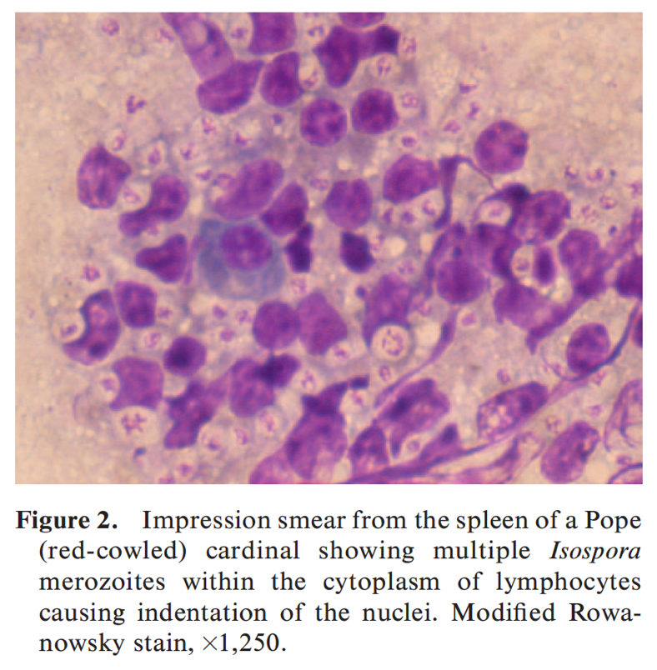

ARTICLE: Landolfi, Jennifer A., et al. "A qpcr assay and testing guidelines for the molecular diagnosis of systemic isosporosis (formerly atoxplasmosis) in passerine birds." Journal of Zoo and Wildlife Medicine 51.2 (2020): 391-397.
Abstract: Systemic isosporosis (formerly atoxoplasmosis), is a protozoal infection that causes death in nestling
and fledgling passerine birds impacting ex situ breeding and reintroduction programs. Because current antemortem diagnostic tests lack sensitivity, a qPCR was developed for detection of Isospora spp. using primers and a fluorescent-tagged MGB probe targeting the large subunit (28s) ribosomal RNA gene (assay efficiency ¼ .100%; sensitivity ¼ ,1 dsDNA copy). The assay was used to screen postmortem frozen or formalin-fixed paraffin-embedded tissue samples from passerine birds (n ¼ 24; 12 with confirmed systemic isosporosis), whole blood and feces (n ¼ 38) from live passerines, and other tissues infected with phylogenetically similar protozoa. The qPCR identified Isospora sp. DNA in tissues from 21/24 birds including 12/12 birds with cytologically histologically confirmed infection (100% sensitivity) and 9/12 birds lacking microscopic organisms. The assay also amplified Eimeria sp. DNA; however, sequence analysis ruled out infection in the passerine cases. Blood and/ or feces were positive in 30/38 birds, and in only 7/38 birds, blood and feces both contained Isospora sp. DNA. Finally, the qPCR was utilized to screen 30 consecutive daily fecal samples from live passerines (n ¼ 20) to determine optimal sampling protocols. One or more of the daily fecal samples were positive in all 20 birds. In individual birds, the interval between positive qPCR amplification results ranged from 0 to 23 days, with an average of 5.85 days. Simulated application of 13 potential sample collection schedules was used to identify the sensitivity of repeated testing for identification of infected birds. Increased sampling days resulted in higher sensitivity but increased both cost and animal handling requirements. Based on statistical analysis and clinical considerations, the testing recommendation for detection of fecal shedding was collection and assay of five consecutive daily fecal samples, which had an average diagnostic sensitivity of 0.86.

Goal of Study
- To validate a RT-qPCR test that was developed to detect Isospora species by targeting the large 28s subunit ribosomal RNA gene
- To create testing guidelines for diagnostic of systemic isosporosis in passerines

Background
- Systemic isosporosis (SI) = protozoal infection causing death in nestling and fledgling passerine birds
- Most Isospora spp associated with systemic disease of passerines are genetically similar to Eimeria spp
  - Two distinct Isospora groups - one infects mammals, one infects birds
- Prior to this study, gold standard diagnosis was based on observation of merozoites in mononuclear leukocytes in the blood (ante-mortem) and viscera (often post-mortem)
- Isopsora undergoes intermittent shedding thus fecals can be falsely negative

Study Design/Methods
- Screened postmortem frozen or formalin-fixed tissue samples from 24 birds (12 confirmed SI via detectable intracellular protozoa in mononuclear cells or conventional PCR/sequencing), and whole blood and feces from 38 live birds, and other tissue infected with similar protozoa (cystoisospora, cryptosporidium, sarcocystis, toxoplasma, eimeria)

Key Points
- There is a validated qPCR assay for systemic Isospora spp DNA in passerine for both clinical (blood, feces) and postmortem (tissue) testing
  - Postmortem samples had 100% sensitivity
  - Antemortem blood and fecal assays had low concordance but all positive cases were confirmed with sequencing
    - Single negative fecal sample does not establish diagnosis due to intermittent shedding
    - Interval between positive qPCR amplification in fecal samples ranged from 0-23 days with an average of 5.85 days; consecutive testing for 5+ days had a probability of detection to be 80-90%
- Cross-reaction with enteric Eimeria occurs thus confirmatory sequencing is required for positive fecal samples
  - No cross-reactivity with other histologically confirmed protozoa (cystoisospora, cryptosporidium, sarcocystis, toxoplasma, eimeria) in postmortem samples
- Recommendations for testing due to intermittent shedding: collection and submission of FIVE consecutive daily fecal samples to provide a minimum probability of 80% detection

JZWM 2022 53(2):461-469
Evaluation Of Clinical Diagnostics For Proventricular Nematodiasis Due To Synhimantus Nasuta In Lorikeets (Trichoglossus spp.)
Pouillevet H, Langlois I, Lamglait B, Fernandez-Prada C, Ferrell ST, Couture ÉL

ABSTRACT: In this case series, clinical investigations were pursued during a Synhimantus nasuta infection in a lorikeet (Trichoglossus spp.) flock outbreak situation to better describe and document clinical presentations. In 11 lorikeets suspected to be infected with Synhimantus based on at least one abnormal finding on their physical examination (lethargy, feather-damaging behavior on the ventrum, weight loss, pale iris), the presence of five additional parameters was documented: anemia, relative eosinophilia, increased proventricular diameter-to-keel height ratio (PKR), proventricular barium filling defect, and positive fecal occult blood detection test. A total score (X of 9) was calculated by combining all these findings. Synhimantus nasuta infection was confirmed in four of these individuals by modified Wisconsin fecal examination. Suspected cases (n = 7 of 11) presented only with low scores (1-3 of 9), whereas birds with confirmed infections (n = 4 of 11) presented with both low (1-3 of 9, n = 2 of 4) and high (6-7 of 9, n = 2 of 4) total scores. High scores were associated with clinical anemia. Fecal occult blood was present in all confirmed cases and 4 of 7 suspected cases. An enlarged proventriculus was only observed in birds with active shedding (n = 3 of 4). Follow-up evaluations after 6 mon of treatment with ivermectin and selamectin suggested complete recovery with lowered or normalized total scores. In conclusion, during an S. nasuta outbreak, a rapid physical examination helps to identify suspect cases, including individuals requiring immediate medical attention. In the absence of ova shedding, infection cannot be excluded on the basis of scarce clinical findings, but the detection of occult fecal blood and an increased PKR should raise the index of suspicion.

Background:
- Synhimantus nasuta, formerly Dispharynx spp., is a spirurid nematode
  - Cosmopolitan distribution and reported in multiple avian taxa, including lorikeets
  - Attachment nematodes within the proventriculus causes significant inflammation
    - Proliferative, papillomatous/adenomatous proventriculitis is often observed
  - Mortality can occur because of decrease in the digestive capacity
  - Life cycle requires the development of larvae in intermediate hosts (mainly isopods)
- Clinical signs include lethargy, inactivity, weight loss, and stunting, despite a good appetite
  - Anorexia, pale MM, emaciation, and death may occur with severe infection
  - Loss of pigment from the iris (due to anemia), and melena may be observed
  - GI positive-contrast radiography, showing dilatation of the proventriculus and/or a filling defect, may be a promising tool for the antemortem diagnosis
- Antemortem gold standard remains fecal flotation which has good specificity, poor sensitivity
  - Prepatent periods vary between 27-42 d with highly intermittent excretion
  - Gastric endoscopy and lavage did not appear feasible in lorikeets
Key Points:
- FOB was detected in all 4 confirmed infections, in addition to 4 of 7 suspected cases
  - This indicator is likely the most informative in an outbreak situation
- Confirmed infections had low (2–3/9) and high (6–7/9) total scores
  - Suggesting two different clinical presentations
- Confirmed cases with a high total score were the only birds with iris pallor
  - Iris pallor was associated concurrent with severe anemia
  - Iris color was deemed to be normal following treatment in these individuals
  - Interestingly, birds with a high total score also had the highest levels of ova shedding
- Proventricular diameter-to-keel ratio (PKR) > 0.48 was observed only with active shedding
  - Although not specific, PKR is an interesting adjunct individual indicator in an outbreak
  - Digestive dilation is likely to be observed in the absence of ova shedding

TLDR:
- Antemortem gold standard for S. nasuta in lorikeets is fecal flotation
- Lorikeets with lethargy and/or a pale iris might suffer from severe anemia
- Hands-on evaluation with weight monitoring may help identify subclinical cases
- PKR > 0.48 on radiographs or digested blood in the feces could be a presumptive diagnosis

Useful Figures:
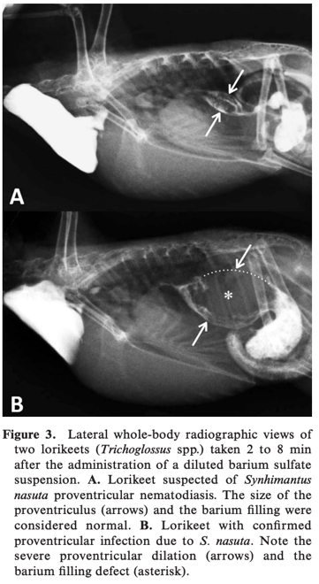
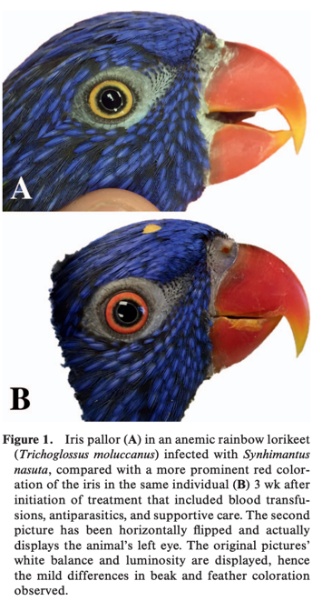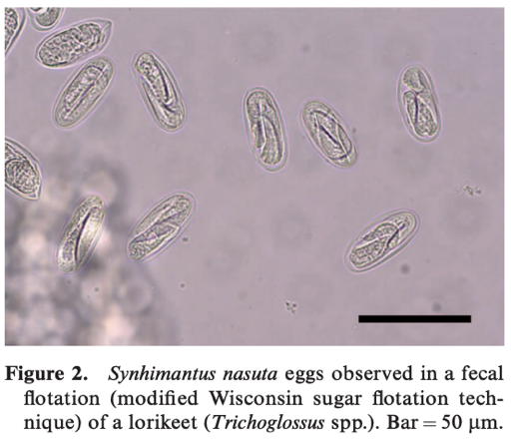

Related Articles:
Cerreta A, Mehalick M, Stoskopf M, Dombrowski D, Lewbart G. Assessment of a visual scoring system for identifying and quantifying anemia in male eastern box turtles (Terrapene carolina carolina). J Zoo Wildl Med. 2018;49(4):977–982

JZWM 2021 52(1):206-216
Sarcocystosis In A Captive Flock Of Thick-Billed Parrots (Rhynchopsitta pachyrhyncha) From 2005 To 2016: Morbidity, Mortality, Diagnostics, And Management Strategies
Rivas AE, Conley K, Seimon TA, et al

ABSTRACT: Sarcocystosis was diagnosed in a captive flock of thick-billed parrots (Rhynchopsitta pachyrhyncha) at the Wildlife Conservation Society's Queens Zoo. Since the index case in 2005, 45% of mortalities in birds over 30 days of age were due to sarcocystosis. Sarcocystis falcatula was repeatedly identified as the causative agent. The disease predominantly affected younger adult parrots. Administration of antiparasitic medications prior to development of respiratory signs prolonged life in infected birds, but disease was fatal until utilization of a three-drug combination (pyrimethamine, trimethoprim-sulfamethoxazole, and ponazuril). This protocol may require in excess of 6 mo of therapy to achieve clinical resolution of active disease. Plasma creatine kinase activity was found to be the most useful test in diagnosing infection and monitoring response to therapy. Polymerase chain reaction (PCR) for apicomplexan organisms on antemortem whole blood, blood smears, or dried blood spots helped confirm suspected cases, but due to the poor sensitivity was sometimes misleading when assessing response to therapy or resolution of clinical disease. Preventive measures, focusing on exclusion and removal of Virginia opossums (Didelphis virginiana) from zoo grounds failed to curtail the occurrence of sarcocystosis in the flock. Other preventative steps, such as modification of feeding stations to exclude potential arthropod paratenic hosts and prophylaxis trials with diclazuril, appeared to successfully mitigate new infections. Given the diagnostic and therapeutic challenges, prevention of exposure to S. falcatula is essential to ex-situ conservation efforts for thick-billed parrots.

Background:
- Endangered thick-billed parrots are native to conifer forests of the Sierra Madre in Mexico
  - WCS Queens Zoo has one of the largest captive breeding flocks in North America
- Sarcocystosis is caused by intracellular coccidian protozoa Sarcocystis spp.
  - Sexual reproduction occurs in GI tract of definitive hosts (carnivore or omnivore)
    - Clinical disease is often mild (enteritis, diarrhea, or weight loss)
  - Asexual reproduction occurs in intermediate hosts (herbivores/prey species)
    - Development of sarcocysts, a cylindrical cyst containing bradyzoites & merozoites, in muscle or other tissues can lead to severe clinical signs
  - Paratenic hosts or vectors (e.g., arthropods) can passively spread Sarcocystis
  - Aberrant or accidental hosts, often experience severe or fatal infections
- Sarcocystis falcatula is often implicated in avian sarcocystosis, particularly in psittacines
  - Virginia opossum (Didelphis virginiana) is the definitive host in North America
Key Points:
- Case series provides evidence for chronic or latent infection in TBPs
  - Birds with chronic sarcocystosis experience relapses or intermittent periods of illness, including neurologic dysfunction
  - Affected birds also appear more susceptible to secondary diseases like aspergillosis
- Reports of successful treatment of avian sarcocystosis are sparse
  - Case series found treatment with ponazuril alone is unreliable
  - Likewise, treatment with potentiated sulfonamides alone is unreliable
  - Triple-drug therapy of ponazuril, pyrimethamine, and trimethoprim-sulfamethoxazole resulted in the highest success rate in the TBPs
- Multiple testing modalities are often required to diagnose avian sarcocystosis
  - A strong, presumptive antemortem diagnosis can be based on marked elevation in plasma CK and a known history in the collection
    - This was found to be the best methodology in TBPs
- Case series found pan-apicomplexan PCR has poor sensitivity for avian S. falcatula infections
  - It was often, though not consistently, positive during the acute phase of disease in TBPs
  - Serial testing during the first few weeks of disease increased the likelihood
  - When positive, specificity of the PCR assay was high
  - PCR didn’t help in determining resolution of disease or discontinuing therapy
- Prevention of infection should be a cornerstone of avian sarcocystosis management
  - Paratenic hosts seemed to play a significant role in the ongoing TBP cases
    - Preventing direct access to opossums and opossum feces was insufficient
  - Changing TBP feed stations to ones that excluded both rodent and nonflying arthropods appeared to halt further case development during the 2016 outbreak
- In horses, prophylaxis is advocated in regions where EPM is prevalent
  - Diclazuril is experimentally effective in preventing Sarcocystis sp in mice and horses
  - For the TBP, daily administration of diclazuril was easily accomplished
    - 1 mg/kg PO SID resulted in plasma levels substantially above ideal threshold
  - There have been no further TBP sarcocystosis cases since prophylaxis started in 2017

TLDR:
- Avian sarcocystosis diagnosis relies on clinical signs, institutional history, and CK elevation
- Pan-apicomplexan PCR may help confirm sarcocystosis early in the course of disease
  - Serial sampling is recommended, and test is less reliable later in the course of infection
- Treatment with a combination of sulfamethoxazole-trimethoprim, ponazuril, and pyrimethamine controlled clinical signs and helped birds survive acute fulminant disease
  - However, it did not clear infection and required a prolonged course of treatment
- Clinical focus should be on prevention through environmental and husbandry management
  - Sarcocystosis prophylaxis with diclazuril appears promising in thick-billed parrots

Related Articles: None on the current ACZM reading list

USING MULTIVARIATE ANALYSES TO EXPLORE DISEASE PROGRESSION OF FINCH MYCOPLASMOSIS
Rachel M. Ruden, Dean C. Adams, and James S. Adelman
Journal of Wildlife Diseases, 2021;57(3):525–533

Lesion severity scales have been developed for a number of wildlife diseases causing external pathology. Perhaps the best known and most widely used scoring system has been developed for finch mycoplasmosis in which observers measure conjunctival pathology along a four-point scale of increasing severity. We developed novel techniques to characterize variation in host phenotype based on occupancy of multidimensional trait space (disease space). First, we used shape analysis to track distortions of the inner and outer eye rims, defined by 16 anatomical landmarks. Then, we used community analysis to evaluate pathology based on the presence or absence of a unique set of binary descriptors. We applied these techniques to experimental infection data to relate differences in conjunctival pathology to stage of infection. Specifically, by comparing specimens that received the same severity score at different time points in infection, we asked if shape or community analyses could distinguish between individuals in early infection versus those in recovery. We found that individual eyes followed predictable loops through disease space, tracking further from their origin with more severe pathology. Also, certain pathological descriptors were more likely to appear earlier versus later in infection. Our results indicated that leveraging differences in pathology captured in complex trait space could complement severity scores by better resolving the time course of infection from limited data points.

Background
- Mycoplasma gallisepticum - Finch mycoplasmosis
  - Causes severe conjunctival inflammation of passerine birds
  - Large die-off of House Finches (Haemorhous mexicanus) on the east coast of the US
  - Several visual scoring systems – most four-point: 0 (no pathology) to 3 (severe pathology) with half points
Key Points
- This study used geometric morphometrics to assign points around the eye and analyze phenotypes throughout the course of disease
- Eyes moved through a predictable pattern of progression based on severity
- Exudate was a weak indicator of pre-peak (active) infection with the low virulence isolate, but crusting was a strong indicator of pre-peak infection with the high-virulence isolate – so crusting could be used as a prognostic indicator
Conclusions
- Geomorphometrics can be applied to disease progression – passerine mycoplasmosis follows a predictable pattern of conjunctival disease. Crusting is a sign of worse disease
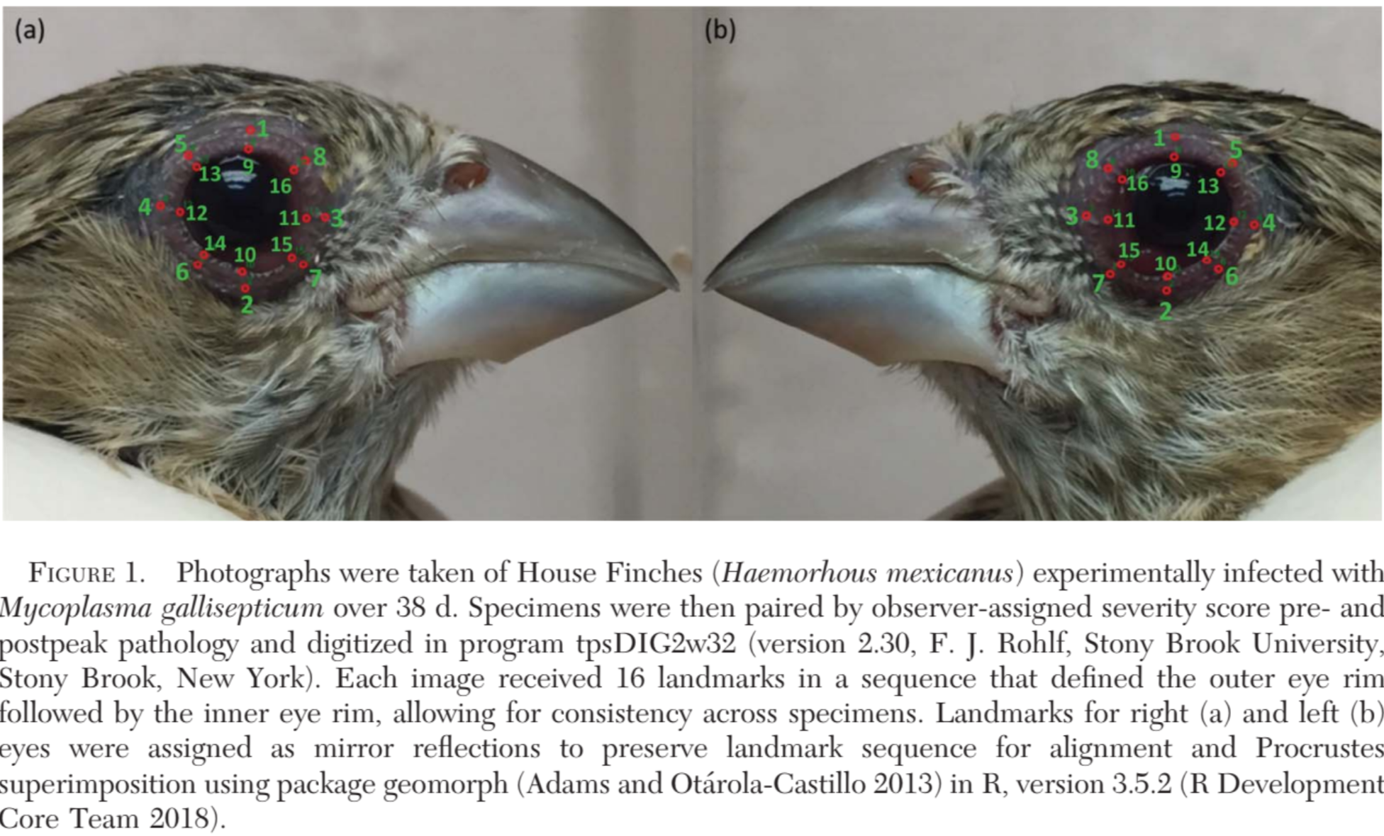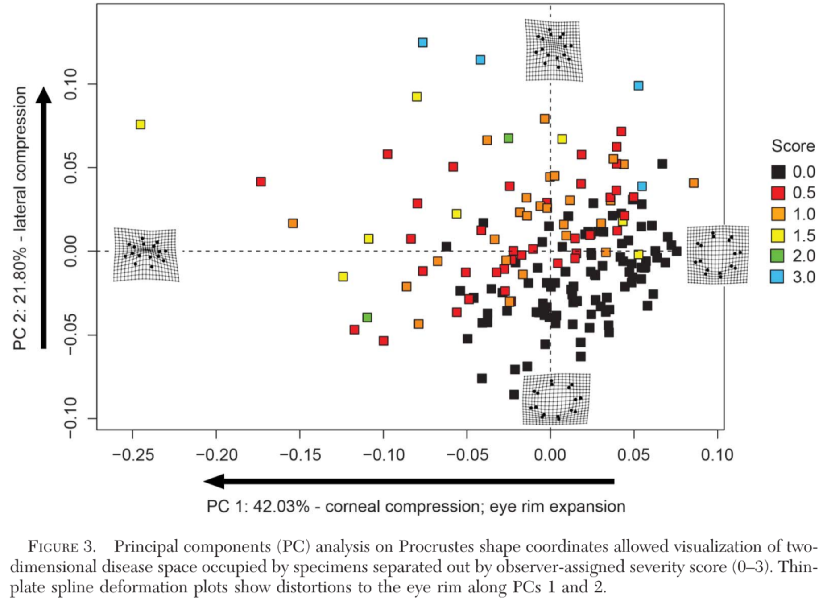

Detection of gliotoxin but not bis(methyl)gliotoxin in plasma from birds with confirmed and probable aspergillosis.
Reidy L, Desoubeaux G, Cardenas J, Seither J, Kahl K, Chauvin D, Adkesson M, Govett P, Aitken-Palmer C, Stadler C, Tocidlowski M.
Journal of Zoo and Wildlife Medicine. 2022 Mar;53(1):60-69.

Aspergillosis remains a difficult disease to diagnose antemortem in many species, especially avian species. In the present study, banked plasma samples from various avian species were examined for gliotoxin (GT), which is a recognized key virulence factor produced during the replication of Aspergillus species hyphae and a secondary metabolite bis(methyl)gliotoxin (bmGT). Initially, liquid chromatography–tandem mass spectrometry methods for detecting GT and bmGT were validated in a controlled model using sera obtained from rats experimentally infected with Aspergillus fumigatus. The minimum detection level for both measurements was determined to be 3 ng/ml, and the assay was found to be accurate and reliable. As proof of concept, GT was detected in 85.7% (30/35) of the samples obtained from birds with confirmed aspergillosis and in 60.7% (17/28) of samples from birds with probable infection but only in one of those from clinically normal birds (1/119). None of the birds were positive for bmGT. Repeated measures from birds under treatment suggests results may have prognostic value. Further studies are needed to implement quantitative methods and to determine the utility of this test in surveillance screening in addition to its use as a diagnostic test in birds with suspected aspergillosis.

Background
- Antibody reactivity often seen in birds in the absence of infection
- Acute phase response on EPH with clinical signalment and imaging often used to aid diagnosis
- Antigen based testing: galactomannan, beta-D-glucan not shown reliable in birds
  - Validated but limited sensitivity
- Metabolite-based diagnostics: gliotoxin
  - most abundant mycotoxin from clinical isolates of A. fumigatus and some nonpathogenic spp. and other fungal genera (Penicillium, Trichoderma, Leptosphaera)
  - Key virulence factor, immune suppression from inhibition of phagocytosis, inflammation, and cytokine production, induces apoptosis in macrophages and monocytes
  - Secondary metabolite: bis(methyl)gliotoxin (bmGT) - reportedly more sensitive than gliotoxin
Key Points
- Experimental rat model: all infected had detectable gliotoxin but not bmGT
- Avian study: 119 clinically normal penguins, n=1 other spp. (trumpeter, crane, hornbill, gyrfalcon, pigeon, African grey)
  - Normal penguins: no bmGT, 1 sample with GT
  - Probable infection: no bmGT, 60% had GT
  - Confirmed infection: no bmGT, 86% had GT
  - 2 cases with resolution of GT once CS resolved.
Conclusions
- Gliotoxin but not bis(methyl)gliotoxin was detected in confirmed or probable aspergillosis penguin cases and may have prognostic value
  - High specificity in experimentally infected rats

Reed, Kathlyn, Kadie Anderson, and Karen Wolf. "Mortality trends for budgerigars (melopsittacus undulatus) housed in a walk-through aviary in a zoo in north america, 2009–2019." Journal of Zoo and Wildlife Medicine 52.4 (2021): 1143-1148.

Many zoos in North America feature walk-through exhibits that allow members of the public to interact with psittacine species, as these exhibits are popular with guests and can generate additional revenue. There is limited research available on the life expectancy and common causes of mortality of psittacines when group-housed in aviaries. This study compiled data on 496 budgerigar (Melopsittacus undulatus) mortalities at a walk-through aviary at a North American zoo from March 2009 to March 2019, including histopathology on 62 tissue sets collected post mortem, and gross necropsy data for 163 birds deceased from March 2015 to March 2019. The mean age at death or euthanasia of all fledged birds from 2015 to 2019 was 3.57 ± 1.58 yr. The most common causes of death or euthanasia found on gross necropsy were granulomatous disease (39.2%), trauma (16.0%), and Macrorhabdus ornithogaster (13.5%). The most common histologic finding was M. ornithogaster, described as the primary pathologic finding in 31.7% of submitted tissue sets, and recorded as a secondary pathologic finding in 53.2% of submitted tissue sets. Mycobacterial disease was the primary pathologic finding in 25.3% of submitted tissue sets, and was recorded as an additional pathologic finding in 35.4% of submitted tissue sets.

Study:
- Walk through exhibits are great- BUT concern for potential zoonotic disease
- Budgies at a walk through at Point Defiance Zoo and Aquarium
  - Outside and behind the scenes enclosure
  - In 2018, sodium benzoate (50 mg/l) was added to the drinking water as a prophylactic measure against Macrorhabdus ornithogaster infection
  - Birds underwent examination PE, 10% CBC, 10% screened for chlamydiosis
  - Birds who are ill- PE, fecal smear, rads, CBC; patients diagnosed with M. ornithogaster- were started on amphotericin B 100 mg/kg PO q12h for 28 day via gavage; received 3 full courses and if still ill or still shedding >1 day post treatment- were euthanized
- 10 yr period 496 mortality rates: medium rate of 3% of population a month
- Gross necropsies on 163 cases
  - Mycobacteriosis accounted for 39.2% mortalities
  - Trauma 16%
  - M. ornithogaster 13.5%
- Full histo on 35 patients
  - M. ornithogaster- 31.7%
  - Mycobacterial disease 25.3%
- Primary finding was granulomatous disease, on histo M. ornithogaster
  - Suspect introduced by reservoir or brought in
  - Despite extensive efforts to mitigate- annual replacement of topsoil, use of mycobactericidal disinfectant
- On study tried treatment with Clarithromycin 61 mg/kg, moxifloxacin 25 mg/kg, and ethambutol 60 mg/kg via crop tube q12h for 18 weeks- 2/9 birds still had lesions
- Another study found adding nystatin to water as a preventative seemed to help

Key Points:
- Managers considering walk through aviaries should be well informed of the disease risks and health implications
- In this flock the two diseases had significant morbidity and mortality
- Management of the aviary to reduce infection risks with Macrorhabdus and mycobacteriosis may help mitigate infection risks and death in such collections

Gall, Andrew J., et al. "Identification and correlation of a novel siadenovirus in a flock of budgerigars (Melopsittacus undulates) infected with Salmonella Typhimurium in the United States." Journal of Zoo and Wildlife Medicine 51.3 (2020): 618-630.

A flock of budgerigars (Melopsittacus undulates) was purchased from a licensed breeder and quarantined at a zoologic facility within the United States in 2016. Following 82 deaths within the flock, the remaining 66 birds were depopulated because of ongoing clinical salmonellosis despite treatment. Gross necropsy was performed on all 66 birds. Histopathologic examination was performed on 10 birds identified with gross lesions and 10 birds without. Pathologic findings were most often observed in the liver, kidney, and spleen. Lesions noted in the livers and spleens were consistent with published reports of salmonellosis in psittacine species. Multisystemic changes associated with septicemia were not noted, most likely because of antibiotic intervention before euthanasia. Of the 20 budgerigars evaluated by histopathology, six had large basophilic intranuclear inclusion bodies within tubular epithelia in a portion of the kidneys. Electronic microscopy, next-generation sequencing, Sanger sequencing, and phylogenetic analyses were used to identify and categorize the identified virus as a novel siadenovirus strain BuAdV-1 USA-IA43444-2016. The strain was 99% similar to budgerigar adenovirus 1 (BuAdV-1), previously reported in Japan, and to a psittacine adenovirus 5 recently identified in a U.S. cockatiel. Salmonella typhimurium carriers were identified via polymerase chain reaction (PCR) and bacterial culture and compared with viral carriers identified via PCR. Inclusion bodies and Salmonella detection were significant in birds with gross lesions versus those without; however, there was no correlation between budgerigars positive with siadenovirus by PCR and concurrent Salmonella infection. Identifying subclinical siadenovirus strain BuAdV-1 USA-IA43444-2016 infection in this flock significantly differs from a previous report of clinical illness in five budgerigars resulting in death caused by BuAdV-1 in Japan. S. typhimurium remains a significant pathogen in budgerigars, and zoonotic concerns prompted depopulation to mitigate the public health risks of this flock.

Introduction
- Adenovirus: nonenveloped, single linear molecule or double stranded DNA
- Siadenovirus: includes avian and amphibian groups and avian is classified into 3 groups
- S. typhimurium is most commonly IDed serovar BUT most commonly has a low prevalence in psittacine populations. Transmission from budgies to humans has been reported
Materials and Methods
- 151 budgies were purchased from a private breeder
  - Started on prophylactic course of doxycycline hyclate
  - Within the first 7 days 10% of flock died: 6 had neurologic signs or extreme weakness
  - 10 more were found dead over 53 days- also neuro signs
  - Day 66- one was found dead and IDed Salmonella spp on culture, and then serotyped as S. typhimurium
- Oral enrofloxacin started on those clinically affected and chlortetracycline for the entire flock
  - Mortalities continued
  - Liver and hearts cultured positive for S. typhimurium
- Treatment with TMS was started in the water= no improvement
- Remaining 66 birds were euthanized - all were submitted for postmortem examination
  - Siadenovirus was sequenced
Results
- Found mostly liver and spleen changes on necropsy
- 10 birds with no gross lesions and 10 birds with were submitted for histo and bacteriologic examinations
  - 5 of 10 birds had large basophilic intranuclear inclusion bodies within the tubular epithelium
  - 10/20 birds had Salmonella spp. (2 of these from the no gross lesions group)
- 7 of 10 birds in group 2 (without gross lesions) were siadenovirus PCR POSITIVE
  - No correlation exists between PCR positivity and histologic evidence of inclusions
Discussion
- Salmonella histo: hepatitis, splenitis, nephritis, meningo/encephalitis, epicarditis/endocarditis and eneteritis
- Of the 66 birds: splenomegaly was most common followed by hepatomegaly- consistent with the published reports of Salmonellosis
- Gross lesions are fairly indicative of active salmonellosis or culturing Salmonella is highly suggestive of disease
- Siadenovirus PCR IDed budgies in the flock as positive however most had no abnormal gross findings on necropsy
Key Points
- There was no association between budgies positive with siadenovirus by PCR and concurrent Salmonella infection
- Intranuclear inclusion bodies identified in liver and spleen is associated with adenovirus infections
- Just because no abnormal gross findings were found on necropsy- did not mean that the birds were negative for Siadenovirus PCR

