What is the most common species of mycobacterium causing conjunctivitis in cockatiels (Nymphicus hollandicus)?

- M. avium
- M. tuberculosis
- M. bovis
- M. genavense
- M. simiae

Answer D

A cockatiel (Nymphicus hollandicus) presents to you with conjunctivitis. A cytology of the conjunctiva reveals the acid fast staining rods seen below. What is the most likely etiology (genus and species) of this disease?
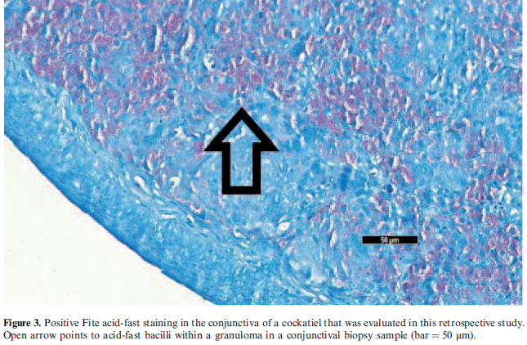

Answer: Mycobacterium genavense

Which method has been found to be the most successful in identifying Macrorhabdus ornithogaster organisms in fecal samples of budgerigars (Melopsittacus undulatus)?

- Fecal gram stain
- Macro suspension
- Direct fecal wet preparation
- Macro suspension with methylene blue
- Macro suspension with gram stain

Answer: B
ARTICLE: Flach, Edmund J., et al. "Systemic isosporosis (atoxoplasmosis) in passerine birds at the zoological society of london, london zoo." Journal of Zoo and Wildlife Medicine 53.1 (2022): 70-82.

In which avian species is systemic isosporosis most likely to cause mortality?
- Bali mynah (Leucopar rothschildi)
- Rock dove (Columba livia)
- Cockatiel (Nymphicus hollandicus)
- Sunbittern (Eurypyga helias)
- Pileated woodpecker (Dryocopus pileatus)

Answer: A - SI has evolved only in passerines; different than enteric isosporosis that is common across avians

ARTICLE: Landolfi, Jennifer A., et al. "A qpcr assay and testing guidelines for the molecular diagnosis of systemic isosporosis (formerly atoxplasmosis) in passerine birds." Journal of Zoo and Wildlife Medicine 51.2 (2020): 391-397.

Which organism do you expect to cause a false positive on a fecal qPCR test for systemic isospora in a passerine?
- Cystoisospora
- Eimeria
- Cryptosporidium
- Sarcocystis
- Toxoplasma

Answer: B

Practice Question: The rainbow lorikeet (Trichoglossus moluccanus) pictured below presents to you for lethargy. What clinicopathologic abnormality do you expect to find on blood work?

Answer: Severe anemia

Practice Question: Which of the following is true regarding avian sarcocystosis in thick-billed parrots (Rhynchopsitta pachyrhyncha)?
- Causative protozoal agent is Sarcocystis neurona
- Pan-apicomplexan PCR was reliable in all disease stages
- Treatment with ponazuril alone was usually successful
- Prophylaxis with oral diclazuril appears promising
- Definitive host mitigation alone was the best prevention

Answer: D

USING MULTIVARIATE ANALYSES TO EXPLORE DISEASE PROGRESSION OF FINCH MYCOPLASMOSIS
Rachel M. Ruden, Dean C. Adams, and James S. Adelman
Journal of Wildlife Diseases, 2021;57(3):525–533

Which of the following clinical signs may be considered a sign of active infection with a high-virulence strain of Mycoplasma gallisepticum in a house finch (Haemorhous mexicanus)?
- Blepharospasm
- Crusting
- Erythema
- Exudate
- Swelling

Answer: B

Detection of gliotoxin but not bis(methyl)gliotoxin in plasma from birds with confirmed and probable aspergillosis.
Reidy L, Desoubeaux G, Cardenas J, Seither J, Kahl K, Chauvin D, Adkesson M, Govett P, Aitken-Palmer C, Stadler C, Tocidlowski M.
Journal of Zoo and Wildlife Medicine. 2022 Mar;53(1):60-69.

Which of the following has the highest specificity for diagnosis of Aspergillus spp. in rats and penguins?
A. Radiographs
B. Protein electrophoresis
C. Galactomannan
D. Gliotoxin
E. Bis(methyl)gliotoxin

Answer: D

You are part of a discussion with the manager about creating a walk-through aviary enclosure within the Australia themed area, housing predominantly Melopsittacus undulates - what are some important steps to take to manage the possibility of mycobacteriosis outbreak in this population?

A: Careful monitoring of sick animals- removal from population and work up immediately; careful screening procedures and proper 30 day quarantine prior to introduction of new birds, if housed with soil- changing the top layer bi annually- discuss possibility of indoor aviary, possibly adding nystatin to drinking water, submitting birds for necropsy and histopathology if found dead to screen for diseases within the population; and then informative and educational to the public about these possible zoonotic diseases

You are evaluating a kidney of a Melopsittacus undulates on postmortem and you see the following lesions. What are the lesions and what disease process are they indicative of?

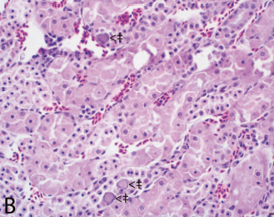

A: intranuclear inclusion bodies, viral infection- possible Adenovirus infection

