JZWM 2021 51(4):752-760
PREVALENCE OF SALMONELLA SPECIES, CLOSTRIDIUM PERFRINGENS, AND CLOSTRIDIUM DIFFICILE IN THE FECES OF HEALTHY ELEPHANTS (LOXODONTA SPECIES AND ELEPHAS MAXIMUS) IN EUROPE
Scharling FS, Bertelsen MF, Sós E, Bojesen AM

ABSTRACT: Pathogenic Salmonella spp., Clostridium perfringens, and Clostridium difficile have been reported to infect and cause severe enteritis and enterotoxemia in African (Loxodonta spp.) and Asian elephants (Elephas maximus). However, little information exists on whether healthy elephants carry and possibly shed these gastrointestinal organisms. This study was conducted to investigate the prevalence of all three bacteria in feces from healthy elephants in European zoos. Bacterial identification was performed by selective culture on fecal samples and a polymerase chain reaction (PCR) amplification protocol, on the basis of primers targeting the hilA gene (Salmonella spp.), the cpa gene (C. perfringens), and the tpi gene (C. difficile) from deoxyribonucleic acid extracted from elephant feces. The PCR protocol was validated prior to initiation of the investigation. Fecal samples collected from 50 African and 86 Asian elephants originating from 30 European zoologic institutions were investigated. The PCR validation revealed detection limits ranging from 10⁴ to 10⁶ colony-forming units per gram of feces of each gene. Only C. perfringens (one type A and two type E) was detected in the initial sampling (2.2%, three Asian elephants), whereas no Salmonella spp. or C. difficile was detected. At a follow-up sampling from C. perfringens-positive animals and relatives, 2 mo after the initial sampling, three animals were culture positive for Salmonella enterica spp. enterica. All positive samples were obtained with bacterial culture, whereas no PCR reactions were positive. Despite carrying these pathogens, all culture-positive animals were clinically healthy and did not develop signs of gastrointestinal disease during the study period. The findings indicate that prevalence of Salmonella spp., C. perfringens, and C. difficile in feces from healthy Asian and African elephants in Europe is very low.

Key Points:
- In horses (an intestinal anatomy and physiology proxy for elephants), the majority of enterocolitis cases is caused by Salmonella spp., C. perfringens, or C. difficile
- Elephants may be exposed through ingestion of contaminated feed or drinking water
  - Salmonellosis in elephants has previously been associated with intestinal flukes (Protofasciola robusta, Pfenderius spp.) or endotoxins of C. difficile
  - Two young Asian elephant calves were coinfected with EEHV and C. perfringens type B resulting in enterotoxaemia
  - Disease, however, likely depends on dysbiosis, triggering overgrowth of the pathogens
- PCR did not detect any target genes in samples in which bacteria was isolated by culture
  - This may relate to the relatively high LOD found when validating the protocol
- Salmonella-positive samples previously tested negative
  - Several serotypes of Salmonella cause intermittent shedding from healthy horses, ruminants, and rhinoceroses
  - Elephants might also be asymptomatic carriers

TLDR: Low prevalence of Salmonella spp., C. perfringens, or C. difficile in healthy elephants in European zoos. Thus, detection may less likely be coincidental and have pathologic manifestations

Related Articles
Boonsri K, Somgird C, Noinafai P, Pringproa K, Janyamethakul T, Angkawanish T, Brown JL, Tankaew P, Srivorakul S, Thitaram C. Elephant endotheliotropic herpesvirus associated with Clostridium perfringens infection in two Asian elephant (Elephas maximus) calves. J Zoo Wildlife Med. 2018;49(1):178–182

JZWM 2021 52(1):67-74
IMPROVED DIAGNOSIS OF FOOT OSTEOARTHRITIS IN ELEPHANTS (ELEPHAS MAXIMUS, LOXODONTA AFRICANA) USING STEREORADIOGRAPHY
Bentley CE, Cracknell JM, Kitchener AC, Pereira YM, Pizzi R

ABSTRACT: Diagnosis of foot disease in elephants is challenging. Owing to their large size, the available diagnostic tools and the expense of imaging are diagnostically limiting. Stereoradiography is the preparation of paired radiographs that form a three-dimensional (3D) image when viewed stereoscopically. Clinicians and veterinary students graded osteoarthritis in the feet of African (Loxodonta africana) and Asian (Elephas maximus) elephants taken postmortem with standard 2D radiographs, as well as 3D stereoradiographs. These gradings were compared with the actual gross pathology identified in the specimens. Although veterinary students diagnoses were no better than chance from 2D radiographs, 83.6% of the students could correctly differentiate severity between joints on stereoradiography; this is an absolute improvement of 30.1% (95% confidence interval [CI] = 19.6%-40.6%). Overall, participants were 27.4% (95% CI = 18.4%-36.3%) more successful at diagnosing pathology on stereoradiographs. Half of participants were shown standard 2D radiographs first, the others stereoradiographs first, but the difference in gradings between the two groups was not statistically significant. Stereoradiography appears to hold the potential to improve diagnosis of osteoarthritis in elephant feet, particularly by less experienced clinicians, and the technique is low-cost and applicable under field conditions

Key Points:
- In managed African and Asian elephant populations, the lifetime risk of foot pathology is 50%, despite most facilities having preventive foot care programs in place
  - A postmortem CT study of 21 elephant feet found had pathology in ≥ one foot
- Stereoradiography is used in human medicine to evaluate spinal and stifle deformities
  - Radiographs are taken normally, but with a shift in the position of the radiographic film or machine between exposures, while keeping the target in the same position
- Stereoradiographs may be generated using the dorsoproximal palmar distal technique and a radiographic generator displacement of 10 cm between exposures
  - This stereoradiographic protocol should be easy in trained live elephants
    - However, the elephant cannot move between exposures
- Participants better identified OA when shown stereoradiographs vs. plain radiography
  - Postgraduates better identified OA on plain radiography vs. veterinary students
    - However, their ability was still improved by use of stereoradiographs

TLDR:
- Stereoradiographs are better for detecting and grading OA in elephants. Also better for inexperienced clinicians and the technique is low-cost and applicable under field conditions

Related Articles
- Johnson G, Smith J, Peddie J, Peddie L, DeMarco J, Wiedner E. Use of glue-on shoes to improve conformational abnormalities in two Asian elephants (Elephas maximus). J Zoo Wildl Med. 2018;49(1):183–188
- Siegal-Willott J, Alexander A, Isaza R. Digital radiography of the elephant foot. In: Miller RE, Fowler ME (eds.). Zoo and wild animal medicine, Volume 7, Current therapy. St Louis (MO): Elsevier; 2012. p. 515–523
- Wiedner E. Proboscidea. In: Miller RE, Fowler ME (eds.). Zoo and wild animal medicine, Volume 8, Current therapy. St Louis (MO): Elsevier; 2014. p. 517–532

Wissink-Argilaga, N., Dastjerdi, A., & Molenaar, F. M. (2019). Using in-house hematology to direct decision-making in the successful treatment and monitoring of a clinical and subsequently subclinical case of elephant endotheliotropic herpesvirus 1b. Journal of Zoo and Wildlife Medicine, 50(2), 498-502.

Abstract: A 3.5-yr-old asymptomatic female Asian elephant (Elephas maximus) with a high load of circulating EEHV1B DNA on qPCR on a routine blood sample, showed progressive depletion of monocytes, lymphocytes, and platelets. Twice daily IV ganciclovir, plasma transfusions, and fluid therapy coincided with a decreasing viral load, which may support potential efficacy of this antiviral drug. An increase in lymphocytes followed initial treatment and preceded the onset of clinical signs. Administration of short-acting glucocorticosteroids for two consecutive days preceded a reduction of lymphocytes, recovery and maturation of monocytes, and gradually decreasing clinical signs, illustrating the potential value of glucocorticosteroids in treatment of clinical EEHV. Three subsequent subclinical episodes with high monocyte and platelet counts did not require intervention. Decision-making was led not just by quantification of viral load and clinical signs, but more specifically by interpretation of the hematological changes using easily accessible, in-house blood smear analysis.
- Key Points:
  - Elephant endotheliotropic herpesvirus – EEHV; fatal hemorrhagic disease in Asian elephants (1-8 yrs age), largest cause of death in calves in Europe and NA.
    - Most fatalities caused by EEHV1 A and EEHV1 B.
  - Circulating viral DNA detectable at least several days before CS, routine monitoring with qPCR of all at-risk calves is recommended.
  - Decreased monocyte:heterophil ratio and reduction in platelets have been suggested as useful prognostic indicators and a way to monitor response to treatment.
- This case:
  - A calf tested positive for EEHV1B on routine qPCR screening.
  - Next day, marked reduction in WBC (~8 vs normal 16-23 for this individual).
    - Relative depletion of lymphocytes and monocytes, significant reduction in platelets (~260 vs 400-900).
  - Day 3 – Increasing viral load and further reduction in monocytes, M:H ratio 0.57 (2.43 normal for this calf). Still no symptoms but started treatment.
    - IV peripheral ear vein, gave plasma, ganciclovir, fluid therapy. Also warm water rectally. Viral load showed reduction within 36h of treatment.
    - Platelet count continued to decrease on day 5, switched to a fresh plasma transfusion instead of previous frozen. Started ceftiofur.
  - Day 6 onwards, increase of lymphocytes, persistently low M:H.
  - Day 9 – Hemorrhages on the tongue and vulva, submandibular and limb edema.
    - Added short-acting glucocorticosteroid (dexamethasone). Lymphs came down.
    - Antiviral tx was suspended due to supply and then started again on Day 11.
  - Day 13 – CBC improved, PCR negative two days later. Back to normal by day 23.
  - Initial viremia followed by three viremic events (day 44-61, 72-87, 98-112), platelets were elevated and increased WBC count was seen, treatment was not initiated and CS did not develop.
- Takeaway: Routinely monitor Asian elephants for viremia and hematological changes. Establish individual database for normal. Lymphocyte surge preceded onset of CS, severe monocyte depletion in initial phases of viremia. Recovery of monocytes coincides with reduction of CS, high monocyte numbers evident in all subclinical events. Fresh plasma recommended over frozen.

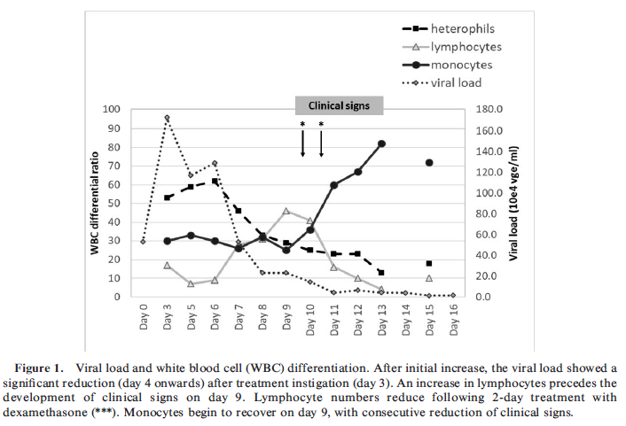
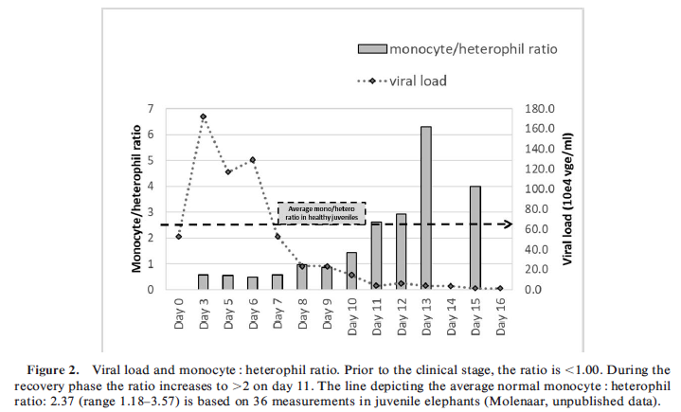
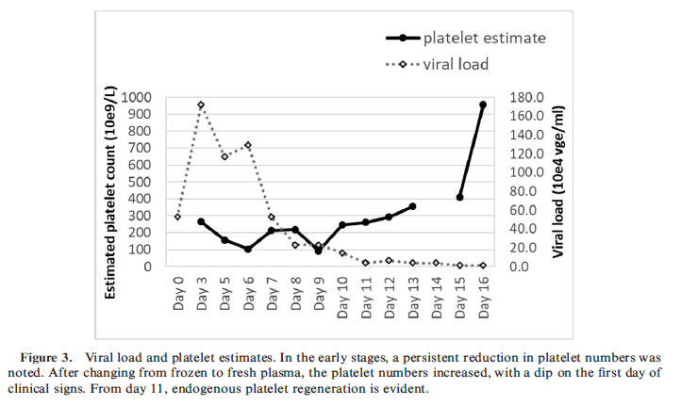

Vital signs and first occurrences in normal and abnormal newborn Asian elephant (Elephas maximus) calves
J Zoo Wildl Med. 2017;48(4):997-1015. doi: 10.1638/2017-0036.1.
Ellen Wiedner, Wendy K Kiso, Janice Aria, Ramiro Isaza, William Lindsay, Gary Jacobson, Kathy Jacobson, Dennis Schmitt

Abstract: Sixteen years of medical records documenting 19 births within a herd of Asian elephants ( Elephas maximus) at a private facility in the southeastern United States were reviewed. Of the 19 calves, 11 were normal at birth, requiring no additional veterinary care, and eight were abnormal, requiring veterinary care immediately or within the first week of birth. Descriptive statistics were used to evaluate morphometrics, vital signs, and behavioral milestones in newborn calves both normal and abnormal. Blood work and urinalysis results from all calves were compared to values for adult elephants. Medical management of abnormal calves is described. All calves had faster heart rates and respiratory rates than did adult elephants, but rectal temperatures were the same. Calves were precocious with regard to sitting and standing but could be very slow to nurse. The most-common medical conditions of newborn calves were umbilical abnormalities and problems associated with nursing. Two calves required cardiopulmonary resuscitation after birth but made full recoveries. Some conditions were not apparent at birth but were recognized a few hours or days later. Following veterinary intervention, six of the eight calves made full recoveries, suggesting that early identification and treatment of problems can greatly decrease mortality. This is the first report of multiple veterinary and behavioral parameters in normal and abnormal neonatal Asian elephants from a facility with a calf survival rate above 90%. This information may be helpful to other elephant-holding facilities in providing care to their newborn elephant calves.

Background
- Heart murmurs have been associated with EEHV and congenital cardiac abnormalities
- Elephant calves are immunocompetent at birth, do not have immediate need for colostrum
- Elephant livers lack bile acids and differ from other species in various ways, liver enzymes are unvalidated
- Short umbilical cord so always ruptures at birth and can result in bleeding and skin tears, normal swelling after birth may preclude identification of problems like umbilical hernia
- Hand-rearing Asian elephant calves rarely succeeds due to extreme variability in milk components (esp fatty acid and oligosaccharide components).

Key points
- 42% required veterinary care within 1st week of birth (‘abnormal’), 6/8 recovered fully, 2 did not survive 1st year of life (maternal rejection and congenital abnormalities)
- All recorded behaviors were precocious (sternal 2 min, standing 6 min, walking within 2 hr, moving trunks, flapping ears, vocalizing shortly after birth). Abnormal calves took longer.
  - Failure to stand within 24 hr typically has poor prognosis
- Abnormal births: 3/4 primiparous and 5/15 multiparous (primiparity may have been a risk factor)
- Normal had teeth and suckle reflex at birth
- CBC: predominantly neutrophils (adults predominantly monocytes), Hct, Hb higher and MCV, platelets lower than adults
- Chem: ALP, AST, P, tbili, crea higher than adults. ALT, TP, glob, BUN lower than adults
- UA: comparable to adults but often positive for blood, protein, bilirubin, and granular casts
- Problems in abnormal calves: umbilical abnormalities and difficulty nursing most common
  - Musculoskeletal issues: extensor rigidity, inability to stand, angular limb deformities, resolved with conservative care. Both calves had high birth weights (> 136 kg)
  - Landing on back after birth likely led to urine retention from sacral nerve injury, supported by seroma over sacrum, managed with analgesia, anti-inflammatories, and antispasmodics
- CPR: right lateral recumbency, manual chest compressions behind the elbow 60.min, vigorous massag and intranasal oxygen 10 L/min, respiratory stimulant. Prolonged resolution of subsequent neonatal maladjustment syndrome (from peripartum hypoxia) but full recovery possible.

Birth parameters | Mean | Mean in normal calves | Abnormal calves
Weight | 126 kg | 121 kg | Slightly higher
HR | 102 bpm | 92 bpm (70-140) | Slightly higher
RR | 44 brpm | 58 brpm (20-140) | Lower
Temp | 37.4 C | 37.4 C | Equal
Gestation length | 655 d | 661 d | Shorter
Time to first nursing | 4 hr
Passing meconium and urine | 20 min, 1-2 hr |  | Later

Conclusions:
- 1st report of vitals, bloodwork, UA, and morphometric and behavioral first occurrences in newborn Asian elephant calves. 1st description of elephant CPR.
- Normal calves had lower heart rates and higher resp rates than abnormal calves
- Heart murmurs may not be clinically significant, raspy thoracic noises at birth are common but should disappear by time of walking unassisted
- High percentage of animals requiring veterinary care after birth and several problems not recognized or present until several days after birth indicate preparation and close, prolonged monitoring may be key to success.

Burke, Sophie M., et al. "Detection of aerosolized bacteria in expired air samples from Asian elephants (Elephas maximus)." Journal of Zoo and Wildlife Medicine 48.2 (2017): 431-439.

Abstract: Elephant-mediated transmission of tuberculosis is assumed to be similar to human models, which state close and prolonged contact with an infected individual is required for transmission. Although considered a risk factor for infection, several case studies have reported that close contact with an elephant is not always necessary for transmission, and the role of aerosolized bacteria remains unclear. To investigate aerosol-mediated transmission of pathogenic bacteria from elephants, a method for the detection of aerosols using an adapted sampling system was developed. A commensal bacterium was isolated from the upper respiratory tract of elephants (Elephas maximus) and was used as a proxy organism to detect aerosolized droplets in the sampling system. It was found that elephants are capable of producing aerosolized bacterial particles of a size small enough to remain airborne for prolonged periods and penetrate the lower regions of the human respiratory tract.

Key Points:
- Mycobacterium tuberculosis – Transmission between elephants, elephants/humans, elephants/other animals. Primary pathogen lower resp tract.
  - Result of close, freq, prolonged contact with shedding elephant.
  - Inhalation of aerosolized droplet nuclei.
  - Several risk factors for contracting TB from shedding elephant:
    - Close or frequent contact.
    - Use of high-pressure hosing when cleaning.
    - Necropsy of elephant with TB.
    - Close contact does not appear necessary in all cases.
  - High risk for transmission for transmission of aerosolized bacteria from elephants – breathing, vocalizing, blowing from trunk.

- M+M: Cultured trunk wash samples; based on sequencing results, biochemical profile for a proxy bacteria (Rothia spp) was established. Similar method for expired air samples.

- Conclusions:
  - Elephants are capable of producing resp aerosols that are small.
  - Could penetrate lower airways, can remain airborne for prolonged periods, have potential for long-distance travel.

Sripiboon, Supaphen, et al. "Successful treatment of a clinical elephant endotheliotropic herpesvirus infection: The dynamics of viral load, genotype analysis, and treatment with acyclovir." Journal of Zoo and Wildlife Medicine 48.4 (2017): 1254-1259.

Abstract: This article describes the treatment of clinical elephant endotheliotropic herpesvirus (EEHV) infection in a male Asian elephant (Elephas maximus; approximately 3 yr old), the dynamics of viral load during the active infection, and genetic analysis of the virus. Treatment included injectable acyclovir (12 mg/kg iv, bid), antibiotic, vitamin, and fluids. Quantitative polymerase chain reaction was used to measure the viral levels in blood, which decreased continuously after initiation of intravenous acyclovir. Low levels of virus were detected in the blood for 2 wk, and the virus was undetectable after 1 mo. No complication was observed during the treatment period. This case report suggests that acyclovir, given parenterally, could potentially enhance survival of clinical EEHV-infected individuals.

Key Points:
- Wild-born male Asian elephant orphan, 1.5yrs of age developed papilloma-like nodule on tongue, resolved with topical povidone-iodine.
- At 3yo, petechial hemorrhages developed on tongue, decreased appetite. Tx flunixin, chlorpheniramine, no improvement. Gave triamcinolone, deteriorated.
- EEHV highest ddx, started acyclovir 24 mg/kg PO. Fever, edema of head and trunk, started refusing oral meds, started giving per rectum at half dose BID. Developed conjunctivitis.
- Started giving acyclovir IV, started to measure viral load with qPCR.
  - Improved significantly over next 48 hours. By day 7 of treatment, appetite returned to normal, fever resolved. Switched back to oral meds.
- qPCR – universal primer pair specific for EEHV. Highest on day 4, still detectable 2 wks later, zero by 33 days. Gene analysis showed this animal was infected with EEHV1A, subtype cluster E not previously reported in Thailand.

- Acyclovir and famciclovir used to tx herpes in humans.
  - Prodrugs activated by phosphorylation by a viral encoded thymidine kinase (TK) gene.
    - May also be activated by other kinases i.e. CPK (conserved protein kinase gene in cytomegalovirus aka UL97).
    - TK gene normally lacking in members of the betaherpesvirus group, EEHV is a unique betaherpesvirus that possesses both TK and CPK genes.
  - Oral famciclovir favored based on better oral bioavailability and longer half-life.
  - A previous study showed that famciclovir at 8-15 mg/kg PO TID in elephants sufficient to attain levels considered to be therapeutic in humans. Challenging since elephants become anorexic with acute dz.
- Acyclovir was used due to availability in Thailand, ability to give IV, cheaper cost vs famciclovir.
  - Disadvantages – need to give IV for extended period, localized vasculitis may occur.
  - Difficult in untrained elephants.
- Ganciclovir is also injectable, commonly used in US and EU for EEHV, not available in Thailand.
- Cannot definitively state that acyclovir caused clearing of viremia in this case. Other supportive care – fluids, abx, vitamin C, calf immune response and expectation for decline in viral load with time.
Reproductive parameter and birth statistics for a herd of Asian elephants (Elephas maximus) in North America over a 20-year period
Kiso WK, Wiedner E, Isaza R, Lindsay W, Aria J, Jacobson G, Jacobson K, Schmitt D.
J Zoo Wildl Med. 2017;48(4):987-996.

We reviewed medical records documenting 28 pregnancies occurring within a herd of Asian elephants ( Elephas maximus) over a 20-yr (1994-2014) period at a private facility in the southeastern United States. Twenty-six pregnancies resulted in live calves and two ended in stillbirths. The 26 live births represented the offspring of 11 cows and 5 bulls. Twenty-four calves survived their first year, including two critically ill calves born after dystocias. Male and female calves occurred in almost equal numbers. Mean duration of labor in this group was 36 hr although the median duration was 13 hr. Although oxytocin was administered to several cows, parturition did not always immediately ensue. Female fecundity ranged from 1-6 calves while female age at parturition ranged from 9-46 yr. Females delivered their first calves between 9 and 26 yr of age whereas bulls sired their first calves in their 20s, on average. The number of live births and the 93% calf survival rate are among the highest reported in any western hemisphere elephant-holding facility. This may reflect the intensive management of cows before, during, and after each pregnancy, the number of experienced multiparous cows, and the skill level of staff, most of whom had worked with each other and with this herd for many years. The data presented here may assist facilities planning to breed Asian elephants.

Background:
- Primary causes of unsustainable Asian elephant populations in captivity in NA and EU
  - Failure to conceive, stillbirth, early calf mortality (infanticide, maternal rejection), low fecundity, short reproductive lifespan, acyclicity
- Decreased reproductive success: housing and husbandry, herd composition, health issues, restricted vs nonrestricted captive management systems.
- Causes of prolonged labor: oversized calf, twinning, calf malposition, malpresentation, or malformation, uterine inertia, hypocalcemia, maternal obesity
  - AI may result in higher number of male calves
- Stages of elephant labor (different from horses)
  - I – fetus already in dorsosacral position without cervical dilation
  - II – dilation of cervix, entry into birth canal, bulge appears under mother’s tail, rupture of fetal membranes, ‘hard labor’ and fetal expulsion
  - III – expulsion of placenta (may take up to 10hr)
Key Points:
- Retrospective 1994-2014 privately owned herd, central FL (Ringling Brothers, Barnum & Baileys)
- Regular exercise, goal: total pregnancy weight gain < 227 kg (500lb)
- If labor ceased: ultrasound to confirm cervix dilated and calf in correct position, then oxytocin 40-80 IU IM (empirical dose) +/- rectal massage (Ferguson’s reflex for release of endogenous oxytocin). If calf in inappropriate position: light exercise to readjust.
- 93% live calves, 7.2% stillbirths, mothers age 9-46 yr, first partition mean 16 yr, parity 1-6 calves, intercalf interval 2.3-7 yr, sire age 10-37 yr, first calf sired at 20-25 yr, gestation 621-695 d (mean 656, median 659d), all births occurred overnight.
- Progesterone levels dropped to baseline (below 300 pg/ml) avg 5 days before birth, milk let down mean 10/median 2d, spontaneous milk dripping 6hr prior to birth, loss of mucosal plug 21 hr prior in 1 case, ruptured fetal membranes occurred with parturition, labor lasts 2-90 hr (mean 36, median 13hr).
  - Calcium concentration in milk does not correlate with imminent parturition like horses
  - Early milk let down (d76) may have been a sign of impending issues in 1 cow with severe dystocia, similar to horses
  - Long pauses during labor without contractions often have no effect on calf survival
- Placenta passed mean 3hr after birth, one retained placenta for 30d with no adverse clinical signs
- Female elephants should conceive as soon as they start cycling regularly (6-15 yr old -younger than previous recommendation of prior to 24yo) based on reproductive senescence and repro tract pathology with exposure to reproductive hormones without being bred.
- Previous recommendations of 10-15 yr or 20 yr intercalf intervals contribute to reproductive pathology. Intercalf interval of 4-6 years allows time for large uterine blood clots (normal post-calving) to disappear and for 1-2 yr lactational anestrus period.
- Retained fetus can last mo to yrs and caused no systemic illness
Conclusions:
- Emphasis on exercise and preventing excessive weight gain may lower dystocia rate
- Bulls presence improves female cyclicity and allows mating as soon as cow is in estrus
- Other possible factors in high success rate in this herd: consistent photoperiod, herd stability, group calf-care, remote monitoring with cameras, staff experienced with elephant care, this specific herd, and each other, intensive hormone monitoring to ID puberty and time breeding, extensive birth preparations.

ACUTE HEMORRHAGIC DISEASE DUE TO ELEPHANT ENDOTHELIOTROPIC HERPESVIRUS 3A INFECTION IN FIVE AFRICAN ELEPHANTS (LOXODONTA AFRICANA) AT ONE NORTH AMERICAN ZOOLOGICAL INSTITUTION
Fayette MA, Brenner EE, Garner MM, Bowman MR, Latimer E, Proudfoot JS.
Journal of Zoo and Wildlife Medicine 2021;52(1):357–365

Acute hemorrhagic disease caused by elephant endotheliotropic herpesvirus (EEHV) infection is well recognized as a major threat to young Asian elephants (Elephas maximus) but has been less frequently documented in African elephants (Loxodonta africana). This report describes ﬁve sequential cases of EEHV3A infection in African elephants in managed care at one institution. All elephants developed disease within a 4-mo period. The ﬁrst two cases were 6.5- and 7.5-yr-old females that presented with depressed mentation, anorexia, hematuria, and diarrhea. Both elephants died within 48–72 hr of the onset of illness despite treatment. Postmortem ﬁndings included widespread edema, ascites, and extensive petechiae and ecchymoses on the heart, liver, and spleen and within the gastrointestinal and urogenital tracts. Histologic examination identiﬁed disseminated vascular necrosis with edema, hemorrhage, and rare endothelial cell intranuclear inclusions typical of herpesvirus in multiple organs. The third and fourth cases were a 13-yr-old male and a 12-yr-old female that presented with minimal to no clinical signs, but with marked changes in hematologic parameters and high viremia detected by quantitative polymerase chain reaction (qPCR). Both elephants survived the infection with early and aggressive treatment. The ﬁfth case was a 37-yr-old female that presented with lethargy and a decreased appetite. Low viremia was detected by qPCR, and mild to moderate hematologic changes were noted. Early treatment resulted in a successful outcome. This case series documents the ﬁrst known reports of clinical disease and fatality associated with EEHV3A in African elephants.

Background
- EEHV: Genus Proboscivirus, proposed subfamily Deltaherpesvirinae
  - endemic in African (LA) and Asian (EM) elephant populations, wild and captive
  - EEHV-HD is a major threat to young EM
  - Risk factors are unknown
- Endemic in EM: EEHV1A, 1B, 4, 5A, 5B
  - Most clinical disease, fatality attributed to 1A and 1B
- Endemic in LA: EEHV2, 3A, 3B, 6, 7A, 7B - ubiquitous, detected in lung and skin nodules, saliva, trunk secretions
  - Clinical disease documented in 5 LA, 3 fatal (EEHV2 in NA zoo, EEHV6 in Thailand zoo), 2 surviving cases (EEHV6, 3B)
Case Series
- CS: depression, ptyalism, inappetance, abdominal pain, tremoring hind limbs, diarrhea, hematuria → scleral hyperemia, superficial periocular ulcers, tongue vesicle, oliguria → dyspnea, abdominal distention, ventral SC edema (cervical, abdomen, hind limbs), rectal mucosal hemorrhage
- BW: hemoconcentration or anemia, leukopenia, monocytopenia, lymphopenia → polycythemia, leukocytosis with left shift, monocytosis, severe thrombocytopenia
  - Azotemia, high AST and GGT, moderate hyperkalemia, hypoproteinemia
  - Elevated SAA +/- haptoglobin
  - Hematuria, proteinuria, pyuria, lacking normal calcium carbonate crystals, cultured Strep
- Low level shedding prior to onset of CS +/- increase
- Treatments: banamine, oral/IV/rectal fluids, butorphanol, CCFA, furosemide, ceftiofur sodium, famcyclovir, dexamethasone, omeprazole, colloids, fortified fresh plasma (cross-matched and negative on EEHV PCR), plasma, whole blood transfusions, IV autologous mesenchymal stem cells (anti-inflammatory, immune modulatory)
- Fatalities: 48-72 hr after onset of CS
- PM: Widespread petechiae serosal and mucosal surfaces, vulvar and gastric ulcers, melena, subcapsular liver hemorrhage, severe pulmonary edema, peritoneal effusion, thickened bladder wall, pyelonephritis, cyanosis of tongue
  - Histo: disseminated endothelial and vascular necrosis with edema and hemorrhage in most tissues
  - Intranuclear eosinophilic inclusions surrounded by a narrow clear halo and with associated chromatin margination: Cowdry type A inclusions in endothelial cells
Key Points
- 12 cases of clinical EEHV documented in LA with 50% mortality
- Low levels of viral DNA (<1,000 VGE/ml) in whole blood and trunk wash fluid of asymptomatic animals - EEHV2, 3, and 6
- Histologic lesions of EEHV3A in these LA were identical to cases in EM
- Intranuclear inclusions in epithelial cells of arteries and capillaries, broad tissue tropism suggests high degrees of virulence for EEHV3A
- Hematologic changes: leukopenia, monocytopenia or monocytosis, lymphopenia, thrombocytopenia, heterophil left-shifting
  - Normalization of mono:het ratio, leukocytosis, and thrombocytosis with clinical improvement, mono:het ratio appears to have prognostic value
  - Substantial elevations in SAA at onset of viremia but comparable between fatal and surviving cases - not a prognostic factor
- Peak whole blood viral counts 2-5 days after onset of CS, most severe BW changes at peak viremia
  - Resolution of symptoms and hematologic changes within 8-10 days
  - Viral load gradually decreased to undetectable within 2-3 weeks of onset of CS
- Based on serology, cases 1, 2 were caused by primary infection, cases 3-5 may have been reactivation of latent virus or primary infection with different EEHV3 strain
Conclusions
- Regular EEHV viremia monitoring should be part of African elephant preventative medicine, just like in Asian elephant juveniles
- First reports of acute hemorrhagic disease and fatality with EEHV3A in African elephants
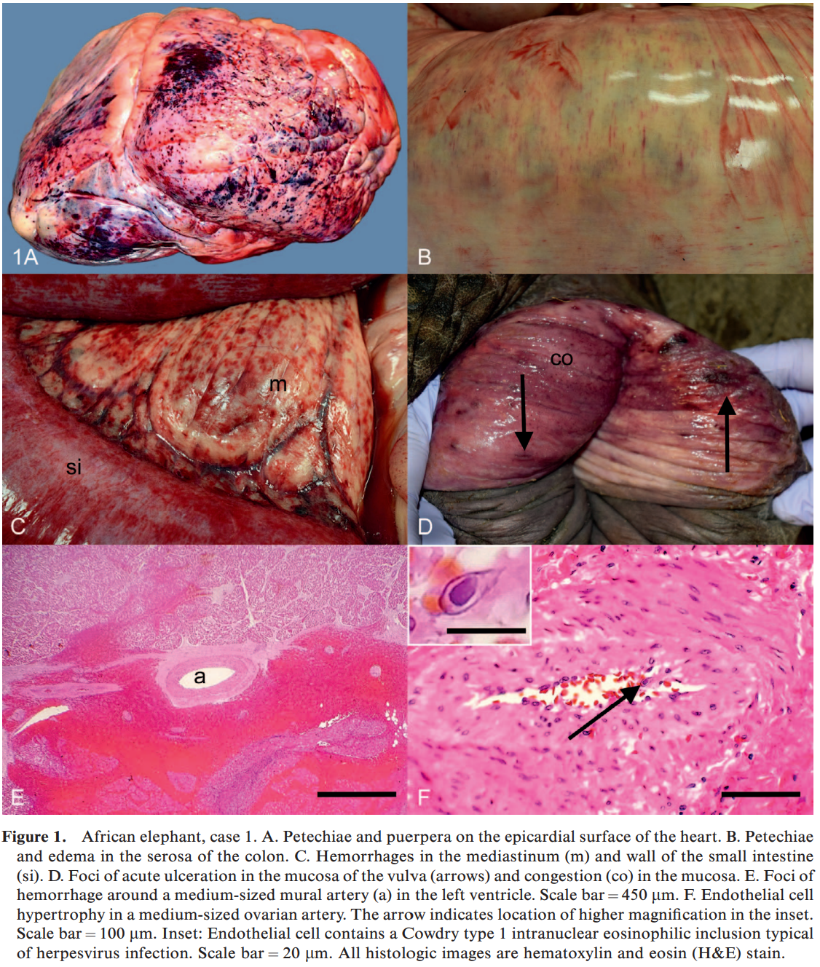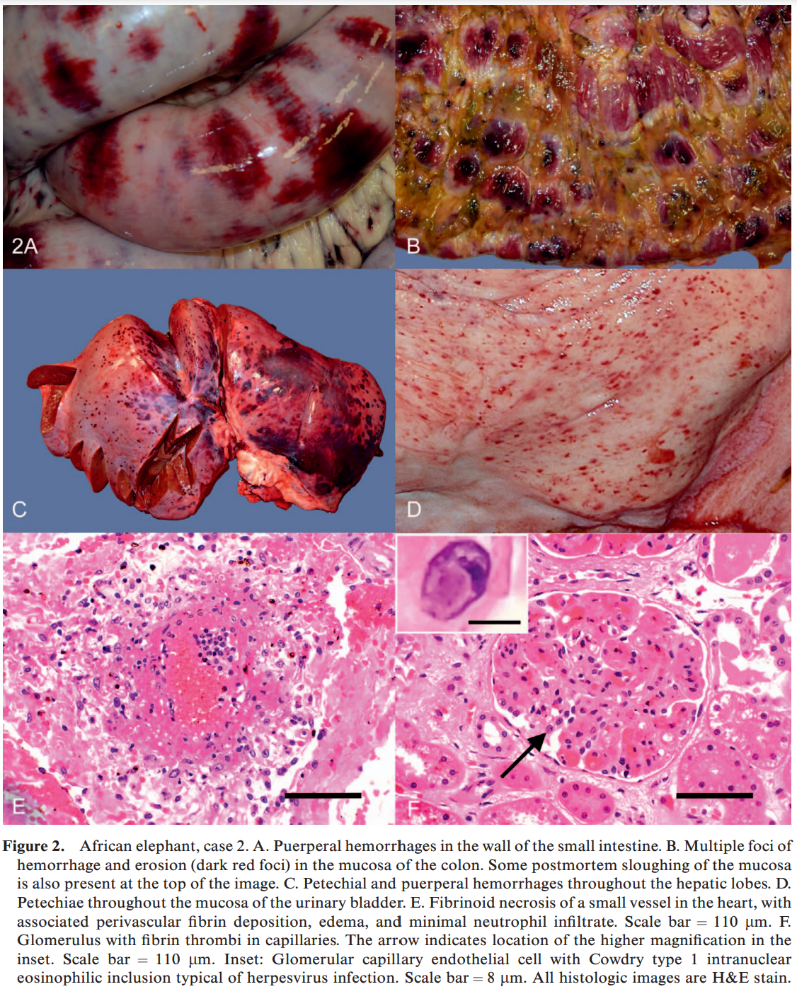

Journal of Zoo and Wildlife Medicine 51(3): 545–560, 2020
SURVEY OF GERIATRIC ELEPHANT MEDICAL CARE, NUTRITION, HUSBANDRY, AND WELFARE Whitney Greene, DVM, MS, and Deena Brenner, DVM, Dipl ACZM

Abstract: Improvements in husbandry, veterinary care, and nutrition have led to increased longevity of animals in human care, including elephants. The goal of this study was to collect and synthesize information pertaining to geriatric elephant medicine, management, husbandry, and nutrition. An electronic survey was created and distributed to American Association of Zoo Veterinarians members through an online link. A total of 61 responses were received from veterinarians, nutritionists, and elephant managers with data encompassing 314 elephants, of which 142 were geriatric (over 40 years old) and 51 were on their final set of molars. Following the initial survey, willing respondents were contacted for follow-up interviews. Osteoarthritis, foot disease, and colic were the most commonly reported diseases, and flunixin meglumine and phenylbutazone were the analgesics most often used. Respondents described diseases treated, husbandry changes specific for older animals, welfare assessments and quality of life monitoring, nutritional modifications for dental attrition, a variety of integrative medicine modalities, and unique cases. It is the hope that the information identified in this study can be used to improve treatment, management practices, and overall welfare for geriatric elephants.
Key Points
- Median life expectancy for Asian elephants – females 46.9, males 32.7 yr
- MLE for African elephants – females 38.6 yr, male 23.8 yr
- Most common disorders – osteoarthritis, colic, dental disease, foot disease (nail cracks, nail abscesses, sole abscesses)
- Most common therapies – foot trimming, exercise, NSAIDS, substrate change
- Most common analgesics – banamine, bute, ibuprofen
- Husbandry
  - Variety of substrates best for foot healthy – grass, sand, dirt, rubberized or padded flooring
  - Efficacy of sand promoted by some studies, distributed by others
  - Concrete is bad
  - Stereotypies higher for individual or transferred elephants, lower for those engaged in training with staff, with juveniles, and larger social groups
  - Horizontal surfaces or sand piles (or ERD) for animals to lie down
  - Cognitive enrichment is available at most facilities but less commonly used
- Health Issues
  - Foot abnormalities – associated with nails (usually N5 on both front feet)
  - Heart disease – blood pressure and troponin levels should be part of geriatric examination
- Nutrition
  - More feedings throughout the day is better – more could be offered at night
  - Mean retention time ~50 hours for African elephants, 65 hours for Asian elephants (longer than what is reported for younger elephants – more in the 20-28 hour range)
  - Vitamin E was the most common supplement – measure levels
  - Psyllium increases fecal output by increasing GI motility – pers comm study said there wasn’t a corresponding increase in sand output
  - Colic therapies – pumpkin, bran, vegetable/mineral oil, apple sauce
  - Senior diets – softer pellets, soaked beet pulp, wheat bran, psyllium husk, rice gruels
    - Senior horse diets have more protein, and Ca:P ratios of 1.5:1
- Welfare: Start conversations and monitoring early and discuss it regularly
Take Home: Geriatric elephants have specific husbandry, health, and diet related issues that need to be addressed
PHARMACOKINETICS OF ORALLY ADMINISTERED FLUNIXIN MEGLUMINE IN AFRICAN (LOXODONTA AFRICANA) AND ASIAN (ELEPHAS MAXIMUS) ELEPHANTS
Journal of Zoo and Wildlife Medicine, 51(4) : 905-914, 2020

Abstract: Flunixin meglumine is the most commonly used nonsteroidal anti-inflammatory drug used to treat elephants; however, no pharmacokinetic study for flunixin has yet been conducted in these species, and dosages used range widely. Pharmacokinetic parameters of flunixin were determined in African (Loxodonta africana) and Asian (Elephas maximus) elephants after single-dose oral administration of 0.8 and 1.5 mg/kg flunixin paste in each species. Elephant compliance to oral administration of banamine was occasionally challenging, especially among older, female African elephants. After administration of 0.8 mg/kg flunixin, mean serum concentrations peaked in approximately 1.3 hr at 2.1 + 0.8 lg/ml for Asian (n=8) and 2.8 hr at 2.5 + 0.7 lg/ml for African (n=8) elephants. Dosages of 1.5 mg/kg flunixin resulted in mean serum concentration peaks of 7.2 + 1.5 lg/ml in Asian elephants (n=7) and 4.4 + 0.7 lg/ml in African elephants (n=6). However, multiple-dose trials using 1.1 mg/kg flunixin resulted in peak serum concentrations that were again less in Asian than African elephants (2.7 lg/ml versus 4.4 lg/ml, respectively). Asian elephants consistently had lower time to maximal concentration, greater area under the curve, and longer mean residence times compared with African elephants. In other species, flunixin is excreted unchanged primarily via hepatic routes with small amounts in the urine. Asian elephants may engage in some level of enterohepatic recycling of flunixin, as was previously reported for phenylbutazone. This study supports that different oral dosing regimens should be used for Asian (1.0 mg/kg SID) and African (1.2 mg/kg SID) elephants, and oral administration techniques used should ensure complete dosage delivery

Intro
- Flunixin meglumine is commonly used in elephants but no PK studies have been done
- The objective of this study was to determine appropriate dosing regimens for both African and Asian elephants based on noncompartmental pharmacokinetic analyses of flunixin administered as both single and multiple doses
M&M
- N=26, 11 African elephants, 15 Asian elephants
- Single dose trial using 0.8 and 1.5 mg/kg orally
- Based on these results a multi dose trial was performed using 1.1 mg/kg every 24 hours for 3 days
- An IV trial was conducted with 3 Asian elephants, single dose at 0.8 mg/kg
Results and discussion
- Oral drug delivery proved to be challenging in multiple individuals
- No negative side effects of the drug were seen
- Asian elephants consistently had lower time to maximal concentration, greater area under the curve, and longer mean residence times compared with African elephants
- The results show that flunixin follows a biphasic disposition in Asian elephants
  - Possibly due to eneterohepatic recycling in this species
- The bioavailability of flunixin in Asian elephants appears to be near 95% or better for oral administration
- No significant difference between males and females, weight and age also not significant
- The T1/2 of flunixin in elephants appears to be greater than other species, ranging from approximately 6 hr in African elephants and 10 to 12 hr in Asian elephants for oral 1.5 mg/kg and 1.1 mg/ kg doses, compared with 3 to 8 hr in cattle, 8.3 hr in white rhinos

Takeaway: Recommended flunixin dosing: Asian (1.0 mg/kg SID) and African (1.2 mg/kg SID) elephants

