J Zoo Wildl Med. 2019 Mar 1;50(1):55-61
EFFECT OF A NUTRIENT ENEMA ON SERUM NUTRIENT CONCENTRATIONS IN WHITE-SPOTTED BAMBOO SHARKS (CHILOSCYLLIUM PLAGIOSUM)
Parkinson L, Gaines B, Nollens H

ABSTRACT: ll and anorectic captive sharks present a unique challenge for husbandry and veterinary staff. Providing adequate fluid and nutritional support to sharks while minimizing handling remains difficult. This study aimed to evaluate the ability of a nutrient enema to alter blood analyte concentrations. Thirty-six healthy, fasted white-spotted bamboo sharks (Chiloscyllium plagiosum) were enrolled in the study with 18 sharks receiving a nutrient enema and 18 sharks receiving a non-nutrient saline enema. The metabolic state of sharks was evaluated via measurement of blood glucose, blood urea nitrogen, and β-hydroxybutyrate as well as other serum biochemistry parameters. Changes in sodium, chloride, calcium, β-hydroxybutyrate, glucose, total protein, and triglyceride concentrations were seen across time in both groups. Blood glucose absolute concentrations and changes over time differed between the nutrient and nonnutrient groups. This pilot study indicates that it is possible to influence the glucose metabolism of healthy sharks via nutrient enema. Further study is needed to better understand potential therapeutics for ill and anorectic sharks

Key Points:
- Ailing sharks are often anorectic and do not tolerate handling well
  - Elasmobranch Husbandry Manual recommends tube feeding of anorectic elasmobranchs as a last resort, with 4-6 weeks of anorexia prior to intervention
  - Due to their aquatic environment, IV fluids remain difficult to administer
  - SC fluids are also not easily given due to limited subcutaneous space
  - Clinical experience suggested sharks tolerated dorsal recumbency and enema administration more readily than placement of a mouth guard and feeding tube
- Parameters assumed to reflect a shark’s metabolic state are glucose, BUN, and BHB
  - BHB is an excellent indicator of a shark’s overall metabolic state
  - Ketone bodies are central to most metabolic processes in elasmobranchs
  - Ketone bodies, mainly BHB and acetoacetate, are produced in the liver and are then released into circulation to provide cellular energy
    - BHB is the ketone body most abundant in blood
  - While ketone bodies are metabolic fuel in mammals during times of starvation, they appear to play the role of primary metabolic energy in elasmobranchs
- BHB was not found to be significantly different between groups throughout
  - This may be due to a lack of sufficient supplemental support for this metabolite.
  - Alanine and pyruvate have been shown to contribute to ketogenesis in elasmobranchs, so the addition of alanine may be worthwhile
- BUN was monitored as an indication of protein metabolism and osmoregulatory status
  - However, BUN did not differ significantly at any time point between groups
  - Urea is normally maintained at elevated levels at significant metabolic cost during fasting, allowing sharks to maintain a slightly hyperosmotic state
- Carbohydrate metabolism is not well understood in elasmobranchs
  - The decrease in blood glucose, seen at 120 hr, indicates that the nutrient enema altered the metabolism of the sharks
  - This suggests that enemas containing dextrose may help with supportive care
- Triglycerides were significantly higher than baseline at 72 and 120 hr in both groups
  - Triglycerides are involved in hepatic lipid storage, in addition to ketone bodies

TLDR:
- Minor differences in glucose were found between nutrient and saline enema groups
- Changes over time in other metabolites, likely due to fasting, were uncovered in both groups.

Related Articles
Janse M, Firchau B, Mohan PJ. Elasmobranch nutrition, food handling, and feeding techniques. In Smith M, Warmolts D, Thoney D, Hueter R (eds.). The elasmobranch husbandry manual: captive care of sharks, rays, and their relatives. Colombus (OH): Ohio Biological Survey; 2004. p. 183–200

J Zoo Wildl Med 2020 51(2):326-333
RADIOGRAPHIC DETERMINATION OF GASTRIC EMPTYING AND GASTROINTESTINAL TRANSIT TIME IN COWNOSE RAYS (RHINOPTERA BONASUS) AND WHITESPOTTED BAMBOO SHARKS (CHILOSCYLLIUM PLAGIOSUM) AND THE EFFECT OF METOCLOPRAMIDE ON GASTROINTESTINAL MOTILITY
Joblon MJ, Flower JE, Thompson LA, Bray RL, Tuttle AD

ABSTRACT: Gastrointestinal (GI) pathology is common in elasmobranchs; however, information regarding normal GI transit time and the effect of therapeutics on GI motility is lacking. The objective of this study was to determine baseline gastric emptying and GI transit times in cownose rays (Rhinoptera bonasus) and white spotted bamboo sharks (Chiloscyllium plagiosum) via radiographic barium sulfate contrast studies. Additionally, a pilot study was undertaken to determine the effect of metoclopramide on GI transit time in whitespotted bamboo sharks. Eight cownose rays and eight whitespotted bamboo sharks were administered a 98% w/w barium sulfate suspension at 8 ml/kg via orogastric tube. Post-contrast radiographs were obtained at 2 min, 3, 6, 12, and 23 hr for rays; and 2 min, 3, 6, 9, 12, 16, 25, 30, 36, and every 12 hr until complete gastric emptying occurred for sharks. In cownose rays, the mean and standard error were established for time of initial spiral colon filling (3.4 ± 0.4 hr), complete spiral colon opacification (12 ± 0 hr), initial spiral colon emptying (21.6 ± 1.4 hr), and complete gastric emptying (23 ± 0 hr). In bamboo sharks, the mean and standard error were established for time of initial spiral colon filling (5.3 ± 0.5 hr), complete spiral colon opacification (12.4 ± 1.3 hr), initial spiral colon emptying (22.5 ± 2.7 hr), and complete gastric emptying (39.9 ± 3.3 hr). Cownose rays had a significantly shorter time to spiral colon filling and complete gastric emptying compared with bamboo sharks (P < 0.05). White-spotted bamboo sharks (n = 8) were administered metoclopramide (0.4 mg/kg orally once daily for 10 days) and the barium series was repeated. Complete gastric emptying time was significantly shorter in treated sharks compared with control (P < 0.05), suggesting that metoclopramide may be a useful therapeutic for GI motility disorders in elasmobranchs

Goal: Establish baseline gastric emptying time and GI transit time of barium sulfate contrast in cownose rays and white-spotted bamboo sharks

Key Points:
- This study found that transit time of barium through the elasmobranch GI tract can be broken up into four distinct time points:
  - Initial spiral colon filling
  - Complete spiral colon opacification
  - Initial spiral colon emptying
  - Complete gastric emptying
- Metoclopramide = 5-HT4 agonist, weak 5-HT3 antagonist, increases ACh release and sensitivity in smooth muscle of upper Gi tract
- Rays have shorter GI transit times than sharks
- Spiral colon filling and complete gastric emptying faster in cownose rays compared to bamboo sharks
- In sharks with metoclopramide, gastric emptying was sooner than un-treated bamboo sharks

TLDR: Cownose rays have a faster GI transit time than bamboo sharks. Metoclopramide increases GI transit in bamboo sharks

Useful Figures:
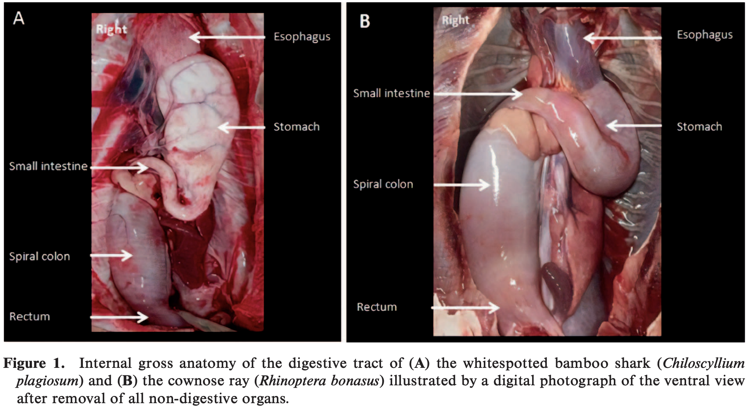
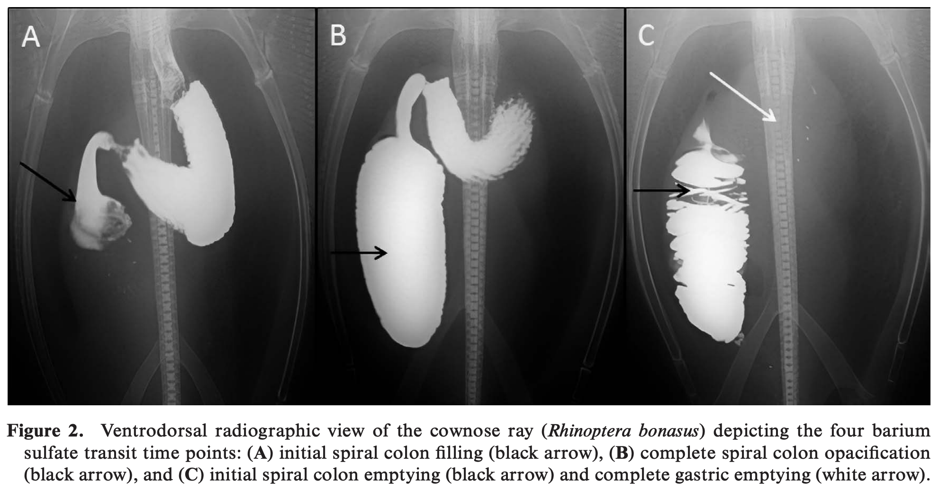

Related Articles:
Firchau B. Elasmobranch touch pools. In: Smith M, Warmolts D, Thoney D, Hueter R, Murray M, Ezcurra J (eds.). The elasmobranch husbandry manual II: recent advances in the care of sharks, rays and their relatives. Columbus (OH): Ohio Biological Survey, Inc; 2017. p. 178–180.

Fowler 7 Ch 22 - Medical Management of Rays

BIOLOGY, ANATOMY, PHYSIOLOGY:
•Rays inhabit a wide variety of environments: freshwater and saltwater or both
•Can be euryhaline- wide rage of salinity or stenohaline- narrow range of salinity, which can affect husbandry and treatment strategies.
•All rays are depressiform (eyes dorsal or lateral and mouths ventral)
•Males have claspers at pelvic fins, females don’t
-copulation occurs by males insertion of a clasper into female cloaca.
-Aplacental viviparity occurs with production of uterine milk absorbed by embryo
-Ray embryos have a yolk sac that is absorbed by 75% gestation
-Histomorph- rich yellow fluid that feeds embryo (do not mistake for pyometra)
-Gestation is variable (2-12 months) and rays can store sperm for months
•Skin is covered in placoid scales composed of dentin and enamel.
•Rays have no teeth but have crushing plates of placoid scales embedded in their gums (constantly overturn by moving forward in the mouth- like shark teeth)
•Gill slits on ventral body wall and spiracle (respiratory aperture) on their dorsum. Respiration occurs through active pumping of water over gills by pulling water into the mouth/spiracle and over gills.
-Rays that rest of the bottom use spiracles for unobstructed respiration, unlike RAM ventilators
•Manta rays are unique and possess gill rakers (like whale shark)
•Musculoskeletal system is cartilaginous with occasional ossification of vertebral column.
•Cardiovascular system- 1 atria, 1 ventricle, sinus venosum, conus arteriosis.
•A renal portal system has been reported
•Rays have no bone marrow and hematopoeisis occurs in spleen, leydig organ, and epigonal organ.
•Liver predominates in the coelom and has natural hepatic lipidosis (lipids make up 80% of liver)- contributes to buoyancy as they have no swim bladder
•Gall bladder present- produces bile acids that form alcohol sulfate esters
•Simple GI tract- distensible esophagus, stomach (cardiac/pyloric), spiral colon, rectum, cloaca.
-rectal gland- unique to elasmobranchs involved in osmoregulation of Na and Cl. (reduced or absent in freshwater rays)
•Coelomic/abdominal pores (adjacent to cloaca) have direct connection to coelom. Function is not understood but suspect involvement with electrolyte balance and osmoregulation.
-Some use these pores for endoscopic exam of coelom or for coelomic flushing
•Vision is poor, pupil control voluntary, difficult to assess PLR. May have pigmented lens (looks opaque)
•Smell and taste are keen sensory abilities.
•Ampullae of Lorenzini detect external vibration and electrical pulses for object detection.
•Lateral line is present with lining of neuromast cells that respond to pressure changes.
•Saltwater rays- hyperosmotic to their environment, high urea content, TMAO protein may aid in buoyancy as it is lighter than sea water.
•Freshwater rays- lower urea content

HUSBANDRY and MANAGEMENT
•In many touch pools large population declines are often due to life-support failure due to overcrowding
-hyperthermia, hypoxia, heavy metal contamination from well water, poor acclimation

RESTRAINT
•Be cautious of barbs and crushing bites
-barbs contain venom-secreting glandular cells and venoms can be cardiotoxic and neurotoxic
-Protocols for managing stingray injuries are recommended
-Trim barbs to reduce risk (exposure still possible bc base of barb containes the venom)
-Fresh water rays may have more potent venom and cause increase pain to humans
•Manual restraint is possible and tonic-clonic immobility may be achieved by flipping over
•Anesthesia should be used in naïve or large specimens and for lengthy procedures (MS222, eugenol, isoeugenol) with appropriate flow-through ventilation

PHYSICAL EXAMINATION
•Routine exams should include: ocular exam, gills, cloacal lavage for fecal sample, ultrasound (coelomic, cardiac)
-hepatic echotexture should be hyperechoic to mammal livers due to normal lipidosis
•Blood can be collected from ventral tail, midline, at 90 degrees
-possess granulocytes
-lower HCT (20%-25%)
-blood gases should be monitored during handling events or long transports
•Normal blood cultures may be (+)- approx 30%-50% (+) in normal animals reflecting normal colonization
•Coelomic lavage common technique to evaluate coccidial burden in cownose

DISEASES
•Signs of disease in rays include: inappetance/anorexia, loss of muscle mass, curling of wings, not burying in substrate, flashing, decreased swimming, redness/erosion of fins, color/pallor.
•Assist/gavage feeding is important, neither repeat handling nor assist feeding will usually prevent normal eating behavior when the ray is ready to eat. Live food, whole prey, variety should be offered.
•Trauma is a common issue
•Bacteria and fungi may be primary or secondary pathogens
-saprolegnia sp. Is common secondary invader and exacerbates skin ulcers.
-septicemia is a common sequel to non-healing wounds
-coelomic Eimeria sp. May cause mortality in large numbers, may be normal in healthy animals.
•Reproductive disease (pyometra, dystocia) have been reported. Spaying is difficult due to anatomy.
•Noninfectious disease- exposure to toxic fumes, GI FB, neoplasia, goiter (recommend iodine supplementation in food or water)

TREATMENT
•Fluid therapy- elasmobranch ringers solution or oral freshwater.
•Copper, formalin, ivermectin , organophosphates may be TOXIC to rays
•Assist feed gruels and gavage at 2%-5% body weight.
-if regurgitation occurs must flush gills

ZOONOTIC DISEASES
•Minimal risk of disease with contact animals
•Marine Vibrio is a concern with punctures or abrasions to human skin.

THE MESOPTERYGIAL VEIN: A RELIABLE VENIPUNCTURE SITE FOR INTRAVASCULAR ACCESS IN BATOIDS
Westmoreland LS, Archibald KE, Christiansen EF, Broadhurst HJ, Stoskopf MK.
Journal of Zoo and Wildlife Medicine. 2019 Jun;50(2):369-74

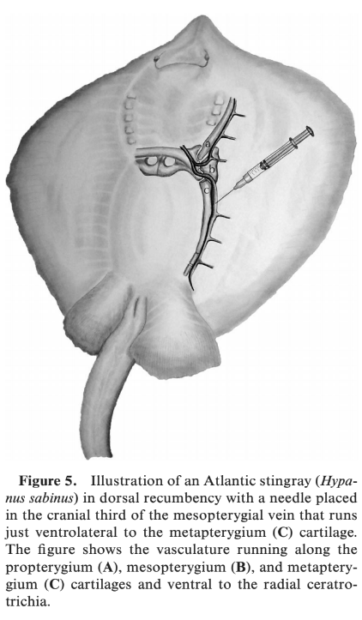
Intravascular access in batoid species is commonly achieved using the ventral coccygeal or radial wing vessels. However, these approaches can be difficult because of the presence of cartilage, lack of specific landmarks, species variation, and small vessel size in many species. This study used postmortem contrast radiography and gross dissection to develop landmarks for a new, dependable vascular access in three Myliobatiform species commonly maintained in captivity: Atlantic stingray (Hypanus sabinus), cownose ray (Rhinoptera bonasus), and smooth butterfly ray (Gymnura micrura). The mesopterygial vein provides quick vascular access and is suitable for administration of large fluid volumes and intravascular drugs. It is located immediately ventrolateral to the metapterygium cartilage, which sits adjacent to the coelomic cavity and supports the caudal half of the pectoral fin. Using the pectoral girdle and cranial third of the metapterygium cartilage as landmarks, vascular access can be achieved by directing a needle medially at approximately a 30° (adult cownose rays) or 45° angle (Atlantic stingrays, juvenile cownose rays, smooth butterfly rays) toward the metapterygium cartilage. Differences in the degree of needle direction are due to species and age-specific shapes of the metapterygium cartilage. The mesopterygial vein is an alternate site of quick and reliable venous access in batoid species.
Background:
- Ventral coccygeal and radial wing vessels like to give mixed arterial-venous sample
  - To reach both vessels, must puncture through cartilage, which can plug needles
  - Ventral coccygeal vein is within the cartilaginous hemal arch
  - Radial vessels between cartilaginous ceratotrichia
- Cranial radial wing veins → propterygial vein
- Caudal radial wing veins → mesopterygial vein
- Metapterygial + propterygial + mesopteryial vein → brachial and subclavian veins → heart
Technique:
- Mesopterygial vein is ventrolateral to metapterygium cartilage
- Hold in dorsal recumbency with angle at 30-45° angle
- Adult cownose rays needed a less steep angle and a larger needle

Venipuncture Site | Pros | Cons
Ventral coccygeal | Familiar technique | Requires restraint near barbs
Radial | Many options to draw from | Lack of clean landmarks  Cartilage can clog needle  Small volumes
Mesopterygial | More reliable venous sample (artery is separated by muscle fibers)  Palpable landmarks  Less muscle to push through | Connective tissue sheath in large animals may cause clog needle  Requires more training

Conclusions: Mesopterygial vein access is on ventral surface, near the body wall at level of pectoral girdle that provides a reliable venous sample.

Mylniczenko, N. D., Sumigama, S., Wyffels, J. T., Wheaton, C. J., Guttridge, T. L., DiRocco, S., & Penfold, L. M. (2019). Ultrasonographic and hormonal characterization of reproductive health and disease in wild, semiwild, and aquarium-housed southern stingrays (Hypanus americanus). American journal of veterinary research, 80(10), 931-942.
Objective: To characterize physical examination, plasma biochemical, and ultrasonographic findings in aquarium-housed, managed semiwild, and wild southern stingrays (Hypanus americanus) with and without reproductive disease.
Animals: Southern stingrays from aquarium (n = 48), lagoon (managed semiwild; 34), and wild (12) habitats.
Procedures: Limited, opportunistic prosections were performed of presumed anatomically normal wild southern stingrays and compared with findings for aquarium-housed stingrays with reproductive disease. Ultrasonographic video data from both groups were used to assign a score (1 to 5) indicating increasing severity of ovarian and uterine reproductive disease. Plasma total 17β-estradiol (E2), estrone (E1), progesterone (P4), and testosterone (T5) concentrations were measured with enzyme immunoassays validated for use in southern stingrays.
Results: Ultrasonographic ovarian scores were significantly correlated with uterine scores. No reproductive disease was detected in semiwild or wild stingrays, but 65% (31/48) of aquarium-housed stingrays had developing or advanced reproductive disease (ie, ultrasonographic ovarian or uterine score of 4 or 5). Significant correlations were identified between ovarian and uterine disease status and plasma concentrations of all steroid hormones except testosterone.
Conclusions and Clinical Relevance: Findings suggested that ultrasonography and plasma hormone concentrations may be useful in the identification of reproductive disease and determination of disease severity in southern stingrays.
- Southern stingrays – Slow to mature, produce low numbers of offspring. Aquariums developing sustainable breeding populations important for education, etc.
- Mating can occur immediately after parturition. Females likely gravid for most of life span.
- In aquaria, can reproduce biannually and are often housed in single-sex groups to prevent this.
  - Nonreproductive states for extended periods.
- Elasmobranchs produce P2, P4, T5, do not always regulate reproduction as expected.
  - P does not increase during early or midgestation.
  - Free P and T concentration peaks prior to parturition in Atl stingrays.
  - No P detectable in granulosa tissue throughout gestation in dogfish.
  - Other P4 metabolites and E metabolites may be important.
  - E2 prime regulatory steroid, and E1 also strong role in repro.
- Collected blood samples for plasma hormones, US data over 1 year.
- Ultrasound scoring system on a 5 pt scale on basis of width of ovary, number of follicular layers, presence of cysts, overlap with uterus.
- General opportunistic postmortem exams on 10 wild stingray cadavers. All gravid. Ovary against left lateral surface of epigonal organ. EO always overlapped uterus on the left side. Width of ovary did not exceed 4 cm. Individual ova rarely exceeded 2 cm. No cysts. Ovary did not overlap with uterus. Right oviduct visibly attenuated with no ova present. Oviduct assoc with epigonal tissue more caudal and smaller than contralateral epigonal tissue.
- Right and left ostia originated ventral and lateral to esophagus, led dorsal then lateral into oviducts. Supported by a ligament connected to each oviduct. Right oviduct widened into vestigial right uterus.
- Left oviduct expanded into nidamental gland aka oviducal or shell gland at cranial uterus. No obvious isthmus. Uterus on left attached to kidney, terminated into urogenital sinus analogous to mammalian cervix, lateral to single urogenital pore and into cloaca.
US Scores:
- 2 – Single layer of uniform follicles and occasional small follicles in periphery of ovary.
- 3 – ovary appeared wider, multiple layers, various sizes of follicles and cysts.
- 4, 5, - greater numbers of different-sized follicles with heterogeneous echogenicity (varying stages of vitellogenesis) and degeneration, cystic structures.
- Semiwild or wild stingrays, only one in category 3, none in 4, 5.
Hormones:
- Plasma E2, E2, P4 increased with increasing ovarian scores.
- E1 also increased with ovarian disease. Some exceptions.
- No differences in T among ovarian scores.
Severity of repro dz positively correlated with plasma total E2, E1, P4.
17β-estradiol (E2), estrone (E1), progesterone (P4)
- Plasma total T5 high in stingrays assigned highest uterine score.
- Regular pregnancy cycles with normal hormone fluctuations presumed to prevent accumulation of ova in southern stingrays, unbred females higher risk of disease.
- Ova produce estrogens in elasmobranchs, increase in number of ova may create estrogen rich environment.
- E2 secretion increases dramatically in Atl stingrays during period when histotroph is produced. E2 in this study only high for highest uterine score, E1 increased with increasing uterine score.
- Plasma conc of total E1 was higher than total E2, may be a more consistent steroid signal to monitor for indication of ovarian and uterine disease. E2 low regardless of disease in some individuals. Examining both probably best.
- Repro disease correlated with disk width, may be due to age and reproductive activity being related.
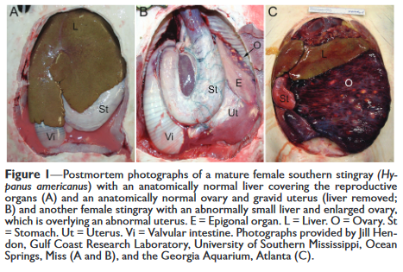
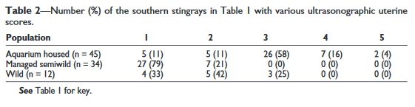
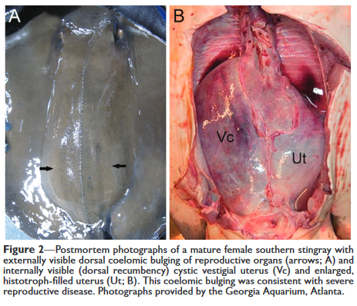
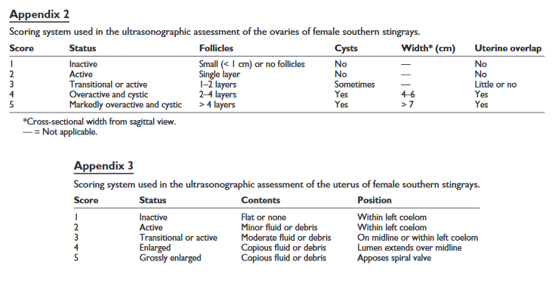

Sheldon, J. D., Allender, M. C., George, R. H., Bulman, F., & Abney, K. (2018). Reproductive hormone patterns in male and female cownose rays (Rhinoptera bonasus) in an aquarium setting and correlation to ultrasonographic staging. Journal of Zoo and Wildlife Medicine, 49(3), 638-647.

Abstract: Reproductive management of cownose rays (Rhinoptera bonasus) under professional care plays an important role in conservation of the species, but hormone and ultrasonographic analyses of their 12-mo reproductive cycle have not been documented previously. Plasma reproductive hormone concentrations (17Bestradiol, progesterone, testosterone, and androstenedione) were measured monthly via radioimmunoassay for 1 yr in an aquarium-managed population of adult females (n ¼ 15) and males (n ¼ 5). Ultrasounds of the uterus were performed each month at the time of sample collection to identify gestation stage (0–5) based on a previously developed in-house staging system. Stages were correlated to hormone concentrations to track progression through pregnancy. Thirteen females were reproductively active, and each produced one pup in March–June, similar to timing for free-ranging populations. Female estradiol increased steadily throughout gestation from stages 0 to 5, while progesterone, testosterone, and androstenedione were increased only in early gestation (stages 1 and 2). Unlike month of year, gestation stage strongly predicted hormone concentration, but specific values to predict parturition date were not identified. Male testosterone and progesterone were higher in March–June (mating season) than July–January, while estradiol and androstenedione did not exhibit a seasonal pattern. Aquarium-managed cownose rays have similar reproductive patterns to what is reported in wild populations. Ultrasonographic monitoring with serial hormone analysis and accurate mating records will provide the most useful information for managing a reproductive population of cownose rays in an aquarium setting.
- Cownose ray reproduction
  - 11-12 month gestation, 1 pup
  - Aplacental viviparity – single embryo, left uterus - histotrophy
  - Annual synchronous reproductive cycles (ovulation & parturition mostly around April-May)
- Males
  - Higher progesterone, testosterone, androstendione than females
  - Lower testosterone in winter months than in spring/summer months
  - Higher testosterone in those months correlates to increased spermatogenesis in wild males
- Females
  - Estradiol rose through each stage of pregnancy
  - Progesterone, testosterone, and androstendione peaked in stages 1-2
  - Higher testosterone in may through august reflects peak fertile periods, similar to Atlantic stingrays
- Increasing estradiol throughout pregnancy seen in bonnetheads, Atlantic stingrays, spiny dogfish – may play a role in pregnancy maintenance & lecithotrophy, yolk sac, matrotrophy, and histotroph production
- Progesterone rises postovulation in bonnetheads, early-midgestation in dogfish, and prior to ovulation & parturition in Atlantic stingrays

Journal of Zoo and Wildlife Medicine 49(4): 952–958, 2018
COMPARISON OF TWO IODINE QUANTIFICATION METHODS IN AN ARTIFICIAL SEAWATER SYSTEM HOUSING WHITE-SPOTTED BAMBOO SHARKS (CHILOSCYLLIUM PLAGIOSUM)
Lily Parkinson, D.V.M., Scott D. Noblitt, Ph.D., Terry Campbell, M.S., D.V.M., Ph.D., and Kurt Sladky, M.S., D.V.M., Dipl. A.C.Z.M., Dipl. E.C.Z.M. (ZHM & Herpetology)

Abstract: Iodine is an essential micronutrient for elasmobranchs in order to prevent goiter. Preventing goiter requires bioavailable iodide: either oral iodide or maintaining adequate aquarium water iodide concentrations. The objective of this study was to determine how oral and water supplementation affected iodine (I₂) and iodide (I-) concentrations in artificial seawater aquaria housing captive white-spotted bamboo sharks (Chiloscyllium plagiosum). Daily water samples were collected and free iodine (I2) was determined using ultraviolet-absorbance spectrophotometry (a relatively simple in-house assay) and total iodide (I-) via liquid chromatography (a more time- and expertise-intense quantification method) to learn the effects of supplementation. One water system received iodine and iodide supplementation in the form of 5% Lugol’s iodine solution added directly to the water, while a second water system received no supplementation. In addition, one tank of sharks in each water system received oral iodide supplementation. Results indicated that oral supplementation provides greater increases in water concentrations of bioavailable iodide (I-) than direct water supplementation. In addition, the chromatographic results suggested that iodide is present in higher concentrations in the systems not receiving water supplementation. Increased iodide concentrations were detected in water samples after water changes and after oral iodide supplementation was administered, but total iodine (I₂) concentration changes were not detectable within the same time frame.

Key Points:
- Iodine found higher in seawater than anywhere else on earth
  - Exists as iodate (IO₃) as 96% of total iodine, iodide (I-), Iodine (I₂) and organoiodine compounds
  - Iodide ranges from 0.001 – 0.03 ppm of a total iodine concentration of 0.06 ppm (goal in aquaria)
  - Goiter happens with low iodine or goitrogenic compounds (perchlorate) in elasmobranchs
  - In teleosts majority of iodine intake is from the water, not the food.
  - Methods for measuring – spectrophotometry (I₂) and chromatography (I-)
  - Ozone eliminates it
- Methods - No supplementation vs water supplentation vs water + oral supplementation
- Results
  - Supplemented tanks had high I2 but lower I-
  - Chromatography was less reliable than spectrophotometry
    - But close to limits of detection (0.04 ppm)
  - Values higher on days after receiving VitaZu tablets

Take home: Supplemented tanks have higher iodine – supplementing orally also contributes to tank values

Fowler 9, Chap 49: Sharks and Medicine

· Popular display animals in zoos/aquaria- 440 species, most of which are marine, with variability in lifestyle/environment
o Smaller species more common, larger species are found at some institutions
· Elasmobranchs, but difference in approach to medical management compared to rays\

Biology, Anatomy, Physiology
- Cartilaginous skeleton, small placoid scales, 2-chambered heart, 5 pairs gills slits
- Ventilation differs- Pelagic (obligate ram ventilators, hard to keep in aquaria) vs Benthic (buccal pumping) vs Intermediate
- Liver is 25% body weight- simple stomach, short GIT, spiral colon (large surface area), rectal gland (Na balance)
- Lack bone marrow/lymph nodes- hematopoiesis by thymus, spleen, epigonal organ, Leydig cells- unique to elasmobranchs

Husbandry, Management
- Monitor water quality closely- needs may vary by taxa
- Design exhibit with animal and human safety in mind, easy access/restraint of animals for illness/injury

Restraint- Manual vs Chemical – goals is to minimize stress
- Manual Restraint: small-medium sized- EXPERIENCED HANDLERS, wear gloves
o Operant conditioning (target train into sling)
o Tonic immobility in dorsal recumbency- no analgesia, may be hyperesthesia?
o Larger- shark box- one person hold jaws shut
o Prolonged pursuit prior to restraint can lead to elevated lactate/acidemia
- Chemical Restraint: large/dangerous species- immersion bath, injectable, oral
o Wide variability in physiology depending on species- efficacy can depend on many factors
o Equipment needed: tub/box, stretcher, tank water, ventilation equipment, air stone, pH meter, dO meter

Physical Exam- history, observation, appetite/attitude, swimming pattern, external lesions- obtain prior to restraint
- Integument, BCS/weight, ocular exam, oral cavity (PVC pipe), opercular movement, Doppler/ECG/US for heart, cloaca

Diagnostics
- Venipuncture sites- dorsal sinus (pools), ventral coccygeal vein (preferred)- immediately placed in anticoag tubes
o Immediately perform hemocytometer count or preserve aliquot in 10% formalin (preserves morphology)
o Retain and resorb urea/solutes to remain hyperosmotic- low values indicate renal disease/hepatic disease
o Efficient salt excretion, however Na and Cl are higher than in mammals
o Differential: 50-75% lymph, 10-30% heterophils, 0-10% eosinophils, 0-1% basophils, 0-3% monocytes
- Skin scrapes, biopsies
- Cloacal wash to obtain fecal sample

Imaging
- Good radiograph detail- can use contrast media to eval GIT- increased risk to animal since out-of-water
- US- useful for soft tissue evaluation, monitoring gilling/HR, diagnosing pregnancy- hyperechoic lipid-filled liver normal
- Advanced imaging challenging- may be used to evaluate specific lesions

Diseases
- Bacteria: Tenacibaculum maritimum (skin lesions), Vibrio species, Aeromonas salmonicida (hemorrhagic septicemia), Flavobacterium sp (neurologic disease)
- Viral (less common): Erythrocytic necrosis (iridovirus, affects young animals), skin discoloration (herpesvirus, self-limiting)
- Fungal: Paecilomyces lilacinus, Fusarium solani (mycotic dermatitis, lateral line, can be fatal), Exophiala sp (mineralization of cervical vert/skull à abnormal circling)
- Parasites: monogeans (Dermophthirius nigrellii, Dionchus penneri), cestodes, nematodes
- Noninfectious: trauma, FB infestion, neoplasia (uncommon- oral fibropapillomas, hepatic adenomas, intrahepatic cholangiocarcinoma, testicular mesothelioma, melanoma, lymphosarcoma), environmental impacts
o Spinal deformities: capture related vs nutritional deficiencies
o Goiter: ozonated aquarium water

Treatments/Therapies- limited PK/PD studies (Cefovecin, Florfenicol)- extrapolate from other species; cross-match for blood transfusions if needed, provide nutritional support for anorectic/debilitated animals (2-5% BW)

