Practice Question:
Which of the following biomarkers is the best indicator of a shark’s overall metabolic state?
- Blood glucose
- β-hydroxybutyrate
- Blood urea nitrogen
- Triglycerides
- C-reactive protein

Answer: B

Practice Question:
Label the four phases (A-D) of contrast passing through the gastrointestinal tract of a white spotted bamboo shark (Chiloscyllium plagiosum):
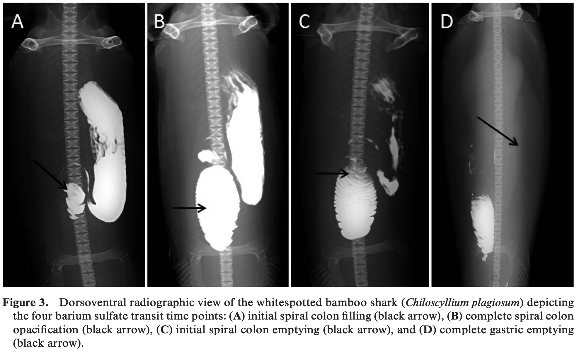

Practice Questions:
A crashing cownose ray is presented to you. What site is the most reliable for IV access and medication administration?
- Radial wing vessel
- Ventral coccygeal vessel
- Mesopterygial vessel
- Cardiac
- Jugular vessel

C: Metopterygial vessel

Choose the correct answers to fill in the blanks regarding ray anatomy and physiology.
Rays breathe through (operculum/spiracle) when water flows over the gills via (swimming/active pumping). Their hearts have (1/2) atria and (1/2) ventricle(s). They (do/do not) have a gallbladder and their liver is (hypo/hyperechoic) to mammals. They have (voluntary/involuntary) PLR’s. Males copulate via (cloaca/claspers) and females are (oviparous/viviparous) with a (yolk sac/placenta) that supports the embryo. A renal portal system (has/has not) been reported.

Rays breathe through (operculum/spiracle) when water flows over the gills via (swimming/active pumping). Their hearts have (1/2) atria and (1/2) ventricle(s). They (do/do not) have a gallbladder and their liver is (hypo/hyperechoic) to mammals (because they have normal hepatic lipidosis). They have (voluntary/involuntary) PLR’s. Males copulate via (cloaca/claspers) and females are (oviparous/viviparous) with a (yolk sac/placenta) that supports the embryo. A renal portal system (has/has not) been reported.

Mylniczenko, N. D., Sumigama, S., Wyffels, J. T., Wheaton, C. J., Guttridge, T. L., DiRocco, S., & Penfold, L. M. (2019). Ultrasonographic and hormonal characterization of reproductive health and disease in wild, semiwild, and aquarium-housed southern stingrays (Hypanus americanus). American journal of veterinary research, 80(10), 931-942.
Objective: To characterize physical examination, plasma biochemical, and ultrasonographic findings in aquarium-housed, managed semiwild, and wild southern stingrays (Hypanus americanus) with and without reproductive disease.
Animals: Southern stingrays from aquarium (n = 48), lagoon (managed semiwild; 34), and wild (12) habitats.
Procedures: Limited, opportunistic prosections were performed of presumed anatomically normal wild southern stingrays and compared with findings for aquarium-housed stingrays with reproductive disease. Ultrasonographic video data from both groups were used to assign a score (1 to 5) indicating increasing severity of ovarian and uterine reproductive disease. Plasma total 17β-estradiol (E2), estrone (E1), progesterone (P4), and testosterone (T5) concentrations were measured with enzyme immunoassays validated for use in southern stingrays.
Results: Ultrasonographic ovarian scores were significantly correlated with uterine scores. No reproductive disease was detected in semiwild or wild stingrays, but 65% (31/48) of aquarium-housed stingrays had developing or advanced reproductive disease (ie, ultrasonographic ovarian or uterine score of 4 or 5). Significant correlations were identified between ovarian and uterine disease status and plasma concentrations of all steroid hormones except testosterone.
Conclusions and Clinical Relevance: Findings suggested that ultrasonography and plasma hormone concentrations may be useful in the identification of reproductive disease and determination of disease severity in southern stingrays.
Which of the following is true regarding reproductive hormones in southern stingrays (Hypanus americanus)?
- 17β-estradiol secretion increases during the period when histotroph is produced.
- Progesterone concentrations have a positive correlation with disk width.
- Estrone increases are associated with cystic ovarian structions.
- Reproductive disease is more common in wild populations.
- Progesterone concentration decreases prior to parturition.
Ans: A

Sheldon, J. D., Allender, M. C., George, R. H., Bulman, F., & Abney, K. (2018). Reproductive hormone patterns in male and female cownose rays (Rhinoptera bonasus) in an aquarium setting and correlation to ultrasonographic staging. Journal of Zoo and Wildlife Medicine, 49(3), 638-647.

Abstract: Reproductive management of cownose rays (Rhinoptera bonasus) under professional care plays an important role in conservation of the species, but hormone and ultrasonographic analyses of their 12-mo reproductive cycle have not been documented previously. Plasma reproductive hormone concentrations (17Bestradiol, progesterone, testosterone, and androstenedione) were measured monthly via radioimmunoassay for 1 yr in an aquarium-managed population of adult females (n ¼ 15) and males (n ¼ 5). Ultrasounds of the uterus were performed each month at the time of sample collection to identify gestation stage (0–5) based on a previously developed in-house staging system. Stages were correlated to hormone concentrations to track progression through pregnancy. Thirteen females were reproductively active, and each produced one pup in March–June, similar to timing for free-ranging populations. Female estradiol increased steadily throughout gestation from stages 0 to 5, while progesterone, testosterone, and androstenedione were increased only in early gestation (stages 1 and 2). Unlike month of year, gestation stage strongly predicted hormone concentration, but specific values to predict parturition date were not identified. Male testosterone and progesterone were higher in March–June (mating season) than July–January, while estradiol and androstenedione did not exhibit a seasonal pattern. Aquarium-managed cownose rays have similar reproductive patterns to what is reported in wild populations. Ultrasonographic monitoring with serial hormone analysis and accurate mating records will provide the most useful information for managing a reproductive population of cownose rays in an aquarium setting.

What hormone increases steadily throughout gestation in female cownose rays (Rhinoptera bonasus)?
- Progesterone
- Estradiol
- Testosterone
- Androstendione
Ans: B
Which of the following is true of shark species?
a) Tonic immobility provides analgesia for minimally invasive exams and procedures
b) Pelagic shark species are ideal to keep in an aquarium setting
c) Heterophils are the most common leukocyte in a normal shark white blood cell differential
d) Low urea can indicate renal or hepatic disease
e) Hypervitaminosis C can lead to spinal deformities

Aquarists ask you to evaluate the shark picture below. What is your top differential for this lesion? What water treatment or environmental factor might predispose this animal to the lesion?
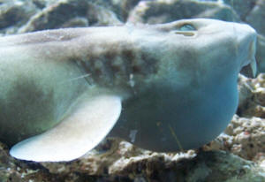

Goiter, ozonated water

