Selina M. Zalesak, Carlos R. Sanchez, Ashley A. Pich, Mark G. Papich. **Preliminary Pilot Study of Itraconazole After a Single Oral Dose of a Veterinary Formulation Solution in African Penguins (Spheniscus demersus)**. JAMS 2020 34(1)

Abstract: Aspergillosis is a common cause of morbidity and mortality in captive penguins. Itraconazole, an antifungal drug, is commonly used to treat aspergillosis infections in avian species; however, commercially available human formulations are costly, and studies have shown the effectiveness of compounded formulations to be unreliable. The US Food and Drug Administration (FDA) recently approved a veterinary formulation of itraconazole, Itrafungol, for use in cats. This study provides preliminary results from limited sampling evaluating whether this veterinary formulation is suitable for future studies in the African penguin (Spheniscus demersus). A 20 mg/kg PO itraconazole dose was administered to 9 African penguins. Blood samples were taken over the course of 24 hours; each sample was collected from a different bird to minimize stress to the animals. Plasma was analyzed by high-performance liquid chromatography for concentrations of itraconazole. The **drug was absorbed in all penguins, and plasma concentrations in 5 of 9 penguins (56%) were found to be greater than the established therapeutic dose of 1.0 lg/ mL**. To our knowledge, this is the first study that has investigated a 20 mg/kg dose of itraconazole in a penguin species. The small sample size limits the conclusions that can be drawn from this preliminary study. Nonetheless, we demonstrate encouraging evidence that the FDA-approved formulation of oral itraconazole solution should be considered for future study as a cost-effective treatment for aspergillosis in African penguins and other avian species.

* Aspergillosis common in captive penguins, high morbidity and mortality rates
* **Itraconazole antifungal of choice for prophylaxis and treatment in penguins** 
  + b/c of side effects after the use of other antifungal drugs
  + highly lipophilic, poorly soluble with inconsistent oral absorption
  + Costly using available human formulation
  + Recommend dose 20mg/kg PO SID
* **Itrafungol new approved itraconazole for cats**
* N = 9, 20mg/kg itraconazole (Itrafungol) administered in fish once
  + One penguin sampled for each time point: 1, 2, 4, 6, 8, 10, 12, 24hr
* No adverse effects
* **Just over half penguin plasma concentrations > established therapeutic dose 1.0g/mL**
* Cmax > 7mg/kg in African and Humboldt penguins
* Similar elimination half-life to Humboldt using 7mg/kg, longer than 7mg/kg in African penguins
* Much cheaper than human formulation

**Takeaway**: about half penguins had therapeutic plasma concentrations, total clearance not observed within 24 hours, encouraging it can be used future after future study





Rivas, A. E., Fischetti, A. J., Le Roux, A. B., Hollinger, C., Oehler, D. A., & Paré, J. A. (2019). Standing computed tomography in nonanesthetized little penguins (Eudyptula minor) to assess respiratory system anatomy and monitor disease. *Journal of Zoo and Wildlife Medicine*, *50*(2), 396-404.

Abstract: Multidetector computed tomography (MDCT) scans were performed in clinically healthy, nonanesthetized, standing little penguins (*Eudyptula minor*) to determine reference ranges for air-sac and lung volumes, as well as lung density. Five of 15 clinically healthy birds were diagnosed with pulmonary granulomas on initial MDCT scans. Granulomas were not readily apparent on radiographs, even in cases where the entire normal pulmonary parenchymal architecture was effaced on the MDCT scan. Serial MDCT scans after antifungal and antimycobacterial therapies demonstrated a response to treatment. **MDCT scanning in nonanesthetized little penguins proved to be a well-tolerated, non-invasive imaging modality for respiratory diseases** that are otherwise difficult to diagnose, including aspergillosis and mycobacteriosis.

**Introduction:**

* Little penguins = smallest penguin species
* Aspergillosis and nontuberculous mycobacteriosis are common respiratory diseases
  + Difficult to diagnose with rads
* MDCT = multidetector CT = high-quality images in a short time

**Results:**

* Lung or air sac volume did not differ between healthy vs. birds with pulmonary granulomas; lung density did differ
* Greater mean, median, maximum lung density greater in birds with pulmonary granulomas

**Discussion**:

* Standing position also allows for evaluation in a more normal anatomic position
* Mass-specific lung volume was almost identical to adelie penguins, king, emperor penguins BUT little penguins had lower air-sac volume than the other species
* CTs provided more accurate assessment of respiratory system than standard rads- eliminates superimposition

**TAKE HOME POINTS**:

* Provided references for baseline information on lung density and lung/air sac volumes
* Provided reliable and potentially earlier diagnosis of pulmonary granulomas but air sac thickening/plaques could be missed

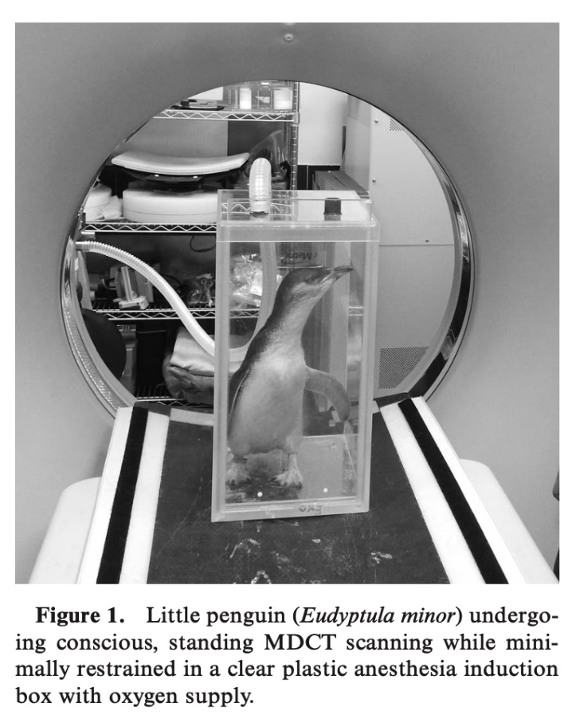

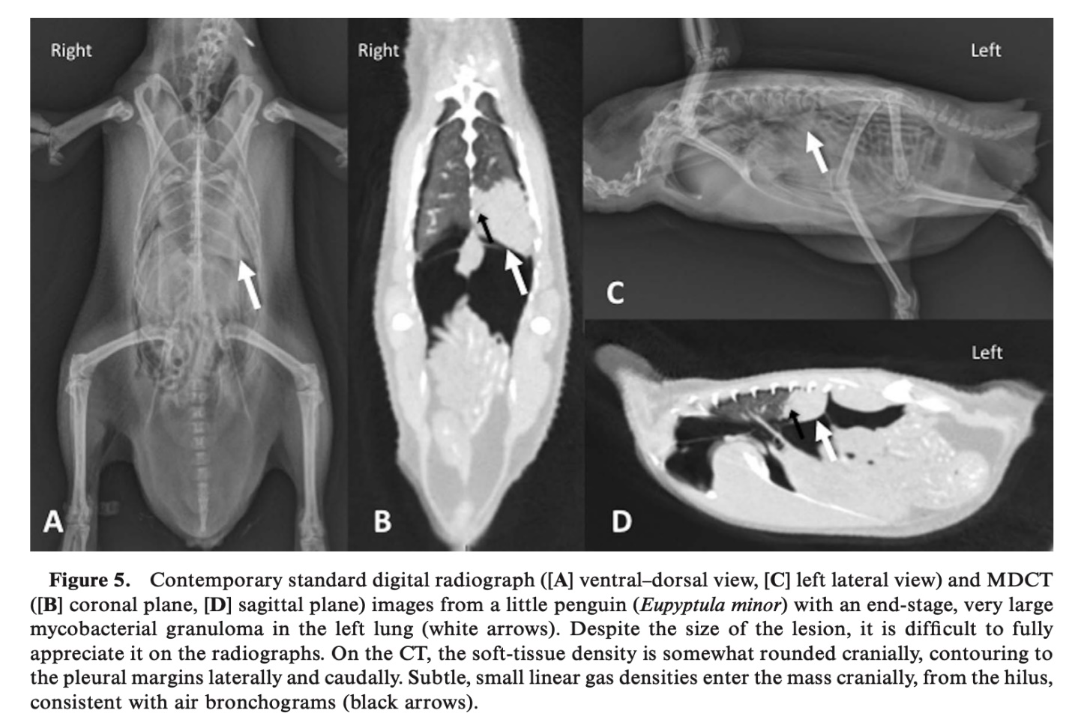

*J Zoo Wildl Med*. 2018;49(3):696-703

[**APPLICATION OF 3-HYDROXYBUTYRATE MEASUREMENT AND PLASMA PROTEIN ELECTROPHORESIS IN THE DIAGNOSIS OF ASPERGILLOSIS IN AFRICAN PENGUINS (*SPHENISCUS DEMERSUS*)**](https://doi.org/10.1638/2017-0172.1)

Desoubeaux G, Rodriguez M, Bronson E, Sirpenski G, Cray C

**ABSTRACT:** New alternative laboratory means are needed to improve the options for antemortem diagnosis of avian aspergillosis. In this study, 3-hydroxybutyrate was measured in plasma samples collected from a cohort of African penguins (*Spheniscus demersus*) maintained under human care. Results were interpreted in combination with those of protein electrophoresis and compared with anti-Aspergillus antibody and galactomannan antigen detection. Overall, 3-hydroxybutyrate levels were found significantly increased in Aspergillus-diseased cases versus the control penguin group (P = 0.002). Mean absolute concentration of β-globulins was increased >20% in samples from infected birds, and α2-globublins were also found to be significantly increased versus clinically normal controls (P < 0.001 and P = 0.001 respectively). Of note, the α2-globulins were also significantly increased versus penguins with inflammatory (non-aspergillosis) diseases (P = 0.001). The specificity of 3-hydroxybutyrate, β-globulins, and α2-globulins for aspergillosis was 78.6%, 79.6%, and 92.2%, respectively. Using these measures in tandem resulted in high specificity (>90%) and negative predictive value (≥80%). In contrast, anti-Aspergillus antibody and galactomannan antigen did not distinguish between infected cases and controls (P > 0.05). This study demonstrates that basic testing in tandem with the new biomarker 3-hydroxybutyrate may provide reliable evidence for the diagnosis of aspergillosis in penguins

**Goal:** Determine diagnostic value of 3-hydroxybutyrate measurement +/- EPH in a cohort of African penguins that had aspergillosis

**Key Points:**

* In penguins with aspergillosis, samples are often negative for galactomannan antigen
  + Similarly, most have high anti-Aspergillus titers regardless of clinical status
* 172 blood samples were collected from:
  + Naturally infected cases (n=47)
  + Controls with inflammatory disease (n=29)
  + Clinically normal controls (n=96)
* EPH
  + The significant change in alpha 2 globulins in Aspergillus-diseased penguins may reflect an increase in haptoglobin/a chronic inflammatory process
  + Changes in gamma globulins are consistent with the stimulation of humoral immunity
  + The alpha 1 fraction remains poorly defined regardless of clinical condition
  + A prealbumin fraction is present, but its clinical significance has not been defined
    - However, prealbumin has been observed to decrease in falcons with naturally acquired and experimentally induced aspergillosis
  + In clinically abnormal penguins, a moderate decrease in % albumin is often present; this is supportive of it being a negative acute-phase protein
  + EPH = only valid method (vs. bromcresol green) for avian albumin quantitation
* 3-hydroxyutyrate
  + Concentrations >1.90 mM/L were observed at the apparent peak of the aspergillosis with significant clinical signs
  + This suggests a possible prognostic value of 3-hydroxybutyrate concentration as levels return to normal when penguins recover

**TLDR:**

* EPH is an excellent primary assessment
  + Changes in alpha 2 globulins appear to be unique to aspergillosis diseased penguins vs. clinically abnormal/inflammatory (non-aspergillosis) controls
* 3-hydroxyutyrate provides a good specificity for the detection of aspergillosis
  + Additional studies need to be undertaken to address the effects of age and anorexia/diet

**Related Articles:** *None on the current ACZM reading list*

*J Zoo Wildl Med*. 2018;49(3):573-580

[**RADIOGRAPHIC EVALUATION OF CARDIAC SILHOUETTE IN CLINICALLY HEALTHY HUMBOLDT PENGUINS (*SPHENISCUS HUMBOLDTI*)**](https://doi.org/10.1638/2017-0193.1)

Yunker KA, Hostnik ET, Johnson JG 3rd, Giatis IZ

**ABSTRACT:** Wild populations of Humboldt penguins (*Spheniscus humboldti*) on the coasts of Chile and Peru have been declining because of food scarcity caused by the El Niño Southern Oscillation and human interference. Part of conserving this vulnerable and threatened species is maintaining the health of penguins within zoo collections. A variety of cardiovascular diseases has been reported in individuals from the Spheniscidae family including ventricular septal defects*, Dirofilaria immitis* infection, pulmonary hypertension, and valvular dysplasia, ultimately resulting in congestive heart failure. An accurate clinical picture of cardiovascular disease in Humboldt penguins requires diagnostics tailored to this specific species. The aim of this study was to establish a routine methodology for evaluating the cardiac silhouette of clinically healthy Humboldt penguins using vertebral heart scale (VHS), cardiocoelomic width ratio (CCWR), and a novel cardiac silhouette-to-keel ratio (CKR). Ventrodorsal and right lateral radiographs were taken of 10 mature Humboldt penguins during routine health evaluations. An echocardiographic exam of each penguin was performed to confirm that there was no evidence of cardiac structural remodeling from disease. Two penguins were excluded on the basis of echocardiographic findings; therefore, data from eight penguins were used to calculate objective cardiac measurements for the clinically healthy population. Right lateral radiographs were used to determine VHS (7.4-10.4) and CKR (3.4-4.4). Ventrodorsal radiographs were used for calculating CCWR (0.45-0.59). The excluded penguins had CCWRs that were outside the 95% confidence interval for the range generated by this study. This initial work supports that standardizing radiographic views provides objective measures for cardiac silhouette evaluation in this species. Further research in larger populations and comparison with birds having confirmed cardiac disease is needed to determine the value of these three measurement techniques in Humboldt penguins

**Study Design**: Cohort cross sectional observational study

**Goal:** Establish a routine methodology for vertebral heart score (VHS) and cardiocoelomic width ratio (CCWR) in Humboldt penguins, as well as to describe a novel cardiac silhouette-to-keel ratio (CKR)

**Key Points:**

* CCWR is modeled after the cardiothoracic ratio but considers that penguins have no diaphragm or true thorax
* The novel CKR is based on studies that determined that a proventriculus-to-keel ratio was a sensitive indicator of proventricular enlargement
* Heart length + heart width = VHS
* Cardiac silhouette width / Coelomic width = CCWR
* Cardiac silhouette width + length / Keel height = CKR
* Right-sided heart disease in birds seems disproportionately represented
  + Right-sided cardiac changes may be better detected on the VD projection, which minimizes the superimposition of the right-sided and left-sided chambers
  + The definitive etiology is unknown but may be due to their anatomy
    - The right AV valve is muscular with no chordae tendinae making it prone to hypertrophy when the RV is overloaded, leading to valvular insufficiency
    - Avian lungs are rigid and do not change in volume with respiration and their pulmonary capillaries are stiff, with minimal expansion ability
      * Respiratory disease including pulmonary hypertension will lead to a drastically increased load on the heart
    - Ventricles fill and empty to a greater degree than those found in mammalian hearts
    - This, along with their higher HR, culminates in a high-performance system prone to failure when placed under stress
* Three of the penguins in this study had evidence of trivial to mild tricuspid regurgitation without secondary structural changes

**Useful Figures:**

**TLDR:**

* The VHS, CCWR, and CKR have potential utility in the detection of cardiac enlargement in Humboldt penguins
* The CCWR may be more sensitive for detecting right-sided chamber enlargement

**Related Articles:** *None on current ACZM reading list*

Trumpp, K., Sander, S., Sander, W., Zimmerman, D., & Bronson, E. (2021). RETROSPECTIVE STUDY OF MORBIDITY AND MORTALITY OF AFRICAN PENGUINS (SPHENISCUS DEMERSUS) UNDER MANAGED CARE IN NORTH AMERICA: 2007–2018. *Journal of Zoo and Wildlife Medicine*, *52*(4), 1135-1142.

Abstract: Currently, more than 20% (51/240) of zoos and aquariums accredited by the Association of Zoos and Aquariums house African penguins (*Spheniscus demersus*) in their collections. The African penguin Species Survival Plan (SSP) veterinary advisors regularly collect information from those facilities to characterize morbidity and mortality for this species and to collate preventative medicine and treatment regimens. These efforts resulted in more than 10 yr of collection of management data across the SSP, representing the care and management of more than a thousand birds. **The most common morbidities reported included those of dermatologic (27%, 125/452 institutions) and musculoskeletal or neurologic (18%, 82/452 institutions) disease, while the most common causes of mortality were respiratory diseases (20%, 65/323 deaths) and systemic or multifactorial conditions (19%, 62/323 deaths). Aspergillosis cases accounted for 69% (45/65 deaths) of respiratory-related mortality and avian malaria cases comprised 31% (19/62 deaths) of mortality related to systemic diseases. Mortality was most commonly reported in geriatric birds, or those older than 15 yr of age (34%, 111/323 deaths). Reproductive related mortality was only defined in female birds,** while other causes of death were more evenly distributed between sexes. Utilizing the SSP data to determine morbidity and mortality trends within this population provides important information to veterinary and animal care teams, allowing them to provide enhanced levels of care to the penguins housed at their institutions. By recognizing the most important diseases and causes of death in this species, management and healthcare resources can target conditions with the highest impact on the population.

Introduction:

* 20% of N American AZA facilities house African penguins.
* SSP regularly collects data for characterization of morbidity and mortality.

Materials and Methods:

* Surveys distributed every 2-3 years to institutions in the SSP.
* Information from 2007-2018 summarized.
* MM data organized based on primary body system affected or by utilizing more generalized categories including neonatal, traumatic, systemic or multifactorial, and unknown causes of disease or death. Categorized by sex, age group.

Results:

* Integumentary disease most common morbidity (27%) – Abnormal or aberrant molt, pododermatitis.
  + Also reported – uropygial gland impaction, overgrowth of beak and/or nails, leukoderma (depigmentation), allergies, sarcoma near beak, chronic dermatitis of unknown cause.
* Musculoskeletal and neurologic disease (18%) – Acute lameness and traumatic injuries, ataxia/paresis, congenital malformations, seizures of unknown origin.
* Respiratory disease (15%) – Aspergillosis, cough, sinusitis.
* Mortality – Respiratory, systemic/multifactorial, and neonatal/developmental most common.
  + Respiratory disease – Males more likely to die, adults and juveniles more likely to die vs chicks. Suspected and confirmed aspergillosis accounted for 69% respiratory related deaths.
  + Systemic disease – Avian malaria most frequently reported (31%) – Most cases in adults, also more likely to die of sepsis, visceral gout, WNV. No sex predilection.
  + Geriatric penguins > 15 yrs made up largest mortality age group.
    - Neoplastic death, respiratory disease, systemic or multifactorial illness, musculoskeletal or neurologic disease, GI or hepatic (FB, hemochromatosis).
  + Chicks second most common group of mortalities.
    - Neonatal disorders most common – Parental neglect/trauma, failure to hatch, developmental abnormalities, respiratory conditions i.e. aspiration, toxicities and sepsis.
  + Least numbers of mortalities in juveniles (4-18 mos) – Most commonly respiratory and musculoskeletal conditions.
  + Reproductive disease only affected females – dystocia, egg yolk peritonitis, salpingitis.

Discussion:

* Proper feather function and successful molting essential for thermoregulation and waterproofing.
* Periods of molt associated with significant physiologic changes, decreased BCS, anemia, decreased corticosteroid hormone levels.
* Older individuals and those with access only to freshwater pools have increased odds of abnormal mots.
* Recent work on aspergillosis has suggested measurement of 3-hydroxybutyrate in plasma, especially in conjunction with beta globulin and alpha-2 globulin plasma concentrations, can diagnose asper antemortem with high specificity (>90%) and negative predictive value (>80%).
  + Itraconazole and terbinafine most commonly used antifungals for prophylaxis and tx in this study.
  + Voriconazole was also used by multiple institutions but toxicities were reported in multiple individuals and some were fatal.
    - Severe neuro signs, death.
* Malaria prophylaxis – Most commonly sulfadiazine/primethamine/folic acid every 2-3 days or primaquine every 2-7 days.
* Many only administer during mosquito season from April/May through October/November.

Parsons, N. J., Vanstreels, R. E., & Schaefer, A. M. (2018). Prognostic indicators of rehabilitation outcomes for adult African penguins (Spheniscus demersus). *Journal of Wildlife Diseases*, *54*(1), 54-65.

**Abstract:** The Southern African Foundation for the Conservation of Coastal Birds facility near Cape Town, South Africa, receives ~900 African Penguins (*Spheniscus demersus*) for rehabilitation every year. Data were analyzed from 3,657 adult African Penguins over a 12-yr period (2002–13), and multivariate logistic regression analysis was used to evaluate whether individual history and clinical parameters upon admission could predict the outcome of rehabilitation. **Penguins admitted due to molt or debilitation were more likely to die during rehabilitation than those admitted due to oiling.** **Individuals admitted during summer and spring were more likely to die during rehabilitation than those admitted during winter.** **Penguins diagnosed with Plasmodium infection at some point during rehabilitation were more likely to die than those that were consistently negative, and no significant effect was found for other blood parasite infections**. **Penguins admitted with low body mass, low total plasma protein, or low hematocrit were more likely to die during rehabilitation than those with normal values.****With regard to euthanasia, penguins admitted due to molt, debilitation, injury, or other causes and those admitted during spring or with low plasma protein were more likely to be euthanized.**

Introduction:

* African penguins (*Spheniscus demersus*) – Population has collapsed by 60% since 2001, Endangered classification (IUCN). Rehabilitation important component of halting population decline.
* SANCCOB rehabs 900 AP a year with a 75% release rate.
* Oiled adults and hand-reared African Penguin chicks have a relatively good survival and breeding productivity after rehabilitation.

Materials and Methods:

* Retrospective 2002-2013 – Evaluated reason for admission, season of admission, body mass, HCT, TP, duration of stay, hemoparasite infection status vs outcome.

Results:

* Total 3,657 penguins admitted between 2002-2013. Overall release 83.3%.
* Most frequent reasons for admission – Oiling, injury, debilitation, molt, other.
* 70% deaths (natural and euthanasia) within first week of admission.
* Increased likelihood of death:
  + Summer or spring admission
  + Molt or debilitation
    - Birds with an arrested molt were likely debilitated before
    - Molt induces a substantial drop in hematocrit
    - Arrested molt associated with poor nutritional status
    - Treat with supplemental hormones or high protein diets
  + Low body mass, hematocrit, or total protein
  + Plasmodium - 6.5% prevalence in this study
  + Traumatic injuries – Legs most common
    - Injuries to chest, abdomen, and back required much longer time in care vs other injury locations. Time needed for feathers to grow back/waterproofing.
* Individuals admitted during spring with low TP upon admission with ANY reason for admittance other than oiling were more likely to be euthanized.

Discussion:

* Oil pollution is a historical threat to the conservation of African penguins.
* 93% oiled penguins in this study period rehabilitated successfully and released.
* Release rate for oiling considerably higher vs other reasons for admittance.
* Oiled penguins often admitted in good body condition and health status otherwise.
* Molt is highly physiologically demanding, vulnerable stage of the annual cycle for adults.
* Inability to fatten up sufficiently before molt may result in arrested molt, those penguins can develop secondary health issues until plumage is replaced (weeks to months).
* Penguins admitted while undergoing molt more likely to die vs oiled penguins.
* Release rate highest in winter, lowest in summer.

Takeaway: Season of admission (summer, spring), reason for admittance (molt, debilitation), Plasmodium infection, low body mass, low HCT, low TP significant prognostic indicators.

Golembeski, Matthew, et al. "Factors affecting abnormal molting in the managed african penguin (spheniscus demersus) population in north america." *Journal of Zoo and Wildlife Medicine* 50.4 (2020): 917-926.

Abstract: Abnormal molting, including partial or incomplete molt, arrested molt cycle, or inappropriate frequency of molt, is a primary concern for the managed African penguin (Spheniscus demersus) population and is documented across institutions. To identify factors associated with increased odds of abnormal molts and characterize intervention opportunities, a comprehensive survey evaluating numerous husbandry and medical parameters was created. Survey results represent 45 North American African penguin holding facilities and 736 unique animals. Of these individuals, 135 (18.3%) demonstrated an abnormal molt over the 5-yr study period (2012–2017). Increased odds ratios for abnormal molt included biologic (age, sex, etc.), geographic (elevation, latitude), and husbandry (exhibit design, diet, etc.) variables. The mean age of affected animals was 15.2 yr (1–45 yr, n ¼ 135) compared with 9.92 yr (4 mo–38 yr, n ¼ 601) for unaffected animals. In addition, although statistically insignificant, males were overrepresented in the affected cohort compared with a near even distribution among unaffected animals. Identified factors with increased odds for abnormal molting included advanced age and facilities using freshwater pools. Normally molting penguins were more commonly found with saltwater pool access and natural lighting exposure. Anecdotal medical intervention attempts are discussed, although further research is needed to define their use. Of attempted interventions, subcutaneous 5.4-mg melatonin implants placed in anticipation of environmental molting cues showed the most promise at inducing catastrophic molt, with 14 of 17 (82.3%) of affected individuals molting normally following this treatment. Survey analysis indicated that abnormal molt is a complex, multifactorial process, and modifiable factors that may predispose animals to abnormally molt exist. Addressing these factors in future exhibit design may mitigate the prevalence of this condition. Despite these efforts, it is likely that medical interventions will be required to aid in the treatment of abnormal molting in this species.

**Background:**

* Abnormal molting important concern in managed penguin populations
  + Molting is very energetically costly – more vulnerable to stress and illness
  + Loss of insulation and waterproofing = modifies metabolism
  + Abnormal or arrested molts associated with lower survival rates in rehab center penguins + predisposition for opportunistic infections (like Aspergillus or Plasmodium)
  + Negative effects on visitor perception

* Normal molting = lose totality of feathers over short period = **catastrophic molting,** particularly energetically costly
  + 96 day period; gain up to 31% of BW in pre-molt, and can lose up to 41% during actual molt (remain terrestrial, no longer feeding)
  + Occurs approx. q321-374 days
  + Linked to breeding cycle and food availability
  + Generally occurs during summer months
  + Hormonal profile: generally rapid decline in sex hormones (estradiol, progestins, GnRH, prolactin) following reproductive phase

**Study design:** Study done by sending comprehensive survey to NA zoos housing these penguins. Use grading scheme (temporal and degree grade) for abnormal molt­­

**Results/Discussion:**

-          18% of African penguins had at least 1 episode of abnormal molt

Affecting factors associated with more abnormal molt:

-          Sig older (14yr median age)

-          Predominantly male (not statistically sig)

-          Freshwater pools (less abnormal molting in salt water) – saltwater inhabitants in the wild

o   Only 20% of institutions housed their penguins in saltwater pools

o   Could be a good idea to supplement with oral salt to prevent atrophy of salt gland

-          Access to both indoor and outdoor enclosures

-          Artificial light sources

o   If indoor exhibits are used, RC mimicking natural light cycles as tightly as possible

-          Minimal (<3 fish species) or markedly diverse (>5 species) diet

-          Allowed to rear chicks for <3 weeks

o   Natural link of chick rearing preceding molting in the wild

-          Molting in winter months

-          Concurrent disease (30%) – 27 w/ minor disease (lameness, cataracts), 13 w/ severe disease

Tx:

-       Melatonin implants resolved problems in 83% of cases (5.4 mg ferretonin implants)

o   17 animals, but most treated in the same institution = possible bias

o   Should be strongly considered in African penguins w/ abnormal molt

-          Levothyroxine was ineffective in 4 animals

o   Not effective in previous studies on chinstrap and Adélie penguins

-          Medroxyprogesterone acetate – not studied in African

o   Successful at inducing molt in chinstrap and rockhopper but associated w/ inappropriate weight gain and cardiomyopathy

-          GnRH agonists – mixed success in African, chinstrap, macaroni and gentoo

Identifying at risk animals:

-          Track weight - may not experience same level of premolt weight gain

-          Tx should be used in anticipation of the time of the penguin’s normal molt cycle bc can take several weeks for full effect

**Take-home:** Abnormal molt moderately prevalent in NA African penguin populations. Multifactorial, some identified factors: older animals housed in freshwater pools w artificial light sources, short chick rearing, concurrent disease, minimal or very diverse diet. Melatonin implants could be considered for tx or prevention

Rivas, Anne E., et al. "Environmental fungal loads in an indoor–outdoor African penguin (Spheniscus demersus) exhibit." *Journal of Zoo and Wildlife Medicine* 49.3 (2018): 542-555.

*Journal of Zoo and Wildlife Medicine 49(3): 542–555, 2018*

**Abstract**: Aspergillosis continues to be one of the most important causes of disease in captive penguins. As such, designing exhibits and holding areas that minimize the risk of aspergillosis is of great interest; however, very little has been published regarding this topic. The goal of this study was to assess total fungal spore loads as well as the loads of Aspergillus spp. encountered in multiple indoor and outdoor microenvironments around the exhibit for a large colony of African penguins (Spheniscus demersus). Air samples were collected via impaction at the microenvironments on a monthly basis over a 1-yr period. Results of this study indicated seasonal trends in both total fungal spore loads as well as Aspergillus spp. loads, with the **lowest levels encountered during January through April.** **During the warmer, more humid spring, summer, and fall months when outdoor microenvironments experienced the highest fungal loads, the air-handling system and the pleated ﬁlters used indoors are thought to have reduced the fungal loads in the indoor microenvironments compared with the outdoor microenvironments.** Additionally, surrounding planting beds were thought to contribute to the higher total fungal loads and Aspergillus spp. loads in the outdoor microenvironments. Results of this study are useful in understanding the factors that contribute to Aspergillus spp. loads in areas that house penguins, and can be used in guiding design, construction, and landscaping of penguin enclosures.

**Key Points:**

* Aspergillosis – most commonly A. fumigatus, but A. flavus, niger, glaucus, & nidulans also reported
  + Birds thought to be more susceptible due to lack of epiglottis for filtering, no cough reflex (diaphragm), large air sac system promotes growth
* PC Exhibit Design
  + Outdoor moat around central building, beach area varied with concrete and basins with larger cobbles
  + Minimal planting in or around exhibit
  + Indoor – keeper area (including kitchen), primary holding area, nest room, hospital room
    - Non-HEPA MERV-8 filters (excluded particles larger than 3-10 um at 70% efficiency) changed monthly
    - Nest material – recycled newspaper pellets
* Study
  + Air samples at different sites cultured on 20 mL of CM+ media, incubated in dark 37C incubators to select for Aspergillus
  + Cultures had susceptibility performed
  + High fungal loads outside – varied with seasonal fluctuations in temperature & humidity
    - August-October had highest loads – the abundance of vegetation followed by the decomposition of leaves helps levels remain high
  + Indoor loads lower, but still varied with season – suggesting most spores come from outside
    - There are higher MERV ratings & HEPA rated filters that may reduce this further, but cost and air circulation efficiencies are the trade-offs
  + No Asper isolated from nest material
  + Much higher CFU loads than in cool-temperature aviaries (less supportive for growth)
  + Still below what is recommended for human hospitals – although levels for birds not established

**Take Home:** Aspergillus loads vary by season, indoor filtration reduces loads (contamination from outside), paper pellets for nesting are asper free

Golembeski, Matthew, et al. "Factors affecting abnormal molting in the managed african penguin (spheniscus demersus) population in north america." *Journal of Zoo and Wildlife Medicine* 50.4 (2020): 917-926.

Abstract: Abnormal molting, including partial or incomplete molt, arrested molt cycle, or inappropriate frequency of molt, is a primary concern for the managed African penguin (Spheniscus demersus) population and is documented across institutions. To identify factors associated with increased odds of abnormal molts and characterize intervention opportunities, a comprehensive survey evaluating numerous husbandry and medical parameters was created. Survey results represent 45 North American African penguin holding facilities and 736 unique animals. Of these individuals, 135 (18.3%) demonstrated an abnormal molt over the 5-yr study period (2012–2017). Increased odds ratios for abnormal molt included biologic (age, sex, etc.), geographic (elevation, latitude), and husbandry (exhibit design, diet, etc.) variables. The mean age of affected animals was 15.2 yr (1–45 yr, n ¼ 135) compared with 9.92 yr (4 mo–38 yr, n ¼ 601) for unaffected animals. In addition, although statistically insignificant, males were overrepresented in the affected cohort compared with a near even distribution among unaffected animals. Identified factors with increased odds for abnormal molting included advanced age and facilities using freshwater pools. Normally molting penguins were more commonly found with saltwater pool access and natural lighting exposure. Anecdotal medical intervention attempts are discussed, although further research is needed to define their use. Of attempted interventions, subcutaneous 5.4-mg melatonin implants placed in anticipation of environmental molting cues showed the most promise at inducing catastrophic molt, with 14 of 17 (82.3%) of affected individuals molting normally following this treatment. Survey analysis indicated that abnormal molt is a complex, multifactorial process, and modifiable factors that may predispose animals to abnormally molt exist. Addressing these factors in future exhibit design may mitigate the prevalence of this condition. Despite these efforts, it is likely that medical interventions will be required to aid in the treatment of abnormal molting in this species.

**Background:**

* Abnormal molting important concern in managed penguin populations
  + Molting is very energetically costly – more vulnerable to stress and illness
  + Loss of insulation and waterproofing = modifies metabolism
  + Abnormal or arrested molts associated with lower survival rates in rehab center penguins + predisposition for opportunistic infections (like Aspergillus or Plasmodium)
  + Negative effects on visitor perception

* Normal molting = lose totality of feathers over short period = **catastrophic molting,** particularly energetically costly
  + 96 day period; gain up to 31% of BW in pre-molt, and can lose up to 41% during actual molt (remain terrestrial, no longer feeding)
  + Occurs approx. q321-374 days
  + Linked to breeding cycle and food availability
  + Generally occurs during summer months
  + Hormonal profile: generally rapid decline in sex hormones (estradiol, progestins, GnRH, prolactin) following reproductive phase

**Study design:** Study done by sending comprehensive survey to NA zoos housing these penguins. Use grading scheme (temporal and degree grade) for abnormal molt­­

**Results/Discussion:**

-          18% of African penguins had at least 1 episode of abnormal molt

Affecting factors associated with more abnormal molt:

-          Sig older (14yr median age)

-          Predominantly male (not statistically sig)

-          Freshwater pools (less abnormal molting in salt water) – saltwater inhabitants in the wild

o   Only 20% of institutions housed their penguins in saltwater pools

o   Could be a good idea to supplement with oral salt to prevent atrophy of salt gland

-          Access to both indoor and outdoor enclosures

-          Artificial light sources

o   If indoor exhibits are used, RC mimicking natural light cycles as tightly as possible

-          Minimal (<3 fish species) or markedly diverse (>5 species) diet

-          Allowed to rear chicks for <3 weeks

o   Natural link of chick rearing preceding molting in the wild

-          Molting in winter months

-          Concurrent disease (30%) – 27 w/ minor disease (lameness, cataracts), 13 w/ severe disease

Tx:

-       Melatonin implants resolved problems in 83% of cases (5.4 mg ferretonin implants)

o   17 animals, but most treated in the same institution = possible bias

o   Should be strongly considered in African penguins w/ abnormal molt

-          Levothyroxine was ineffective in 4 animals

o   Not effective in previous studies on chinstrap and Adélie penguins

-          Medroxyprogesterone acetate – not studied in African

o   Successful at inducing molt in chinstrap and rockhopper but associated w/ inappropriate weight gain and cardiomyopathy

-          GnRH agonists – mixed success in African, chinstrap, macaroni and gentoo

Identifying at risk animals:

-          Track weight - may not experience same level of premolt weight gain

-          Tx should be used in anticipation of the time of the penguin’s normal molt cycle bc can take several weeks for full effect

**Take-home:** Abnormal molt moderately prevalent in NA African penguin populations. Multifactorial, some identified factors: older animals housed in freshwater pools w artificial light sources, short chick rearing, concurrent disease, minimal or very diverse diet. Melatonin implants could be considered for tx or prevention

Rivas, Anne E., et al. "Environmental fungal loads in an indoor–outdoor African penguin (Spheniscus demersus) exhibit." *Journal of Zoo and Wildlife Medicine* 49.3 (2018): 542-555.

*Journal of Zoo and Wildlife Medicine 49(3): 542–555, 2018*

**Abstract**: Aspergillosis continues to be one of the most important causes of disease in captive penguins. As such, designing exhibits and holding areas that minimize the risk of aspergillosis is of great interest; however, very little has been published regarding this topic. The goal of this study was to assess total fungal spore loads as well as the loads of Aspergillus spp. encountered in multiple indoor and outdoor microenvironments around the exhibit for a large colony of African penguins (Spheniscus demersus). Air samples were collected via impaction at the microenvironments on a monthly basis over a 1-yr period. Results of this study indicated seasonal trends in both total fungal spore loads as well as Aspergillus spp. loads, with the **lowest levels encountered during January through April.** **During the warmer, more humid spring, summer, and fall months when outdoor microenvironments experienced the highest fungal loads, the air-handling system and the pleated ﬁlters used indoors are thought to have reduced the fungal loads in the indoor microenvironments compared with the outdoor microenvironments.** Additionally, surrounding planting beds were thought to contribute to the higher total fungal loads and Aspergillus spp. loads in the outdoor microenvironments. Results of this study are useful in understanding the factors that contribute to Aspergillus spp. loads in areas that house penguins, and can be used in guiding design, construction, and landscaping of penguin enclosures.

**Key Points:**

* Aspergillosis – most commonly A. fumigatus, but A. flavus, niger, glaucus, & nidulans also reported
  + Birds thought to be more susceptible due to lack of epiglottis for filtering, no cough reflex (diaphragm), large air sac system promotes growth
* PC Exhibit Design
  + Outdoor moat around central building, beach area varied with concrete and basins with larger cobbles
  + Minimal planting in or around exhibit
  + Indoor – keeper area (including kitchen), primary holding area, nest room, hospital room
    - Non-HEPA MERV-8 filters (excluded particles larger than 3-10 um at 70% efficiency) changed monthly
    - Nest material – recycled newspaper pellets
* Study
  + Air samples at different sites cultured on 20 mL of CM+ media, incubated in dark 37C incubators to select for Aspergillus
  + Cultures had susceptibility performed
  + High fungal loads outside – varied with seasonal fluctuations in temperature & humidity
    - August-October had highest loads – the abundance of vegetation followed by the decomposition of leaves helps levels remain high
  + Indoor loads lower, but still varied with season – suggesting most spores come from outside
    - There are higher MERV ratings & HEPA rated filters that may reduce this further, but cost and air circulation efficiencies are the trade-offs
  + No Asper isolated from nest material
  + Much higher CFU loads than in cool-temperature aviaries (less supportive for growth)
  + Still below what is recommended for human hospitals – although levels for birds not established

**Take Home:** Aspergillus loads vary by season, indoor filtration reduces loads (contamination from outside), paper pellets for nesting are asper free

**RISK FACTORS ASSOCIATED WITH YOLK SAC RETENTION IN CAPTIVE-BRED HUMBOLDT PENGUIN (SPHENISCUS HUMBOLDTI) CHICKS.**

Taylor EL, Flach EJ, Strike T, Benfield CT, Ferguson A, Spiro S, Tahas SA.

Journal of Zoo and Wildlife Medicine. 2021;52(2):660-670.

Multiple occurrences of yolk sac retention prompted a retrospective investigation in a recently formed colony of captive Humboldt penguins (Spheniscus humboldti). **Necropsy reports of 141 parent-reared penguin chicks that died between January 2014 and December 2018 were reviewed for evidence of yolk sac retention, defined as the presence of a yolk sac at postmortem examination of a chick aged 7 d or greater, and analyzed by demographic and pathological variables for identification of risk factors.** Fifty-nine (65%) chicks that died at age 7 d or greater had a retained yolk sac at postmortem examination, revealing that this was a common condition in penguins in this population. Chicks that retained their yolk sac were also more likely to present with minimal gut contents (P = 0.02), have a prominent bursa of Fabricius (P < 0.01), and be the first chick hatched of their clutch (P = 0.02). Parental experience and age were not predictive of yolk sac retention, but there was a trend for chicks with retained yolk sacs to present with a poorer body condition, reduced weight, and reduced crown-rump length compared to chicks without a retained yolk sac. Histopathological and bacteriological findings of retained yolk sacs were not significantly different from those of chicks under 7 d of age. Although likely to be multifactorial, the association between yolk sac retention and indicators of suboptimal feed intake and growth (empty gastrointestinal tract, poor body condition score, decreased crown-rump length, and decreased weight at death) is hypothesized to be a result of parental neglect, leading to starvation and absorption arrest of the yolk, as previously indicated in broiler chicks.

**Background**

* Humboldt penguin - IUCN vulnerable
  + Reduced chick output in newly formed colonies compared to wild
  + Chick mortality from infectious disease (*Plesiomonas shigelloides* septicemia, aspergillosis), gastric impaction, trauma from parents, retention of yolk sac
* Age of yolk sac absorption unknown in penguin chicks - anecdotal high retention rates
  + Predisposing factors for retention: starvation, cold-temp brooding, E. coli omphalitis
  + Yolk transport via yolk stalk to GI is more efficient in fed chicks

**Key Points**

* Prevalence 50-81% (65%) in 7-40d old chicks
* Associated with prominent bursa of Fabricius, poor gut fill, first chick hatched out of clutch, crown-rump length, poor BCS
  + Not associated with chick age at death, parent age, or parent experience
  + First chick of the clutch appears at risk within the colony but not within their clutch
* Histo: thickened capsule, smaller, more numerous endodermal cell vacuoles compared to normal with single, large, well-delineated vacuole
* Culture: variety of bacteria in both normal and retained yolk sacs
  + Most commonly isolated in 7+days old: *Plesiomonas shigelloides*, *Staphylococcus* spp.

**Conclusions**

* Yolk sac retention (>7-14d) is common in Humboldt penguin chicks and is associated with suboptimal feed intake, assumed parental neglect, but not parent age/experience.
* Histo suggests a multifactorial arrest of the regression process rather than a specific pathological change to the sac itself.

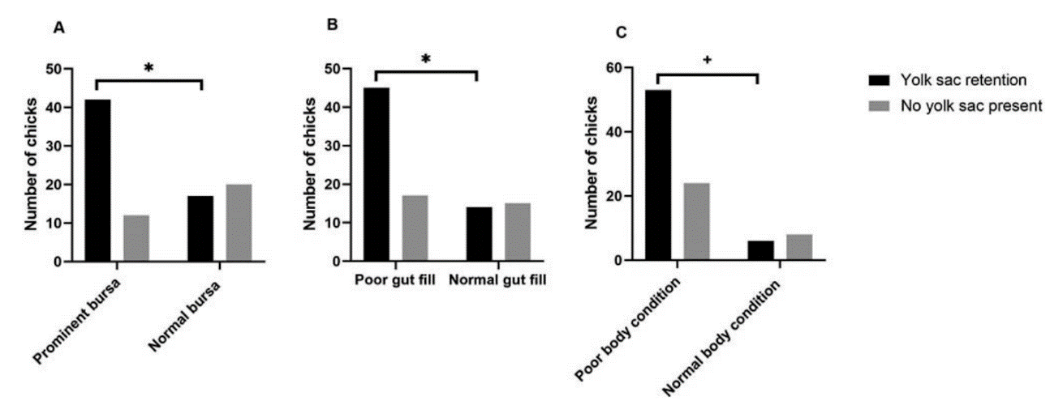

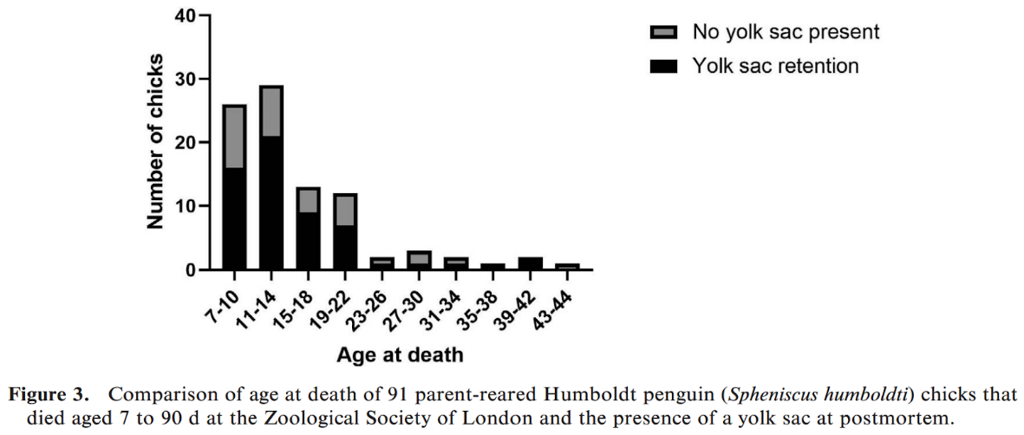

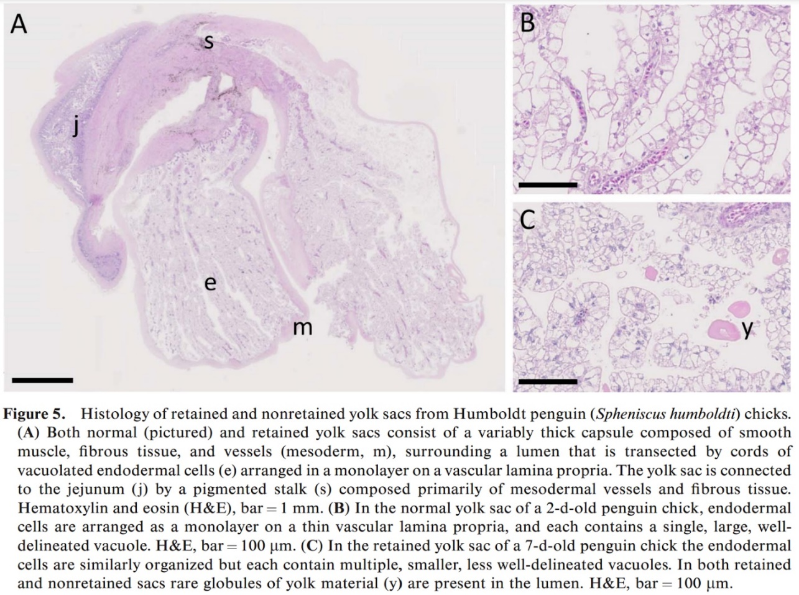

**PHARMACOKINETICS OF ORALLY ADMINISTERED VORICONAZOLE IN AFRICAN PENGUINS (SPHENISCUS DEMERSUS) AFTER SINGLE AND MULTIPLE DOSES**

Hyatt MW, Wiederhold NP, Hope WW, Stott KE.

Journal of Zoo and Wildlife Medicine 2017;48(2):352–362

Aspergillosis is a common respiratory fungal disease in African penguins (Spheniscus demersus)under managed care, and treatment failures with itraconazole due to drug resistance are increasingly common,leading to recent use of voriconazole. Empirical dosing with voriconazole based on other avian studies has resulted in adverse clinical drug effects in penguins. The objective of this study was to determine oral voriconazole pharmacokinetics (PK) in **African penguins (n=18). Single and once daily multiple oral doses of 5 mg/kg voriconazole were evaluated with a 4-mo washout period between trials.** Plasma voriconazole concentrations were determined via high-performance liquid chromatography. Data was modeled using 3-compartamental population methodologies that supported first-order elimination. Observed mean peak concentration (1.89l ug/ml) after single dosing PK analysis was determined within the first hour following voriconazole administration. In the multiple-dose trial average plasma voriconazole concentrations were significantly higher on days 4 and 7 as compared with day 2. The mean estimates for volume of distribution (V/F) and clearance (Cl/F) for the multiple-dose study were 3.34 L and 0.18 L/hr, respectively. Monte Carlo simulations determined the median area under the curve (AUC0–24) at 84 hr was 37.7 ug*h/ml. As this assessment was comparable with the average AUC in humans receiving the recommended human oral dosage 200 mg b.i.d., it suggests that 5 mg/kg p.o. s.i.d. could be a safe and effective regimen in African penguins for treatment of aspergillosis. However, due to potential drug accumulation and subsequent toxicity, therapeutic drug monitoring with dosage adjustments is recommended to individualize dosing.

**Background**

* Voriconazole
  + Inhibits cytochrome P450 enzyme lanosterol 14α-demethylase
    - Prevents C-14 demethylation of lanosterol and the biosynthesis of ergosterol
  + Metabolized in the liver – by CYP2C19 primarily in the liver – in a non-linear fashion likely due to enzyme saturation
  + Adverse effects – anorexia, lethargy, depression, weakness, ataxia, paresis, apparent blindness, seizure-like activity
  + MIC goal of 2-3 ug/mL, most Aspergillus isolates from people <1 ug/mL
* Voriconazole dosing in other birds
  + Magellanic penguins – 5 mg/kg PO q24h x 5 days, then off 1 day
    - This dosing was too low in Humboldt penguins
* Some penguins (magellanic & king) can adjust their gastric pH – not expected to affect Voriconazole absorption

**Key Points**

* Single dose & multiple dose (5 mg/kg q24h x 8d)
* Short Tmax – 0.4 hr – mallards 0.77 hrs, chickens 1.5 hr, African greys 3 hr
* Prolonged elimination (T1/2) - 10.92 hr - (15hr in magellanic penguins), 1 hr in mallards, 1.5 hr in African greys & chickens
* 5 mg/kg PO q24h achieves most reliable levels with lowest risk of toxicity
* May take 4-7 days to get to a steady state

**Conclusions**

* Voriconazole 5 mg/kg PO q24h is recommended for treatment of *Aspergillus* spp. in African penguins
  + May take 4-7 days to achieve steady state