J Herpetol Med Surg 2021 31(1):3-11
The Value of Black Soldier Fly Larvae (Hermetia illucens) as a Food Source: A Review
Kimberly Boykin, Mark A. Mitchell

ABSTRACT: Black soldier fly (BSF) larvae, commonly marketed as Calciworms® (Timberline Fisheries Corp., Marion, IL, USA) or Phoenix Worms® (Insect Science Resource, LLC, Tifton, GA, USA), have become increasingly popular as a feeder insect for reptiles. Their popularity stems from the larvae's potentially calcium-rich nature, capable of surpassing a 2:1 calcium to phosphorus ratio without the need for dusting or gut loading. Despite their popularity, there has been limited research regarding their use as a food item for reptiles. They have, however, been studied extensively in food animal production as a less expensive source of animal protein and as part of an integrated waste management system. This review is meant to provide exotic animal veterinarians with evidenced-based research regarding the BSF's natural history, standard rearing practices, and the larvae's nutritive value in various animal systems, including captive reptiles. The authors hope this review will help veterinarians make better feeding recommendations for their reptile patients

Key Points:
- Insectivorous reptiles are nutritionally the hardest to manage in captivity
  - Captive-raised insects cannot adequately replicate natural diets due to a lack of insect species variance, poor commercial insect diets, and insects being fasted prior to consumption
  - Insects are usually deficient in calcium, fat soluble vitamins (A, D3, and E), thiamine, and omega 3-fatty acids
- Two strategies to improve insects’ nutritional quality are dusting and gut loading
  - Dusting with calcium and multi-vitamin powders is simple but can be unreliable
    - > 50% falls off or is groomed away in < 2.5 min when applied to crickets
  - Gut loading with calcium and vitamin rich diets is preferred; however, these diets provide variable results based on the duration of gut loading, developmental cycle of the insect, nutritional aspects and quality of the gut loading diet, decreased palatability of the diet to the insect, and higher insect mortality due to nutritional toxicosis
- The species most used as feeder insects include house crickets, mealworms, superworms, waxworms, and silkworms
- Most vertebrate animals require dietary calcium intake ≥ phosphorus intake
  - Insects with higher amounts of available calcium and diverse nutrient profiles include black soldier fly (BSF) larvae, common rough woodlice, and soldier termites
- Native to the Americas, BSF are not considered a pest species beyond their native range
  - The ideal rearing temperature is 79–81 F, but can tolerate 54–97 F
  - The ideal rearing humidity is 60-70%, but can tolerate 25-99%
  - As generalist decomposers, they can be reared on several different substrates
  - BSF larvae prefer a moist substrate for feeding and oviposition
  - ~10 larvae per gram of diet yields the best trade-off in terms of larval density
- BSF larvae and prepupae typically have a positive Ca:P ratio of ~2.6:1 fasted; however, these levels are influenced by rearing substrate
  - They are also good sources magnesium, potassium, iron, manganese, and zinc
  - Despite being mineral dense, they are still deficient in fat-soluble vitamins
  - They also have overall poor digestibility, with concerns related to sodium, copper, iron, and molybdenum, and potentially low levels of arginine and taurine

TLDR: Key benefits of BSF larvae is their naturally positive Ca:P ratio and excellent source of Mg, K, B vitamins (including thiamine), and lauric acid. Providing a variety of insects is key to prevent nutrient deficiencies or gut pathologies

Related Articles:
- Boyer TH, Scott PW. 2019. Nutrition. In Divers SJ, Stahl SJ (eds): Mader’s Reptile and Amphibian Medicine and Surgery. Elsevier, St. Louis, MO:201–223.
- Boykin KL, Butler-Perez K, Buck CQ, Peters JW, Mitchell MA. 2020a. Preliminary evaluation of a novel insect-based sausage diet for juvenile corn snakes (Pantherophis guttatus). J Herp Med Surg, 30(3):129–136.
- Boykin KL, Mitchell MA. 2020c. Evaluation of vitamin A gut loading in black soldier fly larvae (Hermetia illucens). Zoo Biol, https://doi.org/10.1002/zoo.21582

J Herpetol Med Surg 2021 31(2):141-146
Neurological Examinations in Healthy Juvenile Bearded Dragons (Pogona vitticeps) and Adult Leopard Geckos (Eublepharis macularius)
Joanna Hedley, Jack MacHale, Matthew Rendle, Abbe Crawford

ABSTRACT: A variety of neurological disorders have been reported in reptiles, but evaluation of a reptile patient with suspected neurological disease can be challenging. The feasibility of performing and interpreting neurological examinations may be affected by a number of factors, including species, body temperature, individual temperament, and stress levels. The aims of this study were to determine whether standard neurological examinations used in other companion animal species could be adapted for use in lizards to establish a reference for healthy animals. The inland bearded dragon (Pogona vitticeps) and leopard gecko (Eublepharis macularius) were selected as two of the most commonly presented pet lizard species. Thirty adult leopard geckos and 30 juvenile bearded dragons were provided by a private breeder as subjects for the study. A complete physical examination was performed on each animal, followed by a standardized neurological examination. Postural reactions, spinal reflexes, and cranial nerve testing were scored as absent, reduced, or present. Certain responses, such as the menace response and response to sound, were consistently absent in all animals, whereas parameters such as jaw tone and righting reflex were present in all animals. Some variation was also observed in response to other tests such as tactile placing and tail pinch. It is hoped that these findings can help clinicians prioritize tests that can be easily performed with minimal stress, and give consistent results in a healthy lizard

Goal: Establish normal reflexes and responses seen during neuro exam in healthy lizards, using techniques extrapolated from other companion animal species

Key Points:
- The reptile brain is simpler compared to mammals, having no cerebral gyri and sulci
- There are 12–13 cranial nerves present in most reptiles
  - Extra nervus terminalis (cranial nerve 0) travels with the olfactory nerves
  - Thought to be associated with one or more gonadotropin-releasing hormones
- Materials used included a nonslip surface, cotton-tipped applicators, a pen torch, a mosquito hemostat, and a bottle of 90% ethanol surgical spirit
- Neuro exam included: mentation, gait, cranial nerves, spinal reflexes, and postural reactions
  - Mental status was assessed prior to handling or on the exam table
  - Gait was assessed for paresis, ataxia, and lameness in a small cage
  - Cranial nerve testing included olfactory response, menace response, palpebral reflex, maxillary and mandibular sensations, auditory response, vestibulo-ocular reflex, jaw tone, and assessment of tongue movement
  - Spinal reflex testing included assessment of the thoracic and pelvic limb withdrawal reflex, patellar reflex, cutaneous trunci reflex, cloacal tone and reflex, and tail pinch
  - Postural reactions included foot replacement of the thoracic and pelvic limbs, hopping of the thoracic and pelvic limbs, wheelbarrowing, hemiwalking, tactile placing of the thoracic and pelvic limbs, visual placing of the thoracic limbs, extensor postural thrust, and righting reflex were assessed
- Palpebral reflex and jaw tone was present in all animals and tongue movement in almost all
  - In dragons, the olfactory response and vestibulo-ocular reflex were consistently present
  - The vestibulo-ocular reflex was recognized as clear jerklike head movements rather than discrete eye movements; however, this reflex was absent in all leopard geckos
  - This may represent a difference in extra-ocular muscle innervation between leopard geckos and bearded dragons
- In leopard geckos, olfactory response to be variable
  - The use of a food odor, rather than a noxious odor may identify a more consistent olfactory response
- Maxillary and mandibular sensations were present in almost all animals
  - Responses were reduced in the dragons compared to geckos, with tests requiring repetition before a reaction could be elicited
- Although only assessed in four animals per species, a slow direct PLR was observed, with absent indirect PLRs
  - In reptiles, the iris is composed of striated muscle, which allows voluntary control of pupil constriction and dilation
- Withdrawal reflexes were present in all animals, but repeat or firm pinching of the digit was necessary to elicit the reflex in some cases
- The cutaneous trunci and cloacal reflexes were absent in all animals, although cloacal tone was present
  - The patellar reflex was also absent, which could be explained by the differences in stifle anatomy between lizards and mammals
- Postural reactions were variable in all lizards tested
  - The righting reflex and wheelbarrowing could be performed consistently and reliably
  - The extensor postural thrust was absent in bearded dragons and the majority of geckos
  - Foot replacement and visual and tactile placing were present in some animals, but the response was variable

TLDR: Provides a template and reference for normal neuro exam in bearded dragon and leopard geckos

Related Articles
- Platt S. 2019. Neurology. In Divers SJ, Stahl SJ (eds): Mader’s Reptile and Amphibian Medicine and Surgery. Elsevier, St. Louis, MO:805–826
- Warnefors E, Rueløkke ML, Gredal H. 2019. Results of a modified neurological examination in 26 healthy rabbits. J Exot Pet Med, 30(2):54–59

J Herpetol Med Surg 2021 31(3):204-210
Evaluation of Tiletamine–Zolazepam Sedation in Central Bearded Dragons (Pogona vitticeps) Following Intramuscular and Subcutaneous Administration
Courtney Patson, Grayson Doss, Christoph Mans

ABSTRACT: The objective of this study was to evaluate the effects of tiletamine–zolazepam as a sedative drug in central bearded dragons (Pogona vitticeps) and determine if efficacy differed based on administration route. Ten healthy, adult central bearded dragons received tiletamine–zolazepam (20 mg/kg) either intramuscularly (IM) or subcutaneously (SC) in the cranial body in a randomized, blinded, complete crossover study with a minimum washout period of 2 wk between treatments. Respiratory rate, heart rate, body position, response to restraint, spontaneous movement, righting reflex, and jaw tone were evaluated. All bearded dragons received flumazenil (0.05 mg/kg, SC) in the cranial body 45 min after the initial tiletamine–zolazepam injection. Righting reflex was lost in all bearded dragons receiving tiletamine–zolazepam IM, but only half of the animals lost righting reflex after SC injection. Jaw tone was lost in 90% (9/10) of animals receiving IM injections compared to 40% (4/10) following SC injections. Recovery from sedation was similar between route of administration (IM: 69 ± 39 min, SC: 57 ± 33 min, P= 0.43). Postsedation food intake was suppressed 2 h after return of righting reflex. Based on the findings of this study, IM administration of tiletamine–zolazepam results in a deeper and more consistent plane of sedation in bearded dragons when compared to the SC route. Prolonged recoveries were noted with both routes of administration

Goal: Evaluate the effects of tiletamine–zolazepam in central bearded dragons (n=10) and determine if efficacy differed based on IM or SC administration

Key Points:
- Tiletamine–zolazepam is a combination of the dissociative tiletamine and the benzodiazepine zolazepam
  - Tiletamine is associated with long duration of action, and zolazepam is a long-acting benzodiazepine
  - Recoveries ranging from < 4 h to > 16 h were reported for IM tiletamine–zolazepam administration in crocodilians and green iguanas
- In ball pythons, corn snakes, leopard geckos, and central bearded dragons, SC dexmedetomidine, ketamine, midazolam, and alfaxalone results in rapid immobilization
  - However, while SC and IM dexmedetomidine and ketamine in red-eared sliders resulted in the same depth of anesthesia by 45 min of administration, IM resulted in faster induction
- The difference between IM and SC in this study could be secondary to a poorly vascularized SC space in reptiles, leading to diminished drug distribution and efficacy
  - Interestingly, the molecular structures of tiletamine and zolazepam are very similar to ketamine and midazolam, both of which have been shown to be effective after SC administration in reptiles
- Complete recovery did not occur in 50% of dragons by 3 h after IM administration

TLDR: 20 mg/kg tiletamine–zolazepam IM induced moderate to deep sedation with loss of righting reflex in most dragons, while SC did not result in the same efficacy. However, the prolonged recovery in some dragons limits the use of this protocol in practice

Related Articles
- Fink DM, Doss GA, Sladky KK, Mans C. 2018. Effect of injection site on dexmedetomidine-ketamine induced sedation in leopard geckos (Eublepharis macularius). J Am Vet Med Assoc, 253(9):1146–1150
- Fleming GJ. 2014. Crocodilians (crocodiles, alligators, caiman, and gharial). In West G, Heard D, Caulkett N (eds): Zoo Animal and Wildlife Immobilization and Anesthesia. 2nd ed. John Wiley and Sons, Ames, IA:325–336
- Fleming GJ. 2014. Crocodilians (crocodiles, alligators, caiman, and gharial). In West G, Heard D, Caulkett N (eds): Zoo Animal and Wildlife Immobilization and Anesthesia. 2nd ed. John Wiley and Sons, Ames, IA:325–336
- Larouche CB, Beaufrere H, Mosley C, Nementh NM, Dutton C. 2019. Evaluation of the effects of midazolam and flumazenil in the ball python (Python regius). J Zoo Wildl Med, 50(3):579–588
- Mans C, Schumacher J. 2014. Anesthesia. In Mader DR, Divers SJ (eds). Current Therapy in Reptile Medicine and Surgery. WB Saunders Co., Philadelphia, PA:134–153. Mans C, Sladky KK, Schumacher J. 2019. General anesthesia. In Divers SJ, Stahl SJ (eds): Mader’s Reptile and Amphibian Medicine and Surgery. 3rd ed. WB Saunders Co., Philadelphia, PA:447–464
- Ratliff C, Parkinson LA, Mans C. 2019. Effects of the fraction of inspired oxygen on alfaxalone-sedated inland bearded dragon (Pogona vitticeps). Am J Vet Res, 80(2):129–134
- Yaw TJ, Mans C, Johnson S, Bunke L, Doss GA, Sladky KK. 2020. Evaluation of subcutaneous administration of alfaxalone–midazolam and dexmedetomidine–midazolam for sedation of ball pythons (Python regius). J Am Vet Med Assoc, 256(4):573–579

Evaluation of subcutaneously administered electrolyte solutions in experimentally dehydrated inland bearded dragons (Pogona vitticeps)
Parkinson LA, Mans C.
American journal of veterinary research. 2020;81(5):437-441.

OBJECTIVE To evaluate the effects of 3 electrolyte solutions administered SC to experimentally dehydrated inland bearded dragons (Pogona vitticeps).
ANIMALS 9 inland bearded dragons.
PROCEDURES In a randomized, complete crossover study, experimental dehydration was induced by means of furosemide (10 mg/kg, SC, q 12 h for 4 doses), and then lactated Ringer solution, Plasma-Lyte A, or reptile Ringer solution (RRS; 1:1 mixture of 5% dextrose solution and isotonic crystalloid solution) was administered SC in a single 50-mL/kg dose in 3 treatments sessions separated by a minimum of 14 days. Food and water were withheld during treatment sessions. Plasma biochemical values, PCV, blood total solids and lactate concentrations, and plasma osmolarity were measured prior to (baseline) and 4 and 24 hours after fluid administration.
RESULTS Administration of RRS resulted in severe hyperglycemia (mean ± SD plasma glucose concentration, 420 ± 62 mg/dL), compared with baseline values (190 ± 32 mg/dL), and this hyperglycemia persisted for at least 24 hours. It also resulted in significant reductions in plasma osmolarity and sodium and phosphorus concentrations, which were not observed after administration of the other 2 solutions. Administration of lactated Ringer solution caused no significant increase in blood lactate concentration.
CONCLUSIONS AND CLINICAL RELEVANCE The changes in plasma glucose, sodium, and phosphorus concentrations and plasma osmolarity observed after SC administration of a single dose of RRS suggested this type of electrolyte solution should not be used for rehydration of bearded dragons. Rather, lactated Ringer solution or PlasmaLyte A should be considered instead.

Background
- Historically LRS not recommended for reptiles - concern for hyperlactatemia from presumed inability of the liver to process the influx of lactate
- Osmolarity of fluids: LRS 273 mOsm/L; PLA 294; RRS 273
- Plasma osmolarity in bearded dragons: 295 or 315 mOsm/L
Key Points
- TP and TS decreased significantly after fluids for all 3 with no difference between the three
  - All fluid types were absorbed from the SQ space
- No difference from baseline in blood lactate
- Reptile ringers resulted in severe hyperglycemia that persisted for at least 24 hours
  - Also caused a significant reduction in plasma osmolarity, Na, and P at 24 hrs
Conclusions
- LRS did not increase blood lactate in bearded dragons.
- Reptile ringers resulted in severe hyperglycemia, reduced plasma osmolarity, sodium, and phosphorus despite having the same osmolarity as LRS, suggesting it is not the ideal fluid option.

Evaluation of glucose absorption rates following intracoelomic or subcutaneous administration in experimentally dehydrated inland bearded dragons (Pogona vitticeps).
Minor RL, Doss GA, Mans C.
American Journal of Veterinary Research. 2021;82(11):920-923.

OBJECTIVE To evaluate glucose absorption rates as an indirect measure of fluid absorption after SC or intracoelomic (ICe) administration of 2.5% dextrose solution to experimentally dehydrated inland bearded dragons (Pogona vitticeps)
ANIMALS 9 adult bearded dragons.
PROCEDURES In a randomized, blinded, placebo-controlled, crossover design study, bearded dragons were experimentally dehydrated with a previously described protocol and then received 2.5% dextrose solution (a 1:1 mixture of 5% dextrose in isotonic multiple electrolytes solution; 20 mL/kg), SC or ICe, or a control treatment (the same electrolytes solution without added glucose; 20 mL/kg). Blood glucose (BG) concentrations were measured at predetermined times up to 24 hours after fluid administration. There was a ≥ 14-day washout period between treatments. Mean changes in BG concentration from baseline were compared among treatments.
RESULTS Administration of 2.5% dextrose solution by either route increased BG concentration with a significantly greater change in values within 5 minutes, compared with control treatment results. The mean change in BG concentration after ICe administration was significantly greater than that after SC administration 15 and 30 minutes after injection, with mean differences of −50 and −36 mg/dL, respectively, for the SC treatment. Within 1 hour after fluid administration, there was no significant difference in BG values between the 2 dextrose administration routes.
CONCLUSIONS AND CLINICAL RELEVANCE Findings supported that fluid therapy by SC administration, which carries a lower risk of iatrogenic complications, can provide results similar to those achieved with ICe administration.

Background
- Potential adverse effects of ICe: puncture of intracoelomic anatomy, restriction of lung expansion
- Concern that SQ fluids are not absorbed in reptiles
Key Points
- Both SQ and ICe 2.5% dextrose had significantly increased BG from baseline < 5 min and compared to control
  - Although mean values remained within expected range for the species
- ICe dextrose had significantly greater increase in BG at 15 and 30 min compared to SQ but was comparable at 1 hr
  - ICe levels plateaued around 15 min
Conclusions
- Both SQ and ICe 2.5% dextrose solutions had increased BG in experimentally dehydrated inland bearded dragons within 5 min that lasted > 24 hr
- SQ had a less rapid increase but reached comparable levels while ICe had a rapid increase but peaked and plateaued around 15 min.
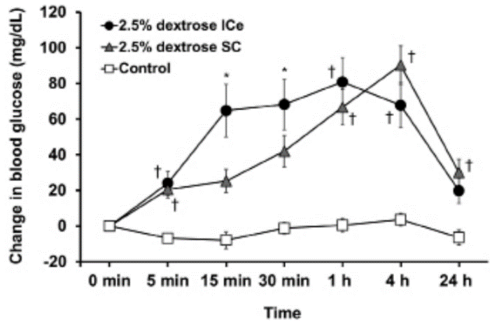

Peiffer, Lauren B., et al. "Fatal ranavirus infection in a group of zoo-housed meller's chameleons (trioceros melleri)." Journal of Zoo and Wildlife Medicine 50.3 (2019): 696-705.

Abstract: A group of five juvenile Meller's chameleons (Trioceros melleri) experienced 100% mortality over a period of 1 mo due to ranavirus infection. The index case was found dead without premonitory signs. The three subsequent cases presented with nonspecific clinical signs (lethargy, decreased appetite, ocular discharge) and were ultimately euthanatized. The final case died after initially presenting with skin lesions. Postmortem examination revealed thin body condition in all five animals and mild coelomic effusion and petechiae affecting the tongue and kidneys of one animal. Microscopically, all animals had multifocal necrosis of the spleen, liver, and kidney; four of five animals had necrosis of the nasal cavity; and two of five had necrosis of adrenal tissue, bone marrow, and skin. Numerous basophilic intracytoplasmic inclusions were present in the liver of all animals and nasal mucosa of three of the five animals. Consensus polymerase chain reaction for herpesvirus and adenovirus were negative, whereas ranavirus quantitative polymerase chain reaction was positive. Virus isolation followed by whole genome sequencing and Bayesian phylogenetic analysis classified the isolates as a strain of frog virus 3 (FV3) most closely related to an FV3 isolate responsible for a previous outbreak in the zoo's eastern box turtle (Terrapene carolina carolina) group. This case series documents the first known occurrence of ranavirus-associated disease in chameleons and demonstrates the potential for interspecies transmission between chelonian and squamate reptiles.
- Ranaviruses – Large, enveloped, dsDNA.
  - Infect wide range of ectothermic vertebrates.
  - Seven recognized species of virus – Frog virus 3 most thoroughly researched.
    - FV3 and FV3-like viruses emerging pathogens in reptiles – Chelonians, snakes, lizards.
    - Other iridoviruses that are reported in chameleons – Lizard erythrocytic virus, invertebrate iridovirus Gryllus bimaculatus iridescent virus.
  - CS in chameleons – Anorexia, ocular discharge, dehydration, lethargy, oral petechiae, sudden death, skin lesions (one individual).
  - Necropsy – Necrosis of hematopoetic tissues (spleen), liver, kidneys, adrenals, necrotizing inflammation within nasal cavity, oral mucosa, and skin.
    - Intracytoplasmic inclusions numerous and affected a greater variety of tissues vs previous reptile infections in other spp.
    - Secondary bacterial and fungal infections.
  - This ranavirus spp closely related to box turtle FV3 and suspected to be directly or indirectly transmitted from a population of box turtles at this facility.
- Takeaway: Mortality associated with ranaviral outbreak in Meller’s chameleons, nearly identical isolate to EBT ranaviral isolate, suggests interspecies transmission or a shared source of infection. Possible exposure – iatrogenic, direct contact with managed or free-ranging animals, environmental sources. Don’t mix reptile species in exhibits. Intracytoplasmic inclusions!
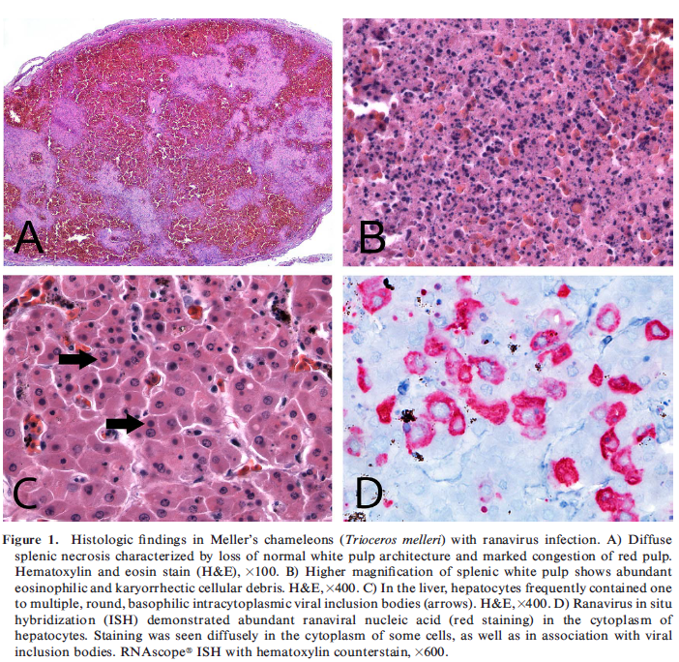

Magnotti, Jessica M., et al. "Retrospective review of histologic findings in captive gila monsters (heloderma suspectum) and beaded lizards (heloderma horridum)." Journal of Zoo and Wildlife Medicine 52.1 (2021): 166-175.

Abstract: A retrospective study was performed by reviewing all Heloderma spp. submissions to Northwest ZooPath from 1996 to 2019. Necropsy and biopsy specimens from 106 captive Gila monsters (Heloderma suspectum) and 49 captive beaded lizards (Heloderma horridum) were reviewed. Inflammatory diseases were the most frequently diagnosed condition in Heloderma spp., and were diagnosed in 72% of all animals examined, including 76% of Gila monsters and 63% of beaded lizards. The most common cause of inflammation was bacterial infection, which was present in 52% of all Heloderma spp. with inflammation. Enterocolitis was common in Gila monsters (20%) and beaded lizards (14%), but the underlying causes were different for each species. Cryptosporidium spp. was the most common cause of enterocolitis in Gila monsters (36%) but was not identified in beaded lizards. Amoebiasis was a common cause of enterocolitis in Gila monsters (27%) and was the most common cause of enterocolitis in beaded lizards (57%). Deposition diseases were diagnosed in 34% of all Heloderma spp. The most frequently diagnosed deposition disease in beaded lizards was urolithiasis-nephrolithiasis (12%). This disease was not diagnosed in Gila monsters. Deposition diseases that were common in Gila monsters and beaded lizards included hepatic lipidosis and renal gout. Neoplasia was diagnosed in 17% of all Heloderma spp., including 17% of Gila monsters and 18% of beaded lizards. The most common neoplasm of Heloderma spp. was renal adenocarcinoma, which was equally common in Gila monsters and beaded lizards. Less common diagnoses included degenerative diseases, trauma, nutritional disease, nonneoplastic proliferative disease, nondegenerative cardiovascular disease, and congenital malformation.

Key Points:
- Helodermatids (Gila monster and Beaded lizard) – venomous, carnivorous lizards native to the Americas
- Objective – describe spectrum of diseases diagnosed histologically in Heloderma spp.
- Amongst categories examined inflammatory diseases were most common followed by deposition diseases, neoplasia, degenerative disease, trauma, nutritional disease, non-neoplastic proliferative disease, cardiovascular disease, and congenital.
  - Inflammatory – most common cause of inflammation was bacterial infection (~50%) and resulted in bacteremia/sepsis in ~20% of cases.
    - Most common location – intestines. Entercolitis in 20% of Gila monstera commonly associated with Cryptosporidia spp. (~35%) or amoeba (~25%). Enterocolitis in beaded lizard most commonly associated with amoeba (no crypto seen) and in some cases spread systemically. Second most common cause of inflammation was coelomitis, most commonly from free yolk.
  - Deposition disease – Renal gout was most frequent cause in Gila monster and second most common cause in Beaded lizards
    - Gout most often occurred in the absence of other renal disease, suggesting that nonrenal causes of gout (e.g. dehydration) may be more substantial in the pathogenesis
  - Urolithiasis-nephrolithiasis most common deposition disease in beaded lizard (not found in Gila monsters). Hepatic lipidosis also common in both species
  - Neoplasia – Most common neoplasm was renal adenocarcinoma in both Gila and Beaded.
  - Degenerative disease – Most frequently diagnosed in in Heloderma spp. was chronic renal disease
- Epidemiologic data:
  - All animals with myocardial fibrosis were male.
  - Yolk coelomitis occurred exclusively in sexually mature or geriatric animals

Take home:
Inflammatory diseases secondary to bacterial infection most common. Enterocolitis secondary to Cryptosporidia (Gila) and amoeba (Gila and Beaded) common. Urolithisis-nephrolithsis common in beaded lizards (not found in Gila). In both species, renal gout, hepatic lipidosis, and renal adenocarcinoma also common.

Evaluation of a ventral and a left lateral approach to coelioscopy in bearded dragons (Pogona vitticeps).
Frei, S., Sanchez-Migallon Guzman, D., Kass, P.H., Giuffrida, M.A. and Mayhew, P.D.
American journal of veterinary research, 2020;81(3):267-275.

OBJECTIVE To compare a ventral and a left lateral endoscopic approach to coelioscopy in bearded dragons (Pogona vitticeps).
ANIMALS 18 adult bearded dragons.
PROCEDURES In a randomized crossover design involving 2 surgical approaches, anesthetized bearded dragons first underwent coelioscopy with a ventral approach (left lateral of midline next to the umbilicus; animal positioned in dorsal recumbency) or left lateral approach (intercostal; animal positioned in right lateral recumbency) and then with the alternate approach. A 2.7-mm × 18-cm, 30° oblique telescope with a 4.8-mm operating sheath and CO2 insufflation at 2 to 5 mm Hg were used. Ease of entry into the coelom and ease of visual examination of visceral structures were scored.
RESULTS Both approaches were straightforward, with the left lateral approach requiring significantly more time than the ventral approach. Scores for ease of visual examination for the heart, lungs, liver, stomach, intestines, pancreas, gallbladder, left kidney, gonads, and fat body were good to excellent. Visual examination of the spleen and adrenal glands was difficult in most animals via either approach. The left kidney, testis, and vas deferens were easier to see with the left lateral approach, whereas the pancreas in females and gallbladder in both sexes were easier to see with the ventral approach. All bearded dragons recovered without complications from the procedures, except for one with nephritis, renal gout, and hepatic necrosis.
CONCLUSIONS AND CLINICAL RELEVANCE Both coelioscopy approaches could be safely and effectively used in bearded dragons. Choice of approach should be based on the coelomic structures requiring evaluation.

Background
- In green iguanas: right lateral is preferred for gallbladder, left lateral is preferred for heart, stomach, and spleen
- Bearded dragons have black pigmented coelomic membrane
- Iguanas and sliders, biopsy created crush artifact in 77% of liver samples and 5% of kidney
  - Kidney biopsies should be performed through lateral approach

Key Points
- 1 (systemically ill) died post-op but otherwise no complications
- Ventral approach was more rapid than left lateral (between 9th and 10th rib)
  - Avoid the ventral abdominal vein and pelvic veins (just caudal to umbilicus)
- Visual exam of heart, lungs, liver, stomach, small intestine, and fat body excellent for both sexes and approaches
- Left lateral: more difficult to examine right lung, right lobe of liver, gallbladder, pancreas
- Ventral: more difficult to visualize left testis and vas deferens (not ovary), and left kidney
- Females: ova or eggs hindered visibility of gallbladder, spleen, adrenals, pancreas
- Approaches to difficult organs:
  - Gallbladder: caudal margin of liver, slightly to the right, move endoscope cranially following abdominal vein then direct tip dorsally between lobes of liver
  - Spleen: left side adjacent to caudal stomach, males start at cranial pole of left testis and direct cranially and dorsally between SI loops
  - Adrenals: difficult to visualize, left was lateral to left testis under coelomic membrane
  - Pancreas: trilobed, suspended in mesentery between stomach and duodenum
- Right kidney difficult to find in ventral and not found in left lateral

Conclusions
- Coelioscopy was safe and effective with few differences between left lateral and ventral approaches and between sexes of bearded dragons
  - Ventral approach recommended when both sides of coelom need to be assessed as well as gallbladder and pancreas
  - Left lateral recommended for left kidney, gonad, and spleen
- Determine female reproductive status as follicles and eggs influenced visualization

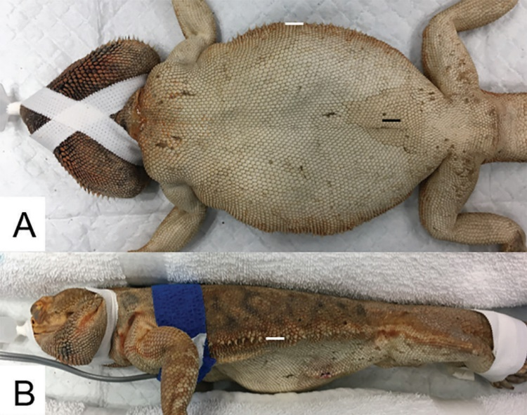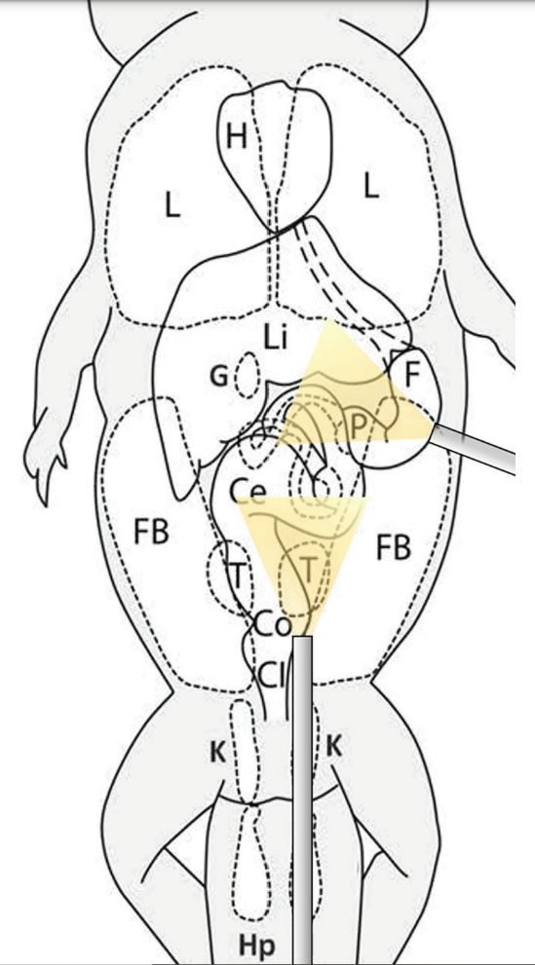
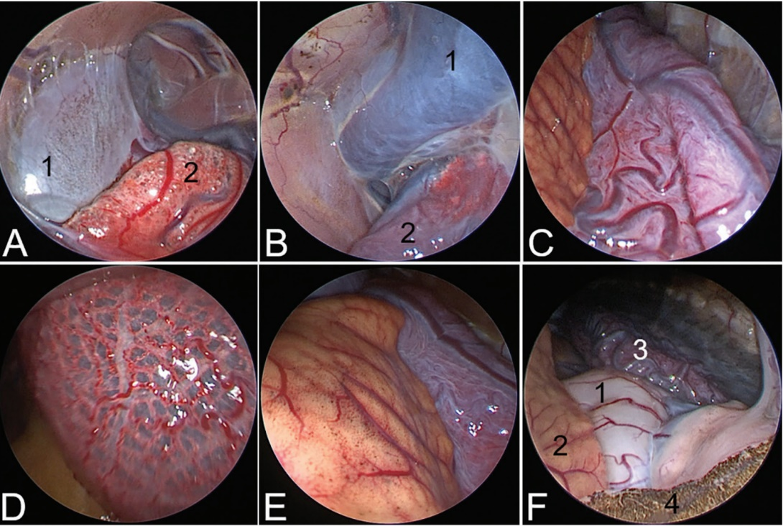
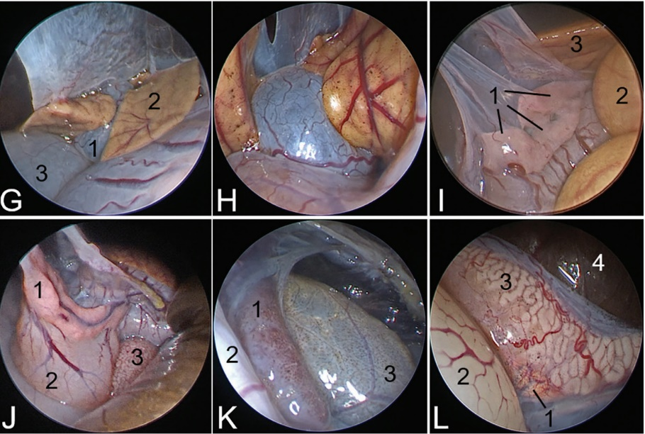
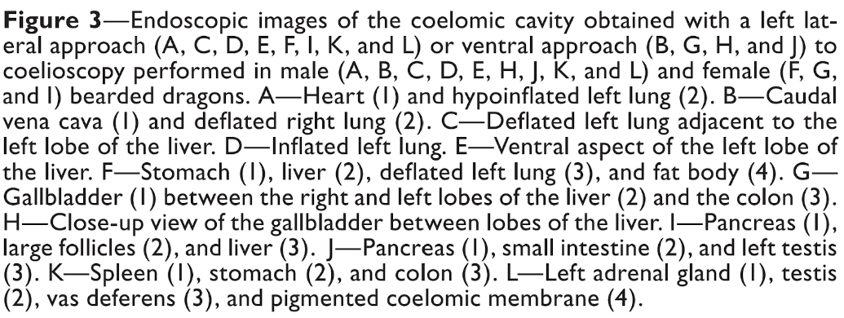

Effect of Positioning on Coelomic Radiography with and without Contrast in the Green Iguana (Iguana iguana)
The Journal of Herpetological Medicine and Surgery, Volume 31, No. 1, 2021 pp. 73–81
Abstract A prospective study was performed in 12 green iguanas (Iguana iguana) to compare the radiographic appearance of coelomic viscera. Five radiographic projections (views) of the coelom were obtained: dorsoventral, right lateral vertical beam, left lateral vertical beam, right lateral horizontal beam, and left lateral horizontal beam. One week later, the same radiographic projections were obtained after oral administration of barium. In 4 of the 12 green iguanas, an additional vertical beam ventrodorsal view was obtained. In comparing lateral projections, lung, liver, and gonads were best imaged in horizontal beam lateral projections, before distention of the stomach with barium, whereas the gastrointestinal tract including the colon was best visualized in vertical beam lateral projections. The shape and size of the cardiac silhouette was considered equivalent between analogous lateral projections in most green iguanas (10 [83%] of 12). In comparing ventrodorsal and dorsoventral projections, the ventrodorsal projections improved visibility of the cardiac silhouette and lung in 4 (100%) of 4 green iguanas, while reducing cardiac length. Dorsoventral projections were preferred for the evaluation of the gastrointestinal tract. This study demonstrates that radiographic beam orientation and patient position result in obvious radiographic differences of the iguanid coelom and that projections are not interchangeable.

Intro
- Radiography is commonly used in the diagnostic workup of reptiles
- At least 2 orthogonal projections are required
- The present study was conducted to assess the effects of radiographic beam orientation and patient laterality on the appearance of the iguanid coelom
M&M
- 12 subadult green iguanas
- Radiographic projections were obtained of each green iguana in the following order: 1) vertical beam dorsoventral (DV), 2) left lateral horizontal beam (LHB), 3) right lateral horizontal beam (RHB), 4) left lateral vertical beam (LVB), and 5) right lateral vertical beam (RVB).
- 4 animals also had VD projections taken
- One week later, a positive contrast gastrointestinal study was performed with the same radiographic projections obtained in the same order as described previously.
- Radiographic images were retrospectively evaluated by a board-certified veterinary radiologist
- Position, shape, opacity, and margination of the coelomic organs were compared between projections
- Animals were euthanized at the end of the study and necropsied
Results and discussion
- 2 animals died during the study, both of sepsis, one was included (all rads had been taken) and the other was excluded
- All other histo findings were minor
- In comparing lateral projections, lung, liver, and gonads were best imaged in horizontal beam lateral projections, before distention of the stomach with barium, whereas the gastrointestinal tract including the colon was best visualized in vertical beam lateral projections.
- The shape and size of the cardiac silhouette was considered equivalent between analogous lateral projections in most green iguanas (10 of 12).
- In comparing ventrodorsal and dorsoventral projections, the ventrodorsal projections improved visibility of the cardiac silhouette and lung in 4 (100%) of 4 green iguanas, while reducing cardiac length.
- Dorsoventral projections were preferred for the evaluation of the gastrointestinal tract
- Small intestines could only be positively identified in 10 (83%) green iguanas with the presence of barium.
- The small intestine was inconsistently visualized, but when it was visualized, VB lateral projections provided the least amount of superimposition with the stomach
- The spleen, urinary bladder, and kidneys were not definitively identified in any of the 12 green iguanas in any projections.
- the shape and length of the cardiac silhouette appeared similar on lateral projections independent of beam orientation or laterality in 83% of green iguanas, whereas mild elongation and flattening was observed in RVB in the remaining 17% of green iguanas.
- A limitation of this study is that although livers, hearts, and kidneys were macroscopically normal, all were histologically abnormal. Hepatic lipidosis, myocardial degeneration, and renal tubular lipidosis were interpreted by the pathologists as incidental, related to short-term anorexia or fasting, and likely agonal and not due to disease, respectively.
- The stomach was the only organ in which notable differences were present between left and right lateral projections
Takeaway: Results of this study confirm our hypothesis that HB lateral projections of the iguanid coelom are essentially equivalent. As predicted, HB and VB projections are not interchangeable, because gravity-dependent organ positional shifts result in obvious radiographic differences, with the exception of the heart where all laterals were similar irrespective of beam orientation in 83% of green iguanas. Lung, liver, and gonads were best imaged in HB lateral projections, before distention of the stomach with barium. The gastrointestinal tract was best visualized in VB lateral and DV projections. VD projections were advantageous for the evaluation of the lung

Misc Lizard Factoids
- Dentition
  - Acrodont: agamids, chameleons - teeth emerge from the top (biting) surface; permanent; periodontal disease common
  - Pleurodont: Iguanids - teeth inserted along medial (lingual) aspect of jaws; shed and replaced regularly; periodontal disease uncommon
  - Helodermatids: grooved teeth for venom flow from sublingual venom glands

Devriesea agamarum - Gram + bacillus
- Oral microbiota of bearded dragon, may be associated with disease
- Uromastyx particularly susceptible, agama, collared lizards, bearded dragon reservoir
- Proliferative and hyperkeratotic dermatitis, cheilitis with crusty brown skin, septicemia, limb swelling
- Water dragons and basilisk: multifocal granulomas, panniculitis, hepatitis, pneumonia, osteitis, myositis, skin wounds, subcu to coelomic fistulae
- Combine infection with Nannizziopsis reported in inland bearded dragon

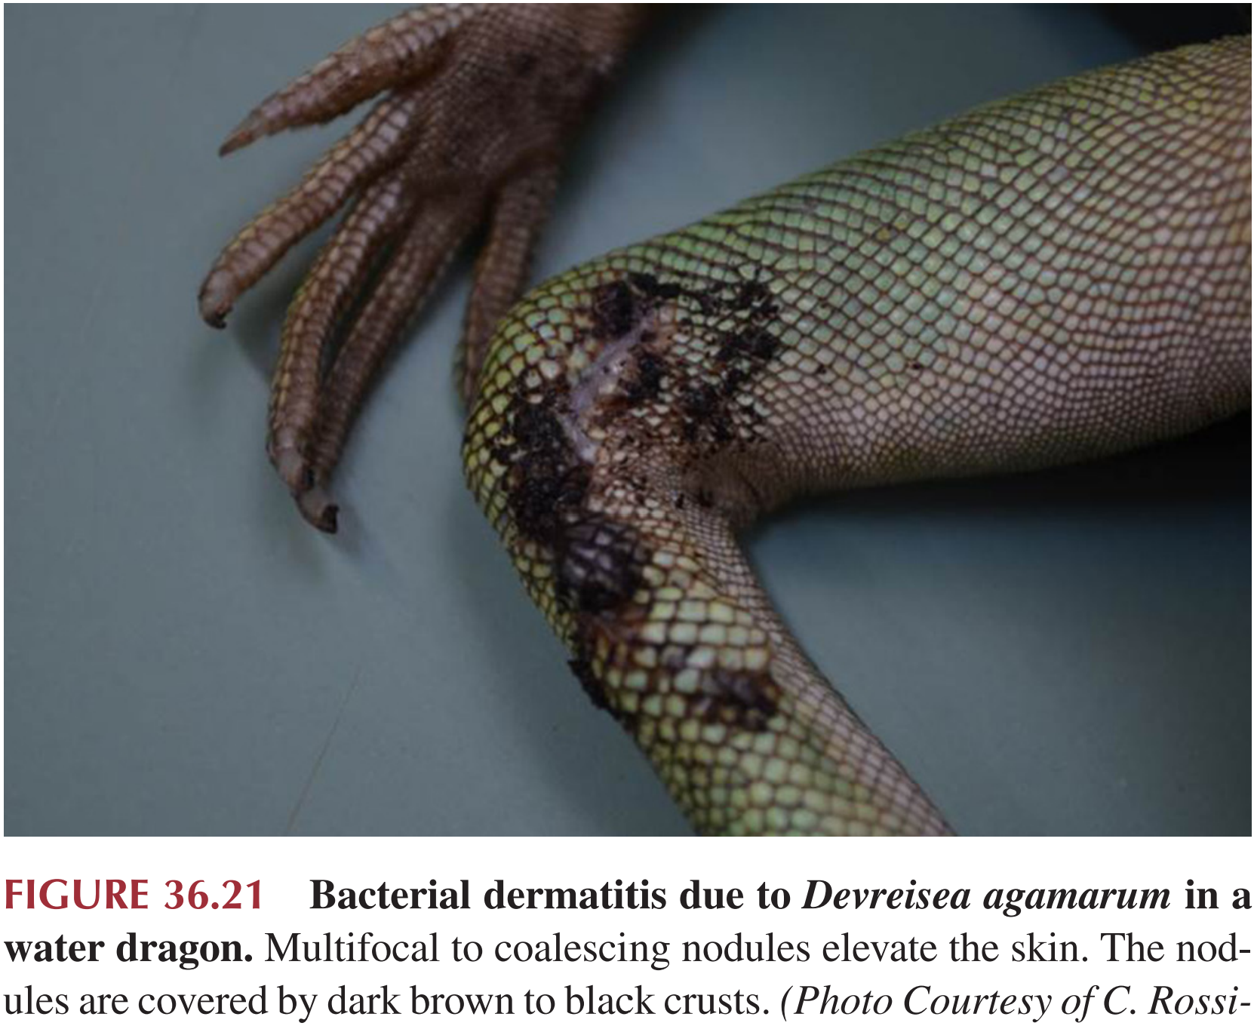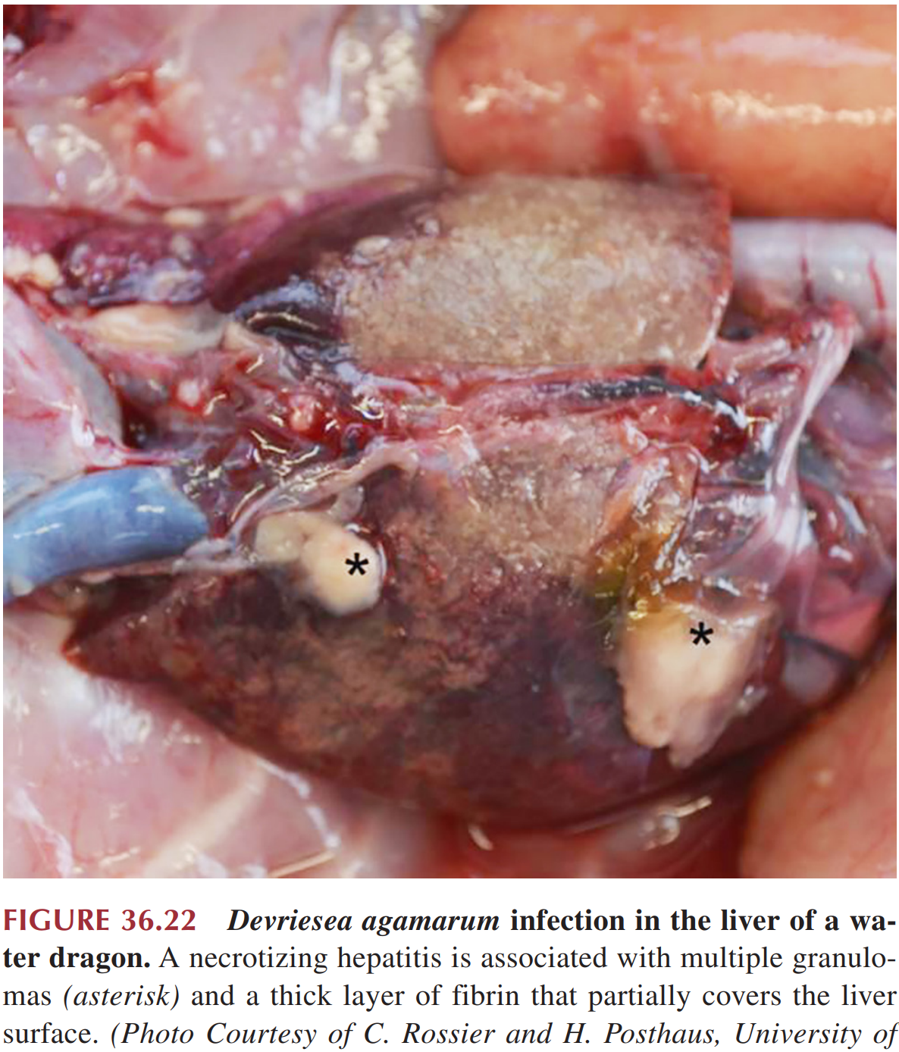

Ratliff, Cameron, Lily AB Parkinson, and Christoph Mans. "Effects of the fraction of inspired oxygen on alfaxalone-sedated inland bearded dragons (Pogona vitticeps)." American journal of veterinary research 80.2 (2019): 129-134.

ABSTRACT: OBJECTIVE To evaluate the effects of providing 100% O2, compared with provision of room air, in sedated spontaneously breathing inland bearded dragons (Pogona vitticeps). ANIMALS 8 adult bearded dragons. PROCEDURES Animals were sedated with alfaxalone (20 mg/kg, SC) and received 21% O2 (equivalent to room air) or 100% O2 via face mask (flow rate, 1 L/min) in a randomized, blinded, complete crossover study (2-week interval between treatments). Sedation variables, cardiopulmonary variables, venous blood gas values, and postsedation food intake were evaluated. RESULTS Respiratory rate, heart rate, oxygen saturation, and sedation quality were comparable between treatments. Venous blood gas analysis revealed a higher total Pco2 and HCO3 – concentration for the 21% O2 treatment. Post-sedation food intake was not affected by the inspired oxygen fraction provided during sedation. CONCLUSIONS AND CLINICAL RELEVANCE The fraction of inspired oxygen did not appear to have clinically relevant effects on physiologic variables of bearded dragons during and after sedation. Therefore, provision of 100% O2 can be considered for use in sedated bearded dragons without the risk of inducing hypoventilation. Similarly, failure to provide 100% O2 would be unlikely to result in clinically relevant consequences in healthy sedated bearded dragons. (Am J Vet Res 2019;80:129–134)
Introduction:
- Reptile ventilation driven by blood oxygen concentration (hypoxia) rather than CO2, so high oxygen tension environments can decrease spontaneous breathing.
- Conscious elephant trunk snakes, savannah monitors, various chelonians – Exposure to 100% O2 has resulted in significantly reduced frequency of ventilation.
- More recent studies of Dumeril monitors, bearded dragons anesthetized with inhalation anesthesia revealed no significant or clinically relevant differences in physiologic variables, time to return of spontaneous ventilation, or recovery time when provided 21% O2 or 100% O2.

M+M:
- Randomly assigned to treatment, complete crossover design.
- 20mg/kg alfaxalone SC and placed in induction chamber with 21% oxygen or 100% oxygen which was then delivered via facemask.
- Monitored for 100 mins afterward. Blood collected 15 min before and 60min after injection

Results:
- Resp rate was not affected by FiO2, administration of 100% oxygen did not result in hypoventilation
- For both tx, resp rate decreased with time. HR was higher for the 21% O2 and spO2 lower but were not significantly different.
- In comparing baseline blood gas with 60min values in tx, bicarbonate, tCO2 and base excess significantly increased for 21% O2 at 60 mins
- No difference in cumulative sedation score between treatments.
- No differences between treatments for time of food intake (ingestion of first crickets, eating all 5 crickets or total number of crickets). All ate 120min after recovery
Discussion:
- Only differences between 21% and 100% O2 were in blood gas values (bicarbonate, tCO2)
- No significant differences in resp rate or pulse ox based on FiO2
- Contrast to results of prior study of intubated beardies which had a lower SpO2
- May be an unreliable method of measuring SpO2 and administration via ET tube may more fully pronounce discrepancy
- Blood gas results were venous and may not fully represent oxygenation
- Not providing 100% O2 did not result in significant hyperlactatemia
- Anecdotally advocated to allow reptiles to recover in room air for faster return to spontaneous breathing
  - Previous studies have indicated no significant differences in recovery and return of spontaneous ventilation with 100% O2 and 21% O2
- No effects on feeding behaviors noted 24-48hrs after sedation in either scenario
Takeaways: Supplementation of sedated beardies with 100% O2 did not have a negative effect on respiratory rate following injectable anesthesia with alfaxalone. Lack of oxygen supplementation did not have clinically important consequences.

Parkinson, Lily A., and Christoph Mans. "Investigation of the effects of cricket ingestion on plasma uric acid concentration in inland bearded dragons (Pogona vitticeps)." Journal of the American Veterinary Medical Association 257.9 (2020): 933-936.
OBJECTIVE To determine whether plasma uric acid concentration in inland bearded dragons (Pogona vitticeps) was affected by recent ingestion of a meal of crickets.
ANIMALS: 12 healthy adult inland bearded dragons.
PROCEDURES Food was withheld for 48 hours prior to experiments. Animals (6/group) were randomly assigned to receive a meal of crickets (equivalent to 1% of the animal’s body weight; 10 g/kg [4.5 g/lb]; treatment group) or have food withheld for an additional 48 hours (control group). Blood samples were collected for plasma uric acid measurement just before (time 0) and 4, 24, and 48 hours after feeding. Effects of feeding and time on the targeted measurement were assessed by repeated-measures ANOVA.
RESULTS Mean plasma uric acid concentration for the treatment group was significantly increased from the time 0 value (2.5 ± 1.5 mg/dL) 24 hours following meal ingestion (6.5 ± 1.2 mg/dL), but not at the 4-hour time point, and returned to the time 0 value by the 48-hour time point. No significant changes in plasma uric acid concentration were detected for the control group.
CONCLUSIONS AND CLINICAL RELEVANCE Results suggested food should be withheld for ≥ 48 hours prior to blood collection if inland bearded dragons are used to establish reference intervals for plasma uric acid concentration or if feasible when obtaining samples from these animals for clinical evaluation. Veterinarians should consider the time from last meal consumption when interpreting plasma uric acid concentration for this species and potentially other terrestrial insectivorous and omnivorous lizards.
Introduction:
- Form of nitrogen excreted varies by species – Land-based mammals (urea), water-based turtles (ammonia or urea), land-based reptiles (uric acid).
  - Uricotelic (UA) – Bearded dragons
  - Ureotelic (BUN) – Chinese soft shelled turtles, green sea turtles, Kemp’s ridley sea turtle, red-eared sliders, and American alligators
- Blood UA in penguins and falcons, snakes and some lizards increases post-prandially.

Results/Discussion Points:
- Bearded dragons in tx group had significantly higher plasma UA at the 24h time point.
- In black-footed penguins and peregrine falcons, blood uric acid peaked < 2 hrs after feeding (sooner than this study). Reptiles appear to have a much later peak in circulating concentrations and remained above preprandial concentration for 4-5 days in some studies.
Takeaways: Bearded dragons had a significant increase in plasma UA at 24h after being fed crickets equivalent to 1% BW

