Practice Questions
You are presented with a siamang (Symphalangus syndactylus) displaying neurologic signs of larval migrans. What is the most reliable diagnostic screening test for determining prior Baylisascaris procyonis infection?
- ELISA
- CSF analysis
- MRI
- Brain biopsy
- Fecal flotation

Answer: A

Members of a group of Goeldi’s monkeys (Callimico goeldii) housed in an indoor enclosure develop signs suspicious of cutaneous demodicosis on their appendages, necks, and perineal regions. What is one potential habitat and/or husbandry factor to review in addition to a routine dermatologic work up?
- Intraspecies social dynamics
- UV intensity and duration
- Vitamin C supplementation
- Access to off-habitat holding
- Cleaning with Virkon® disinfectant

Answer: B

Long, Mackenzie E., Shannon GM Kirejczyk, and Elizabeth Howerth. "Pathology in Practice." Journal of the American Veterinary Medical Association 256.6 (2020): 661-663.
Case summary - Disseminated toxoplasmosis in a captive squirrel monkey.

Question: A 6 year old female squirrel monkey (Saimiri sciureus) acutely dies of respiratory distress. Impression smear cytology of lung tissue (Romanowsky-type stain) shows the following intracytoplasmic organisms with a macrophage (black arrow). What is your diagnosis?

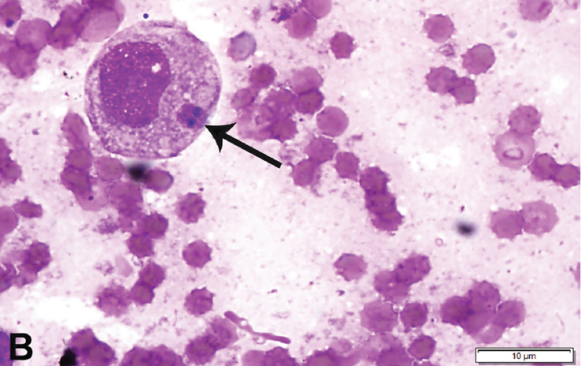
Answer: Toxoplasma gondii (intracellular tachyzoite)

Ceccolini, M. E., Macgregor, S. K., Spiro, S., Irving, J., Hedley, J., Williams, J., & Guthrie, A. (2020). Yersinia pseudotuberculosis infections in primates, artiodactyls, and birds within a zoological facility in the united kingdom. Journal of Zoo and Wildlife Medicine, 51(3), 527-538.

Infection with Yersinia pseudotuberculosis can be difficult to diagnose and treat successfully. Twenty-four cases from the Zoological Society of London (ZSL) London Zoo and ZSL Whipsnade Zoo were identified between 2001 and 2019. Husbandry, medical, and postmortem records for six primates, 10 artiodactyls, and eight birds were reviewed to identify common clinical signs and gross lesions. Most cases occurred during the winter; however, an outbreak in four primates occurred during the summer following a period of stress associated with increased ambient noise and activity. Common clinical signs included lethargy (6/6 primates, 4/10 artiodactyls, 4/8 birds) or death without premonitory signs (3/10 artiodactyls, 4/8 birds). Once clinical signs were observed, disease progressed quickly. Poor condition was common in mammals (6/6 primates, 9/10 artiodactyls), but often went undetected until postmortem examination. Neurological signs occurred in three of six primates. Diarrhea and anorexia were uncommon in all animals. Hepatitis was observed in all groups (4/6 primates, 2/10 artiodactyls, 4/8 birds), mesenteric lymphadenomegaly was common in mammals (4/6 primates, 8/10 artiodactyls), and gastroenteritis was common in artiodactyls (7/10). Erythematous, punctate rashes, which have only been reported with yersiniosis in humans, were present in three of six primates. Bacterial cultures from the liver in primates and birds or enlarged mesenteric lymph nodes in artiodactyls were often diagnostic. All isolates were susceptible to marbofloxacin, oxytetracycline, streptomycin, ceftazidime, amoxicillin clavulanic acid, trimethoprim sulfamethoxazole, azithromycin, and doxycycline, and resistant to clindamycin. Histopathology and Perl's Prussian blue stains were performed on available liver samples (n = 18). Intracellular hemosiderin was present in 17 of 18 cases. Additional research is needed to determine if there is a relationship between hemosiderosis and yersiniosis.

Question:

Which of the following is true regarding Yersinia pseudotuberculosis infection in primates, artiodactyls, and birds?

- Acute death despite good body condition is common in primates
- Hepatic bacterial cultures are often undiagnostic
- Most cases occur during the spring and summer
- Erythematous rashes are a pathognomonic lesion in birds
- Hepatic hemosiderosis is commonly observed with yersiniosis

Answer: E

Pathology in Practice
JAVMA 2018;253(4):423-426

Practice Question:
A common marmoset (Callithrix jacchus) presents to your clinic with dull mentation and a skin ulcer adjacent to the mouth. What is your primary differential, what is the prognosis, and what should the clients know for their other marmoset at home?

A: HHV-1 (Human herpesvirus 1, simplex virus type 1); prognosis is grave (clinical course avg 3 days prior to mortality); transmission is most commonly from humans to marmosets through direct contact and is rapidly fatal, strict biosecurity should be followed especially when a human has an apparent lesion to prevent transmission to the marmoset.

Long-term surveillance of langur alphaherpesvirus in a zoo population of silvered langurs (Trachypithecus cristatus).
Gustavsen, K. A., Raphael, B. L., Wildes, M. J., McAloose, D., McCann, C. M., Hilliard, J. K., & Calle, P. P.
Journal of Zoo and Wildlife Medicine, 2018;49(2):345-354.

Practice Question:
Which of the following is true regarding Langur alphaherpesvirus (HVL) in silvered langurs (Trachypithecus cristatus) under human care?
- Initial introduction is thought to be from a sourcepoint zoonotic transmission
- Transmission to macaques causes an apparent infection or mild mucosal ulceration
- Diagnosis is primarily obtained by virus isolation from mucocutaneous vesicles
- Seropositive juvenile or immunosuppressed langurs routinely develop oropharyngeal lesions
- Although period prevalence has remained static, cumulative incidence has declined over time.

Answer: E
- Initial introduction is thought to be from wild-origin founder population (1 seropositive shortly after importation), zoonotic or anthropozoonotic potential of HVL is unknown.
- Transmission to macaques has not been documented
- Diagnosis is primarily through titers and clinical signs, virus isolation of surveillance mucosal swabs and 2 clinical cases have all been negative
- Only 3 clinical cases, all young adults, low seroprevalence and no reported clinical cases in juveniles, no reported clinical signs in old or sick despite high seroprevalence in <10 yo langurs.

According to a recent study, what is the best way to differentiate pathogenic from nonpathogenic species of Entamoeba?

- Baermann
- Direct morphological assessment
- PCR
- Fecal float
- McMaster fecal

Answer: C

A recent investigation into Leptospira in a zoo in Colombia revealed which of the following?

- Seroprevalence in non-human primates was linked to active infections based on culture and PCR
- Serovars found in free-ranging rodents were the same as those found in non-human primates
- Rodents were found to be seronegative for Leptospira spp
- Clinical signs were seen in primates, but not in rodents
- The source of drinking water may have played a role in transmission to seropositive nonhuman primates

Answer: e

In a recent study investigating the prevalence of Lawsonia intracellularis in non-human primates and small mammals in a zoo setting, which of the following was found to be true?
- A low prevalence (<50%) was found in captured wild small mammals tested
- Shrew were most commonly found to be positive on PCR
- Percentage of asymptomatic carriers among non-human primates was high (>50%)
- Higher prevalence was found in Simiiform infraorder than in Lemuriform infraorder
- Prevalence was significantly higher in Platyrrhine than in Catarrhine micro-orders

Which of the following is true regarding Balamuthia mandrillaris infection in non-human primates?
- Infection has only been documented in immune compromised individuals
- Most common route of transmission is fecal-oral
- Human and New world primates are most commonly affected
- Results in a high morbidity but low mortality neurologic disease
- Signs often develop weeks or years after infection

