Steroidal saponin toxicity in eastern grey kangaroos (Macropus giganteus): A novel clinicopathologic presentation of hepatogenous photosensitization.
Steventon CA, Raidal SR, Quinn JC, Peters A.
Journal of wildlife diseases. 2018;54(3):491-502.

ABSTRACT: We describe the clinicopathologic features of a mortality event characterized by blindness and dermatitis affecting eastern grey kangaroos (Macropus giganteus), secondary to hepatogenous photosensitization. Affected animals exhibited photophobic behavior, blindness, ataxia, recumbency, lethargy, ear shaking, and behavior consistent with distress or depression. The photophobia manifested as abnormal shade-seeking during the day, including finding refuge under or in structures used frequently by people. Severely affected kangaroos were jaundiced and had markedly elevated serum bilirubin and gamma glutamyl-transpeptidase concentrations. Blindness in affected animals was attributed to moderate to severe corneal opacity due to corneal edema and inflammation. Skin lesions were typically subtle on gross examination even in cases which had severe necrotizing dermatitis histologically. Histologic lesions in the liver of affected animals included the presence of acicular clefts typical of steroidal saponins. The outbreak was associated with pasture dominated by the invasive grass, Panicum gilvum, which is a recognized source of saponin-induced photosensitization in livestock.

Background
- Hepatogenous photosensitization: sunlight activation of photoactive compound, phylloerythrin
  - derivative of ingested chlorophyll produced by GI bacteria that should be conjugated and excreted by the liver
  - characteristic feature: necrotizing dermatitis of skin exposed to sunlight, esp dorsorostrally
  - Icterus, photophobia, agitation, inappetence, secondary infection, death
- Previous reports of plant toxicity in wild herbivorous marsupials:
  - Pyrrolizidine alkaloid hepatotoxicosis in southern hairy-nosed wombats (Woolford 2014)
  - Chronic phalaris toxicity in eastern grey kangaroos (Bacci 2014)

Key points
- Outbreak of hepatogenous photosensitization in eastern grey kangaroos in Australia
  - Corneal edema and keratitis causing blindness (not a routine findings in domestic herbivores)
  - Cholangiohepatitis with yellow-brown pigment, variable icterus, liver discoloration
    - Portal/periportal acicular clefts in small bile ducts highly suggestive of steroidal saponin toxicity - destroys biliary epithelium, cholestasis, cholangiohepatitis
  - Necrotizing or ulcerative dermatitis of distal extremities
- High tbili and GGT during outbreak (no association of ALP)
- High monocyte count +/- amylase post-outbreak
- Pasture grass identified: Panicum gilvum (sweet grass/sweet panic): steroidal saponins
- Temporal proximity to two other toxic plant reports in wild macropods may suggest drought followed by wet season promotes invasive/toxic plant species

Conclusion
- Sweet grass (Panicum gilvum) implicated in hepatogenous photosensitization in eastern grey kangaroos in AU causing corneal edema, cholangiohepatitis, and necrotizing dermatitis leading to a mortality event.
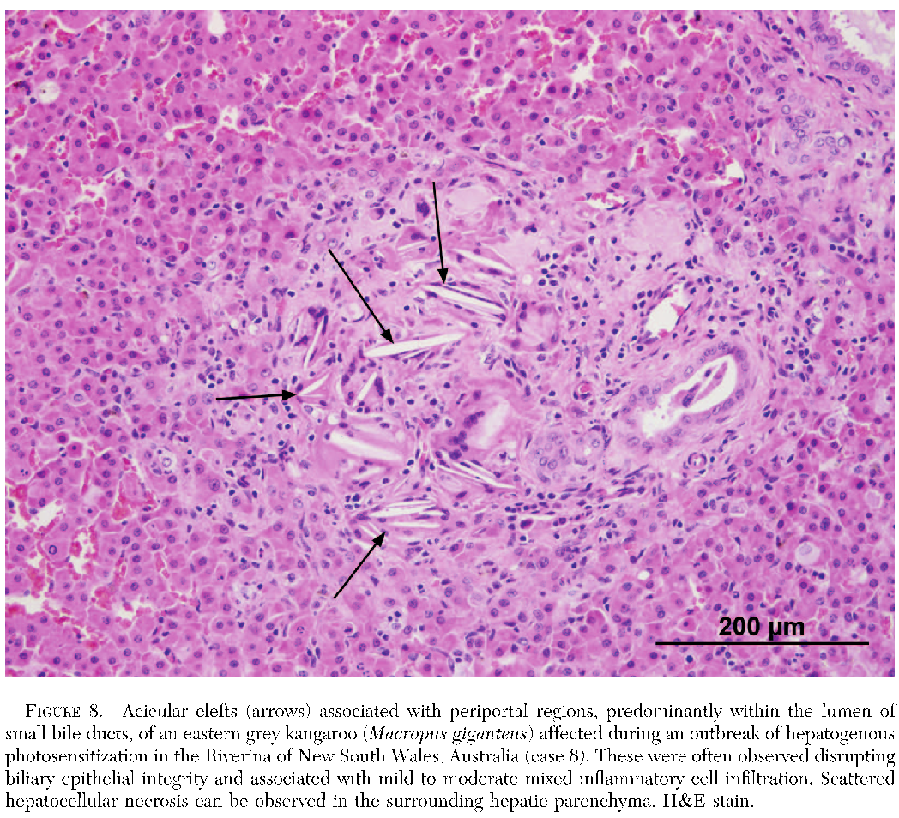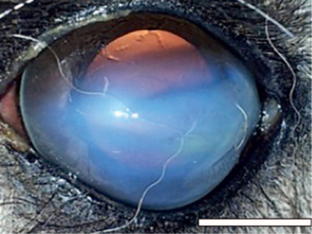

Genotype identification of toxoplasma gondii in macropods from a zoological park in Florida, USA.
Spriggs M, Jiang T, Gerhold R, Stedman N, López-Orozco N, Su C.
Journal of Zoo and Wildlife Medicine. 2020;51(1):131-139.

Abstract: There are limited reports of the genetic characterization of Toxoplasma gondii infecting captive macropods in North America. A novel genotype, ToxoDB PCR-RFLP genotype 263, was reported from six wallabies at a zoological facility in Virginia, USA, prompting an investigation into the genotypes from T. gondii strains infecting macropods at a zoological park in Florida, USA. Cardiac muscle and/or lung samples from an agile wallaby (Macropus agilis, n = 1), red kangaroos (Macropus rufus, n = 8), red-necked wallaby (Macropus rufogriseus, n = 1), and a tammar wallaby (Macropus eugenii, n = 1) that died between 2014 and 2018 were collected. All 11 cases were confirmed to have died from systemic toxoplasmosis by histopathology and immunohistochemical staining. Multilocus PCR-RFLP genotyping of T. gondii was performed directly on tissue samples or on parasites isolated from myocardium by mouse bioassay. Two cases of toxoplasmosis were identified as the reported novel genotype, ToxoDB PCR-RFLP genotype 263, but no common source of exposure could be identified. Five cases were identified as genotype 2 (type III strain, haplogroup 3), and four cases were identified as genotype 216, which has been previously reported in North American wildlife. There were no overt differences in lesion severity or distribution related to genotype. These results suggest that the premise was contaminated with at least three genotypes of T. gondii causing systemic toxoplasmosis in macropods. The largest cluster of fatal toxoplasmosis in macropods in the study period occurred following severe rainfall flooding of the exhibit, suggesting the transmission of T. gondii by water and pointing out the importance of this transmission mechanism. In summary, our study revealed three T. gondii outbreaks that caused significant loss of macropods within 5 yr in a zoological facility in Florida. More studies are needed to understand transmission and prevention of toxoplasmosis in sensitive zoo animals.

Background:
- Toxoplasma gondii = zoonotic intracellular coccidian parasite that causes disease in birds and mammals
  - Definitive host = felids
  - Respiratory, neurologic signs, decreased repro, mortality, recrudescence after latency, death
- Felids shed oocysts → hosts ingest oocysts
  - Vertical transmission of tachyzoites is possible
- Genotypes 1, 2, and 3 have been found in domestic animals
- Genotypes 4 and 5 have been found in wildlife
- Macropods in Virginia died after infection with genotype 4 or a novel genotype 263
- Atavaquone has successfully treated some Bennet’s wallabies but overall treatment is often unsuccessful
  - Synergistic with pyrimethamine, clindamycin, or sulfadiazine

Key Points:
- In a Florida zoo, 20 wallabies/kangaroos died from systemic toxoplasmosis after peracute illness
- Clinical signs = sudden death or diarrhea, ataxia, shaking, recumbency, seizures for <3 days prior to death
- Lesions were common in brain, lung, myocardium, and digestive tract
- Most were positive on serology, but not an effective antemortem test
- Three different genotypes sequenced but no differences in illness
  - Genotype 263 (associated with macropod deaths in Virginia zoo)
  - Genotype 2 and 216 (seen in wildlife) *first report of 216 in captive macropods
- Largest cluster of mortalities associated with large amount of rainfall
  - Macropod exhibits should have good drainage to prevent storm water from collecting

Conclusions: Toxoplasma gondii can cause a rapidly fatal infection in wallabies, especially associated with increased rainfall. Genotypes identified: 2, 216, 263. First report of genotype 216 in captive macropods.

Shopland, S., Stidworthy, M. F., Denk, D., Killick, R., Saunders, R., Lange-Garbotz, A., & Fadda, A. (2021). Early-onset leukoencephalomyelopathy and polyneuropathy in eastern quolls (dasyurus viverrinus) in the european captive population. Journal of Zoo and Wildlife Medicine, 51(4), 1035-1046.

Abstract: Leukoencephalomyelopathy (LEM) is suggested to be an age-related degenerative condition in geriatric Eastern quolls (Dasyurus viverrinus), manifesting in animals greater than 3.5 yr of age. This case series describes four LEM cases from two zoologic collections; three in nongeriatric animals, with one only 1 yr of age, and details advanced diagnostic investigation, including magnetic resonance imaging, cerebrospinal fluid analysis, and electrodiagnostic studies, not previously reported in Eastern quolls. Animals presented clinically with forelimb proprioceptive deficits and hindlimb and lumbar muscle hypotrophy, which were not noted in previous reports, in addition to hindlimb ataxia. Blindness and emaciation, which have been reported previously, were not seen. Disease progression was variable, and time from first clinical signs to euthanasia ranged from 46 days to over 2 yr. Histopathologic findings in the central nervous system were typical of those in previous LEM cases; concomitant polyneuropathy was observed in two quolls. Our findings suggest that age-related degeneration may not be the only cause of LEM in Eastern quolls. Because all quolls were related, a familial component cannot be excluded. LEM should be further investigated for its potential impact on future captive breeding programs, and our findings suggest that daily quality-of-life assessment should guide euthanasia of affected animals.

Key Points:
- Luekoencephalomyelopathy – degenerative dz of white matter in brain and spinal cord
- CS: progressive hindlimb, ataxia, paresis, and blindness with disease progression, emaciation.
- Believed to be degenerative, observed mostly in >3.5 yo. Only in captivity (live up to 6 yo vs wild 3 yo).
- Reported in Tasmanian devils (Sarcophilus harrissii)
- Leukoencephalomyelopathy or leukomyelopathy reported in different mammals, similar to syndrome seen in African pygmy hedgehogs.
- Tasmanian devils more commonly seen in males. This report - no difference males vs females.
- Suggested causes: viral, nutritional, metabolic, genetic, toxic derangements, and old age degeneration
- In other spp including hedgehogs, treatment includes prednisone, vitamins, physiotherapy and hydrotherapy, acupuncture and interferon B1a reported.
- LEM is mostly diagnosis of exclusion, diagnosed with histopathology.
- Marsupial spinal cord similar to eutherian mammals, but lack corpus callosum
- Between Sept 2016, May 2019, 4 quolls from 2 collections in European captive population showed neurologic signs suggestive of LEM and were ultimately euthanized, reported histology findings.
  - Presented with hindlimb ataxia, knuckling, decreased awareness of surroundings, collapse.
  - Blindness and emaciation not observed as a clinical sign in this case series. First reports of polyneuropathy (proprioceptive defects, muscle hypotrophy) as a clinical sign.
- Two quolls in this case series were serologically positive for T. gondii, and molecular detection of Sarcocystis spp. was reported in the youngest animal.
- T. gondii affects Australian marsupials but believed to be nonpathogenic in Eastern quoll.
- Meloxicam trial, no improvement. Renal papillary necrosis on necropsy (decreased renal perfusion leading to ischemia of inner medulla). Caution by authors.
- Histopathology: All had vacuolization of white matter associated with mild astrocytosis in brain and spinal cord.
  - Greater changes in the ventral funiculus and ventral half of the lateral funiculus consistent with other domestic species.
- Familial component is possible as all come from 6 individuals.
- Deficiencies of vitamin B1 (thiamine), vitamin B12, vitamin A, and copper known to cause neurologic disease. Administration of vit B1 did not improve disease.
Takeaways: No antemortem dx with LEM in E. quolls, diagnosis of exclusion and histopathology. NSAIDs may contribute to renal papillary necrosis in this species. First reports of LEM in younger (non-geriatric) quolls. May have a genetic component.

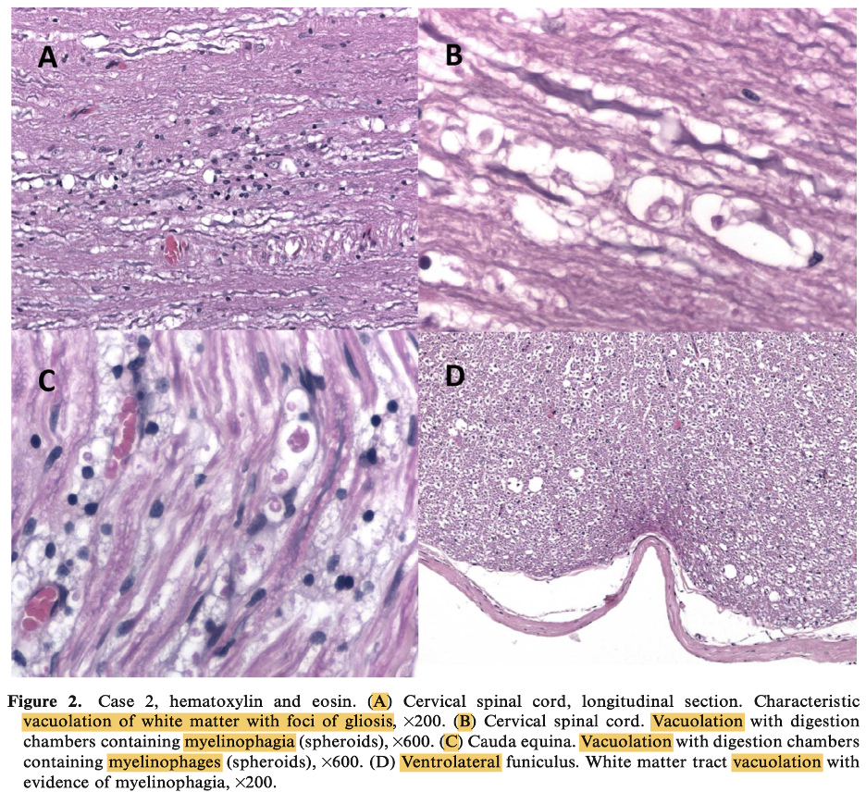
Portas, T. J., Evans, M. J., Spratt, D., Vaz, P. K., Devlin, J. M., Barbosa, A. D., ... & Manning, A. D. (2020). Baseline health and disease assessment of founder eastern quolls (Dasyurus viverrinus) during a conservation translocation to mainland Australia. Journal of wildlife diseases, 56(3), 547-559.

ABSTRACT: We evaluated the health of 31 (eight males, 23 females) founder eastern quolls (Dasyurus viverrinus), translocated to a fenced reserve in the Australian Capital Territory between February 2016 and July 2017. Quolls were wild caught in Tasmania (16 animals) or captive bred at Mount Rothwell Biodiversity Interpretation Centre, Victoria (15 animals). Quolls were assessed for the presence of selected potential pathogens (Toxoplasma gondii, herpesviruses, Salmonella serovars, hemoprotozoa, and ectoparasites). We assessed the relationships among sex, provenance (captive or free ranging), Toxoplasma gondii or herpesvirus infection, weight, and hematologic and biochemical variables. Six of 21 quolls (29%) tested were seropositive for antibodies to Toxoplasma gondii. Seropositive quolls weighed significantly more and had significantly lower potassium levels, anion gaps, and urea and triglyceride levels than seronegative quolls had. Eighteen of 31 (58%) combined conjunctival-pharyngeal-cloacal swabs collected from quolls were PCR positive for a newly identified gammaherpesvirus, tentatively named dasyurid gammaherpesvirus 3. There were no significant differences among hematologic and biochemical variables or body weights from PCR-positive and PCR-negative quolls. Eighteen of 18 (100%) of rectal-swab samples were culture negative for Salmonella serovars. Three species of tick (Ixodes tasmani, Ixodes fecialis, and Ixodes holocyclus), two species of mite (Andreacus radfordi, one unidentified), and four species of flea (Pygiopsylla hoplia, Acanthopsylla rothschildi rothschildi, Uropsylla tasmanica, and Stephanocircus dasyuri), were detected on wild-caught quolls, whereas a fifth species of flea, Echidnophaga myremecobii, was detected only on captive-bred quolls. Five of 15 blood samples (33%) were positive for hemoprotozoan DNA via PCR, a novel Hepatozoon species, a novel Theileria species, Theileria paparinii, and Trypanosoma copemani were detected (in one animal each). Despite the presence of several potential pathogens known to be associated with disease in other marsupials, the quolls were considered to be in good general health, suitable for translocation, and a viable population was subsequently established.

Introduction:
- Eastern quoll (Dasyurus viverrinus) – Medium sized predominantly terrestrial carnivorous marsupial.
- Diet includes mostly invertebrates, small vertebrates, carrion, vegetables.
- Sexually dimorphic with synchronized patterns of breeding, birth of young in early winter.
- Translocated to Mulligans Flat Woodland Sanctuary in the Australian Capital Territory in two separate conservation translocations in Mar 2016 and June 2017.
- Did health evaluations during a conservation translocation, assessed for Toxoplasma, herpesviruses, Salmonella, protozoan hemoparasites, and ectoparasites.
- Evaluated relationship between sex, wild caught vs captive bred, and two potential pathogens influenced hematologic and biochemical variables or body weight and whether or not captive bred vs wild and infection with Toxoplasma and herpesviruses were related.
Methods:
- Anesthetized wild (n = 16) and captive bred (n = 15) quolls, collected blood for hematology and biochemistry/Toxoplasma serology and conjunctiva/oropharyngeal/urogenital tract swabs for herpesviruses, rectal fecal samples for Salmonella serovar culture. Ectoparasites collected, burdens scored. PCR for hemoparasites.
Results/Discussion:
- PE abnormalities - Ulcerative glossitis and cheilitis in one captive-bred male and one wild female, granulomatous and necrotizing dermatitis and panniculitis caudal to pouch (cultured Hafnia alvei and Enterococcus spp).
- 100% rectal swabs negative for Salmonella serovars.
- 29% positive antibodies to T. gondii. No clinical signs.
- 58% swabs positive for herpesvirus DNA via PCR. Sequenced same gammaherpesvirus, closely repated to dasurid gammaherpesvirus 2. Tentatilvely named dasurid gammaherpesvirus 3.
- 61% had ectoparasites – 3 spp tick, 2 spp mites, 4 spp fleas (wild). 1 spp flea only found on captive-bred quolls (Echidnophaga myremecobii). 84% low parasite burdens.
  - Prevalence for individual parasite spp except for the flea Pygiopsylla hoplia was generally low.
- 33% (4 wild, 1 captive) positive for hemoprotozoan DNA via PCR.
- Differences between captive and wild-caught quolls – Hemoglobin, RBC count, neutrophils, sodium, urea, AST, ALP, protein, globulin, albumin.
  - Differences between male and female quolls for hemoglobin, RBC count, sodium, phosphate.
  - Quolls seropositive for T. gondii significantly lower potassium, AG, urea, TG.
  - Quolls that were seropositive for T. gondii weighed significantly more. Unrelated to sex.
  - Wild quolls more likely to be seropositive for T. gondii.
Takeaways: Wild caught quolls higher Na, AST, ALT, TP, Alb, Glob, phosphate, and lower urea. Seropositive for T. gondii infection had lower K, AG, urea, TG. Quolls seropositive for T. gondii were heavier.

Hall, Jane, et al. "Baseline Health Parameters For A Newly Established Population of Long-Nosed Potoroo (Potorous tridactylus) At Booderee National Park, Australia." Journal of Wildlife Diseases (2021).

ABSTRACT: Over two field seasons during 2014–15, 35 long-nosed potoroos (Potorous tridactylus) were captured in state forests in South Eastern New South Wales for translocation to Booderee National Park, Jervis Bay Territory, Australia. Animals were anesthetized for physical examination and collection of samples to assess general health and screen for select diseases identified during a disease risk assessment. Morphologic, hematologic, and biochemical parameters were determined, and parasites were identified where possible. Trypanosoma gilletti, Trypanosoma vegrandis, and novel genotypes most similar to a Trypanosoma wallaby-derived isolate (ABF) were identified from blood samples by PCR; the first time Trypanosoma has been described in this species. Also reported is the first confirmation of the Australian paralysis tick, Ixodes holocyclus, from the long-nosed potoroo. Surveillance showed that Cryptococcus sp. may form part of the normal nasal flora for long-nosed potoroo. Salmonella enterica serotype Dublin and Salmonella enterica subsp. enterica was identified from rectal swabs of otherwise healthy animals. The data provide baseline health and disease parameters for this newly established population and the source population and will inform future translocation and conservation management activities. These data expand current knowledge on aspects of the biology and microbiology of the long-nosed potoroo, both locally and nationally.

Intro
- The long-nosed potoroo is a medium sized nocturnal marsupial that has been undergoing population declines, largely due to predation and habitat destruction
- This study evaluated the health of individual longnosed potoroos and conducted surveillance for a range of disease agents to support translocation of a healthy founding population to Booderee and to inform ongoing management of these populations and future conservation management activities at this site
M&M
- 2014-2015 35 long-nosed potoroos were captured for translocation
- Anesthesia, PE, and collection of samples to assess health and disease prevalence
Results and discussion
- All animals considered to be clinically healthy
- Mild to moderate hyperkeratosis, with or without erythema and alopecia, was identified in seven female and five male potoroos, generally around the inguinal area, at the base of the testicles or around the pouch, and inner thighs
- Occasional Howell–Jolly bodies were present in 60% of blood smears, and hemoglobin crystals were present in low numbers in 65% of smears.
- With the use of molecular techniques, all blood samples were negative for piroplasms; however, 44% (16/36) of long-nosed potoroos tested positive for Trypanosoma spp
  - The first time Trypanosoma has been described in this species
- Nasal swabs from three of the 36 potoroos grew Cryptococcus spp. in culture.
  - May be a normal commensal. No disease seen
- From the rectal swabs of 36 potoroos, one tested positive for Salmonella enterica serotype Dublin, and Salmonella enterica subsp. enterica was identified from two others.
- First confirmation of the Australian paralysis tick, Ixodes holocyclus in this species
- Low-level burdens of both internal and external parasites were detected (many not speciated)

Martínez-Pérez, Pedro, et al. "A widespread novel gammaherpesvirus in apparently healthy wild Quokkas (Setonix Brachyurus): A threatened and endemic Wallaby of Western Australia." Journal of Zoo and Wildlife Medicine 52.2 (2021): 592-603.

Abstract: Five genetically distinct macropodid marsupial herpesviruses have been reported [Macropodid alphaherpesviruses 1 and 2 (MaHV-1 and -2); Macropodid herpesviruses 3 to 5 (MaHV-3 to -5)]. MaHV-2 was originally isolated from an outbreak of fatal disease in captive quokkas (Setonix brachyurus) that were in contact with other macropodid species. This warranted a survey of the presence of herpesviruses in this threatened and endemic Western Australian (WA) wallaby. Blood samples from 142 apparently healthy quokkas were tested for exposure to MaHV-1 and -2 by serology. Of these 142, 121 [Rottnest Island (RI), n ¼ 93; mainland WA, n ¼ 28] were tested for herpesvirus infection by polymerase chain reaction (PCR). Antibodies to MaHV-1 and -2 were detected in one individual [prevalence, 0.7%; 95% confidence interval (CI), 0.1%–3.2%] from the mainland and none from RI. However, a novel gammaherpesvirus [designated Macropodid herpesvirus 6 (MaHV-6)] was detected by PCR in the blood of 13 of 121 individuals (11%; 95% CI, 6.2–17.2). Infection with MaHV-6 was significantly more prevalent on the mainland (7/28; i.e., 25%) compared with RI (6/93; i.e., 6.45%; difference in sample proportions, 95% CI, 6%–32%; P ¼ 0.015). There was no association (P . 0.05) between infection with MaHV-6 and differences in hematology, blood chemistry, peripheral blood cell morphologies, or on clinical status. There was a significant association between infection with MaHV-6 and the presence of Theileria spp. in blood [odds ratio (OR) ¼ 11.0; 95% CI, 2.31–52.3; P ¼ 0.001] and yeast in the nasal lining (OR ¼ 7.0; 95% CI, 1.54– 31.8; P ¼ 0.021), suggesting that quokkas may be more susceptible to infection with these microorganisms if also infected with MaHV-6. MaHV-6 infection may be a catalyst for vulnerability to disease with other infectious agents and may pose a significant threat to other macropods. These findings have implications for in situ and ex situ management programs of quokkas.

Intro
- Infections with five herpesviruses have been reported in kangaroos and wallabies.
  - Macropod herpesviruses 1-5 (MaHV-1 to 5)
  - 1, 2 and 4 are alphaherpesviruses, 3 and 5 are gamma herpesviruses
- These viruses have been associated with clinical disease as well as with healthy animals
M&M
- In this study, 142 wild quokkas from Rottnest Island (RI) and mainland Western Australia (WA) were tested for neutralizing antibodies to MaHV1 and -2 and for the presence of herpesviral DNA in blood.
- 121 on Rottnest island and 28 on the mainland of Australia
Results and Discussion
- Antibodies against MaHV-1 and -2 were observed in one mainland male of the 142
- However, 13 of 121 animals tested positive to herpesviral DNA in peripheral blood by PCR (11%)
- Sequencing revealed that it was a novel gammaherpesvirus, now called MaHV-6
- Infection with MaHV-6 was significantly more prevalent on the mainland
- No correlation with blood values or clinical status
- There was a significant association between MaHV-6 infection and the presence of coinfections (Theileria, yeast in the nasal lining) so it may have an immunosuppressive effect
- The findings of this study suggest that the quokka is the natural host for MaHV-6
  - No clinical signs or changes in blood parameters
  - identical predicted herpesvirus amino acid sequences were detected in wild S. brachyurus from mainland sites and Rottnest Island, which separated from the mainland approximately 7,000 years ago because of rising waters
- Prevalence may be higher than was detected, as many animals could be subclinically infected but not be viremic

Take home: First report of MaHV-6, a novel gammaherpesvirus, in quokka

Epidemiology of Chlamydia-induced reproductive disease in male koalas (Phascolarctos cinereus) from southeast Queensland, Australia as assessed from penile urethral swabs and semen. Journal of wildlife diseases, 2020;56(1):82-92.
Hulse, L.S., Beagley, K., Ellis, W., Fitzgibbon, S., Gillett, A., Barth, B., Robbins, A., Pyne, M., Larkin, R. and Johnston, S.D.
Declining population sizes of koalas (Phascolarctos cinereus) in SE Queensland (QLD), Australia can partially be attributed to chlamydiosis, with the majority of epidemiological studies focusing on the prevalence of infection and associated pathology in female koalas, with lesser attention given to males. We aimed to explore the epidemiology of Chlamydia pecorum infection in the male urogenital tract from wild (hospitalized and free-ranging) koalas in SE QLD. Although 67% of male koalas were infected with C. pecorum in their urogenital tract and 55% were shedding the organism in their semen, only a third of the males sampled presented with overt signs of urogenital disease. Infection with C. pecorum was lower in populations from rural locations, compared with periurban locations, with a corresponding low association between urogenital infection and clinical disease. The presence of C. pecorum in penile urethral swabs was a good predictor of the presence of C. pecorum in semen, with a significant correlation (P=0.006) in 58% of males. In contrast, the C. pecorum load in penile urethral swabs was not a good predictor of the C. pecorum load in semen, with no significant correlation. In addition, 57% of male koalas had large numbers of bacterial copy numbers in the penile urethra (upper quartile) and 40% shedding into semen with no overt signs of disease. Investigation of the association of C. pecorum infection, body condition score, and age revealed that the highest incidence of urogenital infection occurred in males with the lowest body score (1 out of 10). Furthermore, 63% of sexually mature male koalas (>2 yr old) had urethral infections and 50% had C. pecorum in their semen. Our study suggested that the role of chlamydia in male koala infertility has been previously underestimated.
Background
- Chlamydia pecorum - chlamydiosis in free-ranging koalas, up to 88% prevalance
    - Less commonly Chlamydia pneumoniae (less pathogenic)
  - Keratoconjunctivitis leading to blindness
  - UTI, cystitis, incontinence, urine scalding of hind end
  - Reproductive tract lesions, female infertility, urethritis, prostatitis
  - 50% subclinical infection
  - Dx: ultrasound, cysto and urine sediment cytology, conjunctival, urogenital sinus, and cloacal or rectal swabs for PCR, semen collection for PCR
Key Points
- 250 koalas, PCR of urethral swabs and semen from electroejaculation, scoring of urine scalding
- Positive: 67% urethral swabs, 55% semen samples, both strong association with clinical signs
  - 58% both
- Highest in periurban population, lowest in rural - likely chronic stress
- 57% urethral swabs and 40% semen positive and no clinical signs
- Positive urethral swab was predictor of presence in semen
- Higher prevalence in >4 yo males, koalas with BCS <3
  - 40% of sexually immature males <1yo were infected - likely from birth/pouch
- BCS of 10 (highest) - high prevalence in urethral swab but no detection in semen
Conclusions
- Male koalas shed Chlamydia pecorum in semen and are likely subclinical carriers
- Increased infection prevalence with increasing age and decreasing BCS
Journal of Zoo and Wildlife Medicine 51(4): 771–779, 2020
MOLECULAR IDENTIFICATION OF MEMBERS OF THE FAMILY PASTEURELLACEAE FROM THE ORAL CAVITY OF KOALAS (PHASCOLARCTOS CINEREUS) AND THEIR RELATIONSHIP WITH ISOLATES FROM KOALA BITE WOUNDS IN HUMANS
Connie Wan Hui Chong,* BBioMedSc, MBiotech, Carmen Espinosa-Gongora,* DVM, PhD, Patrick J. Blackall, BSc, PhD, Holly A. Sinclair, BMedSc, MBBS (Hons), Anders M. Bojesen, DVM, PhD, ECPVS, Lida Omaleki, DVM, PhD, and Conny Turni, BSc (Hons), PhD
Abstract: A total of 22 Pasteurellaceae isolates obtained from the oral cavity of koalas (Phascolarctos cinereus) at different wildlife centers in Australia were investigated using amplification and sequencing of two housekeeping genes, rpoA and recN. The available sequences from the Lonepinella koalarum type strain (ACM3666T) and the recent isolates of Lonepinella-like bacteria obtained from human infected wounds associated with koala bites were also included. Phylogenetic analysis was performed on the concatenated rpoA-recN genes and genome relatedness was calculated based on the recN sequences. The oral cavity isolates, the koala bite wound isolates, and L. koalarum ACM3666T resulted in four clusters (Clusters 1–4). Clusters 1–3 were clearly not members of the genus Lonepinella. Cluster 1 was closely related to the genus Fredericksenia, and Clusters 2 and 3 appeared to be novel genera. Cluster 4 consisted of three subclusters: Cluster 4a with one koala bite wound isolate and L. koalarum ACM3666T, Cluster 4b with three oral cavity isolates and two Lonepinella-like wound isolates, and Cluster 4c with three nearly identical oral cavity isolates that may represent a different species within the genus Lonepinella. The rich Pasteurellaceae population, including potential novel taxa in the oral cavity of koalas supports an important role of these highly adapted microorganisms in the physiology of koalas. Moreover, the pathogenic potential of Lonepinella-like species is an important consideration when investigating infected koala bites in humans.

Key Points
- Pasteurellaceae family host adapted, mainly colonizing mucosal surfaces of alimentary, genital, or respiratory tract
- Previous studies showed that most marsupial species are host to some member of the Pasteurellaceae family and thought to be host adapted.
- Lonepinella koalarium facultative anaerobic gram negative, found in oral cavity of healthy koalas. Lonepinella-like bacteria found koala bite wound infections.
  - Lonepinella koalarium – degrades tannin
- Aim was to characterize members of Pasteurellaceae family obtained from oral cavity of koalas and possible associations with koala bite wounds in humans.
- Koalas hosts to highly diverse Pasteurellaceae population in their oral cavity
  - None of the strains could be assigned to any recognized species within Pasteurellaceae family
  - Majority of isolates NOT members of Lonepinella genus.
  - Some related to the Lonepinella-like bite wound infections supporting that these infections occurred from koala bites.
    - Likely represent different species within the Lonepinella genus.

Take Home: Highly diverse Pasteurellaceae population in koala oral cavity. Lonepinella-like species may play a role in human bite wounds from koalas.

Epidemiology of Chlamydia-induced reproductive disease in male koalas (Phascolarctos cinereus) from southeast Queensland, Australia as assessed from penile urethral swabs and semen. Journal of wildlife diseases, 2020;56(1):82-92.
Hulse, L.S., Beagley, K., Ellis, W., Fitzgibbon, S., Gillett, A., Barth, B., Robbins, A., Pyne, M., Larkin, R. and Johnston, S.D.
Declining population sizes of koalas (Phascolarctos cinereus) in SE Queensland (QLD), Australia can partially be attributed to chlamydiosis, with the majority of epidemiological studies focusing on the prevalence of infection and associated pathology in female koalas, with lesser attention given to males. We aimed to explore the epidemiology of Chlamydia pecorum infection in the male urogenital tract from wild (hospitalized and free-ranging) koalas in SE QLD. Although 67% of male koalas were infected with C. pecorum in their urogenital tract and 55% were shedding the organism in their semen, only a third of the males sampled presented with overt signs of urogenital disease. Infection with C. pecorum was lower in populations from rural locations, compared with periurban locations, with a corresponding low association between urogenital infection and clinical disease. The presence of C. pecorum in penile urethral swabs was a good predictor of the presence of C. pecorum in semen, with a significant correlation (P=0.006) in 58% of males. In contrast, the C. pecorum load in penile urethral swabs was not a good predictor of the C. pecorum load in semen, with no significant correlation. In addition, 57% of male koalas had large numbers of bacterial copy numbers in the penile urethra (upper quartile) and 40% shedding into semen with no overt signs of disease. Investigation of the association of C. pecorum infection, body condition score, and age revealed that the highest incidence of urogenital infection occurred in males with the lowest body score (1 out of 10). Furthermore, 63% of sexually mature male koalas (>2 yr old) had urethral infections and 50% had C. pecorum in their semen. Our study suggested that the role of chlamydia in male koala infertility has been previously underestimated.
Background
- Chlamydia pecorum - chlamydiosis in free-ranging koalas, up to 88% prevalance
    - Less commonly Chlamydia pneumoniae (less pathogenic)
  - Keratoconjunctivitis leading to blindness
  - UTI, cystitis, incontinence, urine scalding of hind end
  - Reproductive tract lesions, female infertility, urethritis, prostatitis
  - 50% subclinical infection
  - Dx: ultrasound, cysto and urine sediment cytology, conjunctival, urogenital sinus, and cloacal or rectal swabs for PCR, semen collection for PCR
Key Points
- 250 koalas, PCR of urethral swabs and semen from electroejaculation, scoring of urine scalding
- Positive: 67% urethral swabs, 55% semen samples, both strong association with clinical signs
  - 58% both
- Highest in periurban population, lowest in rural - likely chronic stress
- 57% urethral swabs and 40% semen positive and no clinical signs
- Positive urethral swab was predictor of presence in semen
- Higher prevalence in >4 yo males, koalas with BCS <3
  - 40% of sexually immature males <1yo were infected - likely from birth/pouch
- BCS of 10 (highest) - high prevalence in urethral swab but no detection in semen
Conclusions
- Male koalas shed Chlamydia pecorum in semen and are likely subclinical carriers
- Increased infection prevalence with increasing age and decreasing BCS
Journal of Zoo and Wildlife Medicine 51(4): 771–779, 2020
MOLECULAR IDENTIFICATION OF MEMBERS OF THE FAMILY PASTEURELLACEAE FROM THE ORAL CAVITY OF KOALAS (PHASCOLARCTOS CINEREUS) AND THEIR RELATIONSHIP WITH ISOLATES FROM KOALA BITE WOUNDS IN HUMANS
Connie Wan Hui Chong,* BBioMedSc, MBiotech, Carmen Espinosa-Gongora,* DVM, PhD, Patrick J. Blackall, BSc, PhD, Holly A. Sinclair, BMedSc, MBBS (Hons), Anders M. Bojesen, DVM, PhD, ECPVS, Lida Omaleki, DVM, PhD, and Conny Turni, BSc (Hons), PhD
Abstract: A total of 22 Pasteurellaceae isolates obtained from the oral cavity of koalas (Phascolarctos cinereus) at different wildlife centers in Australia were investigated using amplification and sequencing of two housekeeping genes, rpoA and recN. The available sequences from the Lonepinella koalarum type strain (ACM3666T) and the recent isolates of Lonepinella-like bacteria obtained from human infected wounds associated with koala bites were also included. Phylogenetic analysis was performed on the concatenated rpoA-recN genes and genome relatedness was calculated based on the recN sequences. The oral cavity isolates, the koala bite wound isolates, and L. koalarum ACM3666T resulted in four clusters (Clusters 1–4). Clusters 1–3 were clearly not members of the genus Lonepinella. Cluster 1 was closely related to the genus Fredericksenia, and Clusters 2 and 3 appeared to be novel genera. Cluster 4 consisted of three subclusters: Cluster 4a with one koala bite wound isolate and L. koalarum ACM3666T, Cluster 4b with three oral cavity isolates and two Lonepinella-like wound isolates, and Cluster 4c with three nearly identical oral cavity isolates that may represent a different species within the genus Lonepinella. The rich Pasteurellaceae population, including potential novel taxa in the oral cavity of koalas supports an important role of these highly adapted microorganisms in the physiology of koalas. Moreover, the pathogenic potential of Lonepinella-like species is an important consideration when investigating infected koala bites in humans.

Key Points
- Pasteurellaceae family host adapted, mainly colonizing mucosal surfaces of alimentary, genital, or respiratory tract
- Previous studies showed that most marsupial species are host to some member of the Pasteurellaceae family and thought to be host adapted.
- Lonepinella koalarium facultative anaerobic gram negative, found in oral cavity of healthy koalas. Lonepinella-like bacteria found koala bite wound infections.
  - Lonepinella koalarium – degrades tannin
- Aim was to characterize members of Pasteurellaceae family obtained from oral cavity of koalas and possible associations with koala bite wounds in humans.
- Koalas hosts to highly diverse Pasteurellaceae population in their oral cavity
  - None of the strains could be assigned to any recognized species within Pasteurellaceae family
  - Majority of isolates NOT members of Lonepinella genus.
  - Some related to the Lonepinella-like bite wound infections supporting that these infections occurred from koala bites.
    - Likely represent different species within the Lonepinella genus.

Take Home: Highly diverse Pasteurellaceae population in koala oral cavity. Lonepinella-like species may play a role in human bite wounds from koalas.

Journal of Zoo and Wildlife Medicine 51(3): 705–719, 2020
TREATMENT OF ORAL DISEASE IN EIGHT CAPTIVE BENNETT’S WALLABIES (MACROPUS RUFOGRISEUS) BETWEEN 2011 AND 2019: A CASE SERIES
Naomi Hoyer, DVM, Dipl AVDC, Jennifer Rawlinson, DVM, Dipl AVDC, Dipl AVDC (Equine), and Eric Klaphake, DVM, Dipl ACZM

ABSTRACT: Oral disease, such as endodontic disease and macropod progressive periodontal disease (MPPD), which can progress to chronic alveolar osteomyelitis (CAO), have been identified as a common source of morbidity and mortality in captive macropods. This case series reviews the diagnosis and treatment of dental disease in eight captive Bennett’s wallabies (Macropus rufogriseus) over the course of an 8-yr period (2011–2019) in a zoological collection. Two wallabies were treated at four separate times, for a total of 14 anesthetized dental surgical procedures. Two wallabies died after treatment for dental disease. Endodontic disease, MPPD, and CAO were all identified and treated with extraction. Cases in which disease was identified early and treated aggressively had a good outcome with no return of clinical signs in the affected area. Several cases of extensive CAO were treated successfully with extraction and extensive debridement. One wallaby developed immune-mediated anemia, a suspected adverse drug reaction associated with prolonged administration of intravenous clindamycin

Study Design: Case series

Goal: Describe presentation and treatment of dental disease in eight captive Bennett’s wallabies (Macropus rufogriseus)

Key Points:
- Dental disease is one of the most common and significant diseases of captive macropods
  - The prevalence of oral disease in macropods has been reported as > 40% in captive populations
- Chronic alveolar osteomyelitis (CAO), historically oral necrobacillosis, is a commonly recognized sequelae of dental disease
  - CAO is chronic expansive periosteal bone proliferation with osteolytic cavitation and soft tissue reaction
  - Treatments in the literature include medical, surgical, and endodontic management with variable success
- The dental formula for the Bennett’s wallaby is I 3/1, C 0/0, PM 2/2, M 4/4, and caudal teeth erupt by sequential eruption, with rostral premolars being shed as more caudal molars erupt
- Endodontic disease affected six wallabies
  - Endodontic lesions that progressed to endodontic-periodontal lesions affected seven teeth
  - The age range for animals affected by endodontic and endodontic-periodontal lesions was 1.5–8yo
- The high prevalence of primary endodontic disease associated with incisors, particularly in younger animals, illustrates the importance of dental trauma as a causative factor of dental disease in macropods
- Endodontic disease can progress to CAO when not identified early in the disease process
  - Endodontic disease is treated by addressing the source of the infection in the pulp
  - Either the tooth can be extracted or a total pulpectomy (root canal therapy) can be performed
- Periodontal disease affected 28 teeth in four wallabies
  - The age range for animals affected by periodontal disease was 5–12yo
- A newly proposed syndrome of macropod progressive periodontal disease (MPPD) has been proposed to capture the full spectrum of ‘‘lumpy jaw,’’ CAO, or both in macropods
  - MPPD broadly applies the term periodontal disease to a variety of oral conditions in macropods, but periodontal and endodontic disease have their origins in different dentoalveolar structures
  - In addition, the presence of periodontal disease can vary widely within a mouth
    - Because of the pathophysiology of periodontal disease, a predisposed individual will develop lesions independently in multiple locations throughout the oral cavity, but periodontal disease does not spread from one arcade to another, which appears to be the basis of MPPD
  - The new description of MPPD mentions oral trauma as a possible trigger, but endodontic disease originates within the pulp of the tooth and progresses to the apex and then periodontium
- Primary periodontal disease in the case series was more common in older macropods and associated more commonly with the premolar and molar teeth, particularly in the region of exfoliation of sequentially erupting teeth
  - The application of the term MPPD would be appropriate to these cases because the periodontium was primarily infected
- All animals treated with complete dental extraction and aggressive regional debridement had resolution of presenting clinical signs and lack of recurrence in the treated area except W7
  - Development of disease in the same animal was only considered recurrence if it developed associated with same teeth that were previously treated
  - W7 and W2 were not treated with complete extraction at the time of initial surgery, and both these animals had recurrence of disease in the same location associated with the same tooth
- The variety of microbes found on culture suggested that no one microbe was responsible for disease, and cultures should be used to guide antimicrobial therapy
- No cases responded to antimicrobial therapy without surgery, and one wallaby, W4, developed an immune-mediated anemia during its presurgical antimicrobial therapy with clindamycin and penicillin
  - This is the first reported case of this adverse drug reaction in wallabies
  - It is recommended to monitor bloodwork on wallabies receiving antibiotics to help determine whether this was truly the first report of an adverse drug reaction or a reaction to the combination of factors present
  - The dose of clindamycin used in this wallaby was higher than that used on any other wallaby in this series

TLDR:
- CAO is a sequelae of both MPPD and endodontic disease in wallabies
  - If identified early and treated aggressively, resolution of clinical signs and prevention of recurrence in the same area are possible
  - Animals that have developed lesions consistent with CAO should be monitored closely to detect additional disease early
- Regular intraoral radiographic screenings of Bennett’s wallabies may allow for early detection of dental disease and possible prevention of CAO

Related Articles
Vogelnest L. Marsupialia (marsupials). In: Miller RE, Fowler ME (eds.). Fowler’s zoo and wild animal medicine, Volume 8. St. Louis (MO):Elsevier; 2015. p. 255–274

Journal of Zoo and Wildlife Medicine 50(2): 389–395, 2019
EVALUATION OF NONINVASIVE OSCILLOMETRIC BLOOD PRESSURE MONITORING IN ANESTHETIZED BENNETT’S WALLABIES (MACROPUS RUFOGRISEUS)
Megan K. Watson, D.V.M., M.S., Dipl. A.C.Z.M., and Sathya K. Chinnadurai, D.V.M., M.S., Dipl. A.C.Z.M., Dipl. A.C.V.A.A., Dipl. A.C.A.W.

ABSTRACT: The objective of this study was to determine the accuracy of a noninvasive oscillometric method in relation to invasively measured blood pressure in anesthetized Bennett’s wallabies (Macropus rufogriseus) and also to compare the accuracy of two commonly used oscillometric blood pressure monitors (manufactured by Cardell and Datascope). Eleven animals were anesthetized, and each animal was instrumented with an arterial catheter in the right medial metatarsal artery connected to a pressure transducer to obtain invasive measurements of systolic (SAP), diastolic (DAP), and mean (MAP) arterial blood pressure as well as a pressure waveform. A cuff connected to an oscillometric device was placed on the base of the tail for noninvasive measurements. Paired data from noninvasive and invasive blood pressure measurements (SAP, DAP, and MAP) were obtained every 5 min for 60 min. Bland–Altman plots were used to compare invasive and noninvasive measurements and calculate bias and 95% limits of agreement for SAP, DAP, and MAP. For both monitors, the bias of SAP, DAP, and MAP was significant, although the bias of the Cardell was consistently lower than that of the Datascope for all parameters. Limits of agreement were wide for all parameters. In conclusion, when using an oscillometric blood pressure monitor on anesthetized Bennett’s wallabies, trends in blood pressure may be monitored, although all displayed readings may not represent the true blood pressure measurement. Indirect measurements of blood pressure made with the oscillometric device cannot substitute for direct measurements.

Study Design: Experimental method-comparison study with 11 Bennett’s wallabies (six male, five female)

Goal: 1) Determine the accuracy of noninvasive oscillometric blood pressure in relation to invasively measured blood pressure in anesthetized Bennett’s wallabies and 2) Compare the accuracy of two oscillometric data monitors that are routinely used for anesthetic monitoring

Key Points:
- There are two means of collecting blood pressure: direct or indirect methods
  - Direct, or invasive, measurement of blood pressure requires inserting a catheter into a suitable artery and measuring arterial pressures with a transducer
    - This remains the gold standard, although it can be technically challenging
  - Indirect, or noninvasive, blood pressure includes oscillometric methods
    - Oscillometric units work by inflating a cuff around a limb to impede arterial blood flow
    - As the cuff is slowly deflated, arterial oscillations are monitored
    - Mean arterial pressure (MAP) is estimated by determining the peak amplitude of arterial oscillations (waveform) in all devices
    - Depending on the unit, some will also measure systolic arterial pressure (SAP); however, all will use species-specific proprietary algorithms to calculate diastolic arterial pressures (DAP)
- For wallabies or other macropods, blood pressure is often measured via the oscillometric method using a cuff around the tail, which has not yet been validated
- Wallabies were anesthetized with 50 mcg/kg medetomidine IM + 5 mg/kg ketamine IM via hand injection under manual restraint
  - Animals were then intubated, maintained on isoflurane, and were monitored under anesthesia for 60 min during data collection
- An arterial catheter was placed in the right medial metatarsal artery and connected to a pressure transducer using a nondistensible arterial blood pressure monitoring line for direct arterial blood pressure measurements
- To measure oscillometric blood pressure, a cuff was placed at the base of the tail
  - The size was determined after measuring the base of the tail and calculating 40% of the circumference obtained
- For both monitors used in the present study, agreement between direct blood pressure measurements and indirect blood pressure measurements was poor
  - Limits of agreement = measure of precision; bias = measure of accuracy
    - Bias = deviation from the true mean or gold standard (direct arterial blood pressure measurements)
    - Limits of agreement = consistency of measurements of the same method
- For both monitors, MAP was the most accurate of the three measurements (SAP, DAP, and MAP) but was not necessarily as precise
  - The Datascope overestimated SAP, DAP, and MAP, and the MAP was overestimated on the Cardell
  - For the Cardell monitor, although all three blood pressure measurements did not meet the ACVIM guidelines, the MAP and DAP were close
  - With this knowledge, the MAP could be used to guide clinical decision making and is often the most clinically relevant value
  - Some of the disagreement between direct and indirect SAP and DAP might be secondary to inappropriate algorithms for the species
- A few studies have also been performed in cats and exotic species, which have similar results
  - In cats, direct blood pressure was compared to three different veterinary-specific oscillometric units and found poor agreement for all three units
  - In boid snakes, it was determined that oscillometric methods cannot substitute for direct and also that oscillometric overestimated SAP and underestimated DAP and MAP
  - In Hispaniolan Amazon parrots, there was also poor agreement between direct and Doppler methods
- It is important to monitor trends, as the oscillometric method may give an inaccurate assessment of a normotensive patient when in fact a direct measurement would indicate hypotension

- Low heart rate secondary to administration of alpha-2 agonists and anatomic placement of the cuff may have contributed to poor agreement noted by both monitors
  - Placement of the cuff at the base of the tail could have also contributed to poor agreement
    - Previous studies have demonstrated significant differences in arterial blood pressure measurements based on anatomic location
  - The tail was not clipped prior to placement of the cuff; however, a previous study in cats did not find a significant difference in readings between clipped limbs and haired limbs
  - Although cuff size was determined by manufacturer standards, cuff placement also has not been validated in macropods

TLDR:
- When using an oscillometric blood pressure monitor on anesthetized Bennett’s wallabies, trends in blood pressure may be monitored
  - However, displayed readings may not represent the true blood pressure measurement
- Indirect measurements of blood pressure made with an oscillometric device cannot substitute for direct measurements in anesthetized Bennett’s wallabies.

Related Articles
Acierno MJ, Seaton D, Mitchell MA, da Cunha A. Agreement between directly measured blood pressure and pressures obtained with three veterinary-specific oscillometric units in cats. J Am Vet Med Assoc. 2010; 237(4):402–406

Chinnadurai SK, Wrenn A, DeVoe RS. Evaluation of noninvasive oscillometric blood pressure mon- itoring in anesthetized boid snakes. J Am Vet Med Assoc. 2009;234(5):625–630

