Steroidal saponin toxicity in eastern grey kangaroos (Macropus giganteus): A novel clinicopathologic presentation of hepatogenous photosensitization.
Steventon CA, Raidal SR, Quinn JC, Peters A.
Journal of wildlife diseases. 2018;54(3):491-502.

Practice Question
Corneal edema and impaired vision in eastern grey kangaroos (Macropis giganteus) is associated with which toxicosis?
- sodium monofluoroacetate
- Bufotoxin
- Pindone
- Saponin
- mebendazole

Answer: D saponin

An eastern grey kangaroo was euthanized for acting blind, ataxic, and anorexic. Gross postmortem exam shows diffuse corneal edema, scabbing of the pinnae, and icterus. What plant toxicity may be implicated and what feature would be highly suggestive on histopathologic examination of the liver?

A: saponin toxicity; portal acicular clefts in the biliary tract with associated cholangiohepatitis

Genotype identification of toxoplasma gondii in macropods from a zoological park in Florida, USA.
Spriggs M, Jiang T, Gerhold R, Stedman N, López-Orozco N, Su C.
Journal of Zoo and Wildlife Medicine. 2020;51(1):131-139.

Practice Question
A Bennett's wallaby is found dead with no premonitory signs soon after a severe rainstorm. What is your top infectious differential? What treatment has been successful in this species? What is the definitive host?

A: Toxoplasma gondii; atovaquone; felids

Shopland, S., Stidworthy, M. F., Denk, D., Killick, R., Saunders, R., Lange-Garbotz, A., & Fadda, A. (2021). Early-onset leukoencephalomyelopathy and polyneuropathy in eastern quolls (dasyurus viverrinus) in the european captive population. Journal of Zoo and Wildlife Medicine, 51(4), 1035-1046.

Abstract: Leukoencephalomyelopathy (LEM) is suggested to be an age-related degenerative condition in geriatric Eastern quolls (Dasyurus viverrinus), manifesting in animals greater than 3.5 yr of age. This case series describes four LEM cases from two zoologic collections; three in nongeriatric animals, with one only 1 yr of age, and details advanced diagnostic investigation, including magnetic resonance imaging, cerebrospinal fluid analysis, and electrodiagnostic studies, not previously reported in Eastern quolls. Animals presented clinically with forelimb proprioceptive deficits and hindlimb and lumbar muscle hypotrophy, which were not noted in previous reports, in addition to hindlimb ataxia. Blindness and emaciation, which have been reported previously, were not seen. Disease progression was variable, and time from first clinical signs to euthanasia ranged from 46 days to over 2 yr. Histopathologic findings in the central nervous system were typical of those in previous LEM cases; concomitant polyneuropathy was observed in two quolls. Our findings suggest that age-related degeneration may not be the only cause of LEM in Eastern quolls. Because all quolls were related, a familial component cannot be excluded. LEM should be further investigated for its potential impact on future captive breeding programs, and our findings suggest that daily quality-of-life assessment should guide euthanasia of affected animals.

Question: A 2 year old male Eastern quoll (Dasyurus viverrinus) presents with progressive hindlimb ataxia, proprioceptive deficits, and decreased awareness of surroundings. Euthanasia and necropsy are performed. The following lesions are observed on histopathology of the cervical spinal cord. What lesion is shown? What is your diagnosis?

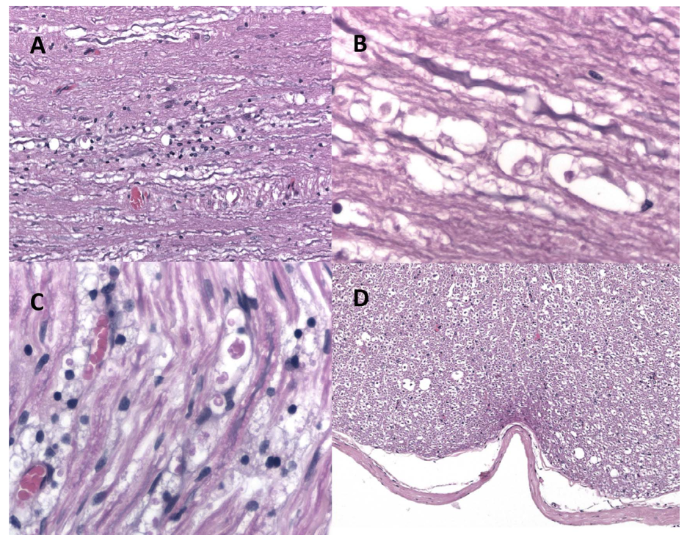

Answer: Vacuolization of white matter; Leukoencephalomyelopathy
Portas, T. J., Evans, M. J., Spratt, D., Vaz, P. K., Devlin, J. M., Barbosa, A. D., ... & Manning, A. D. (2020). Baseline health and disease assessment of founder eastern quolls (Dasyurus viverrinus) during a conservation translocation to mainland Australia. Journal of wildlife diseases, 56(3), 547-559.

ABSTRACT: We evaluated the health of 31 (eight males, 23 females) founder eastern quolls (Dasyurus viverrinus), translocated to a fenced reserve in the Australian Capital Territory between February 2016 and July 2017. Quolls were wild caught in Tasmania (16 animals) or captive bred at Mount Rothwell Biodiversity Interpretation Centre, Victoria (15 animals). Quolls were assessed for the presence of selected potential pathogens (Toxoplasma gondii, herpesviruses, Salmonella serovars, hemoprotozoa, and ectoparasites). We assessed the relationships among sex, provenance (captive or free ranging), Toxoplasma gondii or herpesvirus infection, weight, and hematologic and biochemical variables. Six of 21 quolls (29%) tested were seropositive for antibodies to Toxoplasma gondii. Seropositive quolls weighed significantly more and had significantly lower potassium levels, anion gaps, and urea and triglyceride levels than seronegative quolls had. Eighteen of 31 (58%) combined conjunctival-pharyngeal-cloacal swabs collected from quolls were PCR positive for a newly identified gammaherpesvirus, tentatively named dasyurid gammaherpesvirus 3. There were no significant differences among hematologic and biochemical variables or body weights from PCR-positive and PCR-negative quolls. Eighteen of 18 (100%) of rectal-swab samples were culture negative for Salmonella serovars. Three species of tick (Ixodes tasmani, Ixodes fecialis, and Ixodes holocyclus), two species of mite (Andreacus radfordi, one unidentified), and four species of flea (Pygiopsylla hoplia, Acanthopsylla rothschildi rothschildi, Uropsylla tasmanica, and Stephanocircus dasyuri), were detected on wild-caught quolls, whereas a fifth species of flea, Echidnophaga myremecobii, was detected only on captive-bred quolls. Five of 15 blood samples (33%) were positive for hemoprotozoan DNA via PCR, a novel Hepatozoon species, a novel Theileria species, Theileria paparinii, and Trypanosoma copemani were detected (in one animal each). Despite the presence of several potential pathogens known to be associated with disease in other marsupials, the quolls were considered to be in good general health, suitable for translocation, and a viable population was subsequently established.

Question: Which of the following was observed during a baseline health and disease assessment of founder eastern quolls (Dasyurus viverrinus)?

- Animals seropositive for Toxoplasma spp exhibited clinical signs of disease.
- The majority of rectal swabs obtained cultured positive for Salmonella serovars.
- Echidnophaga myremecobii was the most common flea species infecting wild quolls.
- Wild caught quolls had higher sodium and phosphate than captive-bred individuals.
- Quolls seropositive for Toxoplasma spp had significantly higher potassium than captive-bred animals.

Answer: D – Wild caught quolls also had higher AST, ALP, TP, Alb, and glob, and lower urea vs captive bred quolls.

In a recent survey of Long-Nosed Potoroo (Potorous tridactylus), which of the following blood-borne pathogens was detected for the first time?

- Trypanosoma spp
- Babesia spp
- Theileria spp
- Cytauxzoon spp
- Rangelia spp

Answer: a

Of the following macropod herpesviruses, please indicate whether the virus is alpha or gamma herpesvirus, and what (if any) clinical signs are associated with it

MaHV- 1
MaHV- 2
MaHV- 3
MaHV- 4
MaHV- 5
MaHV- 6

MaHV- 1 – alpha, resp signs and cloacal ulceration
MaHV- 2 –alpha, oral ulcers and conjunctivitis
MaHV- 3 –gamma, respiratory signs
MaHV- 4 –alpha, respiratory and neuro signs
MaHV- 5 –gamma, none
MaHV- 6 –gamma, none

Which of the following is true of a recent epidemiology study of Chlamydia-induced reproductive disease in male koalas (Phascolarctos cinereus)?
- Decreased infection prevalence with increasing age
- No correlation was found with body condition score
- Presence of C. pecorum in penile urethral swabs was a good predictor of the presence in semen
- C. pecorum load in penile urethral swabs was a good predictor of the load in the semen
- Subclinical infection rate in males is low (<25%)

Name the most common organisms associated with chlamydiosis in koalas.
Chlamydia pecorum, Chlamydia pneumoniae

Practice Questions:
Which of the following treatments options is recommended for chronic alveolar osteomyelitis in Bennett’s wallabies (Macropus rufogriseus) under managed care?
- Penicillin and high dose clindamycin therapy
- Dental extraction and regional debridement
- Antibiotic impregnated PMMA beads
- Euthanasia given high chance of reoccurrence
- Total pulpectomy (root canal therapy)

Answer: B

Which of the following is true regarding indirect or non-invasive blood pressure monitoring via oscillometric methods in anesthetized Bennett’s wallabies (Macropus rufogriseus)?
- Oscillometric cuff placement should be on a forelimb
- Indirect and direct measurements are interchangeable
- Single measurements are more reliable than trends
- MAP readings are the most accurate, but not as precise
- SAP is overestimated and DAP and MAP are underestimated

Answer: D

