Practice Question:
In stranded sea otters (Enhydra lutris) found on the Washington coast, which of the following was identified as the causative agent of morbilliviral disease and what was a principal diagnostic feature?
- Phocine distemper virus & white and gray matter inflammation
- Canine distemper virus & morbillivirus-associated pneumonia
- Cetacean morbillivirus & lymphocytolysis and lymphoid depletion
- Phocine distemper virus & morbillivirus-associated pneumonia
- Canine distemper virus & white and gray matter inflammation

Answer: E

Moriarty, M. E., Miller, M. A., Murray, M. J., Duignan, P. J., Gunther-Harrington, C. T., Field, C. L., ... & Johnson, C. K. (2021). Exploration of serum cardiac troponin I as a biomarker of cardiomyopathy in southern sea otters (Enhydra lutris nereis). American Journal of Veterinary Research, 82(7), 529-537.

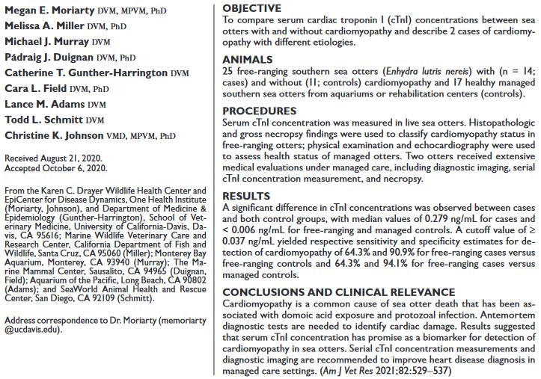
Question:
Which of the following is true regarding cardiomyopathy in southern sea otters (Enhydra lutris nereis)?
- Cardiac troponin 1 increases in response to acute endocardial injury.
- Hypertrophic cardiomyopathy is the most common end stage lesion.
- Cardiac troponin 1 has a long half-life in serum and is useful for evaluation of historic cardiac lesions.
- Domoic acid exposure and protozoal infection have been identified as risk factors.
- Cardiac troponin 1 was observed to reliably decline with progression of cardiomyopathy.
Answer: D

Which of the following is most consistent with normal urinalysis results for the Antillean manatees (Trichechus manatus manatus)?
- Clear urine color
- Moderate glucosuria
- Alkaline urine
- Urine specific gravity >1.030
- Moderate proteinuria
Which of the following methods was found to be most accurate in assessing core body temperature of the Florida Manatee (Trichechus manatus latirostris)?
- Oral
- Nasal
- Rectal
- Infrared
- Esophageal

Answer: E

MORTALITY TRENDS IN NORTHERN SEA OTTERS (ENHYDRA LUTRIS KENYONI ) COLLECTED FROM THE COASTS OF WASHINGTON AND OREGON, USA (2002–15)
C. LeAnn White, Emily W. Lankau, Deanna Lynch, Susan Knowles, Krysten L. Schuler, Jitender P. Dubey, Valerie I. Shearn-Bochsler, Marcos Isidoro-Ayza, and Nancy J. Thomas
Journal of Wildlife Diseases, 54(2), 2018, pp. 238–247

Practice Question:
Which of the following is the etiology of the leading cause of death in Washington Northern sea otters (Enhydra lutris kenyoni) from 2002-2015?
- Trauma
- Streptococcus phocae
- Toxoplasma gondii
- Sarcocystis neurona
- Morbillivirus

Answer: D

