The Journal of Herpetological Medicine and Surgery, Volume 30, No. 1, 2020 pp. 38–41
Anesthetic Efficacy of MS-222 in White’s Tree Frogs (Litoria caerulea)
Ashley R. Krisp1,2, DVM, Jennifer C. Hausmann1,3, DVM, Kurt K. Sladky1, MS, DVM, DACZM, DECZM (Herpetology, Zoo Health Management), Christoph Mans1, Dr med vet, DACZM, DECZM (Zoo Health Management)

ABSTRACT: Tricaine methanesulfonate (MS-222) is a bath anesthetic agent commonly used in amphibians, but few studies have demonstrated its efficacy in a wide variety of anuran species. In this study, White’s tree frogs (Litoria caerulea; n =9) were used in a blinded, randomized, complete cross-over study to assess the anesthetic effects of two MS-222 concentrations (0.5 g/L and 2 g/L). Frogs were placed in MS-222 to induce chemical restraint. Heart and gular rates and palpebral, corneal, withdrawal, and righting reflexes were measured every 5 min. Frogs were removed from the anesthetic solution when reflexes were lost or after 25 min. Only mild sedation was induced with 0.5 g/L MS-222 after 25 min in all frogs, and surgical anesthesia was induced in all frogs with 2 g/L MS-222 within 5–20 min. Time from rinsing with distilled water to regaining reflexes in the 2 g/L group ranged from 10 to 43 min. There was a time- dependent decrease in heart rate with no significant difference between treatments. There was a significant decrease in gular rate for the 2 g/L dose compared to the 0.5 g/L dose. These results suggest that 0.5 g/L MS-222 can be used for mild sedation to facilitate diagnostic techniques, and 2 g/L MS-222 can be used to induce surgical anesthesia in White’s tree frogs

Study Design: Blinded, randomized, complete cross-over study with 7-day washout period; n=9 White’s tree frogs

Goal: To evaluate two doses of MS-222 (0.5 g/L and 2 g/L) for induction of anesthesia in White’s tree frogs

Key Points:
- Empirical doses for MS-222 range from 0.1-3 g/L in a in a wide variety of anurans
  - These dose ranges are largely based on studies with leopard frogs (Rana pipiens) and African clawed frogs (Xenopus laevis)
- In this study, 0.5 g/L and 2.0 g/L of MS-222 resulted in different depths of anesthesia in White’s tree frogs
  - At 0.5 g/L, corneal reflexes and righting reflex remained present in all frogs
    - Palpebral reflex was the first and most consistent reflex lost
  - At 2.0 g/L, all reflexes were rapidly and consistently lost in all frogs, except for the corneal reflex
    - Loss: righting (first) << palpebral << withdrawal (last)
    - Regain: palpebral (first) << withdrawal << righting (last)
  - All animals recovered without complications
- Species variation can play a clinically significant role in the efficacy of MS-222
- Recovery has been shown to be significantly more variable than induction within and among anuran species
  - If rapid recovery is desired, animals should be induced with the lowest concentration and removed once fully induced
  - Any additional time in the bath can prolong the recovery, independent of species
- In this current study, a time-dependent decrease in heart rate occurred when frogs were exposed to MS-222
  - Similarly, respiratory depression was dose dependent and time dependent
- When exposing a new anuran species to MS-222, there could be cardiac depression even at shorter exposure times and lower concentrations

TLDR:
- 2.0 g/L is an acceptable concentration of MS-222 for induction of surgical anesthesia
  - A surgical plane of anesthesia can be successfully reached in 5–20 min
- 0.5 g/L may be suitable to facilitate handling for minor nonpainful procedures

References On ACZM Reading List
Baitchman E, Stetter M. 2014. Amphibians. In West G, Heard D, Caulkett N (eds): Zoo Animal and Wildlife Immobilization and Anesthesia. 2nd ed. John Wiley & Sons, Inc., Ames, IA:307–308

Barbon, Alberto Rodriguez, Andrew Routh, and Javier Lopez. "Inhalatory isoflurane anesthesia in mountain chicken frogs (leptodactylus fallax)." Journal of Zoo and Wildlife Medicine 50.2 (2019): 453-456.

Abstract: One hundred and fourteen mountain chicken frogs were anesthetized, to place intracoelomic radiotracers. The animals were placed in a clear plastic bag that was filled with isoflurane 5% and oxygen. Loss of righting reflex occurred at 3.4 +/- 2.3 min; loss of gular movements was observed at 7.6 +/- 2.7 min. Intubation was carried out using a modified cuffed tube between 2.5 and 3.5 mm, at 7.6 +/- 2.2 min from the beginning of the anesthesia. Manual intermittent positive pressure ventilation every 5 to 10 sec was initiated and maintained
through the anesthesia. Isoflurane concentration was maintained at 2%. Loss of withdrawal reflex occurred at 10.6 +/- 4.8 min, while loss of response to painful stimuli was noted at 11.1 +/- 2.9 min. Surgery started at 16.9 +/- 9.9 min; the procedure from incision to last suture took 8.2 +/- 2.3 min. Total anesthesia time was 21 +/- 6.4 min. Intermittent positive pressure ventilation was continued with room air until the animals recovered the righting reflex, which occurred at 40.4 +/- 10.1 min.

Key points
- 3 modes of respiration in anurans: pulmonic, bucopharyngeal, and cutaneous
  - Pulmonic primary in adults
- Gas-exchange efficiency in skin lower than pulmonary alveolar-capillary system (contributes to long periods of anesthetic equilibration once active ventilatory efforts cease
  - Upper airway intubation and IPPV may be the most effective method to deliver volatile anesthetic agents in anurans
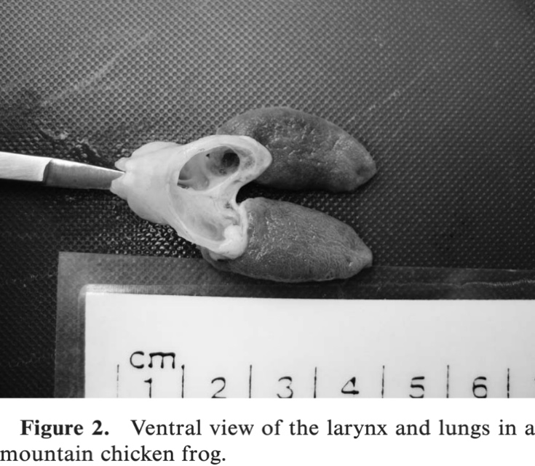
- Trachea short in anurans → bifurcates into main bronchi
  - This spp has no trachea or bronchi → larynx formed by two lateral cartilages that extend symmetrically in an incomplete ring, closed by a fine membrane --> directly connected to the lungs
- Risk of iatrogenic trauma to lungs lessened by shortening tip of ETT and inserting only the tube distal to the cuff
  - Cuff still allows seal over opening of larynx
- Isoflurane anesthesia was adequate but resulted in bradycardia
Take home: Isoflurane induction successful in chicken frogs. can intubate chicken frogs if use just distal tip of cuffed ETT. Chicken frogs lack trachea and bronchi.

Comparison of subcutaneous administration of alfaxalone–midazolam–dexmedetomidine with ketamine–midazolam–dexmedetomidine for chemical restraint in juvenile blue poison dart frogs (Dendrobates tinctorius azureus).
Yaw TJ, Mans C, Martinelli L, Sladky KK.
Journal of Zoo and Wildlife Medicine. 2020;50(4):868-873.

Blue poison dart frogs (Dendrobates tinctorius azureus) are commonly maintained in zoological institutions and are becoming popular in the pet trade industry. Sedation or light anesthesia is required for safe and effective handling of this species. In this study, the sedative effects of subcutaneously intrascapular administered alfaxalone–midazolam–dexmedetomidine (AMD) (20, 40, 5 mg/kg, respectively) and ketamine–midazolam– dexmedetomidine (KMD) (100, 40, 5 mg/kg, respectively) were compared in a prospective, randomized, blinded, crossover study in juvenile blue poison dart frogs (n ¼ 10). Both protocols were partially reversed 45 min after administration of either protocol with subcutaneously administered flumazenil (0.05 mg/kg) and atipamezole (50 mg/kg). Heart rate, pulmonic respiratory rate, various reflexes, and behavioral parameters were monitored after drug administration. Both protocols resulted in rapid loss of righting reflex [median (range): AMD, 5 min (5–5 min); KMD, 5 min (5–10 min)]. Time to complete recovery was similar with both protocols (mean 6 SD: AMD, 97.5 6 11.4 min; KMD, 96.5 6 25.4 min). The AMD protocol resulted in pulmonic respiratory depression, whereas no significant difference in heart rate was found between the two protocols. All frogs were observed eating within 24 hr of chemical restraint. Gastric prolapses occurred in four frogs (AMD 3, KMD 1) that were easily reduced with a cotton-tip application. No other adverse reactions were observed. The results of this study provide two different subcutaneous chemical restraint protocols in juvenile blue poison dart frogs.

Background:
- Human risks of MS-222: respiratory irritation, local skin reactions, retinopathies with prolonged exposure

Key points:
- Similar depths of restraint with loss of righting reflex, jaw tone, spontaneous movement, palpebral reflex, and tactile response in all frogs
- Both required diluting of drugs
- KMD: more limb rigidity, “sawhorse” stance that was more pronounced after antagonists given
- Similar time to loss of righting reflex
- Time to ventral recumbency faster in AMD (5 min) vs KMD (16 min)
- Similar time to return of spontaneous movement (70 min) and time to full recovery (100 min)
- HR decreased with both within 10 min
- RR decreased with AMD, increased with KMD
- All frogs were eating within 24 hr, no mortalities, no signs of tissue damage
- Gastric prolapse after antagonist administration with both protocols (3 AMD, 1 KMD)
  - Easily replaced, did not recur
  - Suspect doses of reversals may have been too high

Conclusions
- Higher doses of anesthetics compared to reptiles
- Both protocols provided adequate sedation without mortality
- Gastric prolapse reported with both protocols, respiratory depression with AMD, rigidity and slower time to effect with KMD

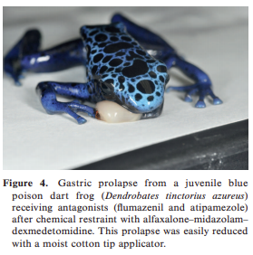
Williams, C. J., Alstrup, A. K., Bertelsen, M. F., Jensen, H. M., Leite, C. A., & Wang, T. (2018). Cardiovascular effects of alfaxalone and propofol in the bullfrog, Lithobates catesbeianus. Journal of Zoo and Wildlife Medicine, 49(1), 92-98.

Abstract: Alfaxalone is becoming a popular anesthetic for nonmammalian vertebrates, but the physiological effects of its administration remain largely unknown in these taxa. Therefore, the cardiovascular responses to a clinically relevant dose of alfaxalone (10 mg/kg) are reported in the bullfrog (Lithobates catesbeianus), following intramuscular (IM) and intravascular (IV) administration (via a femoral artery catheter) and compared with an IV dose of propofol, another parenteral GABA (c-aminobutyric acid) agonist in common veterinary use as an induction agent. Heart rate (HR) and mean arterial blood pressure (MAP) (assessed by direct measurement from the catheter) are reported from under undisturbed conditions to assess both the direct effects of the drugs and the interaction with the stress of handling associated with IM injection of alfaxalone where IM administration is possible. Alfaxalone caused HR to increase significantly for over 45 min in both groups from a baseline of approximately 30 beats/min. This was significantly different from the lack of significant HR response on the IV administration of propofol. MAP increased in the peri-injection period with both routes of administration for alfaxalone but after IV use decreased significantly from 10 min following administration. Propofol did not affect blood pressure after 5 min from injection. Assessment of immobilization following intramuscular injection of alfaxalone in a pilot study was in accordance with the literature, as it provided no antinociception as a sole agent but did produce sedation and loss of righting reflex.
Key points
- Alfaxalone – Synthetic neurosteroid anesthetic.
  - Current formulation (Alfaxan) does not possess the cremophor carrier of a previous formulation, which had caused tissue swelling and hypotension via histamine release.
- Propofol – GABA alpha agonist.
- Catheterized femoral artery for measurements of HR and blood pressure.
- Monitored for 10 min prior to injection in three groups.
  - Propofol or alfaxalone IV via femoral catheter.
  - IM injection of alfaxalone.
  - Monitored for the 10 min period prior to administration and up to 95 min after injection.
- Propofol at 10 mg/kg did not affect HR when administered intravascularly and increased MAP significantly for only 5 min after injection.
- Alfaxalone resulted in initial significant increase in HR when administered IV and IM.
  - IV administration caused hypotension.
  - Withdrawal persisted (no anti-nociception).
  - Alfaxalone produced respiratory depression.
- Propofol IV did not result in significant hypotension or change in HR.

Take home: Alfaxalone produced sedation with hypotension (IV) and tachycardia (IV,IM), but no antinociception

Balko, J. A., Watson, M. K., Papich, M. G., Posner, L. P., & Chinnadurai, S. K. (2018). Plasma Concentrations of Ketoprofen and Meloxicam after Subcutaneous and Topical Administration in the Smoky Jungle Frog (Leptodactylus pentadactylus). Journal of Herpetological Medicine and Surgery, 28(3-4), 89-92.
Abstract: Non-steroidal anti-inflammatory drugs (NSAIDs) are commonly used for analgesia in veterinary patients; however, evaluation of NSAID pharmacokinetics in amphibians is limited. A wide variety of pharmacotherapeutics have been administered topically to the skin of anurans with limited empirical evidence of absorption or efficacy. Systemic absorptions of two NSAIDs, meloxicam and ketoprofen, were evaluated after subcutaneous and topical cutaneous administration in smoky jungle frogs (Leptodactylus pentadactylus). Eighty-four, 8 month old, 38.0 g (26.1–56.6 g) (median [range]) frogs were randomly assigned to receive one of four treatments, with 21 animals in each group: 1 mg/kg racemic ketoprofen administered either subcutaneously (SK) or topically (TK) or 0.2 mg/kg meloxicam administered either subcutaneously or topically. Plasma concentrations of meloxicam and the R- and S-enantiomers of ketoprofen were quantified at 3, 8, and 24 h after administration. At each time point, seven frogs per group were anesthetized for blood collection and then euthanized. Plasma samples were pooled within each group for drug quantification. Both enantiomers of ketoprofen were detectable in groups SK and TK, and plasma concentrations decreased from 3 to 24 h. The drop in concentration was less predictable for TK than for SK. Plasma concentrations of meloxicam were nondetectable at most time points by both routes. Topical absorption of ketoprofen is possible in frogs, although therapeutic levels have not been determined for this species.
- Introduction:
  - NSAIDs in amphibians:
    - Flunixin and meloxicam in dorsal lymph sac of Xenopus showed marked analgesia with 25 mg/kg flunixin but minimal effects with 0.2 mg/kg meloxicam.
    - Meloxicam attenuated prostaglandin E2 increase after surgical trauma at 0.1 mg/kg IM.
  - Topical administration of drugs in amphibians:
    - Antibiotics, antiparasitics, no NSAIDs prior to this study.
    - Not yet known whether COX1 or 2 selectivity has a beneficial role in anurans.
- Results/Discussion:
  - Topical and SQ routes resulted in detectable ketoprofen.
    - Decline in concentration was more variable for the topical route vs SQ.
    - Unknown if this has any analgesic effect based on concentration detected.
  - Meloxicam only detected by SQ route.
    - Only detectable before 8 hrs.
  - Other analgesics to consider – morphine (30-100 mg/kg) and alpha2s at high doses.
- Takeaway: Ketoprofen detectable for up to 24h in frogs by topical and SQ routes. Meloxicam only detectable by SQ route and only at 3 hour time mark (not 8 or 24h).

