Practice Question
When anesthetizing White’s tree frogs (Litoria caerulea) with a high concentration MS-222 (2g/L), which of the following reflex was still present?
- Corneal
- Palpebral
- Righting
- Withdrawal
- None

Answer: A

Question: Which of the following is true in regards to anesthesia of chicken frogs?
- Gas-exchange efficiency is higher in the skin than the pulmonary alveolar-capillar system
- There are 2 modes of respiration: pulmonic and cutaneous
- Chicken frogs lack a trachea and bronchi
- There is minimal risk of iatrogenic trauma when intubating chicken frogs, and any endotracheal tube is sufficient
- Intubation of chicken frogs was unsuccessful in maintaining anesthesia for placement of intracoelomic radiotracers

Answer: C

Comparison of subcutaneous administration of alfaxalone–midazolam–dexmedetomidine with ketamine–midazolam–dexmedetomidine for chemical restraint in juvenile blue poison dart frogs (Dendrobates tinctorius azureus).
Yaw TJ, Mans C, Martinelli L, Sladky KK.
Journal of Zoo and Wildlife Medicine. 2020;50(4):868-873.

Practice Question
Please label A and B on the following graph as either “alfaxalone-midazolam-dexmedetomidine” or “ketamine-midazolam-dexmedetomidine”. This graph details the changes in pulmonic respiratory rate over time in sedated juvenile blue poison dart frogs.
- _____________________
- _____________________

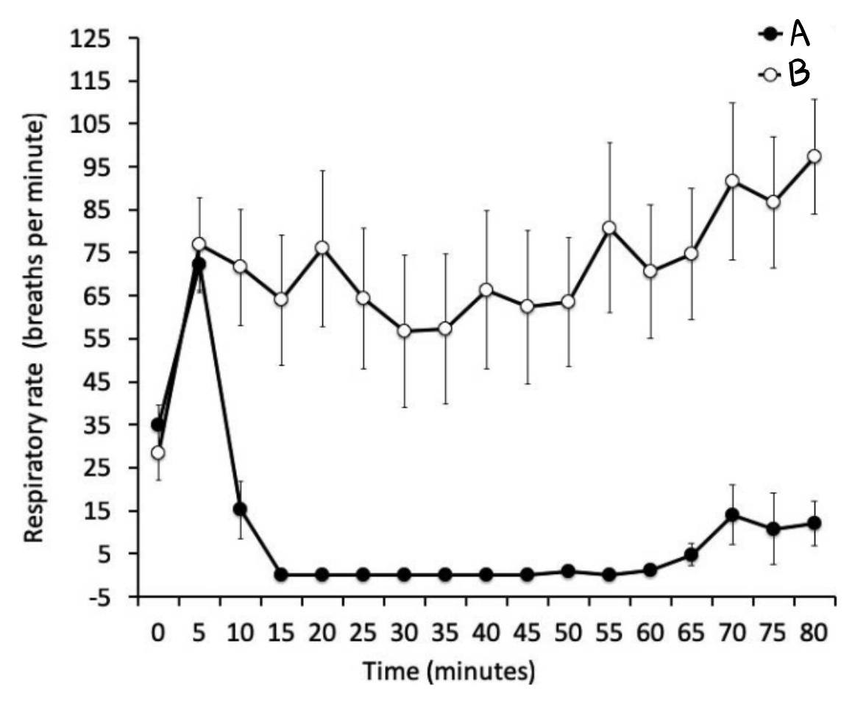
Answer:
- AMD
- KMD

Please list two adverse effects reported with a combination protocol of ketamine, midazolam, and dexmedetomidine for chemical restraint of juvenile blue poison dart frogs (Dendrobates tinctorius azureus).
Answer: Limb rigidity (“sawhorse” stance) and gastric prolapse.

Williams, C. J., Alstrup, A. K., Bertelsen, M. F., Jensen, H. M., Leite, C. A., & Wang, T. (2018). Cardiovascular effects of alfaxalone and propofol in the bullfrog, Lithobates catesbeianus. Journal of Zoo and Wildlife Medicine, 49(1), 92-98.

Abstract: Alfaxalone is becoming a popular anesthetic for nonmammalian vertebrates, but the physiological effects of its administration remain largely unknown in these taxa. Therefore, the cardiovascular responses to a clinically relevant dose of alfaxalone (10 mg/kg) are reported in the bullfrog (Lithobates catesbeianus), following intramuscular (IM) and intravascular (IV) administration (via a femoral artery catheter) and compared with an IV dose of propofol, another parenteral GABA (c-aminobutyric acid) agonist in common veterinary use as an induction agent. Heart rate (HR) and mean arterial blood pressure (MAP) (assessed by direct measurement from the catheter) are reported from under undisturbed conditions to assess both the direct effects of the drugs and the interaction with the stress of handling associated with IM injection of alfaxalone where IM administration is possible. Alfaxalone caused HR to increase significantly for over 45 min in both groups from a baseline of approximately 30 beats/min. This was significantly different from the lack of significant HR response on the IV administration of propofol. MAP increased in the peri-injection period with both routes of administration for alfaxalone but after IV use decreased significantly from 10 min following administration. Propofol did not affect blood pressure after 5 min from injection. Assessment of immobilization following intramuscular injection of alfaxalone in a pilot study was in accordance with the literature, as it provided no antinociception as a sole agent but did produce sedation and loss of righting reflex.
Question:
Which of the following effects was observed following administration of alfaxalone and propofol to bullfrogs (Lithobates catesbeianus)?
- Loss of withdrawal reflex was observed with alfaxalone administration.
- Tachycardia was observed following administration of alfaxalone.
- Alfaxalone administration resulted in hypertension.
- Propofol administration resulted in tachycardia and respiratory depression.
- Intramuscular administration of alfaxalone resulted in hypotension.
Answer: B

A smoky jungle frog (Leptodactylus pentadactylus) presents to you after sustaining trauma to the right forelimb. You would like to administer a non-steroidal anti-inflammatory medication (NSAID) to this animal for analgesia. Based on a pilot study performed in this species, which NSAID would you recommend and what route would you administer it? Why?
Ketoprofen SC
Ketoprofen was detectable via TO and SC route for up to 24hr. Plasma concentrations less predictable via TO route. Meloxicam was non-detectable at most time points by both SC and TO administration.

