Le Net, R., Mulcahy, D. M., Santamaria-Bouvier, A., Gilliland, S. G., Bowman, T. D., Lepage, C., & Lair, S. (2019). Intranasal administration of midazolam hydrochloride improves survival in female surf scoters (melanitta perspicillata) surgically implanted with intracoelomic transmitters. Journal of Zoo and Wildlife Medicine, 50(1), 167-175.

Abstract: The intracoelomic implantation of satellite transmitters is associated with lower survival in surf scoters (Melanitta perspicillata) compared with other species of diving ducks, potentially due to physiologic alterations following physical exertion and stress caused by handling and confinement. The effect of intranasal administration of midazolam hydrochloride on survival of surf scoters surgically implanted with intracelomic transmitters was evaluated. Shortly after their capture in Forestville (QC, Canada) in the fall of 2013, 26 randomly selected adult female surf scoters were administered midazolam hydrochloride (4.6–5.9 mg/kg) intranasally. The same volume of saline (1 mL) was given to another 26 adult female surf scoters as a control group. All birds were surgically implanted with an intracoelomic transmitter equipped with a percutaneous antenna. Transmitters were programmed to transmit 2 hr each day for 30 days after implantation, and mortality was estimated for each group using the telemetry data. The association between the administration of midazolam and survival was assessed while controlling for other factors such as body mass, transmitter-mass-to-body-mass ratio, hematocrit, total solids, and duration of surgery, anesthesia, and confinement. The odds of presumed death in the saline group were 5.3 times higher than in the midazolam group (95% confidence interval: 1.7, 19.0; P = 0.004). The presumed mortality at 30 days for the midazolam group (23%) was lower than for the saline group (61%). No other variable was significantly associated with survival. These results suggest that sedation with midazolam shortly after capture increased the postsurgical survival of female surf scoters surgically implanted with intracoelomic transmitters.
Introduction:
- In diving seabirds, intracoelomic transmitters with external antennas preferred vs external.
    - Cause fewer changes in maintenance behaviors, thermoregulation, hydrodynamic drag when diving.
    - Post-surgical mortality of implanted birds varies among species.
      - Scoters high mortality, up to 61% post implantation.
      - Acute stress and physical exertion during handling and confinement may play a role.
- Midazolam – sedative, anxiolytic agent with muscle-relaxant properties.
    - Short onset of action, readily absorbed by nasal mucosa.
M+M:
- Captured with mist nets, performed PE.
- Two groups – midazolam (5 mg/kg) vs saline control of same volume IN.
- Anesthesia; Implanted telemetry transmitters in both groups, monitored outcome.
Results/Discussion:
- Sedation with midazolam significantly increased postsurgical survival in surf scoters implanted with ICT.
- Mortality postrelease may be due to predation, acidosis, capture myopathy, failure to return to proper foraging due to mechanical or wt burden of ICT and infection of surgical site. PM exam of dead birds was not feasible.
- Still had 23% mortality at 30 days in the midazolam group. But 61% in controls.
- Midazolam may have decreased stress and likelihood of capture myopathy.

Takeaway: Sedation with midazolam increased post-surgical survival in surf scoters implanted with intracoelomic transmitters.

Vanstreels, Ralph Eric Thijl, et al. "Empirical Primaquine Treatment of Avian Babesiosis in Seabirds." Journal of avian medicine and surgery 33.3 (2019): 258-264.

Abstract: Babesia species are tickborne hemoprotozoans. Although experiments have shown that primaquine is highly effective in the treatment of Babesia species infections in mammals, this drug has not been widely used for the treatment of avian babesiosis. Consequently, the treatment of this disease for avian patients has traditionally relied on an empirically established imidocarb treatment. In this study, the authors examined the efficacy of primaquine as a treatment alternative for avian babesiosis (Babesia peircei and Babesia ugwidiensis) in seabirds. Retrospective analysis was performed on the medical records and blood smears of 446 B peircei–positive African penguins (Spheniscus demersus) and 41 B ugwidiensis–positive Cape cormorants (Phalacrocorax capensis) admitted for rehabilitation at the Southern African Foundation for the Conservation of Coastal Birds (SANCCOB, Cape Town, South Africa). Treatment with primaquine (1 mg/kg PO q24h for 10 days) was effective in rapidly and markedly decreasing the proportion of Babesia– positive blood smears in African penguins and Cape cormorants. No regurgitation, loss of appetite, or any other signs after administration of primaquine were observed during the study period. The use of primaquine can be a particularly advantageous treatment alternative for avian babesiosis in circumstances in which it is not possible to determine confidently whether the intraerythrocytic inclusions seen in blood smears correspond to Babesia or Plasmodium or in cases in which there is a coinfection by Babesia and Plasmodium.

Introduction:
- Babesia in kestrels/falcons → anemia, weakness, death
- Susceptible aquatic birds = murres, gulls, and terns (Charadriiformes); herons (Pelecaniformes); darters, gannets, boobies, and cormorants (Suliformes); and penguins (Sphenisciformes)
- Treatment - imidocarb dipropionate, 5–7 mg/kg SC/IM single dose, optionally repeated after 1 week; regurgitation seen after the first injection
- Primiquine (8-aminoquinolones class) has been used to treat babesiosis in mammalian species, malaria in birds
  - Significant side effects can be seen- emesis, methemoglobinemia, thrombocytopenia, and liver/ kidney degenerative changes
  - Long term doses of primaquine have been used in captive penguins as a preventative for malaria (up to 1.25 mg/kg) without significant adverse effects
M+M/Results:
- Retrospective evaluating records and blood smears from penguins, cormorants.
- This dose eliminated B ugwidiensis parasitemia in all Cape cormorants and was effective in eliminating parasitemia in 99.6% of African penguins
Discussion:
- Babesia peircei infections can cause mild anemia, leukocytosis, and impairment of hepatic function in African penguins
- Survival rate of juvenile Cape cormorants during rehabilitation is lower for B ugwidiensis–positive individuals than it is for negative individuals
- Cases of acute Babesia species infections leading to the death of common murres (Uria aalge) 25 and in a king penguin (Aptenodytes patagonicus)
- Primaquine can be effective in the treatment of Babesia species infections in penguins and cormorants (need further studies to determine ideal dose)
  - Advantages: cheap, can be used if unsure if infection is babesia or plasmodium or there are both infections present
  - Disadvantages: need to give meds daily- can be an issue in critical patients (may prefer to just give the imidocarb injections)
- No adverse effects noted but biochem/enzymes not evaluated so unsure if there were hematologic changes

Takeaway: Primaquine effective alternative treatment for Babesiosis in penguins and cormorants.

Daoust, Pierre-Yves, et al. "Pathology of Northern Fulmars (Fulmarus glacialis) and Shearwaters Beached On Sable Island, Nova Scotia, Canada." Journal of Wildlife Diseases (2021).

ABSTRACT: Marine birds are frequently found dead on beaches, either from natural or from anthropogenic causes. Complete necropsies of those carcasses can provide valuable information, particularly for pelagic species, such as Northern Fulmars (Fulmarus glacialis) and shearwaters, which come to land only to breed and for which information on diseases that may affect them is, therefore, sparse. Between 2000 and 2012, 315 carcasses of four species of Procellariiformes (173 Northern Fulmars, 89 Great Shearwaters [Ardenna gravis], 50 Sooty Shearwaters [Ardenna grisea], and three Cory’s Shearwaters [Calonectris diomedea]) were collected on Sable Island, Nova Scotia, Canada, an isolated island near the edge of the continental shelf. A complete necropsy, including examination for the presence of ingested plastic, was performed on all carcasses. Most (70%) of these birds were immature. The cause of death was undetermined in 22% (n¼70) of the birds: 36% (62/173) of the Northern Fulmars, 4% (4/89) of the Great Shearwaters, 6% (3/50) of the Sooty Shearwaters, and 33% (1/3) of the Cory’s Shearwaters. Emaciation was considered the primary cause of death in 91% of the remaining 245 birds: 87% (97/111) of the Northern Fulmars, 92% (78/85) of the Great Shearwaters, 100% (47/47) of the Sooty Shearwaters, and 100% (2/2) of the Cory’s Shearwaters. Notable primary causes of death other than emaciation included mycobacteriosis and neoplasia in Northern Fulmars and transmural parasitic proventriculitis in Great Shearwaters. For Northern Fulmars, nutritional condition (as determined semiquantitatively) was compared with other parameters. Birds in good nutritional condition had heavier body mass and flight muscle mass than those in poor nutritional condition (P,0.01). More adults were in poor nutritional condition than expected by chance (91%; v2 ¼8.23, P,0.01), whereas only 57% of immature birds were in poor condition. There was no relationship between nutritional condition and sex or mass of ingested plastic. Our study provides information on some previously unsuspected health threats in Procellariiformes.

Key points
- Between 2000 and 2012, 315 carcasses of four species of Procellariiformes were collected on Sable Island, Nova Scotia.
- A necropsy was performed including noting the presence of plastic, determination of sex and age, and scoring of nutritional condition
- Most birds were immature (70%)
- COD was undetermined in 22% of birds
- Emaciation was considered the primary cause of death in 91% of the remaining birds
- Other COD’s included trauma, primary infection (bacterial, fungal, or parasitic), neoplasia (round cell, but could not be further characterized), and metabolic
  - Single case of mycobacteriosis
- Birds in good nutritional condition had heavier body mass and flight muscle mass than those in poor nutritional condition--supports BCS as a proxy for nutritional status
- A lower proportion of Northern Fulmars was emaciated (56%) compared with that of Sooty (94%) or Great Shearwaters (88%). This disparity may be partially explained by species-specific movements and home ranges
- Did not find lesions suggestive of drowning or capture in fishing nets as described by a previous study
- More adults were in poor nutritional condition than immature birds
- No relationship between either nutritional condition or body mass and mass of ingested plastic in Northern Fulmars

McCain, Stephanie, et al. "Myonecrosis and death due to presumed microcystin toxicosis in American white pelicans (pelecanus erythrorhyncos)." Journal of Zoo and Wildlife Medicine 51.2 (2020): 407-415.

Abstract: Over a period of 5 mo, seven out of eight American white pelicans (Pelecanus erythrorhynchos) housed on a spring-fed pond at a zoo died or were euthanized. Clinical signs included inability to stand, anorexia, and weight loss. Clinicopathologic findings included heterophilic leukocytosis and elevated creatine kinase and aspartate aminotransferase. Histopathologic findings on all pelicans demonstrated severe, chronic, diffuse rhabdomyofiber degeneration and necrosis, making vitamin E deficiency a differential diagnosis despite routine supplementation. Based on tissue and pond water assays for the cyanobacterial toxin, microcystin, toxicosis is suspected as the inciting cause of death in these cases. We hypothesize that vitamin E exhaustion and resultant rhabdomyodegeneration and cardiomyopathy were sequelae to this toxicosis

Key points:
- Over a period of 5 months, seven out of eight American white pelicans (Pelecanus erythrorhynchos) housed on a spring-fed pond at a zoo died or were euthanized
- Presenting signs included lameness, anorexia, weight loss
- Clin path findings: Heterophilic leukocytosis, inc CK, iinc AST
- Histopath: severe, chronic, diffuse rhabdomyofiber degeneration and necrosis
- Suspected vitamin E deficiency
- Analysis of the water confirmed presence of microcystin
- Suspected cyanoacterial overgrowth with microcystin toxicosis leading to vitamin E deficiency and rhadomyolysis
- While the liver is considered the primary target organ of microcystin there was no evidence of acute hepatic failure or hemorrhage in any of the pelicans.
- Vitamin E has been found to have a protective effect against microcystin toxicity.
- The authors suspect that the pelicans mobilized vitamin E stores in response to the toxin exposure, resulting in vitamin E deficiency despite routine supplementation.
- In this cohort of pelicans, serum concentrations of vitamin E were within expected ranges for avian piscivores, as has been seen in previous reports of rhabdomyolysis due to hypovitaminosis E in pelicans, suggesting that serum vitamin E concentration may not be a reliable indicator of deficiency.
- Other species of birds (swans and screamers) in the same pond were unaffected
- It is possible that the levels were not high enough to cause hepatic failure, so only the pelicans were affected due to their sensitivity to vitamin E deficiency.

Effects of Season, Location, Species, and Sex on Hematologic and Plasma Biochemical Values and Body Mass in Free-ranging Grebes (Aechmophorus species).
Anderson NL, De La Cruz SE, Gaydos JK, Ziccardi MH, Harvey DJ.
Journal of Avian Medicine and Surgery. 2021;35(2):135-54.

The effects of season, location, species, and sex on body weight and a comprehensive array of blood chemistry and hematology analytes were compared for free-ranging western (Aechmophorus occidentalis) and Clark's (Aechmophorus clarkii) grebes. Birds (n = 56) were collected from Puget Sound, WA, and Monterey Bay and San Francisco Bay, CA, from February 2007 to March 2011. The data supported generalization of observed ranges for most analytes across Aechmophorus grebe metapopulations wintering on the Pacific coast. Notable seasonal and location effects were observed for packed cell volume (winter 6% greater than fall; winter California [CA] 5% greater than Washington [WA]), total white blood cell count (CA 3.57 × 103 cells/µL greater than WA), heterophils (WA 10% greater than CA), lymphocytes (winter 19% greater than fall), heterophil to lymphocyte ratio (fall 5.7 greater than winter), basophils (CA greater than WA), plasma protein (WA about 10 g/L [1.0 g/dL] greater than CA), plasma protein to fibrinogen ratio (winter about 15 greater than fall), potassium (CA 2 mmol/L greater than WA), and liver enzymes (alanine aminotransferase, aspartate aminotransferase, lactate dehydrogenase: WA greater than CA). Within California, season had a greater effect on body mass than sex (mean winter weights about 200 g greater than fall), whereas within a season, males weighed only about 80 g more than females, on average. These data give biologists and veterinarians quantitative reference values to better assess health at the individual and metapopulation level.

Background
- Grebes: Aechmophorus occidentalis (western) and clarkii (Clark’s)
- Breed on freshwater lakes in western NA in summer, migrate end of summer into fall and winter along the Pacific coast
- Evaluated 3 free-ranging metapopulations during nonbreeding season: WA (winter) and CA (Mont Bay - winter, SF Bay - “fall”, spring)
  - *different analyzers (Cobas in CA and Hitachi in WA) and fibrometers (Stago CA and BBl WA)
- Natt and Herrick technique: all WBC types counted - more difficult to differentiate small lymphocytes from thrombocytes (add 0.5% methylene blue to differentiate)
- Phloxine B: only granulocytes counted - depends on an accurate WBC differential count

Key Points
- No difference in Monterey bay vs SF bay
- PCV: winter > fall, in winter CA > WA
- tWBC: CA > WA
  - Hets WA > CA
  - Lymphs winter > fall
  - H:L ratio fall > winter
  - Baso CA > WA
- TP: WA > CA
  - P:F ratio: winter > fall *due to Fb 65% higher in fall
- K: CA > WA
- ALT, AST, LDH: WA > CA esp. LDH
- Only effect of sex was on body weight (no blood parameters) *nonbreeding population
- CA: season had a greater effect on body mass than sex (winter > fall)
  - Within a season: males 80g > females (avg)
  - WA: males weighed 250g more than females

Conclusions
- Hematology and chem reference for nonbreeding western and Clark’s grebes on Pacific coast
- In winter (compared to fall): PCV higher, lymphocytes higher and H:L ratio lower, fibrinogen lower so TP:F higher, higher body mass
- WA (compared to CA): higher liver enzymes, lower PCV in winter, lower tWBC, higher hets, higher TP, lower K
- Males weigh more than females across the board

Seabirds As Possible Reservoirs of Erysipelothrix rhusiopathiae on Islands Used for Conservation Translocations in New Zealand.
Jayasinghe M, Midwinter A, Roe W, Vallee E, Bolwell C, Gartrell B.
Journal of Wildlife Diseases. 2021;57(3): 534–542.

Erysipelothrix rhusiopathiae, the causative agent of the disease erysipelas, is a gram-positive bacillus, and an opportunistic pathogen in diverse species of animals. In New Zealand, E. rhusiopathiae has killed endangered birds on offshore islands, including Kākāpō (Strigops habroptilus), Takahē (Porphyrio hochstetteri), and Kiwi (Apteryx spp.). The source of infection is uncertain, and the prevalence of E. rhusiopathiae among wild birds is currently unknown. During October 2018 to December 2018, we surveyed dead and live seabirds that visit two of New Zealand's offshore islands used for Kākāpō conservation with the goal of determining the prevalence of E. rhusiopathiae. Bone marrow from dead birds was cultivated on selective agar, and organisms cultured were identified using matrix-assisted laser desorption/ionization with time-of-flight mass spectrometry. The prevalence of E. rhusiopathiae was calculated in different species for each island. We surveyed live birds using PCR with Erysipelothrix spp.–specific primers on blood samples. The prevalence of E. rhusiopathiae in dead seabirds on Whenua Hou and Te Hauturu-o-Toi was 3.4% (3/86) and 11.4% (5/44), respectively. On Whenua Hou, E. rhusiopathiae was detected in Sooty Shearwaters (Puffinus griseus; 5.9%, 2/34) and Mottled Petrels (Pterodroma inexpectata; 2.7%, 1/36) while it was detected only in Cook's Petrels (Pterodroma cookie; 13.5%, 5/37) on Te Hauturu-o-Toi. Blood samples were collected from two seabird species; only one of 50 Mottled Petrels (2.0%) was positive for the presence of Erysipelothrix spp. Our findings confirm that burrowing seabirds are possible reservoirs of E. rhusiopathiae on both islands studied and may be the source of spillover to other species on the island. The differences in observed prevalence suggest the species composition of the reservoir of E. rhusiopathiae may vary geographically.

Background
- Erysipelothrix rhusiopathiae: Gram-positive bacillus, ubiquitous, opportunistic
  - Found in tonsils or intestines of healthy carrier animals
  - Transmission: contaminated food or water, breaks in mucous membranes/skin
- Erysipelas in birds: acute, fulminated infections or (rarely) chronic infections causing infertility
- 2004 outbreak in critically endangered Kakapo during translocation to protected New Zealand island
  - Seabirds implicated as most likely source of infection based on culture of ulnar bone marrow

Key Points
- Whenua Hou: 86 dead birds, mostly Mottled Petrels and Sooty Shearwaters
  - 50 blood samples from Mottled Petrels - one PCR positive
  - Prevalence: 3.5%
- Te Hauturu-o-Toi: 44 dead birds, mostly Cook’s Petrels
  - 18 blood samples from Cook’s Petrels - none positive
  - Prevalence 11.4%
- Positives in all three species

Conclusions
- Confirm burrowing seabirds are a possible reservoir of E. rhusiopathiae on New Zealand’s offshore islands used for Kākāpō conservation

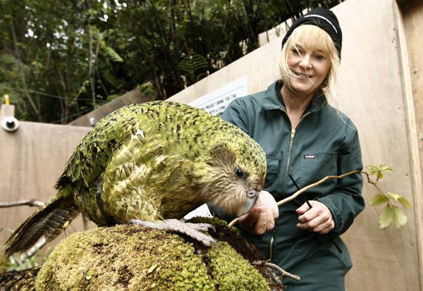

Pelecaniformes & Shorebirds 9/8/21 Summaries
Journal of Wildlife Diseases, 56(1), 2020, pp. 167–174
SUSCEPTIBILITY OF LAUGHING GULLS (LEUCOPHAEUS ATRICILLA) AND MALLARDS (ANAS PLATYRHYNCHOS) TO RUDDY TURNSTONE (ARENARIA INTERPRES MORINELLA) ORIGIN TYPE A INFLUENZA VIRUSES
Charlie S. Bahnson,1,2 Rebecca L. Poulson,1 Laura P. Hollander,1 Jo A. Crum Bradley,1 and David E. Stallknecht1

ABSTRACT: Delaware Bay, US is the only documented location where influenza A virus (IAV) is consistently detected in a shorebird species, the Ruddy Turnstone (RUTU; Arenaria interpres morinella). Although IAV in shorebirds has been well studied at this site for decades, the importance of other species in the avian community as potential sources for the IAVs that infect RUTUs each spring remains unclear. We determined the susceptibility of Mallards (Anas platyrhynchos) and Laughing Gulls (Leucophaeus atricilla), to IAVs isolated from RUTUs in order to gain insight into the potential host range of these viruses. Captive-reared gulls were challenged with RUTU-origin H6N1, H10N7, H11N9, H12N4, and H13N6 IAV, as well as Mallard-origin H6N1 and H11N9. We challenged captive- reared Mallards with the same viruses, except for H13N6. At a biologically plausible challenge dose (104 50% embryo infective doses/0.1 mL), one of five gulls challenged with both H6N1 IAVs shed virus. The remaining gulls were resistant to infection with all viruses. In contrast, all Mallards were infected and shed virus. The H12N4 Mallard challenge group was an exception with no birds infected. These results indicated that Mallards are permissive to infection with viruses originating from a shorebird host and that interspecies transmission could occur. In contrast, host adaptation of IAVs to RUTUs may compromise their ability to be transmitted back to gulls.

Study Design: Experimental inoculation

Goal: In this study, we challenged Mallards and LAGUs with RUTU-origin IAVs to assess the degree to which adaptation of IAVs to RUTUs permits or impedes subsequent infections in ducks and gulls

Key Points:
- A high prevalence of influenza A virus (IAV) is detected annually at Delaware Bay, New Jersey, US in one shorebird species, the Ruddy Turnstone (RUTU)
  - Despite long-term studies at this site, the source of IAVs that annually infect RUTUs is unclear, as is the necessity of a multispecies avian community to maintain these viruses
  - It has been suggested that at least some of the IAVs isolated from RUTU originate from gulls that cohabit DE Bay
  - Laughing Gulls (LAGU; Leucophaeus atricilla) are commonly observed feeding alongside RUTU flocks during the stopover
  - Alternatively, as RUTUs utilize marsh habitats that are also used by dabbling ducks such as Mallards (Anas platyrhynchos)

- Both ducks and gulls may contribute to IAV dynamics during the stopover by serving as a source of IAVs, amplifying IAVs, or contributing to subtype reassortment
  - However, it is unknown to what degree IAVs can be readily transmitted between these species
- No birds displayed clinical signs during the study despite experimental inoculation
- In the present study, Mallards were susceptible to three of the four RUTU-origin IAVs.
  - By comparison, at what we argue is a biologically plausible challenge dose (104 EID50), LAGUs were very resistant to several IAVs of varying subtypes
- This lends strength to our overall finding that Mallards are susceptible to a variety of RUTU-origin IAVs of several HA subtypes, whereas gulls may be comparatively less susceptible
  - However, caveats to this theme were observed in three of the five HA subtypes: H6, which replicated poorly in gulls; H12, which did not replicate in either species; and H13, which did not replicate in gulls but was not used to challenge Mallards
- Our study demonstrated a resistance of LAGUs to infection with RUTU- and Mallard-origin IAVs, but the underlying determinants of this observed host restriction were not fully understood
  - However, one key adaptation of a duck virus to gulls may be a shift in preferential affinity for sialic acids bound to a penultimate galactose that is fucosylated

TLDR:
- Susceptibility of a species, as determined by the mean infectious dose required to infect a given species, is an indicator of how host-adapted a particular IAV is to a species
- Thus, the overall pattern of our findings demonstrated that RUTU-origin IAVs may be poorly host adapted to LAGUs, yet readily infect ducks
- Although either ducks or gulls may be a source of IAVs for RUTUs at DE Bay, host adaptation may compromise the ability of these viruses to be transmitted to gulls, whereas IAVs may be readily exchanged between RUTUs and ducks

Journal of Wildlife Diseases, 57(1), 2021, pp. 1–18
A SYSTEMATIC REVIEW AND NARRATIVE SYNTHESIS OF THE USE OF ENVIRONMENTAL SAMPLES FOR THE SURVEILLANCE OF AVIAN INFLUENZA VIRUSES IN WILD WATERBIRDS
Michelle Coombe,1,2,3,9 Stefan Iwasawa,4 Kaylee A. Byers,3,5,6 Natalie Prystajecky,7,8 William
Hsiao,7,8 David M. Patrick,1,8 and Chelsea G. Himsworth1,2,3

ABSTRACT: Wild waterbirds are reservoir hosts for avian influenza viruses (AIV), which can cause devastating outbreaks in multiple species, making them a focus for surveillance efforts. Traditional AIV surveillance involves direct sampling of live or dead birds, but environmental substrates present an alternative sample for surveillance. Environmental sampling analyzes AIV excreted by waterbirds into the environment and complements direct bird sampling by minimizing financial, logistic, permitting, and spatial-temporal constraints associated with traditional surveillance. Our objectives were to synthesize the literature on environmental AIV surveillance, to compare and contrast the different sample types, and to identify key themes and recommendations to aid in the implementation of AIV surveillance using environmental samples. The four main environmental substrates for AIV surveillance are feces, feathers, water, and sediment or soil. Feces were the most common environmental substrate collected. The laboratory analysis of water and sediment provided challenges, such as low AIV concentration, heterogenous AIV distribution, or presence of PCR inhibitors. There are a number of abiotic and biotic environmental factors, including temperature, pH, salinity, or presence of filter feeders, that can influence the presence and persistence of AIV in environmental substrates; however, the nature of this influence is poorly understood in field settings, and field data from southern, coastal, and tropical ecosystems are underrepresented. Similarly, there are few studies comparing the performance of environmental samples to each other and to samples collected in wild waterbirds, and environmental surveillance workflows have yet to be validated or optimized. Environmental samples, particularly when used in combination with new technology such as environmental DNA and next generation sequencing, provided information on trends in AIV detection rates and circulating subtypes that complemented traditional, direct waterbird sampling. The use of environmental samples for AIV surveillance also shows significant promise for programs whose goal is early warning of high-risk subtypes

Study Design: Systematic review and narrative synthesis based on the full body text of peer-reviewed articles (n=113)

Goal:
- Compare and contrast the different sample types used in environmental AIV surveillance
- Identify key themes and recommendations to aid in the implementation of AIV surveillance using environmental sample

Key Points:
- Avian influenza viruses (AIV) can cause morbidity and mortality in domestic animals, wild animals, and humans
  - Ongoing AIV infections in people— involving multiple subtypes, including H5, H7, and H9 highlight a growing public health concern due to the viruses’ pandemic potential
- Wild birds are reservoir hosts for all strains of AIV and play a key role in AIV ecology, particularly waterbirds, which include Anseriformes and Charadriiformes
  - Waterbirds are usually asymptomatic carriers of low pathogenicity avian influenza (LPAI), shedding virus in feces
  - Viral excretion by waterbirds during migration is essential to the spread AIV across geographic locations
  - Migration also results in the intermingling of birds from disparate locations, leading to co-infection with multiple viruses, reassortment, and the emergence of new strains
  - As a result, waterbirds are a primary target for AIV surveillance
- Most surveillance programs are based around AIV detection (i.e., identification of AIV RNA in a sample) or isolation (i.e., growing AIV using cell or egg culture) from individual birds who are sampled through some combination of:
  - Live trapping
  - Hunting
  - Collection of birds dead from other causes
  - Sentinel birds
  - All of these methods have significant limitations that affect their utility
- Surveillance based on environmental samples has been proposed as a supplementary strategy for testing individual birds because wild waterbirds excrete the virus, and environments where waterbirds congregate (e.g., wetlands, beaches) can be heavily contaminated
  - AIV have been found in several different environmental substrates, including feces, feathers, water, and sediment
Sample Types
- Feces: Feces were the most commonly used environmental sample for AIV surveillance
  - Feces can be considered an intermediate sample type between samples obtained directly from wild waterbirds (e.g., cloacal swabs) and environmental substrates (e.g., water)
    - For example, cloacal swabs and feces can be handled and analyzed the same way in the laboratory but, similar to other environmental samples, fecal samples are often dissociated from the source animal, resulting in a loss of ecological data
- Water: Laboratory studies that use AIV-inoculated samples have demonstrated it is possible to detect or isolate AIV from a variety of water sources
  - In contrast, field studies have only successfully detected or isolated AIV from fresh lake water or ice sources
  - AIV in water are present in lower concentrations than in fecal samples; thus large volumes (i.e., 1 L or more) or a concentration step are often used prior to detection or isolation
- Soil-based substrates: AIV have been identified in a number of soil- based wetland substrates including soil, mud, sand, and sediment
  - Sediment is the organic and inorganic material that collects at the bottom of a water body and was the most common soil-based substrate investigated
  - Although the depth of sediment sample collection is typically not reported, sediment in shallow water is thought to be an important medium for fecal-oral transmission among dabbling ducks
  - AIV detection and isolation in sediment can be hampered by low viral concentrations, viral inactivation, RNA degradation, and the presence of inhibitory substances
    - However, in some scenarios, AIV RNA can also be preserved by being bound within the substrate matrix
- Feathers: AIV can be introduced onto feathers through contact with water contaminated by feces or through contact with respiratory secretions from preening or allogrooming
  - Uropygial secretions present on feathers can also act to concentrate AIV and feathers often remain longer in the environment than feces
- Biotic Samples: It is of note that AIV has also been found in aquatic plants and animals.
  - Aquatic invertebrate filter feeders such as bivalves and Daphnia are of particular interest because they can accumulate AIV through their normal feeding behavior
  - The dynamics of AIV in aquatic organisms is likely dependent on the complex interactions among waterbirds, AIV, aquatic organisms, and the environment
Collection of Samples
- Despite the global distribution of waterbirds, inland temperate biomes from the northern hemisphere are over-represented among field studies of AIV using environmental samples
  - The represented tropical biomes are all sites within one country (Cambodia) and there are no sampling sites from the southern hemisphere
  - Unequal representation of ecosystems is problematic as the ecology of waterbirds and AIV can vary among biomes and between hemispheres
- Anthropogenic habitat disturbance can also affect AIV in waterbirds and the environment
  - For example, the provision of resources through activities such as baiting traps can increase waterbird concentration, thereby increasing AIV transmission and shedding
- Given the indirect nature of environmental sampling, it was nevertheless often uncertain which species were actually contributing to the sample results
- Relative to the live capture of wild waterbirds specifically for the purposes of AIV surveillance, the collection of all environmental sample types is less technical, requires less equipment, and can be undertaken in areas where capture or hunting is prohibited
- Environmental samples can require additional pre-analysis processing compared to feces and cloacal swabs

Epidemiology of AIV
- The presence of AIV in a sample is usually identified through virus isolation (VI), reverse transcription PCR, or both
  - In general, PCR is more sensitive than VI because VI only detects infectious virus, whereas PCR can detect both infectious and noninfectious viruses, as well as free viral RNA
- AIV are mainly subtyped based on the hemagglutinin (HA) and neuraminidase (NA) surface proteins or the genes encoding them
  - Serological assays (i.e., hem- agglutination inhibition and neuraminidase inhibition), subtype-specific PCR, or sequencing can be used to characterize AIV
  - Sequencing of AIV can be done either on isolates obtained through VI or directly on the environmental sample
- In general, environmental samples do not provide accurate measures of AIV prevalence in birds
- Environmental samples appear to be valuable for identifying trends in circulating AIV subtypes
  - Studies have shown that subtypes found in sediment can reflect the predominant strains circulating in birds and might be more sensitive than direct waterbird sampling for identifying low-prevalence subtypes
- Results of environmentally based AIV surveillance must also be interpreted in light of a variety of abiotic factors that can influence viral persistence and detection
  - These include physiochemical factors such as temperature, pH, and salinity, which can affect the survival of AIV in water
- Samples collected directly from waterbirds are most appropriate where the goal is to understand the epidemiology of AIV, provided those samples adequately represent the larger waterbird population
- Environmental samples can be useful where the goal is to understand the role of the environment itself in the ecology of AIV
- Providing an early warning for possible AIV spillover to domestic species or humans is the most commonly cited reason for the surveillance of AIV in wild waterbirds, and environmental samples are particularly well-suited to this goa
  - Surveillance for early detection differs from epidemiological goals in that it is principally concerned with the presence and spread of high-risk AIV segment subtypes (e.g., LPAI H5, LPAI H7, any highly pathogenic avian influenza)
  - Environmental sam- ples can also be used to monitor geographic and temporal trends in circulating high-risk HA subtypes over time

TLDR:
- Environmental samples, particularly when used in combination with new technology such as environmental DNA and next generation sequencing, provided information on trends in AIV detection rates and circulating subtypes that complemented traditional, direct waterbird sampling
- Environmental samples might be particularly beneficial in the early detection of high-risk AIV subtypes, because they provide high information density per sample, might represent multiple birds or species within one sample, and a large number of samples can be collected easily and quickly, making them attractive for large- scale (e.g., national) surveillance programs; however, their utility in this context remains to be confirmed
- Given that environmental samples and those obtained from waterbirds have different strengths and limitations, these two approaches must be used in a complementary manner to address the range of surveillance goals and needs for AIV risk assessment and mitigation

Useful Figures: 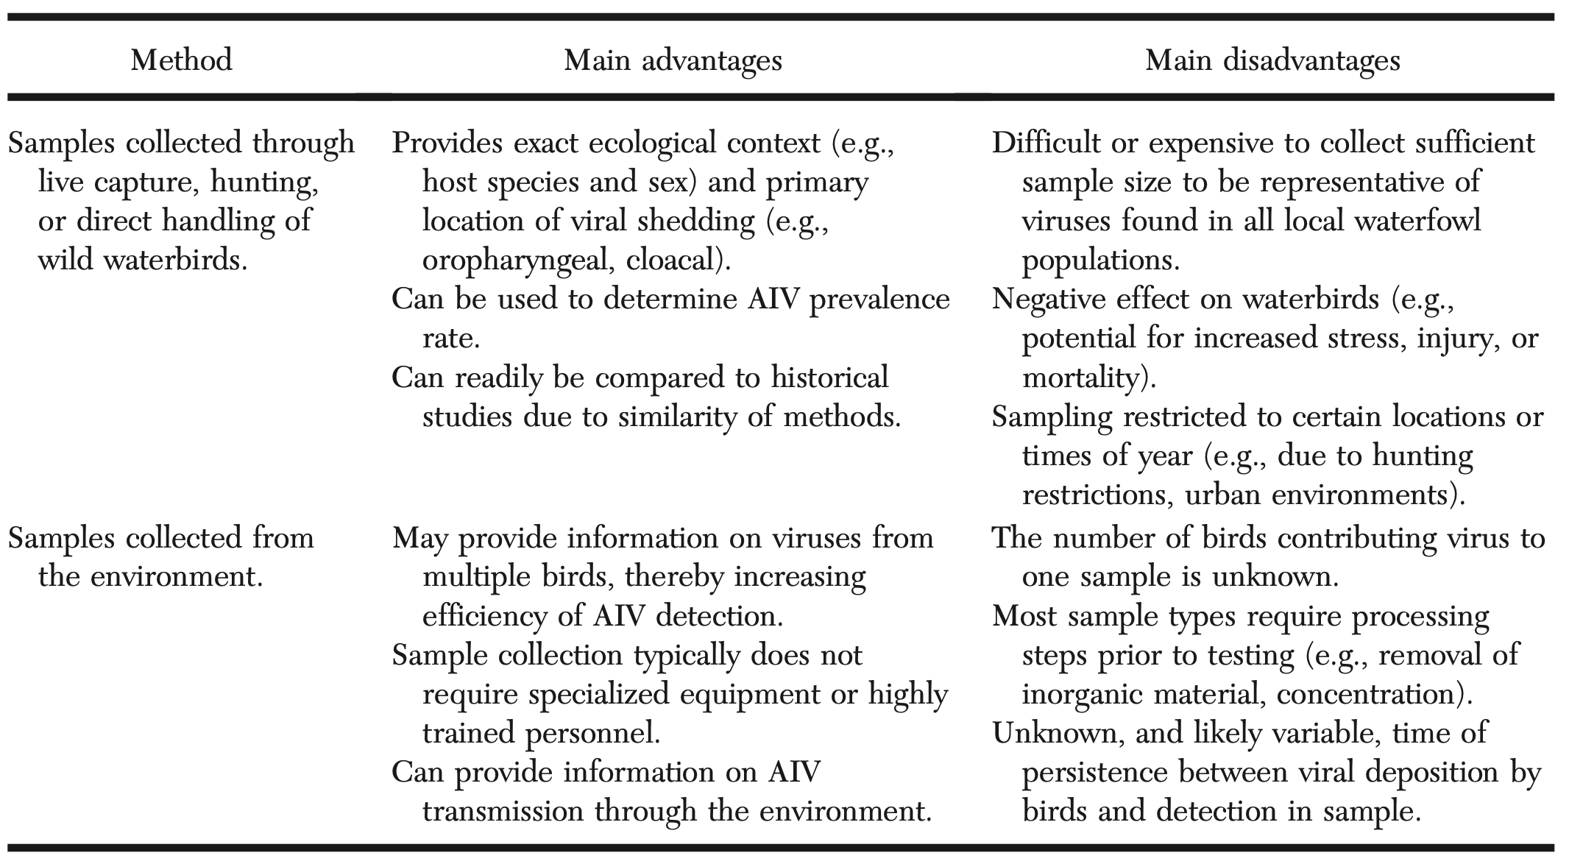
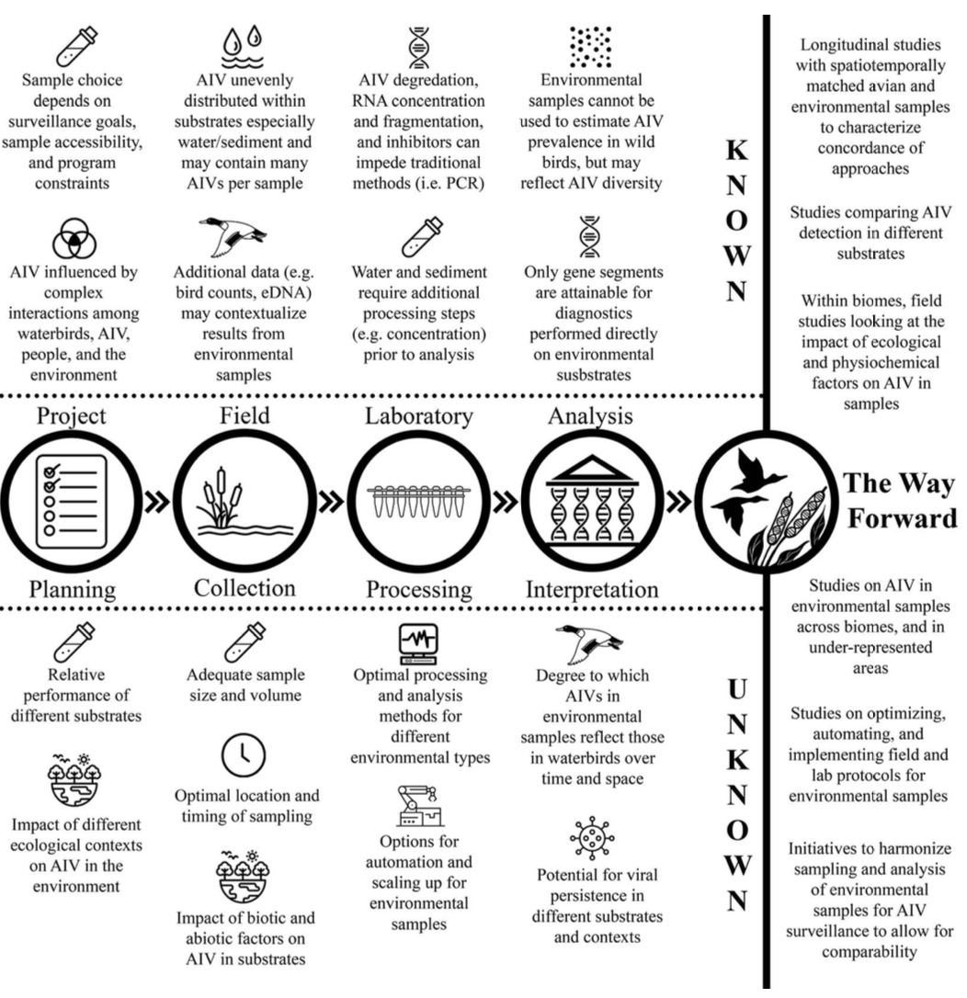

Whitmer, E. R., Elias, B. A., Harvey, D. J., & Ziccardi, M. H. (2018). An experimental study of the effects of chemically dispersed oil on feather structure and waterproofing in Common Murres (Uria aalge). Journal of wildlife diseases, 54(2), 315-328.

Abstract: Following an oil spill in the marine environment, chemical dispersants, which increase oil droplet formation and distribution into the water column, are assumed to provide a net benefit to seabirds by reducing the risk of exposure to oil on the water surface. However, few data are available regarding acute, external impacts of exposure to dispersed oil. We evaluated the effects of known concentrations of dispersant and crude oil in artificial seawater on live Common Murres (Uria aalge). Waterproofing and microscopic feather geometry were evaluated over time and compared to pre-exposure values. Birds exposed to a high concentration of dispersant experienced an immediate, life-threatening loss of waterproofing and buoyancy, both of which resolved within 2 d. Birds exposed to oil, or a dispersant and oil mixture, experienced dose-dependent waterproofing impairment without resolution over 2 d. Alterations in feather geometry were observed in oil-exposed or dispersant- and oil-exposed birds and were associated with increased odds of waterproofing impairment compared to control birds. At a given contaminant concentration, there were no significant differences in waterproofing between oil-exposed and dispersant- and oil-exposed birds. We found that acute, external effects of oil and dispersed oil exposure are comparable and dose-dependent. Our results also indicate that a zero-risk assumption should not be used when seabirds are present within the dispersant application zone.
- Introduction:
  - Structural properties of feathers establish water-resistance and trap insulating air against skin for thermoregulation.
  - Oil exposure acutely disrupts the plumage barrier (dose-dependent).
  - Chemical dispersants – detergent-like, increase oil droplet formation and promotes entrainment into the water column.
    - Reduces surface oil, increases availability of petroleum to bacteria for biodegradation, decreases shoreline habitat contamination.
    - Available data insufficient to evaluate impacts of dispersant on seabirds.
  - Pilot study: examined impacts of dispersant, Prudhoe Bay crude oil, or dispersant-trated oil on Common Murre feathers.
    - Exposure to dispersant alone and dispersant/oil mix resulted in grossly decreased water repellency, altered microscopic feather geometry, increased crystalline debris.
    - This study – multifactorial to build on that pilot.
- M+M:
  - 40 Common Murre captured, Monterey Bay CA.
  - Itraconazole for prevention of aspergillosis.
  - NaCl tablets and vitamin supplements every other day.
  - Physical exams, CBC/chem.
  - Randomly assigned to control or treatment groups.
    - Prior to exposure – weight, BCS, attitude, hydration, plumage condition, waterproofing status.
    - Plucked two feathers for comparison with postexposure.
  - Control group: Exposed to artificial seawater.
  - Tx groups: Exposed to increasing conc of dispersant (Corexit) or mix of oil and dispersant.
  - Post-exposure: Each group placed in a pool for evaluation period. Day 1, 2.
    - Waterproofing assessed following removal from pool, feathers plucked from ventrum after day 2 evaluation.
    - Birds were cleaned, rinsed, dried in standard manner on day 3.
    - Day after cleaning had another evaluation in the pool.
    - Released.
  - Evaluated several feather parameters (measurements between barbs and rachis, ratio of number of barbules from rachis and clumps formed from barbules, etc..).
  - Evaluated distribution of morphologic and physiologic characteristics within and between exposure groups.
- Results/Discussion:
  - 36 birds met inclusion criteria (didn’t have other illness).
    - Four mortalities occurred between exposure and cleaning phases; multiple abnormalities on necropsy (bacterial pneumonia, air sacculitis, viral bronchitis, coccidial enteritis).
    - Distribution of waterproofing scores significantly different across tx groups immediately after and on days 1, 2.
      - Catastrophic loss of waterproofing in DISP-H group.
      - Waterproofing scores worsened after exposure to oil and mixed oil and dispersant group in dose-dependent manner.
  - Seabird waterproofing is negatively affected in a similar dose-dependent manner by both crude oil and chemically dispersed crude oil.
    - Dispersant alone – negative waterproofing effects, catastrophic consequences at high concentrations.
    - Impacts of dispersant improved with the time the birds spent out of the water.
    - Oil exposure – birds affected in dose-dependent manner.
      - Decreased distance and increased clumping in feather tips relative to control, indicates collapse of normal feather architecture.
      - Structural changes may affect waterproofing.
      - No evidence of recovery from oil-associated feather structural change and waterproofing impairment 2 days after exposure.
        - Recovery from contamination without human intervention is unlikely.
    - Dispersant and oil exposure – similar to oil alone.
      - Feathers had increased clumping relative to control immediately after exposure and on day 2.
      - Chemical dispersant does not notably alter the impacts of oil exposure on waterproof, nor does it improve the likelihood of recovering functional waterproofing after exposure (similar to other prior studies).
    - Dispersant only – Three phenomena were observed:
      - Impacts of exposure immediate and life-threatening.
        - Complete loss of buoyancy. SW and WTS scores increased significantly after exposure.
        - Intervention in the rinse pool necessary to prevent drowning.
      - Loss of waterproofing in dispersant-exposed groups distinctly improved after day 1.
      - Dispersant-only exposure did not impact distance or clumping, indicating that in contrast to oil, observed impacts to waterproofing do not arise from feather structural changes.
  - Conclusion:
    - Accidental exposure of birds to pure, high-concentration dispersant may result in high morbidity and mortality.
      - Birds that are off water for at least 1 day may survive to recover functional waterproofing without further intervention.
      - Structural changes assoc with waterproofing loss after oil exposure not found after dispersant exposure alone.
    - Oil-dispersant mixed have similar waterproofing impacts to oil alone.
    - Ratio applied to spill that encounters bird may be variable (US industry recommendation 1:20 used in this study).

POSTRELEASE SURVIVAL OF CALIFORNIA BROWN PELICANS (PELECANUS OCCIDENTALIS CALIFORNICUS) FOLLOWING OILING AND REHABILITATION AFTER THE REFUGIO OIL SPILL
JWD 2021 57(3) 590-600
Abstract: Oil spills represent a continued threat to marine wildlife. Although the public expects, and the State of California, US requires, oiled animals to be rescued for rehabilitation and release, scientists have questioned the welfare and conservation value of capture and rehabilitation of oiled wildlife, based on poor postrelease survival documented in the few available studies. In May 2015, Plains Pipeline 901 spilled .100,000 gallons of oil near Refugio State Beach, California. Many California Brown Pelicans (Pelecanus occidentalis californicus) were oiled; capture and rehabilitation efforts began within 1 d. Ultimately, 65 live birds were captured, including 50 pelicans. Forty-six pelicans survived and were released. Of these, 12 adults (six male, six female) were fitted with solar-powered GPS satellite Platform Terminal Transmitters (PTT) and released in June 2015. In early July, we captured eight adult (three male, four female, one unknown), unoiled pelicans from the Ventura, California area. These control birds were similarly instrumented and released immediately. At 6 mo after release, PTTs from nine of 12 oiled pelicans and six of eight control pelicans were still transmitting; at 1 yr, those numbers decreased to two of 12 and two of eight, respectively. Survival analysis revealed no difference in survival between oiled and control birds. Although our sample size is limited, these data demonstrate that most oiled and rehabilitated pelicans can survive for 6 mo following release, and some individuals can survive over 1 yr.
Summary:
Intro:
- Long term post-release studies for rehabilitation of oiled wildlife are rare
  - Exception – penguins, tend to do well
- Plains Pipeline 901 spill – pelicans monitored for post release survival for 1 year
M+M:
- 46 pelicans survived and were released – 12 fitted with transmitters
  - CBC, serum chemistry, fibrinogen, EPH performed on rehab birds
- 8 unoiled pelicans captured and used as controls, also fitted with transmitters
Results/discussion:
- Oiled and released birds survived an average of 251 + 93.7 days, compared to average of 240.3 + 85.6 days for control birds
- no significant difference in survival between oiled and control birds at either 6 mo or 1 yr
  - survival rates in both groups ~75% at 6 mo
- limitations – difficult to determine mortality definitively using transmitters
- oiled and rehabbed birds had higher TP
- control birds had higher eosinophil counts
Conclusion: California Brown Pelicans that were oiled during Refugio oil spill and captured, cleaned, rehabilitated, and instrumented with PTT satellite tags did not have higher mortality in year following release compared to unoiled pelicans that were captured and similarly instrumented

