Way, K., Haenen, O., Stone, D., Adamek, M., Bergmann, S. M., Bigarré, L., ... & Waltzek, T. (2017). Emergence of carp edema virus (CEV) and its significance to European common carp and koi Cyprinus carpio. Diseases of aquatic organisms, 126(2), 155-166.

Abstract: Carp edema virus disease (CEVD), also known as koi sleepy disease, is caused by a poxvirus associated with outbreaks of clinical disease in koi and common carp Cyprinus carpio. Originally characterised in Japan in the 1970s, international trade in koi has led to the spread of CEV, although the first recognised outbreak of the disease outside of Japan was not reported until 1996 in the USA. In Europe, the disease was first recognised in 2009 and, as detection and diagnosis have improved, more EU member states have reported CEV associated with disease outbreaks. Although the structure of the CEV genome is not yet elucidated, molecular epidemiology studies have suggested distinct geographical populations of CEV infecting both koi and common carp. Detection and identification of cases of CEVD in common carp were unreliable using the original PCR primers. New primers for conventional and quantitative PCR (qPCR) have been designed that improve detection, and their sequences are provided in this paper. The qPCR primers have successfully detected CEV DNA in archive material from investigations of unexplained carp mortalities conducted >15 yr ago. Improvement in disease management and control is possible, and the principles of biosecurity, good health management and disease surveillance, applied to koi herpesvirus disease, can be equally applied to CEVD. However, further research studies are needed to fill the knowledge gaps in the disease pathogenesis and epidemiology that, currently, prevent an accurate assessment of the likely impact of CEVD on European koi and common carp aquaculture and on wild carp stocks.

Question:
You are contacted for consultation on a disease outbreak that occurred at a koi (Cyprinus carpio) farm following introduction of new fish. Affected individuals have been reportedly lethargic and lying on their side at the bottom of the tank. On physical exam, you observe the following clinical signs. What is your primary differential diagnosis, and how can you test for the suspected disease?
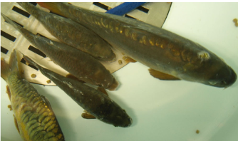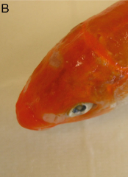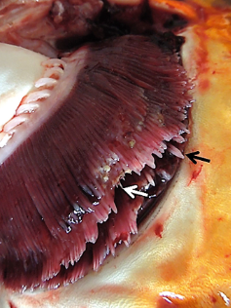
Answer: Carp edema virus disease (CEVD) aka koi sleepy disease; Dx with PCR of gill tissue.

Which of the following is true regarding a recent orthopoxvirus seroprevalence study in wild carnivores in northwestern Chihuahua, México?
- Raccoons had the highest seroprevalence.
- Fox kits had the highest seroprevalence.
- The presence of antibodies was suspected to be related to oral rabies vaccine exposure.
- Northwestern Chihuahua, México overall had a very low seroprevalence.
- Half of the animals tested also had antibodies to rabies.

Practice Question:
Which of the following is true regarding avipoxvirus infection in aviary-housed, wild-caught snow buntings (Plectrophenax nivalis) in Quebec?
- Infection resulted in an epornitic characterized by high morbidity, but low mortality
- The associated avipoxvirus originated from black-capped chickadees (Poecile atricapillus)
- Sequencing of the associated avipoxvirus placed it phylogenetically in avipoxvirus clade A
- Topical treatment with a dexamethasone/tobramycin ophthalmic ointment proved successful
- The seasonal pattern of cases was suggestive of transmission by local biological vectors

Answer: E Novel poxviral infection in three finch species illegally imported into Trinidad, West Indies, with implications for native birds.
Suepaul RB, Seetahal JF, Oura C, Gyan L, Ramoutar VV, Ramkissoon V, Sahadeo N, Carrington CV.
Journal of Zoo and Wildlife Medicine. 2019;50(1):231-237.

Which infectious disease has been found in illegally imported finches in Trinidad, presenting a risk to native finch species in decline?
- Canarypox virus
- Starlingpox virus
- Mycoplasma gallisepticum
- Mycoplasma synoviae
- Candida albicans

Answer: A

Which of the following is consistent with avipoxvirus on electron microscopy?
- Nuclear inclusions with large numbers of brick shaped, enveloped, viral particles with a nucleocapsid
- Cytoplasmic inclusions with large numbers of oval-shaped, enveloped, viral particles with a nucleocapsid
- Cytoplasmic inclusions with large numbers of oval-shaped, non-enveloped, viral particles with a nucleocapsid
- Cytoplasmic inclusions with large numbers of brick-shaped, non-enveloped, viral particles with a nucleocapsid
- Cytoplasmic inclusions with large numbers of brick-shaped, enveloped, viral particles with a nucleocapsid

What family of virus is carp edema virus? What is the classic clinical sign? What is a proposed treatment?

Answer: Poxvirus, lethargic “sleepy” behavior (could also accept gill edema), treatment with salt

Answer: E

