Goodarzi, Nader, et al. "Anatomy of the Tarsometatarsal Region and Digits in the Ostrich (Struthio Camelus): A Computed Tomography and Cross-Sectional Study." Journal of avian medicine and surgery 34.2 (2020): 142-151.

The ostrich is the largest living bird and has unique characteristics in its locomotor system that differentiate it from other bird species. The purpose of this study was to provide a reference atlas of reference-interval computed tomography (CT) and cross-sectional anatomy of the tarsometatarsal region and digits in the ostrich (Struthio camelus). The pelvic limbs of 25 ostriches were used for this imaging study. The transverse CT images were obtained from the middle third of the tarsometatarsal bone to the distal end of the third digit. The specimens were frozen and sectioned with an electric band saw at 1.5–2 cm intervals. The CT images were compared with the corresponding frozen cross sections. The bones, ligaments, and tendons were identified and labeled at each 1.5–2 cm intervals. The CT images provided anatomic details of the tendons and ligaments in the tarsometatarsal region and digits of the ostrich. The transverse CT images provided an excellent depiction of the anatomic structures of the leg and foot when compared with the corresponding frozen cross sections. The information presented in this study may be used as an initial reference when evaluating the CT images of an ostrich's tarsometatarsal region and digits. Moreover, the information provided in this report may be helpful in determining definitive diagnoses of musculoskeletal disorders affecting the lower leg in this species.

Background
- Ostrich: Struthionidae, genus Struthio - fastest biped (>50 km/h), lowest running energy cost
  - Flightless, only has 3rd and 4th digit, suspended metatarsophalangeal joint, strong pelvic limb musculature
Key points
- Twenty-five distal pelvic limbs of 1-year-old ostriches were used
- Limbs were put through the CT, then physically cross sectioned, and CT reconstructions were compared to the anatomic specimens
- CT images of ostrich distal pelvic limb provided acceptable detail of structures and correlated with gross anatomic sections (tendons, ligaments, and bones were all readily identified)
- Images can be used as reference interval for evaluated tarsometatarsal region and digits in the ostrich

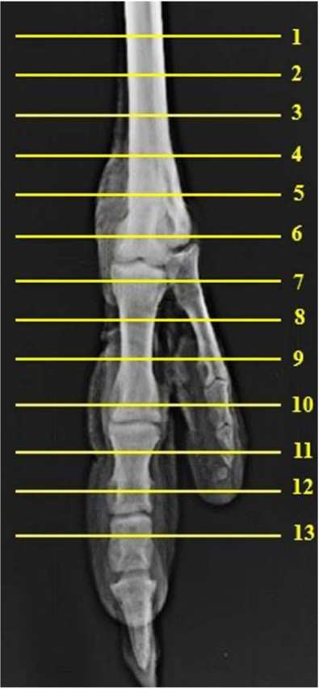 *See paper for cross sectional images

Tehrani, P. R., Gilanpour, H., & Veshkini, A. (2017). Radiographic anatomy of the Metatarsophalangeal joint and digits of the ostrich (Struthio camelus). Journal of avian medicine and surgery, 31(3), 198-205.

Abstract: The aim of this study was to develop a detailed and accessible set of reference images of the normal radiographic anatomy of the digits of the ostrich (Struthio camelus), with emphasis on the metatarsophalangeal joint and its arthrography. The distal excised pelvic limbs of 10 normal ostriches of different ages (ranging from 10 to 365 days of age) obtained from an abattoir were radiographed, and 2 arthrograms were performed. To illustrate the normal radiographic anatomy of the tarsometatarsal bone, 39 images were selected, labelled, and presented along with detailed descriptions and corresponding images of the bony skeleton. These results provide a valuable dataset to assist in understanding the normal anatomy of the ostrich metatarsophalangeal joint and digits and allow comparison of abnormal corresponding structures in clinical cases in ostriches.
- Introduction:
  - Ostrich has 2 toes, suspended metatarsophalangeal joint.
    - Standing weight is borne entirely by the digits.
    - Metatarsophalangeal joint exhibits largest flexion/extension excursion of all joints.
    - Other studies exist for shoulder, elbow, stifle, and intertarsal joints.
- M+M: Rads and arthrography (contrast imaging of joints) of metatarsophalangeal joint of 10 normal ostrich limbs, ages 10-365 days.
- Results:
  - Metatarsophalangeal joint:
    - Day 10 – 3 bones at proximal and distal metatarsal bone, P5 D4 was cartilaginous, not visible on rads. Diaphysis incompletely ossified, epiphyses of bones of metatarsophalangeal joint not visible.
    - Day 20 – TMT bones fused at distal end.
    - Day 90 – TMT bone formed by 3rd and 4th metatarsal bones separated at proximal and distal ends, fused medially. Metatarsophalangeal joint 3 formed, joint 4 not formed.
    - > 135 days – process present on medial surface of medial trochlea likely remnant of the second metatarsal bone.
  - Digits:
    - D3 – 4 phalanges with 3 interphalangeal joints.
    - First IP joint between P1, P2. Saddle-shaped, sagittal groove and ridge system helps limit medial and lateral movement.
    - Second IP joint between P3, P2. Third IP joint between P4, P3.
    - D4 (smaller, outer toe) – 5 phalanges, 4 IP joints.
  - Arthrography of MTP joint:
    - Dorsal, plantar pouches. Pouches around flexor tendons.
    - No connection between MTP joint cavities of the 2 digits.
- Takeaways: Bones of the MTP joint ossify after 135 days of age. No communication between MTP joints 3 and 4. Normal radiographic anatomy reference.

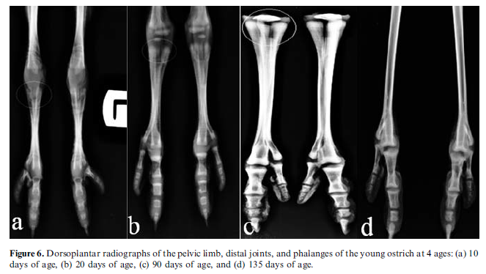
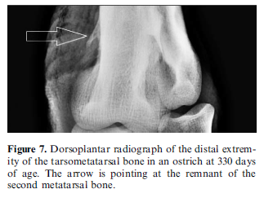
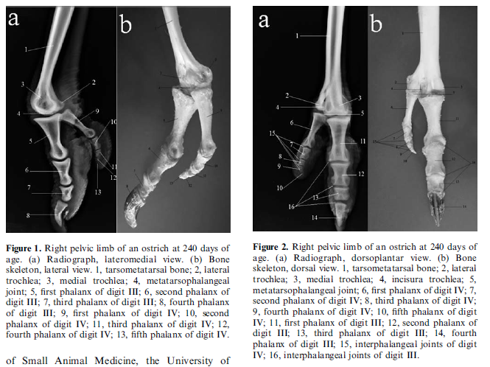
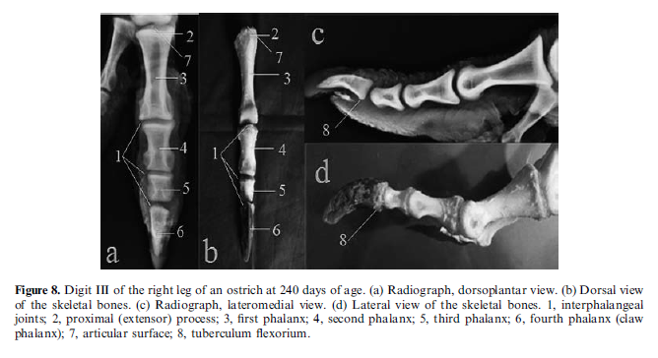
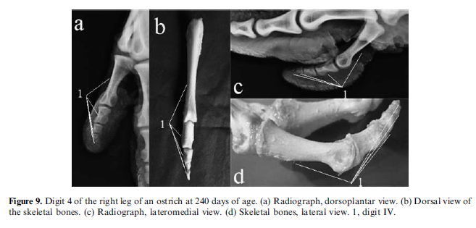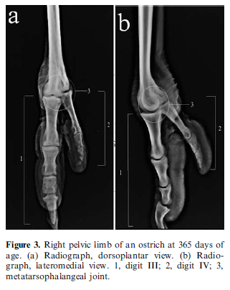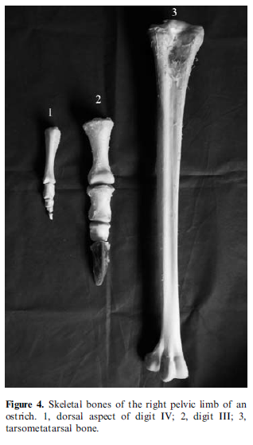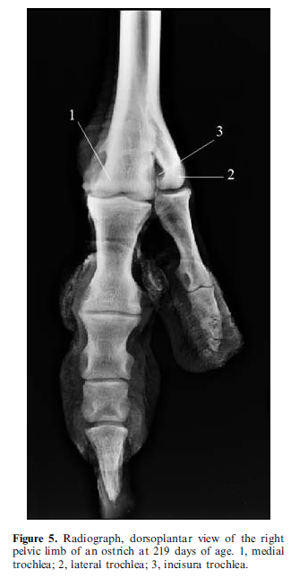

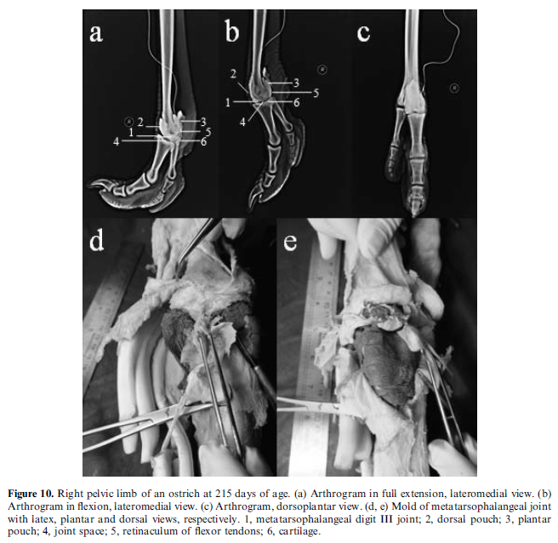

Management of Knuckling in an Ostrich (Struthio camelus) Using a Custom-Made Orthotic Shoe.
Raghav, R., Al Busaidi, T. M., & Samour, J.
Journal of Avian Medicine and Surgery, 2020;34(4):381-389.

Abstract: A 4-year-old female ostrich (Struthio camelus) developed knuckling on its left foot after a traumatic event. Conservative treatment, rest, and traditional splinting methods failed to resolve the gait abnormality or improve mobility. A dynamic multicomponent orthotic shoe was then custom designed and fabricated with an ultra-high–molecular weight, low-pressure polyethylene polymer (St 1000 DIN16972 TG2) to correct the foot malposition. The affected foot and leg were wrapped with soft padding and the orthosis was attached and secured by nylon belts (Nylon PA [polyamide] 6, a semicrystalline polyamide polymer) with self-locking modified wrench straps. The orthosis immediately prevented knuckling and improved ambulation. After 2 weeks, this shoe was replaced with a modified orthotic shoe of lighter weight to improve kinetics and ease of use by the bird. The modified orthosis dramatically improved ambulation and was left attached to the affected leg for 7 more weeks. Thereafter, the bird was able to ambulate comfortably without the aid of the shoe, even though permanent anatomical changes to the affected leg seemed to restrict its speed of locomotion. The ostrich had another unfortunate traumatic event 10 weeks later, the result of which was knuckling on the contralateral (right) foot. After routine medical and supportive care, the orthosis was then applied to the right foot for a period of 9 weeks. During this period the bird was able to ambulate well, despite having to support the bulk of its weight on the previously affected left limb. At the end of 9 weeks, the orthosis was removed, and the bird was able to ambulate without aid, although the bird's speed of locomotion was considerably reduced. After recovery of its leg problems, the ostrich was confined to a relatively small paddock for the rest of its life.

Background
- Peroneal nerve compression on lateral stifle - innervates flexors of hock and extensors of digits
  - Inability to extend digits results in knuckling
  - Even <1 hr of pressure can cause compression and ischemic edema of peroneal nerve
  - Prevent with maintenance in sternal as early as possible, padding under legs
- Dermal pads on plantar surface of the digits: thick, epidermis is tightly packed vertical rods of cornified tissue
  - Deeper paired tubular plantar fat bodies in fibrous capsules aid in absorbing pressure and weight distribution during locomotion
  - Larger digit bears more weight, especially distal phalanges while walking
    - Metatarsophalangeal joint and proximal phalanx are elevated from the ground
  - During running, weight loading increases on proximal phalanges of third digit and distal phalanx of fourth digit (acts as a balancing outrigger)
- Zoletil 4 mg/kg to anesthetize

Key Points
- Knuckling; L metatarsophalangeal joint rigid, painful, hyperflexed; sensation and withdrawal intact
- Custom orthotic shoe 7 weeks
- Permanent reduced extension, increased weight distribution to distal phalanges of 3rd digit

Conclusions
- Successful management of post traumatic knuckling in an ostrich with dynamic custom-designed orthosis
- Avoid prolonged recumbency in ostriches with uneven pressure on lateral stifle

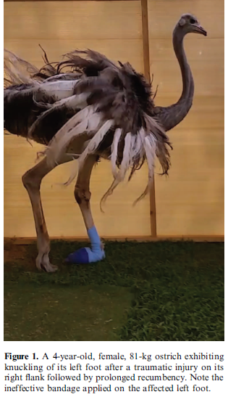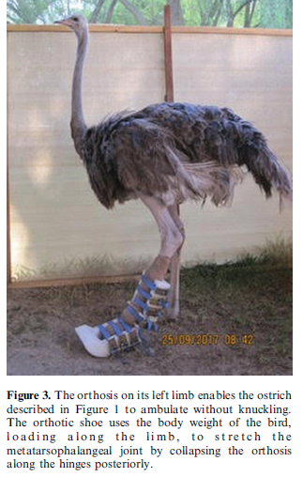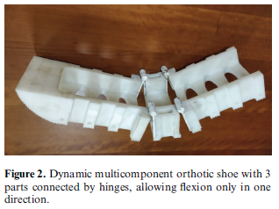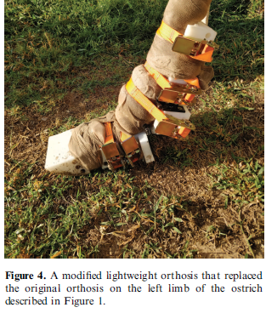
Ratites 8/18/21 Summaries
Journal of Avian Medicine and Surgery 34(4):396–401, 2020
Self-limiting Orbital Emphysema Following Ocular Evisceration and Demonstration of Nasolacrimal-Oropharyngeal Communication in a South African Ostrich (Struthio camelus australis)
Callie M. Rogers, BS, Alice Blue-McLendon, DVM, Erin M. Scott, VMD, Dipl ACVO, and Lucien V. Vallone, DVM, Dipl ACVO

ABSTRACT: A 25-year-old, male, sanctuary-owned, South African ostrich (Struthio camelus australis) was evaluated for orbital emphysema after evisceration of a nonvisual and chronically irritated eye. On initial ophthalmic examination, the ostrich’s left eye displayed severe corneal fibrosis, broad anterior synechia, and a shallow anterior chamber, all suggestive of a previous corneal perforation. Conjunctival hyperemia and eyelid crusts were also present, reportedly associated with chronic rubbing. Evisceration of the left eye was performed by excising the eyelid margins, conjunctiva, nictitans, cornea, and intraocular contents. Four weeks postoperatively, a nonpainful, fluctuant swelling of the surgical site was noted. Trocarization of the surgical site verified orbital emphysema and served to temporarily decompress the orbit. Orbital emphysema reoccurred within 48 hours but gradually regressed without intervention over the subsequent 9 months. A Jones test was performed in the healthy, right eye and demonstrated clear communication to the oropharynx. To our knowledge, this is the first reported case of an evisceration performed on an ostrich and the first reported case of orbital emphysema in any avian species. It is probable that the emphysema noted in this case was secondary to nasolacrimal duct- oropharynx communication.

Study Design: Case report

Goal:
- This report describes a rare complication of eye-removal techniques, known as orbital emphysema, resulting from ocular evisceration in an adult ostrich

Key Points:
- In avian species possessing tubular or large globes, such as birds of prey and ratites, ocular evisceration is a preferred alternative to enucleation because of the surgical technical challenges associated with large globe size, boney scleral ossicles, and the delicate boney interorbital septum
  - Complete removal of the avian globe in these species is time consuming, prone to iatrogenic complication (i.e., inadvertent damage to the contralateral eye), and leads to significant disfigurement because the globe in birds can contribute 25%–50% of the mass of the head
  - However, evisceration is not without disadvantages because it does not allow for complete surgical removal of the eye, preventing a full histopathologic assessment of the globe
    - Thus, ocular evisceration is not indicated in cases of suspected ocular neoplasia or aggressive infections
- In previous reports of enucleation-related orbit- al emphysema, air is suspected to enter the orbit through persistent patency of the nasolacrimal duct (NLD) at the medial canthus, via the upper and/or lower puncta
- Contrast dacryocystorhinography was considered but not elected for concerns related to the animal handling and transport, general anesthesia, and cost
  - The Jones test is a less-invasive diagnostic tool used to evaluate the patency of the NLD and is typically assessed by evaluating fluorescein egress from the nares after ocular surface application
    - After application of fluorescein stain to the ocular surface, no stain was observed at the nares
    - Instead, the stain was immediately observed entering the oral cavity through the choana
- Orbital emphysema, when left untreated, appears to be a self-limiting condition

TLDR:
- First reported case of an evisceration performed on an ostrich and the first reported case of orbital emphysema in any avian species
- Orbital emphysema, when left untreated, appears to be a self-limiting condition

Lamglait, B. (2018). Retrospective study of mortality in captive struthioniformes in a french zoo (1974–2015). Journal of zoo and wildlife medicine, 49(4), 967-976.

Abstract: The husbandry and medical records, and necropsy reports, of 1,002 captive Struthioniformes that died at the Réserve Africaine de Sigean (France) from 1974 to 2015 were examined. The goal of this study was to determine the most common causes of mortality in ostriches (Struthio camelus), emus (Dromaius novaehollandiae), and American rheas (Rhea americana), in order to highlight common causes of mortality, as well as the influence of age, gender, and rearing methods on mortality. The most prevalent cause of mortality was pathology of digestive origin in the neonates of all three species, especially yolk-sac infections, which accounted for 41% of all deaths in this captive neonate population and was especially prevalent in hand-reared neonates. Other causes included musculoskeletal disorders in emus (particularly hand-reared) and rheas; trauma in neonate ostriches, mainly due to crushing by parents; leg deformities in emu chicks and juveniles; general sepsis in hand-reared ratite chicks due to a chlamydiosis outbreaks (1989–1990); trauma by conspecifics in subadult ostriches and emus; stress myopathy in subadult rheas, particularly after introduction to a new enclosure; evisceration inflicted by herbivorous enclosure mates on adult male ostriches; fatal peritonitis following salpingitis in adult female ostriches; and death associated with ocular disorder in adult male emus. Although this study was conducted at one institution, and its results reflect this zoo's management and zoo technical practices, its findings could well have implications for management practices involving other captive Struthioniforme populations.
- Introduction:
  - Struthioniformes aka ratites.
- M+M: Retrospective, 1,002 deaths, 1974-2015.
  - Divided patients by age groups.
- Results:
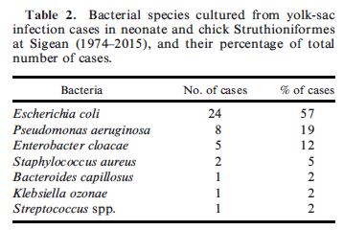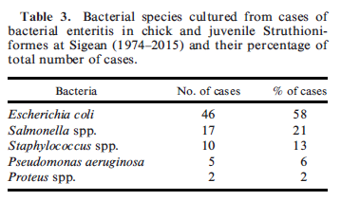
- Discussion/Key Points:
  - Majority of deaths in the neonatal, chick, and juveniles was digestive origin.
    - Gastrointestinal infections are very common in ratite chicks and juveniles.
    - Yolk-sac infection multifactorial.
      - Source likely egg contamination, navel infection, or husbandry practices i.e. assistance in hatching, tying off the omphalomesenteric vessels, bandaging the abdomen.
      - It is thought that when absorption of yolk material by the vitelline membrane is delayed, bacterial contamination occurs through the ostium at the ileal opening.
        - E. coli most common primary causative agent in this population and has been previously reported.
        - Possible treatments may include surgical removal or aspiration of yolk, abx not usually effective.
        - Reduce incidence of yolk-sac infection with healthy environment, regular cleaning and disinfection.
  - Gastrointestinal disorders in neonates and juveniles highly prevalent.
    - Causes include failure to establish balanced gut flora, use of abx, lack of appropriate fiber in diet, hypothermia, excessive coprophagy, poor hygiene.
    - Introduction of unbalanced fibrous diet likely linked to high prevalence of GI impaction and cloacal prolapse, and incidence of bacterial enteritis may be linked to poor hygiene.
    - Cloacal prolapse in chicks < 3 mos linked to insufficient hydration and enteritis.
    - Salmonella enteritis has been assoc with stress in hand-reared chicks.
      - Typhimurium most common serovar, always of pathological importance.
    - To prevent GI disorders in juvenile ratites, excellent sanitation and good quality food essential.
      - Fibrous diet should be introduced progressively, long fibers should be avoided in juvenile ostriches.
  - Leg deformities highly prevalent in the neonatal to juvenile age groups, esp in ostriches and emus. More prevalent in hand-reared individuals.
    - Perosis.
      - Multifactorial – nutritional, inadequate exercise and flooring, trauma, genetic.
    - In this group, tibiotarsal rotation and bowed legs most prevalent conditions.
      - Tibiotarsal rotation may be due to high protein and mineral deficient (i.e. Ca:P) diets.
  - Neonates often crushed by parents.
    - The following considerations should be carried out during intro of subadults to exhibits where other ratites are present:
      - Subadult should be large enough.
      - Progressive intro.
      - Closely monitored, carried outside of the breeding season.
      - Few subadults introduced simultaneously.
  - Primary cause of death in adult ostriches was trauma.
    - Mainly evisceration by horned herbivorous mammals in the exhibit.
    - Trauma inflected by zebras has also been reported.
      - Bite-related cervical trauma.
  - Second most common cause in adult ostriches was fatal peritonitis assoc with salpingitis.
  - Ocular disorders in adult male emus were also noted (palpebral, conjunctival), and assoc with social behavior of pecking at males on nests.
-Conclusions
- factors that could be avoided through changes in husbandry management:
  - close attention to neonates and chick ratites for early detection of yolk-sac infections, especially in hand-reared chicks
  - gastric impaction and cloacal prolapse in juvenile ratites prevented by good husbandry practices, progressive introduction of long-fiber diet and good sanitation
  - leg deformities - provide appropriate diet and room for exercise on appropriate substrate
  - trauma to chicks –provision of chick safety areas around nests
  - intro of subadults to exhibits where other ratites are present should be progressive and closely monitored to avoid aggression and reduce exertional myopathy
  - mixed-species exhibits with horned mammalian herbivores - close attention to male ostriches should be paid during breeding season to mitigate interspecific aggression
  - prevent ocular disorders in adult male emus sitting on eggs by isolation from exhibit-mates
  - exhibiting emus in pairs or small groups to reduce the incidence of traumatic injuries

