Which digit(s) is(are) present in the foot of an Ostrich (Struthio Camelus)?

Digit 3 and 4

Tehrani, P. R., Gilanpour, H., & Veshkini, A. (2017). Radiographic anatomy of the Metatarsophalangeal joint and digits of the ostrich (Struthio camelus). Journal of avian medicine and surgery, 31(3), 198-205.

Abstract: The aim of this study was to develop a detailed and accessible set of reference images of the normal radiographic anatomy of the digits of the ostrich (Struthio camelus), with emphasis on the metatarsophalangeal joint and its arthrography. The distal excised pelvic limbs of 10 normal ostriches of different ages (ranging from 10 to 365 days of age) obtained from an abattoir were radiographed, and 2 arthrograms were performed. To illustrate the normal radiographic anatomy of the tarsometatarsal bone, 39 images were selected, labelled, and presented along with detailed descriptions and corresponding images of the bony skeleton. These results provide a valuable dataset to assist in understanding the normal anatomy of the ostrich metatarsophalangeal joint and digits and allow comparison of abnormal corresponding structures in clinical cases in ostriches.
Question: Below are radiographs of the right pelvic limb of an ostrich. Identify the numbered anatomic structures 1-3.
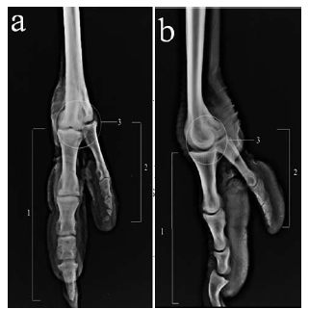
Answer:
- Digit III
- Digit IV
- Metatarsophalangeal joint
Management of Knuckling in an Ostrich (Struthio camelus) Using a Custom-Made Orthotic Shoe.
Raghav, R., Al Busaidi, T. M., & Samour, J.
Journal of Avian Medicine and Surgery, 2020;34(4):381-389.

Practice Question
Lateral recumbency in an ostrich can result in knuckling of the down leg due to compression of which nerve over the stifle?
- Lateral plantar nerve
- Peroneal nerve
- Sciatic nerve
- Femoral nerve
- Tibial nerve
Answer: Peroneal (Fibular) nerve

Ratites 8/18/21 Question
A positive Jones test in a South African ostrich (Struthio camelus australis) indicates which of the following:
- Corneal ulceration
- Nasolacrimal duct patency
- Orbital emphysema
- Keratoconjunctivitis sicca
- Corneal perforation

Lamglait, B. (2018). Retrospective study of mortality in captive struthioniformes in a french zoo (1974–2015). Journal of zoo and wildlife medicine, 49(4), 967-976.

In a recent retrospective study investigating causes of mortality in ratites in the zoo setting, what was found to be the most common cause of death in neonate birds?
- Yolk sac infection
- Trauma
- Congenital malformation
- Chlamydiosis
- Salmonella enteritis

