Quiz 1
CBS 818 – Spring 2021

- Name the bones highlighted by the red and blue arrows in these images.
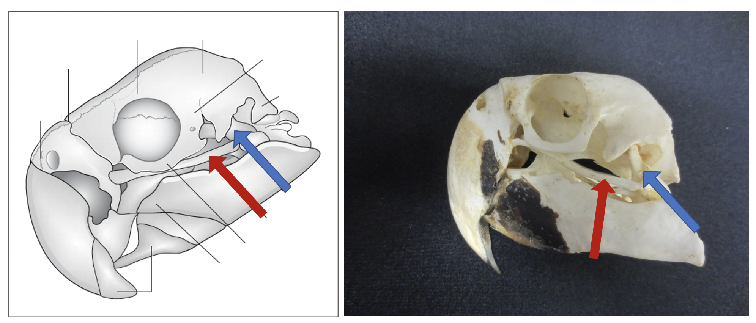
Red arrows _____________________________________________
Blue arrows_____________________________________________

- What is the function of the spiral valve in elasmobranchs?

- What is a key difference in clinical presentation between Batrachochytrium dendrobatidis (Bd) and Batachochytrium salamandrivorans (Bs)?

- What trematode can cause limb deformities in amphibians?
- Ribeiroia ondatrae
- Cercariae ranae
- Diplostomulum xenopi
- Haematolechus medioplexus
- Polystoma integerrimum

