Accuracy of noninvasive anesthetic monitoring in the anesthetized giraffe (Giraffa camelopardalis).
Bertelsen MF, Grøndahl C, Stegmann GF, Sauer C, Secher NH, Hasenkam JM, Damkjær M, Aalkjær C, Wang T.
Journal of Zoo and Wildlife Medicine. 2017 Sep;48(3):609-15.

Which of the following defines positive predictive value?
- The proportion of positives that are correctly identified
- The proportion of negatives that are correctly identified
- The probability that subjects with a negative screening test truly don't have the disease.
- The probability that subjects with a positive screening test truly have the disease.
- The degree of closeness of measurements of a quantity to that quantity's true value
- The degree to which repeated measurements under unchanged conditions show the same results

Answer:
- Sensitivity: The proportion of positives that are correctly identified
- Specificity: The proportion of negatives that are correctly identified
- Positive Predictive Value: The probability that subjects with a negative screening test truly don't have the disease.
- Negative Predictive Value: The probability that subjects with a positive screening test truly have the disease.
- Accuracy: The degree of closeness of measurements of a quantity to that quantity's true value
- Precision: The degree to which repeated measurements under unchanged conditions show the same results
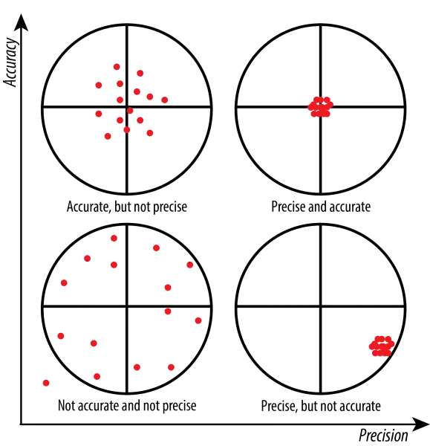
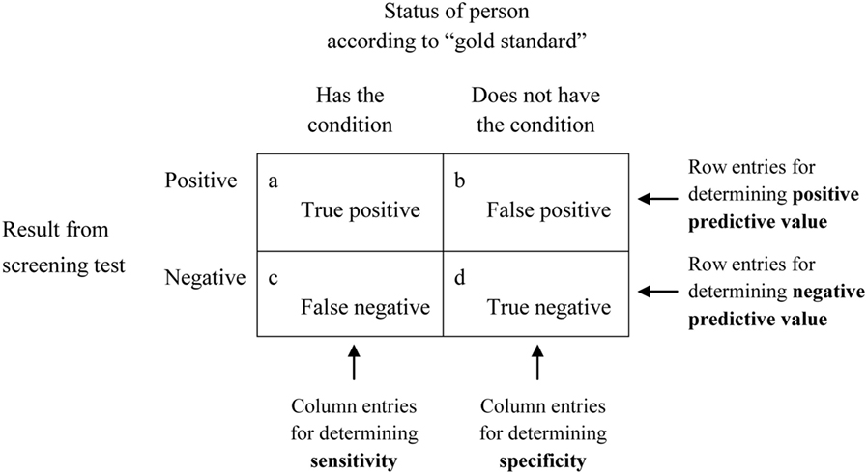

Pharmacokinetics and pharmacodynamics of buprenorphine and sustained-release buprenorphine after administration to adult alpacas
Dooley SB, Aarnes TK, Lakritz J, Lerche P, Bednarski RM, Hubbell JA.
American journal of veterinary research. 2017 Mar;78(3):321-9.

What effect would you expect when administering buprenorphine subcutaneously in an alpaca?
- Increased heart rate
- Decreased respiratory rate
- Increased hyperexcitability
- Decreased thermal withdrawal
- Increased sedation

Bahrami, Somayeh, Mohammad Reza Tabandeh, and Ali Reza Ganjali Tafreshi. "Prevalence and molecular identification of piroplasmids in Iranian dromedaries (Camelus dromedarius)." Journal of Zoo and Wildlife Medicine 48.4 (2017): 1026-1030.

Abstract: Camels (Camelus dromedarius) are important, multipurpose local animals in Iran. Despite their importance, camelid parasitic diseases have not received adequate attention in the veterinary literature. The present study investigated the prevalence of, and molecularly identified, camel piroplasms in Iran. Blood samples from 248 camels from five different regions of Iran were screened for the presence of piroplasmid infection using an 18SrRNA polymerase chain reaction (PCR) sequencing method. Of the 248 samples, 16 were positive for piroplasms via PCR (6.45%). Ten PCR amplicons with expected sizes were sequenced for molecular characterization. Three camels were infected with Babesia caballi and seven with Theileria equi. Statistical analysis showed that age, sex, and location were not risk factors for infection with piroplasmids in camels.

Question:

Name the genus of the infectious agent shown on this blood smear from a giraffe (Giraffa camelopardalis):

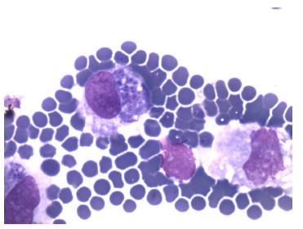

Answer: Theileria

Image from Pathology of Wildlife and Zoo Animals (Terio) Ch 5 Bovidae, Antilocapridae, Giraffidae, Tragulidae, Hippopatamidae. A large circulating mononuclear cell contains a basophilic protozoal schizont, and a few erythrocytes contain basophilic, punctate pirpoplasms.

Bos, Jan H., Fokko C. Klip, and Marja JL Kik. "Congenital nutritional myodegeneration (white muscle disease) in a Giraffe (Giraffa camelopardalis) calf." Journal of Zoo and Wildlife Medicine 48.4 (2017): 1193-1196.

Brief Communication
Abstract: It is well known that vitamin E and selenium deficiencies in domestic ruminants can lead to white muscle disease. After a clinically normal gestation period at Ouwehand Zoo in the Netherlands, a newborn giraffe (Giraffa camelopardalis) calf showed clinical signs of white muscle disease almost immediately after birth. The calf was rejected by the mother and was euthanized 3 days later because of deterioration of clinical signs. At necropsy, pulmonary edema and pallor of skeletal and heart muscles was noted. Histologically, there was hyaline degeneration of skeletal muscle myocytes and pulmonary edema. Blood concentrations of vitamin E were ≤ 0.7 mg/L. Based on clinical, biochemical, and gross and microscopic pathological findings, congenital nutritional myodegeneration was diagnosed. This case of neonatal white muscle disease is particularly remarkable given that the diet of the dam contained more than the recommended amount of vitamin E.
Question:

Which of the following is true regarding dietary vitamin E recommendations for ruminants in the families Giraffidae and Bovidae?
- Requirements should be extrapolated from recommendations for cattle.
- Grazers display lower mean vitamin E levels than browsers when fed similar diets.
- Bovine colostrum lacks vitamin E and neonatal calves rely on placental transfer.
- Peracute mortality syndrome is caused by vitamin E and selenium deficiencies.
- Vitamin E remains stable when exposed to heat, humidity, and UV radiation.

Answer: B

Growth, husbandry, and diets of five successfully hand-reared orphaned giraffe calves (giraffa camelopardalis rothschildi and giraffa camelopardalis reticulata).
Meuffels, J., Ververs, C., Pootoolal, J., van Zijll Langhout, M. and Govaere, J.
Journal of Zoo and Wildlife Medicine, 2019;50(1):205-218.

At what age are captive, hand-reared giraffes ideally weaned?
- 2-3 mo
- 4-5 mo
- 6 mo
- 7-9 mo
- 1 yr

Answer: D

Comparison of anesthesia of adult giraffe (Giraffa camelopardalis) using medetomidine-ketamine with and without a potent opioid.
Delk, K.W., Mama, K.R., Rao, S., Radcliffe, R.W. and Lamberski, N.
Journal of Zoo and Wildlife Medicine, 2019;50(2):457-460.
You are planning to anesthetize a giraffe (Giraffa camelopardalis) and deciding between two protocols: medetomidine 0.06 mg/kg and ketamine 0.9 mg/kg (MK) OR medetomidine 0.01 mg/kg, ketamine 0.6 mg/kg, and thiafentanil 5.2 mcg/kg (MKT). Which of the following considerations is true?
A. Due to their large size, giraffes have a large inspiratory reserve volume and require deeper breaths to increase tidal volume
B. Using the MK protocol will reduce the need for respiratory and oxygenation support
C. Using the MKT protocol will reduce the time to initial drug effect and time to recumbency
D. Using the MKT protocol will reduce the need for supplemental drugs such as propofol or guaifenesin
E. Using the MK protocol will increase the risk of re-sedation following initial reversal
Answer: E

Questions:
The acute-phase and hemostatic response in dromedary camels (Camelus dromedarius)
JZWM 2018 49(2) 361-370

- Dromedary camels (Camelus dromedarius) infected with Corynebacterium spp. had which of the following changes compared to healthy camels?
  - Higher haptoglobulin
  - Lower fibrinogen
  - Reduced blood clot strength
  - Lower white blood cell count
  - Faster prothrombin time

FIRST MOLECULAR DETECTION OF ANAPLASMA PHAGOCYTOPHILUM IN DROMEDARIES (CAMELUS DROMEDARIUS)
JZWM 2018 49(4) 844–848

- Which of the following is true regarding Anaplasma phagocytophilum infection in dromedary camels (Camelus dromedarius) in Iran?
  - Being female was found to be a risk factor for infection.
  - Odds of infection decreased with increasing age.
  - No significant difference in prevalence was found between geographical regions.
  - There was a low subclinical infection rate in tested camels.
  - Camels had a lower prevalence than cattle.

In a recent study radiographically evaluating the front feet of reticulated giraffe (giraffa camelopardalis), which of the following were associated?

- P3 osteitis and age
- P3 rotation and age
- P3 osteitis and weight
- P3 rotation and P3 fractures
- P3 osteitis and P3 fractures

Answer: E

Giraffe skin disease most commonly effects which part of the body?

- Dorsum
- Front legs
- Ventrum
- Back legs
- Tail

Answer: B

