Hernández, F. A., Sayler, K. A., Bounds, C., Milleson, M. P., Carr, A. N., & Wisely, S. M. (2018). Evidence of pseudorabies virus shedding in feral swine (Sus scrofa) populations of Florida, USA. Journal of wildlife diseases, 54(1), 45-53.

Abstract: Feral swine (Sus scrofa) are a pathogen reservoir for pseudorabies virus (PrV). The virus can be fatal to wildlife and contributes to economic losses in the swine industry worldwide. National surveillance efforts in the US use serology to detect PrV-specific antibodies in feral swine populations, but PrV exposure is not a direct indicator of pathogen transmission among conspecifics or to non-suid wildlife species. We measured antibody production and the presence of PrV DNA in four tissue types from feral swine populations of Florida, US. We sampled blood, nasal, oral, and genital swabs from 551 individuals at 39 sites during 2014–16. Of the animals tested for antibody production, 224 of 436 (51%) feral swine were antibody positive while 38 of 549 feral swine (7%) tested for viral shedding were quantitative polymerase chain reaction (qPCR)-positive for PrV. The detection of PrV DNA across all the collected sample types (blood, nasal, oral, and genital [vaginal] swabs) suggested viral shedding via direct (oronasal or venereal), and potentially indirect (through carcass consumption), routes of transmission among infected and susceptible animals. Fourteen of 212 seronegative feral swine were qPCR-positive, indicating 7% false negatives in the serologic assay. Our findings suggest that serology may underestimate the actual infection risk posed by feral swine to other species and that feral swine populations in Florida are capable of shedding the virus through multiple routes.

Question:
Which of the following is true about Pseudorabies viral infection?
- Respiratory signs are a hallmark of natural infections in boars.
- Diagnosis can be made by immunohistochemistry on sections of tonsil and brain.
- Clinical disease and lesions are more common and more severe in adult suids.
- Oral, nasal, and venereal shedding are unlikely based on recent surveys of feral swine in Florida
- Domestic swine are considered reservoir hosts for the virus.

Answer: B

Question (short answer):
What is the causative agent of Pseudorabies virus?
Answer:
Suid herpesvirus 1 (SuHV1)

Evaluation of a Partially Reversible Immobilization Protocol Using Medetomidine, Butorphanol, Zolazepam–tiletamine, and Ketamine in Free-ranging Warthogs (Phacochoerus Africanus) in Kruger National Park, South Africa

Practice question
Which of the following is a normal blood gas parameter in a common warthog?
- pH 7.3
- PaCO2 60
- PaO2 80
- SO2 70
- Lactate 9.0

Answer: C
According to a recent study assessing prevalence of viral and bacterial pathogens in Colombian collared peccaries and feral pigs, which of the following pathogens was most prevalent?

A. Brucella spp
B. Classical Swine Fever Virus
C. Porcine circovirus 2
D. Leptospira spp
E. Aujeszky’s disease virus

Answer: D

Questions:
In a recent serologic survey of wild boars (Sus scrofa) in Sweden, no antibodies were detected for which of the followed pathogens?
- Porcine parvovirus
- Brucella suis
- Erysipelothrix rhusiopathiae
- Mycoplasma hyopneumoniae
- Toxoplasma gondii

You are examining a wild boar (Sus scrofa) and observe skin lesions similar to the lesions seen below. The animal is also febrile and lame on the right forelimb and left hind limb. What is the likely etiologic agent and what would be the recommended treatment for this animal assuming your suspicion is correct?
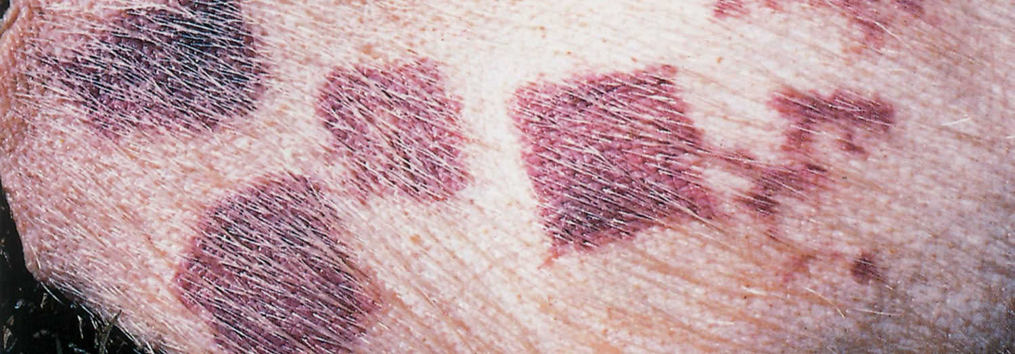
Erysipelothrix rhusiopathiae
Penicillin

UROLITHIASIS IN A GROUP OF VISAYAN WARTY PIGS (SUS CEBIFRONS NEGRINUS)
Chatterton J, Unwin S, Lopez J, Chantrey J.
J Zoo Wildl Med. 2017 Sep;48(3):842-850

Slide Exam: What is the most likely urolith found in the sigmoid flexure of a Visayan warty pig (pictured)?
