Student Reading Assignments
CBS 818, Spring 2020

Students have to read and complete ALL nine of these assignments, and answer the questions provided for that assignment. This is an open book assignment but it should be completed individually.
- NOTE: there is no assignment for Suidae/Tayassuidae/Hippos lecture, as this is a make-up lecture from last semester.

- Avian Anatomy
Reference: Speer, Current Therapy in Avian Medicine and Surgery, pgs. 252-265

List six differences between the avian and mammalian cardiovascular system.

- Reptile Virology
Reference: Divers, Reptile Medicine and Surgery, 3rd Edition – Chapter 30: Virology

What is the most likely viral disease that caused the following lesions:

Case photo | Case description | Virus
 | A Russian tortoise with severe stomatitis and diphtheroid plaques in the oral cavity.
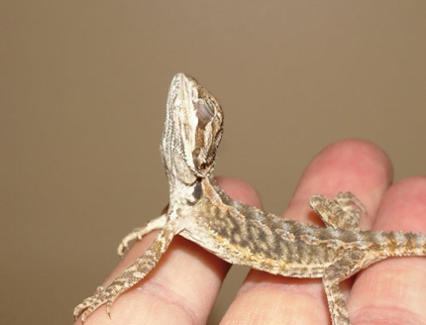 | A juvenile bearded dragon with anorexia, lethargy, and neurologic signs
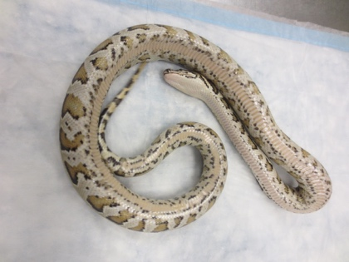 | A ball python with anorexia and loss of righting reflex.

- Amphibian Diseases
Reference: Divers, Reptile Medicine and Surgery, 3rd edition – Chapter 89:
Amphibian medicine (pgs. 1001 – 1013)

Compare and contrast the clinical signs associated with B. dendrobatidis (Bd) and B.
salamandrivorans (Bs).

- Aquatic Anatomy
Reference: Mitchell-Tully, Current Therapy in Exotic Pet Practice – Chapter 3: Respiratory system (pages 78-80)

Name the two types of ventilation in fish.

What is the name of the air-breathing organ in Anabatid fish (such as bettas and gouramis)?

- Camelids/Giraffidae
Reference: Giraffidae, Chapter 61—Fowler’s Zoo and Wildlife Animal Medicine, 8th
edition.

Name three differences in giraffe cardiovascular anatomy and physiology that are different
from other large mammals.

- Plague and Toxoplasmosis

Reference: EcoHealth 2017, (14)432-437. Vaccines for conservation: plague, prairie dogs and black footed ferrets as a case study, by D.J. Salkeld

Name three main control interventions for plague (Y. pestis) for prairie dogs and/or black footed ferrets that were stated in this paper.

- Rabies
Reference: Rabies surveillance in the United States during 2018. Journal of the American Veterinary Medical Association Jan 2020, Vol. 256, No. 2, Pages 195-208

List the rabies virus variant (RVV) among the wild mesocarnivores in each of the 7 geographical regions identified this map.

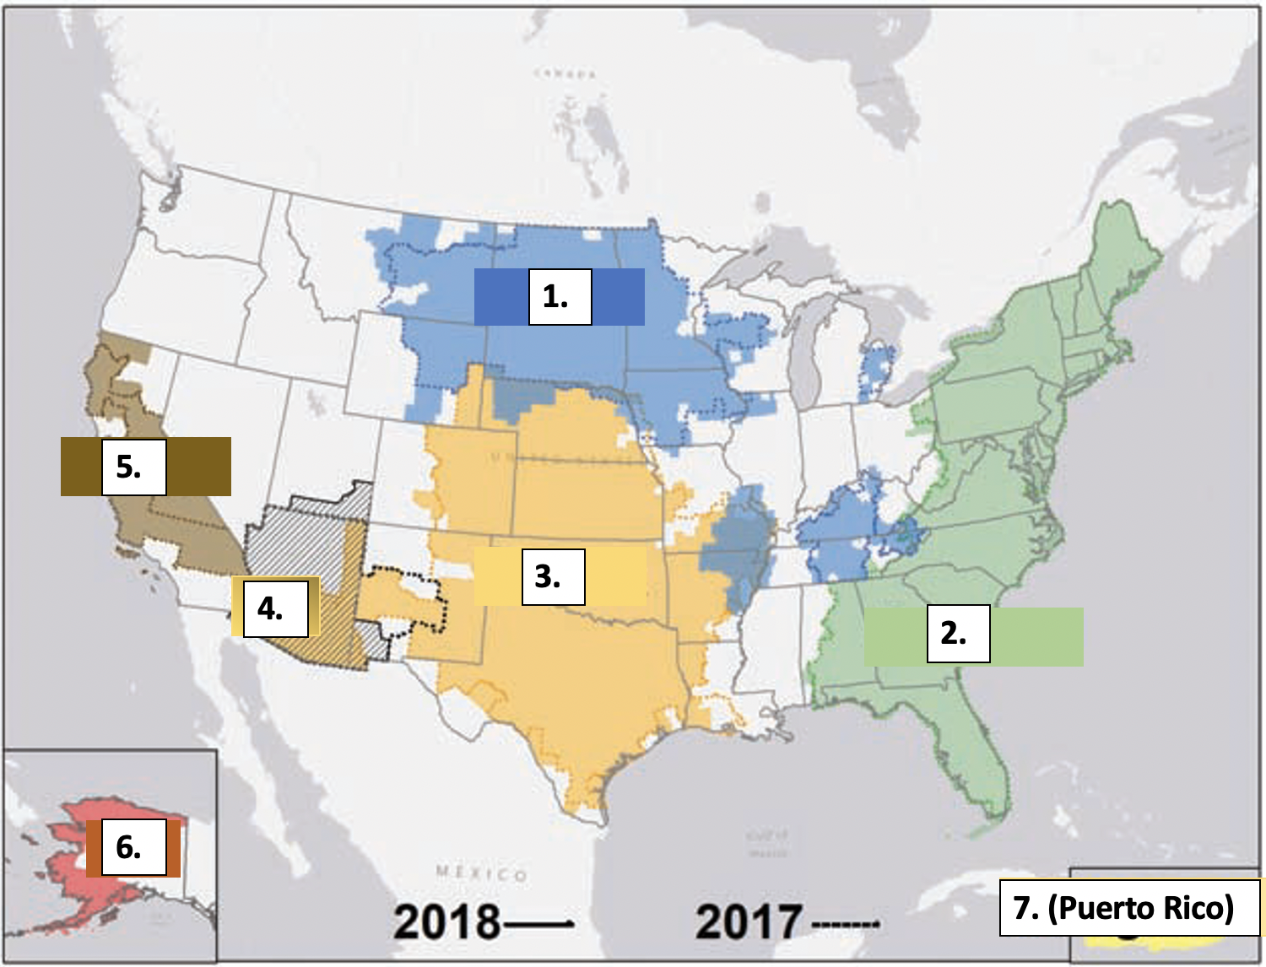

- Cetaceans
Reference: Cetacea, Chapter 43—Fowler’s Zoo and Wildlife Animal Medicine, 8th edition

Compare and contrast open and closed housing systems for cetaceans in captivity.

What is the most common venipuncture site for captive cetaceans?

- Galliformes
Reference: Galliformes, Chapter 18—Fowler’s Zoo and Wildlife Animal Medicine,
8th edition.

List the etiologic agent for each of these diseases of galliformes.

Common name | Etiologic agent
Infectious coryza
Marek’s disease
Avian cholera
Blackhead disease
Quail disease

