Rijks, Jolianne M., et al. "Report on the 4th International Symposium on Ranaviruses 2017." Journal of Herpetological Medicine and Surgery 28.1-2 (2018): 13-18.

- Ranaviruses are large, ds DNA viruses in the family Iridoviridae
- Important pathogens in fish, amphibians, and reptiles
  - Associated with population declines in amphibians across the world
- Highlights from the 4th international symposium on ranavirus
- More fully sequenced ranavirus isolates have consequences for classification and beyond
  - The iridoviridae alphairoviridae which infects vertebrates currently includes seven member species
  - More genomic sequencing will likely reveal more species and challenge the current taxonomic classifications
- New findings emphasize the ranavirus threat resulting from human economic activities
  - Ornamental pet trade and farming have been linked to mortality events, especially when involved in international trade
- Phylogeographic patterns remain difficult to grasp but are needed to refine risk analysis
  - It is important to understand which ranaviruses exist in which ecosystems in order to better understand outbreaks/mortality events and the novelty of the pathogen to that region
  - Longterm surveillance activity is needed
- Ranavirus infection affects amphibian population demography
  - ranavirus-positive populations contained a higher proportion of younger individuals than the negative populations, indicating a shift in age structure
  - no effect on growth rates or age of sexual maturity of individuals.
  - More information is needed
- Advances in detection of virulence determinants and understanding of host immunity
  - Understanding the immune response is crucial
  - Poor immunologic response of tadpoles has been demonstrated
- Advances in the study of ranavirus pathogenesis
  - ranavirus can pass the blood–brain barrier in Xenopus laevis tadpoles
  - more work is needed to understand the pathogenesis in various species
- Knowledge gaps identified by the thematic breakout groups:
  - Need for pan-ranavirus assays
  - Vaccine development
  - Better understanding of epidemiology, transmission, environmental persistence

Peiffer, Lauren B., et al. "Fatal ranavirus infection in a group of zoo-housed meller's chameleons (trioceros melleri)." Journal of Zoo and Wildlife Medicine 50.3 (2019): 696-705.

Abstract: A group of five juvenile Meller's chameleons (Trioceros melleri) experienced 100% mortality over a period of 1 mo due to ranavirus infection. The index case was found dead without premonitory signs. The three subsequent cases presented with nonspecific clinical signs (lethargy, decreased appetite, ocular discharge) and were ultimately euthanatized. The final case died after initially presenting with skin lesions. Postmortem examination revealed thin body condition in all five animals and mild coelomic effusion and petechiae affecting the tongue and kidneys of one animal. Microscopically, all animals had multifocal necrosis of the spleen, liver, and kidney; four of five animals had necrosis of the nasal cavity; and two of five had necrosis of adrenal tissue, bone marrow, and skin. Numerous basophilic intracytoplasmic inclusions were present in the liver of all animals and nasal mucosa of three of the five animals. Consensus polymerase chain reaction for herpesvirus and adenovirus were negative, whereas ranavirus quantitative polymerase chain reaction was positive. Virus isolation followed by whole genome sequencing and Bayesian phylogenetic analysis classified the isolates as a strain of frog virus 3 (FV3) most closely related to an FV3 isolate responsible for a previous outbreak in the zoo's eastern box turtle (Terrapene carolina carolina) group. This case series documents the first known occurrence of ranavirus-associated disease in chameleons and demonstrates the potential for interspecies transmission between chelonian and squamate reptiles.
- Ranaviruses – Large, enveloped, dsDNA.
  - Infect wide range of ectothermic vertebrates.
  - Seven recognized species of virus – Frog virus 3 most thoroughly researched.
    - FV3 and FV3-like viruses emerging pathogens in reptiles – Chelonians, snakes, lizards.
    - Other iridoviruses that are reported in chameleons – Lizard erythrocytic virus, invertebrate iridovirus Gryllus bimaculatus iridescent virus.
  - CS in chameleons – Anorexia, ocular discharge, dehydration, lethargy, oral petechiae, sudden death, skin lesions (one individual).
  - Necropsy – Necrosis of hematopoetic tissues (spleen), liver, kidneys, adrenals, necrotizing inflammation within nasal cavity, oral mucosa, and skin.
    - Intracytoplasmic inclusions numerous and affected a greater variety of tissues vs previous reptile infections in other spp.
    - Secondary bacterial and fungal infections.
  - This ranavirus spp closely related to box turtle isolate of FV3 and suspected to be directly or indirectly transmitted from a population of box turtles at this facility.
- Takeaway: Mortality associated with ranaviral outbreak in Meller’s chameleons, nearly identical isolate to EBT ranaviral isolate, suggests interspecies transmission or a shared source of infection. Possible exposure – iatrogenic, direct contact with managed or free-ranging animals, environmental sources. Don’t mix reptile species in exhibits.

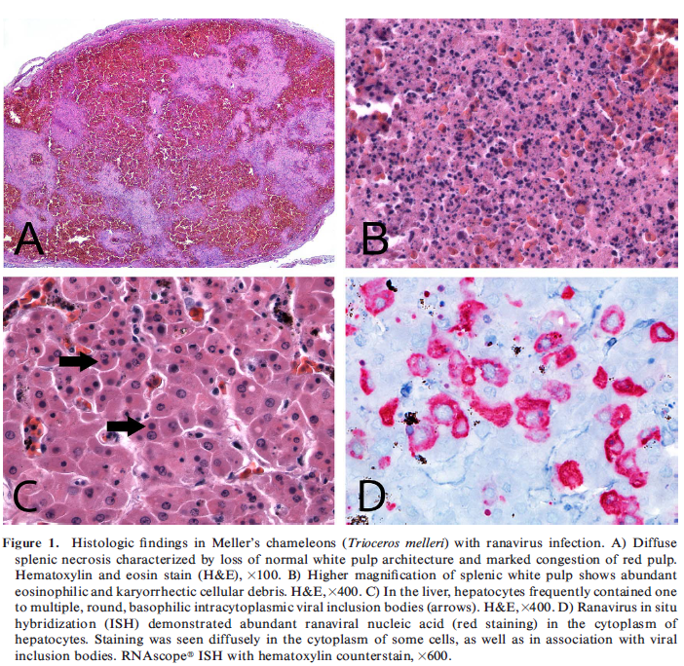

PROTEIN ELECTROPHORESIS OF PLASMA SAMPLES FROM BOA CONSTRICTORS WITH AND WITHOUT REPTARENAVIRUS INFECTION
Christoph Leineweber, Jules Simard, Ekaterina Kolesnik, Tom Hellebuyck, Rachel E. Marschang
J. of Zoo and Wildlife Medicine, 51(2):350-356 (2020)

Taxonomy: Reptilia → Squamata → Serpentes (suborder) → Boidae
Abstract:.Reptarenaviruses infect a variety of boid and pythonid snake species worldwide and have been shown to be the cause of inclusion body disease (IBD). Little is known about the correlations between virus infection and clinical disease, as well as the effects of viral infection on the immune system and the blood protein fractions. The goal of this study was to examine the differences in the plasma protein fractions in reptarenavirus reverse transcription polymerase chain reaction (RT-PCR)-negative and -positive tested snakes with and without clinical signs of disease. Blood from a total of 111 boa constrictors (Boa constrictor) was evaluated. Reverse transcription PCRs and H&E staining for inclusion bodies were carried out on each sample for the detection of reptarenavirus, and the plasma protein fractions were evaluated by capillary zone electrophoresis (CZE). Thirty four of the 111 evaluated snakes were positive by RT-PCR and 19 of the 34 showed clinical signs of disease. In comparison with IBD-negative healthy boa constrictors, the positive snakes with clinical signs had significantly lower albumin levels (P = 0.0052), lower A: G ratios (P = 0.0037), and lower α-globulin levels (P = 0.0073), while their γ-globulin levels were significantly higher (P = 0.0004). In the same comparison, clinically healthy arenavirus-positive boas showed only significantly lower α-globulin (P = 0.0124) and higher γ-globulin levels (P = 0.0394). The results of the present study indicate that reptarenavirus infection may influence plasma protein fractions in boa constrictors.

Introduction / Background:
- Reptarenaviruses- IBD (Inclusion body disease) in boid and pythoid snakes
  - Common in Boas; can be chronic and shedding w/o CS
  - Chronic regurg, anorexia, stomatitis, pneumonia, lymphoprolif disorders, neurological dz (head tremors, incoordination, and disorientation)
  - Eosinophilic and amphophilic intracytoplasmic inclusions in visceral epithelial cells (H&E)
    - In pythonids- rare and more frequently observed in neuro tissue

Discussion / Key Points:
- Artifacts in EPH:
  - Hemolysis can falsely increase Beta-2 fraction
  - Lipemia can increase Alpha-2
- IBD infected boas had:
  - Decreased albumin, A:G, and alpha globulins
  - Increase in gamma globulins (generally contain antibodies)

Take Home Message/Conclusions: IBD in boas with clinical signs: decreased albumin and alpha globs and increased gamma globs.

DETECTION OF AN ARENAVIRUS IN A GROUP OF CAPTIVE WAGLER'S PIT VIPERS (TROPIDOLAEMUS WAGLERI)
Dietz J, Kolesnik E, Heckers KO, Klingberg MN, Marschang RE
Journal of Zoo and Wildlife Medicine. 2020 Mar;51(1):236-40.

Taxa: Reptilia → Squamata → Serpentes → Viperidae
Abstract: A group of eight Wagler's pit vipers (Tropidolaemus wagleri) from a private collection died with respiratory signs within 6 mo of one another. The group consisted of an adult breeding pair that was wild caught and six offspring from this pair. Four of the dead snakes were submitted for gross and histopathology. Signs of bacterial pneumonia were detected in all four examined snakes. No inclusion bodies suggestive of viral infection were found in any of the examined tissues. Polymerase chain reactions for the detection of ferla-, adeno-, reo-, and nidoviruses were all negative, but reptarenaviruses closely related to viruses previously described in boa constrictors (Boa constrictor) with inclusion body disease were detected in two of the four snakes. This is the first description of reptarenaviruses in viperid snakes. The pathogenic role of the virus in illness is unknown.

Cases: Group of 8 Wagler’s pit vipers died within 6 months following dyspnea
- Heterophilic inflammation of tracheal mucosa and pulmonary interstitium
- Positive for reptarenavirus (University of Giessen virus) on PCR (associated with IBD)

Key Points:
- Viruses that cause respiratory disease in snakes: ferlavirus, reovirus, arenavirus (more often enterohepatic), nidovirus (only in pythons)
- Inclusion body disease is caused by reptarenavirus and has eosinophilic, intracytoplasmic inclusions in hepatocytes and brain

Conclusions: Viperids can be clinically affected with reptarenavirus, too.

Flach, E. J., Dagleish, M. P., Feltrer, Y., Gill, I. S., Marschang, R. E., Masters, N., ... & Wheelhouse, N. M. (2018). Ferlavirus-related deaths in a collection of viperid snakes. Journal of Zoo and Wildlife Medicine, 49(4), 983-995.

Abstract: Between June and October 2013, 26 snakes of six viperid species kept in two adjoining rooms died (n = 16) or were euthanized on medical (1) or welfare grounds (9). Two were from the main zoo collection, but the other 24 had been imported and quarantined for a minimum of 6 mo. Four of those that died and the single snake euthanized on medical grounds showed minor signs of respiratory disease prior to death, and five were weak, lethargic, and/or poor feeders. Frequent postmortem findings among all snakes were poor body condition (18) and respiratory disease (13). Seventeen cases were examined histologically, and pneumonia, sometimes with air sacculitis and/or tracheitis, was present in 15 individuals. Lung samples from 24 snakes were ferlavirus polymerase chain reaction (PCR) positive, and one of the two snakes for which only liver was available was also positive. The negative liver sample was from a snake that died of sepsis following anesthesia for surgical removal of a spindle cell sarcoma. Correlation with antemortem PCR testing of glottal and cloacal swabs in five cases was poor (sensitivity = 40%). Immunohistochemistry (IHC) for ferlaviruses on the tissues of 13 PCR-positive cases showed positive labeling in 7 only. Tissues samples from 22 ferlavirus PCR-positive snakes were examined for Chlamydia species by PCR, and 9 were positive, although DNA sequencing only confirmed two of three tested as Chlamydia pneumoniae. Immunohistochemistry for Chlamydia pneumoniae of seven cases (two Chlamydiales PCR positive, one of which was sequenced as C. pneumoniae, plus five negative) confirmed the Chlamydia PCR results. These two Chlamydiales PCR and IHC positive snakes were ferlavirus PCR positive, but IHC negative suggesting that, even though a ferlavirus was the predominant cause of the outbreak, in a few cases death may have been due to chlamydiosis with ferlavirus present, but not acting as the primary pathogen.

Introduction:
- Epizootics in reptile collections are common, often involving the respiratory tract.
  - Viruses – Ferlaviruses, herpes, adeno, nido, reoviruses.
  - Bacteria – Aeromonas, Pseudomonas (secondary, opportunistic). Chlamydial infection in puff adders. Mycobacterial granulomatous infection.
  - Mycotic pneumonia.
  - Parasitic infections.
- Ferlavirus
  - Enveloped RNA virus
  - First reptilian ferlavirus isolated from neotropical viper (Bothrops moojeni).
  - CS – respiratory noises, exudate, abnormal posture, head tremors, anorexia, and regurgitation. Many found dead without clinical signs.
  - Pathologic findings – congestion/hemorrhage of the lungs, proliferative interstitial pulmonary disease – vacuolation of faveolar epithelial cells
    - Lesions also found in brain, spinal cord, liver, pancreas, salivary gland
    - Intracytoplasmic inclusion bodies are rarely observed
  - Diagnostics
    - Can be detected by PCR – usually from lung tissue post-mortem or oral and cloacal swabs. Preferred clinical sample – transtracheal wash.
    - IHC can also be used on tissues
    - Serologic response can be detected by HI (hemaglutination inhibition).
  - Some spp appear more susceptible; also significant differences in virulence between viral strains.
Case reports:
- From March 2011-Oct 2012, 42 viperid snakes of 9 spp importated to London Zoo, joining two existing eyelash vipers. Soured from various breeders in Eu and Costa Rica.
- Quarantined new snakes for 6 months. Fecal parasite screening, fecal cultures, visual obs.
- 14 snakes died during period of importations, 11 during quarantine. Ultimately 32 individuals joined the main collection.
- Epizootic
  - 17 snakes died from June – October 2013 after they were introduced – one was euthanized (seizures), remainder died or were euthanized over the next three years
    - Six found dead without clinical signs, four mild resp disease, five lethargic/weak/anorexic.
  - Eyelash vipers appeared highly susceptible.
  - Most common gross findings on necropsy – Poor BCS, respiratory disease (pulmonary, air sac congestion, exudate), hepatic lesions (congestion, enlargement, pale foci).
  - All negative for Cryptosporidium spp.
  - Histo – 15 cases had pneumonia with air sacculitis in 4 and treacheitis in 2. 11 had lesions in the splenopancreas (pancreatitis, pancreatic atropy, pancreatic hyperplasia). 9 had lesions in liver (hepatitis, cholangitis, hepatic necrosis, vascular hepatopathy, hepatic lipidosis).
    - Viral inclusion bodies were not found in any cases.
      - They are rarely observed with ferlavirus in general.
  - Tissues submitted for ferlavirus RNA testing – Negative; Subsequent PCR testing of frozen lung positive in all cases. Mixed results with testing frozen liver. Variable results with glottal/cloacal swab PCR.
  - IHC was also found to be variable.
  - Also tested tissues for Chlamydia PCR – 9 were positive.
    - Two positives for chlamydia via IHC were neg for ferlavirus IHC.
    - 5 Chlamydia neg cases all had positive ferlavirus IHC.
    - Chlamydia pneumonia likely primary pathogen in some individuals, although major chlamydial pathogen in snakes might be a highly related, distinct Chlamydia spp: Candidatus Chlamydia sanzinia.
- New Quarantine Protocol
  - Risk assessments before bringing in new snakes – health questionnaires.
  - PCR testing of tracheal washes & serology
  - Snakes with different temperature requirements are no longer quarantined in same facility – dedicated veterinary team member for care of snakes (not the herp department)
  - Any deaths during quarantine are fully investigated with ferlavirus testing
Key Discussion Points:
- Some snakes were able to carry the virus asymptomatically for long periods of time (at least 3 yrs in this report).
- Poor sensitivity of testing antemortem swabs via PCR. Viral shedding may vary over time.
- Conservation practitioners should avoid using snakes for reintroduction purposes if they originate from zoo collections, especially when the prevalence of these pathogens in free-ranging wild reptiles is unknown.
  - Dedicated species-specific conservation facilities should be built and stocked with wild-caught founders that are subjected to preimport and ongoing routine pathogen screening.

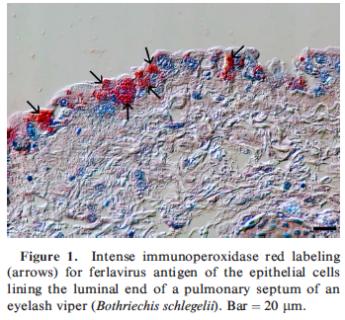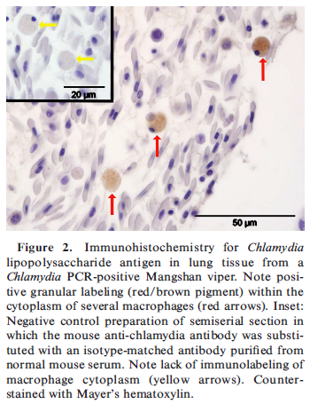

Lindemann, D. M., Allender, M. C., Thompson, D., Glowacki, G. A., Newman, E. M., Adamovicz, L. A., & Smith, R. L. (2019). Epidemiology of Emydoidea herpesvirus 1 in free-ranging Blanding's turtles (Emydoidea blandingii) from Illinois. Journal of Zoo and Wildlife Medicine, 50(3), 547-556.

Abstract: Herpesvirus infections have been associated with high morbidity and mortality in populations of captive emydid chelonians worldwide, but novel herpesviruses have also recently been identified in apparently healthy free-ranging emydid populations. Blanding’s turtle (Emydoidea blandingii), an endangered species in Illinois, has experienced range-wide declines because of habitat loss, degradation, and fragmentation. A novel herpesvirus, Emydoidea herpesvirus 1 (EBHV1), was identified in Blanding’s turtles in DuPage County, IL, in 2015. Combined oral-cloacal swabs were collected from radio transmitter–fitted and trapped (n = 54) turtles multiple times over the 2016 activity season. In addition, swabs were collected at a single time point from trapped and incidentally captured (n = 84) Blanding’s turtles in DuPage (n = 33) and Lake (n = 51) counties over the same field season. Each sample was tested for EBHV1 using quantitative polymerase chain reaction (qPCR). EBHV1 was detected in 15 adult females for an overall prevalence of 10.8% (n =15/138; 95% confidence interval [CI]: 6.2– 17.3%). In radio transmitter–fitted females, there was a significantly higher prevalence of EBHV1 DNA in May (23.8%, n = 10/42) than June (3.6%, n = 1/28), July (0%, n = 0/42), August (0%, n = 0/47), or September (7.7%, n = 3/39) (odds ratio: 12.19; 95% CI: 3.60–41.30). The peak in May corresponds to the onset of nesting and may be associated with increased physiologic demands. Furthermore, all positive turtles were qPCR negative in subsequent months. There were no clinical signs associated with EBHV1 detection. This investigation is the critical first step to characterizing the implications of EBHV1 for Blanding’s turtle population health and identifying management changes that may improve sustainability.
Introduction:
- Herpesviruses increasingly important concern in chelonians, assoc with dz in FW turtles (Emydidae).
- Chelonian herpesviruses form a monophyletic cluster consistent with Chelonivirus/Scutavirus
  - Tortoise and FW turtle herpes more closely related than to marine sea turtle herpes
  - 4 genetically distinct clusters of tortoise herpes (Testudinid herpes 1-4); and 6 emydid herpesviruses – Emydid herpesvirus 1 and 2, Glyptemys herpesvirus 1 and 2, and Terrapene herpesvirus 1 and 2.
  - Characterized by lifelong infections and latency, or persistent infection with recurring virus replication and shedding
- These authors identified a novel EHv-1 in Blanding’s turtles and validated a qPCR assay
- Objectives – Determine the baseline longitudinal and cross-sectional prevalence of EBHV1 viral DNA shedding using qPCR in DuPage and Lake counties, IL and evaluate whether qPCR prevalence is associated with sex, age class, county, month of sampling, or clinical signs.
Results:
- 14 adult female turtles positive for EBHV-1 DNA (oral-cloacal swabs); prevalence 25.9% in each county. Highest prevalence of DNA shedding in May, then Sept and June. No clinical signs. When results from longitudinal and cross-sectional study population combined, found overall prevalence of 10.8%
- Same individuals more likely to be positive in May than any other month
- All qPCR positive turtles were negative in other months sampled. All herpesviruses establish life-long latent infections, so likely reverted to latency
- Oral swabs most suitable sample for routine antemortem diagnosis of chelonian herpesviruses due to tropism for epithelial tissues
Discussion:
- Low prevalence EBHV1 in this study low vs Gleptemys herpesvirus 1 in bog turtles (48%) and Terrapene herpes 1 in EBTs (30%) but high vs Emydid herpes 2 in bog turtles (3%) and spotted turtles (6%).
- Stark seasonal differences observed between herpesvirus qPCR prevalence in EBTs (higher in July) and Blanding’s turtles (higher in May) underscores importance of baseline infectious dz monitoring in a target spp before outbreaks or making conservation recommendations. Terrapene herpesvirus 1 higher prevalence in fall (98%).
- Increase in EBHV1 qPCR prevalence in late May in this study corresponds to onset of nesting, may be assoc with increased physiologic stress during reproduction and subsequent viral shedding. Also may include permissive temp change that contributes to increased viral persistence and replication.
Butkus, C. E., Allender, M. C., Phillips, C. A., & Adamovicz, L. A. (2017). Detection of ranavirus using bone marrow harvested from mortality events in eastern box turtles (Terrapene carolina carolina). Journal of Zoo and Wildlife Medicine, 48(4), 1210-1214.

Abstract: The causes of free-living chelonian mortality events are often unknown because of infrequent recovery of remains and rapid postmortem decomposition. This study describes a technique to harvest bone marrow and detect frog virus 3-like ranavirus (FV3) using quantitative polymerase chain reaction in skeletonized eastern box turtles (Terrapene carolina carolina) (N = 87), and assesses agreement with concurrent perimortem samples (N = 14). FV3 was detected in bone marrow samples from 12 turtle shells (14%). Three of 14 turtles had detectable FV3 loads in both bone marrow and perimortem samples, two turtles had detectable FV3 in bone marrow only, and nine turtles tested FV3 negative in both bone marrow and concurrent perimortem samples. There was substantial agreement between FV3 testing of bone marrow and other tissues (κ = 0.658). Harvesting bone marrow from shells is easily performed and can serve as a means for biologists and wildlife veterinarians to improve postmortem surveillance for systemically distributed pathogens, including FV3.
- Key Points:
  - Shells are commonly the only evidence left behind during chelonian mortality events.
  - FV3 – systemic infection, multiple tissues including spleen, kidney, livers, others.
    - Dx with TEM, ELISA, histo, PCR, VI, antemortem sampling of oral/cloacal mucosa and blood for live virus or genetic material.
    - Cadavers frozen at -20 deg C for up to 5 years.
    - BM collection with autoclaved metal drill bits. Ventral aspect of rigjht 6-8 marginal scutes disinfected with 70% ethanol, sterile aluminum foil to catch shavings during drilling. Drill bit at 45 deg angle to ventral right 7th marginal scute, advancing 5-15 mm into marrow cavity.
    - FV3 qPCR performed on all tissues.
  - Substantial agreement between bone marrow and perimortem tissue testing.
  - DNA yield from bone morrow much lower vs soft tissue samples. In those that tested positive for BM but negative for oral swabs, BM may be more reflective of pathogen presence vs intermittent shedding of oral mucosa.
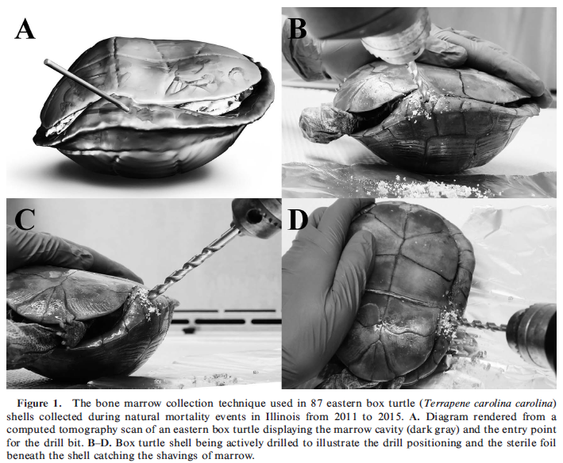

Allender, M. C., Barthel, A. C., Rayl, J. M., & Terio, K. A. (2018). Experimental transmission of frog virus 3–like ranavirus in juvenile chelonians at two temperatures. Journal of wildlife diseases, 54(4), 716-725.

Abstract: The pathogenicity of frog virus 3 (FV3)–like ranavirus varies in adult chelonian species at different environmental temperatures, but differences in pathogenicity at different temperatures has yet to be determined in juveniles. Our objective was to determine the susceptibility to FV3-like ranavirus in four species of juvenile chelonians: red-eared sliders (RES; Trachemys scripta elegans), Mississippi map turtles (Graptemys pseudogeographica kohnii), false map turtles (FMT; Graptemys pseudogeographica), and eastern river cooters (Pseudemys concinna concinna) at two environmental temperatures. Two simultaneous trials (n=8 treatment and n=4 controls of each species) were conducted in separate temperature-controlled rooms with animals maintained at 22 C or 27 C. All of the inoculated animals of each species at each temperature died, but no mortality was observed in control animals. Median survival times varied between 8 d and 11 d, based on species and temperature, with RES in the 27 C trial surviving the shortest time and the FMT in the 22 C trial surviving the longest. Combining all species, turtles in the 27 C trial survived for fewer days than those housed at 22 C, despite all turtles in both trials having similar viral copies detected in postmortem tissues. Lesions in inoculated turtles resembled those noted in natural and experimental FV3-like ranavirus infections and included vasculitis, thrombosis, hemorrhage in multiple organs, renal tubular necrosis, and hepatic necrosis. Myositis was not present in any juvenile, infected turtles in this study. This study confirmed that juvenile chelonians have a high susceptibility to ranaviral disease.
- Introduction:
  - Ranavirus – OIE reportable, infects amphibians, fish, reptiles.
  - Marked systemic disease, may or may not show gross CS.
  - Environmental temperature contributes to variable outcomes in fish, amphibians, reptiles.
    - A. tigrinum high mortality at 10 and 18C, low mortality at 26C.
    - R. temporaria tadpools greater mortality at higher temps.
    - Tiger salamander larvae, wood frog tadpoles, N leopard frog tadpoles higher mortality at lower temps.
    - RES greater mortality at lower environmental temps.
  - Age significant predictor of mortality in amphibians, higher in larval or metamorphic age classes in NA and adults in UK.
- MM:
  - Inoculated IM. Monitored outcomes, performed necropsies.
- Results:
  - Lethargy only CS observed, present in a single RES in 22C.
  - Most died before development of CS or were euthanized due to severity of CS (lethargy).
  - All died between 6-16d inoculation, 100% mortality rate.
  - Lesions on necropsy – Vasculitis, thrombosis, hepatic necrosis, renal tubular necrosis, pneumonia.
  - Warmer temperatures led to shorter MST in both RES and MMT and no difference in FMT or RC.
  - More turtles housed at 22C were observed with intracytoplasmic inclusions than were seen in the turtles housed at 27C. Not significant. Inclusions most often in MMT.
- Takeaway: Juvenile chelonians, high mortality after inoculation with FV3. Minimal clinical signs prior to death. Warmer temperatures shorter MST vs colder for all species evaluated.

Journal of Zoo and Wildlife Medicine, 50(1), 238-242, 2019.
IDENTIFICATION OF HELODERMATID ADENOVIRUS 2 IN A CAPTIVE CENTRAL BEARDED DRAGON (POGONA VITTICEPS), WILD GILA MONSTERS (HELODERMA SUSPECTUM) AND A DEATH ADDER (ACANTHOPHIS ANTARCTICUS)
Shemi L. Benge, Timothy H. Hyndman, Richard S. Funk, Rachel E. Marschang, Renata Schneider, April L.Childress, and James F.X. Wellehan Jr.

Abstract: Adenoviruses are medium-sized DNA viruses with very high host fidelity. The phylogenetic relationships of the adenoviruses strongly resemble that of their hosts, consistent with evolutionary codivergence. The genus Atadenovirus appears to have evolved in squamate hosts. Perhaps the best known of the squamate adenoviruses is Agamid adenovirus 1 (AgAdV1), found most commonly in central bearded dragons (Pogona vitticeps), where it is a prevalent cause of hepatitis/enteritis, especially in young animals. All previous reports of adenoviruses in bearded dragons were AgAdV1. Helodermatid adenovirus 2 (HeAdV2) was first seen in Mexican beaded lizards (Heloderma horridus). Subsequently, partial adenoviral polymerase gene sequence from a western bearded dragon (Pogona minor) in Australia was found to share 99% nucleotide homology with HeAdV2. This article reports the discovery of a virus identical to HeAdV2 in a captive central bearded dragon in Florida and wild Gila monsters (Heloderma suspectum) in Arizona. Additionally, a partial adenoviral polymerase gene sharing 98% homology with this HeAdV2 was discovered in a death adder (Acanthophis antarcticus) in Australia. These findings call into question the provenance of HeAdV2. Further studies of atadenoviral host range, diversity of adenoviruses in captive animals, and characterization of adenoviruses from wild squamates are indicated.
IMPORTANCE: mild, probably just know that adenoviruses can cross over species
Background
- 5 accepted genera of adenoviruses (Mastadenovirus, Aviadenovirus, Atadenovirus, Ichtadenovirus and Siadenovirus).
  - Testadenovirus: 6th proposed genus
  - All known adenoviruses of squamates are in the genus Atadenovirus
  - High host specificity suggests tight coevolution
- Clade Toxicofera
  - Family Agamidae (infraorder Iguania): Pogona vitticeps (central bearded dragons)
    - Agamid adenovirus 1: lethargy, weakness, diarrhea, sudden death, primarily enterohepatic lesions
    - Widespread (NA, EU, AU), and only adenovirus reported in bearded dragons
  - Family Helodermatidae (infraorder Anguimorpha): Heloderma suspectum (gila monsters) and Heloderma horridum (Mexican beaded lizards)
    - Helodermatid adenovirus 1: gia monsters
    - HeAdV2: Mexican beaded lizards
    - 2011: partial polymerase gene of a virus with 99% homology to HeAdV2 reported in western bearded dragon (Pogona minor) *Not a helodermatid
  - Family Elapidae (infraorder Serpentes)

Key Points
- Helodermatid adenovirus 2 (HeAdV2) found in an inland bearded dragon (P. vitticeps) in FL, 3/5 wild Gila monsters in Arizona, and partial (98%) gene homology to HeAdV2 in a death adder (Acanthophis antarcticus) in Australia
Conclusions
- Lack of host specificity for HeAdV2 (found in an agamid, a snake, and a Gila monster)
  - Adenoviruses are generally considered “host-specific” but there have been reports of host cross over
  - Possibly due to unique virion architecture (one short or three long fibers attached to the penton host) involved in cell entry
- Unclear how transmission may have occurred between wild and captive populations

Prevalence of box turtle adenovirus in eastern box turtles (terrapene carolina carolina) presented to a wildlife rehabilitation center in Virginia, USA.
Franzen-Klein, D., Adamovicz, L., McRuer, D., Carroll, S. A., Wellehan, J. F., & Allender, M. C.
Journal of Zoo and Wildlife Medicine, 2019;50(4):769-777.

Abstract: Eastern box turtles (Terrapene carolina carolina) are a native North American species with a declining population trend that may be attributable to habitat fragmentation, vehicle collisions, and disease. Adenoviral infections can cause significant morbidity and mortality in captive reptile populations. Adenoviruses have been documented in box turtles, but their occurrence and impact in wild populations are unknown. A disease survey was performed at The Wildlife Center of Virginia, USA, to assess the prevalence of box turtle adenovirus (BTAdV) in wild eastern box turtles and evaluate potential associations with clinical disease. Swabs from the oral cavity, including the choanal slit, and the cloaca were collected from 106 eastern box turtles from July 2015 through June 2016. The quantitative polymerase chain reaction (qPCR) primer detected both ornate box turtle adenovirus 1 and eastern box turtle adenovirus. The resulting qPCR adenovirus prevalence was 55.7% (n = 59). Most animals (99.3%) that tested positive for BTAdV had fewer than 100 viral copies/ng DNA. This study did not find a statistically significant association between cause of admission, age, sex, outcome, and BTAdV qPCR status. However, the probability of BTAdV detection was 1.5 times higher in rehabilitation turtles compared with wild turtles (P = 0.01). Albumin was significantly lower in qPCR BTAdV-positive turtles (P = 0.007). Hypoalbuminemia is not generally associated with adenovirus infections in other species, and no obvious clinical cause for this abnormality was identified. The results of this study suggest that eastern box turtles may harbor BTAdV infections at low levels and that infection is rarely associated with clinical disease, potentially identifying BTAdV as a host-adapted pathogen. Future studies should focus on this pathogen's ability to induce clinical disease and its potential impact on recovery efforts for this species.
Background
- Eastern box turtle: vulnerable IUCN
- Adenoviridae – Nonenveloped, dsDNA viruses that replicate in host nuclei and are released when the host cell ruptures.
  - Mastadenovirus – Mammals.
  - Aviadenovirus – Birds.
  - Ichtadenovirus – Single viral isolate from a white sturgeon.
  - Siadenovirus – Amphibians, chelonians, birds.
  - Atadenovirus – Squamates, also some turtles, birds, frogs, possums, ruminant mammals.
- Chelonians – Siadenovirus infections in Sulawesi tortoises, impressed tortoises, ornate box turtle, pancake tortoise, eastern box turtles, yellow-bellied slider, red-eared slider.
  - Proposed new genus “Testadenovirus”
  - Box turtle adenovirus 1 (BTAdV1) named for genetically distinct AdV in the ornate box turtle
- Source is frequently unknown, very stable in environment
  - Horizontal transmission via fecal-oral, direct contact with nasal secretions, or fomites/aerosols suspected
- Range of clinical abnormalities from subclinical dz to high mortality.
  - Lethargy, anorexia, mucosal ulcerations, oculonasal discharge, sudden death, systemic inflammation, hepatic necrosis, GI ulcers, intranuclear inclusions.
- qPCR on choanal/cloacal swabs, nasal flushes, plasma, and necropsy tissue

Key Points
- Prevalence of BTAdV was 55.7%, majority had low copy numbers (<100)
  - Higher probability (1.5x) of detection in rehab turtles than wild population
  - No association between AdV status or copy number and clinical outcome (lived or died), turtle size, age, sex, or cause of admission
  - Albumin was significantly lower in BTAdV positive turtles
- DNA sequencing from qPCR positive showed ornate box turtle adenovirus 1 and eastern box turtle adenovirus (qPCR primer was detecting both)
- Albumin significantly lower in qPCR positive turtles.
- Two individuals with clinical signs – nasal discharge, conjunctivitis/exophthalmia, neuro signs and death.
  - Both confounded by dog bite trauma
  - Tested negative of PCR for Mycoplasma, ranavirus, herpesvirus
  - Number of viral copies did not correlate with clinical signs.

Conclusions
- Relatively high prevalence of adenovirus in eastern box turtles
  - Both ornate box turtle adenovirus 1 and eastern box turtle adenovirus present in wild eastern box turtles in Virginia
- Most were subclinical, healthy eastern box turtles may be carriers
- Higher prevalence in rehabilitated turtles vs wild caught
- Albumin was significantly lower in positive turtles

Practice Question
Adenoviruses recently sequenced from wild eastern box turtles in Virginia are members of which genus in the family Adenoviridae?
- Ichtadenovirus
- Aviadenovirus
- Siadenovirus
- Testadenovirus
- Atadenovirus

Answer: D (proposed new 6th gneus)

