Avian Respiratory System Anatomy and Physiology Summary
• Mitchell-Tully, Current Therapy in Exotic Pet Practice – Chapter 3: Respiratory system (pages 88-93, Avian section)

- Upper Respiratory System: Nasal cavity, infraorbital sinus and diverticula.
- Nares
  - Perforated – Gruiformes, Cathartiformes
  - Closed – Pelecaniformes
  - Tip of Beak – Kiwi
  - Tubular – Procellariformes
  - Operculated – Psittaciformes, Galliformes
  - Nasal Valve – aquatic birds – diverts water from olfactory chamber
  - Nasal Gland – salt excretion
  - Sense of small – kiwis, turkey vultures, petrels, albatrosses
- Nasal cavity is divided successively into nasal vestibule with squamous epithlium, (rostral nasal concha), respiratory region with mucociliary epihtlieum (middle nasal concha), and olfactory chamber (olfactory epithelium).
  - Concha – Cartilaginous structures that increase SA, limit heat and water loss during ventilation.
  - Rostral concha visible through nostrils in falconiformes.
  - Rostral and middle conchae communicate with nasal cavity through common meatus nasalis. Caudal concha only connects to the infraorbital sinus.
- Sinuses
  - Infraorbital sinus – Only paranasal sinus in birds. Communicates dorsally with nasal cavity and caudal concha and pneumatizes most structures of the head and neck.
    - Quadrate bone, articular bone, and most bones of the braincase are pneumatized by diverticula arising from the tympanic cavity (opening is the infundibular cleft) with no connection to the upper resp system.
    - Infraorbital sinus diverticula absent in cormorants.
  - Amazon parrots:
    - One rostral unpaired diverticulum
    - Six paired diverticula
  - Macaws:
    - Two rostral unpaired diverticula (including transverse canal)
    - Eight paired diverticula
  - Psittacines – R and L sinuses communicate through transverse canal (not present in most other birds).
  - Largest diverticulum of the psittacine paranasal sinus – Cervicocephalic diverticulum.
    - Reaches as far as the shoulder, not connected to the lower respiratory system (not an air sac!).
- Larynx
    - 4 cartilages – cricoid, procricoid, 2 arytenoid
    - Epiglottic cartilage, thyroid cartilage, and vocal cords absent in birds.
    - Does not generate sound, may modulate.
  - Crista ventralis – Median crest
    - Arises ventrally from the cricoid cartilage inside the glottis and should be avoided during endotracheal intubation.
    - Pelicans, hornbills, kiwis, penguins, some ducks
  - Dilator and constrictor muscles of the larynx control the glottal opening.
- Trachea
  - High variability in length and anatomy
  - Lines by ciliated columnar epithelium
  - Starts on midline, passes slightly to the right side of the neck and enters the thoracic inlet.
  - May have multiple loops:
    - In keel – Trumpeter Swans and Whooping Cranes
    - Subcutaneous – curassows, Magpie Geese, Trumpeters, some birds of paradise.
  - Tracheal Sacs – Emu, Ruddy Duck
  - Bulbous expansions – Males of certain duck species; Rosy Billed Pochard.
  - Double Trachea – Penguins, petrels.
    - Septum extends from bronchial bifurcation.
  - Mynahs and toucans have a slight ventral kink to trachea before entering the thorax.
  - Tracheal cartillages are complete but asymmetric with broader half part usually overlapping narrow parts of two adjacent rings.
  - Increased tracheal diameter to compensate for increased tracheal length.
    - Tracheal dead space still ~4x mammals.
    - Compensated by a larger tidal volume.
- Syrinx – Voice production.
  - At bronchial bifurcation, surrounded by interclavicular air sac.
  - Variations are categorized into tracheobronchial (most common) and bronchial.
  - Main structures of syrinx:
    - Tympanum (structural body of organ), pessulus (Divides the airway vertically), paired medial and lateral tympaniform membranes (vibrate).
    - Left dilation of the tympanium (syringeal bulla) frequently present in males of Anatidae.
    - Syrinx of psittaciformes lacks pessulus.
      - Two unique pairs of short syringeal muscles: superficial and deep.
    - Passeriformes may have up to five pairs of intrinsic syringeal muscles.

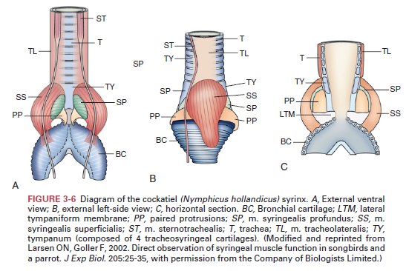
- Lung-Air Sac System:
  - Lungs:
    - Avian lungs are dorsal, do not enclose the heart.
    - Lungs are not lobed, indented dorsally by ventral ribs.
    - Caudal border of lungs may extend as far as hip joints (storks, geese).
    - Lungs bordered ventrally by horizontal septum.
  - Two primary bronchi -> intrapulmonary primary bronchi -> abdominal air sac.
  - Four groups of secondary bronchi arise from primary bronchi:
    - From cranial to caudal:
    - Medio-ventral, medio-dorsal, latero-ventral, latero-dorsal secondary bronchi.
    - Multiple parabronchi branch off the secondary bronchi.
    - Anastomosed parabronchi carry atria -> infundibula and air capillaries (site of gas exchange).
  - Parabronchial lungs divided into two structural units:
    - Paleopulmo – Ventilation is unidirectional, formed by the medioventral-mediodorsal system of bronchi and parabronchi. Characterized by layers of hooplike parallel parabronchial connections between secondary bronchi.
    - Neopulmo – Ventilation is bidirectional. Formed by anastomosing network of parabronchi connecting the lateroventral-laterodorsal system of bronchi to each other and other secondary bronchi. Located caudally, less than 1/3 pulmonary parenchyma. Absent in Sheniciformes, most developed in Passeriformes.
  - Air capillaries anastomose (unlike mammalian alveoli which are dead-end).
  - Air and blood capillaries are in cross-current pattern – Blood-gas barrier is much thinner vs mammals.
    - This arrangement + greater surface exchange area and thinner blood-gas barrier makes avian lung more efficient gas exchange mechanism vs other vertebrates.
- Air Sacs – Generally 9 total.
  - 2 cervical
  - 1 interclavicular
  - 2 cranial thoracic
  - 2 caudal thoracic
  - 2 abdominal air sacs
  - Exceptions
    - Passerines – 7 (cranial thoracics fused to interclavicular)
    - Chickens – 8 (fused cervicals)
    - Storks – 11 (caudal thoracic divided in 2)
    - Turkeys – 5 (no caudal thoracic, cervical fused with two primordial clavicular air sacs, one small pair of clavicular air sacs)
  - Air sac diverticula pneumatize various anatomical structures.
    - Cervical air sacs – Vertebral and large subcutaneous diverticula (ganets, ostriches).
    - Interclavicular air sac – Many intra- and extrathoracic diverticula including two large axillary diverticula; surrounding the heart, pneumatizing the sternum, coracoids, humerus.
    - Cranial and caudal thoracic air sacs below lungs.
    - Abdominal air sacs largest except penguins.
    - Perirenal diverticula dorsal to kidneys and femoral diverticula pneumatizing the femurs arise from abdominal air sacs.
  - Air sacs connected to lungs through ostia
    - Cervical, caudal thoracic, abdominal air sacs have one ostium.
    - Cranial thoracic and interclavicular air sacs have two ostia (medial and lateral).
  - Large number of parabronchi may form a funnel-like tubular structure (Saccobronchus, present with caudal thoracic and abdominal air sacs).

- Respiratory Mechanics and Regulation:
  - Avian lung does not participate in ventilation (unlike mammals).
  - Ventilation performed by air sac system.
    - Bellows to ventilate lungs.
    - Lungs are pracitically rigid, vary minimally in volume.
    - Ventilation is both tidal (bidirectional in neopulmo, as in mammals) and through-flow (unidirectional in paleopulmo).
    - Air sacs functionally divided into two groups:
      - Cranial – Cervical, interclavicular, cranial thoracic.
        - Receive expiratory air.
      - Caudal – Caudal thoracic, abdominal air sacs.
        - Receive inspiratory air.
      - Inspired air -> caudal air sacs, bypassing the medioventral secondary bronchi (ispiratory aerodynamic valving).
      - Expiratory air from caudal air sac -> Paleopulmonic lungs through mediodorsal seoncary bronchi by expiratory aerodynamic valving terminating in cranial air sacs.
      - Crnaial air sacs -> Medioventral secondary bronchi, intrapulmonary primary bronchi, and trachea.
      - Flow is bidirectional in the neopulmo, inseries with caudal air sacs.
      - Two respiratory cycles necessary for a given volume of inspired air to move through the avian respiratory system.
      - Both expiration and inspiration are active processes.
      - Thoracic cavity is not at subatmospheric pressure as in mammals.
      - Intercostal and abdominal muscles are main resp muscles, others also.
      - All abdominal muscles are expiratory!
    - Wingbeats may assist respiratory ventilation during flight in some spp.
    - Volume of air sac system varies.
    - Position during anesthesia may influence the air sac.
      - Tidal volume lowest in dorsal recumbency.
    - Respiratory rhythm originates from brainstem, modulated by reflexes.
      - Central chemoreceptors initiate increase in ventilation when PaCO2 increases.
      - Arterial chemoreceptors at carotid bodies near parathyroid glands modulate ventilation in response to changes in PaO2, PaCO2, pH. Innervated by vagus nerve.
      - Intrapulmonary chemoreceptors – Unique to birds and reptiles, also innervated by vagus nerve.
        - Stimulated by decrease in PCO2, contrast to arterial chemoreceptors.
        - Air sac mechanoreceptors also present.
    - Changes in ventilation occur in response to changes in PaCO2, intrapulmonary PCO2, PaO2, and pH.

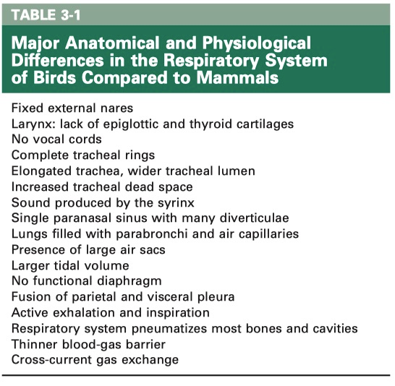
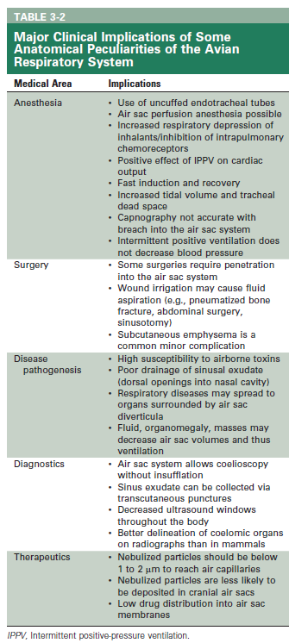

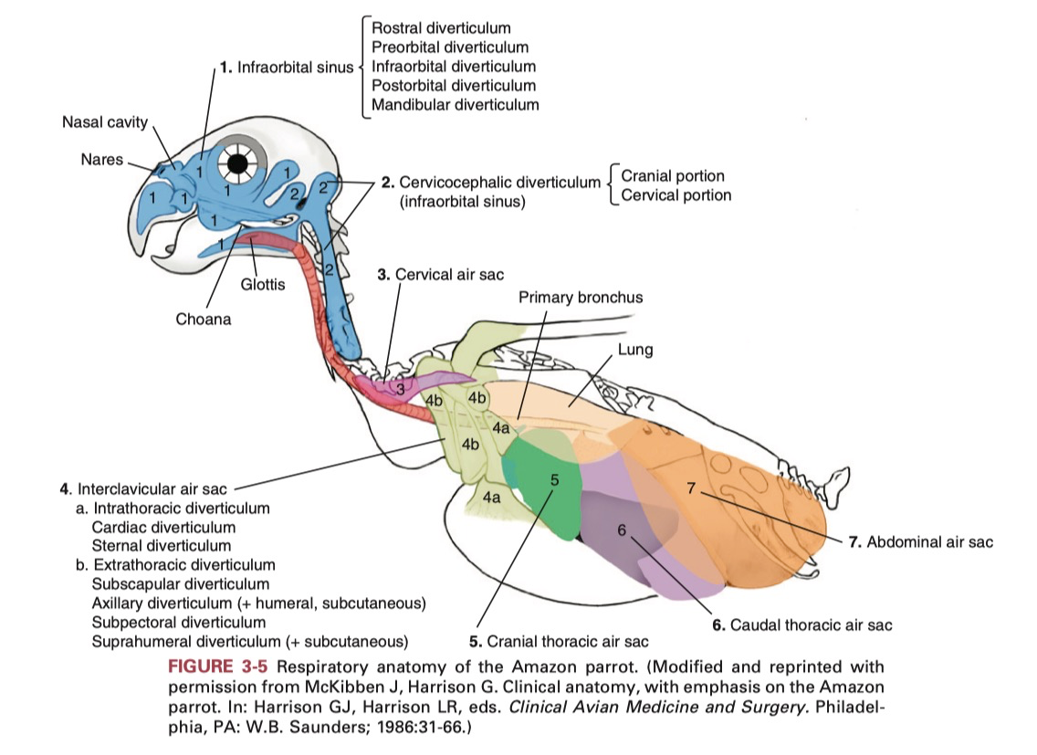

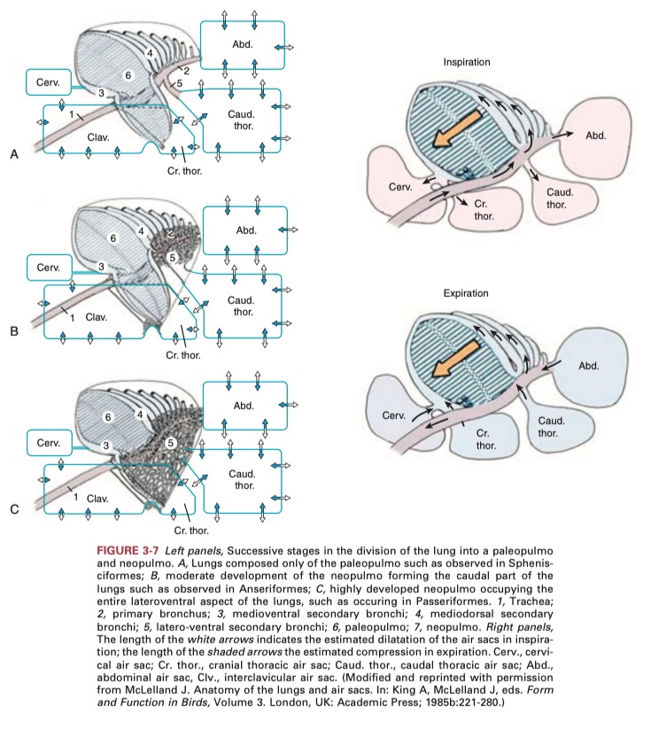

Ch 6. Cardiology
Current Therapy in Avian Medicine and Surgery (Speer 2015)

Anatomy and Physiology
- Unique Avian Features
  - HR relative to body mass is lower in birds vs mammals
  - Heart is relatively larger and stroke volume and CO greater
  - HR can increase 2-4 X during flight (ex: budgerigar in flight has CO 7X dog in max. exercise)
  - MAP higher vs mammals, but total peripheral resistance is lower
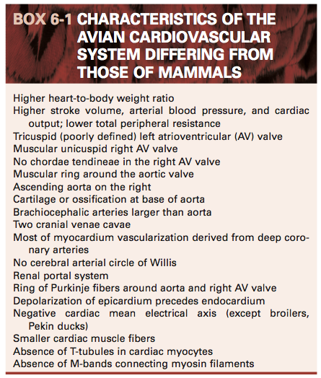
- Heart
  - Located in cranioventral coelom next to sternum, tracheal bifurcation, esophagus, proventriculus
  - Surrounded by cervical, clavicular, and cranial thoracic air sacs
  - Intrathoracic diverticula of the unpaired clavicular air sac surrounds the heart and great vessels
    - Also pneumatize the sternum and suspend the esophagus, trachea, syrinx
  - 4 chambered heart (LA, RA, LV, RV) composed of endocardium, myocardium, epicardium
    - Cardiac cartilage forms fibrous rings around aorta and pulm. arteries
    - Some spp. have sinus venosus prior to RA (ex: chickens, crows, ostriches, kiwis)
  - Right AV valve lacks chordae tendinae (unique to birds)
    - Has a spiral muscular flap composed (atrial myocardium and ventricular myocardium)
  - Avian cardiomyocytes are smaller and more numerous than mammalian
    - T-tubule system is absent lacking in birds
    - Sarcolemma and sarcoplasmic reticulum occur at cell surface
    - Lack M-bands that connect myosin filaments in mammalian cardiac muscle
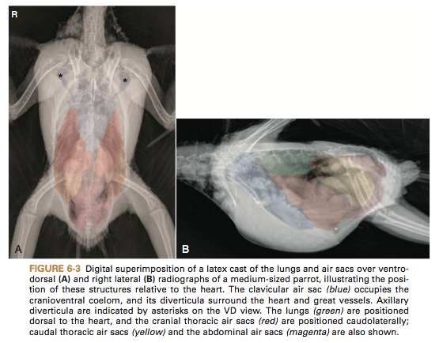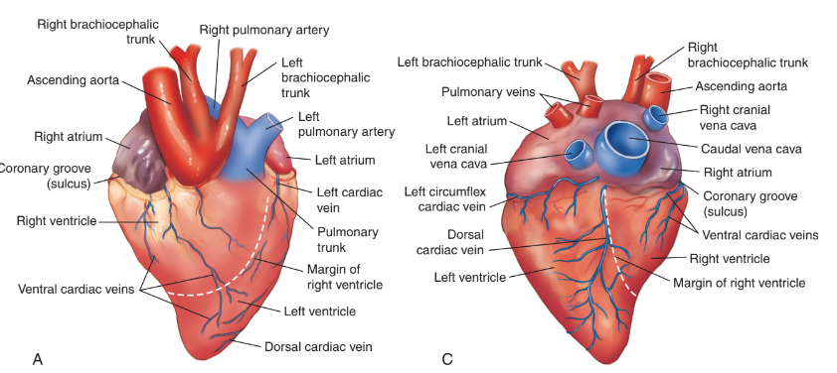
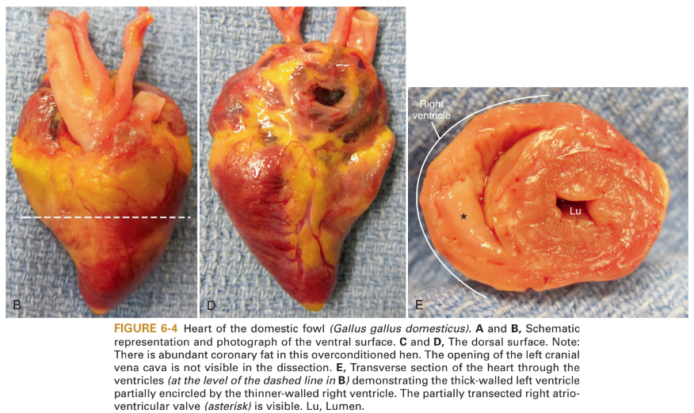
- Cardiac conduction system
  - Three bundle branches (left, right, middle)
  - AV ring of Purkinje fibers surrounding the right AV opening and connecting to the right AV valve
  - Ventricular depolarization begins subepicardially and spreads to endocardial surface
    - Reason for negative ECG in lead II
    - Different from mammals whose depolarization starts at endocardium
- Pericardium = non-compliant sac
  - Outer layer is continuous with adventitia of great vessels
  - Attachments exist to sternal plate, hilus of lungs, adjacent air sacs, and liver
- Vascular Anatomy
  - Vena Cava
    - Paired crania venae cavae enter at sinoatrial valve
      - Septum sinus venosi separates LCrVC and RCrVC
    - Single caudal vena cava empties into right atrium
  - Coronary Arteries and Cardiac Veins
    - Unlike in mammals, the ascending aorta immediately gives rise to L and R coronary arteries
    - R coronary is largest in most spp. and anastomose frequently
    - Left, right, middle, and left circumflex cardiac veins (middle and left circumflex = largest)
  - Ascending aorta – supply of head, neck and thoracic limbs
    - Large, paired brachiocephalic trunks brach simultaneously from ascending aorta
    - Subclavian arteries supply flight muscles, so they are larger than aorta
    - Intercarotid anastomosis at base of brain, present in virtually all bird spp. 🡪 no circle of Willis
  - Descending aorta – supply of trunk, viscera and pelvic limbs
    - Major branches: Coeliac, cranial mesenteric, pair cranial renal, external iliac, ischiatic, caudal mesenteric, internal iliac
    - Testicular arteries arise from cranial renal arteries
    - Single or multiple ovarian arteries arise from either left cranial renal artery or from aorta
  - Pulmonary vasculature
    - RV → pulmonary trunk → R and L pulmonary arteries 🡪 intraparabronchial arteries 🡪 intraparabronchial arterioles
  - Venous System
    - Right jugular is larger than left and receives blood from the left via anastomosis at base of head
  - Renal Portal System = ring formed by cranial and caudal renal portal veins ventral to kidneys
    - Receives blood from gut and pelvic region
    - Passes through renal parenchyma mixing with post-glomerular efferent arteriolar blood 🡪 renal veins 🡪 common iliac veins and CdVC
    - Renal portal valve = smooth muscle sphincter in external iliac v.
      - Sympathetic and parasympathetic control of venous blood that enters kidney tissue
    - Venous flow can be shunted into internal vertebral venous sinus or to hepatic portal system
      - Through caudal mesenteric vein (bidirectional flow)
  - Vascular microanatomy
    - 2 classifications for arterial structure: elastic and muscular arteries
    - Resilience of avian elastic arteries are superior to mammals
- Cardiovascular Control Systems
  - Systemic arterial blood pressure is function of cardiac output and resistance of arterial system
  - Both epinephrine and norepinephrine act on beta-adrenergic receptors
  - Positive inotropic, chronotropic, and lusitropic effects
  - Unlike in mammals, norepinephrine believed to be more potent stimulant

Clinical Disease States
- Atherosclerosis
  - Definition: chronic inflammatory and degenerative disease of arterial wall where the lumen narrows by progressive accumulation of inflammatory cells, fat, cholesterol, calcium, cellular debris that forms fibrofatty atheromatous plaques within the intima
  - Potential complications: stenosis, ischemia, thrombosis, hemorrhage, aneurysm
  - Pathophysiology
    - Endothelial dysfunction, damage and oxidative stress which promotes increased endothelial permeability to lipoproteins and intimal adherence and migration of inflammatory cells
    - Attracts monocytes 🡪 macrophages (internalize lipoproteins, store cholesterol) 🡪 foam cells
    - foam cells die by necrosis or apoptosis = further accumulation of lipid and necrotic debris = necrotic core
    - Smooth muscle cells proliferate and migrate into intima/subintimal space producing extracellular matrix
    - Fibrous cap overlays lipid and necrotic core
    - Smooth muscle cells also form foam cells
  - Lesion Characterization
    - I and II: early – increased foam cells, extracellular lipids and Ca, no arterial wall disruption
    - III: intermediate – mild arterial wall architectural disruption
    - IV-V: advanced – formation of fibroatheromatous plaque by accumulation of lipid and cell debris
    - VI and VII – fissure, hematoma, thrombosis and VII is calcific lesion (osseous metaplasia)
    - Unlike in humans, avian clinical dz primarily progressive flow-limiting arterial stenosis in birds, rather than thrombosis and hemorrhage of disrupted plaques
    - Acute myocardial infarction less likely in birds because:
      - Differences in coronary vasculature
      - Greater collateral circulation
      - Inability of avian thrombocyte to form shear-resistant arterial thrombi
  - Lesion Location
    - Most frequently: ascending aorta, brachiocephalic trunks, pulmonary arteries
    - Coronary and aortic aneurysms secondary to atherosclerosis d/t decreased compliance of vessels
  - Prevalence
    - Prevalence (2 to 92%) varies with highest reported in Amazons and Grey parrots
    - Advanced lesions most common in Grey parrots > Amazons > cockatiels
      - Cockatiels and macaws are least susceptible
  - Risk Factors
    - Increasing Age
    - Female sex
      - Estrogen → lipoproteins used to transport lipid from liver to yolk
    - High cholesterol and dyslipidemia
      - Grey parrots, Amazons, cockatiels >>>> cockatoos >macaws
      - High HDL is not protective because most cholesterol in birds is transported as HDL
    - High calorie and fat diets
    - Limited physical activity
    - Reproductive disease
    - Hepatic disease
    - Concurrent myocardial fibrosis
    - Low intake of omega-3 fatty acids protect
      - Severity of atherosclerosis negatively correlates with muscle and adipose tissue content of linolenic acid in parrots
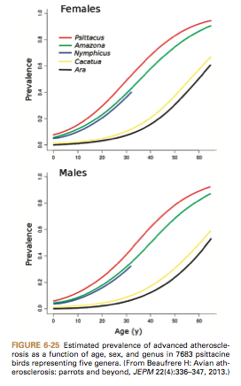
  - Non-psittacine species
    - Galliformes
      - Chickens/Turkeys – males more prone vs female
      - Turkeys can get dissecting aortic aneurysms with copper deficiency and atherosclerosis
    - Raptors
      - Common in lder captive birds and free-ranging
      - Falconiformes and Accipitriformes: 8%; Strigiformes: 16%
      - Risk factors – inactivity in captivity, increasing age, obesity, rapid wgt loss
      - Common practice of feeding day-old chicks may potentiate atherosclerosis
    - Also seen in Columbiformes, Spheniscifomes, and Ciconiiformes
- Non-atherosclerotic Aneurysm and Arterial Rupture
  - Copper deficiency, hypertension, fungal infection, spontaneous/idiopathic
  - Mainly seen in ostriches and turkeys – systemic hypertension, genetics, connective tissue disorders, peas in the ration (toxin beta aminopropionitrile in the peas can cause interference with collagen formation), dietary deficiencies (copper deficiency)
  - Copper dependent enzyme is needed for connective cross-linking collagen & elastin in artery wall
- Heart Failure
  - Right-sided CHF – venous congestion, hepatic congestion, ascites, pericardial effusion
  - Left-sided CHF – pulmonary edema and congestion of pulmonary veins
  - Pathophysiology
    - CHF is not primary disease, but it is a frequent clinical endpoint to CV dz in companion birds
    - Myocardial failure – primary dz of myocardium or 2ndary to chronic pressure or volume overload
    - Hypertrophy initially decreases wall stress and increases contractility but eventual ischemia of hypertrophied myocardium 🡪 fibrosis and increased collagen content impairing bot hsystolic and diastolic function
    - Eccentric hypertrophy characterized by chamber enlargement and increased myocardial mass with little increase in wall thickness
    - Birds = greater propensity for developing pulmonary hypertension and R-sided CHF vs mammals
    - Due to morphology of right AV valve, less deformable nucleated erythrocytes, rigid non-distensible lungs which limit blood capillary expansion and accommodate greater blood flow
  - Primary myocardial disease
    - DCM – ventricular dilation, thinning of myocardium, systolic and diastolic dysfunction
      - 4 wk old turkey poults – spontaneous DCM
    - Myocardial changes consistent with ischemic injury assoc with atherosclerosis in psittacines
      - Potential to produce arrhythmias, risk of sudden death
      - Acute myocardial infarction rare
      - Difference in coronary artery and greater collateral circulation vs humans
    - Proventricular Dilatation Disease PDD caused by Avian Bornavirus (ABV) characterized by lymphoplasmacytic infiltration of nerve ganglia.
      - Inflammatory infiltrates found in epicardium and myocardium, esp Purkinje fibers
      - Potentially precipitates arrhythmias and sudden death
      - Study: 70% PDD cases had cardiac lesions
    - Polyomavirus produces myocarditis with necrosis and hemorrhage
      - Intranuclear inclusion bodies within cardiomyocytes
    - WNV, parasites (protozoal, filaroid nematodes)
    - Visceral gout – inflammatory reaction accompanies urate deposition
    - Deficiencies of vit E/selenium – myocardial degeneration, white streaks
    - Dietary Ca-Phos imbalance, vitamin D toxicity - cardiac and vascular mineralization
    - Cardiotoxins – furazolidone induces DCM in turkey poults (used as model for human DCM)
    - Lead toxicosis in waterfowl – myocardial degeneration, necrosis, subsequent thrombosis/infarction
    - Neoplasia – hemangioma, hemangiosarcoma, rhabdomyoma, rhabdomyosarcoma, fibrosarcoma, melanosarcoma, lymphoma
    - Poultry – oncogenic viruses – lymphoma (diffuse or nodular)
    - Traumatic injury
    - Congenital defect
  - Pressure overload
    - HCM – arterial luminal stenosis and decreased compliance from atherosclerosis or pulmonary hypertension 2ndary to atherosclerosis, chronic pulmonary dz or L-sided CHF
    - The incidence of fibrotic changes increases in proportion to atherosclerotic lesion severity
    - Systemic hypertension has not been defined in psittacines
    - Iron storage dz in mynah and yellow-billed magpie 🡪 severe hepatic fibrosis with cardiomegaly or CHF
    - Cor pulmonale – Grey parrot d/t pulmonary arterial atherosclerosis and severe pulmonary hypertension
    - Pulmonary hypertension plays key role in ascites syndrome of broilers
      - Primary cause of pulmonary hypertension and hypoxemia 🡪 inadequate cardiac output related to relatively small LV and poor systolic function
      - Environmental conditions that contribute: high altitude, hot/cold temps that increase O2 demand
  - Volume Overload
    - Endocardiosis – non-inflammatory nodular thickening of valves
      - Idiopathic, mostly affecting left AV valve
    - Congenital – ventricular or atrial septal defects in 7% Mississippi Sandhill Cranes
      - Cockatoos overrepresented with ventricular septal defects
  - Arrhythmias
    - C/S: absent OR weakness, syncope, sudden death
    - Supraventricular and VPCs reported in chickens, Amazons, Grey parrots
    - First-degree AV block, 2nd degree AV block – may be found in healthy individuals
    - Mobitz type 2 2nd degree AV block has potential to progress to 3rd degree AV block
  - Compensatory mechanisms in heart failure
    - In mammals – AII and aldosterone – mediators of inflammation, oxidative stress, myocardial and vascular remodeling and fibrosis
    - AVT product of posterior pituitary homologous to mammalian antidiuretic hormone ADH
      - Released in response to increases in plasma osmolality, hypotension, and AII
      - Induces vasoconstriction, decreases GFR by constriction of afferent glomerular arterioles and promotes tubular water resorption
    - Prevalence
      - Cardiac dz in 10% of 269 psittacines (path survey at Ohio State – 1991-1995)
      - 58% CHF, 42% systemic infectious diseases
    - Another study 36% of 107 psittacines had grossly visible heart abnormalities (99% had histo changes)
      - 60% inflammatory infiltrates
      - Majority of noninfectious CV dz = atherosclerosis and CHF
      - Aatherosclerosis in 13%
- Pericardial Disease and Effusion
  - Pathophysiology
    - Causes of pericardial effusion - pericarditis, trauma or aneurysmal rupture, cardiac or pericardial neoplasia, metabolic derangement, toxicity, R-sided CHF, idiopathic
    - Cardiac tamponade – thinner walled RV overcome by the pressure of pericardial effusion more rapidly than left 🡪 R-sided CHF occurs first
      - Clinical severity depends on the rate that the pericardial effusion develops
  - Pericarditis and Visceral Gout
    - Fibrinous pericarditis in 10% of C. psittaci infected psittacines
    - Pericarditis = most severe and persistent lesion in domestic turkeys infected with virulent C psittaci
    - Mycotic infections (Aspergillus) – pericardial dz by extension from resp tract or hematogenous spread
    - Viral etiologies (ex: psittacid herpesevirus, polyomavirus, adenovirus, avian influenza…)
    - Visceral gout frequently affects pericardium and causes heterophilic inflamm response
      - Gout = smooth white plaques vs infectious = yellow rough exudates

DIAGNOSTIC METHODS

Diagnostic Methods
- History, Clinical Signs, Exam Findings
  - C/S: subtle insidious onset with owner report progressively declining activity, reduced appetite, waning interest in house-hold activities, toys, vocalizations
    - Many subclinical and go unrecognized
    - No premonitory signs appreciated prior to sudden death
  - Presenting complaint: lethargy, depression, weakness, reduced appetite, respiratory distress, exercise intolerance
  - PE findings: cachexia, tachypnea, dyspnea, harsh lung sounds, pallor or cyanosis, tachycardia, arrhythmia, systolic murmur, poor pulse quality or deficits, coelomic distension, acites, peripheral edema, peripheral venous congestion, altered mentation
  - Cardiac auscultation relatively insensitive tool, absence of audible murmur does not r/o CV pathology
  - Arterial pulses best palpated proximal antebrachium and relative warmth of each extremity
- Atherosclerosis
  - C/S: diminished blood flow through stenotic arteries; vary based on artery affected, severity and any concurrent disease, falling, weakness, dysfunction of one or more limbs, +/- altered mentation
    - Sudden death as result of cerebral infarct, aneurysmal rupture, lethal cardiac arrhythmia
    - Recurrent or non-resolving derm conditions (axillary feather loss) 🡪 atherosclerotic lesions in vessels supplying these areas
      - Tissue hypoperfusion or pain/numb/tingling sensation
- Congestive Heart Failure
  - Present most consistently w/ respiratory embarrassment as a results of intracoelomic air sac compression
    - Ascites and organomegaly, pulmonary edema or combination
  - Hepatomegaly (palpation beyond sternal margin), venous congestion (jugular and cutaneous ulnar veins), edema of hocks/feet, delayed absorption of SQ fluids (>48 hrs)
  - Pericardial effusion = muffled heart sounds, pulmonary edema (increased resp noise cranial dorsum parallel to spine; rare to hear cough, severe cases crackles and wheezes)
- Baseline Diagnostic for Birds with Signs of Cardiovascular Disease
  - CBC, Chem, rads, U/S, ECG, BP, Endoscopy, CT, MRI
  - CBC low sensitivity for CV dz – leukocytosis, heterophilia, lymphopenia, polycythemia
    - Polycythemia can result from chronic hypoxemia resulting from persistent ventilation/perfusion mismatch and increased oxygen demands
  - Chem – elevations in AST, CK, LDH; cardiac troponins T and I sensitive and specific in humans but no reference range established for birds
  - Diagnostic value of plasma lipid profile not established; hypercholesterolemia neither necessary nor sufficient for diagnosis of atherosclerosis
    - Birds with normal plasma cholesterol may have atherosclerotic dz, while those with hypercholesterolemia may not
- Electrocardiography
  - Severe pathology and mechanical dysfunction can exist in absence of ECG changes
  - Benzodiazepines used with increasing regularity in companion birds of unknown effect on ECG
  - Right thoracic limb (RA – white), left thoracic limb (LA – black), left pelvic limb (LL – red)
  - P wave followed in some birds by small depression in beginning of PR interval = Ta wave
  - rS complex negative in lead II (prominent deflection); Q typically absent
  - ST is short or absent and S merges into T wave (ST slurring), elevated above baseline
    - May have P-on-T phenomenon which can be normal in some Amazons and Greys
  - Unlike in mammals, ventricular MEA is negative in most birds (-90 degrees)
    - Except: broiler chickens, Pekin ducks
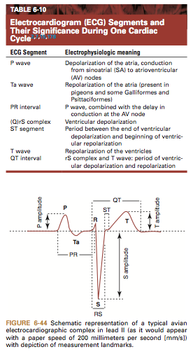
- Blood Pressure
  - Arterial BP higher in birds than in most other vertebrates
  - Direct BP = arterial catheter in superficial ulnar artery, deep radial artery or external carotid artery
  - Indirect BP = Doppler and sphygmo 🡪 cuff 30-40% limb circumference
    - Don’t usually agree with direct BP but monitor trends
    - Oscillometric method is unreliable
  - Hypotension defined as: systolic < 90 mmHg, MAP < 60 mmHg
- Radiography
  - Most practical = measurement of cardiac silhouette at widest point on VD view and comparison with both thoracic width at same level and length of sternum
    - Medium sized psittacines: 51-61% of thoracic width, 35-41% length of sternum
  - Increasing radiodensity and tortuosity of great vessels suggestive of atherosclerosis (not conclusive)
    - Most often along ascending and descending aorta, brachiocephalic trunk, occasionally along smaller arteries incl coeliac artery
  - Fluoroscopy may be considered – does not require patient restraint, sedation or anesthesia
- Ultrasound
  - 2D (B mode) – Motion-mode (M-mode) not useful - only longitudinal and semitransverse views attainable
  - presence of large sternal plate and air sacs substantially limits acoustic windows
  - 2 approaches for transcoelomic U/S
    - ventromedian – most commonly used for psittacine and raptors; liver is acoustic window
      - 2 longitudinal views (horizontal 4 chamber view) and vertical (2 chamber view)
      - reflection off ultrasound beam may produce mirror artifact 🡪 false impression of chamber dilation or aneurysm
    - parasternal – right lateral approach to avoid ventriculus
      - birds that do not have ribs with caudal extension ex: pigeons, gallinaceous birds
  - transesophageal U/S: 5 consistent views of cardiac structures, can use M-mode
    - size limitation b/c of narrow thoracic inlet, risk of esophageal perforation
  - some reference values available
  - accuracy and precision questionable with rapid HR, current resolution of equipment, and different observer can add up to 30% variability
- CT and MRI
  - seldom used to image heart because cannot be gated to fast cardiac cycle in birds to reduce motion artifacts and improve diagnostic value
  - CT can be used to image vasculature – investigate arterial calcification associated with advanced arteriosclerosis, cardiomegaly, ventricular dilation, pericardial effusion, effusion, ascites, pulmonary edema, venous congestion, cerebral complications (ischemic and hemorrhagic strokes)
- Endoscopy
  - Interclavicular approach – best for visualizing heart base, ascending aorta, brachiocephalic trunks, carotid and subclavian arteries, pulmonary arteries and jugular veins
  - Ventral midline approach – pericardiocentesis and pericardial biopsy; preferred if ascites because does not require entry to air sacs, minimizing fluid leakage into respiratory tract
Therapeutic Intervention
- Atherosclerosis
  - controlling risk factors and managing sequelae
  - Isoxsuprine – peripheral vasodilator causing vascular smooth muscle relaxation via alpha-adrenoreceptor blockade
  - ACE inhibitors – blocks formation of AII which promotes vasoconstriction by mediating release of catecholamines
  - Pentoxifylline – promotes passage of erythrocytes through damaged microvasculature by increasing flexibility 🡪 used in mammals
  - Statins – group of lipid lowering drugs for atherosclerotic effects via inhibition of cholesterol synthesis
    - Efficacy in birds questionable
      - Hispaniolan Amazons: 10 and 25 mg/kg PO 🡪 plasma levels below limit of quantitation
  - Omega-3 fatty acids – improve lipid metabolism, reduce inflammation, minimize devmt of atherosclerosis
- Congestive Heart Failure (prognosis is poor)
  - Mainstays similar to small animal medicine 🡪 diuretics, ACE inhibitors, positive inotropes, beta blockers
  - Furosemide – potent loop diuretic inhibits Na, , and Cl co-transporter in ascending limb of loop of Henle promoting diuresis and excretion of Na and Cl
    - Efficaceous and has rapid onset of action in birds DESPITE the presence of only 10 – 30 % of looped nephrons in avian kidney
    - Dose and administration based on clinical effect 🡪 ultimate goal is for lowest dose that controls the congestive signs
    - Oral bioavailability assumed poor (60-75% in humans), so dose increased at least 2 fold
      - Chickens – 2.5 mg/kg SQ or 5 mg/kg PO q8-12h
    - Must monitor renal functional status and electrolytes given potential for dehydration and hypoK+
      - Lories and lorikeets – extremely susceptible to adverse effects of furosemide
  - Spironolactone – aldosterone antagonist 🡪 K+ sparing diuretic that can be used concurrently with furosemide to offset K+ loss (not expected to be efficacious as sole agent)
  - ACE-inhibitor – essential management for CHF long-term by blunting effects of RAAS
    - Enalapril most commonly used in birds and empirically appears safe and effective
      - PK supports 1.25 mg/kg PO q8-12h in pigeons and Amazons
      - Shorter half=life and lower max plasma concentration in Amazons vs pigeons
    - Potential AE: hypotension, renal dysfunction, hyperkalemia
  - Positive inotropes – enhance myocardial contractility 🡪 use if systolic dysfunction
    - Contraindicated: HCM where diastolic dysfunction is primary problem and outflow obstruction
    - Digoxin – digitalis glycoside: weak positive inotrope and negative chronotrope (slows sinus rate and decreases AV nodal conduction) – increases myocardial contractility by directly inhibiting the Na-K-ATPase pump resulting in intracellular Ca accumulation via activation of Na/Ca exchanger
      - Controversial in small animal and human medicine because failure to reduce overall mortality and proarrhythmic and GI side effects
      - Risks of digoxin toxicity 🡪 require therapeutic drug monitoring and ECG follow up
        - Arrhythmia further potentiated by hypoK+ from diuretic use
    - Pimobendan – calcium sensitizer and phosphodiesterase inhibitor: positive inotrope, vasodilator, positive lusitrope – enhances myocardial contractility via Ca sensitization of cardiac myofibrils and by phosphodiesterase III inhibition without increasing myocardial O2 consumption
      - Increases survival time and QoL in dogs with DCM and heart failure 2ndary to mitral valve disease
      - PK in Hispaniolan Amazons: 10 mg/kg PO required to reach peak plasma levels considered therapeutic in dogs and humans
      - AE: GI upset, potential for proarrhythmic effects
- Hypertrophic Cardiomyopathy
  - Mostly secondary to pressure overload states
  - Beta blockers to reduce HR and myocardial O2 consumption, improve diastolic coronary artery flow
- Systemic Hypertension
  - Beta blockers reduce arterial BP by decreasing CO and inhibiting RAAS activation
  - Amlodipine is treatment of choice in cats
  - No established definition of hypertension in avians
- Arrhythmias
  - Lidocaine – parenteral antiarrhythmic agent to control life-threatening ventricular tachyarrhythmias
    - Contraindications: SA or AV block
    - AE: neuro dysfunction
    - ED 50 6.3 mg/kg in chickens
  - Antimuscurinic agents – atropine and glycopyrrolate – competitively inhibit binding of acetylcholine to muscarinic receptors
    - Antidote for organophosphate and carbamate intoxication
    - Contraindication: tachycardia or tachyarrhythmias, use cautiously if heart failure

Avian cavities: Speer, Current Therapy in Avian Medicine and Surgery, pgs. 345-361
- Lung and air sac system
  - rigid, tubular air exchange surfaces linked in continuous flow pattern within lung parenchyma designed to remain fixed in volume and shape
  - lungs
    - rigid
    - situated dorsally within (and between) dorsal curvature of the ribs, flanking vertebral column
  - ventilation dependent on air sacs connected on several surfaces that expand and contract due to bellows-like motion of sternum at cranial fulcrum
- Embryologic Development of the Body Cavities
  - as lung primordia develops during first 5 days of incubation, small buds appear first on caudal surfaces and then on cranial and ventral surfaces
  - abdominal air sac (AAS) buds develop from terminus of primary bronchus, ends on caudal edge of lung
  - 2nd week of incubation, clavicular and cervical air sacs arise from cranial aspect of lung, with cranial thoracic air sac (CrTAS) and caudal thoracic air sac (CaTAS) expanding from ventromedial surface
  - expansion of CrTAS and CaTAS into postpulmonary septum part and divide this structure as they expand ventrally and caudally away from lungs, creating extracoelomic cavity
  - ventral surface of lung supported and strengthened by development of horizontal septum, forms with attached walls of portions of caudal and cranial thoracic air sacs
  - visceral and parietal pleura on lung fuse to horizontal septum, adding strength
  - AAS pushes through post-pulmonary septum to expand within IPC of all birds except Kiwi
- Pericardial cavity
  - situated ventrally on midline, just dorsal to sternum
  - restrained by fibrous attachments to surrounding structures, most notably sternum
  - apex of sac intimately associated with, and positioned between, two lobes of liver
  - base attached dorsolaterally to horizontal septum near hilus of each lung
  - ventral pericardium attached to inner surface of sternum fibrous strands
  - pericardium in contact dorsally with esophagus and primary bronchi
  - outer layer of sac lined by parietal pericardium
  - at heart base near great vessels pericardium reflects back on itself to produce visceral pericardium aka “epicardium” adherent to outer surface of myocardium
  - normal pericardial sac only contains ~1-2mL or < of free fluid in large bird, <1 mL in medium-sized parrot, <0.5mL in small bird
- Pleural cavities
  - lungs in visceral pleura develop unique, tubular architecture with fixed dimensions and bilateral symmetry
  - parietal pleura that surrounds each lung and mesothelial coating of visceral pleura applied to lung form small, potential pleural cavity due to fixed dimensions of lung
  - parietal and visceral pleura develop fibrous cross-connections starting along ventromedial surface of lung
  - pleural cavity is small potential or nonexistent space
  - horizontal septum
    - developed from splitting of post-pulmonary septum
    - helps maintain rigidity of lung during respiration
    - composed of thick layer of connective tissue attached to dorsal parietal pleura
  - costoseptal muscles
    - fanshaped, striated muscle bundles (m. costoseptalis) run from ribs of lateral body wall and attach to surface of horizontal septum
    - contract during expiration to help maintain volume constancy of lung
  - further support provided by CrTAS and CaTAS walls that adhere to horizontal septum
  - saccopleural membrane - complete multilayered structure of pleura, connective tissue (horizontal septum), and air sac
- Subpulmonary cavities - right and left subpulmonary cavities
  - unique to birds
  - not true coelomic cavities - not lined by mesothelium
  - form when CrTAS and CaTAS bud from lung into postpulmonary septum, split connective tissue layer into horizontal and oblique septa
  - clavicular and cervical air sacs develop cranially to lung and laterally to pericardial sac
    - expand subpulmonary cavities cranially to thoracic inlet
  - horizontal septa form ventral walls of pleural cavities
  - bilateral horizontal septa penetrated by ostia of cervical, clavicular, CrT, and CaT air sacs
  - oblique septum
    - composed of parietal peritoneum on its dorsal and medial surfaces and air sac epithelium on ventral and lateral surfaces
    - bilateral structures composed of peritoneum and connective tissue layer
    - referred to as left and right saccoperitoneal membrane when including air sac epithelium applied to opposite side
  - saccoperitoneal membranes
    - run from lateral body walls starting from where they split from saccopleural membranes near caudal border of lungs then pass medially to posthepatic septa, then reflect ventrally to attach to sternum
      - portion torn by removal of sternum at necropsy
    - CrTAS and CaTAS walls fixed to horizontal and oblique septa to maintain shape and fixed to each other where they contact
    - abdominal air sac penetrates unsplit oblique and horizontal septa near caudolateral border of each lung to enter IPC
      - Kiwi - abdominal air sacs within subpulmonary cavities along with CrTAS and CaTAS
- Peritoneal cavities
  - 5 distinct peritoneal cavities
  - 4 HPCs surround right and left liver lobes
  - single, midline IPC contains most of GI tract, gall bladder (if present), repro organs, and spleen

  - Hepatic peritoneal cavities
    - composed of 2 paired structures - large left and right ventral HPCs (VHPCs) and smaller right and left dorsal HPCs (DHPCs)
    - chicken - left DHPC communicates with IPC via small opening covered on IPC side only by AASs, connection small and likely present in most birds
    - ventral wall of VHPCs - parietal peritoneum lining sternum
    - lateral walls of VHPCs formed by oblique septa
    - dorsal wall of VHPCs formed by posthepatic septum
    - passerines - left and right oblique septa meet over liver and form ventral surface of DHPCs
    - divided on midline into right and left entities by ventral mesentery
    - post-hepatic septum separates HPCs from IPC and runs from dorsal attachment at vertebral column just caudal to hilus of lung and continues in caudoventral direction toward caudal border of sternum or ventral body wall
    - HPC - potential spaces under normal conditions w/ limited serosal fluid present
      - normally larger than liver lobes
    - gall bladder (when present) located within IPC but attached to posthepatic septum via terminus of ventral mesentery
      - one of VHPCs must be entered in order to perform hepatic biopsy
  - Intestinal peritoneal cavity
    - single IPC - centrally located in mid-to-caudal coelom
    - contains proventriculus, ventriculus, gall bladder (if present), spleen, intestines, and male or female repro tracts
    - only coelomic cavity containing air sacs (left and right AASs)
    - air sacs enter IPC through small, unsplit portion of horizontal and oblique septa and run dorsally and caudally toward pelvic region
    - AASs most variable in shape of all air sacs because affected by volume and relative location of viscera, especially proventriculus and ventriculus
      - Kiwi - CaTAS, CrTAS, and AASs all within subpulmonary cavity
    - complete GI from proventriculus to rectum suspended by dorsal mesentery
    - ovary suspended dorsally by mesovarium
    - oviduct suspended by mesosalpinx
    - testicles suspended dorsally by mesorchia
    - ventral mesentery ends at or before caudal wall of ventriculus
      - IPC mostly single chamber except right and left lateral “pockets” that run along left proventricular–ventricular border and right hepatic border
    - ventral midline incision made caudal to ventriculus leads directly and specifically into IPC, not into “coelom” or “coelomic cavity”
    - IPC - potential space in normal birds containing little visible fluid
    - walls of AAS and IPC adherent in some areas, especially dorsally

- Summary:
  - 8 coelomic cavities: 1 pericardial and intestinal peritoneal cavities, 2 pleural cavities, and 4 HPCs
  - each cavity lined with serous mesothelium, secretes small amounts of lubricating fluids
  - all visceral organs except right and left liver lobes contained within IPC
  - ascites due to portal hypertension or right heart failure will occur first in HPCs, spilling over to IPC only when critical level reached
  - effusion, specifically of IPC, may occur with internal ovulation; ovarian, testicular, and splenic disease processes; or lymphoid neoplasia

- Diagnostics
  - Paracentesis
    - controlled puncture of ventral body wall in region of distension
    - transillumination can help guide needle placement
  - Imaging
    - Standard rads helpful
    - Fluoro with contrast
      - Demonstrate GI contractions in ventriculus and duodenum
      - used to define, by subtraction of GI elements, shape of HPCs and space-occupying structures within IPC
      - imaged in a standing or perching position without restraint

  - endoscopy
    - air sac system used to allow movement of endoscope within body and structures examined through thin, clear walls
    - recommended general approach - enter directly into CaTAS from body wall on one side so associated CrTAS and AAS walls punctured and all 3 air sacs can be entered from single incision
      - left CaTAS endoscopic approach- left AAS entered by puncturing the saccoperitoneal membrane and gonad, oviduct or ductus deferens, rectum, coprodeum, urodeum, spleen, and left portions of proventriculus and ventriculus, and some loops of small intestine visible
        - adrenal gland; cranial, middle, and caudal divisions of left kidney, and ureter also clearly visible, but these structures are retroperitoneal and not within IPC
    - IPC may be entered directly from body wall without penetrating an air sac by using one of two approaches:
      - midline, paramedian, or transverse incision in ventral body wall, incision made caudal to end of posthepatic septum and medial to distal limits of CaTAS and AAS
      - left or right postischial approach - incision dorsal to pubis and just caudal to ischium allows for puncture through body wall dorsolateral to coprodeum
        - endoscope first enters lateral IPC (right or left), and caudal wall of respective AAS seen directly ahead of telescope
        - IPC is potential space and will need to be insufflated or AAS manipulated to reduce its size so that peritoneal organs can be visualized and accessed
- Diseases
  - Ascites
    - accumulation of excess fluid within peritoneal cavities
    - fluid analysis - total protein (preferably using biuret method) and cytology, including total cell count, measurement of biochemical constituents (triglycerides, cholesterol, and amylase)
  - Cardiac
    - pericardial effusion and active pericarditis common in birds
      - if effusion occurs slowly and does not cause much fibrosis, pericardial sac may greatly increase in size before cardiac deficits occur
      - causes:
        - many systemic bacterial infections cause pericardial inflammation
          - Chlamydia psittaci - most well known
        - hydropericardium occurs frequently with pulmonary hypertension, with ascites of HPCs
        - systemic viral infections - serous pericardial effusion
          - polyomavirus infection in juvenile psittacines
    - ascites secondary to cardiomyopathy and pulmonary hypertension
      - ascites of HPCs occurs in slowly decompensating cardiomyopathy and pulmonary hypertension right heart failure, portal hypertension
      - chronic interstitial fibrosis of lung and resulting hypoxemia lead to secondary polycythemia, gradual pulmonary hypertension, and eventually right heart failure - broiler chicken, confirmed in Ara sp. macaws (predominantly Ara ararauna) and Amazona sp.
      - increasing oncotic pressure within hepatic portal system w/ RCHF leads to leakage of plasma from liver sinusoids into HPCs
        - protein content of fluid high
        - as fluid pressure in HPCs increases, overflow to IPC will occur via left dorsal HPC connection
  - hepatic cirrhosis
    - chronic hepatic inflammation leads to fibrosis of liver parenchyma, leading to restriction of portal blood flow, creating portal hypertension
    - chronic Chlamydia or Coxiella infections and excessive iron uptake (hemochromatosis) - common causes of hepatic fibrosis in pet birds
  - Neoplasia
    - primary neoplasia of liver and occasionally metastatic neoplasia to liver can lead to ascites due to disruption of hepatic portal blood flow
      - reported - hepatic carcinoma, advanced biliary duct carcinoma, hemangiosarcoma of liver, lymphosarcoma
    - neoplasia of spleen, ovary, testes, and pancreas often lead to ascites of IPC, most commonly by disrupting drainage of lymphatic system
    - occasionally, tumors of IPC may produce cystic structures as part of neoplastic growth (some testicular and pancreatic tumors)
  - Peritonitis
    - right and left lobes of liver surrounded by parietal peritoneum of HPCs
    - spleen, ovary or testicles, ductus deferens or oviduct, gall bladder (if present), proventriculus, ventriculus, and intestines contained within IPC
    - inflammation within any or all of 4 HPCs or IPC will lead to peritonitis
    - Egg related
      - inflammation of IPC may occur with spillage of yolk at ovulation or retropropulsion of an unfinished egg back into cavity
      - unknown why some spills of egg material clinically can cause marked effusions, whereas others do not
      - many cases of “egg peritonitis” fail to identify infectious agent or show evidence of host response to presence of infectious organisms
      - effusion - large volume, dilating IPC, producing abdominal swelling
      - paracentesis - elevated triglyceride and cholesterol levels
    - Bacterial
      - bacterial peritonitis relatively rare in pet birds
      - causes - foreign body puncture of GI, proventricular ulceration, ascending infection of oviduct (usually with retropropulsion of egg material back into IPC), or penetrating wounds
        - Escherichia coli, Pseudomonas aeruginosa, Klebsiella sp
      - birds do not have well-developed omentum, so “patching” and adhesion formation unlikely to occur in avian GI perforations
        - occasionally liver or fat pad may perform this role, less common
      - high rates of morbidity and mortality
      - certain strains of E. coli cause marked effusion during hematogenous spread due to toxin production that damages vascular endothelium
    - Viral
      - viral serositis - generalized pathology caused by certain viruses that cause diffuse damage to endothelium and mesothelial surfaces causing effusion into pleural, pericardial, hepatic peritoneal, and intestinal peritoneal cavities
        - EEE virus and avian polyomavirus in juvenile psittacine birds
    - Parasitic
      - Atoxoplasmosis
        - caused by tissue invasive forms of apicomplexan protist Atoxoplasma genus
        - cause widespread tissue damage in young passerines
        - direct life cycle
        - fecal-oral transmission - oocytes shed in urofeces
        - peritoneal and pericardial effusions not uncommon in response to asexual reproduction in liver, spleen, heart, lung, intestine
      - Eustrongylides sp.
        - group of parasitic nematodes that migrate through serosal surfaces of ventriculus and proventriculus, leaving tracts chronically, peritonitis and visceral adhesions with severe infestation
        - heavy infestations in young birds often fatal
        - intermediate host usually fish
        - piscivorous birds most commonly effected
      - other adult filarid worms
        - species of Chandlerella, Cardiofilaria, Eulimdana, Lemdana, and Pelecitus reported
        - life cycle usually requires biting arthropod for transmission
    - Hernias
      - hernia of abdominal wall
        - protrusion of viscus, fat, or fascial attachment through defect in body wall, creating a hernial sac
        - with prolonged hyperestrogenism and abnormal abdominal fat accumulation, ventral body wall becomes thinned and distended - not true herniation
        - cases of left lateral body wall and pericloacal herniation in female psittacines, where egg yolk, oviduct, or visceral fat (contents of the IPC) have passed through
        - excess abdominal fat complicates reduction
        - abnormal ovarian cycling and potential multiendocrine abnormalities often coincide
      - hernia of hepatic peritoneal cavity, intestinal peritoneal cavity, or posthepatic septum
        - internal herniation of loops of bowel or mature oviduct caused by developmental or traumatic abnormalities reported rarely in chickens
    - Post-op
      - iatrogenic peritoneal herniation can occur if surgical disruption of air sac and peritoneal integrity or trauma to post-hepatic septum - intestinal loops or oviduct can herniate internally from IPC into air sac or HPC
    - Traumatic
      - Rare -wild birds that collide with vehicles may suffer herniation
Current Therapy in Exotic Pet Practice Chapter 10: Reproductive system (pages 463 – 4, Avian section)
- reproductive system of birds entirely internal, no external genitalia present across species
- birds not sexually dimorphic can be sexed by DNA analysis of blood from commercial test kits or endoscopy
- all birds have cloaca - composed of coprodeum, urodeum, proctodeum
  - reproductive tract connected to urodeum
  - urodeum contains openings of ureters and genital ducts
- reproductive tract of all female psittacines located on left side of coelom
  - right ovary and oviduct normally regress prior to hatching in psittacines
  - in some species (raptors) these organs may be vestigial remnants or functional (rare)
  - oviduct takes up much of left coelom during breeding season
- left ovary connected to urodeum via oviduct
- ovary located cranial to left kidney and caudal to adrenal gland
- oviduct - five sections: infundibulum, magnum, isthmus, uterus (shell gland), vagina
  - peristalsis transports ovum from cranial oviduct to uterus
  - oviduct transit time varies across species but generally 24 hours in chicken and most companion birds
- ovary contains follicles that vary in size
- smooth muscle contractions move ovum toward sperm
- vaginal sphincter - located at junction between uterus and vagina
  - where sperm stored
- uterus (shell gland) - site for formation of shell of egg
- 48 hours to fully form an egg – 80% time spent in uterus acquiring calcium to form shell
- male reproductive organs
  - paired and located on both right and left sides of coelom
  - testes located ventral to cranial border of kidney
  - sperm formation occurs in seminiferous and straight tubules of testis
  - mature spermatozoa travel through rete testis, epididymis, epididymal duct, and ductus deferens
  - ductus deferens connects testes to urodeum – forms papilla at urodeum
    - where sperm stored
  - no accessory sex glands
  - copulation involves eversion of cloacal wall to expose papilla to transfer semen to orifice of oviduct – most species
    - waterfowl - males have phallus comprised of erectile lymphatic tissue with an external groove (seminal groove) used to transport semen, purely reproductive function, may be amputated if necessary
- reproductive cycle of psittacines
  - regulated by hypothalamus-pituitary-gonadal axis
  - environmental triggers and other internal factors cause hypothalamus to produce GnRH stimulates pituitary gland to produce LH and FSH
  - LH increases in concentration with lengthening photoperiod
  - LH and FSH regulate gonadal function and production of androgens and estrogens
  - FSH – role unclear
  - estrogens - responsible for secondary sex characteristics, stimulation of medullary bone production, and products used to form the egg
    - provide feedback regulation to hypothalamus, which controls GnRH
  - LH stimulates progesterone production, both estrogens and progesterone must first prime pituitary and hypothalamus
  - when progesterone increases preovulatory LH surge
  - release of PGF2α coincides with shell gland contractions
  - PGF2α and PGE2 increase smooth muscle contractions in connective tissue of follicle, cause follicle to rupture
    - ratio of PGF2α to PGE2 changes with transition of midsequence oviposition and terminal oviposition
    - PGF2α most prominent at midsequence oviposition, PGE2 concentration higher at terminal oviposition
  - PTHr protein concentration in shell gland increases, may increase blood flow to shell gland while egg present and membranes deposited on egg surface, signal Ca deposition
  - PGF2α binds at shell gland receptor sites to cause mobilization of calcium, causes shell gland muscle contractions
  - binding sites for PGE2 predominate in vagina and may block binding of PGF2α and allow for relaxation of uterovaginal sphincter and vagina
  - PGF2α has no ability to relax uterovaginal sphincter
Avian neurology: Speer, Current Therapy in Avian Medicine and Surgery, pgs. 363-371

Central Nervous System
- 3 embryonic divisions of the brain: prosencephalon, mesencephalon, and rhombencephalon
- The latter two are similar to mammals, the prosencephalon has followed a divergent line of evolution
- Paired cerebral hemispheres with deep lateral ventricles. Integrates motor and sensory information as well as memory.
  - Outer surface has no neocortex, they are lissencephalic
- Diencephalon made of thalamus and hypothalamus
- Midbrain contains the optic lobe (analogous to superior colliculus in mammals) and caudal colliculus
- Metencephalon = pons and cerebellum, myelencephalon = medulla
- Prominent venous sinuses in the subarachnoid space, so CF collection poses high risk of hemorrhage
- No lateral foramina, instead transfer of water and solute occurs by diffusion through the 4th ventricle
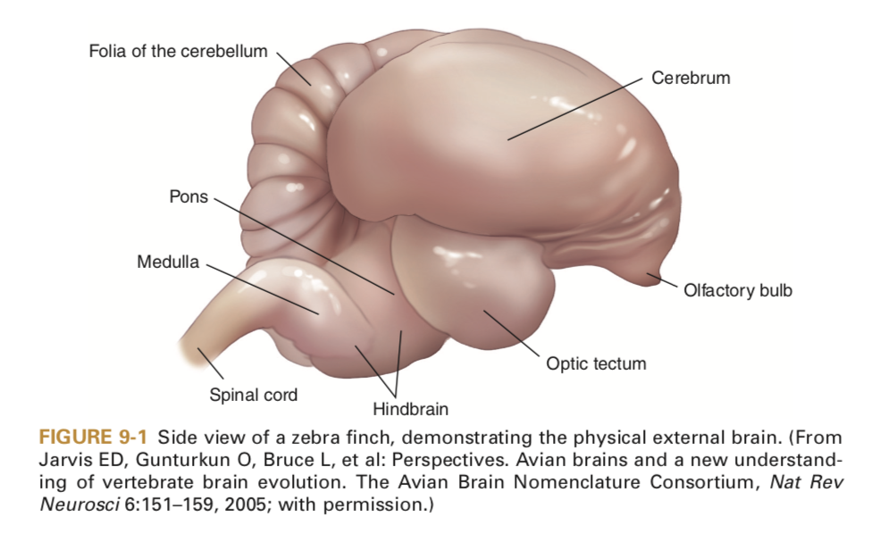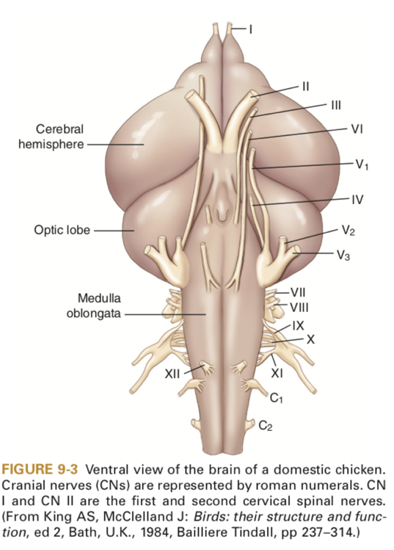

Brainstem
- No obvious pons, but pontine fibers exist
- Cranial nerves V-XII come from the brainstem
Cerebellum
- Similar anatomy and function to mammals
Optic lobe
- Also known as the optic tectum, mesencephalic colliculus, and mesencephalic tectum
- CN III and IV emerge from this lobe
- Coordinates eye and head movements
- Red nucleus also contained within the midbrain
Hypothalamus
- Control of homeostasis, as in mammals
Epithalamus
- Region of the pineal gland involved in reproduction, strongly responsive to light in birds
Olfactory lobe
- Smaller in birds than in mammals
- There is no neocortex. There is a telencephalic complex in birds, a combination of elements in the avian cerebrum for which there is no comparative structure in the mammalian brain. Functionally, the avian telencephalic complex is similar to the mammalian neocortex.
Spinal cord development
- Begins at 16-18 hours of incubation
- Invagination of the neural plate begins rostrally and moves caudally, terminating in the rhomboid sinus
- Neural crest cells migrate and form the dorsal and ventral roots
Spina cord anatomy
- Grey and white matter arranged similarly to mammals
- Spinal cord is same length as the vertebral column
- Spinal nerves pass laterally rather than caudally as in mammals
- Cervical and lumbosacral enlargements of the spinal cord
- The glycogen body is found in the lumbosacral cord and is a collection of periependymal glycogen cells with nests of argentaffin cells. Also present are nerve terminals that may play a role in vascular reflexes and are believed to have neurosecretory roles
- The dorsal column consists of ascending, afferent pathways
  - These fibers end in the nucleus gracilis or nucleus cuneatus
  - Fibers from the dorsal ascending bundle sends info from the muscle receptors of the wings to the cerebellum ipsilaterally (CP)
  - Fibers from the ventrolateral ascending bundle sends info from the pelvic limbs contralaterally, decussates again at the rostral cerebellar peduncle (CP)
  - Dorsolateral fasiculus sends info on pain, temp, and tactile
  - Prospinal system, vague non-localized pain
- Descending pathways are not as well known
  - Lateral reticular, visceral motor function
  - Rubrospinal.l tract, flexor tone
  - Corticospinal tract, UMN input to the cervical region only
  - Vestibulospinal tract – extensor tone
  - Reticulospinal tract – alters somatic and visceral motor tone
  - Tectospinal tract – coordinates reflex movement between eyes and neck/upper body
- Spinal nerves
  - Dorsal and ventral roots
  - All spinal nerves are mixed sensory and motor once leaving the spinal canal
  - 4 types of fibers: Somatic and visceral afferents, somatic and visceral efferents
  - Numbering of spinal nerves depends on the number of vertebrae in a given species
The Avian Neuro Exam
- Mentation
  - Examine both the level and content of consciousness ie look for abnormal or inappropriate behavioral responses
- Cranial nerves
- CN I – olfactory – difficult to assess
- CN II – optic
  - Vision perception or avoidance of obstacles
  - PLR also involves CN II but can be overridden in birds. Consensual PLR not present due to complete decussation of the optic nerves
- CN III – oculomotor – PLR
- CN IV – trochlear – dorsolateral strabismus indicates dysfunction
- CN V – trigeminal
  - Ophthalmic – dysfunction is loss of sensation to face or beak
  - Maxillary – loss of sensation to face, beak, mouth or palate
  - Mandibular – inability to close eye or beak, diminished beak strength
- CN VI – abducens – loss of function of 3rd eyelid, medial strabismus
- CN VII – facial – facial droop or asymmetry, dec facial sensation
- VIII – vestibulocochlear – difficult to assess hearing, nystagmus, head tilt, circling
- IX – glossopharyngeal – dysphagia, voice loss, decreased gag reflex
- X – Vagus – regurgitation, vocal dysphoria, loss of gag reflex
- XI – accessory - poor neck mobility
- XII - hypoglossal - decreased tone of the tongue

Mitchell-Tully, Current Therapy in Exotic Pet Practice – Chapter 8: CNS (pages 396 – 398, Avian section)
- The avian brain consists of the prosencephalon (telencephalon and diencephalon) and the caudal brain (medulla, pons, and mesencephalon)
- Caudal brain is similar to mammals, but prosencephalon is anatomically different, though functionally similar
  - Cortical cells are found within the cerebral cortex, not on the surface
  - Lissencephalic
- Spinal cord is same length as vertebral column, and spinal segments correlate to vertebral segments
  - No cauda equina
- The 2 spinal cord enlargements correlate to innervation of the thoracic and pelvic limbs
- The glycogen body is found in the lumbosacral cord and is a collection of periependymal glycogen cells with nests of argentaffin cells
- Spinal cord is generally similar to mammals, except the dura mater is separate from the periosteal lining
- Ascending and descending pathways are in need of more study, but are thought to be similar to mammals
- Internal vertebral venous plexus courses the entire length of the vertebral column
- Neuro exam requires knowledge of the CN’s in birds and their deficits. Often mentation changes are not seen

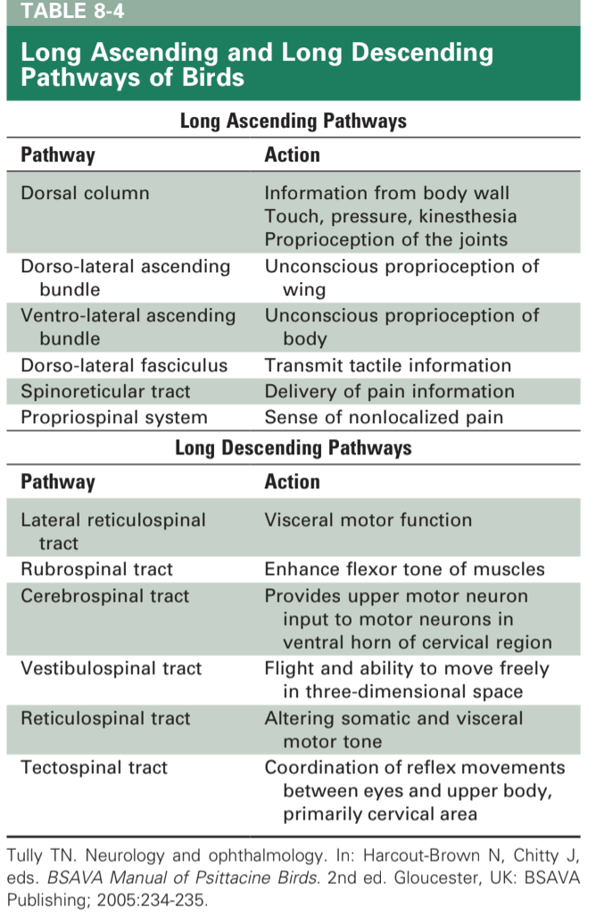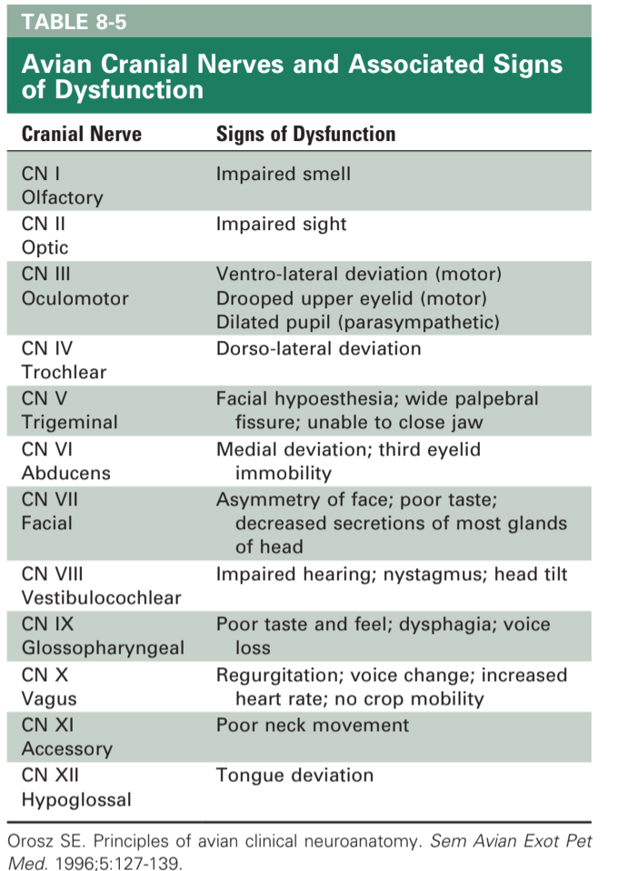

The Urinary and Osmoregulatory Systems of Birds
Orosz, Susan E., and M. Scott Echols.
Vet Clin North Am Exot Anim Pract 2020;23(1):1-19

Key Points:
- The kidneys of birds are fixed under the area of the synsacrum and are composed of di-visions not lobes.
- Birds osmoregulate using their kidneys; intestinal tract; and, in some birds, salt glands.
- Avian nephrons are of 2 main types: the cortical, loopless, or reptilian nephrons and the medullary or looped nephrons. Knowing this anatomy, along with that of the renal portal system, is important in understanding the pharmacodynamics of drugs in birds.
- The kidney filters up to 11 times the total body water per day. Although the nephrons do not concentrate urine to the extent of mammals, they use the large intestine and/or the colon for resorption of ureteral urine. In addition, urates are modified by special colonic bacteria and some products produced are recycled through the renal portal system.
- There are some birds, particularly marine species, that are able to remove excess sodium through a countercurrent system in the salt glands. Angiotensin II has been shown to inhibit secretion of sodium chloride, whereas atrial natriuretic peptide enhances secretion.
- Changes in GFR are regulated by the antidiuretic hormone of birds, arginine vasotocin

Summary
Osmoregulation: unique kidney, lower portion of GI tract, salt glands

Renal Anatomy
3 divisions: cranial, middle, caudal
  - Chicken and many parrots: distinct divisions
  - Passerines: middle division blends
  - Puffins, penguins, herons: caudal divisions fused on midline
- External Iliac artery: divides cranial and middle
- Ischiatic artery: divides middle and caudal
Spinal nerves from lumbar and sacral plexuses move through parenchyma
- Swelling or dorsal pressure on kidneys can reduce nerve function: become non-weight bearing, muscle atrophy and sometimes loss of bone mass (esp lateral femur), minimal or absent deep pain. Esp budgies
Basic unit: lobule
- Long axis perpendicular to long axis of kidney, pear shaped, wedged between interlobular veins of renal portal system
- Wide portion: cortical region contains cortical and medullary-type nephrons
- Narrow portion: medullary region, contains collecting tubules and loops of Henle from medullary-type nephrons
- Artery: in center of lobule
- Intralobular vein
- Collecting ducts are on periphery of each lobule: collecting tubules converge to form branches of ureter
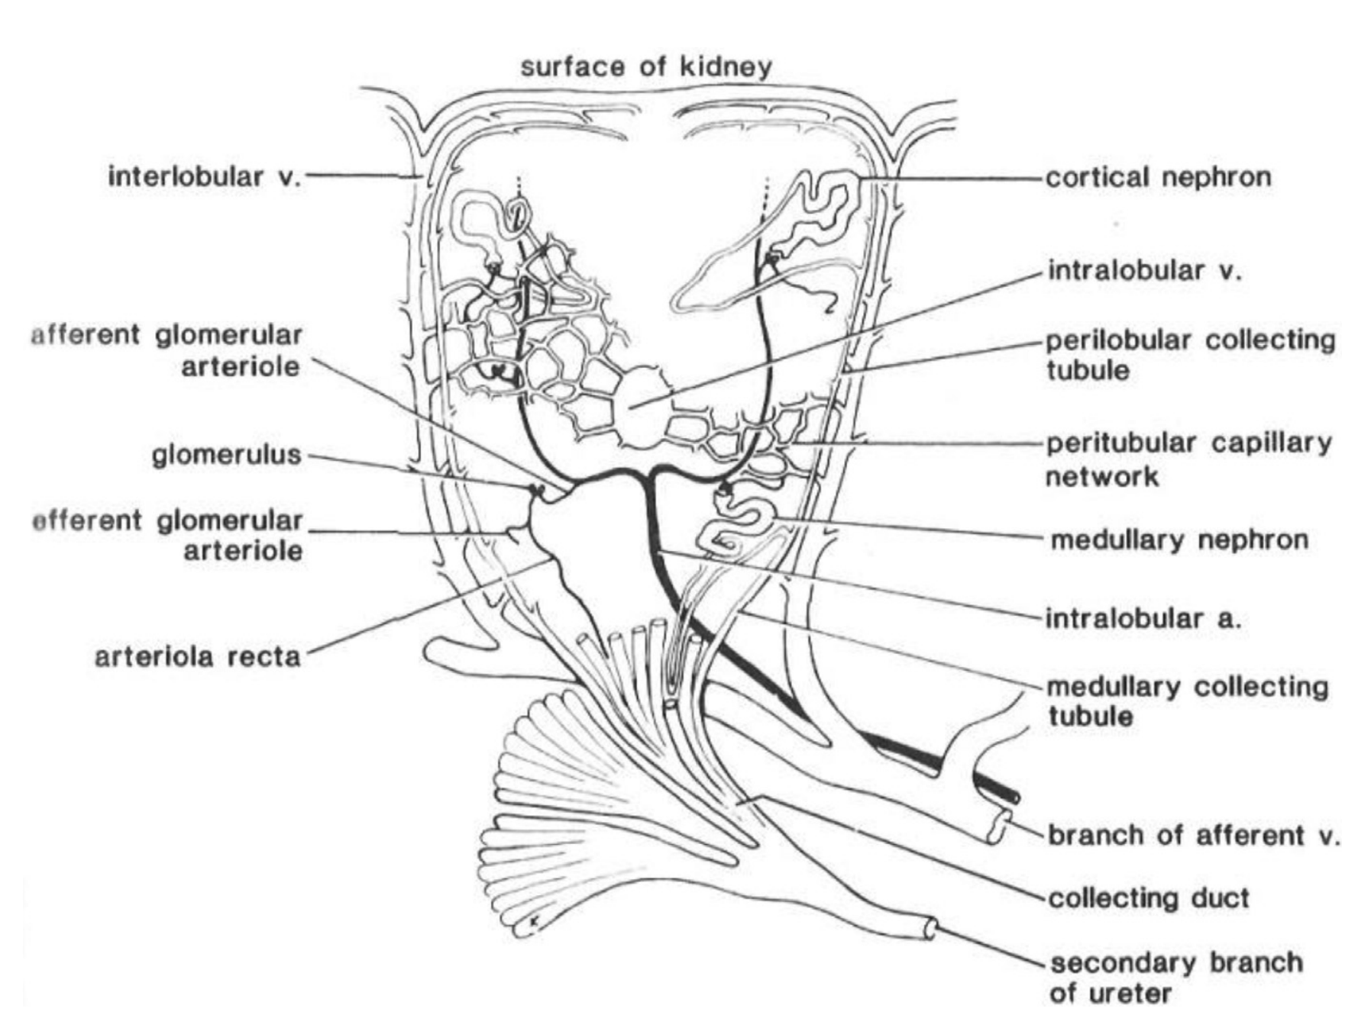

Nephrons
- Medullary: looped, mammalian-type, contain loops of Henle (10-30%)
- Cortical: loopless, reptilian-type, *most of avian nephrons - secrete uric acid
- +/- transitional nephron: elongated looping intermediate segments not in medullary gones or rays
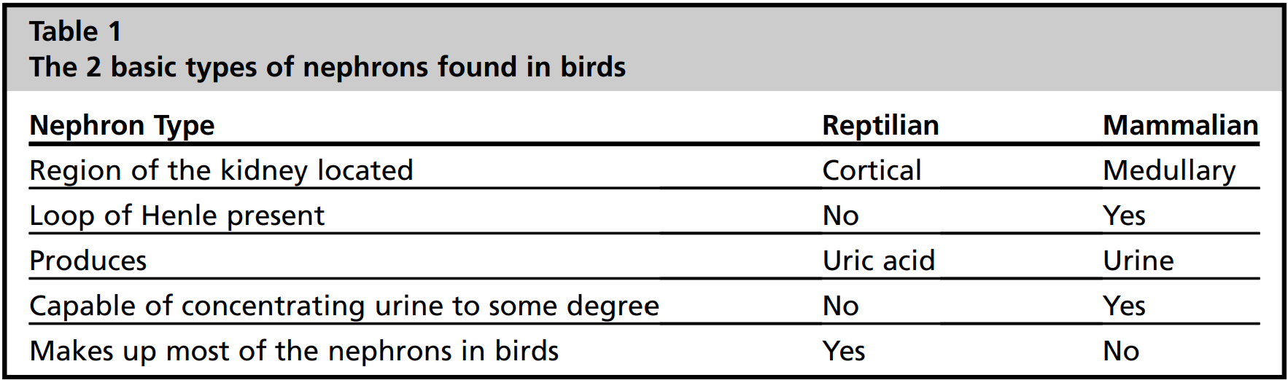
- Arid environment: smaller kidneys, larger medullary volume, smaller cortical volume
- Renal corpuscle: glomerular capsule and tuft of capillaries, midway between interlobular and intralobular veins
  - Simpler capillary tufts than mammals, only 2-3 capillaries with limited interconnections
  - RBCs larger, fusiform, and more rigid than mammalian so capillaries are larger to accommodate and capillaries tufts are larger than mammals
  - Podocytes: have slits that act as pores for solute movement from blood into Bowman space
  - Larger podocyte slits (40-80% larger in chickens) and decreased polyanionic charge on filtration barrier compared to mammals contributes to greater flow and larger particles passing
    - Avian ureteral urine contains 100x more protein (5 mg/mL) than mammals
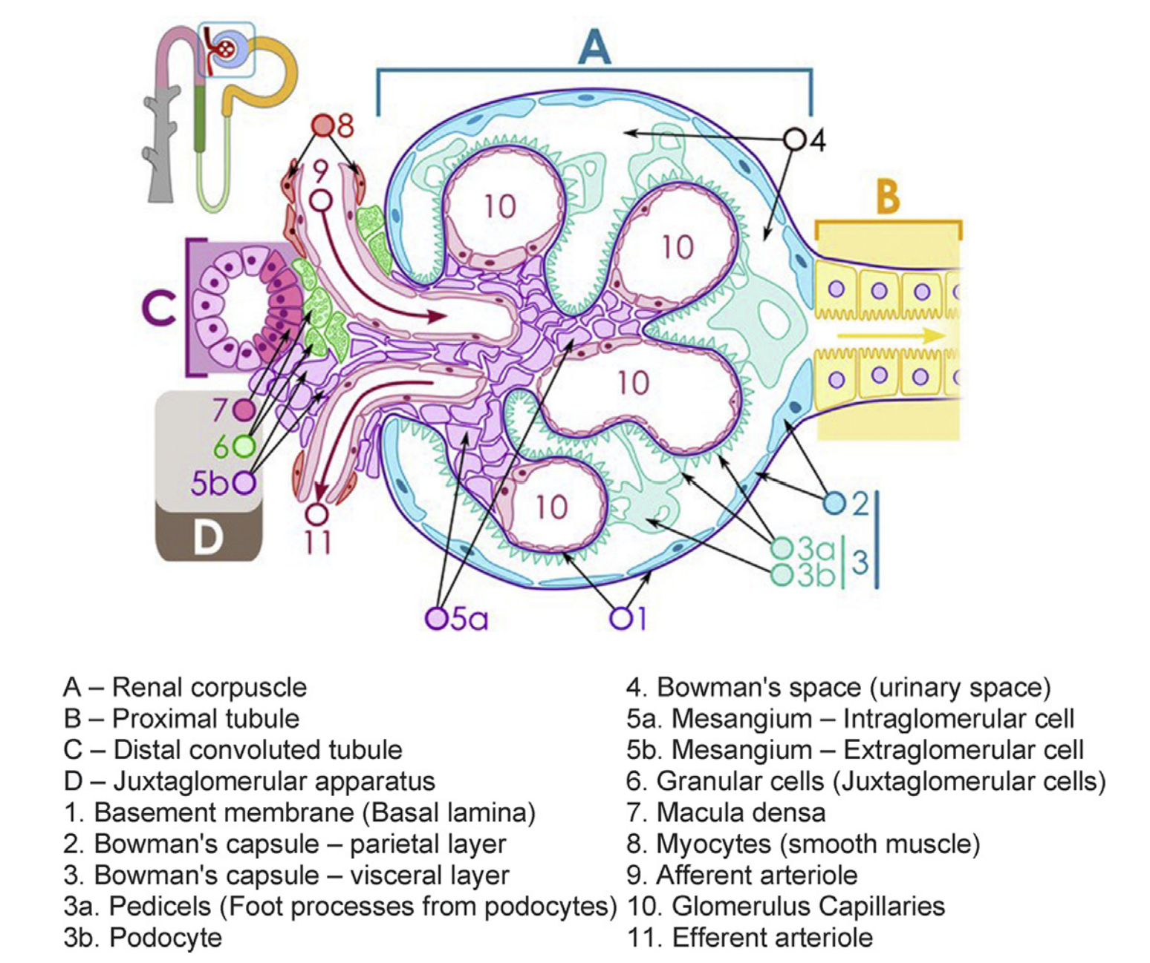
- Proximal and distal portions
- Perilobular collecting tubules and medullary collecting tubules combine to form collecting duct to secondary branch of ureter
- Juxtaglomerular apparatus
  - Macula densa: epithelial thickening at beginning of distal convoluted tubule, detect sodium concentrations in tubules leaving renal corpuscle, signal release of renin from JG cells
    - Taller with more prominent nuclei making them appear darker (‘denser’)
  - Juxtaglomerular (JG) cells: specialized myocytes in afferent arterioles that secrete renin
  - Extraglomerular mesangium: modified connective tissue between macula and specialized cells of afferent arterioles
  - Decreased sodium levels: relaxation of afferent arteriole: increases glomerular blood flow: increases glomerular hydrostatic pressure: increases filtration rate
    - Macula densa signal JG cells to release renin
    - Renin increases blood pressure via renin-angiotensin-aldosterone system
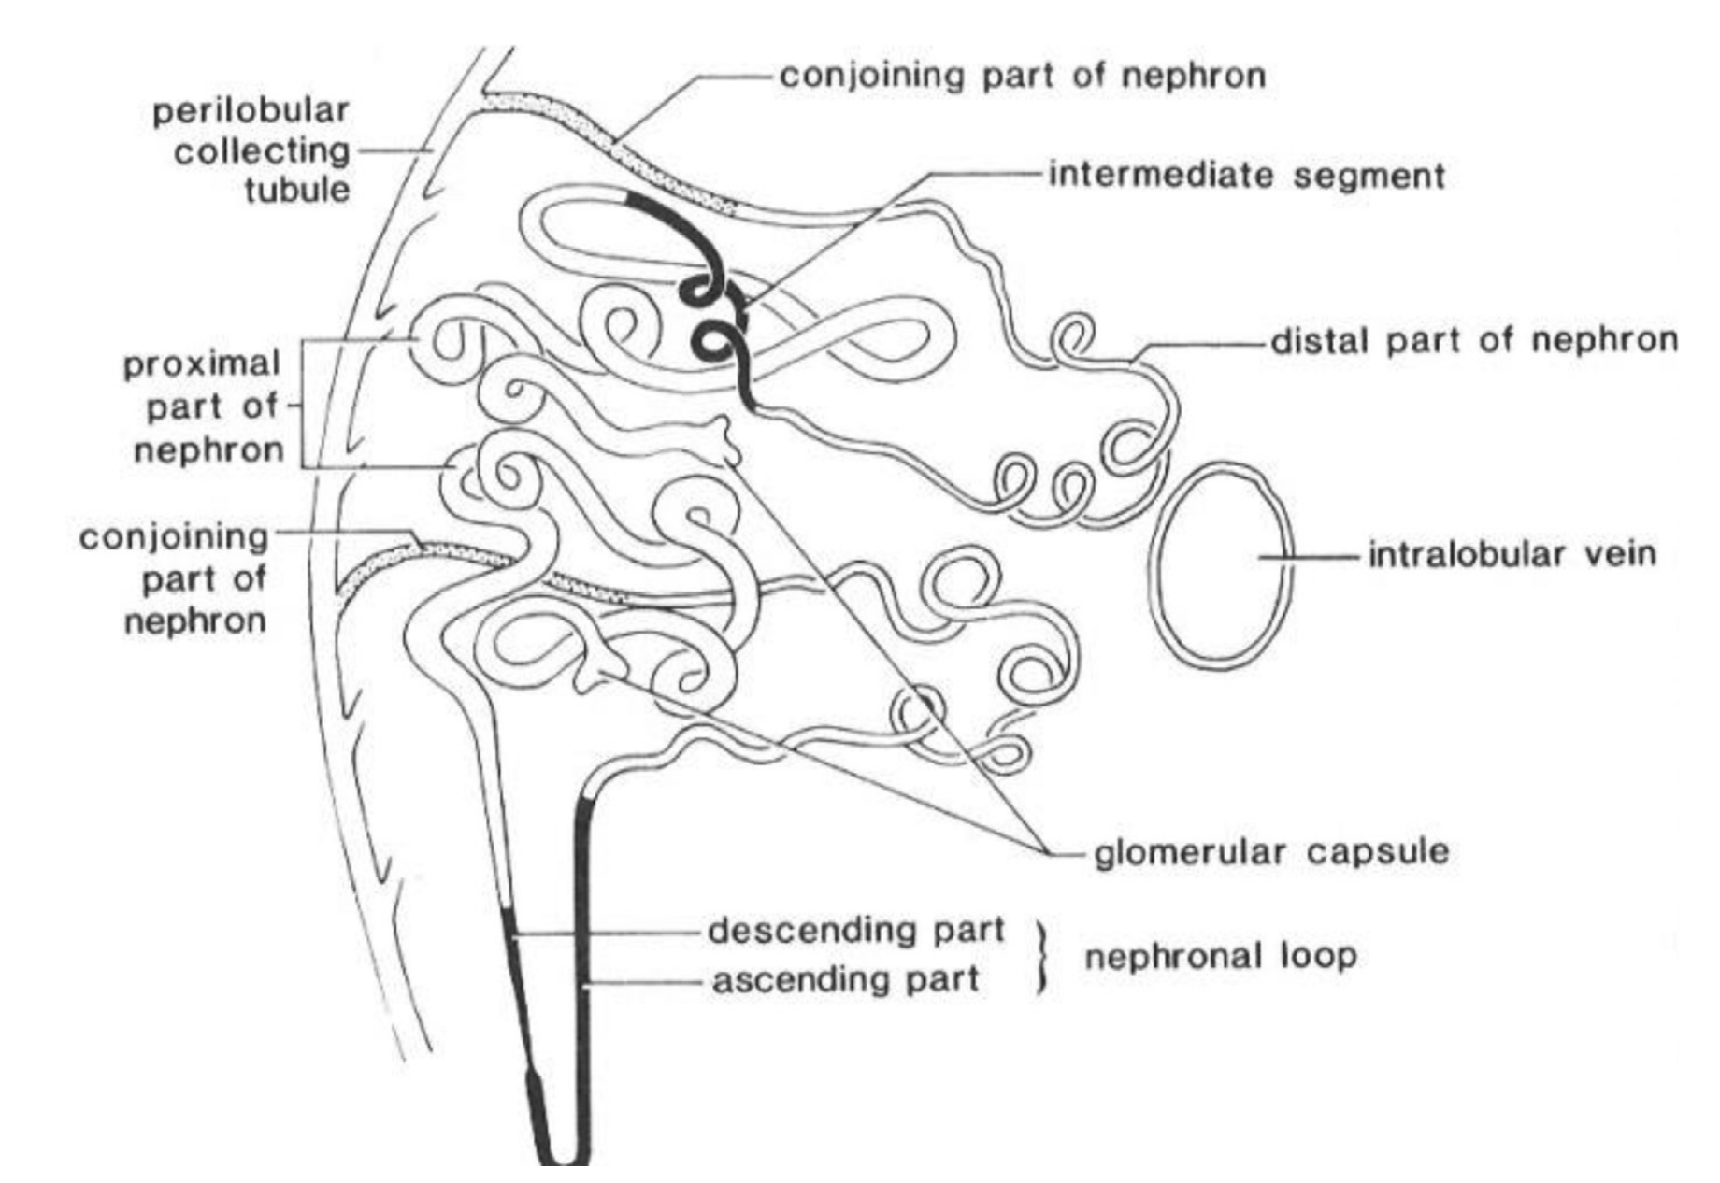
Arterial supply
- Cranial, middle, and caudal renal arteries from abdominal aorta
  - Branch to form intralobular arteries (midway between interlobular and intralobular veins)
  - Intralobular arteries form short afferent glomerular arteries
  - Coalesce to form glomerulus
  - Continues as efferent glomerular arterioles
  - Divide to form peritubular capillary plexus
    - surrounds epithelium of convoluted tubules in cortical region
    - Form arteriolar recta lying alongside loops of Henle in medullary region before forming venulae recta to drain the area
Venous supply
- Loops of henle drained by venulae recta into intralobular veins
- Drain into efferent renal veins or branches
  - Cranial renal veins drain into common iliac vein after renal portal valve or into abdominal vena cava directly
  - Caudal renal vein drains into common iliac vein after renal portal valve
- Renal portal system: venous blood to peritubular capillary plexus surrounding proximal convoluted tubules at periphery of the lobule, responsible for urate secretion
  - (urates also filtered by glomerulus but rate is insufficient)
  - Renal portal system provides about ⅔ of the blood supply to the kidneys that bypasses the glomeruli
  - Forms a venous ring with both kidneys
    - Right and left cranial renal portal veins connect via internal vertebral venous sinus (drains the vertebral column)
    - Right and left caudal renal portal veins anastomose with caudal mesenteric vein
  - Afferent renal branches have muscular sphincters at base to control volume of blood entering the kidney
    - Afferent renal branches connect with interlobular veins
    - Interlobular veins connect to peritubular capillary plexus at periphery of each lobule
  - Renal portal valves: found in lumen of common iliac veins between renal and portal veins
    - Innervated by adrenergic and acetylcholine receptors
    - Valve closure inhibited by norepinephrine and epinephrine
      - Sympathetic tone: valves open
      - Valves open: blood bypasses the kidney and flows directly into the caudal vena cava (and/or caudal mesenteric vein to the liver, internal vertebral venous plexus within the vertebral canal)
      - *often only partially activated, not bypassing kidneys completely
    - Acetylcholine stimulates valve closure
      - Parasympathetic: valves close
      - Valves close: blood flows into parenchyma of kidney
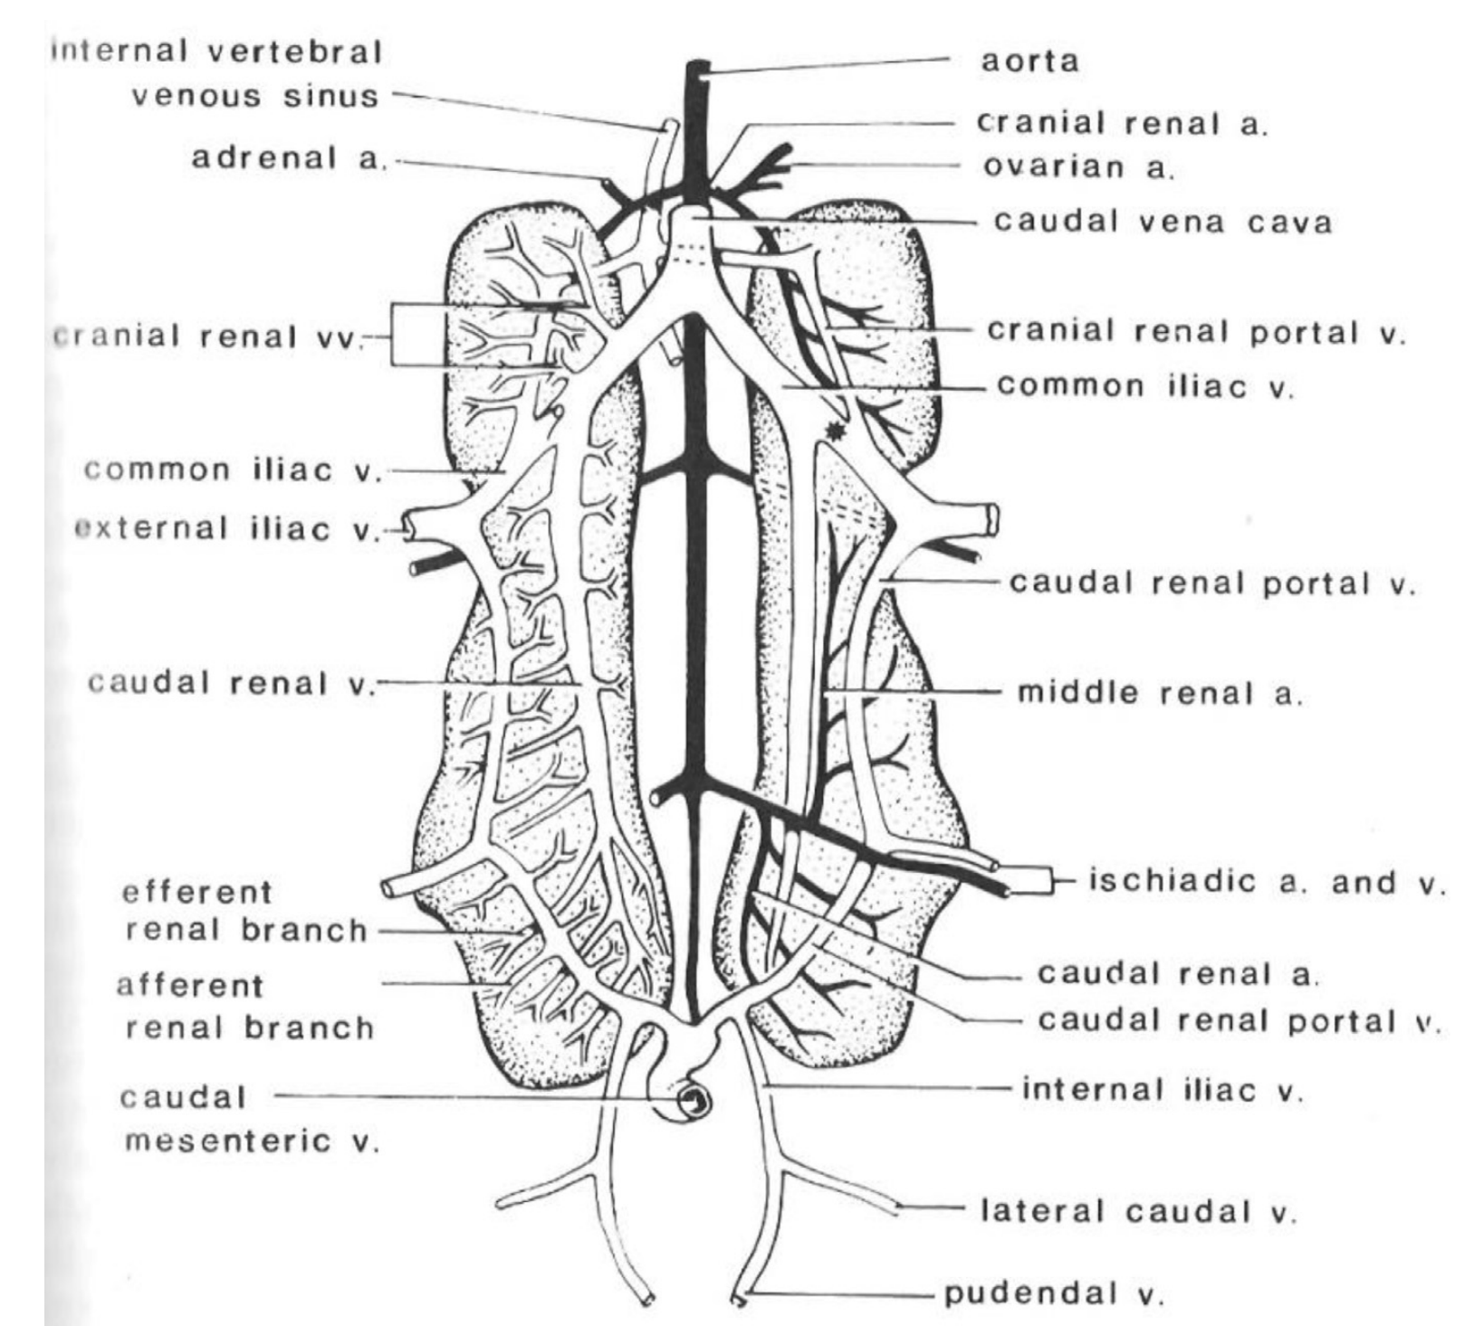

Renal function
Glomerular filtration
- Function of hydrostatic pressure produced by the heart
- Charges on fenestra and size of openings oppose movement of large, negatively charged proteins such as albumen
- GFR of a single nephron is lower in avian than mammals but total kidney GFR is the same, offset by larger number of nephrons
- Whole-kidney GFR most dependent on hydration status
  - Hummingbirds alter GFRs diurnally
- Water deprivation: GFR can decrease up to 65%
- Changes in GFR regulated by arginine vasotocin (antidiuretic hormone of birds)
  - Arginine vasotocin alters tone of renal vasculature and tubular epithelium to conserve water
  - Peptide hormone released by neurohypophysis, most commonly stimulated by increased extracellular fluid osmolality
  - Dehydration: increased circulating arginine vasotocin levels: decreases GFR and enhances tubular reabsorption: reduces urine flow
    - Reptilian/cortical/loopless nephrons most sensitive to arginine vasotocin
  - Water overload: increased GFR but mechanism is unknown
  - Birds capable of autoregulation of renal blood flow over wide range of systemic blood pressures (chickens systemic BP as low as 50 mmHg with maintenance of GFR)
Nitrogen excretion
- Major end product of nitrogen catabolism in birds: uric acid (70-80%)
  - Minor amounts: creatinine, amino acids, urea
- Uric acid: low solubility, removes 4 nitrogen atoms/molecule
  - Metabolic cost of synthesis is much higher than ammonia or urea
- Urates pass freely through fenestrae of glomerulus
  - Albumen takes urates out of solution and prevents crystal formation
    - Small spherical structures begin to form in proximal tubule and grow as they travel toward ureter, most are 65% urates
  - Urate does not contribute to osmolality of urine when taken out of solution by albumen
  - As concentration of urates secreted into lumen increases past solubility limit: potential is created for crystal formation in the proximal tubule
- Dietary vitamin A helps keep reptilian/cortical/loopless nephrons healthy by reducing squamous metaplasia
Water/solute Intake
- Carnivores, frugivores: many species meet water needs from food items
- Est. 100g bird drinks ~5% BW daily
  - Lower BW increases water requirement (10-20g, drinking rate increases to 50%)
- Birds with salt glands typically need an increased volume of water compared to those lacking glands
- Physiologic stimuli to drink primarily include cellular dehydration, extracellular dehydration, angiotensin II
Water excretion
- Kidney filters large volume of fluid daily (up to 11x total body water in 100g bird)
- Most (~95% filtered fluid) reclaimed by tubular reabsorption
- Able to concentrate urine by varying degree of tubular reabsorption (range <70->99%)
  - Concentrating ability generally varies inversely with body mass (small birds 10-25g concentrate to 1000 mmol/kg vs birds >500g concentrate to 600-700 mmol/kg)
- Tubular reabsorption depends on active sodium reabsorption but not bicarbonate
  - Osmolality gradient in medullary region produces countercurrent multiplier system in loop of Henle which allows for reabsorption
- Further concentration of urine occurs by retroperistalsis into coprodeum and large intestine: single layer of columnar epithelium can reabsorb water

Lower GI tract
- Retroperistalis moves urates and urine from urodeum into large intestine or colon and cecum
- Moves around a central fecal core, contacting brush border of colonic epithelium and its resident bacterial population
- Large amounts of albumen in ureteral urine is degraded into amino acids, dipeptides, and tripeptides, used by the bacteria to produce volatile short-chain fatty acids
  - Glutamic acid (a major product formed): glutamine transported into cells - deaminated - recycled to ammonia, transported into caudal mesenteric vein to enter renal portal system
  - Recycling of nitrogen may be particularly important in species with low nitrogen diets (nectarivores, frugivores)
- Movement of ureteral urine and urates is controlled by tonicity of fluid in GI tract
  - Tonicity 200 mOsm/kg H2O higher than plasma: retrograde peristalsis is stopped or significantly slowed.
  - Villanoid receptor type in the cloaca responds to changes in shape of cells that occurs from changes in their osmotic environment
  - Receptors allow local feedback effect to help maintain osmolality
- Sodium transport in coprodeum and colon results in recovery of urinary water
  - low sodium diet increases plasma aldosterone resulting in increased sodium absorption in coprodeum and colon

Salt gland
- Located close to nasal cavity or orbit
- Series of blind-ended tubules that branch out
  - Epithelium is strongly secretory, with basolateral infoldings and large numbers of mitochondria
- Tubules coalesce to form 2 secretory ducts that drain into nasal cavity
- Blood flow is countercurrent to flow in tubules
- Hyperosmolar fluid produced, consisting of predominantly sodium
  - Chloride is likely actively transported across epithelium vs sodium moves passively through intercellular spaces
- Increase in plasma sodium level causes enhanced secretory activity of tubules and increased blood flow to gland
- Hormones modulate rate of secretion but do not seem to initiate secretion
  - Angiotensin II shown to inhibit secretion
  - Atrial natriuretic peptide enhances secretion

Current Therapy in Exotic Pet Practice
Mitchell MA, Tully TN, eds.
St. Louis, MO: Elsevier; 2016:494-548.

Ch 11. Urinary System - Avian (pg 498)
Johnson JG, Brandão J, Perry SM, Mitchell MA

- No corticomedullary definition
- Nephrons are cortical (90%, lack a loop of Henle) or medullary (have a loop of Henle)
- GFR of individual nephrons is lower than mammal but kidney has more nephrons
- Juxtaglomerular apparatus present - aldosterone stimulates release of renin(converts angiotensin I to angiontensin II) resulting in sodium absorption, potassium excretion, decreased GFR
  - Atrial natriuretic peptide increases sodium and water excretion
- Three lobes of kidney (cranial, middle, caudal)
  - Passerines and hornbills have two instead of three
- Sits in retroperitoneum, renal fossa of ventral synsacrum
  - Nerves and vessels of lumbar and sacral plexuses often pass through renal parenchyma
- No renal pelvis - urine carried in collecting ducts to branches of ureters along ventral surface of kidney
- Ureter terminates in dorsal wall of urodeum
  - Urine is retrograded into colon and rectum for fluid reabsorption
  - Some species (ostrich) have rectocoprodeal sphincter - prevents water reflux into colon, coprodeum functions similar to a urinary bladder so they can pass either feces or solely urine
- Renal perfusion: caudal renal arteries to glomeruli, caudal renal portal veins to renal tubules *primary route of uric acid excretion
  - Blood flow from renal portal veins controlled by valves - blood flows through kidney when hydrated or shunted to heart and brain when dehydrated
- Primarily excrete uric acid (ammonia converted to amino acids, purine synthetic pathway produces uric acid)
  - Uric acid 40,000 times more insoluble, cannot be reabsorbed in cloaca or allantois of egg (won’t reach toxic concentrations in embryonic blood)
  - Arginine can be degraded by arginase into urea but highest concentration of arginase is in the kidney instead of liver and is inhibited by adenosine triphosphate during energy abundance
- USG measurement is erroneous in birds
  - Protein in bird urine that maintains uric acid in suspension does not contribute to osmotic pressure
  - Sodium, potassium, and chloride predominate urine osmolality

