Avian Respiratory System Anatomy and Physiology Questions
• Mitchell-Tully, Current Therapy in Exotic Pet Practice – Chapter 3: Respiratory system (pages 88-93, Avian section)

Question 1:
Q: What is the largest diverticulum of the psittacine paranasal sinus?
A: Cervicocephalic diverticulum

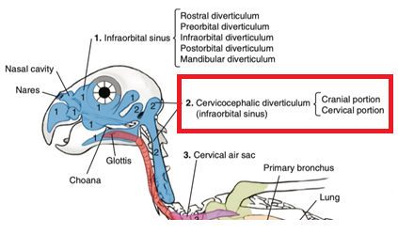

Question 2:
Q: Name 3 anatomical differences in the respiratory system of birds compared to mammals and describe a clinical implication of each of those anatomical peculiarities.
A: Answers based on tables in chapter (see below). Examples: Complete tracheal rings, use of uncuffed endotracheal tubes; Presence of air sacs, wound irrigation may cause fluid aspiration; Elongated trachea, increased tracheal dead space under anesthesia.

Question 3:
Q: Which of the following is true regarding the modulation of the respiratory rhythm in birds?
- Central chemoreceptors initiate an increase in ventilation when PaO2 increases.
- Arterial chemoreceptors modulate ventilation in response to blood pressure.
- Intrapulmonary chemoreceptors are stimulated by a decrease in pCO2.
- Air sac chemoreceptors modulate ventilation in response to pH.
- Intrapulmonary chemoreceptors are innervated by the phrenic nerve.

Ans: C

Correct info:
A – Central chemoreceptors initiate increase in ventilation when PaCO2 increases.
B – Arterial chemoreceptors modulate ventilation in response to changes in PaO2, PaCO2, pH.
D – Air sacs have mechanoreceptors.
E – Intrapulmonary chemoreceptors (and arterial chemoreceptors) are innervated by the vagus nerve.
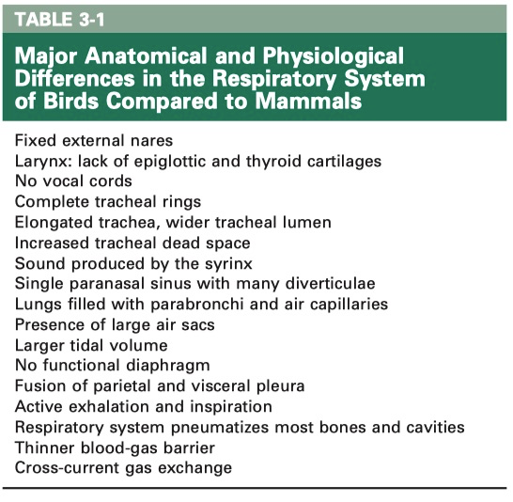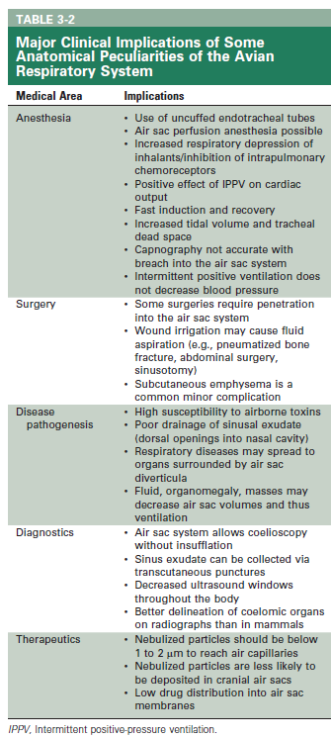

Ch 6. Cardiology
Current Therapy in Avian Medicine and Surgery (Speer 2015)

What structure is denoted by the asterisk?

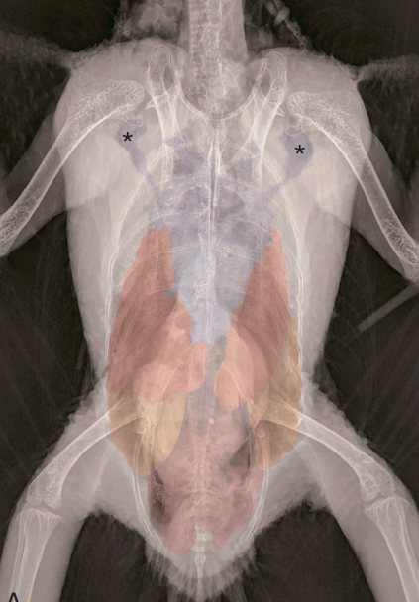

Axillary diverticula of the clavicular air sac

Which structure is paired in psittacines?

- Clavicular air sac
- Intestinal peritoneal cavity
- Cranial vena cava
- Coeliac artery
- Syrinx

What is the primary inflammatory cell associated with progression of artherosclerotic lesions in birds?

- Red blood cell
- Thrombocyte
- Lymphocyte
- Heterophil
- Monocyte

Which genus is most at risk for atherosclerosis?

- Psittacus
- Nymphicus
- Eclectus
- Cacatua
- Ara

Which is a risk factor for atherosclerosis in psittacines?

- Female sex
- Low HDL levels
- High exercise levels
- Under 15 years old
- High LDL levels

High dietary intake of which compound is protective against the development of atherosclerosis in parrots?

- Manganese
- L-glutamine
- Alpha-linoleic acid
- Stearic acid
- Arachidonic acid

What toxin found in avocados is cardiotoxic in birds?

- Beta-aminopropionitrile
- Githagenin
- Erucic acid
- Persin
- Monocrotaline

Accumulation of caseous debris in which air sac can cause compression of the great vessels?

- Cranial Thoracic
- Abdominal
- Clavicular
- Caudal Thoracic
- Cervical

Which electrocardiographic wave is negative in lead II in most avian species?

- P wave
- Ta wave
- R wave
- Q wave
- S wave

What does the Ta wave represent in Columbiform ECGs?

- Atrial depolarization
- Atrial repolarization
- Ventricular depolarization
- Ventricular repolarization
- AV node conduction

CBS Questions:
Current Therapy in Avian Medicine and Surgery
- List the distinct coelomic cavities in the avian coelom and list the organs within each cavity.
  - 8 coelomic cavities:
    - 1 pericardial cavity - heart
    - 1 intestinal peritoneal cavity – proventriculus, ventriculus, intestines, spleen, pancreas, reproductive tract (gonads, oviduct), +/- gallbladder
    - 2 pleural cavities - lungs
    - 4 hepatic peritoneal cavities – liver

Current Therapy in Exotic Pet Practice
- Which of the following about avian reproductive anatomy and physiology is true?
- The oviduct consists of four sections: infundibulum, isthmus, shell gland, and vagina.
- The ductus deferens opens into the proctodeum within the cloaca.
- The ovary and oviduct are located on the right side of the coelom.
- PGE2 stimulates shell gland muscle contractions.
- PGE2 allows for relaxation of uterovaginal sphincter and vagina.
Question:

The avian optic lobe is most analogous to which mammalian structure?

- Occipital lobe
- Rostral colliculus
- Thalamus
- Parietal lobe
- Caudal colliculus

Answer: B

