Quiz 2
CBS 817 – Fall 2020

- What is the genus of this parasite, and briefly explain why this disease causes the external change as shown in the photo on the left. (2 points)

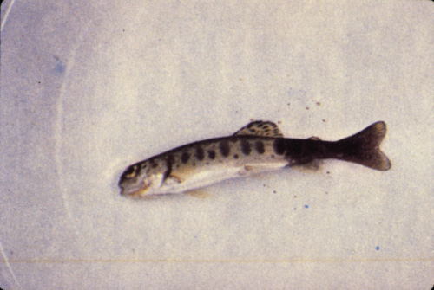
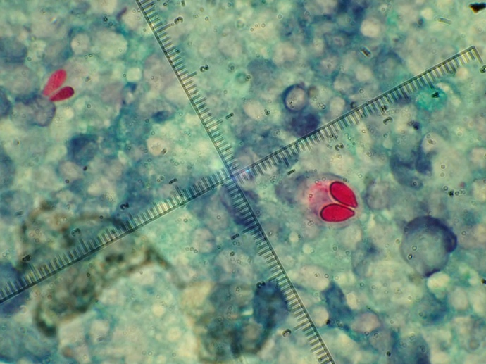

- Which of the following solutions is preferred for the humane euthanasia of moon jellyfish (Aurelia aurita) to minimize interference with nuclear magnetic resonance (NMR) analysis of tissues following euthanasia?
  - KCl
  - MgSO4
  - Eugenol
  - MgCl2
  - Pentobarbital

- Which of the following parasite-vector associations is correct?
  - Plasmodium – Simulidae
  - Leucocytozoon – Hippoboscis
  - Plasmodium – Ceratopogonidae
  - Leucocytozoon – Culicidae
  - Haemoproteus - Hippoboscis

Continued on next page

- List THREE anatomic differences between suids and peccaries (3 points)

- _______________________________________________

- _______________________________________________

- _______________________________________________

