Quiz 2
CBS 817 – Fall 2020
KEY

- What is the genus of this parasite, and briefly explain why this disease causes the external change as shown in the photo on the left. (2 points)

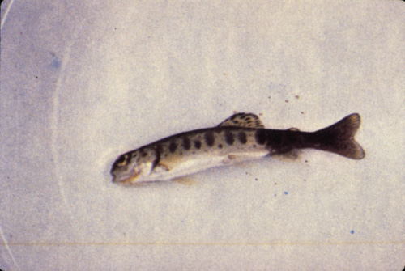
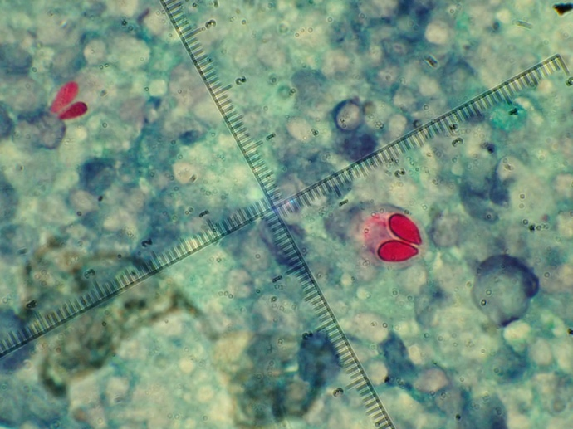

- M. cerebralis cause of ‘Whirling disease’ or ‘blacktail’, typically in salmonids
- Attacks cartilage of spine and damages sympathetic nerves (color change)
- Then see tail-chasing behavior

- Which of the following solutions is preferred for the humane euthanasia of moon jellyfish (Aurelia aurita) to minimize interference with nuclear magnetic resonance (NMR) analysis of tissues following euthanasia?
  - KCl
  - MgSO4
  - Eugenol
  - MgCl2
  - Pentobarbital

- Which of the following parasite-vector associations is correct?
  - Plasmodium – Simulidae
  - Leucocytozoon – Hippoboscis
  - Plasmodium – Ceratopogonidae
  - Leucocytozoon – Culicidae
  - Haemoproteus - Hippoboscis

Continued on next page

- List THREE anatomic differences between suids and peccaries (3 points)

Suids | Peccaries
Short, barrel shaped | Longer limbs, more slender
Males > females | No sexual dimorphism
Pelage variable | Dense, coarse, long bristles
Multiple scent gland locations | Dorsal rump scent gland
Facial “warts” | Salivary papillae
Prezygomatic shelf | Complex rostral cavity
Large canines, variable orientation | Canines point down and interlock
Simple stomach | 4-chambered stomach
Yes gallbladder | No gallbladder

