Thorel, Milan, et al. "Clouded leopard (neofelis nebulosa) morbidity and mortality in captive-bred populations: a comprehensive retrospective study of medical data from 271 individuals in european, asian, and australian zoos." Journal of Zoo and Wildlife Medicine 51.1 (2020): 150-158.

Abstract: The clouded leopard (Neofelis nebulosa) is classified as vulnerable on the International Union for the Conservation of Nature Red List of Threatened Species. However, diseases affecting this species across zoo populations are not well documented. The primary objective of this retrospective study was to identify common and significant causes of morbidity and mortality in captive-bred clouded leopards from European, Asian, and Australian institutions. Medical records from 44 zoological parks that held 271 clouded leopards from 1934 to 2017 were reviewed. Major causes of mortality in the dead leopards (n ¼ 141) were respiratory disease (17%), maternal neglect and starvation (12%), generalized infectious disease (10%), digestive disease (10%), and trauma (10%). Six animals lived more than 20 yr and two were older than 22 yr. Diseases were recorded 344 times (average of two per leopard) in 166 living leopards. The body systems most frequently affected by disease in these 166 individuals were, in order of frequency, integumentary (prevalence ¼ 21%), digestive (21%), respiratory (16%), musculoskeletal (12%), and urinary (10%) systems. Neoplasia (7%) was less frequent, followed by cardiovascular (5%), genital (3%), and viral (3%) disorders. Extensive, self-induced alopecia on the tail and dorsum was the most frequently reported dermatological disease, which is proposed to be called the ‘‘clouded leopard alopecia syndrome.’’ The most common neoplasm was pheochromocytoma (1%), followed by squamous cell carcinoma of the paw pads, pleural mesothelioma and multicentric lymphomas (,1% each). Dilated cardiomyopathy (2%) was the most common cardiovascular disease. Bronchopneumonia (7%), enteritis (4%), and nephritis (4%) were the most frequently reported respiratory, digestive, and renal diseases, respectively. Diagnosed disease incidence was significantly higher in Europe. This paper reports the results of a comprehensive study

INTRO
- The primary objective of this retrospective study was to identify common and significant causes of morbidity and mortality in captive-bred clouded leopards from European, Asian, and Australian institutions

M&M
- Medical records from 44 zoological parks that held 271 clouded leopards from 1934 to 2017 were reviewed
RESULTS
- Mortality: n = 141, causes were respiratory disease (17%), maternal neglect and starvation (12%), generalized infectious disease (10%), digestive disease (10%), and trauma (10%)
- Morbidity: n=166, integumentary (21%), digestive (21%), respiratory (16%), musculoskeletal (12%), and urinary (10%) systems. Neoplasia (7%) was less frequent, followed by cardiovascular (5%), genital (3%), and viral (3%) disorders
- Extensive, self-induced alopecia on the tail and dorsum was the most frequently reported dermatological disease (n=32), which is proposed to be called the ‘‘clouded leopard alopecia syndrome
  - Lesions were observed extending from the lumbar to tail regions (79%) and included the perineal and pelvic regions. Tail was most commonly affected site
  - 10 leopards with extensive, self-induced alopecia of the tail shared the same familial history with marked inbreeding
- The most common neoplasm was pheochromocytoma (1%), followed by squamous cell carcinoma of the paw pads, pleural mesothelioma and multicentric lymphomas (>1% each)
- Dilated cardiomyopathy (2%) was the most common cardiovascular disease. Bronchopneumonia (7%), enteritis (4%), and nephritis (4%) were the most frequently reported respiratory, digestive, and renal diseases, respectively
- Diagnosed disease incidence was significantly higher in Europe.

DISCUSSION
- Geographic location appeared to play a role in the prevalence of alopecia (worse in Europe and Middle East than in Asia)
- ‘‘clouded leopard alopecia syndrome’’ is more likely to be associated with a genetic origin rather than a climatic origin
- May also be due to pheochromocytoma with secondary hypertension and follicular telogenization
- Apoquel may help based on anecdotal evidence but may lead to an acute, inflammatory, life threatening condition when used chronically

Greunz, Eva Maria, et al. "Amyloidosis in caracals (caracal caracal)." Journal of Zoo and Wildlife Medicine 51.1 (2020): 202-209.

Abstract: Nine cases of amyloidosis in caracals (Caracal caracal) from three different institutions in Europe were reviewed and evaluated histopathologically. The six males and three females died between 2008 and 2018 at an age of 6 yr 2.5 mo (median 6 interquartile range). In two out of nine (2/9) animals, amyloidosis was an incidental postmortem finding; the animals died of bronchopneumonia and gastric ulceration due to Helicobacter spp., respectively. Seven (7/9) animals suffered from acute renal failure due to amyloidosis, one of them additionally of cardiac decompensation. The predominant clinical signs were weight loss, lethargy, dys- or anorexia, dehydration, increased BUN and creatinine, and azotemia. The main gross lesion was a pale renal cortex on cut surface; in two animals, the kidneys appeared enlarged. Histologically, glomerular amyloid was present in every animal (9/9), and was the predominant renal manifestation of amyloidosis. Additional findings included splenic amyloid (8/8), amyloid in the lamina propria of the intestine (5/5), and amyloid in the lingual submucosa (4/4). Gastric mineralization was present in four animals suffering from renal failure. In the animal dying from bronchopneumonia, severe pancreatic amyloid deposits mainly affecting the exocrine pancreas (1/5) were identified. Immunohistochemistry was employed to identify amyloid AA in eight cases; only in the caracal dying from bronchopneumonia AA was amyloid confirmed. In several organs, especially in those where only small amyloid deposits were detected, a Congo red stain was often necessary to confirm the deposition. The etiology of the amyloidosis remains unknown. Three caracals were related within two generations, another three within four generations, so one might hypothesize a familial trait. In conclusion, amyloidosis should be considered as a significant disease in the caracal. Particularly in cases with renal disease, it should be included as a major differential diagnosis

INTRO
- Amyloidosis is a disease in which amyloid, a homogenous proteinaceous, eosinophilic material, is deposed mostly extracellularly in many organs.
- Histologically it can be stained with the azo dye Congo red (CR)
- Amyloidosis may exhibit various clinical forms and lesions, for example kidney or hepatic failure, diabetes mellitus, and Alzheimer’s disease
- The most common type of amyloid described in domestic animals5 and nondomestic felids is amyloid AA
- Chronic stress has been linked to AA amyloidosis in a variety of species, while genetic, familial AA amyloidosis has been described in certain breeds of dogs and cats
- Amyloidosis has previously been reported in cheetahs, Siberian tigers, black footed cats, and one caracal
CASE SERIES
- Nine cases of amyloidosis in caracals (Caracal caracal) from three different institutions in Europe were reviewed and evaluated histopathologically
- The six males and three females died between 2 and 15 yr of age
- In 2/9 animals, amyloidosis was an incidental postmortem finding; the animals died of bronchopneumonia and gastric ulceration due to Helicobacter spp., respectively. 7/9 animals suffered from acute renal failure due to amyloidosis, one of them additionally of cardiac decompensation
- Histologically, glomerular amyloid was present in every animal (9/9), and was the predominant renal manifestation of amyloidosis
- Additional findings included splenic amyloid (8), amyloid in the lamina propria of the intestine (5), and amyloid in the lingual submucosa (4).
- Gastric mineralization was present in four animals suffering from renal failure
- Immunohistochemistry was employed to identify amyloid AA in eight cases; only in the caracal dying from bronchopneumonia AA was amyloid confirmed
- Congo red staining was needed in majority of cases to confirm presence of AA
DISCUSSION
- Glomerular amyloid deposition was present in every animal of this study, and could be the predominant renal manifestation of amyloidosis in caracals
- Glomerular amyloid deposition found in this study contrasts with the predominant deposition within the renal medulla of Siberian tigers, cheetahs, and black-footed cats
- Despite that amyloid AA is the main type seen in captive and wild felids,25,27,29 in seven caracals tissues were unreactive with the antibodies applied against amyloid AA, indicating that the amyloidosis was of another type.
- Based on ZIMS pedigree data, three caracals (3/9) in this study were related within two generations. Three other caracals (3/9) were related within four generations—there may be a genetic component, as is seen in some domestic cats

CBS Felidae Summary

Stagegaard, Julia, et al. "Ketamine-medetomidine and ketamine-medetomidine-midazolam anesthesia in captive cheetahs (acinonyx jubatus)—comparison of blood pressure and kidney blood flow." Journal of Zoo and Wildlife Medicine 48.2 (2017): 363-370.

Abstract: Six clinically healthy captive cheetahs (Acinonyx jubatus) were anesthetized twice using two different drug combinations to investigate if blood pressure and kidney blood flow are affected by medetomidine dosage. Protocol KM (2.0 mg/kg ketamine and 0.05 mg/kg medetomidine) was compared with protocol KMM (2.0 mg/kg ketamine, 0.02 mg/kg medetomidine, and 0.1 mg/kg midazolam). Heart rate (HR), respiratory rate (RR), body temperature, end-tidal carbon dioxide pressure (ETCO₂), and anesthetic depth were monitored every 10 min. Noninvasive mean (MAP), systolic (SAP), and diastolic (DAP) arterial blood pressure were measured, and Duplex Doppler ultrasonography was performed on the kidneys. The mean arterial resistive index (RI) was determined and the pulse pressure index (PPI) was calculated, as indicators for kidney blood flow. There were no significant differences in induction and recovery times. MAP was significantly higher with KM than KMM at 35 min, and in both protocols decreased significantly after atipamezole administration. DAP was significantly higher at 25 and 35 min in animals anesthetized with KM; it also decreased significantly with both protocols after atipamezole administration. The PPI was significantly lower throughout the procedure with KM, and with both protocols increased significantly after atipamezole administration. Both the higher blood pressure and the reduced PPI with KM were likely a direct effect of the higher medetomidine dosage, and these findings indicate that lower medetomidine dosages might reduce hypertension and lead to a better PPI in cheetah immobilization.

- Introduction:
  - Medetomidine: alpha 2 agonist, promotes severe peripheral vasoconstriction at low doses in domestic cats, decreased HR and mean aortic flow.
    - Dogs – dexmedetomidine decreases renal blood flow by 25% even at very low doses (1 mcg/kg).
    - Medetomidine increases GFR and urine volumes in dogs after IV ingestion.
    - Not recommended in domestic cats with known renal disease to avoid oxygen desaturation and low circulating volume.
  - Midazolam: benzodiazepine, does not affect HR or BP in cats.
    - Potentiates sedative effects of medetomidine.
  - CKD common in cheetahs, alpha 2 agonists cause transient increased BP and ecreased renal blood flow, may contribute to renal damage.
  - Arterial resistive index RI – evaluation of renal blood flow obtained by doppler US.
  - Prerenal changes in pressure difference between systole and diastole PPI linear relationship to RI.
- Aim of study:
  - 6 healthy captive cheetahs 1-5 yrs age, safari park.
  - Drugs IM by remote injection.
    - Ketamine-medetomidine KM
    - Ketamine-medetomidine-midazolom KMM
    - 2 mg/kg ketamine in both
    - 0.05 mg/kg medetomidine for KM
    - 0.02 mg/kg medetomidine, 0.1 mg/kg midazolam KMM.
  - Recorded anesthetic parameters, performed doppler US of kidneys to calculate RI and PPI.
  - Reversed after 40 min with atipamezole. Recorded BP until initial arousal.
- Results/Discussion:
  - NSD in time to first effect or lateral recumbency.
  - Both protocols, HR significantly lower at 15 min vs later time periods.
    - Medetomidine – stimulation of central and peripheral adenoreceptors cause reduction of cardiac output, increased systemic vascular resistance, results in peripheral vasoconstriction and decreased HR.
      - Relative hypertension.
  - RR significantly higher with KM.
    - Mild resp depression expected from midazolam.
  - MAP significantly higher with KM at 35 min.
    - Ketamine may increase BP but the decreased in BP after reversal of the alpha 2 suggests the hypertension was alpha 2 related.
  - MAP, SAP, DAP decreased in both protocols after reversal.
  - Mean RI did not differ between protocols.
  - PPI lower throughout KM ax vs KMM.
    - PPI increased after reversal for both protocols.
- Takeaway: No statistically significant difference for RI between KM and KMM protocols in cheetahs. Lower medetomidine dose might reduce hypertension and lead to a better PPI.

Georoff, Timothy A., et al. "Review of canine distemper vaccination use and safety in north american captive large felids (panthera spp.) from 2000 to 2017." Journal of Zoo and Wildlife Medicine 50.4 (2020): 778-789.

Abstract: Data on canine distemper virus (CDV) vaccination were collected on 812 large felids (351 tigers, Panthera tigris; 220 lions, Panthera leo; 143 snow leopards, Panthera uncia; 50 leopards, Panthera pardus; and 48 jaguars, Panthera onca) from 48 institutions to assess vaccine use and safety. The documented individual vaccination events with multiple products numbered 2,846. Canarypox-vectored CDV vaccines were the most commonly used vaccines (96.3% of all vaccinations) and the Purevax® Ferret Distemper (PFD) vaccine was the most commonly used canarypox-vectored vaccine (91.0% of all vaccinations). Modified live virus (MLV) CDV vaccines were used for 3.7% of all vaccinations, and only in tigers, lions, and snow leopards. Adverse effects were reported after 0.5% (13 of 2,740) of the canarypox-vectored vaccinations and after 2.9% (3 of 104) of the MLV CDV vaccinations. This low complication rate suggests large felids may not be as sensitive to adverse effects of MLV CDV vaccines as other exotic carnivores. Serological data were available from 159 individuals (69 tigers, 31 lions, 31 snow leopards, 22 jaguars, and 6 Amur leopards, Panthera pardus orientalis) vaccinated with the PFD vaccine, and 66.0% of vaccinates seroconverted (defined as acquiring a titer ≥1: 24) at some point postvaccination: 24.3% after one vaccination, 55.8% after two vaccinations, 54.3% after three vaccinations, and 79.2% after four or more vaccinations. Among animals exhibiting seroconversion after the initial PFD vaccinations, 88.9% still had titers ≥12 mo and ≥24 mo after the last vaccination, and 87.5% had titers ≥1: 24 at ≥36 mo after the last vaccination. The study was unable to assess fully the safety of vaccination with either canarypox-vectored or MLV CDV vaccines during gestation because of the small number of animals vaccinated while pregnant (n = 6, all vaccinated with PFD).
- Introduction:
  - CDV – Morbidity and mortality described in all Panthera spp.
    - Captive and free-ranging.
    - Acute to chronic presentations of respiratory, enteric, and central nervous system signs, with severe disease often resulting in death.
    - Extinction risk for Amur tiger subspecies.
  - MLV CDV vx generally not recommended in nondomestic carnivores although reports of vaccine induced CDV in captive Felidae not reported.
  - Monovalent canary-pox vectored CDV vaccine (Purevax Ferret) has been primary vx used for nondomestic carnivores at US zoological institutions.
    - Intermittently becomes unavailable.
- This study:
  - Summary of data on CDV vx of large felids 2000-2017, humoral immune responses after vx with PFD vx. Long term duration of Ab titers after vx also assessed.
  - 163 facilities (126 AZA, 21 non-AZA, 16 exotic felid sanctuaries).
  - 48 reported CDV vaccination of Panthera spp.
  - Few complications, more likely related to anesthetic event than the vx.
  - One snow leopard CNS signs 10 days after vx with MLV vx.
  - Majority (66%) seroconverted, snow leopards lowest rate of seroconversion, amur leopards highest followed by jaguars.
    - Seroconversion increased by number of vaccines (highest with 3 vx).
    - Titers still present up to 3 years out.
- Discussion:
  - Canary-pox vectored CDV vaccines are safe in tigers, lions, leopards, jaguars, snow leopards.
    - No accounts of vaccine induced disease.
    - Very few adverse effects associated with MLV in large felids. But significantly greater than the canary-pox vectored vx.
    - The one snow leopard with neuro signs after MLV CDV vx was the only animal to receive the Galaxy DA2PPv+Cv combo vaccine.
      - Adverse effects rare in puppies but still occur.
      - Has been used in lions (2) without adverse effects.
      - Could be due to immunosuppression from the combo vaccine or from the parvo part of the vaccine, no conclusive evidence of adverse effects from non-CDV vaccine components.
  - Four of six pregnant animals receiving PFD vx delivered normal cubs, others had gestational or neonatal losses but both females have had these issues prior unrelated to vaccine.
  - Debate over what constitutes a protective titer for CDV, cutoff used in this study for seropositive was > 1:24. Significantly greater rates of seroconversion noted after second and third vaccinations, consistent with other studies of canarypox-vectored vaccines.
    - Snow leopards lowest spp for seroconversion rate.
    - Amur leopards and jaguars highest.
  - Serological studies are inherently limited because they do not measure the entire immune response to vaccinations. i.e. Cell-mediated immunity.
- Takeaway: Author recommends canine distemper vx in captive large felids with a monovalent canarypox-vectored recombinant vaccines followed by a minimum of one to two boosters at 2-4 week intervals as an initial series, and annual vx after. Purevax Ferret Distemper v is preferred because of higher antigen load, documented humoral immune response, and additional anecdotal evidence of protection. Titers may persist up to 36 mos. Apparently safe. Use of MLV CDV vx may not be as risky in large flids vs other exotic carnivores, although higher risk vs canary-pox vx in this study. Novibac DPv vx safest commercially available MLV CDV vx option with exception of pregnant females.

Tiger (panthera tigris) and domestic cat (felis catus) immune responses to canarypox-vectored canine distemper vaccination.
McEntire M, Ramsay EC, Kania S, Prestia P, Anis E, Cushing AC, Wilkes RP.
J Zoo Wildl Med 2020;50(4):798-802.

Two methods for delivering a canarypox-vectored canine distemper vaccine to tigers (Panthera tigris) and domestic cats (Felis catus) were investigated. Eight tigers were divided randomly into two vaccination groups: subcutaneous injection or topical tonsillar application. Each tiger received 2 ml of canine distemper virus (CDV) vaccine (Merial Ferret Distemper Vaccine). Blood was collected from tigers on days 0, 21, 35 or 37, and 112 post– initial vaccination (PIV). Domestic cats were divided randomly into four treatment groups: saline injection (negative controls), low- and high-dose oral, and subcutaneous vaccinates. Blood was collected from domestic cats on days 0, 7, 21, and 28 and 165 or 208 PIV. Sera were tested for CDV antibodies by virus neutralization. All individuals were seronegative at the beginning of the study. One tiger vaccinated subcutaneously developed a titer of 32 by day 35, which reduced to 16 by day 112. Another tiger vaccinated by tonsillar application developed a titer of 8 on day 112. All other tigers remained seronegative. Cats that received saline injection or oral vaccination remained seronegative at each sampling time. Domestic cats vaccinated subcutaneously developed titers ranging from 4 to .128 by day 28, and those re-bled at day 166 had titers of 16 or 64. The disparity in response between domestic cats and tigers may be due to species differences or it may represent a dose-dependent effect. Subcutaneous vaccination with canarypox-vectored Purevax Ferret Distemper is safe and elicits persistent antibody titers in domestic cats vaccinated parenterally.

Background
- Canine distemper virus (CDV) - currently recommended for NA Tiger Species Survival Plan
- Canarypox-vectored recombinant hasn’t caused vaccine-induced illness compared to live attenuated distemper
- Live attenuated - produced profound antibody response in tigers but single pregnant tiger had kittens with congenital heart defects so not recommended for reproductively active female tigers.
- PureVax Ferret Distemper - more potent monovalent canarypox-vectored. Safe in several nondomestic carnivore species
- Domestic cat - model for CDV vaccination in larger felids
  - Signaling lymphocyte activation molecule (SLAM) is a highly conserved receptor for CDV across different felid species
  - Domestic cats mount humoral responses to CDV vaccination but do not develop clinica disease
- Oral PFD vaccination in wild dog pups 1ml had minimal serologic response but Channel Island fox receiving 2 ml had measurable antibody response
  - Oral transmucosal may be viable for free-ranging tiger vaccine

Key Points
- Tigers
  - Only two tigers developed titers following vaccination
    - One 90 kg, SQ (titer 32 at day 35, 16 by day 112)
    - One 130 kg, tonsillar (titer 8 at day 112)
  - No adverse effects of vaccinated tigers
- Domestic cats
  - All domestic cats oral PFD had no titers
  - All SQ developed titers (4 - >128) that lasted through day 166 (one 16, 3 64)
- Difference in tigers and cats suggests different reactions to canarypox vector or dose-dependent effect of the vaccine
  - Dose-dependent documented in domestic dog, Siberian polecats

Conclusions
- Tonsillar application of Purevax Ferret canarypox-vectored vaccine did not produce measurable titers in domestic cats or tigers (except one tiger)
- Domestic cats had titers after SQ PFD but tigers did not (except one tiger)
- There is evidence of dose-dependent effect of the PFD vaccine

A retrospective study of reported disorders of the oral cavity in large felids in australian zoos.
Whitten C, Vogelnest L, D'Arcy R, Thomson P, Phalen D.
J Zoo Wildl Med 2019;50(1):16-22.

Abstract: Disorders of the oral cavity are conditions reported by veterinarians that impact the health and welfare of large felids in human care. There have been no studies documenting the prevalence of these conditions and species affected in Australian zoos. A review of the medical records of lions (Panthera leo), tigers (Panthera tigris), cheetahs (Acinonyx jubatus), jaguars (Puma onca), snow leopards (Panthera uncia), Persian leopards (Panthera pardus saxicolor), and cougars (Puma concolor) from 10 Australian zoos and an online survey of zoo professionals from Australian and New Zealand zoos was performed to determine the recorded prevalence of disorders of the oral cavity in these species. Preliminary assessments were also made to determine if there was an association between the occurrence of tooth fractures and diet, feeding practices, species, sex, and age of the animal. The study also examined associations of these conditions with behavior, such as fighting, and husbandry practices, such as the provision of enrichment items. The review found that tooth fractures were common in tigers and lions greater than 8 yr of age. Animal caregivers attributed this to animals chewing on large, hard pieces of bone in some instances, but this could not be verified. Instances of bones being lodged between canine teeth were observed and appeared to be related to the feeding of bones of inappropriate size. Based on these findings, it is recommended that guidelines for bone size fed be developed and that animals over the age of 8 yr receive regular dental examinations under general anesthesia.

Background
- Previous studies in captive jaguars and cougars in Brazil
- This study: 10 zoos in AU 1975-2015, data from ZIMS or hardcopy medical records
  - Chi square tests for association

Key points
- Disorders of the oral cavity identified: tooth fractures, focal palatine erosion (FPE), periodontal disease, gingivitis of unknown etiology (1 case), bones lodged on canine teeth
- Tooth fractures most commonly in aged (> 8 yo) tiers and lions compared to other species and ages.
  - Canines > premolars > incisors > molars
  - Most commonly associated with fighting, not associated with chewing on large bones
  - 50% required intervention: root canal > extraction > crown, all by dental specialist
- Bones lodged in mouth - all cases between max and mand canines
  - 52% resolved on own; 48% required general anesthesia and removal
  - Appears that bones cut too short are more problematic than long bones.
- Abnormal tooth wear, failure of tooth eruption, malpositioning of teeth not seen in this study
  - Calculus, gingivitis were rare, no odontoclastic resorption
  - Lower rate of Focal Palatine Erosion in Cheetahs in AU zoos

Conclusions
- Dental fractures most common oral cavity disorder in lions and tigers, most frequently older than 8 yo, most commonly canines
- Suspect improved diet and dental prophylactic procedures contribute to reduced records of calculus, gingivitis
- Bones cut short may predispose to bone lodging on canines.

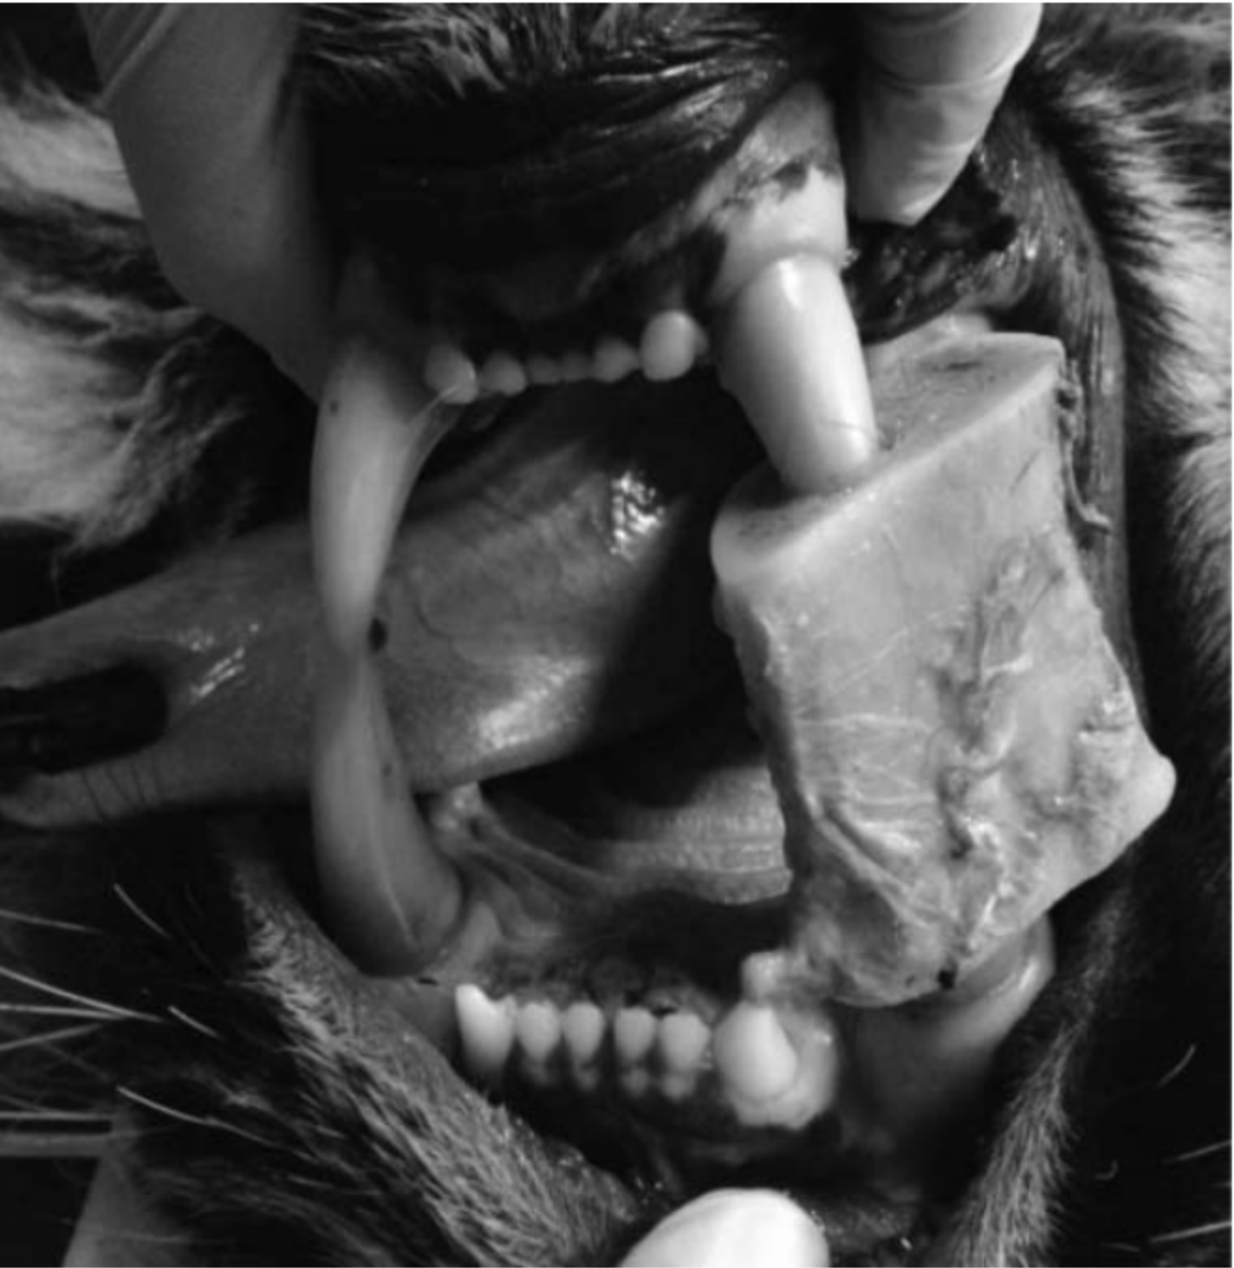

Gastric Dilatation and Enterotoxemia in Ten Captive Felids
Kadie M Anderson, Michael M Garner, Victoria L Clyde, Kurt A Volle, Donna M Ialeggio, Scott W Reid, Jill K Hobbs, Karen N Wolf
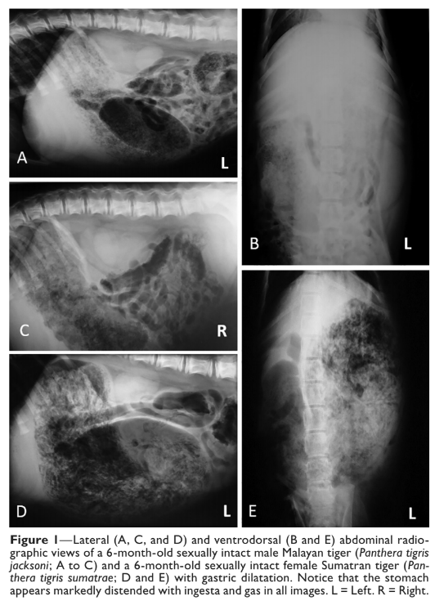
J Am Vet Med Assoc 2018 Oct 1;253(7):918-925.

Taxonomy: Mammalia > Carnivora > Felidae
Abstract: CASE DESCRIPTION 10 large felids at 8 facilities were determined or suspected to have developed gastric dilatation with or without enterotoxemia over a 20-year period. Four felids were found dead with no premonitory signs. CLINICAL FINDINGS 4 felids (2 male snow leopards [Uncia uncia], 1 male Amur tiger [Panthera tigris altaica], and 1 male Sumatran tiger [Panthera tigris sumatrae]) were found dead or died before they could be evaluated. Six felids had hematemesis (1 male and 1 female African lion [Panthera leo] and 1 male jaguar [Panthera onca]) or abdominal distention and signs of lethargy with or without vomiting (1 male African lion, 1 male Malayan tiger [Panthera tigris jacksoni], and 1 female Sumatran tiger). Gastric dilatation was radiographically and surgically confirmed in the male Malayan and female Sumatran tigers and the jaguar. TREATMENT AND OUTCOME In 3 felids with an antemortem diagnosis, the gastric dilatation resolved with decompressive laparotomy but then recurred in 1 felid, which subsequently died. Three others died at various points during hospitalization. Although Clostridium perfringens type A was recovered from 3 of the 5 felids for which microbial culture was performed, and 2 felids had a recent increase in the amount fed, no single factor was definitively identified that might have incited or contributed to the gastric dilatation. CLINICAL RELEVANCE Gastric dilatation was a life-threatening condition in the large felids of this report, causing sudden death or clinical signs of hematemesis, abdominal distention, or vomiting. Even with rapid diagnosis and surgical decompression, the prognosis was poor. Research is needed into the factors that contribute to this emergent condition in large felids so that preventive measures might be taken.

Key Points:
- Clinical signs of gastric dilatation +/- volvulus in large felids = death, lethargy +/- vomiting, hematemesis
- Tried gastric decompression during a laparotomy with intermittent success; almost all died
- One jaguar successfully recovered from GDV after surgery and gastropexy
- Gastric dilatation has also been reported in polar bears, fur seals, red wolves, echidnas, rabbits, guinea pigs, red pandas, sloths, black-footed ferrets, NHP
- No single risk factor identified
  - Clostridium perfringens is hypothesized to contribute to gastric dilatation in simians, ferrets, and dogs
    - Raw meat could be a source of C. perfringens in exotic felids
  - Other potential contributors: chronic gastritis, presence of foreign bodies, increase in meal weight fed

Take Home Message: Aggressive management is necessary to treat large felids with gastric dilatation and volvulus.

EVALUATION OF SYMMETRIC DIMETHYLARGININE AS AN EARLY BIOMARKER OF CHRONIC KIDNEY DISEASE IN CAPTIVE CHEETAHS (ACINONYX JUBATUS)
Benjamin Lamglait, Marielle Vandenbunder-Beltrame
J Zoo Wildl Med 2017 Sep;48(3):874-877

Taxonomy: Mammalia > Carnivora > Felidae
Abstract: Symmetric dimethylarginine (SDMA) has been shown to be a valuable biomarker for early detection of chronic kidney disease (CKD) in canine and feline patients. Recognition of early (subclinical) kidney disease would be of value in cheetahs (Acinonyx jubatus) as prevalence of CKD is relatively high in this species in captivity. Fifty-eight banked serum and plasma samples from seven adult cheetahs that died of CKD were analyzed for creatinine, urea, and SDMA. A marked increase in SDMA was noted on five of the tested cheetahs earlier than the rise of serum creatinine and urea (estimated 8-35 mo; mean 21.4 mo; median 22 mo). SDMA appears as an early biomarker to evaluate renal function for the diagnosis of CKD in cheetahs regardless of the cause of this disease.

Background:
- SDMA: formed by intranuclear methylation of L-arginine by methyltransferases and released into circulation after proteolysis
  - Estimates renal clearance, good marker of GFR
  - Not affected by freeze-thaw
- Glomerular disease present on >80% cheetah necropsies in NA and EU
- Causes of death in these cheetah: oxalate nephrosis, glomerulonephrosis, chronic interstitial nephritis
- Creatinine production decreases with age in cats as muscles breakdown
- SDMA increases as GFR decreases in cats
Key Points:
- SDMA did increase 5-40 months prior to CKD diagnosis based on BUN/Crea
- Once SDMA reference intervals are created, can use a single SDMA value to diagnose early CKD in cheetahs

Take Home Message: SDMA serves as an early marker of CKD in managed cheetahs and increases before BUN/Cr cheetahs with CKD.

Related Articles:
Url A, Krutak V, Kübber-Heiss A, Chvala-Mannsberger S, Robert N, Dinhopl N, Schmidt P, Walzer C. Nephropathies in the European captive cheetah (Acinonyx jubatus) population. J Zoo Wildl Med. 2016;47:797–805

Waugh L, Lyon S, Cole GA, D'Agostino J, Cross J, Strong-Townsend M, Yerramilli M, Li J, Rakitin A, Hardy S, Brandão J. Retrospective analysis and validation of serum symmetric dimethylarginine (SDMA) concentrations in cheetahs (Acinonyx jubatus). Journal of Zoo and Wildlife Medicine. 2018 Sep;49(3):623-31.

Sanchez CR, Hayek LA, Carlin EP, Brown SA, Citino S, Marker L, Jones KL, Murray S. Glomerular filtration rate determined by measuring serum clearance of a single dose of inulin and serum symmetric dimethylarginine concentration in clinically normal cheetahs (Acinonyx jubatus). American Journal of Veterinary Research. 2020 Apr;81(4):375-80.

Epidemiology of clinical feline herpesvirus infection in zoo-housed cheetahs (Acinonyx jubatus)
JAVMA 2017 251(8) 946-956
OBJECTIVE To determine the incidence of and risk factors for clinical feline herpesvirus (FHV) infection in zoo-housed cheetahs and determine whether dam infection was associated with offspring infection.
DESIGN Retrospective cohort study.
ANIMALS 144 cheetah cubs born in 6 zoos from 1988 through 2007.
PROCEDURES Data were extracted from the health records of cheetahs and their dams to identify incident cases of clinical FHV infection and estimate incidence from birth to 18 months of age. Univariate and multivariable Cox proportional hazards models, controlling for correlations among cheetahs with the same dam, were used to identify risk factors for incident FHV infection.
RESULTS Cumulative incidence of FHV infection in cheetah cubs was 35% (50/144). No significant association between dam and offspring infection was identified in any model. Factors identified as significant through multivariable analysis varied by age group. For cheetahs up to 3 months of age, the most important predictor of FHV infection was having a dam that had received a preparturition FHV vaccine regimen that included a modified-live virus vaccine versus a dam that had received no preparturition vaccine. Other risk factors included being from a small litter, being born to a primiparous dam, and male sex.
CONCLUSIONS AND CLINICAL RELEVANCE This study provided the first population level characterization of the incidence of and risk factors for FHV infection in cheetahs, and findings confirmed the importance of this disease. Recognition that clinical FHV infection in the dam was not a significant predictor of disease in cubs and identification of other significant factors have implications for disease management.
Summary:
- Feline herpesvirus is endemic in cheetahs in zoos
  - Self-limiting, mild dz in some, others chronic, severe URT dz, cutaneous and ocular ulcers, life-long problems due to viral latency/reactivation
  - Free-ranging cheetahs also have evidence of exposure, dz not reported
  - Horizontal transmission - contact with bodily fluids
  - Infections assoc with poor hygiene, close conditions
  - Domestic cats - kittens highest risk
    - Waning of maternal Ab and viral shedding by lactating dams
  - AZA recommends physical separation of pregnant cheetahs from other cheetahs, minimizing number of naïve cubs at a time
    - If cubs develop FHV lesions, remove from dam
  - Killed-virus vaccines currently recommended at 6, 9, 12, 16 wks
  - Regular booster for breeding and pregnant females also recommended
  - Vx does not completely prevent infection or dz, nor prevent viral shedding
    - May reduce infection severity or viral load
- M+M:
  - Retrospective study
  - FHV infection based on at least 1 of the 3 following criteria:
    - Corneal ulcer or keratitis without hx of trauma to eye or evidence of neoplasia
    - Patten of clinical signs > 7 days including conjunctivitis, epiphora, blepharospasm, ocular discharge, corneal lesions, sneezing, congestion, nasal discharge, and focal to multifocal skin ulcers, dermatitis, or skin lesions, or dx by PCR, IFA, viral culture, or viral inclusions on histo
- Results/discussion:
  - FHV infection status of the dam was the main factor of interest
  - 28% positive cheetahs born to dams that had a hx of clinical FHV infection
    - Higher proportion of cubs with FHV positive dams developed FHV infection than negative dams, but not statistically significant
  - Dam FHV status was not a significant predictor of subsequent FHV infection in cubs
  - Severity of the dam’s prior FHV infection was also not a significant predictor of subsequent FHV infection in cubs
  - 35% developed clinical signs during the first 1.5 years after birth
  - Large proportion of infections within first month after birth
  - Hx of clinical FHV infection in dam not predictive of development of clinical FHV in cubs
  - 31% cubs with dams with no history of an FHV infection developed clinical disease
    - Indirect transmission may be possible, suspected in domestic cats
  - Most important predictor of clinical FHV in this study was vaccination of the dam with a regimen that included a KV vaccine followed by a MLV vaccine as pre-breeding booster, then another KV booster while pregnant
    - Strong association with preparturition MLV vaccine regimen
    - MLV may also promote undetected viral shedding in cheetah dams, resulting in transmission to offspring (not proven)
    - Authors recommend caution using MLV FHV vaccine near time of parturition
  - Clinical dz in cubs more likely with primiparous vs multiparous dams in cubs from > 3- 18mos age
  - Increased risk in males significant only for cubs with FHV-positive dams
  - Removal of cub from dam for hand rearing within first week was not significantly associated with reduction in incidence of FHV infection in present study
  - Management decisions for cubs should not be based solely on the clinical history of dam based on this study

Suspected adverse reactions to oral administration of a praziquantel-pyrantel combination in captive cheetahs (Acinonyx jubatus)
JAVMA 2017 251:1188–1195
OBJECTIVE To characterize adverse reactions to oral administration of a combination of praziquantel and pyrantel embonate or pyrantel pamoate, with or without oxantel embonate, in captive cheetahs (Acinonyx jubatus).
DESIGN Retrospective case series and case-control study.
ANIMALS 16 captive cheetahs with signs of adverse reaction to oral administration of praziquantel and pyrantel, with or without oxantel embonate (affected group), and 27 cheetahs without such reactions (unaffected group), all from 3 independent facilities.
PROCEDURES Medical records and postmortem findings for affected cheetahs were reviewed and compared with those of unaffected animals. Anthelmintic doses administered, age, and sex of cheetahs were compared between groups.
RESULTS 3 reactions in affected cheetahs were fatal, whereas the remainder ranged from mild to severe. Postmortem examination failed to reveal any disease processes or conditions to explain the deaths. No differences in anthelmintic dose were identified between affected and unaffected cheetahs for all facilities combined, and no correlation existed between dose and reaction severity. No association with sex was detected, but affected cheetahs were significantly younger than unaffected cheetahs. This difference was not significant after controlling for facility.
CONCLUSIONS AND CLINICAL RELEVANCE Cheetahs were concluded to have had an adverse reaction to the praziquantel-pyrantel combination because of temporal proximity of onset of clinical signs to dose administration, similarity of signs to those reported for toxicosis in other species for these drugs, and a lack of other disease process or environmental explanatory factors. A highly cautious approach to the use of this drug combination is recommended for cheetahs.
Summary:
- 16 cheetahs with reactions and 27 cheetahs without reaction to praziquantel-pyrantel in study
- Signs in cheetahs suggestive of toxicity after administering praziquantel-pyrantel
  - Within 4 hours of administration
  - Signs ranged from mild to severe, even fatal in few cases
  - Neurologic – ataxia, seizures, eventually pulmonary hemorrhage & respiratory distress (in severely affected animals)
  - No detectable difference between affected and unaffected cheetahs in praziquantel or pyrantel dose
  - No documented overdoses
  - Cheetahs w/ fatality had evidence of gastritis – may have enhanced absorption of drugs
- Praziquantel
  - Toxicity infrequently reported – weakness, vomiting, depression, ataxia
- Pyrantel
  - Poor GI absorption due to salt (pamoate or embonate)
  - Tachycardia, hypersalivation, diarrhea, vomiting, tremors, convulsions, excitation, ataxia
- Gastritis may enhance absorption of drugs which could predispose to adverse events. Careful with praziquantel and pyrantel administration in cheetahs
- younger cheetahs appeared to be at greater risk of adverse reactions than older cheetahs

