Question 1:
According to a recent study, what is the proposed underlying cause of Clouded leopard alopecic syndrome?

a. Stereotypy leading to self-trauma
b. Climate conditions
c. Ectoparasites
d. Allergic dermatitis
e. Genetics and inbreeding

Answer: E

Question 2:
A caracal (caracal caracal) at your zoo dies after a one-week history of hyporexia, lethargy and vomiting. Below is the gross (A) and histologic (B, C) findings of the kidney as well as congo red staining (D). What is your diagnosis?
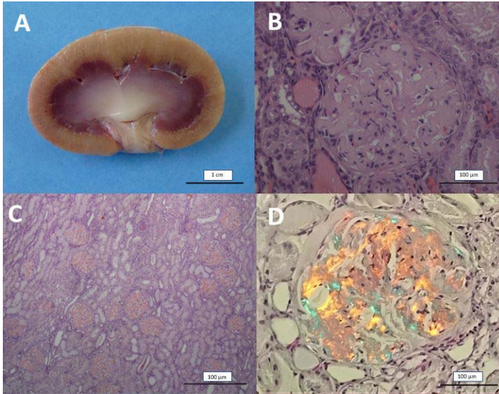

Answer: Renal amyloidosis

CBS Felidae Questions

Stagegaard, Julia, et al. "Ketamine-medetomidine and ketamine-medetomidine-midazolam anesthesia in captive cheetahs (acinonyx jubatus)—comparison of blood pressure and kidney blood flow." Journal of Zoo and Wildlife Medicine 48.2 (2017): 363-370.

Abstract: Six clinically healthy captive cheetahs (Acinonyx jubatus) were anesthetized twice using two different drug combinations to investigate if blood pressure and kidney blood flow are affected by medetomidine dosage. Protocol KM (2.0 mg/kg ketamine and 0.05 mg/kg medetomidine) was compared with protocol KMM (2.0 mg/kg ketamine, 0.02 mg/kg medetomidine, and 0.1 mg/kg midazolam). Heart rate (HR), respiratory rate (RR), body temperature, end-tidal carbon dioxide pressure (ETCO₂), and anesthetic depth were monitored every 10 min. Noninvasive mean (MAP), systolic (SAP), and diastolic (DAP) arterial blood pressure were measured, and Duplex Doppler ultrasonography was performed on the kidneys. The mean arterial resistive index (RI) was determined and the pulse pressure index (PPI) was calculated, as indicators for kidney blood flow. There were no significant differences in induction and recovery times. MAP was significantly higher with KM than KMM at 35 min, and in both protocols decreased significantly after atipamezole administration. DAP was significantly higher at 25 and 35 min in animals anesthetized with KM; it also decreased significantly with both protocols after atipamezole administration. The PPI was significantly lower throughout the procedure with KM, and with both protocols increased significantly after atipamezole administration. Both the higher blood pressure and the reduced PPI with KM were likely a direct effect of the higher medetomidine dosage, and these findings indicate that lower medetomidine dosages might reduce hypertension and lead to a better PPI in cheetah immobilization.

Question: Which of the following was observed in a study using a ketamine-medetomidine (KM) and ketamine-medetomidine-midazolam (KMM) anesthetic protocols in healthy captive cheetahs (Acinonyx jubatus)?
- Respiratory rate was significantly higher with the KMM.
- Mean arterial resistive index did not differ between protocols.
- Mean arterial pressure increased with both protocols after reversal.
- Pulse pressure index was significantly lower for the KMM protocol.
- Pulse pressure index decreased following reversal for both protocols.

Ans: B

Georoff, Timothy A., et al. "Review of canine distemper vaccination use and safety in north american captive large felids (panthera spp.) from 2000 to 2017." Journal of Zoo and Wildlife Medicine 50.4 (2020): 778-789.

Abstract: Data on canine distemper virus (CDV) vaccination were collected on 812 large felids (351 tigers, Panthera tigris; 220 lions, Panthera leo; 143 snow leopards, Panthera uncia; 50 leopards, Panthera pardus; and 48 jaguars, Panthera onca) from 48 institutions to assess vaccine use and safety. The documented individual vaccination events with multiple products numbered 2,846. Canarypox-vectored CDV vaccines were the most commonly used vaccines (96.3% of all vaccinations) and the Purevax® Ferret Distemper (PFD) vaccine was the most commonly used canarypox-vectored vaccine (91.0% of all vaccinations). Modified live virus (MLV) CDV vaccines were used for 3.7% of all vaccinations, and only in tigers, lions, and snow leopards. Adverse effects were reported after 0.5% (13 of 2,740) of the canarypox-vectored vaccinations and after 2.9% (3 of 104) of the MLV CDV vaccinations. This low complication rate suggests large felids may not be as sensitive to adverse effects of MLV CDV vaccines as other exotic carnivores. Serological data were available from 159 individuals (69 tigers, 31 lions, 31 snow leopards, 22 jaguars, and 6 Amur leopards, Panthera pardus orientalis) vaccinated with the PFD vaccine, and 66.0% of vaccinates seroconverted (defined as acquiring a titer ≥1: 24) at some point postvaccination: 24.3% after one vaccination, 55.8% after two vaccinations, 54.3% after three vaccinations, and 79.2% after four or more vaccinations. Among animals exhibiting seroconversion after the initial PFD vaccinations, 88.9% still had titers ≥12 mo and ≥24 mo after the last vaccination, and 87.5% had titers ≥1: 24 at ≥36 mo after the last vaccination. The study was unable to assess fully the safety of vaccination with either canarypox-vectored or MLV CDV vaccines during gestation because of the small number of animals vaccinated while pregnant (n = 6, all vaccinated with PFD).

Question: Based on a multi-instutional study, which of the following species showed the lowest rate of seroconversion following vaccination for canine distemper virus?

- Jaguar (Panthera onca)
- Amur leopard (Panthera pardus orientalis)
- Snow leopard (Panthera uncia)
- Tiger (Panthera tigris)
- Lion (Panthera leo)

Ans: C

Tiger (Panthera tigris) and domestic cat (Felis catus) immune responses to canarypox-vectored canine distemper vaccination.
McEntire M, Ramsay EC, Kania S, Prestia P, Anis E, Cushing AC, Wilkes RP.
J Zoo Wildl Med 2020;50(4):798-802.

In a study comparing Purevax Ferret canarypox-vectored canine distemper vaccination in tigers and domestic cats, which of the following was true?
- Tigers did not have measurable titers following oral-transmucosal administration but domestic cats did.
- Tigers did not have measurable titers following subcutaneous administration but domestic cats did.
- Tigers had measurable titers following oral-transmucosal administration but domestic cats did not.
- Tigers and domestic cats had measurable titers following oral-transmucosal administration.
- Neither tigers nor domestic cats had measurable titers following subcutaneous administration.

Answer: B

A retrospective study of reported disorders of the oral cavity in large felids in Australian zoos.
Whitten C, Vogelnest L, D'Arcy R, Thomson P, Phalen D.
J Zoo Wildl Med 2019;50(1):16-22.

Which of the following is the most common oral cavity disorder seen in tigers and lions in Australian zoos?
- Calculus
- Gingivitis
- Abnormal tooth wear
- Bones lodged on canine teeth
- Fractured canines

Answer: E

Gastric Dilatation and Enterotoxemia in Ten Captive Felids
Kadie M Anderson, Michael M Garner, Victoria L Clyde, Kurt A Volle, Donna M Ialeggio, Scott W Reid, Jill K Hobbs, Karen N Wolf
J Am Vet Med Assoc 2018 Oct 1;253(7):918-925.

Which genus of bacteria has been found in large managed felids with gastric dilatation?
A) Ehrlichia
B) Proteus
C) Salmonella
D) Clostridium
E) Bacteroides

EVALUATION OF SYMMETRIC DIMETHYLARGININE AS AN EARLY BIOMARKER OF CHRONIC KIDNEY DISEASE IN CAPTIVE CHEETAHS (ACINONYX JUBATUS)
Benjamin Lamglait, Marielle Vandenbunder-Beltrame
J Zoo Wildl Med 2017 Sep;48(3):874-877

Which of the following is true regarding chronic kidney disease in managed cheetahs?
- Most common nephrolith is calcium carbonate
- Creatinine is expected to increase as healthy cheetah age
- Pyelonephritis is a top cause of CKD
- SDMA will detect CKD prior to a rise in creatinine
- Hypocalcemia has been correlated with CKD

Question 1:
Which of the following has been associated with praziquantel and pyrantel administration in captive cheetahs (Acinonyx jubatus)?
- Ataxia and seizures
- Photosensitization dermatitis
- Bone marrow suppression
- Fulminant hepatic failure
- Acute kidney injury

Question 2:
Which of the following was found to be a risk factor for feline herpesvirus (FHV) infection in captive cheetah cubs (Acinonyx jubatus)?
- Previous infection of the dam with FHV
- Pre-parturition vaccination of the dam with a modified-live FHV vaccine
- Large litter size
- Born to a multiparous dam
- Female sex

