McRee, Anna Elizabeth, et al. "Effect of routine handling and transportation on blood leukocyte concentrations and plasma corticosterone in captive hispaniolan amazon parrots (amazona ventralis)." Journal of Zoo and Wildlife Medicine 49.2 (2018): 396-403.

Abstract: Increased glucocorticoids cause a characteristic stress leukogram in mammalian taxa. It is assumed that avians exhibit a similar response, but to date, there have been no controlled studies to correlate serial endogenous corticosterone levels to hematologic values. An established flock of 18 Hispaniolan Amazon parrots (Amazona ventralis) was used as a model in a crossover study. The treatment group was subjected to the stress of transport, restraint, and common clinical procedures with serial blood samples collected at 20-min intervals for hematology and corticosterone levels; the control group was sampled at the same intervals. Longitudinal data analysis was performed with linear mixed modeling. For all hematologic analytes, the baseline value had a significant positive effect on subsequent values (all P , 0.001). The white blood cell, heterophil, and eosinophil counts and heterophil to lymphocyte ratio increased over time in the treatment group, whereas it remained stable in the control group (P ¼ 0.016, P , 0.001, P , 0.001, P ¼ 0.02, respectively, for the time*treatment effect). Lymphocyte absolute counts decreased over time, although not significantly; the decrease was significant for the relative lymphocyte count in the treatment group. Monocytes and basophils were not significantly altered. The treatment group had a higher mean corticosterone level overall than the control group by approximately 60% (P = 0.008). The mean corticosterone level also increased over time in both groups by three- to fourfold (P , 0.001) by 20 min then plateaued. These results demonstrate that some significant hematologic changes may arise with routine handling and transportation of birds and should be accounted for in hematologic interpretation of cell counts.

INTRO
- The release of endogenous corticosteroids and catecholamines is known to affect physiologic and biochemical parameters in the mammals and can confound interpretation of clinical pathologic data
- The primary objective was to confirm that increased handling time causes an increased release of corticosterone that correlates with changes in paired hematologic values.
M&M
- 18 hispaniolan amazon parrots (amazona ventralis) used in a crossover study design
- 5 blood collection time points
- Treatment group netted, blood drawn, transported, blood drawn, PE and grooming, blood drawn, then drawn at 2 more time points (20 mins and 40 mins) prior to transportation back to colony
- Control group drawn at similar time intervals with no transport or PE, only capture and handling for blood draw
- CBC and corticosterone measured in all samples
- Washout of 4 weeks, then repeated with opposite groups
RESULTS
- The white blood cell, heterophil, and eosinophil counts and heterophil to lymphocyte ratio increased over time in the treatment group, whereas it remained stable in the control group
- Lymphocyte absolute counts decreased over time, although not significantly; the decrease was significant for the relative lymphocyte count in the treatment group. Monocytes and basophils were not significantly altered.
- The treatment group had a higher mean corticosterone level overall than the control group by approximately 60%
- The mean corticosterone level also increased over time in both groups by three- to fourfold
DISCUSSION
- A rapid increase of corticosterone in response to stress was seen in this study, followed by significant changes in the leukocyte component.
- The H:L ratio was significantly increased in the treatment and not the control group 60 min and after, however, there was not a significant absolute lymphopenia
- This is in contrast to a study in Harris hawks in which stress resulted in a lymphopenia and eosinopenia—species variation is suspected
- The mean responses of groups of birds of the same species can also vary in relation to season, weather, and population

DiGeronimo, Peter M., et al. “Comparison of alligator snapping turtle (macrochelys temminckii) plasma biochemical profiles from two clinical analyzers.” Journal of Zoo and Wildlife Medicine 49.4 (2018): 925-930.

Abstract: The interpretation of plasma biochemical profiles can be confounded by the methodologies by which samples are analyzed. The goal of this study was to compare agreement between two biochemical analyzers for plasma samples from alligator snapping turtles (Macrochelys temminckii). Blood was obtained from the dorsal coccygeal vein of captive-reared, juvenile turtles (n = 34), stored in lithium heparin tubes, and centrifuged to separate plasma from whole blood. Plasma samples were stored at 58C prior to and in between analyses on VetScan (VetScan2, Abaxis, Union City, CA 94587, USA) and Olympus (Olympus AU640, Beckman Coulter, Brea, CA 92821, USA) analyzers within 2 hr of each other. Agreement between the VetScan and Olympus analyzers was investigated using Passing-Bablok regression analysis for aspartate aminotransferase, creatine kinase, glucose, calcium, phosphorus, total protein, albumin, globulin, potassium, and sodium. Agreement between the two analyzers was outside of acceptance limits and outside of clinical allowable error limits for all analytes as established by the American Society for Veterinary Clinical Pathology. The results of biochemical analyses of alligator snapping turtle plasma cannot be compared between VetScan and Olympus analyzers in a clinical setting. Comparison of biochemical analyses within analyzer units, however, may still be clinically useful. Future studies are warranted to investigate the precision of each analyzer for alligator snapping turtle plasma.

INTRO
- The goal of this study was to compare agreement between two biochemical analyzers for plasma samples from alligator snapping turtles (Macrochelys temminckii)
M&M
- Blood was obtained from the dorsal coccygeal vein of captive-reared, juvenile turtles (n = 34), stored in lithium heparin tubes, and centrifuged to separate plasma from whole blood
- VetScan and Olympus analyzers
- Comparison of AST, CK, UA, Glu, Ca, P, TP, Alb, Glob, K, Na
- .Passing-Bablok regression analysis
RESULTS
- Agreement between the two analyzers was outside of acceptance limits and outside of clinical allowable error limits for all analytes
- Overall, linear correlation was weak to moderate for most analytes between analyzers
DISCUSSION
- The results of biochemical analyses of alligator snapping turtle plasma cannot be compared between VetScan and Olympus analyzers in a clinical setting.
- Comparison of biochemical analyses within analyzer units, however, may still be clinically useful, though precision was not evaluated in this study

Barratclough, Ashley, et al. "Baseline plasma thromboelastography in Kemp's ridley (Lepidochelys kempii), green (Chelonia mydas) and loggerhead (Caretta caretta) sea turtles and its use to diagnose coagulopathies in cold-stunned Kemp's ridley and green sea turtles." Journal of Zoo and Wildlife Medicine 50.1 (2019): 62-68.

Abstract: Cold-stunning in sea turtles is a frequent natural cause of mortality and is defined as a hypothermic state due to exposure to water temperatures <12°C. Derangements of biochemistry and hematology data by cold stunning have been well documented, although the effects on coagulation have not yet been investigated. The objectives of this study were to characterize the hemostatic state of non–cold-stunned sea turtles and to compare cold-stunned sea turtles at admission and after successful rehabilitation via a sea turtle–specific thromboelastography (TEG) protocol. TEG enables evaluation of the entire coagulation process, and the methodology has recently been established in sea turtles. Initially, 30 wild and apparently healthy sea turtles were sampled as controls: loggerhead sea turtles (Caretta caretta), n =17; Kemp's ridley sea turtles (Lepidochelys kempii), n = 8; and green turtles (Chelonia mydas), n = 5. In addition, paired TEG samples were performed on 32 Ch. mydas and 14 L. kempii at admission and prerelease after successful rehabilitation from cold stunning. Statistically significant differences in reaction time, kinetics, angle, and maximum amplitude parameters in L. kempii and Ch. mydas species demonstrated that the time taken for blood clot formation was prolonged and the strength of the clot formed was reduced by cold stunning. These findings indicate that cold stunning may cause disorders in hemostasis that can contribute to the severity of the condition. Early diagnosis of coagulopathies in the clinical assessment of a cold-stunned sea turtle may influence the treatment approach and clinical outcome of the case.
- Introduction:
  - Cold stunning – Hypothermia resulting in lethargic/moribund clinical state.
    - Exposure to cold water temps < 12 deg C.
  - Thromboelastography (TEG).
    - Clotting in reptiles – lack of intrinsic system and factors XI and XII.
    - TEG only coag test to provide global evaluation of the hemostatic process vs single pathway.
    - Four main parameters:
      - R – reaction time.
      - K – clot formation time.
      - Angle alpha – clot formation rate.
      - MA – maximum amplitude (clot strength).
- M+M:
  - Sampled wild/apparently healthy turtles; also paired samples before and after rehab for cold stunned turtles.
  - Developed TEG protocol from frozen sea turtle brain thromboplastin.
- Results/Discussion:
  - No significant difference between acute and chronic turtles. Both acute and chronic had similar results vs controls.
  - Clot strength (MA) reduced in cold stunned individuals.
  - Clot formation rate (alpha angle) significantly reduced in cold stunned individuals.
  - Greens – had significant differences in R and K, demonstrating time to initiate clot formation was also affected by cold stunning in this species.
  - Only coagulation factors and functional fibrinogen could be assessed because used plasma instead of whole blood (no effect from thrombocytes).
  - Improvement in TEG observed in initial cold stun presentation vs release.
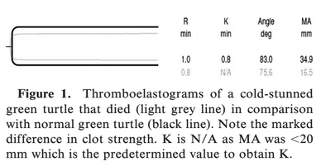

Parlier, Mark R., et al. "Evaluation of cell preservatives on the integrity of attwater's prairie chicken (tympanuchus cupido attwateri) whole blood samples over time." Journal of Zoo and Wildlife Medicine 51.1 (2020): 116-122.

Abstract: The processing of blood samples can be delayed during health assessments of wildlife populations in distant locations. The use of whole blood preservatives may be useful in these situations. However, there is scant information regarding their use in nonmammalian species. This study tested the efficacy of two cell preservatives on whole blood collected from 12 Attwater's prairie chickens (Tympanuchus cupido attwateri). The preservatives used were Streck Cell Preservative© (SCP), a proprietary proteinaceous stabilizer developed for human flow cytology and validated in other mammalian species, and formalin, which is commonplace in histopathology, but its use in whole blood has been limited to fish. Grouped blood samples were treated with heparin, SCP, or formalin and analyzed at 0, 1, 4, and 7 days after collection for packed cell volume (PCV), complete blood count (CBC), and cellular morphology. SCP effectively preserved most cell types in Attwater's prairie chicken blood samples over a period of 7 days, with the exception of monocyte cell counts, which were significantly reduced from day 0. Formalin maintained total white blood cell counts at baseline levels measured by hemocytometer, but irregular staining characteristics prevented accurate analysis of differential counts or cellular morphology. Both preservatives altered PCV compared with the heparin control, but these values remained constant over time, highlighting the need for method-specific reference intervals. The validation of SCP in Attwater's prairie chickens supports its potential for use in other avian species for the collection of accurate hematologic data when the processing of blood samples may be delayed.
- Introduction:
  - No blood preservation techniques have been validated in avian spp.
  - Attwater’s prairie chicken – Critically endangered subspecies of prairie grouse historically native to coastal Texas and Louisiana.
  - Streck Cell Preservative (SCP) – Liquid stabilization reagent originally formulated to extend human leukocyte integrity for use in flow cytometry.
    - Effective at stabilizing blood samples from dogs, sea lions, koalas.
  - Formalin – Used to fix tissues for histo, also for preservation of fish blood for analysis.
  - Goal of study – Compare the effectiveness of SCP and formalin preservatives to heparinized controls over 7 days on whole blood from APC for CBCs.
- M+M:
  - 12 chx – 6F, 6M 1-2yrs old. Blood collected, transferred to lithium heparin tubes.
  - Within 1 hour put sample in SCP (1:1 ratio) or formalin (1:4 ratio).
  - CBC on days 0, 1, 4, 7 after collection for PCV, WBC count, blood smear evaluation.
- Results:
  - Heparinized controls – Significant decreases from day 0 within 1 day after collection for heterophils, within 4 days for total WBC, and basophils, and within 7 days for lymphocytes and monocytes.
  - Cellular morphology in hemocytometer was different depending on preservative used.
    - SCP – erythrocytes did not fully lyse, leukocytes stained deeply and were easy to distinguish.
    - Formalin – Erythrocytes remained fully intact, WBC only lightly stained making it difficult to distinguish from RBC.
  - Cellular morphology on blood smears also affected by the preservative used.
    - Formalin – Low cellularity due to the dilution ratio, all WBC stained solid basophilic, obscured characteristics for differentiation of cell types.
  - SCP and formalin successfully stabilized PCV and WBC counts over 7 day period.
    - SCP better for cell morphology assessment (differential cell counts).
    - Both preservatives produced some artifactual changes.
      - Both influenced initial PCV, but these values were constant over time.
        - SCP lowered PCV by 17% avg.
        - Formalin elevated PCV by 36% avg.
        - Predictable, could manually correct for it.
    - Both preservatives effective at stabilizing the total WBC count vs heparin controls with hemocytometer.
      - Formalin blood smears could not be used for differentials.
        - Could collect a sample in heparin, prep a blood smear, and then save the rest in formalin to make up for this.
        - SCP simplifies this since you don’t need to do that.
    - SCP artificially lowered monocytes compared to control at baseline.
      - Also in the koalas.
      - Potential for misinterpretation for monocytopenia.
      - This could also affect monocytosis typical of granulomatous inflammation in response to an infectious agent such as mycobacterium, chlamydophila, or aspergillus.
      - Absence of monocytosis in a blood sample preserved with SCP from a bird with other clinical signs of infection may not be accurate and should be evaluated closely.
- Takeaways:
  - PCV – Increased in formalin, decreased in SCP, predictable for both.
  - Hemocytometry – SCP preserved sample better; formalin did not stain well, had low cellularity due to dilution, and RBCs did not lyse.
  - SCP artificially lowered monocytes vs control at baseline.
    - Potential for misinterpretation for monocytopenia.
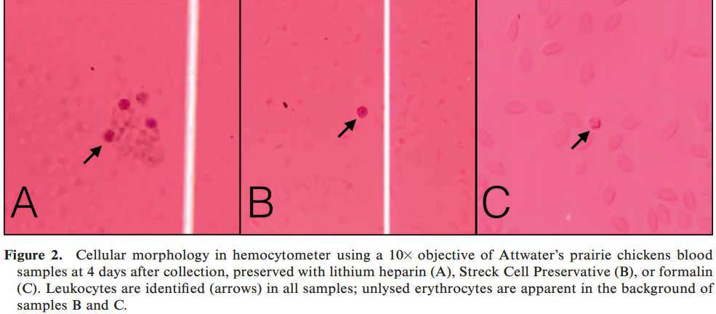

EFFECTS OF SEASON AND POSTMORTEM CHANGES ON BLOOD ANALYTES IN PYRENEAN CHAMOIS (RUPICAPRA PYRENAICA PYRENAICA)
Tvarijonaviciute A, Marco I, Cuenca R, Lavín S, Pastor J.
J Wildl Dis. 2017 Oct;53(4):718-724.

Taxa: Mammalia → Artiodactyla → Bovidae → Caprinae
Abstract: Our objectives were to evaluate the effects of the 1) season, and 2) postmortem changes on serum biochemistries related with metabolism in Pyrenean chamois (Rupicapra pyrenaica pyrenaica). Serum samples from 98 animals obtained from 2009 to 2012 were included. To investigate seasonal influences on blood parameters, the Pyrenean chamois were captured in drive-nets during the feed abundant (FA; n=32) and food deficient (FD; n=35) seasons. To evaluate the possible differences in biochemistry analytes when sampling live or dead animals, we used serum samples from 32 captured animals and 31 dead animals (obtained during controlled hunting) in the FA season. Significant increases in high-density lipoprotein cholesterol (24%), nonesterified fatty acids (NEFA, 190%), total antioxidant capacity (68%), and haptoglobin (33%) were observed in FD when compared with FA seasons. Albumin and insulin-like growth factor-1 (IGF-1) showed statistically significant decreases of 10% and 11%, respectively, in samples taken in the FD season compared to the FA season. Statistically significant higher concentrations were found in serum low-density lipoprotein cholesterol (22%), triglycerides (28%), acetylcholinesterase (50%), NEFA (383%), albumin (18%), IGF-1 (53%), cortisol (959%), and paraoxonase-1 (20%) in samples collected from live animals compared to samples collected from dead ones. We demonstrated that season should be taken into account when evaluating serum biochemistries in Pyrenean chamois because, in the FD season, these animals present lipid mobilization, decreased albumin and IGF-1, and increased total antioxidant capacity compared with the FA season. In addition, if samples are taken from dead animals, observed decreases in serum low-density lipoprotein cholesterol, triglycerides, albumin, paraoxonase-1, acetylcholinesterase, NEFA, cortisol, IGF-1, and an increase in haptoglobin should be expected.

Background:
- Pyrenean chamois are distributed in the alpine and subalpine habitats in the French and Spanish Pyrenees
  - During the winter season, nutritional resources are reduced.
  - During the rut season (November), higher energy output and reduced food intake in males
Key Points:
- Blood collected from wild animals (n=67) food deficient seasons (compared to food abundant):
  - Higher: HDL-C, NEFA, and TAC
  - Lower: albumin and IGF-1
- Blood collected from hunted carcasses (compared to live animals in food abundant season):
  - Lower: LDL-C, triglycerides, AChE, NEFA, albumin, IGF-1, cortisol (10x lower in dead animals), PON1
  - Highter: haptoglobin
- Food deficient season likely provides poor nutrition and a negative energy balance
  - Endogenous fat become the main source of energy
  - Haptoglobin accompanies increasing lipid metabolism
  - Minimal increases in butyrate and haptoglobin suggest no overt ketoacidosis
    - Wild ungulates prevent ketosis by obtaining glucogenic precursors from body protein, resulting in decreased protein in body tissues and potentially lower albumin
  - Lower IGF-1 because it is involved in regulation of growth and metabolism and mediates anabolic effects of growth hormone
- Capture and manipulation is stressful due to 10x higher cortisol in live animals under physical restraint compared to post-mortem samples from hunted animals

Conclusion: Season should be taken into account when evaluating serum biochemistry in Pyrenean chamois because food deficient animals have higher lipid mobilization and total antioxidant capacity and decreased albumin and IGF-1. Samples from dead animals have decreased serum albumin, LDL-C, triglycerides, albumin, PON1, AChE, NEFA, cortisol, IGF-1, and increased haptoglobin.

The effects of migratory flight on hematologic parameters in northern bald ibises (Geronticus eremita).
Stanclova G, Schwendenwein I, Merkel O, Kenner L, Dittami J, Fritz J, Scope A.
Journal of Zoo and Wildlife Medicine. 2017 Dec;48(4):1154-64.

Taxa: Aves → Pelecaniformes → Treskiornithidae
Abstract: Under the project of “Human-Led Migration,” the authors had the unique opportunity to accompany hand-raised northern bald Iibises (NBIs; Geronticus eremita) during migration, which occurred in stages from Bavaria, Germany, to southern Tuscany, Italy. The aim of this study was to investigate the immediate effects of flight, with respect to flight duration, and the more delayed recovery effects on hematologic variables. A total of 31 birds were sampled. Blood samples were taken immediately before takeoff, after landing, and 1 day after the flight. Hematocrit was determined and blood smears were prepared to estimate the total white blood count (tWBC) with leukocyte concentrations (absolute [abs.]) and differential blood cell count (%). Postflight, significant decreases in hematocrit, tWBC, lymphocytes (abs., %), heterophils (abs.), eosinophils (abs., %), and monocytes (abs.) were observed. In contrast, heterophils (%), basophils (%), and the heterophil/lymphocyte (H/L) ratio increased significantly. With increasing flight duration, the H/L ratio increased further. One day postflight, there were still significant decreases in tWBC, lymphocytes (abs.), and eosinophils (abs., %) and significant increases in heterophils (%) and the H/L ratio. The hematocrit dropped even further. These data show that the decrease of tWBC is mainly caused by the lymphocyte fraction and that NBIs need more than 1 day to reverse the postflight changes in some hematologic values. Hematocrit changes postflight and on the recovery day are most likely to be explained by hemodynamics and the metabolic and hormonal changes caused by flight. The hematologic changes postflight in NBIs were largely consistent with those of other birds, but they differed from humans and mammals postexercise mainly in the levels of tWBC, heterophils (matching neutrophils in mammals), and lymphocytes.

Background:
- Critically endangered northern bald ibis were taught via Human-Led Migration to travel from Morocco to Europe
  - Sample pre-flight, immediately post-flight, and 1 day post-flight
Key Points:
- Compared to pre-flight, the immediate post-flight data found:
  - Decreased HCT, TWBCs, lymphocytes, eosinophils
  - Increased heterophil:lymphocytes, heterophils, basophils
- One-day post-flight was very similar to immediately post-flight
- Potential causes for decreased HCT: water conservation, decreased erythropoiesis, less blood viscosity
- Similar leukogram changes compared to:
  - Pigeons: decreased eosinophils, monocytes; increased heterophils

Conclusions: After migration in northern bald ibises, hematocrit, white blood cells (from a decrease in lymphocytes and eosinophils) decreased, while heterophils and basopils increased.
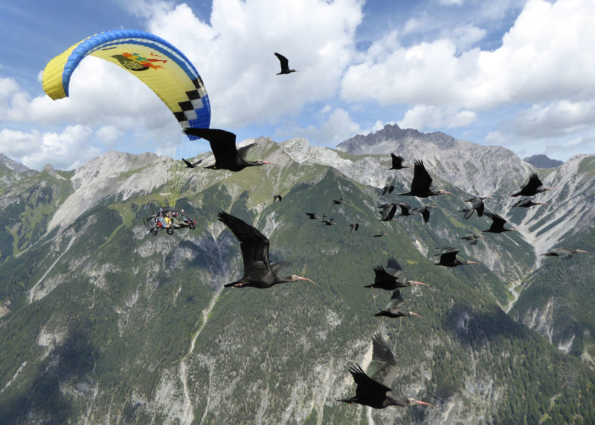

Reference intervals for erythrocyte sedimentation rate, lactate, fibrinogen, hematology, and plasma protein electrophoresis in clinically healthy captive gopher tortoises (Gopherus polyphemus).
Rosenberg, J.F., Wellehan Jr, J.F., Crevasse, S.E., Cray, C. and Stacy, N.I.
Journal of Zoo and Wildlife Medicine, 2018;49(3):520-527.

Abstract: Currently available tests for the diagnosis of inflammatory disease in reptiles are limited and poorly sensitive. However, a number of hematological and plasma biochemical analytes are validated in the diagnosis of inflammation in mammals. The objective of this study was to establish reference intervals for erythrocyte sedimentation rate, lactate, heat-precipitated fibrinogen, hematology, and plasma protein electrophoresis based on total protein by biuret method in 23 clinically healthy, captive gopher tortoises (Gopherus polyphemus) after successful rehabilitation and to determine differences by age, sex, and season. In order to investigate biological differences, samples were collected in April, July, and November. There were no sex differences in any measured analyte; however, there were significant differences by age and season. Immature animals (,2 kg) had significantly higher total protein, albumin : globulin ratio, pre-albumin, albumin, and a-1 globulin than adults. Tortoises sampled in the spring season had significantly higher total solids (refractometer) and lower eosinophils compared with animals sampled in the summer. Further investigation is required to determine the clinical utility of these analytes in the diagnosis of inflammation in this species.

Background
- Reptiles have variable leukocyte response to inflammation/infection, need a more sensitive test for inflammation
- Erythrocyte sedimentation rate (ESR; mm sedimentation/60 min) - increases with inflammation (RBCs form rouleaux with APPs, primarily fibrinogen)
  - EDTA is anticoagulant of choice for ESR but this study used heparin
- Lactate - reptiles have slow metabolism and unique lactate removal methods that can cause extremely high lactate levels with physical exertion or illness
  - 50% of lactate is produced within 30 sec of capture/physical exertion
  - 90% formed within first 90 sec
- Fibrinogen - acute phase protein, highly conserved across species
  - “Heat-precipitated fibrinogen provides an insensitive method for quantifying an inflammatory condition and should be interpreted with caution, especially with hypofibrinogenemia”
- Plasma protein electrophoresis

Key points
- Venipuncture from subcarapacial sinus
  - potential for lymph contamination
- No stat sig difference in any analyte between male and female
- Immature: significantly higher TP by biuret, A:G ratio, pre-albumin, albumin, and alpha-1 globulin compared to adults
- TS significantly increased in the spring compared to summer
- Eos significantly decreased in spring compared to summer
- No stat sig difference between TS by refractometer and TP by biuret
- Lactate lower than other chelonians (sea turtles) - possibly due to less restraint and habituated ‘nonreleasable’ tortoises
- Several animals WBC 22-30 x 10^3/uL so not actually “healthy”

ESR | 3-8 mm/hr
Lactate | 0.3-1.3 mM/L
Fibrinogen | 100-380 mg/dL
Plasma protein electrophoresis | Beta peak higher than other fractions (trend)

Conclusions
- Reference ranges provided for ESR, lactate, fibrinogen, hematology, and plasma protein electrophoresis in apparently healthy, captive gopher tortoises
- No sex differences in any analyte
- TS and TP differed between age (higher TP in immature) and season (higher TS in spring compared to summer)
- Correlation between TS and TP indicates use of TS as a rapid and inexpensive diagnostic tool for estimating TP

Paired biochemical analysis of pigmented plasma samples from zoo-kept american flamingos (phoenicopterus ruber) using a point-of-care and a standard wet chemistry analyzer.
Gancz, A.Y., Eshar, D. and Beaufrère, H.
Journal of Zoo and Wildlife Medicine, 2019;50(3):619-626.

Abstract: American flamingos (Phoenicopterus ruber) are commonly kept in zoological collections, making health monitoring essential. Use of point-of-care (POC) blood analyzers that require small volumes of whole blood samples produces prompt results allowing for rapid clinical decision-making. To evaluate and compare blood biochemistry analysis results analyzed by a POC biochemistry analyzer (VetScan/Abaxis) and a laboratory wet biochemistry analyzer (Cobas), blood was collected from 17 apparently healthy zoo-kept American flamingos. Analyzer agreement was investigated using the Passing–Bablock regression analysis and Spearman correlation coefficients. Plasma samples from all birds were bright yellow in color. The results from the POC analyzer used in this study were found to be outside acceptance and clinical allowable error limits when compared with the laboratory analyzer for phosphorus (Phos), total protein (TP), albumin (Alb), glucose (Glu), creatine kinase (CK), and potassium (K). For aspartate aminotransferase (AST), results were within clinical allowable error but outside the acceptance limits, and for calcium (Ca) and sodium (Na), results were within both limits. The POC analyzer failed to measure the uric acid (UA) concentrations of all the samples, and reported all bile acids (BA) concentrations as below its minimal measurable limit. The use of analyzer-specific reference intervals is recommended for most analytes tested. The POC analyzer used in this study cannot be recommended for measuring UA concentrations in brightly colored samples from American flamingos.

Background
- Other species have variable agreements and significant proportional errors or bias between POC analyzers and reference values for several analytes
- Canthaxanthine in diet (fed for pink feather coloration) causes bright yellow coloration of flamingo plasma samples
  - May interfere with biochemical analysis

Key points
- Objective: validate VetScan VS2 Analyzer (Abaxis) in American flamingo
- All plasma samples were bright yellow
  - All reported as icterus 2+ by VSARR
  - 13/17 were lipemia 1+ but no suppression by Vetscan which happens when it expects >10% effect of lipemia on results so likely didn’t affect results
- Unable to read UA in any sample
  - Vetscan reads Trinder reaction results at 515 nm and 600 nm
  - Cobas reads at 546 nm and 700 nm
  - Canthaxanthine peak light absorbance is at 470 nm up to 515 nm so could interfere with UA reading in Vetscan (also likely cause of icterus and lipemia readings)
- BA levels below measurable limit (<35 uM/L) in all samples
- Phos, TP, Alb, Glu, CK, K all outside acceptance limits and clinical allowable error limits
  - Higher K on Vetscan - different methodology (Vetscan is enzymatic, Cobas is ion selective electrode) or lag time of sample to Cobas (less than 4 hrs) allowing K to move into cells
  - Higher Alb on Vetscan - similar to Amazons and owls *bromocresol green dye-binding method is considered inaccurate in avian species anyway, protein electrophoresis is gold standard
- AST within clinical allowable error limits but outside acceptance limits
- Ca and Na within both acceptance and clinical allowable error limits
- Fewer analytes in acceptable agreement compared to Hispaniolan Amazon and owl studies
  - Including Ca and AST which were reported as good or close agreement in other studies
  - Other studies had Na as poor agreement (Spearman correlation was low in this study)

Conclusions
- Biochemistry values on VetScan and Cobas should not be directly compared due to variable disagreement in American flamingos
  - Phos, TP, Alb (VetScan higher), Glu, CK, K (VetScan higher) in disagreement
  - Ca and Na were in agreement
  - UA not read and bile acids read out as low
- Cannot recommend VetScan for analyzing plasma UA in American flamingos or potentially other species with pigmentation of the plasma.

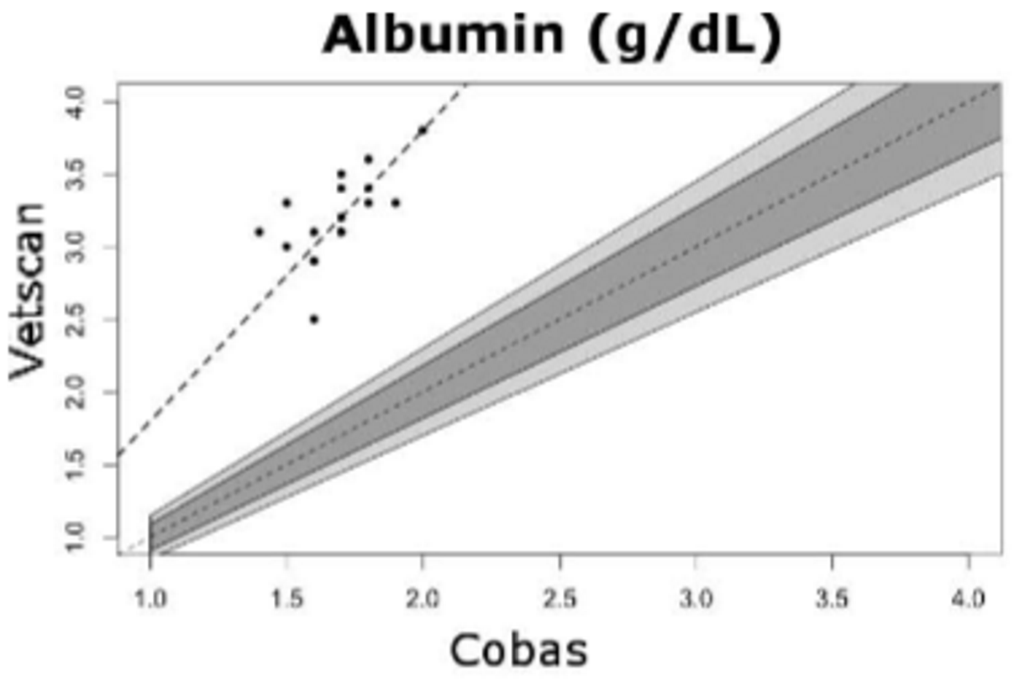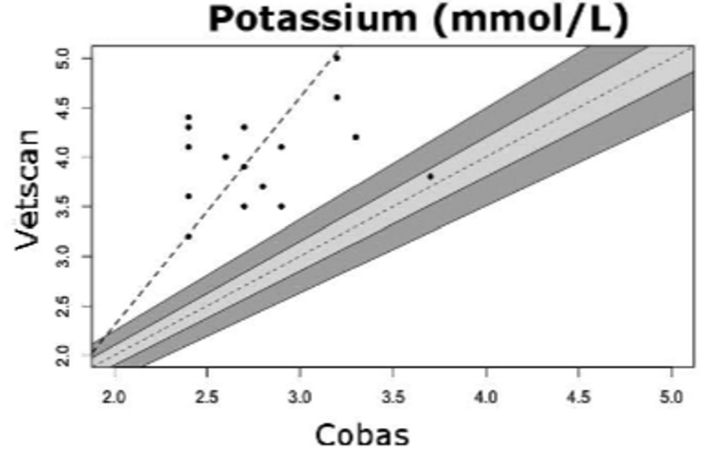

Method Comparison Using 2 Point-of-Care Meters and a Reference Analyzer for Measuring Blood Triglycerides in Psittacine Birds
JAMS 2019 33(3) 229-234
Abstract:
Female reproductive disorders, such as chronic egg laying, are common in captive psittacine birds. While a disease diagnosis related to reproductive disorders can often be accomplished by physical examination and diagnostic imaging, monitoring of the response to environmental modification and medical treatment is more challenging. Monitoring ideally would involve measurement of luteinizing hormone or estrogen to assess ovarian activity. However, the amount of blood required for hormone analysis is greater than the small sample size that one can collect from these birds. Additionally, the lack of reference intervals limits their use as a diagnostic tool. Because plasma triglyceride increases during sustained estrogen release from the ovary, it may be used as an alternative method for assessing ovarian activity in birds. Point-of-care (POC) analyzers for measuring lipids in human plasma use very small sample volumes and have been used for measuring triglycerides in animals, including chickens. The authors therefore performed a method comparison study with 2 POC analyzers and a reference analyzer and plasma and whole blood from psittacine birds to determine whether these meters are suitable for triglyceride measurement in a known population of psittacine birds. Correlation, Deming regression, and Bland-Altman analyses were used to assess performance, and the total observed error for each meter relative to the reference analyzer was calculated. One of the meters exhibited fair performance and, with species-specific reference intervals, is likely to be clinically useful for triglyceride measurement in psittacine birds. The other meter demonstrated poor performance with unacceptable error, and its use for this purpose is strongly discouraged.
Summary:
Intro:
- blood triglyceride concentration increases in female birds in response to increased estrogen levels indicating ovarian activity
- triglyceride may also be helpful in screening for hepatic lipidosis, thyroid disorders, and atherosclerosis
- Portable POC analyzers used in human medicine to measure triglycerides
  - Rapid test
  - Small sample volume
- objective - comparison of 2 POC analyzers for measuring triglycerides in whole blood and plasma obtained from psittacine birds to monitor reproductive problems
M + M:
- 40 psittacine birds: 11 cockatoos, 9 macaws, 8 Amazons, 6 African greys, 2 conures, 1 eclectus, and 3 unknown species
- 3 analyzers used: reference analyzer and 2 POC analyzers (CardioChek PA and Accutrend Plus GCT)

Results/discussion:
- POC meters have narrower reportable range than reference analyzer
- CardioChek PA and Accutrend Plus GCT able to detect triglycerides in plasma from psittacines
- CardioChek PA - fair performance for measuring triglycerides in psittacines but requires further investigation into clinical use in hypertriglyceridemic psittacines with ovarian disease
  - high correlation and reasonable agreement with reference analyzer with both whole blood and plasma, performance subjectively better with plasma
  - need to establish reference intervals or decision limits specific to plasma and whole blood for relevant psittacine species
  - meter-specific reference intervals needed for both whole blood and plasma
- Accutrend Plus GCT - unacceptable error compared with reference analyzer for both whole blood and plasma, not recommended for measuring triglycerides in psittacines
  - correlation with reference analyzer poor for whole blood and moderate for plasma

BRIDGING GAPS BETWEEN ZOO AND WILDLIFE MEDICINE: ESTABLISHING REFERENCE INTERVALS FOR FREE-RANGING AFRICAN LIONS (PANTHERA LEO)
JZWM 2017 48(2) 298–311

Abstract:
The International Species Information System has set forth an extensive database of reference intervals for zoologic species, allowing veterinarians and game park officials to distinguish normal health parameters from underlying disease processes in captive wildlife. However, several recent studies comparing reference values from captive and free-ranging animals have found significant variation between populations, necessitating the development of separate reference intervals in free-ranging wildlife to aid in the interpretation of health data. Thus, this study characterizes reference intervals for six biochemical analytes, eleven hematologic or immune parameters, and three hormones using samples from 219 free-ranging African lions (Panthera leo) captured in Kruger National Park, South Africa. Using the original sample population, exclusion criteria based on physical examination were applied to yield a final reference population of 52 clinically normal lions. Reference intervals were then generated via 90% confidence intervals on log-transformed data using parametric bootstrapping techniques. In addition to the generation of reference intervals, linear mixed-effect models and generalized linear mixed-effect models were used to model associations of each focal parameter with the following independent variables: age, sex, and body condition score. Age and sex were statistically significant drivers for changes in hepatic enzymes, renal values, hematologic parameters, and leptin, a hormone related to body fat stores. Body condition was positively correlated with changes in monocyte counts. Given the large variation in reference values taken from captive versus free-ranging lions, it is our hope that this study will serve as a baseline for future clinical evaluations and biomedical research targeting free-ranging African lions.
Summary:
Intro:
- reference intervals prone to wide range of error and variation
  - differences in geographic location, individual laboratory, instrumentation, preanalytic preparation, reference population, and species
  - differences between captive animals versus free-ranging wildlife
M + M:
- 52 clinically normal African lions captured and sampled in Kruger National Park
- CBC and flow cytometry
- Chemistry panel: ALT, ALP, BUN, creatinine, BG, and TS measured
- testosterone, leptin, and ghrelin measured
- erythrocyte sedimentation rate measured
Results/discussion:
- study establishes reference intervals for biochemical, hematologic, immune, and endocrine markers in largest intact population of free-ranging lions in southern Africa
- Age associated with decreases in WBC and ALP and increases in BUN and ALT
- Males – higher PCV and leptin, lower ALT than in females
- Monocytes increase with body condition
- Creatinine higher in captive lions than free-ranging
- Lower leukocytes counts in captive vs free-ranging
- Higher BUN in wild population
  - Wild populations drink once a week and have very high protein diets and protracted periods of starvation
- Wild lion parameters more narrow than Species 360 one – associations with age and sex

