Terio KA et al. 2018. Pathology of Wildlife and Zoo Animals, p. 842

- Caryospora cheloniae
  - Associated with mortality events in farmed green sea turtles (Cayman).
  - Mass mortality in free-ranging Australian green sea turtles.
  - Main lesion – Heterophilic to granulomatous meningoencephalitis and fibrinous or fibrinonecrotizing enteritis.
  - Meronts meas 30-80 micrometers packed with numerous basophilic merozoites within cytoplasm of intestinal epithelial cells and leukocytes in the intestine, thyroid, and brain. Organisms may be in the renal tubular epithelium.

Manire et al. 2017. Sea Turtle Health & Rehabilitation, pp. 743-744.

- Protozoa – Apicomplexa.
  - Two spp of coccidia:
    - Caryospora cheloniae in green turtles.
    - Eimeria carettae in loggerheads.
    - Life cycle unknown.
    - C. cheloniae – Hemorrhagic enterocolitis, mortality of hatchling greens; two mass mortalities in juvniles and adults.
      - Course of infection relatively acute – Turtles in good nutritional condition.
      - CS – Weakness, lethargy, neurological abnormalities (circling, head tilt, nystagmus).
      - Gross – Diffuse exudative enteritis affecting all but proximal SI with diphtheritic membrane.
        - Extra-intestinal schizonts found within brain and thyroid, assoc with meningoencephalitis.
        - Single sporocyst and 8 sporozoites.
    - E. carettae – Identified in a single stranded loggerhead once.
      - Two coccidia within family Eimeriidae found in leatherback adrenal glands, effects on host unknown.

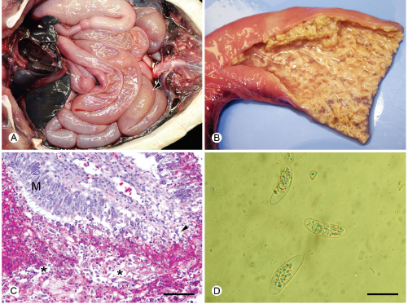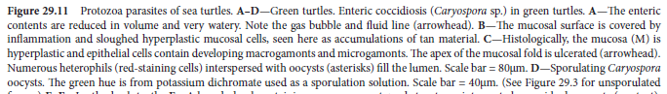

Stacy, B. A., Chapman, P. A., Stockdale-Walden, H., Work, T. M., Dagenais, J., Foley, A. M., ... & Rodriguez, M. (2019). Caryospora-like coccidia infecting green turtles (Chelonia mydas): an emerging disease with evidence of interoceanic dissemination. Frontiers in veterinary science, 6, 372.

Abstract: Protozoa morphologically consistent with Caryospora sp. are one of the few pathogens associated with episodic mass mortality events involving free-ranging sea turtles. Parasitism of green turtles (Chelonia mydas) by these coccidia and associated mortality was first reported in maricultured turtles in the Caribbean during the 1970s. Years later, epizootics affecting wild green turtles in Australia occurred in 1991 and 2014. The first clinical cases of Caryospora-like infections reported elsewhere in free-ranging turtles were from the southeastern US in 2012. Following these initial individual cases in this region, we documented an epizootic and mass mortality of green turtles along the Atlantic coast of southern Florida from November 2014 through April 2015 and continued to detect additional, sporadic cases in the southeastern US in subsequent years. No cases of coccidial disease were recorded in the southeastern US prior to 2012 despite clinical evaluation and necropsy of stranded sea turtles in this region since the 1980s, suggesting that the frequency of clinical coccidiosis has increased here. Moreover, we also recorded the first stranding associated with infection by a Caryospora-like organism in Hawai'i in 2018. To further characterize the coccidia, we sequenced part of the 18S ribosomal and mitochondrial cytochrome oxidase I genes of coccidia collected from 62 green turtles found in the southeastern US and from one green turtle found in Hawai'i. We also sequenced the ribosomal internal transcribed spacer regions from selected cases and compared all results with those obtained from Caryospora-like coccidia collected from green turtles found in Australia. Eight distinct genotypes were represented in green turtles from the southeastern US. One genotype predominated and was identical to that of coccidia collected from the green turtle found in Hawai'i. We also found a coccidian genotype in green turtles from Florida and Australia with identical 18S and mitochondrial sequences, and only slight inter-regional differences in the internal transcribed spacer 2. We found no evidence of geographical structuring based on phylogenetic analysis. Low genetic variability among the coccidia found in green turtle populations with minimal natural connectivity suggests recent interoceanic dissemination of these parasites, which could pose a risk to sea turtle populations.

- Introduction:
  - Caryospora – Coccidian parasides, family Eimeriidae.
    - Morphologid ID – sporulated oocysts with single sporocyst and 8 sporozoites.
    - Caryospora cheloniae first described 1970s, enterocolitis distal SI and colon with presence of coccidia in maricultured green hatchlings and juveniles.
    - Wild immature green turtles in Australia.
      - Extra-intestinal schizonts found in brain, thyroid,, kidney.
      - Meningoencephalitis.
    - Genetic characterization of the coccidia from 2014 Aus epizootic ID two genotypes based on partial sequencing of ribosomal 18S gene.
      - Absence of genetic data from original Caribbean epizootic.
  - In this paper they describe an epizootic in SW florida and results of genetic characterization and phylogenetic analysis.

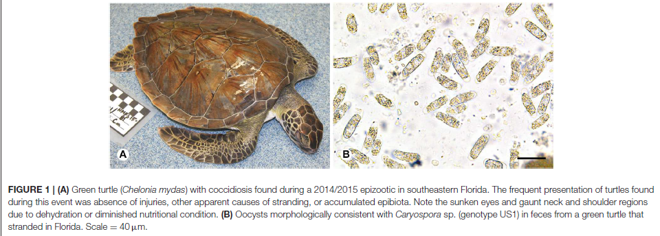
- Materials and Methods:
  - Dx CLO infection based on detection of oocysts in fecal or by histo.
  - Case criteria – Stranded turtles without traumatic injury or other external anomaly. Emaciated turtles excluded but dehydrated turtles included.
  - Did necropsy, genetic characterization and phylogenetic analysis from enteric contents or feces.
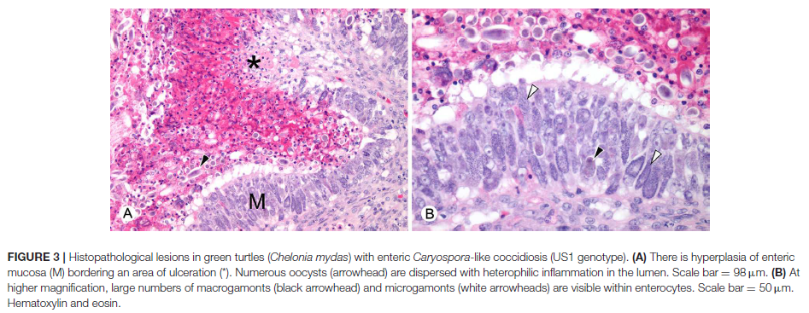

- Results/Discussion:
  - Necropsy lesions – Enterocolic lesions similar to previous.
    - Watery, straw-colored contents with gas formation, mucosal lesions with hyperplasia, ulceration in distal SI, floughing of mucosa.
    - Developing stages of coccidia numerous within enterocytes on histo in all areas of intestine.
    - No extra-intestinal coccidia found in brain or other major organs in all 31 cases.
  - CS – Lethargy, weakness, abnormal neurological signs including loss of coordination and abnormal head movements in conjunction with severe hypoglycemia. Neuro abnormalities attributed to hypoglycemia or biotoxicosis since coccidia were not seen in the brain on histo.
  - Genetic characterization
    - Inter and intraregional genetic variation among coccidia with oocysts that resemble previous description of C. cheloniae.
    - Found identical or highly similar genotypes in the Atlantic and Pacific green turtles.
    - These genotypes were found during epizootics involving green turtles in US and AUs.
    - At least three distinct clades in Eimeriidae called Caryospora.
    - Florida epizootic largely attributable to coccidia of a single genotype US1, also linked to the first case of enteric coccidiosis ID in HA.
    - Another coccidian genotype in two stranded green turtles in FL highly similar to one characterized during an Aus epizootic in 2014.
      - The findings indicate that pathogenic coccidia of sea turtles have undergone recent dissemination among ocean basins.
        - Spread could occur through transportation or migration of infected hosts or transport of oocysts.
        - IM hosts may also spread it, LC is unknown.
        - Anthropogenic transport of oocysts or infected IM hosts another possibility. Ballast water, etc.
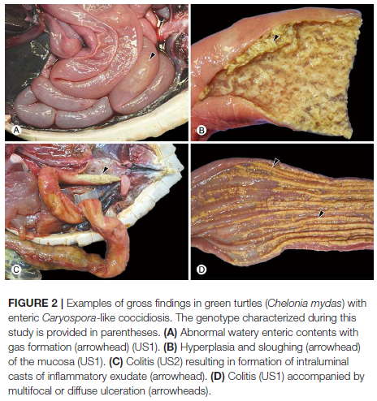

Wang et al. 2020. Detection and characterization of new coronavirus in bottlenose
dolphin, United States, 2019. Emerg Infec Dis 26:1610-1612.

- Coronaviruses divided into alpha, beta, gamma, and delta coronaviruses
- Cetacean coronavirus is a recently proposed new species in the genus Gammacoronavirus
- Cetacean coronavirus species contains bottlenose dolphin coronavirus (BdCoV) HKU22, identified in 2014, and beluga whale coronavirus (BWCoV) SW1, identified in 2008
- Four Atlantic bottlenose dolphins cared for by the US Navy Marine Mammal Program showed acute signs of GI upset
- Fecal samples collected, coronavirus PCR positive in all four samples
- Next gen sequencing performed
- These viruses are closely related to the other 2 known cetacean coronaviruses, Hong Kong BdCoV and beluga whale CoV
- A deletion in the spike gene and insertions in the membrane gene and untranslated regions were found in US BdCoVs (unrelated to severe acute respiratory syndrome coronavirus 2).

Dolphins in Navy program sickened by gammacoronavirus – JAVMA news
- A novel coronavirus sickened four U.S. Navy dolphins in spring 2019—acute onset diarrhea and anorexia
- Gammacoronavirus detected on fecal sample
- 3 sea lions in the same program developed similar illnesses at the same time, although tests on samples from those animals were negative
- All animal recovered with supportive care
- The virus is related to two other coronaviruses: beluga whale coronavirus SW1, identified in 2008, and bottlenose dolphin coronavirus HKU22, identified in 2014.

CRC Handbook of Marine Mammal Medicine, 3 rd ed., p. 341.

- Coronaviruses (CoVs) were detected during mortality investigations in captive harbor seals at an aquarium in Florida (Bossart and Schwartz 1990), and among free-ranging harbor seals along the coast of central California (Nollens et al. 2010). In cetaceans, CoVs were isolated from a captive beluga whale (Mihindukulasuriya et al. 2008), and from the feces of three Indo-Pacific bottlenose dolphins (Woo et al. 2014).
- Enveloped, positive-strand linear RNA viruses, with intracytoplasmic replication and large genomes
- Clinical signs variable and include sudden death, diarrhea, leukocytosis, electrolyte abnormalities
- Path: Infection was characterized by acute necrotizing enteritis and pulmonary edema in the captive harbor seals. The beluga whale had severe, multifocal, and coalescing centrilobular-to-massive acute hepatic necrosis
- IFA or RT-PCR for dx
- Birds are suspected to be the origin of these virsues but little is known at this time
- Non known zoonotic risk

Lactococcus garvieae: an emerging bacterial pathogen of fish
CM Meyburgh, RR Bragg, CE Boucher
Dis Aquat Organ. 2017 Feb 8;123(1):67-79.

Abstract: Lactococcus garvieae is the causative agent of lactococcosis, a hyperacute, haemorrhagic septicaemia of fish. This bacterium is also considered an emerging zoonotic pathogen, as reports of human infection are increasing. Significant economic loss in aquaculture is suffered as a result of lactococcosis, as numerous freshwater and marine species of commercial interest are affected. Development of antibiotic resistance in L. garvieae to several chemotherapeutic agents complicates and restricts treatment options. Effective, sustainable treatment and prevention options are thus needed, but progress is impeded by the lack of knowledge concerning several aspects of the disease and the pathogen. This review aims to present the latest research on L. garvieae, with specific focus on pathogenesis, virulence factors, risks associated with chemotherapeutic administration and possible control options.

- Lactococcus garvieae = Gram + facultative anaerobe cocci that produces ɑ and β hemolytic toxins
- Causes disease in marine aquaculture (esp in Japan) at water temp > 15 C
- Clinical signs: hyperacute infection with anorexia, melanosis, exophthalmia, coelomic distension from hemorrhage
- Necropsy: extensive hemorrhage on internal organs and external surfaces
- Affects a wide variety of species (e.g. eel, wrasse, tilapia, flounder, kingfish, trout, mullet, prawn, dolphin, octopus)
  - Zoonotic potential: Two reported cases of human infection from consumption of raw fish
- Isolate with same techniques as Streptococcus
- Treatment with lincomycin, tetracyclines, macrolides, but do it judiciously as antibiotic resistance has developed
  - Oral medication is difficult because fish are often anorexic
- Prevent with inactivated vaccination IP one month before bringing water temps > 15 C
- Virulence factors = hemolytic toxins + capsule formation + adhesion proteins + prophages

Conclusions: Lactococcus garvieae is a bacterial disease of marin aquaculture that causes acute hemorrhage and death.

Viral emergence in marine mammals in the North Pacific may be linked to Arctic sea ice reduction
VanWormer E et al. 2019. Sci Rep 9:15569
Abstract:
Climate change-driven alterations in Arctic environments can infuence habitat availability, species distributions and interactions, and the breeding, foraging, and health of marine mammals. Phocine distemper virus (PDV), which has caused extensive mortality in Atlantic seals, was confrmed in sea otters in the North Pacifc Ocean in 2004, raising the question of whether reductions in sea ice could increase contact between Arctic and sub-Arctic marine mammals and lead to viral transmission across the Arctic Ocean. Using data on PDV exposure and infection and animal movement in sympatric seal, sea lion, and sea otter species sampled in the North Pacifc Ocean from 2001–2016, we investigated the timing of PDV introduction, risk factors associated with PDV emergence, and patterns of transmission following introduction. We identifed widespread exposure to and infection with PDV across the North Pacifc Ocean beginning in 2003 with a second peak of PDV exposure and infection in 2009; viral transmission across sympatric marine mammal species; and association of PDV exposure and infection with reductions in Arctic sea ice extent. Peaks of PDV exposure and infection following 2003 may refect additional viral introductions among the diverse marine mammals in the North Pacifc Ocean linked to change in Arctic sea ice extent.
Summary:
- Reduction in sea ice may change animal behavior and interactions altering disease transmission
- Methods
  - serology on marine mammals for phocine distemper virus
  - PDV seroprevalence and prevalence of viral infection (PCR) calculated
- serologic, PCR, and sequencing results show evidence for:
  - widespread exposure and infection with PDV across North Pacifc Ocean beginning in 2003
  - viral transmission across multiple marine mammal species
  - decline of viral infections following peaks of exposure in 2003 and 2009, with sporadic detection of PCR positive animals from 2005–2008 and 2011–2016
- increased PDV exposure and infection followed reductions in Arctic sea ice extent and presence of open water route along Russia
- cross-species transmission resulting in PDV circulation among ice-associated seals, Steller sea lions, northern fur seals, and northern sea otters might also result in peaks of infection
- exposed animals can carry PDV long distances

CRC Handbook of Marine Mammal Medicine, 3rd ed., pp. 333-337
- Morbilliviruses
  - enveloped negative sense single-stranded RNA viruses
  - intracytoplasmic replication
  - ex- canine distemper virus, phocine distemper virus, cetacean morbillivirus
  - signs
    - dolphins
      - rarely observed alive
      - tremors, poor nutritional state, high ectoparasites and epibionts burden
    - phocids
      - pyrexia, serous or mucopurulent ocular and nasal discharges, coughing, mucosal cyanosis, dyspnea, impaired swimming/diving due to interstitial pulmonary and subcutaneous emphysema
      - pressure necrosis lesions and high ectoparasite burdens from prolonged land time
      - hyperkeratotic dermatitis may be present
      - neurological signs - depression, lethargy, head tremors, convulsions, and seizures
      - pregnant females may abort
  - treatment – supportive
  - CeMV – no vaccine
  - CDV - attenuated, inactivated, and subunit vaccines used in phocids
    - vaccination program in free-ranging Hawaiian monk seals
      - seroconversion and no side effects of vaccination
  - pathogenesis
    - predilection for lymphocytes, epithelial cells, and neurons
    - replication in lymphoid organs can result in immunosuppression
    - eosinophilic intracytoplasmic and intranuclear inclusion bodies in skin, GI tract, respiratory tract, urogenital tract, or CNS
    - acute vs chronic
      - acute - death from diffuse interstitial pneumonia and emphysema
      - chronic – death from secondary infection, septicemia
      - Cetaceans that resolved systemic DMV may develop chronic nonsuppurative encephalitis
    - difference between phocids and odontocetes - pneumonia in phocids results in severe interstitial emphysema tracking to fascia of thorax and neck with resultant inability to dive
  - diagnosis
    - gold standard - virus isolation and sequencing
    - presence of characteristic gross and histologic lesions and positive IHC
  - transmission
    - shed in ocular, nasal, oral, or preputial secretions, shed epidermis, urine, feces
    - predominant route of horizontal transmission likely respiratory
    - vertical transmission – rare
- CDV
  - epidemics among Baikal seals, Caspian seals
- PDV
  - most susceptible - North Atlantic harbor seals
  - less susceptible - gray, harp, and hooded seals
- walruses not susceptible to morbilliviruses
- Otariidae (sea lions and fur seals) may not be susceptible
- CeMV
  - harbor porpoises, striped dolphin outbreaks
  - infection in wide range of odontocetes and some mysticetes
- Florida manatee - only sirenian in which morbillivirus documented but no mortality

Terio. Pathology of Wildlife and Zoo Animals, pp. 578-579
- Morbilliviruses
  - CDV
  - PDV
    - Signs - oculonasal discharge, conjunctivitis, keratitis, coughing, dyspnea, diarrhea, abortion, head tremors, convulsions, and increased buoyancy
    - Lesions - bronchointerstitial pneumonia, pulmonary atelectasis, congestion, and edema, pulmonary, mediastinal and subcutaneous emphysema, nonsuppurative encephalitis, and lymphocyte depletion in lymphoid tissue
    - intracytoplasmic and intranuclear eosinophilic inclusion bodies
    - viral-induced immunosuppression - often associated with secondary parasitic (pulmonary nematodiasis), bacterial (Bordetella bronchiseptica), concurrent viral infections (Herpesvirus, Influenza)
    - diagnosis – IHC, RT-PCR
      - serology - assessment of exposure and susceptibility
  - most commonly transmitted through respiratory, nasal, or ocular secretions
- Influenza A
  - Harbor seal mortality events
  - H4N6 and H3N3
  - Signs - dyspnea, nasal discharge, lethargy, emphysema, similar to PDV
  - Lesions - partially collapsed lungs, pulmonary congestion, necrotizing bronchitis and bronchiolitis, hemorrhagic alveolitis, bronchial gland adenitis, and occasionally interstitial pneumonia
  - Diagnosis
    - IHC, ELISA
    - RT-PCR – lung and throat swabs

Coelomic Fluid Evaluation in Pisaster ochraceus Affected by Sea Star Wasting Syndrome: Evidence of Osmodysregulation, Calcium Homeostasis Derangement, and Coelomocyte Responses
Sarah J. Wahltinez, Alisa L. Newton, Craig A. Harms, Lesanna L. Lahner and Nicole I. Stacy
Front Vet Sci. 2020;7:131

Abstract: Sea Star Wasting Syndrome (SSWS) is one of the largest marine wildlife die-offs ever recorded, killing millions of sea stars from more than 20 Asteroid species from Alaska to Mexico from 2013 to 2015 from yet undetermined cause(s). Coelomic fluid surrounds the sea star's organs, playing critical roles in numerous systemic processes, including nutrient transportation and immune functions. Coelomocytes, which are cellular components of coelomic fluid and considered functionally equivalent to vertebrate leukocytes, are responsible for innate cell-mediated immunity. The objectives of this study were to (1) evaluate changes in coelomic fluid chemistry, coelomocyte counts, and cytology from ochre sea stars (Pisaster ochraceus) (n = 55) with clinical signs consistent with SSWS at varying intensity (SSWS score 1: n = 4, score 2: n = 2, score 3: n = 3, score 4: n = 18, score 5: n = 26) in comparison to coelomic fluid from clinically normal sea stars (n = 26) and to (2) correlate SSWS score with cellular and biochemical analytes. SSWS-affected sea stars had wider ranges of all electrolytes, except calcium; statistically significantly higher chloride, osmolality, and total protein; lower calcium; and higher coelomocyte counts when compared to clinically normal sea stars maintained under identical environmental conditions. Free and/or phagocytized bacteria were noted in 29% (16 of 55) coelomic fluid samples from SSWS-affected sea stars but were absent in clinically normal sea stars. SSWS score correlated significantly with increasing chloride concentration, osmolality, and coelomocyte counts. These chemistry and cytological findings in coelomic fluid of SSWS-affected sea stars provide insight into the pathophysiology of SSWS as these results suggest osmo- and calcium dysregulation, coelomocyte responses, and presumptive opportunistic bacterial infection in SSWS-affected sea stars. This information provides potential future research applications for the development of treatment strategies for sea stars in managed care and for understanding the complexity of various biochemical and cellular pathophysiological mechanisms involved in sea star wasting.

Background:
- Sea Star Wasting Syndrome (disease) (SSWS) – mass mortalities from Alaska to Mexico
  - Ochre sea star, keystone species, heavily affected - causes large scale, complex effects on marine invertebrate population dynamics along Pacific coast
  - Behavioral changes: abnormally curled rays and inability to grasp substrate
  - Progresses to white epidermal lesions, ray autotomy, loss of turgor (deflation), loss of structural integrity, disintegration and death within days.
  - Histo: epidermal degeneration, necrosis, ulceration, dermal separation, and inflammation
- No etiologic agent identified yet
  - Associations with densovirus, novel circular DNA virus, increasing temperatures, decreasing temperatures (no association with temp in 20 year data analysis)
- Osmoconformers: equilibrate inorganic ions with seawater within 24 hours
- Isoionic: capable of minimally maintaining ionic homeostasis with sea water for potassium and calcium
  - Mechanism for regulating coelomic fluid volume is not known

Key points:
- Wild caught ochre sea stars from Puget Sound (days to weeks before study), all clinically normal at collection but considered infected due to area of collection. All showed signs of SSWS under care.
  - Compared to clinically normal sea stars maintained at aquarium
- Coelomic fluid from perivisceral coelomic cavity from distal tip of ray on aboral surface, 1 ml/sea star
- Higher n of higher score cohorts (more progressed disease) reflects rapid disease progression and severity
- Diseased sea stars had wider ranges of all chem analytes except calcium, and wider ranges of electrolytes.
  - Higher chloride, total protein, and osmolality
  - Lower calcium
- Highly variable coelomocyte counts
  - Higher in diseased but some diseased of varying SSWS scores had 0/uL
  - No difference in cell counts between EDTA or heparin formalin preps
- Majority coelomocytes were mononuclear phagocyte morphotype in diseased and normal
  - Salt crystals found in diseased and normal
  - Bacterial likely secondary infection
    - Enrofloxacin reaches therapeutic levels with intracoelomic injection
  - Basophilic and proteinaceous material and cholesterol crystals likely due to apoptosis or necrosis
- SSWS score significantly correlated with higher chloride, coelomocytes, and osmolality
  - Low sample size for osmolality

Conclusions:
- Osmodysregulation (higher osmolality)
- Calcium dysregulation (lower calcium)
- Coelomocyte response
- Presumptive opportunistic bacterial infection
- SSWS score correlated significantly with chloride, osmolality, and coelomocyte counts

https://marine.ucsc.edu/data-products/sea-star-wasting/
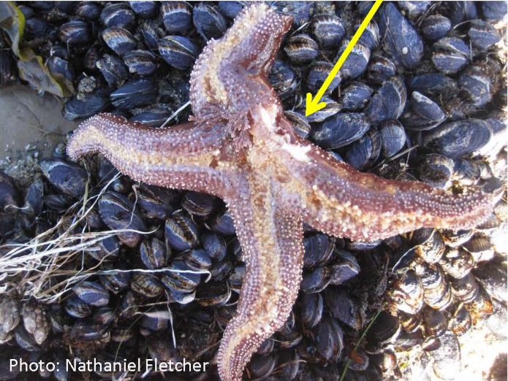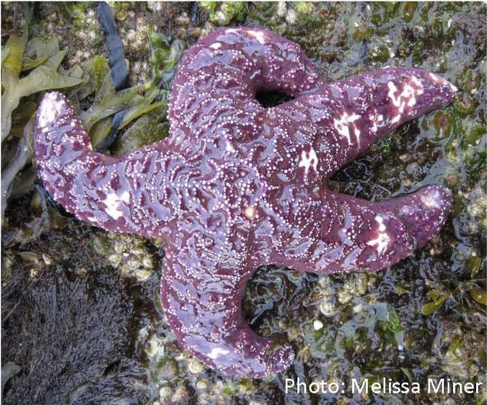

Disease epidemic and a marine heat wave are associated with the continental-scale collapse of a pivotal predator (Pycnopodia helianthoides)
C. D. Harvell, D. Montecino-Latorre, J. M. Caldwell, J. M. Burt, K. Bosley, A. Keller, S. F. Heron, A. K. Salomon, L. Lee, O. Pontier, C. Pattengill-Semmens, J. K. Gaydos
Sci Adv. 2019;5(1):eaau7042

Multihost infectious disease outbreaks have endangered wildlife, causing extinction of frogs and endemic birds, and widespread declines of bats, corals, and abalone. Since 2013, a sea star wasting disease has affected >20 sea star species from Mexico to Alaska. The common, predatory sunflower star (Pycnopodia helianthoides), shown to be highly susceptible to sea star wasting disease, has been extirpated across most of its range. Diver surveys conducted in shallow nearshore waters (n = 10,956; 2006–2017) from California to Alaska and deep offshore (55 to 1280 m) trawl surveys from California to Washington (n = 8968; 2004–2016) reveal 80 to 100% declines across a ~3000-km range. Furthermore, timing of peak declines in nearshore waters coincided with anomalously warm sea surface temperatures. The rapid, widespread decline of this pivotal subtidal predator threatens its persistence and may have large ecosystem-level consequences.

Background
- Sea Star Wasting Disease (SSWD) massive mortality Mexico to Alaska: Northeast Pacific SSWD event.
  - Trophic cascade, increased density of urchin populations, kelp rapidly diminished
- Progressive dermal lesions, arms detached from central disc, gonads spilled from fully reproductive stars, and death leaving white piles of ossicles and disconnected limbs
- Links to sea star-associated densovirus (SSaDV; family Parvoviridae)
  - Possible reservoir species: asymptomatic star species within P helianthoides range have tested positive for SSaDV genetic metaerial
- Increasingly warm/anomalous temps influence prevalence and severity of marine infectious diseases
  - Warmer temps, higher risk of infection and progression to mortality in Pisaster ochraceus
  - Infected stars exposed to warmer temperatures died at a faster rate
  - High water temps associated with lower coelomic fluid volumes, higher metabolic demands, metabolic stress in asteroids
- No relations between pre-outbreak P. ochraceus density and degree of population decline

Key Points
- Pre- and post-outbreak data 2004-2017
- Investigated P. helianthoides in shallow nearshore and deep offshore waters from Ca to British Columbia
- Correlated anomalously high temperatures with precipitous declines in biomass in nearshore waters
  - Accounted for 38% of variance in abundance categories
  - For every 1 degree C increase in maximum temperature anomaly, expect 6% increase in odds of observing low abundance category
  - Mortality still occurred at high levels in colder temps of British Columbia

Conclusions
- Rapid collapse along most of P. helianthoides range and at all depths
  - Confirms no deep-water refuge for this species
- Negative association detected between P. helianthoides abundance and anomalously warm sea surface temperature (SST)

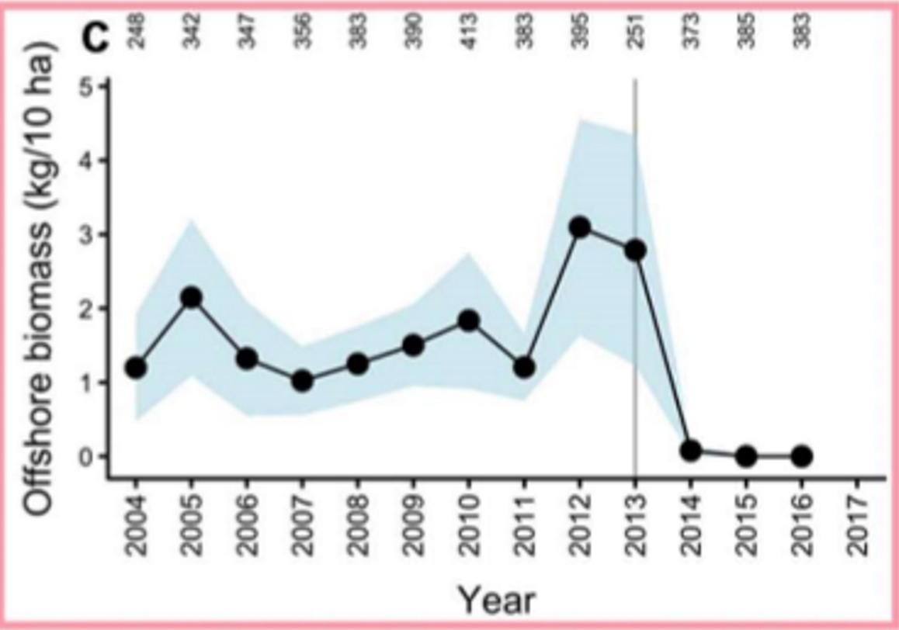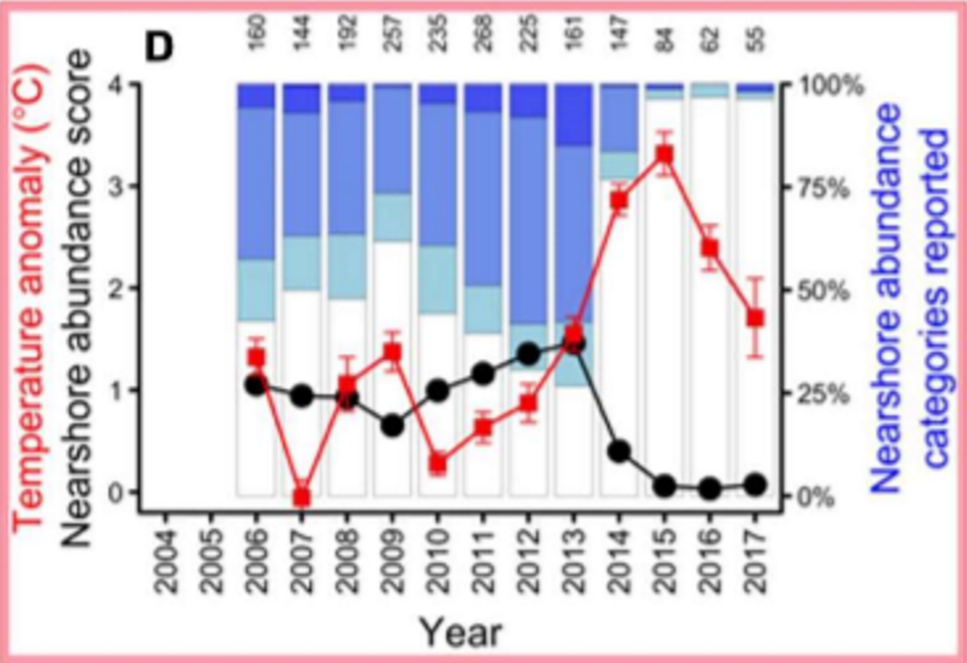
Ex. California: decline in biomass, decline in abdundance score with concurrent spike in temperature anomaly.

