Bradford, C., & Eschenbrenner, M. (2017). Health survey including selected blood parameters in the african slender snouted crocodile (mecistops cataphractus) at the abidjan zoo in côte d'ivoire. Journal of Zoo and Wildlife Medicine, 48(2), 510-513.

Abstract: The Zoo National d'Abidjan (Abidjan Zoo) in Côte d'Ivoire, West Africa, holds the world's largest captive population of African slender-snouted crocodiles (Mecistops cataphractus, formerly Crocodylus cataphractus), at 36 adults, 16 yearlings, and 23 hatchlings. Twelve yearling and 12 adult slender-snouted crocodiles at the Abidjan Zoo were restrained for physical exam, body condition scoring, and venipuncture in September 2015. Blood samples collected from the supravertebral venous sinus were analyzed using a handheld blood analyzer (Abaxis® I-stat, Abaxis, Inc., Union City, California 94587, USA) with Chem8 cartridges (CLIAwaived, Inc., San Diego, California 92130, USA). The adult crocodiles appeared in good general health and demonstrated blood values similar to those of other reptiles. The yearlings had low, ionized calcium values and low hematocrit and hemoglobin levels compared with the adult crocodiles and to other crocodile reference ranges. These findings may dramatically improve the health of the crocodiles and help to ensure a thriving captive population of this critically endangered species.
- Key Points:
  - African slender-snouted crocodile – Critically endangered.
    - Shy, reclusive, specialized diet – fish and small prey items.
    - Aibidjan Zoo raises them to be released around 3-4 ys old.
    - Adults fed whole fish.
    - Yearlings fed filets, no bone/organ meats.
  - Yearlings lower mean ionized Ca, low HCT, and low Hgb vs adults and vs previously reported values (not specific to this species).
  - One juvenile – Weakness, tetany may have been due to hypocalcemia or other conditions such as trauma, hypovitaminosis B or D, hypoglycemia, electrolyge imbalance, or congenital or developmental disorders.
  - Crocodilians lack sex chromosomes; temp dependent sexual determination.
    - Females at LOWER temp ranges (28-30C).
    - Predominance of MALES at MIDRANGE temps (31-33C).
    - Females at HIGH temp ranges (33-34C).
  - Low HCT/Hgb may be due to trauma, septicemia, parasitemia, toxemia, infectious agents, chronic disease, or chemicals etc.
  - Low Ca possibly due to dietary insufficiency (not eating bones).
  - Lymph or CSF contamination possible due to smaller size in yearlings.
INTRAMUSCULAR EPINEPHRINE RESULTS IN REDUCED ANESTHETIC RECOVERY TIME IN AMERICAN ALLIGATORS (ALLIGATOR MISSISSIPPIENSIS) UNDERGOING ISOFLURANE ANESTHESIA

JZWM 2017 48(1) 55–61

Abstract: Inhalants are commonly used to anesthetize reptiles, but volatile anesthetics have been associated with prolonged recovery times. The objective of this study was to determine the effects of intramuscular (IM) epinephrine on anesthetic recovery times following isoflurane anesthesia in a population of subadult American alligators (Alligator mississippiensis). In this prospective randomized crossover study, five clinically healthy alligators were anesthetized for 90 min with the use of isoflurane. Alligators were randomly assigned into one of two treatment groups: Group E received IM epinephrine (0.1 mg/kg), and Group S received an equal volume of 0.9% saline administered after isoflurane was discontinued. Time from the end of inhalant administration to return of spontaneous ventilation, return of the palpebral reflex, movement in response to a standardized toe pinch, and spontaneous movement was recorded. The time of extubation was noted and occurred following the return of spontaneous ventilation and movement. Pulse rate, surface body temperature, and airway gases including expiratory and inspiratory isoflurane concentrations and end-tidal carbon dioxide were measured every 5 min throughout the study. The time from the end of anesthesia to extubation was significantly faster in Group E (51.2 ± 16.7 min) compared to Group S (107.4 ± 43.7 min). Pulse rate was significantly higher within the first 15 min following epinephrine injection compared to the saline group at these time points. Therefore, IM epinephrine administered at the end of general anesthesia can significantly hasten anesthetic recovery from isoflurane in alligators.

Intro:
- Crocodilian cardiac anatomy and physiology
  - 4 chambered heart
    - Allows different ventricular pressures to be generated between systemic and pulmonary circulations
  - Right to left shunting (adaption for prolonged apnea) occurs via:
    - Foramen of Panizza – between right and left aortic arches at base
    - Distal abdominal aortic anastomosis
  - Subpulmonary conus
    - located proximal to pulmonary valve within right ventricular outflow tract
    - contains cog-teeth valve – regulates degree of pulmonary to systemic shunting
- Epinephrine – increases HR, myocardial contractility, myocardial oxygen consumption, inhibits pulmonary to systemic shunting by increasing resistance of flow through foramen of Panizza
- Inhalant clearance – depends on solubility of agent (sevo less soluble than iso), CO, PP gradient between pulmonary vasculature and lung unit
- Non-avian reptiles have lower cardiac index compared to mammals – decreases amount of anesthetic rich blood entering lungs for elimination

Methods:
- Alligators anesthetized with isoflurane and received either epinephrine 0.1mg/kg or saline IM on recovery
- Time from end of inhalant to return of spontaneous ventilation, return of palpebral reflex, movement in response to toe pinch, and spontaneous movement recorded

Results/discussion:
- Epi group:
  - faster time to extubation
  - regained spontaneous movement more quickly
  - heart rate higher 5-15 minutes after epi admin
- Epinephrine reduces recovery time in anesthetized alligators
- IM epinephrine 0.1 mg/kg significantly hastens extubation time following isoflurane anesthesia in subadult American alligators

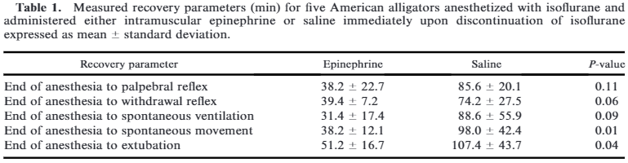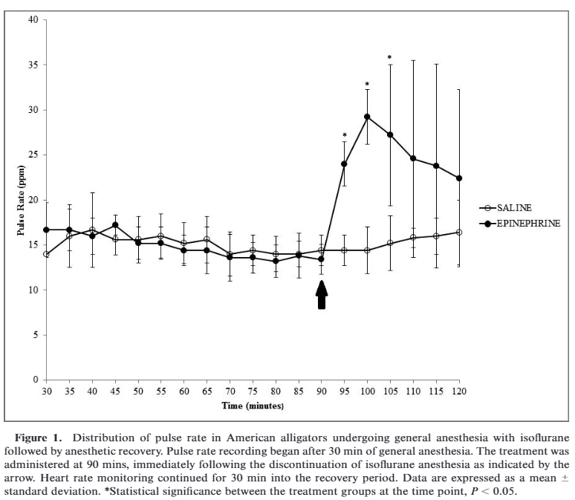

DiGeronimo, Peter M., et al. "Effects of plant protein diets on the health of farmed American alligators (Alligator mississippiensis)." Journal of Zoo and Wildlife Medicine 48.1 (2017): 131-135.

Abstract: The objective of this prospective, blinded study was to compare plasma biochemical values and gross and histologic evaluation of kidney and liver from American alligators (Alligator mississippiensis) fed extruded diets with protein derived from animal or plant sources. Alligators in two treatment groups were fed an extruded diet with protein derived primarily from plant products for 7 (n ¼20) or 10 (n ¼20) mo prior to harvest. A control group (n¼20) was fed a commercial diet with protein derived from animal products for the duration of the study. Plasma biochemistry panels were obtained and gross and histologic examination of kidney and liver tissues was conducted for each animal. No differences were found between alligators fed diets with animal or plant protein in terms of either biochemistry profiles or gross or histologic examination of kidney and liver. Plant-based diets, fed for up to 10 mo, do not appear to have any ill effects on the kidney or liver of American alligators.

INTRO
- Typical commercial alligator diets are animal based, high in protein
- Plant based alternatives are more economical and ecologically friendly
- Objective: To compare plasma biochemical values and gross and histologic evaluation of kidney and liver from American alligators (Alligator mississippiensis) fed extruded diets with protein derived from animal or plant sources
M&M
- Alligators in two treatment groups were fed an extruded diet with protein derived primarily from plant products for 7 (n =20) or 10 (n =20) mo prior to harvest. A control group (n=20) was fed a commercial diet with protein derived from animal products for the duration of the study
- Plasma biochemistry panels were obtained and gross and histologic examination of kidney and liver tissues was conducted for each animal
RESULTS
- No differences were found between alligators fed diets with animal or plant protein in terms of either biochemistry profiles or gross or histologic examination of kidney and liver.
DISCUSSION
- Biochemistry profiles and postmortem evaluations showed no evidence of acute negative health effects or of subclinical pathology after a 10-mo feeding period with a plant based diet
- Although no differences in uric acid levels were found between control and experimental groups, plasma ammonia concentrations were not tested for
  - both are produced by alligators as a byproduct of protein metabolism
  - However, no evidence of renal disease observed so unlikely to have been elevated
- Possible that adverse effects may occur with a longer duration of feeding

MYCOTIC DERMATITIS IN JUVENILE FRESHWATER CROCODILES (CROCODYLUS JOHNSTONI) CAUSED BY NANNIZZIOPSIS CROCODILI.
Hill AG, Sandy JR, Begg A.
J Zoo Wildl Med. 2019 Mar 1;50(1):225-230.

Taxa: Reptilia → Crocodilia → Crocodylidae
Abstract: Nannizziopsis crocodili, a contagious, keratinophilic fungus, was identified from biopsied tissue in a captive juvenile freshwater crocodile during an outbreak of severe multifocal dermatitis affecting four of five crocodiles. Lesions progressed from superficial, well-demarcated ulceration of scales, to black pigmentation, localized edema, erythema, and flattening of the scales. Treatment with topical enilconazole provided clinical improvement in three of four crocodiles but all developed terminal gout. One crocodile did not develop clinical disease despite long-term exposure. This is the first report of N. crocodili in freshwater crocodiles and in a location remote to the index Australian case.

Background:
- Nannizziopsis crocodili is a contagious keratinophilic ascomycetous fungus
  - Often progresses to systemic and fatal fungal disease
- First reported in outbreak in commercially-reared saltwater crocodiles in 1990s
  - Multifocal lichenification on the head, ventral mandible, limbs, and abdomen → death
- Successful treatment regiments
  - Systemic voriconazole for Nannizziopsis vriesii in bearded dragons
  - Topical betadine and in-water formaldehyde for Nannizziopsis in saltwater crocodiles

Cases: Juvenile freshwater crocodiles (n=4) developed multifocal grey-to-black pigmentation of scales
- Progressed to loss of scale definition, ulceration, desquamation, and erythema
- Diagnosed Nannizziopsis crocodili with PCR skin biopsy; unsuccessful culture
- Topical enilconazole improved dermal lesions, but 3/4 crocodiles died with gout
- A co-housed conspecific remained unaffected

Conclusions: Nannizziopsis crocodili caused multifocal dermatitis in freshwater crocodiles; treatment with topical enilconazole was associated with fatal gout.
