Question:
What is the characteristic gross lesion associated with both infectious myonecrosis (IMN) virus and microsporidiosis in decapods? Describe the major difference between the lesions histologically.

Gross lesion - enlarged, pale muscle, sometimes described as resembling ‘‘cooked meat’’
Histo lesions:
- Microsporidiosis - very little tissue reaction or inflammation
- IMN virus - coagulative myonecrosis and hemocytic infiltration in acute phase, fibrosis in chronic stages

2-PHENOXYETHANOL (2-PE) AND TRICAINE METHANESULFONATE (MS-222) IMMERSION ANESTHESIA OF AMERICAN HORSESHOE CRABS (LIMULUS POLYPHEMUS).
Archibald KE, Scott GN, Bailey KM, Harms CA.
J Zoo Wildl Med. 2019 Apr;50(1):96-106

Which of the following parameters were unchanged with 2-phenoxyethanol anesthesia of horseshoe crabs?
- Gilling rate
- Heart contractility
- Blood pressure
- pCO2
- Heart rate

Histologic Findings in Captive American Horseshoe Crabs (Limulus polyphemus)
Elise E. B. LaDouceur, Lisa Mangus, Michael M. Garner, and Andrew N. Cartoceti
Veterinary Pathology 2019;56(6):932-939

Describe this structure and its significance in the hepatopancreas of an American horseshoe crab.
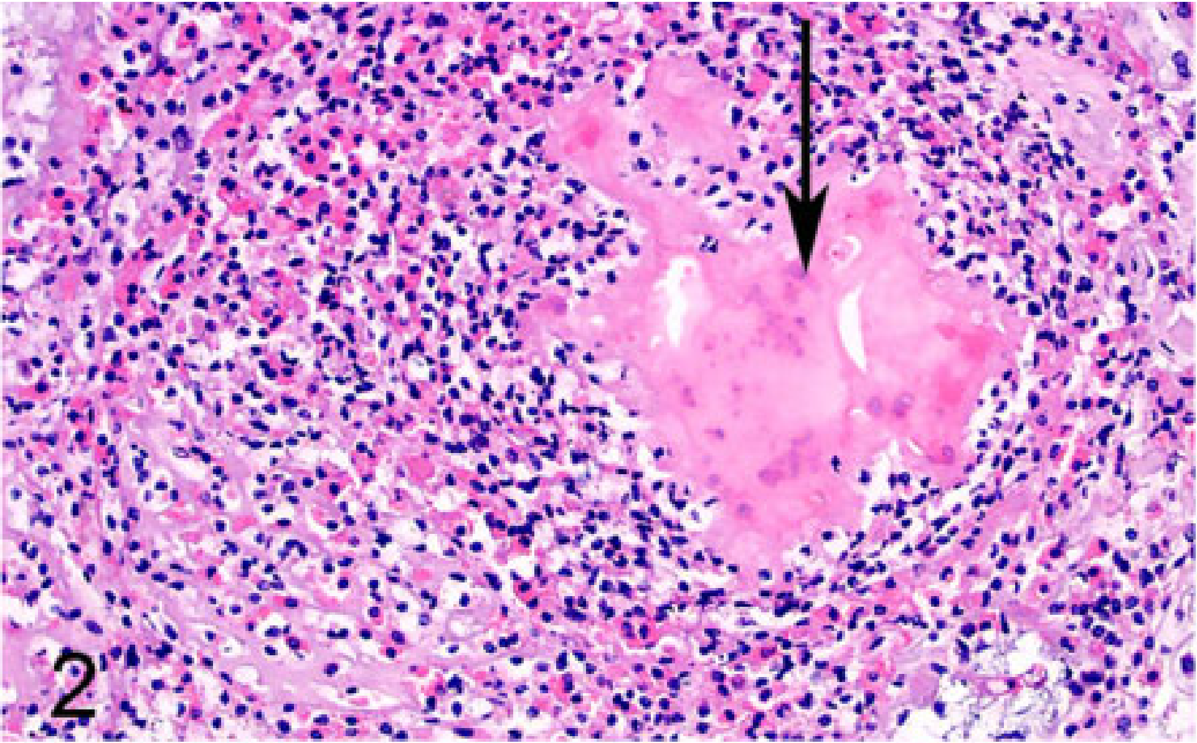

Hemocyte coagulum: hemocytes, coagulin, necrotic cellular debris. This is an inflammatory response, likely to an infectious agent (most common with inflammation in the hepatopancreas is bacterial > fungal). Encysted parasites are truly the most common infectious agent found in the hepatopancreas but often are easily appreciated on H&E stain and only variably have an associated inflammatory response.

Ex. 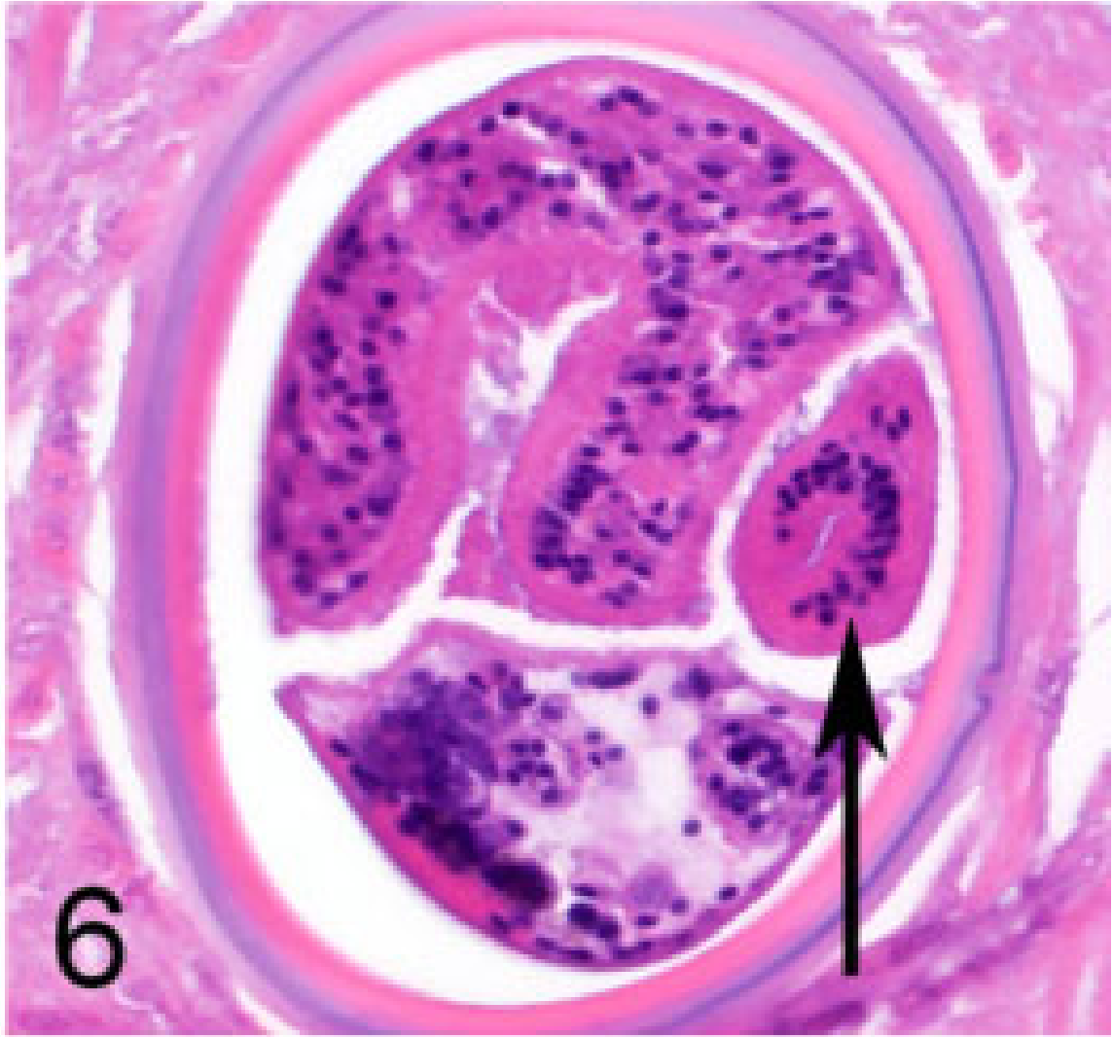

Doerr, M., & Stoskopf, M. K. (2019). Evaluation of euthanasia of moon jellyfish (Aurelia aurita) using simple salt solutions. Journal of Zoo and Wildlife Medicine, 50(1), 123-126.

Abstract: Immersion euthanasia methods reported over the most recent decades for aquatic invertebrates use organic alcohols or halogenated hydrocarbons that can interfere with nuclear magnetic resonance (NMR) analysis. A rolling study design evaluated potassium chloride (KCl), magnesium chloride (MgCl2), and magnesium sulfate (MgSO4) as potential ion-based euthanasia methods for moon jellyfish (Aurelia aurita) destined for metabolomic analysis by NMR spectroscopy. Death was defined as the cessation of autonomous bell pulsing and response to external stimulus. MgCl2 applied at a dose of 142 g/L provided euthanasia within 32 sec of applications without the untoward effects observed with the other two salts. Euthanasia with KCl at the doses tested was associated with abnormal behavior and tissue degradation during dissection. MgSO4 at the doses tested resulted in abnormal behavior and failed to provide rapid euthanasia.

Question:
Which of the following solutions is preferred for humane euthanasia of moon jellyfish (Aurelia aurita) to minimize interference with nuclear magnetic resonance (NMR) analysis of tissues following euthanasia?
- KCl
- MgSO4
- Eugenol
- MgCl2
- Pentobarbital
Ans: D – MgCl2 provides rapid euthanasia without eliciting abnormal behavior and suspected distress, does not interfere with NMR analysis.

KCl is associated with abnormal behavior and tissue degradation during dissection.
MgSO4 resulted in abnormal behavior and failed to provide rapid euthanasia.

A recent study evaluating the effects of oxygen and isoflurane on blood gas values in two species of scorpions found which of the following?

a. pO2 was higher for oxygen alone than for oxygen with isoflurane
b. There were no significant differences in baseline blood gas values between species
c. Hemolymph pH decreased significantly in oxygen compared to room air and isoflurane
d. There were no significant differences in induction time between species
e. Hemolymph bicarbonate decreased significantly in isoflurane compared to oxygen and room air

Answer: C

