MICROSPORIDIOSIS IN PEPPERMINT SHRIMP (DECAPODA: HIPPOLYTIDAE: LYSMATA SPP.)

Elise E.B. LaDouceur, D.V.M., Dipl. A.C.V.P. and Brian G. Murphy, D.V.M., Ph.D., Dipl. A.C.V.P.

Journal of Zoo and Wildlife Medicine 2017 48(4):1223-1229

Abstract: Microsporidia are a diverse, parasitic phylum closely related to fungi. They infect a broad range of host species and tissues. This report describes microsporidiosis infection in a captive, wild-caught peppermint shrimp (Lysmata spp.). The animal was found dead in its enclosure approximately 5 days after molting. Grossly, the skeletal musculature was diffusely swollen, opaque, and pale tan to white. Histologically, skeletal myofibers were replaced by large aggregates of sporophorous vesicles containing up to eight spores and earlier stages of sporogony. Tissue inflammation was minimal. Spores had positive staining with Luna's, Giemsa, Fites acid fast, and Brown and Brenn Gram stains. Ultrastructurally, spores were ovoid with an exo- and endospore, lamellar polaroplast, and polar tube arranged in 9 to 14 basilar, bilayered coils with a straight, apical manubrium. Spores and earlier stages of sporogony were contained within sporophorous vesicles. This is the first report of microsporidiosis in a shrimp from the family Hippolytidae.

Intro:
- Microsporidia = diverse parasitic phylum recently classified as fungal-related taxon
- broad or narrow host range
- transmitted via ingestion
- some may require intermediate hosts
- obligate intracellular (depend on cell mitochondria)
- spores invade host, lifecycle in cell, form microsporidia
- Peppermint shrimp= small, benthic, common in marine aquaria
- transmission generally by host death and release of spores

Case:
- Wild-caught from Caribbean sea, private aquaria, died in 5 days
- gross exam - markedly swollen, opaque, pale-tan muscle
- Histo - all myofibers distended by dense aggregates of intracellular oganisms in two forms: mature spores and early stages of sporogeny. No inflammatory response.
- Morphology identified microsporidian as Thelohania or Agmasoma spp.
- PCR unsuccessful

Discussion:
- first report of microsporidiosis in a peppermint shrimp
- characteristic gross lesion - enlarged, pale muscle, sometimes described as resembling ‘‘cooked meat’’
  - microsporidiosis causes very little tissue reaction or inflammation
- DDX gross findings in shrimp - infectious myonecrosis (IMN) virus
  - coagulative myonecrosis and hemocytic infiltration in acute phase, fibrosis in chronic stages
- Gram stain recommended for diagnosis/visualization of microsporidiosis
  - most effective stain with greatest contrast between organism and surrounding tissue
- Impression smears recommended for speciation (all spores will be visible vs. histo section)

2-PHENOXYETHANOL (2-PE) AND TRICAINE METHANESULFONATE (MS-222) IMMERSION ANESTHESIA OF AMERICAN HORSESHOE CRABS (LIMULUS POLYPHEMUS).
Archibald KE, Scott GN, Bailey KM, Harms CA.
J Zoo Wildl Med. 2019 Apr;50(1):96-106

Taxa: Arthropoda (phylum) → Euchelicerata (class) → Xiphosurida (order) → Limulidae (family)
Abstract: Despite extensive literature examining American horseshoe crab physiology, there are comparatively few publications addressing their medical care. Establishing anesthesia protocols for horseshoe crabs is integral to limiting the potential stress and pain associated with invasive procedures and for advancing euthanasia techniques. The objective of this study was to compare the effects of two immersion anesthetics, tricaine methanesulfonate (MS-222) at 1 g/L (buffered with sodium carbonate) and 2-phenoxyethanol (2-PE) at 2 mL/L, on horseshoe crabs. Twenty horseshoe crabs were assigned to one of two anesthetic treatment groups and individually anesthetized in natural seawater. Water quality, cardiac contractility, and hemolymph gas analytes were measured prior to anesthesia and at 30 min Animals were monitored via heart rate, gilling rate, and sedation score every 5 min until recovered. Transcarapacial ultrasonography was used to obtain heart rate, gilling rate, and percent fractional shortening. Light or surgical anesthesia was produced in 10/10 animals in the 2-PE group and 8/10 animals in the MS-222 group. There was no significant difference in sedation scores, induction time (median 15 min), or recovery time (median 20.5 min). Gilling rate and cardiac contractility decreased during anesthesia, whereas heart rate did not. Hemolymph pH and pO2 were not different among treatment groups or time points. Baseline pCO2 was higher than pCO2 at 30 min for both groups but significantly elevated only in the MS-222 group. This is attributed to increased activity during the handling of awake animals. Invasive blood pressure obtained via cardiac catheterization in two animals was markedly decreased during surgical anesthesia. In conclusion, 2-PE and MS-222 provided effective anesthesia with clinically useful induction and recovery times. 2-PE provided a subjectively more reliable and smoother anesthesia compared to MS-222.

Background:
- Horseshoe crabs are osmoconfomers (osmolality matches surroundings)
- Horseshoe crabs respond to hypoxia with a decreased blood pressure, heart rate, and gilling rate
- Hemocyanin is the extracellular oxygen-carrying molecule and holds only one oxygen
- MS-222 blocks voltage-gated sodium channels and is excreted by the gills
- The mechanism of 2-PE is unknown

Objective: Compare the effects of two immersion anesthetics, tricaine methanesulfonate (MS-222) at 1 g/L (buffered with sodium carbonate) and 2-phenoxyethanol (2-PE) at 2 mL/L, on horseshoe crabs.

Key Points:
- Surgical anesthesia produced in 9/10 2-PE crabs and 7/10 MS-222 crabs
- Parameters that decreased with both protocols: heart contractility, gilling rate, pCO2, blood pressure
- Parameters that did not change with both protocols: heart rate, pH, pO2

Conclusions: Immersion in 2-PE or MS-222 produced anesthesia in American HSCs with clinically useful induction and recovery times.
Histologic Findings in Captive American Horseshoe Crabs (Limulus polyphemus)
Elise E. B. LaDouceur, Lisa Mangus, Michael M. Garner, and Andrew N. Cartoceti
Veterinary Pathology 2019;56(6):932-939

Abstract: Histopathology of 61 captive American horseshoe crabs (HSCs; Limulus polyphemus) is reviewed. HSC organs evaluated histologically included body wall (chitin, epidermis, dermis, and skeletal muscle), hepatopancreas, gut, gonads, book gills, eyes, heart, brain, and coxal gland. In descending order, lesions were most frequently identified in compound eye, body wall, book gills, hepatopancreas, chitinous gut, nonchitinous gut, heart, and brain; lesions were not observed in coxal gland or gonads. Hemocytes (also called amoebocytes) surrounded infectious agents and occluded ulcers. Large hemocyte aggregates had a central eosinophilic coagulum (ie, hemocyte coagulum). Cutaneous ulceration (34/60 cases), branchitis (29/48 cases), and ophthalmitis (17/20 cases) were common lesions and consistently associated with fungi, which were invasive into subjacent tissues, and/or bacteria, which were usually superficial. Fungal culture was performed in 3 cases and isolated Fusarium spp., although fungal morphology varied and multiple fungal species may have been present. Presumptive green algae were associated with ulceration in 1 case with minimal to no inflammation. Presumptive cyanobacteria were identified within a biofilm overlying the gills in 4 of 48 cases and were not invasive. Multifocal, random hepatopancreatitis was identified in 16 of 57 cases, 10 of which were associated with bacteria. Metacercarial cysts were identified in 25 of 61 cases and associated with minimal to no inflammation. Depleted eosinophilic globules in hepatopancreatic interstitial cells were interpreted as decreased nutritional status in 12 of 57 cases.

Background
- Marine invertebrates, habitat east coast North America, migrate to deep waters in winter and shallow waters to spawn in late spring/early summer
- Used in biopharmaceuticals for endotoxin detecting enzyme limulase amebocyte lysate (LAL), in hemolymph collected from wild - causes 8-30% mortality.
- Inflammatory response: hemocyte coagulum (hemocytes, coagulin, necrotic cellular debris, rarely plump spindle cells in branchitis)

Key points
- Retrospective, reviewed path reports, slides
- Most common organs with lesions: compound eye and body wall (external organs, could be sampling bias)
- Most common infection: bacteria (G- rods most common)
- Fungal lesions appeared to be invasion in from external body wall or gill surface
  - Fungal: filamentous, septate hyphae, branching at acute angles
- Bacteria found in small foci throughout internal organs suggesting hemolymphatic spread
- Encysted parasites, metacercariae likely Microphallus limulus - in almost every organ including brain, variable inflammatory response
- Algae: (green or blue-green) highly pleomorphic, occasional septation, budding, internal structure
- Most common lesions
  - Hepatopancreas: inflammation associated with infectious agent (encysted parasites > bacteria > fungi)
  - Body wall: erosion (loss of epicuticle, often bacteria with no inflammation), parasitic cysts, ulceration (often fungal with significant inflammation), 1 case of invasive green algae, dysecdysis, myositis (3 cases bacteria, 1 amoeba)
  - Book gills: Inflammation, variably associated with infectious agents (bacteria > fungi > parasitic cysts), some mats of mixed infectious agents and parasites on the surface (biofilm mats), not associated with inflammation, often including blue-green algae (possibly incidental)
  - Other: compound eye (fungal/bacterial ophthalmitis, variable ulceration), enteritis (bacteria, 1 case acid-fast, mixed bacteria/fungi)
  - No lesions identified in coxal gland or gonads in any case
- Culture (6 cases):
  - Hemolymph: Pseudomonas putrefaciens, Aeromonas hydrophila
  - Hepatopancreas: Micrococcus sp.
  - Gills: Fusarium spp.

Conclusions
- Inflammatory response results in hemolymph coagulum
- Fungal infection appears to invade from external infection vs bacteria appears to be spread by hemolymphatic showering
- Blue-green algae found on book gill lamellae in biofilm mat with no host reaction

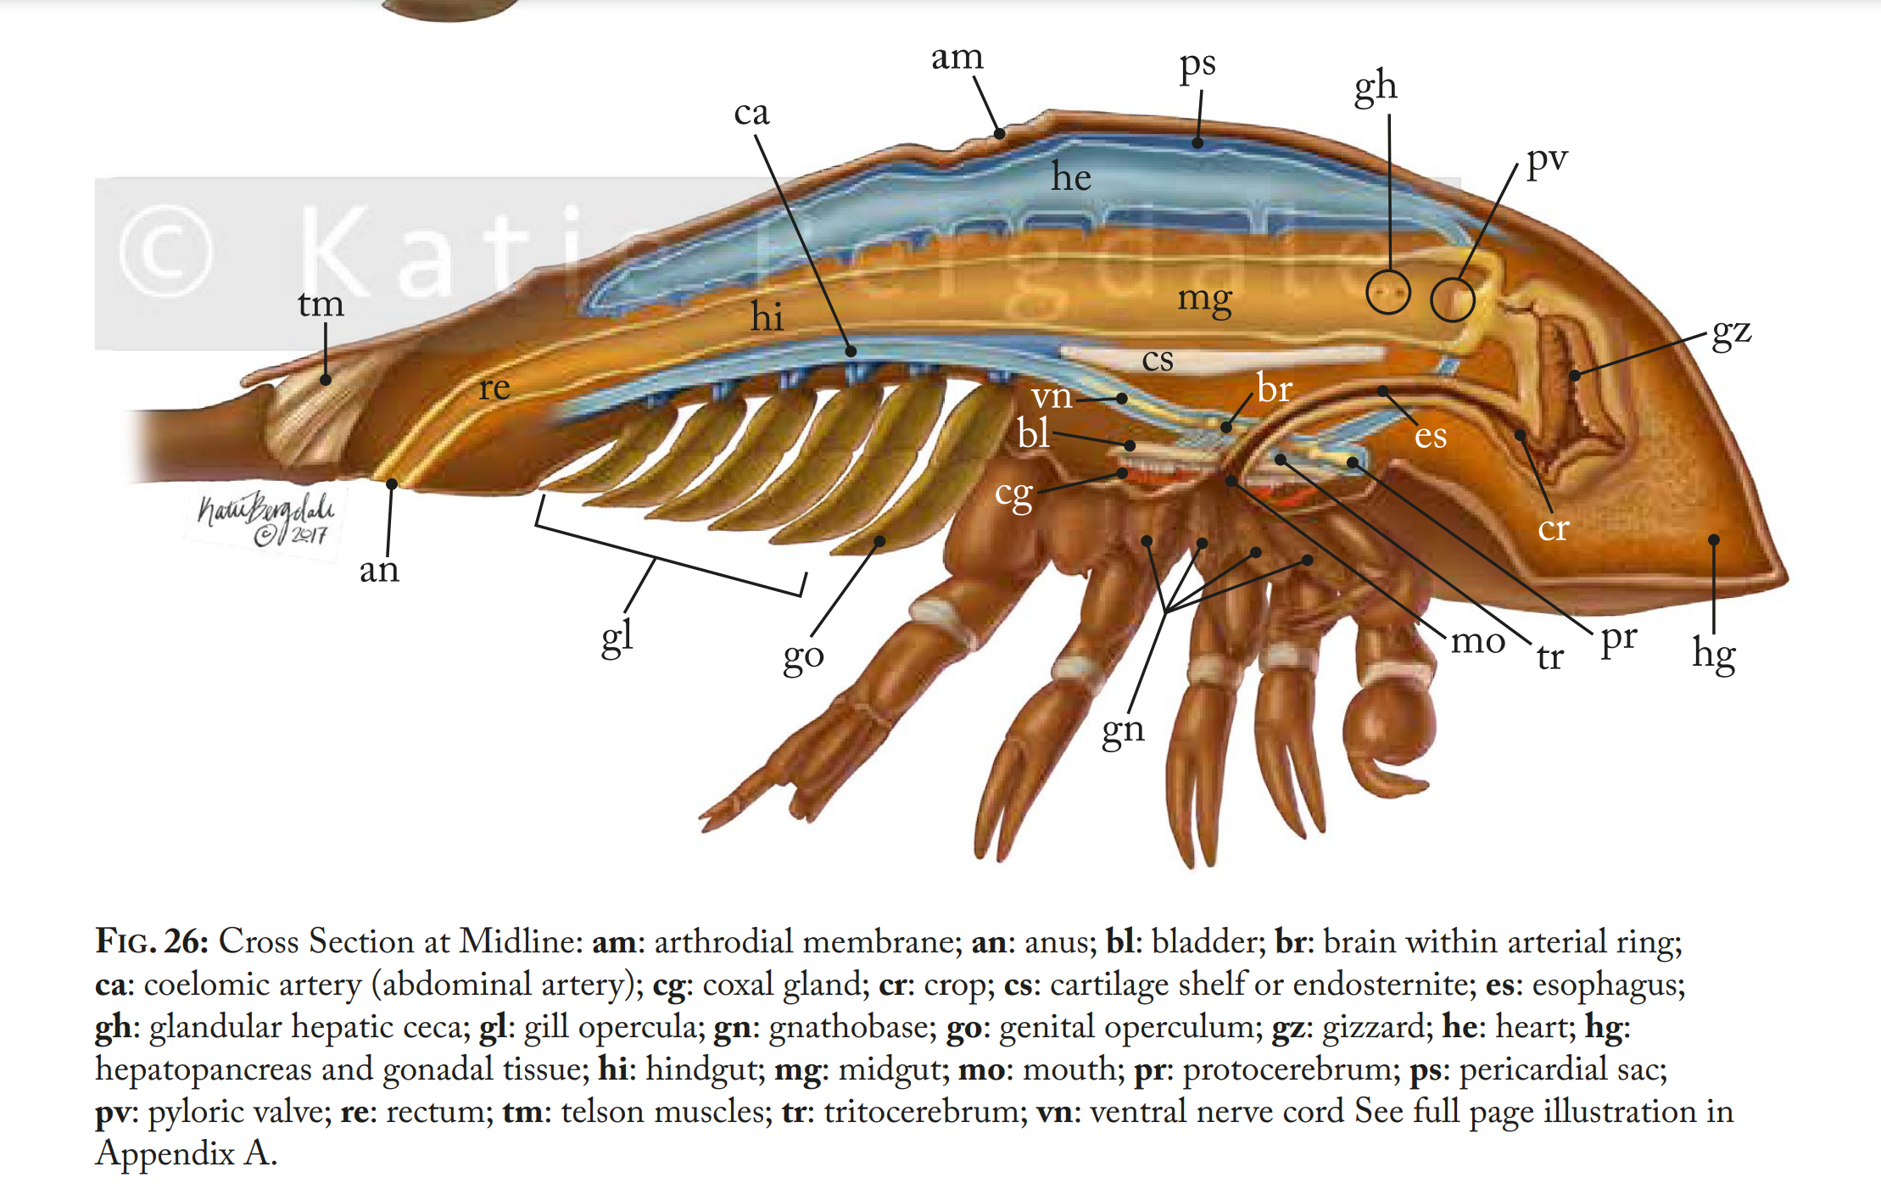
Bergdale KJ. Illustrations for Health Assessment Techniques of the Atlantic Horseshoe Crab, Limulus polyphemus [thesis]. Baltimore, MD: Johns Hopkins University; 2017.
https://jscholarship.library.jhu.edu/bitstream/handle/1774.2/40736/BERGDALE-THESIS-2017.pdf

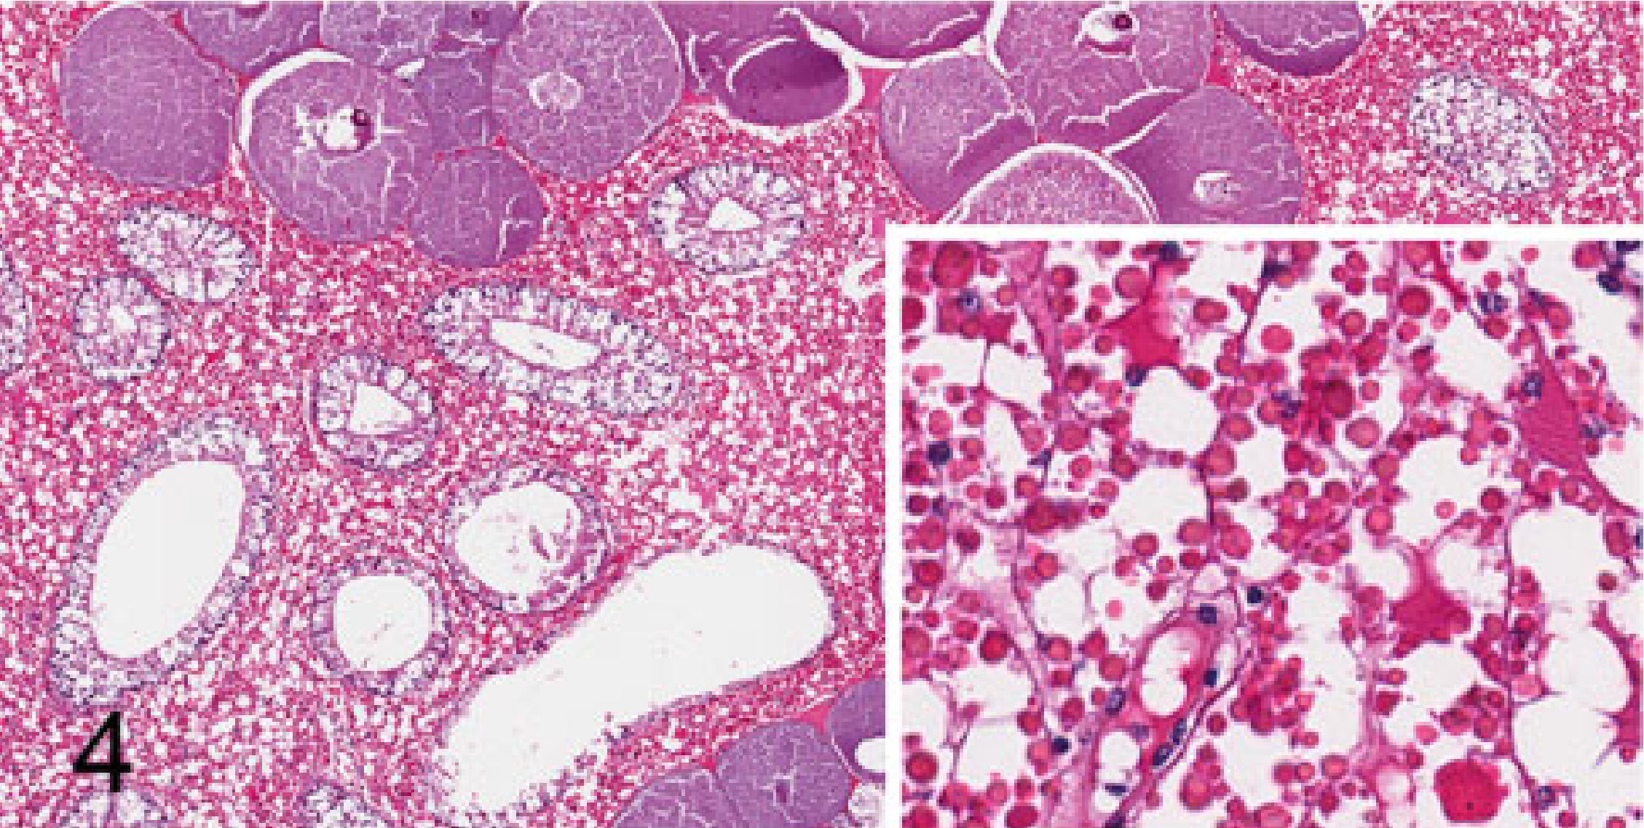
Interstitial cells with eosinophilic globules
Collecting tubule
Ovary
Normal hepatopancreas with interdigitating ovary:
- interstitial cells (aka storage or reserve cells) with variable eosinophilic globules (fewer basophilic globules)
- Collecting tubules
- Rare granular, birefringent, brown crystalline material, no associated host reaction, intra and extracellular
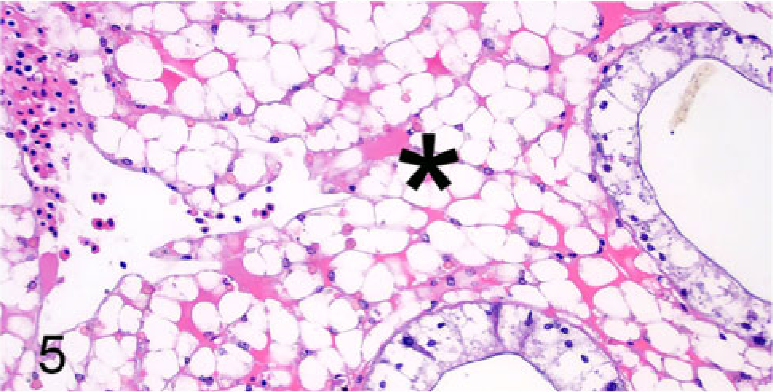
Interstitial cell eosinophilic globule depletion - may represent decreased overall nutritional status
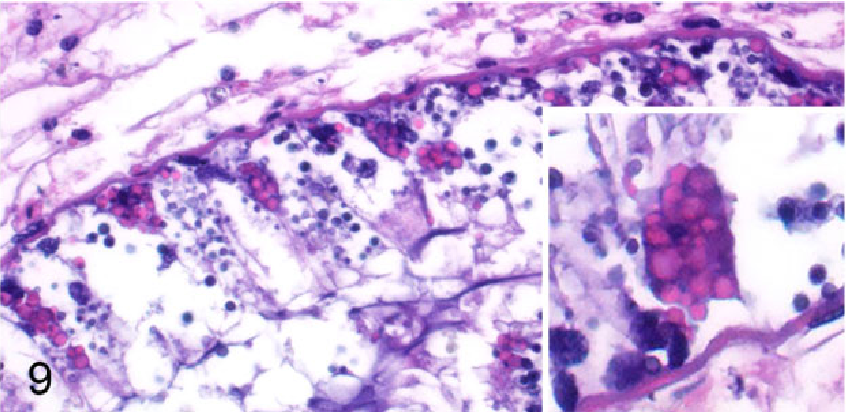
Collecting tubules: simple, tall, columnar epithelial cells
  - light cells (acidophils)
  - dark cells (basophils): secretory/zymogen granules (lipase, amylase, trypsin), analogous to exocrine pancreas
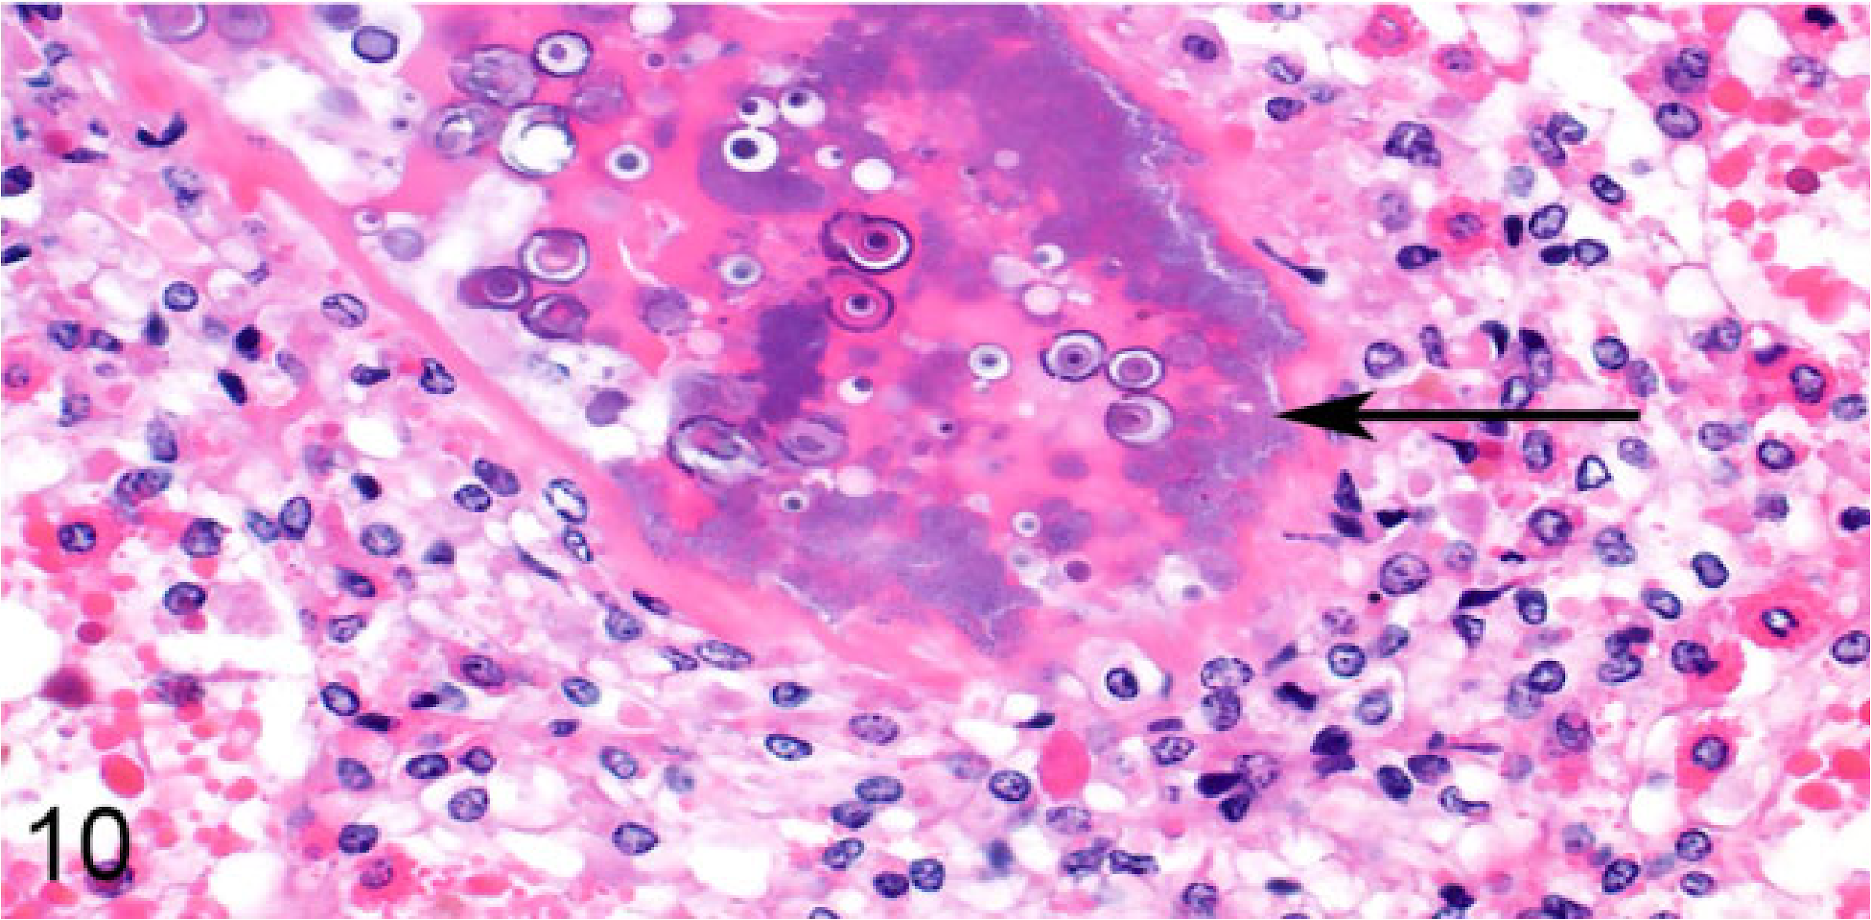
Bacterial tubulitis
Epicuticle
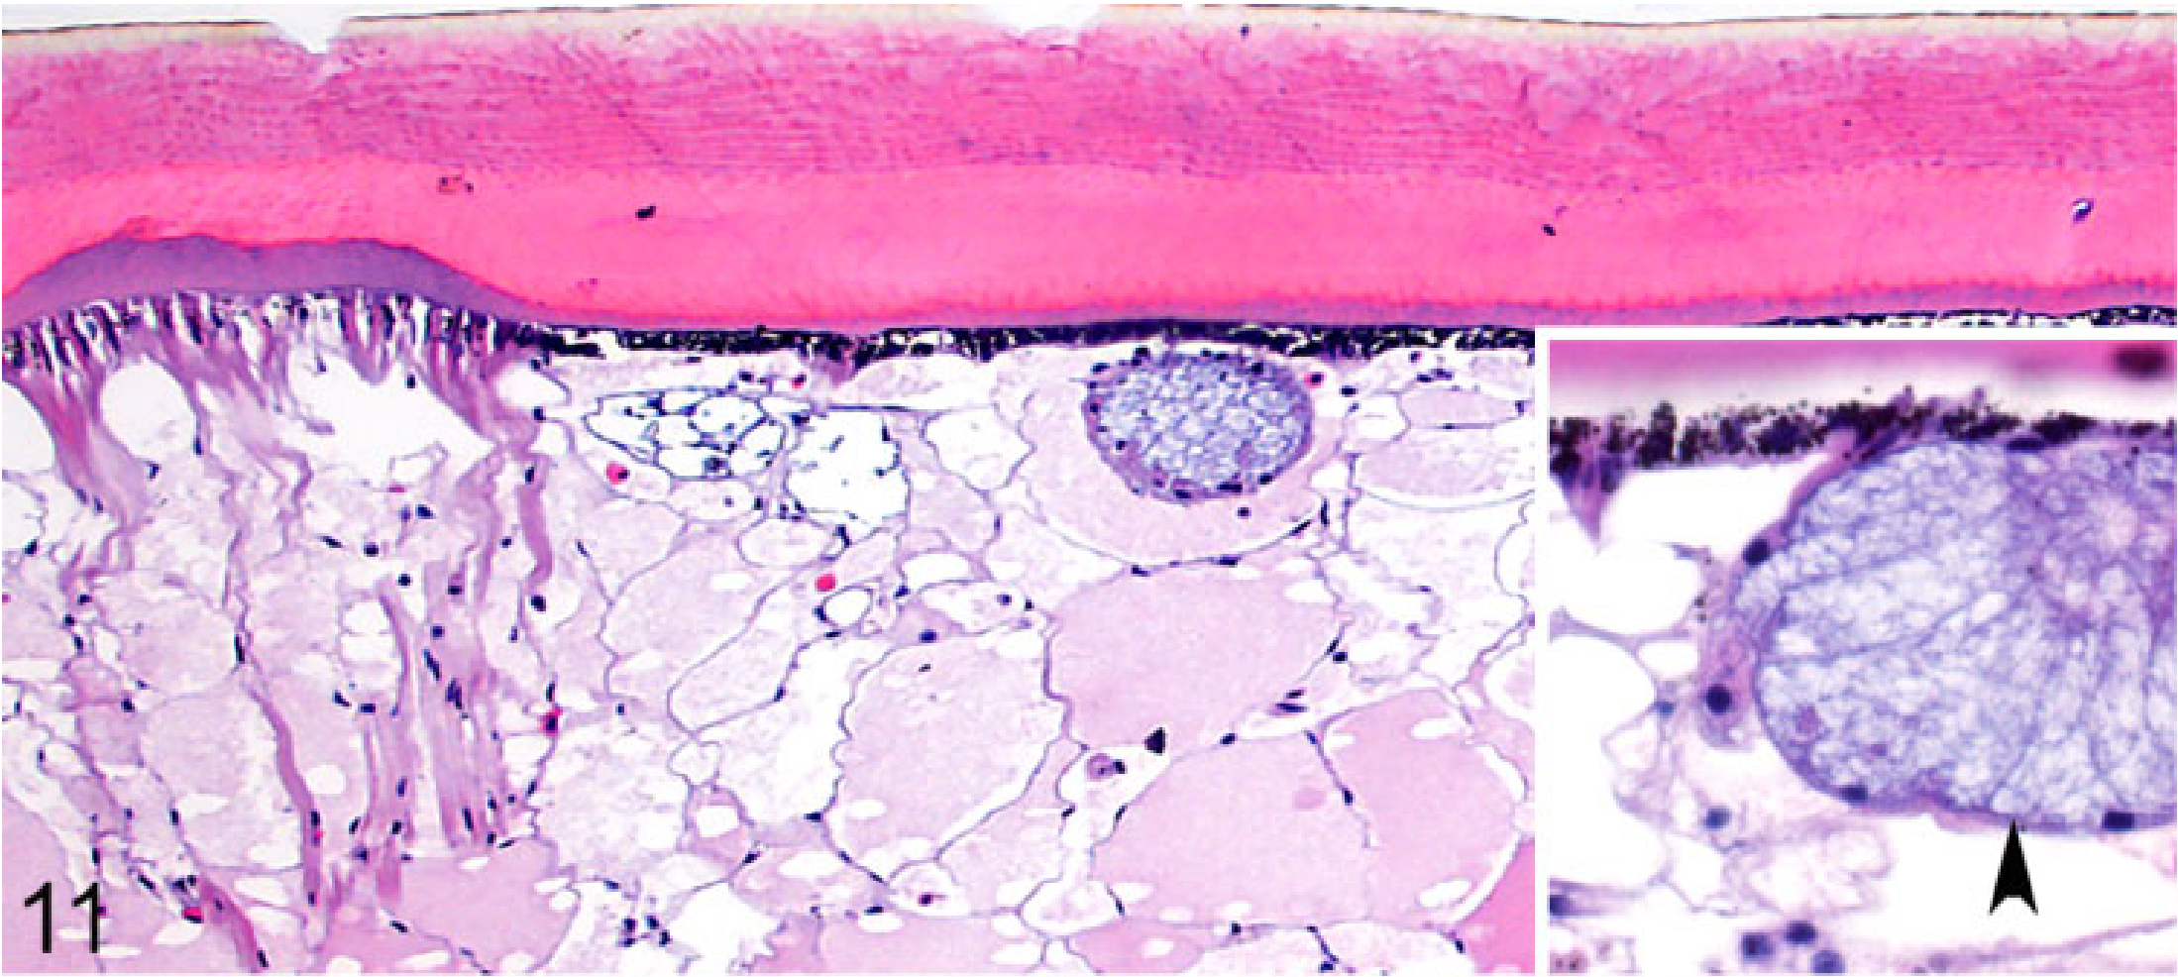
Exocuticle
Dermis
Epidermis
Endocuticle
Body wall:
Cuticle
- Epicuticle: thin, acellular
- Exocuticle: thick, chitinous, acellular
- Endocuticle: strongly eosinophilic
Epidermis: melanized columnar cells
Dermis: with secretory glands (arrowhead)
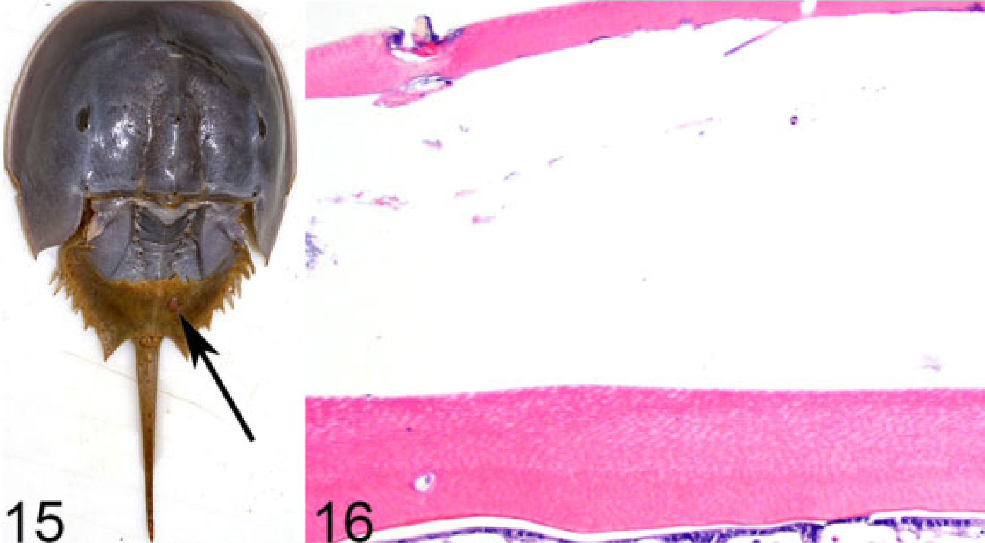
Dysecdysis - retained cuticle (arrows)
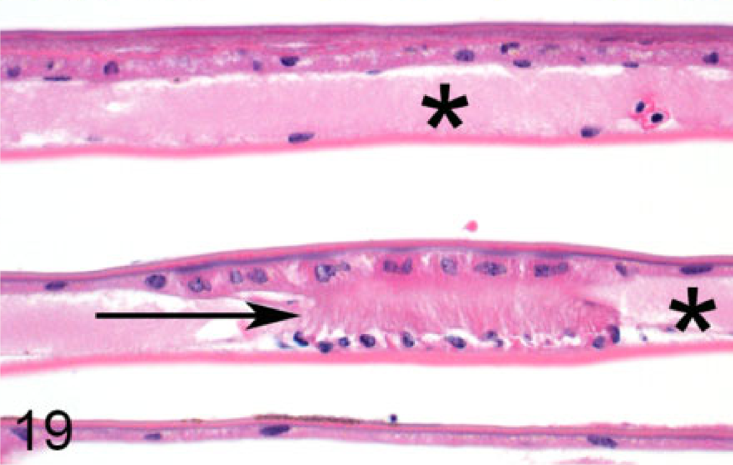
Book gills: lamellae arising from opercula
- Lamellae: 2 simple flattened epithelial layers around a vascular lumen (asterisk), held apart by pillar cells (arrow)
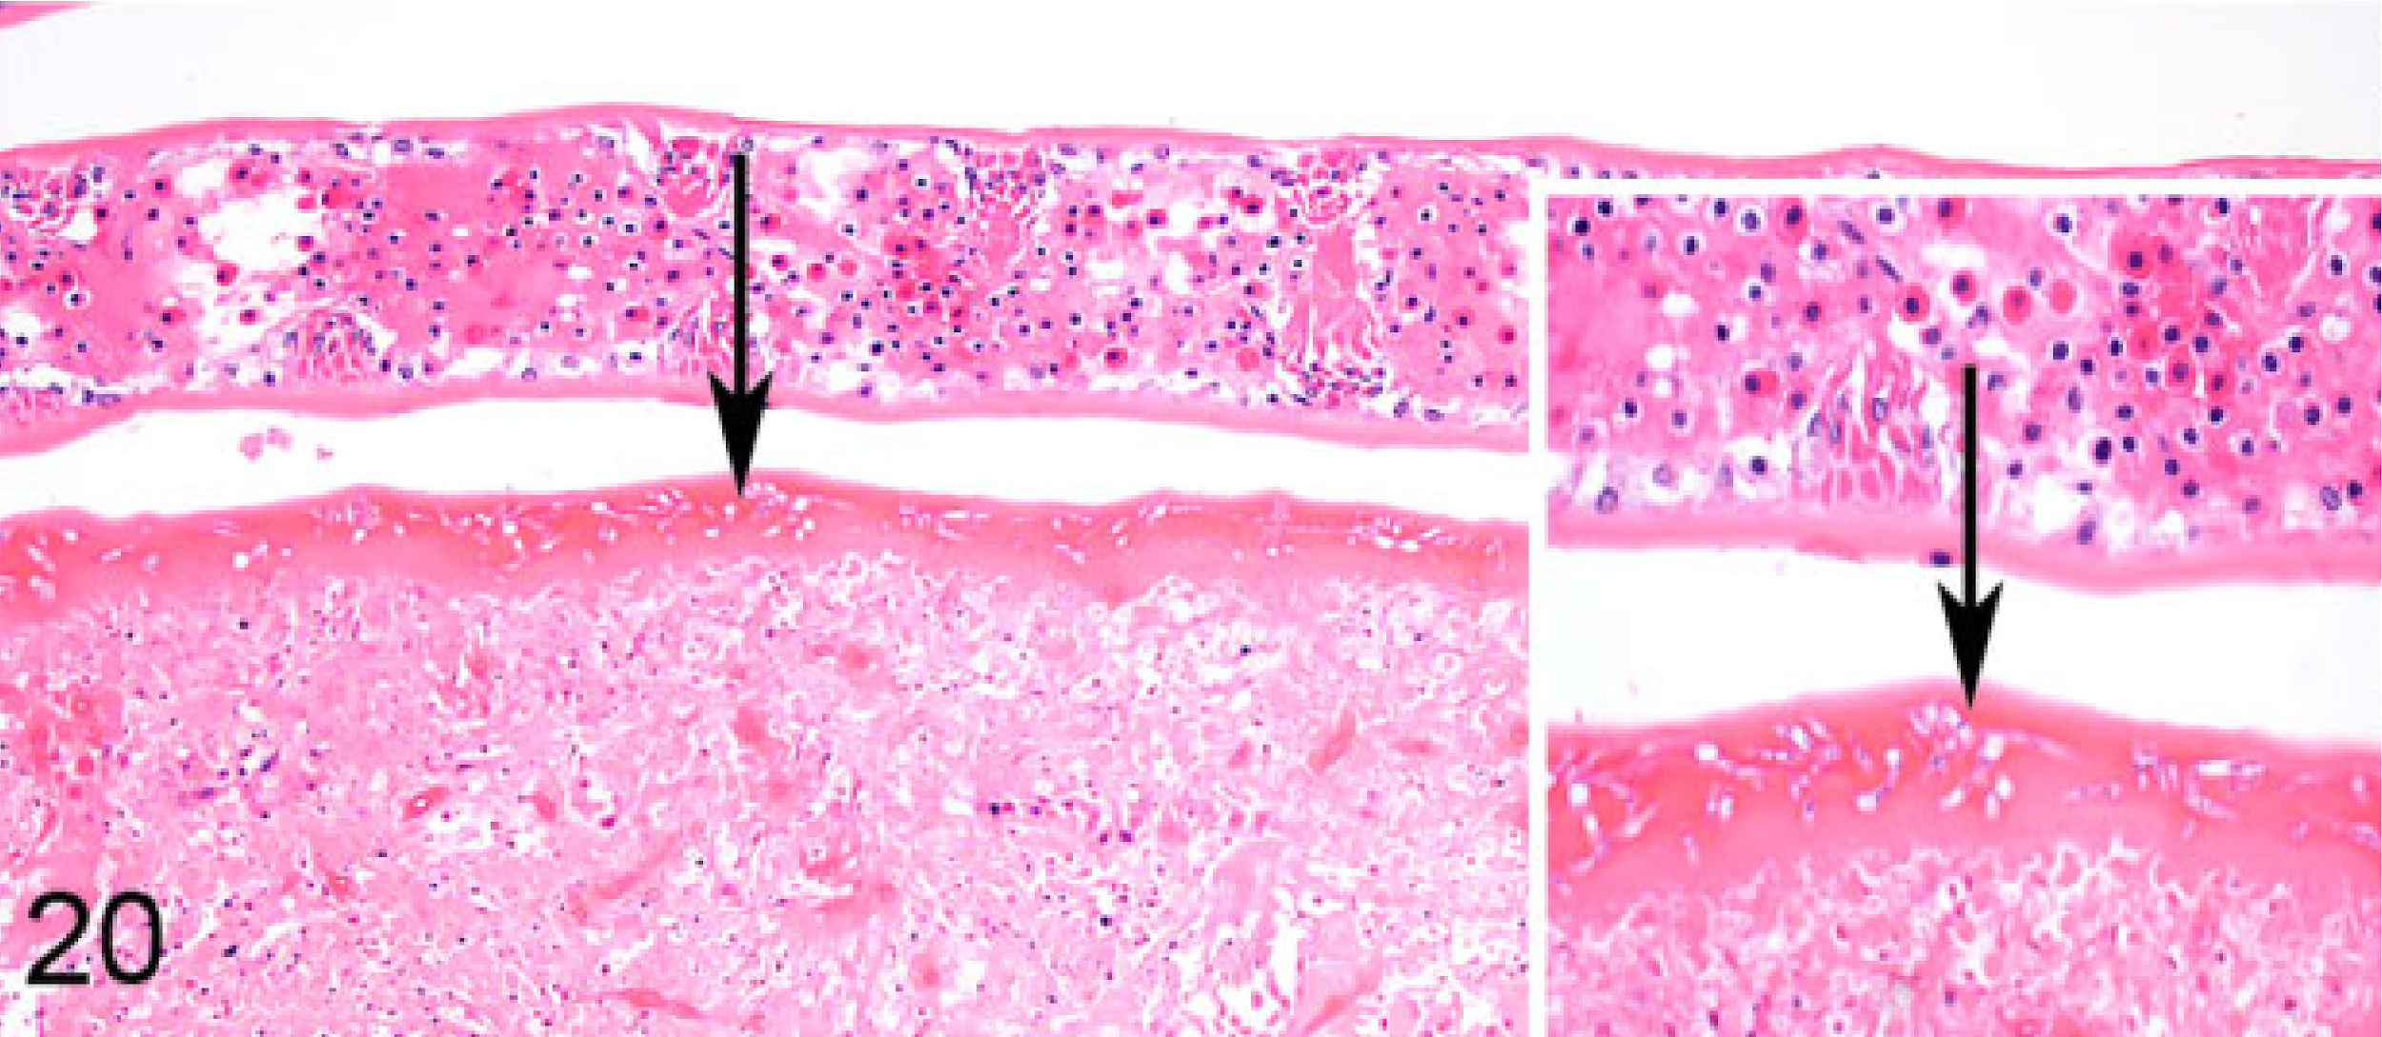
Fungal branchitis
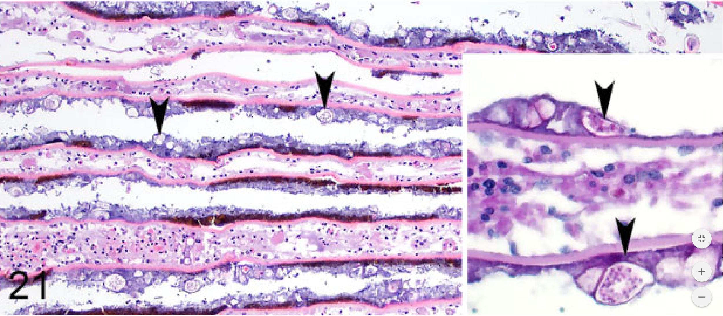
Biofilm mat over gills with blue-green algae cells (arrowheads)

Doerr, M., & Stoskopf, M. K. (2019). Evaluation of euthanasia of moon jellyfish (Aurelia aurita) using simple salt solutions. Journal of Zoo and Wildlife Medicine, 50(1), 123-126.

Abstract: Immersion euthanasia methods reported over the most recent decades for aquatic invertebrates use organic alcohols or halogenated hydrocarbons that can interfere with nuclear magnetic resonance (NMR) analysis. A rolling study design evaluated potassium chloride (KCl), magnesium chloride (MgCl2), and magnesium sulfate (MgSO4) as potential ion-based euthanasia methods for moon jellyfish (Aurelia aurita) destined for metabolomic analysis by NMR spectroscopy. Death was defined as the cessation of autonomous bell pulsing and response to external stimulus. MgCl2 applied at a dose of 142 g/L provided euthanasia within 32 sec of applications without the untoward effects observed with the other two salts. Euthanasia with KCl at the doses tested was associated with abnormal behavior and tissue degradation during dissection. MgSO4 at the doses tested resulted in abnormal behavior and failed to provide rapid euthanasia.

Background information:
- Euthanasia of invertebrates complicated by lack of knowledge of invert nociception, as well as the diversity of phyla
- Current recommendations are MS222 or ethanol BUT these are not appropriate for inverts that are going to be assessed by NMR (nuclear magnetic resonance) analysis after euthanasia- leads to abnormal peaks/obscuring of peaks from key molecules
  - Study objective is to find an inorganic method of euthanasia for jellyfish
- Scyphozoa = “true jellyfish,” marine only class of phylum Cnidaria
  - Central nervous system
    - Rhopalia = ganglia-like centers on the bell margin
      - Contain photosensitive structures (ocelli), statoliths and pacemaker cells that set the rhythm of bell contractions
    - Motor Nerve Net (MNN) = innervates the muscle sheet of the subumbrella cavity; causes bell contractions
    - Diffuse Nerve Net (DNN)= relays sensory input to the bell margin and rhopalia

Study design: “rolling design” using 13 captive bred moon jellies. Put into a tank and their resting pulse rate and response to a bell-tap stimulus were measured. Euthanasia considered achieved with cessation of response to bell-tap stimulus and pulse rate.
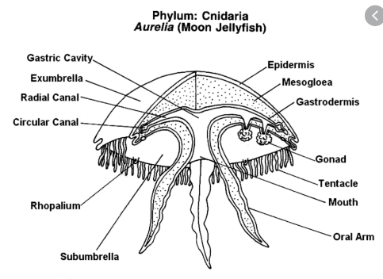

Results: Most pertinent= MgCl2 at 142 g/L was the most effective lowest dose that maintained efficiency as a euthanizing agent
- KCl, MgCl2 and MgSO4 - at the highest dose, caused immediate unresponsiveness and discharge of nematocysts and oral mucous → considered acute distress.
- KCl caused loss of tissue integrity after euthanasia
- MgSO4 failed to provide effective euthanasia within the 20 minute time period

Discussion:
- Pulse rate and response to stimulus were chosen as markers of euthanasia
  - Difficult to tell between anesthetic response vs. paralysis
    - Loss of pulse in response to stimulus indicates inactivation of all three components of the CNS → loss of any nociceptive state → puts the jellyfish functionally into an insensate state
  - Challenge #2 is evaluation of pain/distress in reaching euthanized state
    - Nematocyst expulsion = very regulated and highly costly; occurs when a mechanical signal at the cnidocyte triggers a Ca-mediated response
      - Likely an isolated biochemical reaction that is precipitated by altered water ion concentrations NOT an integrated distress response
    - Mucous production: occurs in response to handling but also during feeding → could be interpreted as a marker of distress but still not fully understood mechanistically

Take home points: Magnesium chloride at 142 g/L is recommended for euthanasia of scyphozoans when an inorganic method is needed. Inorganic methods are better for nuclear magnetic resonance (NMR) analysis as they don’t interfere with peaks from other key molecules.

Sheldon, Julie D., et al. "Effects of oxygen and isoflurane anesthesia on hemolymph gas analysis and righting reflex of asian forest (heterometrus longimanus) and dictator scorpions (pandinus dictator)." Journal of Zoo and Wildlife Medicine 50.1 (2019): 111-122.

Abstract: Large arachnids are commonly managed under professional care, and anesthesia is occasionally required for physical examination and diagnostic and therapeutic procedures. Anesthetic responses and hemolymph gas analysis have been studied previously in spiders, but scorpions have yet to be investigated. This study measured hemolymph gas values with an i-STAT point of care blood gas analyzer in healthy adult Asian forest scorpions (Heterometrus longimanus HL, n=8) and dictator scorpions (Pandinus dictator PD, n=12) breathing: 1) room air (RA), 2) 100% oxygen for 10 min in a chamber (OX), and 3) 5% isoflurane and oxygen (ISO) in a chamber until induction or loss of righting reflex. All scorpions recovered without complications, and there were no cartridge failures. Analysis of hemolymph gas values revealed that pH was lower in OX compared with RA and ISO and was lower in PD compared with HL scorpions. The partial pressure of carbon dioxide did not differ between inhaled gases but was higher in PD compared with HL. The partial pressure of oxygen (pO2) was higher in ISO compared with OX, and both were higher than when breathing RA. Despite a lack of species difference in pO2, PD had a more dramatic increase in pO2 in ISO compared with HL (significant species and inhalant interaction). PD had a significantly shorter induction time than HL, but recovery time (return of righting reflex) did not differ between species. Subjectively, HL exhibited rough inductions compared with PD, characterized by violent whole-body and tail movements. The unexpected increase in pO2 in ISO compared with OX, along with the species-specific differences and anesthetic effects, emphasizes the unique respiratory physiology of scorpions and demonstrates that further species-specific studies of anesthetics are warranted.

Intro
- Most information regarding scorpion anesthesia and hemolymph analysis is anecdotal or extrapolated from information on spiders
- The objectives of this study were to measure and describe hemolymph gas parameters in two species of scorpion; characterize the effects of room air (RA), 100% oxygen (OX), and 5% isoflurane in oxygen (ISO) on hemolymph gas parameters; and compare anesthetic induction and recovery time between species

M&M
- 20 animals (8 HL and 12 PD)
- PE followed by hemolymph collection for blood gas analysis
- Put in chamber with 100% oxygen at 1.5 L/mini for 10 mins, blood gas run a second time
- Allowed to recover in their enclosure for 2.5-3 hours prior to anesthetic induction
- Chamber induction with 5% isoflurane, after loss of righting reflex iso was d/c and hemolymph collected
- Recovery time measured as minutes from removal to iso to return of righting reflex

Results
- All animals recovered from anesthesia without complication
- 2 animals were found dead 11 and 96 days after anesthesia
- Hemolymph collected as a percentage of body weight ranged from 2.3% to 5.6% (mean 2.8%)
- pH, pO2, TCO2 and BE all differed significantly between scorpions breathing RA, OX, and ISO
- pCO2 was not significantly different between inhalants
- Specifically, hemolymph pH, TCO2, HCO3, and BE were lower in OX compared with RA, and pO2, was lower in RA compared with OX.
- Similarly, hemolymph pH, pO2, TCO2, HCO3, and BE, were lower in OX compared with ISO
- PD had a significantly shorter (and subjectively smoother) induction time than HL, but recovery time did not differ between species

Discussion
- Hemolymph pH decreased significantly in OX compared with RA and ISO. Blood (hemolymph) pH is dependent on concentration of HCO3 and pCO2; pH decreases with increased pCO2 (respiratory acidosis) and decreased HCO3 (metabolic acidosis). In this study, there was a statistically insignificant increase in pCO2 and decrease in HCO3 during exposure to 100% oxygen that together might have contributed to the significant change in pH – suspect hypoventilation
- For both scorpion species in this study, pO2 significantly increased when exposed to OX and increased further with ISO
  - Arachnids perform gas exchange by passive diffusion across book lungs. Spiracle diameter can also increased with exercise
  - All animals showed increased activity in response to iso, which could have caused spiracle dilation
- PD had a more dramatic pO2 increase in isoflurane compared with HL despite being in oxygen for less time on average (shorter induction time) and thus inhaling lower FiO2.
  - Possible difference in respiratory and hemocyanin physiology or different reaction to inhalant anesthesia with PD being more relaxed during induction compared with HL and thus ventilating more effectively
- In RA, PD had a lower pH and higher pCO2, TCO2, and HCO3 than HL—species differences even at baseline
- Induction times for PD were shorter than for HL; HL had rougher inductions compared with PD and seemed more irritated by the anesthetic gas
- Recovery times variable
- Longer inductions and increased movement of HL scorpions may explain the decreased pH compared with PD, possibly as a result of metabolic acidosis.
- Hemocyanin concentrations were not measured in the current study, therefore BE and SO2 values are likely not accurate, and their clinical utility may be difficult to determine
- TCO2 and HCO3 also likely not accurate in these species due to calculation method
- One limitation is the possibility that the 2.5–3 hr washout period between oxygen and isoflurane trials did not allow for complete oxygen washout

Conclusions
- Isoflurane by chamber induction is an effective method for general anesthesia in HL and PD scorpions
- However, because HL scorpions experienced rough anesthetic inductions, other methods for this species should be prioritized.
- Scorpions experience significantly elevated pO2 under isoflurane anesthesia compared with room air, so preoxygenation before inhalant anesthesia is likely not beneficial.
- Oxygen supplementation alone caused a mixed acidosis in HL scorpions

