Rosser et al. “Arrested Development of Henneguya ictaluri (Cnidaria: Myxobolidae) in ♀ Channel Catfish × ♂ Blue Catfish Hybrids.” Journal of Aquatic Animal Health. 2019. 31:201–213.

Abstract: Henneguya ictaluri is the etiologic agent of proliferative gill disease (PGD) in farm‐raised Channel Catfish Ictalurus punctatus and hybrid catfish in the southeastern United States, and significant annual losses are attributed to this disease. Research suggests that H. ictaluri infection dynamics in Blue Catfish I. furcatus and hybrid catfish (Channel Catfish × Blue Catfish) differ from those in Channel Catfish. Two separate infectivity trials were conducted to investigate H. ictaluri development in Channel Catfish, Blue Catfish, and their hybrids. On two separate occasions with two different year‐classes, fish were exposed to pond water containing H. ictaluri actinospores and sampled weekly for 12 weeks (trial 1) or 14 weeks (trial 2). In trial 1, the presence of H. ictaluri was evaluated histologically and by quantitative PCR of fish tissues, including gills, blood, anterior kidney, brain, heart, liver, posterior kidney, spleen, and stomach. Henneguya ictaluri DNA was detected in significantly higher concentrations throughout multiple organ systems in the Channel Catfish compared to the hybrid catfish and Blue Catfish, with the gills having higher quantities. Myxospores were observed in Channel Catfish gill tissue at 8 weeks postexposure. No myxospores were observed in Blue Catfish or hybrid catfish. The second trial focused on gills only and yielded similar results, with Channel Catfish having significantly greater H. ictaluri DNA quantities than hybrids or Blue Catfish across all time points. Myxospores were observed in Channel Catfish beginning at 6 weeks postexposure and were found in 36% (58/162) of Channel Catfish sampled for molecular and histological analysis during weeks 6–14. Myxospores in hybrid catfish were sparse, with single pseudocysts observed in two hybrid catfish (1.2%) at 14 weeks postexposure. These results imply arrested development of H. ictaluri in hybrid catfish. As such, culture of hybrid catfish may be an effective management strategy to minimize the burden of PGD.

- Introduction:
  - Losses attributed to infectious dz account for nearly half of all losses in catfish aquaculture.
  - Henneguya ictaluri – causative agent of proliferative gill disease PGD.
    - Myxozoan parasite, complex life cycle.
    - Actinospore stages released by benthic oligochaete host Dero digitate, myxospore stages in Channel Catfish gills.
    - Seasonal outbreaks assoc with increased parasite shedding in spring (infectious actinospore stages).
    - Clinical manifestation of PGD associated with the initial parasitic penetration and proliferation rather than myxospore stage maturation.
    - Catastrophic fish kills, up to 100% mortality.
    - H. ictaluri present at some level in nearly all catfish ponds March-May. Gill damage results in secondary infection/sepsis.
  - Host specificity plays significant role in transmission.
    - Blue Catfish less gill damage than Channel Catfish and hybrids.
    - Less efficient transmission, reduced proliferation of the parasite in hybrids.
- M+M:
  - 2010 and 2014 channel catfish, blue catfish, and hybrid catfish fingerlings.
  - Reared indoor, infectivity trials to assess H. ictaluri development.
  - Pond water containing actinospores used for challenges.
  - Trial 1 – qPCR estimated dose 25-100 actinospores/L over 4 days.
  - Trial 2 – infectious dose 10-25 actinospores/L over 4 days.
  - Necropsies, tissue collection, histology 12 wks post exposure. Three fish sampled weekly.
  - Assessed for PGD lesions, developing myxospores assessed by microscopic examination of gill clip wet mounts, collected blood, collected organ samples for histo. Also did DNA extraction from tissues.
- Results/Discussion:
  - Trial 1 – Early developmental stages observed in both Channel Catfish and hybrids, similar acute stages of infection. Gill tissue predominant predilection site consistent with previous studies.
  - Developing plasmodia observed 7d post exposure.
  - Blue Catfish incurred fewer lesions, DNA less prevalent in Blue and hybrids vs Channel Catfish.
  - Thourhout both trials, Blue Catfish had no lesions. No DNA on PCR.
  - No myxozoan plasmodia were observed grossly in any gill clip wet mounts from hybrid catfish.
    - Pseudocysts observed on histo in two hybrid catfish, week 14.
  - Detectable levels on PCR in brain, gills, heart, ant and post kidneys, spleen, liver, and stomach. Life stages only observed on histo in gills, post kidney and liver. Systemic nature of acute stages of infection.
  - Potential for hybrid catfish to reduce the propagation of H. ictaluri in commercial production systems.
  - Hybrid catfish appear to be unsuitable hosts for H. ictaluri given significant reductions in myxospore development compared to Channel catfish.
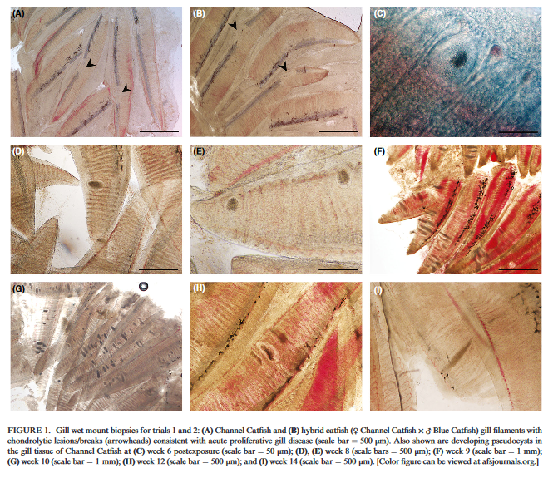
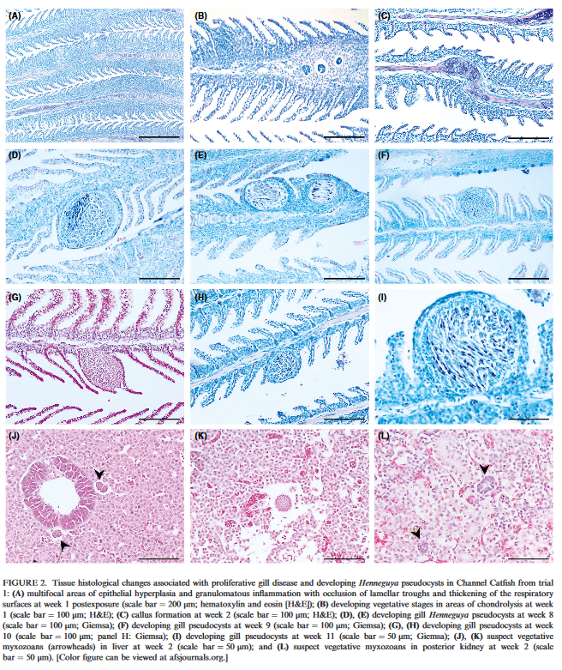

Swimming Endurance in Juvenile Chinook Salmon Infected with Salmincola californiensis
Journal of Aquatic Animal Health. 2018. 30:81–89
Abstract:
Juvenile Chinook Salmon Oncorhynchus tshawytscha moving downstream through tributaries of the upper Willamette River basin can spend months in reservoirs created by dams. While residing in the reservoirs, they often obtain heavy infections of the freshwater parasitic copepod Salmincola californiensis. The physiologic effect these parasites have on salmonids is poorly understood. We developed a method to infect juvenile Chinook Salmon in a laboratory with the copepodid stage of S. californiensis. Infected and uninfected fish were subjected to a swimming challenge to ascertain swimming endurance. Severity of gill damage was assessed using a dissecting microscope. Juvenile Chinook Salmon naturally infected with S. californiensis in Cougar Reservoir, Oregon, were also challenged and compared with their lab‐infected counterparts. Copepod infection greatly impaired the swimming ability of laboratory fish, and the naturally infected fish were entirely incapable of swimming at low velocity. Chinook Salmon collected in the wild were more heavily infected than the laboratory fish and had trouble surviving collection and transport to our laboratory. The intensity of infection and severity of gill damage were positively correlated with diminished swimming ability, suggesting that heavy infection with copepods impairs gas exchange and osmotic regulation, which likely results in diminished fitness and decreased survival of infected fish.
Summary:
Intro:
- S. californiensis
  - life cycle - one host and multiple phases that last for a total of 6 weeks from egg to adult
  - infective immediately after hatching for up to 48 h posthatch
  - egg stage (embryonic and nauplius stages), then free‐swimming, infective, copepodid stage, four chalimus stages, and an adult stage
  - copepod cause damage by feeding on nearby epithelium and mucus while attached to host
- parasites can reduce swimming performance in juvenile salmonids
Methods:
- infected juvenile salmon in lab with copepodid stage of S. californiensis
- infected and uninfected subjected to swimming challenge to determine swimming endurance
- severity of gill damage assessed using dissecting microscope
- juvenile naturally infected salmon challenged and compared with lab‐infected salmon
Results/Discussion:
- S. californiensis reduced ability of juvenile Chinook Salmon to sustain swimming
- infected fish had lower swimming endurance than uninfected fish
- wild fish had more gill damage than lab fish
- positive correlation between gill damage and intensity of infection
- even low infection intensity appeared debilitating
- gill damage from copepods unique - localized to where copepod directly interacts w/ fish
- extremely high mortality observed in wild fish following capture and transport

Grass carp which survive Dactylogyrus ctenopharyngodonid infection also gain partial immunity against Ichthyophthirius multifiliis
Jian-Pei Li, Yao-Wu Fu, Qi-Zhong Zhang, De-Hai Xu, Yan-Meng Liu, Sheng-Yu Zhou, De-Jie Lin
Diseases of Aquatic Organisms 2018;129:63–70.

ABSTRACT: Dactylogyrus ctenopharyngodonid and Ichthyophthirius multifiliis are 2 important ectoparasites of fish. Both parasites can induce an immune response in fish that leads to a decrease in parasitic infection intensity and the development of resistance against parasitic reinfection. The present study evaluated whether grass carp Ctenopharyngodon idella that survived a D. ctenopharyngodonid infection could develop immunity against infection by D. ctenopharyngodonid and I. multifiliis. The results demonstrated that when grass carp were infected with D. ctenopharyngodonid, the number of red blood cells and the percentages of thrombocytes, monocytes, and neutrophils in the white blood cells increased significantly in the early stage of infection. The percentage of lymphocytes increased over time following parasitic infection. The mean infection intensity of D. ctenopharyngodonid decreased to 0 on Day 28. The activities of serum acid phosphatase, alkaline phosphatase, lysozyme, and superoxide dismutase increased significantly after D. ctenopharyngodonid infection. In addition, the grass carp that survived a previous D. ctenopharyngodonid infection could completely resist D. ctenopharyngodonid reinfection and partially resist I. multifiliis infection.

Background:
- Dactylogyrus ctenopharyngodonid: oviparous monogenean parasite, host response: cytokine production, mucus secretion, peptide release
- Fish can develop significant resistance to reinfection by same parasite species
- Rainbow trout immunized with Gyrodactylus derjavini monogenean had partial cross-proteciton against ciliate protozoan Ichthyophthirius multifiliis

Key points:
- 700 grass carp from 2 fish farms, one farm had D cteno and other had no parasites. All treated with potassium permanganate prior to study. Infected some grass carp with I multifiliis isolated from a goldfish.
- Control (no parasites) vs D cteno infected assessed for 28 days:
  - Results: mean intensity of D cteno infection decreased over time – host-response likely clears parasite (0 by day 28)
  - RBCs, lymphocytes, monocytes, and neutrophils were higher in infected than control. Lymphocytes increased over time, monocytes and neutrophils decreased over time.
  - Acid phosphatase, ALP, and SOD (superoxide dismutase) were higher in infected group, lysozyme activity increased initially then decreased
- Survivors of D cteno and naïve fish placed with D cteno infected, I multifiliis infected, or co-infected. Assessed for 14 days.
  - Survivors did not re-infect with D cteno (mean parasite intensity was 0)
  - Mean intensity of I multifiliiswas higher in control than survivors, mortality rate was 100% in controls, 25-30% in survivors

Conclusions:
- Grass carp survive a low intensity D cteno infection (100%) and will eliminate the parasite overtime
- Hematology changes suggest immune response to the parasites, enzymes and RBCs may play a role in immune response.
- Survivors had robust protective immunity to D cteno and cross protection against I multifiliis.
Diagnosis and treatment of multi-species fish mortality attributed to Enteromyxum leei while in quarantine at a US aquarium.
Hyatt MW, Waltzek TB, Kieran EA, Frasca Jr S, Lovy J.
Diseases of Aquatic Organisms. 2018 Dec 11;132(1):37-48.

Abstract: Enteromyxum leei is an enteric myxozoan parasite of fish. This myxozoan has low host specificity and is the causative agent of myxozoan emaciation disease, known for heavy mortalities and significant financial losses within Mediterranean, Red Sea, and Asian aquaculture industries. The disease has rarely been documented within public aquaria and, to our knowledge, has never been confirmed within the USA. This case report describes an outbreak of E. leei in a population of mixed-species east African/Indo-Pacific marine fish undergoing quarantine at a public aquarium within the USA. Four of 16 different species of fish in the population, each of a different taxonomic family, were confirmed infected by the myxozoan through cloacal flush or intestinal wet mount cytology at necropsy. Clinical and histopathological findings in this case are similar to previous findings describing myxozoan emaciation disease, e.g. severe emaciation, cachexia, enteritis, and death. Sequence analysis of the 18S rDNA of intestinal samples from a powder blue tang Acanthurus leucosternon and an emperor angelfish Pomacanthus imperator confirmed the parasite to have 99-100% identity with other E. leei sequences. Spore morphology and ultrastructure were consistent with previous reports of E. leei. Treatment of clinically affected fish by oral administration of the coccidiostats amprolium and salinomycin led to reduction of mortalities and resolution of clinical signs. This case report highlights the importance of thorough examination and surveillance of fish during quarantine, particularly with respect to enteric myxozoans.

Background:
- Enteromyxum leei = enteric myxozoan parasite → emaciation, enophthalmos, cachexia, and mortality
  - Low host specificity, reported to affect > 50 species
  - Commonly affects sea breams, turbot, flounder, tiger puffer, and grouper
  - Common locations: Mediterranean, Red Sea, Asian aquaculture
- E. leei is transmitted directly from cohabitation, coprophagy, ingestion of infected tissues, contaminated water
  - Plasmodia develop in distal intestines → catarrhal enteritis → malabsorption and impaired osmoregulation

Cases: 16 species of wild African/Indo-Pacific tropical fish imported to US with emaciation and mortalities in quarantine
- Clinical signs took > 2 months to develop, consistent with prepatent period of E. leei
- Myxoxoans confirmed on wet mount of intestines
- Identified Enteromyxum leei on PCR of intestines
- Histopathology = myxospores with polar capsules in enterocytes, esp in pyloric ceca and intestine
- Treatment with amprolium and salinomycin in gel food lessened mortalities and resulted in negative cloacal washes in survivors
  - Amprolium = structural analogue of thiamine that competes with thiamine use in parasite
  - Salnomycin = lipophilic ionophore that accumulates in cell membranes and disrupts potassium balance

Conclusions: Enteromyxum leei caused emaciation and mortalities in tropical marine fish but morbidity and mortality was slowed with amprolium and salinomycin treatment.
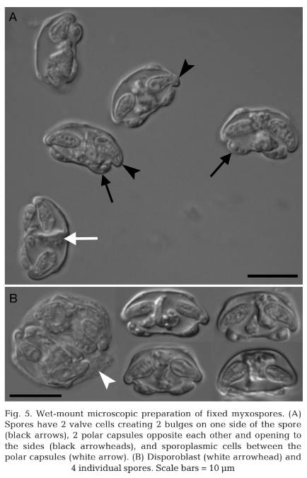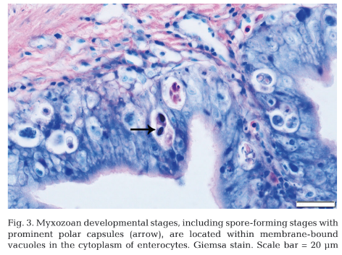
Retallack et al. “Metagenomic next-generation sequencing reveals Miamiensis avidus
(Ciliophora: Scuticociliatida) in the 2017 epizootic of Leopard sharks (Triackis semifasciata) in
San Francisco Bay, California, USA.” Journal of Wildlife Diseases, 55(2), 2019, pp. 375–386.

ABSTRACT: During March to August of 2017, hundreds of leopard sharks (Triakis semifasciata) stranded and died on the shores of San Francisco Bay, California, US. Similar mass stranding events occurred in 1967 and 2011, but analysis of those epizootics was incomplete, and no etiology was confirmed. Our investigation of the 2017 epizootic revealed severe meningoencephalitis in stranded sharks, raising suspicion for infection. We pursued a strategy for unbiased pathogen detection using metagenomic next-generation sequencing followed by orthogonal validation and further screening. We showed that the ciliated protozoan pathogen, Miamiensis avidus, was present in the central nervous system of leopard (n¼12) and other shark species (n¼2) that stranded in San Francisco Bay but was absent in leopard sharks caught elsewhere. This ciliated protozoan has been implicated in devastating outbreaks in teleost marine fish but not in wild elasmobranchs. Our results highlight the benefits of adopting unbiased metagenomic sequencing in the study of wildlife health and disease.

Intro
- During March to August of 2017, hundreds of leopard sharks (Triakis semifasciata) stranded and died on the shores of San Francisco Bay
- No etiology was confirmed
- The authors sought to identify a cause sing metagenomic next-generation sequencing (mNGS)
M&M
- Post mortem samples taken from freshly (<72h) stranded sharks
- Samples submitted for cytology, histo, culture, and DNA and RNA extraction for mNGS
Results
- Gross and cytologic lesions consistent with meningoencephalitis
- No growth on culture
- mNGS performed on CSF samples and revealed the ciliated protozoan pathogen, Miamiensis avidus (n=12 leopard sharks, n=2 other sharks stranded in the SF Bay)
- M avidus was absent in leopard sharks caught elsewhere
- Ciliated protozoan parasites, morphologically consistent with M. avidus, were present in the olfactory lamellae of two sharks on histo
Discussion
- We observed M. avidus only in sharks exposed to SF Bay water, including two wild-caught animals in captivity.
- Given the distribution of protozoa observed on histopathology, pathogenesis in leopard sharks likely involves a nasal route, as suggested for other host species
- This study demonstrates the ability of mNGS to identify potential pathogens rapidly in an unbiased manner

