Quiz 1
CBS 817 – Fall 2020

- (1 point) In Cacatuidae psittacines infected with Psittacine Beak and Feather Disease (PBFD), which feather type is the first affected?

- Pulviplumes
- Remiges
- Retrices
- Filoplumes
- Semiplumes

- (2 points)
  - What subfamily of psittaciformes does the bird pictured below belong to?
  - And, what is the role of this subfamily in the epidemiology of Psittacine Beak and Feather disease virus in wild birds?
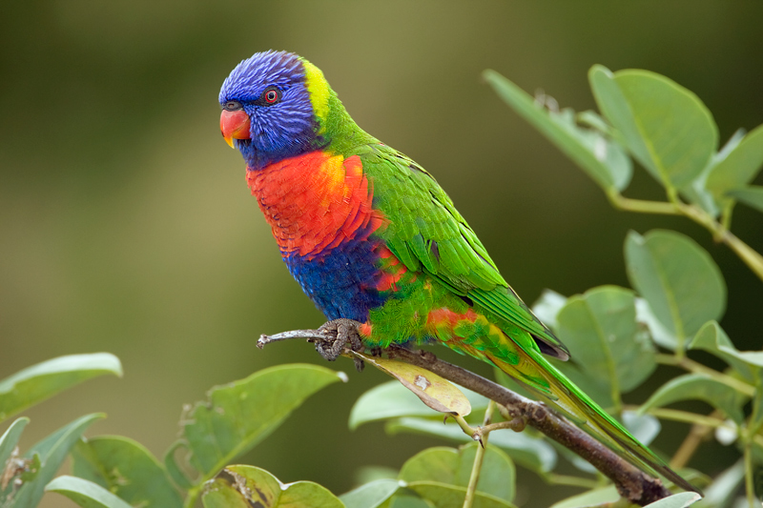

- (3 points) List THREE main differences between of the heart and great vessels in a crocodilian vs a mammal.

Continued on next page

- (1point) Callatrichine herpesvirus 3 usually causes asymptomatic infections but in common marmosets (Callithrix jacchus) it has been associated with:
  - Sudden death
  - Seizures
  - Diarrhea
  - Diabetes
  - Pneumonia

