Question:
According to a recent study evaluating the prevalence of Aves Polyomavirus 1 and Beak and Feather Disease Virus in Captive Psittacines, which sampling method is recommended for routine screening?
- Antibody serology
- Choana/cloacal swab PCR
- Viral isolation
- DNA extraction with genome sequencing
- Feather bulb PCR

Answer: E

Superficial Chronic Ulcerative Dermatitis (SCUD) in Psittacine Birds: Review of 11 Cases (2008-2016).
Abou-Zahr, T., Carrasco, D. C., Shimizu, N., Forbes, N. A., Dutton, T. A., Froehlich, F., & De Bellis, F.
JAMS 2018 32(1): 25-33
Question:
Which of the following infectious organisms is most commonly associated with superficial chronic ulcerative dermatitis (SCUD) in psittacine birds?
- Aspergillus fumigatus
- Enterobacter cloacae
- Malassezia spp.
- Mycobacterium avium
- Ornithonyssus bursa
HINDLIMB PARALYSIS SYNDROME IN WILD CARNABY'S COCKATOOS (CALYPTORHYNCHUS LATIROSTRIS): A NEW THREAT FOR AN ENDANGERED SPECIES
Anna Le Souëf, Simone Vitali, Rick Dawson, Rebecca Vaughan-Higgins, Kristin Warren
J Wildl Dis. 2020 Jul;56(3):609-619.

What is the hypothesized etiology of hindlimb paralysis syndrome in Carnaby’s cockatoos in Australia?
- Bacterial Menin
- Fungal granuloma
- Hypocalcemia
- Acute trauma
- Toxin exposure

A wild Carnaby’s cockatoo presents to a wildlife clinic in Australia with hindlimb paralysis and no signs of trauma. What treatment would you recommend for the most likely etiology?
- Atropine
- Antifungal therapy
- Calcium
- Supportive care
- Euthanasia

What is true regarding hindlimb paralysis in Carnaby’s cockatoos?
- Associated with elevated bile acids
- Also affects Baudin’s cockatoos
- Most commonly presents in winter months
- Affected cockatoos are anorexic and depressed
- Plasma acetylcholinesterase activity is not depressed
- Fatal Leucocytozoon Infection in a Captive Grey-headed Parrot (Poicephalus robustus suahelicus)
Livio Galosi, Frine E. Scaglione, Gian Enrico Magi, Susan C. Cork, Michael A. Peirce, Stefano Ferraro, Laura Starvaggi Cucuzza, Francesca T. Cannizzo, Giacomo Rossi
Journal of Avian Medicine and Surgery. 2019;33(2):179-183
- Taxa: Aves Psittaformes Psittacidae Poicephalus robustus suahelicus
Abstract: A necropsy was conducted on a female grey-headed parrot (Poicephalus robustus suahelicus) that died following signs of depression, ruffled feathers, and inappetence. Microscopic examination revealed the presence of hemoprotozoa in the liver. A nested polymerase chain reaction (PCR), targeting the mitochondrial cytochrome b gene of Haemoproteus species, Plasmodium species, and Leucocytozoon species, was performed on frozen tissue samples collected at necropsy. The hemoprotozoa were identified by PCR analysis as Leucocytozoon species. Hemoprotozoa are rarely reported in African parrots, and this is the first report of a Leucocytozoon species infection in a Poicephalus robustus suahelicus.

- Practice Question:

- What is the common definitive host for avian Leucocytozoon parasites?

- A. Psittacines
- B. Mosquitos
- C. Corvids
- D. Black flies

- Dieckmann, H., Jiménez-Soto, M., Jiménez-Rocha, A., Rojas, E., & Conrad, P. A. (2020). INTESTINAL AND BLOOD PARASITES IN SCARLET (ARA MACAO) AND GREAT GREEN (ARA AMBIGUA) MACAWS IN WILDLIFE REHABILITATION CENTERS IN COSTA RICA. Journal of Zoo and Wildlife Medicine, 51(2), 385-390.

- Abstract: Costa Rica undertakes continuous efforts to recover the native population of macaw species through rehabilitation programs for breeding and releasing birds in protected areas. In the summer of 2018, a total of 107 scarlet (Ara macao) and 93 great green (Ara ambigua) macaws were sampled in four wildlife rehabilitation centers in Costa Rica. Fecal samples representing 200 individuals were analyzed for intestinal parasites, and 23 individuals were sampled for hemoparasites. Ascaridia and Capillaria were found in fecal samples. No hemoparasites were found. The distribution of percentage of infection was analyzed by location, species, and housing type. As part of a health screening prior to release, parasitological examination is recommended.
- Q: Name the following avian parasites (Genus):
- 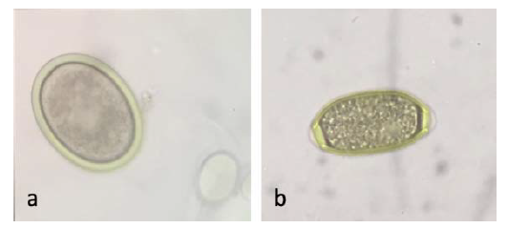
- C 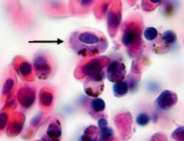 D 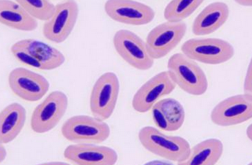
- A - Ascaridia spp
- B - Capillaria spp
- C - Hemoproteus spp
- D - Plasmodium spp

